Occurrence, fate, removal efficiency and ecological risk of selected antibiotics in wastewater and surface water of some hospitals: A case study in Vietnam
Hung Nguyen Xuan^{a*}; Thuy Le Minhª; Nam Vu Ducª; Tung Nguyen Ngocª; Nhan Le Vanª; Trung Nguyen Quang^{b}; Tuan Nguyen Anh^{c}.
ª High Technology Innovation Center, Vietnam Academy Science and Technology, No. 18 Hoang Quoc Viet, Nghia Do, Hanoi, Vietnam.
^{b} Institute of Environmental Science and Public Health, No. 18 Hoang Quoc Viet Street, Nghia Do, Hanoi, Vietnam
^{c} Centre for Community Capacity Development Nhan Van, No. 199 Trung Kinh Street, Yen Hoa, Hanoi, Vietnam

Appendix A. Supplementary data
Table S1: Mass; Standard curve, MDL, LOQ of analytical method
TT | Compounds | Mass | RT  (min) | Standard curve | R² | MDL | LOQ
 |  |  |  |  |  | ng/L
1 | Ciprofloxacin | 332.1405 [M+H]⁺ | 9.53 | Y = 3,118E7*X – 2,756E5 | 0.9993 | 0.067 | 0.222
2 | Levofloxacin | 362.1511 [M+H]⁺ | 9.33 | Y = 7,103E7*X – 3,551E5 | 0.9975 | 0.066 | 0.219
3 | Moxifloxacin | 402.1824 [M+H]⁺ | 10.08 | Y = 1,162E8*X – 4,954E5 | 0.9988 | 0.036 | 0.121
4 | Clarithromycin | 748.4842 [M+H]⁺ | 13.02 | Y = 4,169E7*X + 2,543E6 | 0.9998 | 0.069 | 0.230
5 | Amoxicillin | 398.1380 [M+CH₃]⁺ | 8.60 | Y = 3,316E6*X + 2,956E4 | 0.9996 | 0.032 | 0.107
6 | Cephalexin | 148.1012 [M+H]⁺ | 9.56 | Y = 1,900E6*X + 1,042E4 | 0.9997 | 0.031 | 0.103

Table S2: Average concentration of antibiotics in wastewater, treated waster
and surface waster at H1 hospital
TT | Compounds | BW | AW | EW 1 | EW 2 | EW 3 | EW 4 | EW 5
TT | Compounds | ng/L
1 | Amoxicillin | 47.8 | 6.68 | 0.503 | 0.124 | N.D | N.D | N.D
2 | Cephalexin | 2163 | 587 | 23.9 | 5.54 | 3.00 | 6.78 | 2.40
3 | Ciprofloxacin | 1360 | 197.4 | 11.9 | 31.4 | 20.8 | 16.9 | 13.4
4 | Clarithromycin | 46.4 | 7.11 | 0.267 | 0.479 | 0.576 | 0.156 | 0.650
5 | Levofloxacin | 541 | 321 | 5.75 | 6.36 | 0.792 | 8.50 | 4.60
6 | Moxifloxacin | 241 | 91.6 | 0.339 | N.D | N.D | N.D | N.D

Table S3: Average concentration of antibiotics in wastewater, treated waster
and surface waster at H2 hospital
TT | Compounds | BW | AW | EW 1 | EW 2 | EW 3 | EW 4 | EW 5
TT | Compounds | ng/L
1 | Amoxicillin | 55.8 | 11.6 | N.D | N.D | N.D | N.D | N.D
2 | Cephalexin | 3603 | 1260 | 63.0 | 3.15 | 0.17 | N.D | N.D
3 | Ciprofloxacin | 3506 | 479 | 23.4 | 37.6 | 18.2 | 42.8 | 32.2
4 | Clarithromycin | 27.5 | 4.21 | N.D | N.D | 1.24 | N.D | N.D
5 | Levofloxacin | 1476 | 897 | 11.6 | 18.4 | N.D | 10.1 | 13.6
6 | Moxifloxacin | 850 | 322 | N.D | N.D | N.D | N.D | N.D

Table S4: Average concentration of antibiotics in wastewater, treated waster
and surface waster at H3 hospital
TT | Compounds | BW | AW | EW 1 | EW 2 | EW 3 | EW 4 | EW 5
TT | Compounds | ng/L
1 | Amoxicillin | 28.3 | N.D | N.D | N.D | N.D | 1.47 | 0.54
2 | Cephalexin | 1130 | N.D | 177.7 | N.D | N.D | N.D | N.D
3 | Ciprofloxacin | 4634 | 99.6 | 69.5 | N.D | 2.28 | 3.28 | N.D
4 | Clarithromycin | 1.67 | N.D | N.D | N.D | N.D | N.D | 0.222
5 | Levofloxacin | 2476 | 0.206 | 33.8 | 0.124 | 0.498 | 0.771 | 0.682
6 | Moxifloxacin | 24.7 | N.D | 94.3 | N.D | N.D | N.D | N.D

Table S5: Average concentration of antibiotics in wastewater, treated waster
and surface waster at H4 hospital
TT | Compounds | BW | AW | EW 1 | EW 2 | EW 3 | EW 4 | EW 5
TT | Compounds | ng/L
1 | Amoxicillin | 9.66 | N.D | N.D | N.D | N.D | N.D | N.D
2 | Cephalexin | 5041 | N.D | 187 | 174 | 114 | 72.7 | 101
3 | Ciprofloxacin | 1775 | 15.4 | 0.953 | 23.1 | 4.59 | 1.28 | 1.43
4 | Clarithromycin | 2.86 | N.D | N.D | 0.420 | N.D | 0.893 | N.D
5 | Levofloxacin | 1092 | 88.9 | 1.25 | 28.0 | 3.70 | 4.50 | 0.899
6 | Moxifloxacin | 453 | 0.125 | N.D | 0.246 | 0.225 | N.D | N.D
BW: Hospital wastewater; AW: Treated water; EW: Surface Water; N.D = not detected

 |  | Table S6: Average concentration of antibiotics in surface waster
 | TT | Compouns | H1 |  | H2 |  | H3 |  | H4 | Mean
 | TT | Compouns | ng/L
 | 1 | Amoxicillin | 0.125 |  | n.d |  | 0.402 |  | n.d | 0.176±0.206
 | 2 | Cephalexin | 8.32 |  | 13.3 |  | 3.54 |  | 13.0 | 9.53±4.59
 | 3 | Clarithromycin | 0.426 |  | 0.248 |  | nd |  | 0.438 | 0.370±0.106
 | 4 | Ciprofloxacin | 18.9 |  | 30.8 |  | 15.0 |  | 6.27 | 17.8±10.2
 | 5 | Levofloxacin | 5.20 |  | 10.7 |  | 1.09 |  | 7.67 | 6.18±4.08
 | 6 | Moxifloxacin | 0.085 |  | n.d |  | 1.89 |  | 0.094 | 0.688±1.04
Table S7: RQs of antibiotics in surface water in hospitals
Compounds |  |  |  | H1 |  | H2 |  | H3 |  |  | H4
Amoxicillin |  |  |  | 0.157 |  | - |  | 0.503 |  |  | -
Cephalexin |  |  |  | 0.001 |  | 0.002 |  | 0.002 |  |  | 0.001
Ciprofloxacin |  |  |  | 1.888 |  | 3.084 |  | 2.502 |  |  | 0.627
Clarithromycin |  |  |  | 0.043 |  | 0.124 |  | 0.022 |  |  | 0.066
Levofloxacin |  |  |  | 0.520 |  | 1.343 |  | 0.109 |  |  | 0.767
Moxifloxacin |  |  |  | 9.97E-07 |  | 0.00E+00 |  | 2.77E-05 |  |  | 6.93E-07
Total RQs |  |  |  | 2.61 |  | 4.55 |  | 3.14 |  |  | 1.46

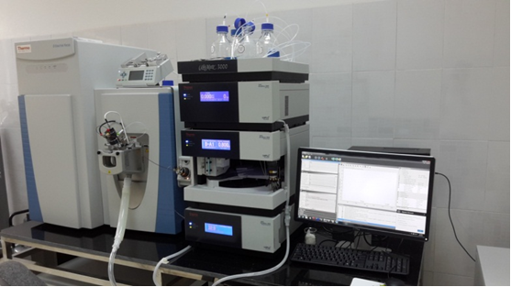Figure S1: Ultra Performance Liquid Chromatography coupled with High-Resolution Mass Spectrometry: Q Extractive Focus
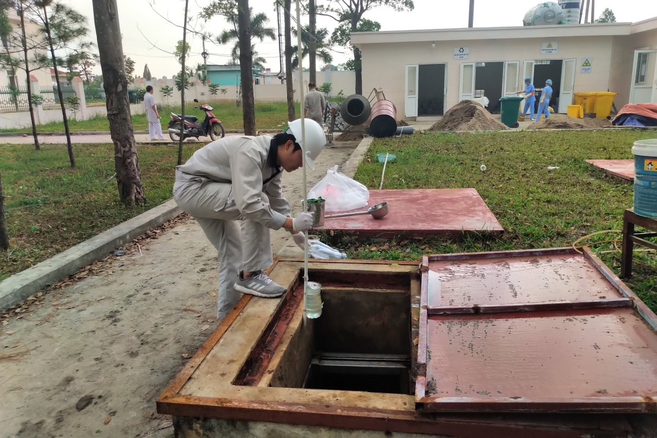
Figure S2: Sampling hospital wastewater sample
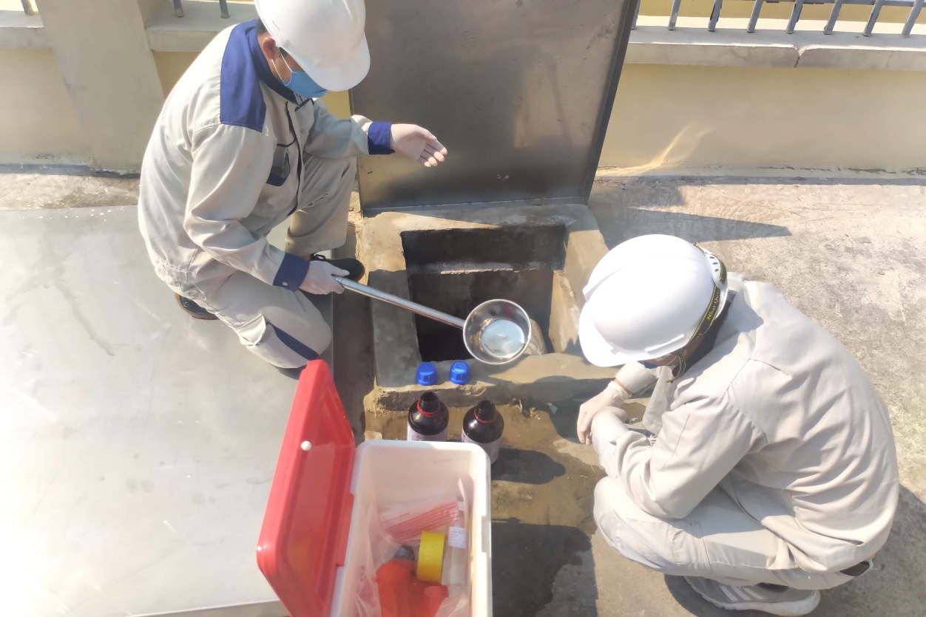
Figure S3: Sampling treated wastewater sample
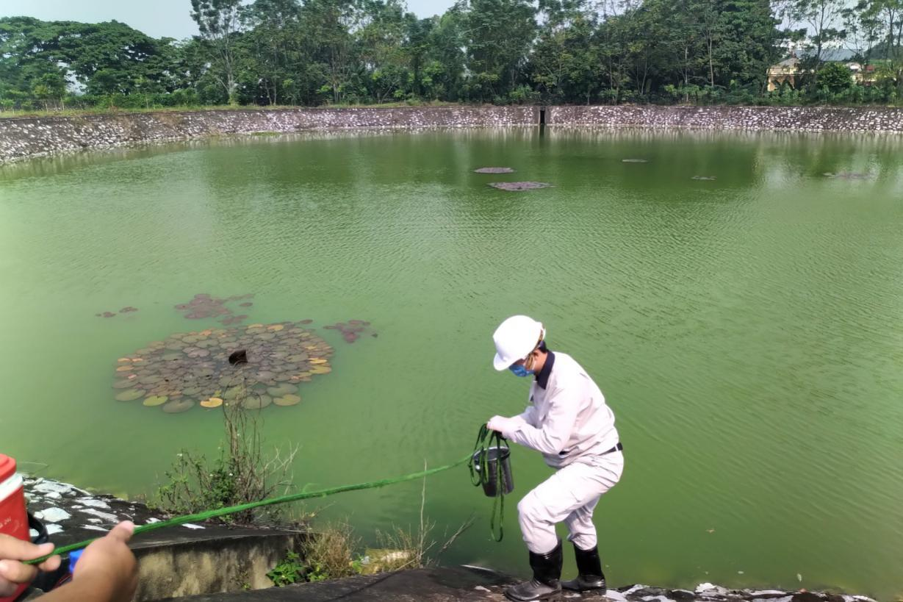
Figure S4: Sampling surface water sample
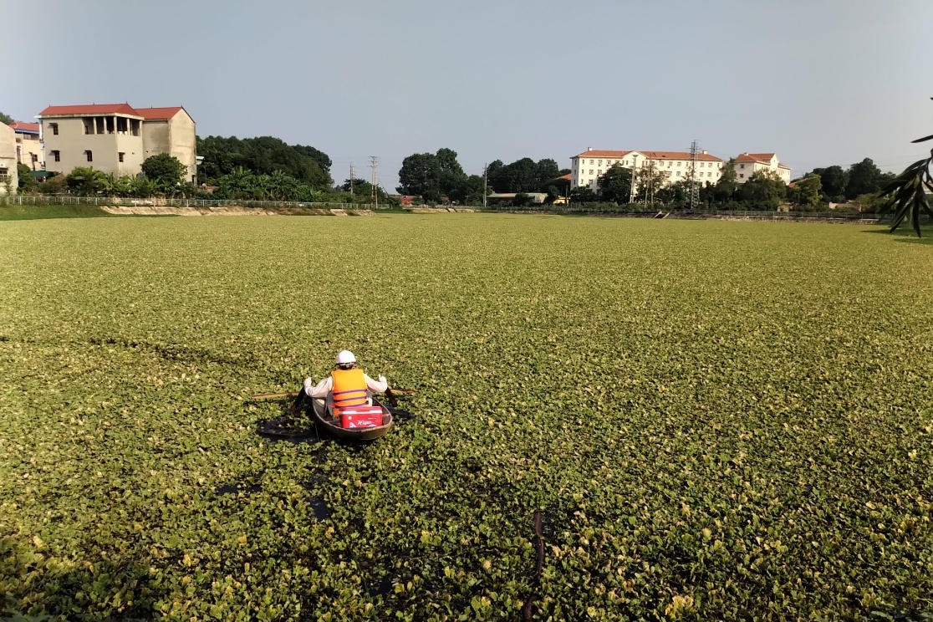
Figure S5: Sampling surface water sample

