Supplementary materials
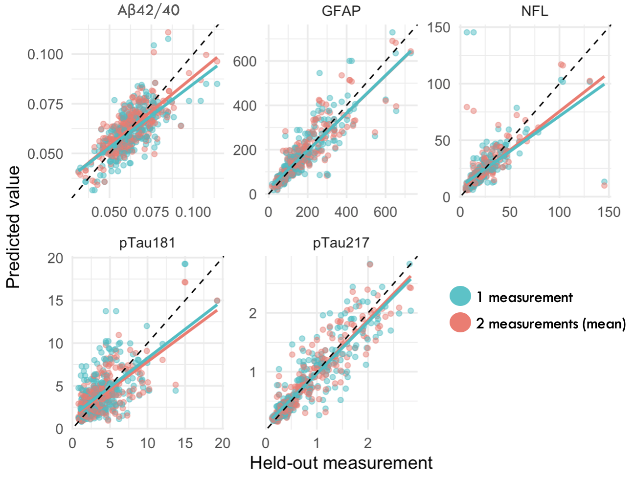
Figure 1S | Monte Carlo leave-one-out analysis.
On the x-axis the held-out measurement, on the y-axis the predicted value. One measurement is represented in light blue dots whilst the mean of two measurements is represented by salmon dots.
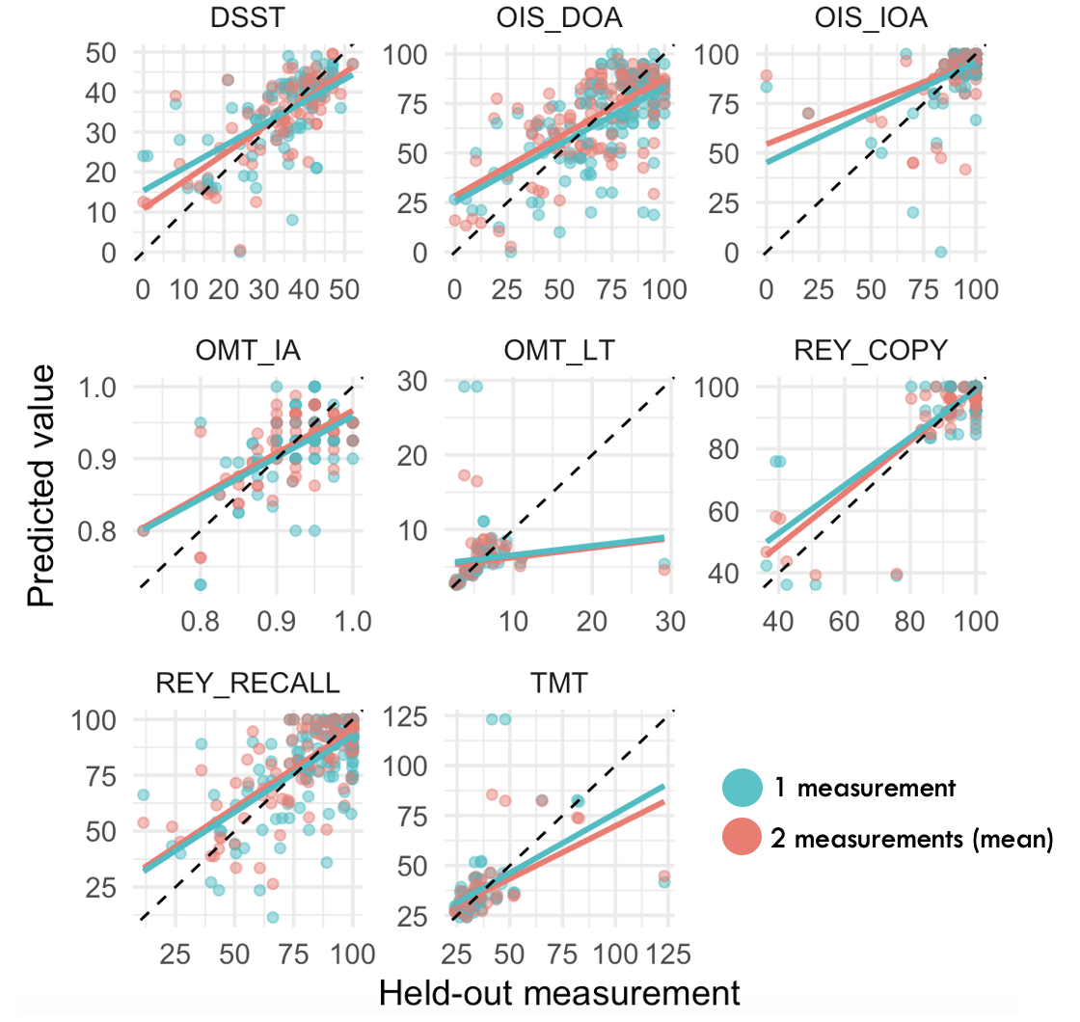

Figure 2S | Monte Carlo leave-one-out analysis.
On the x-axis the held-out measurement, on the y-axis the predicted value. One measurement is represented in light blue dots whilst the mean of two measurements is represented by salmon dots.
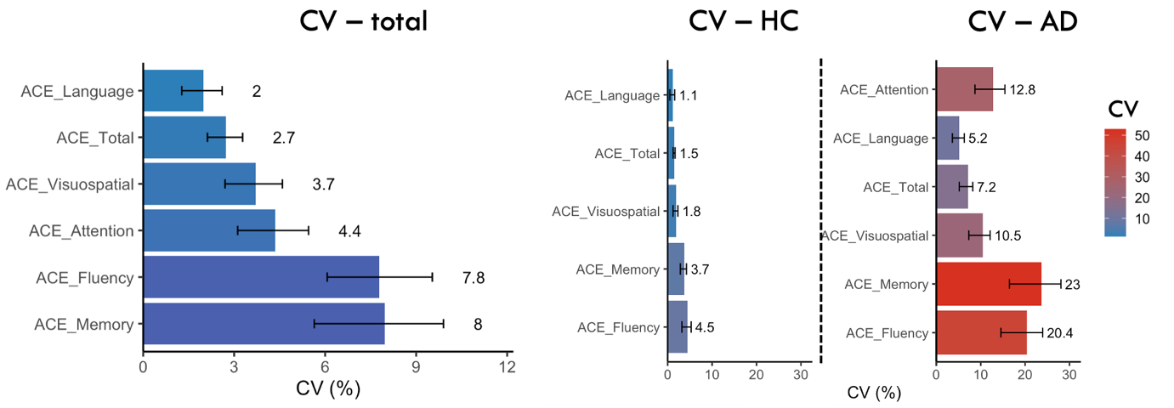
Figure 3S | Coefficient of variation of ACE
CV% is presented in entire sample and within groups (HC and AD).
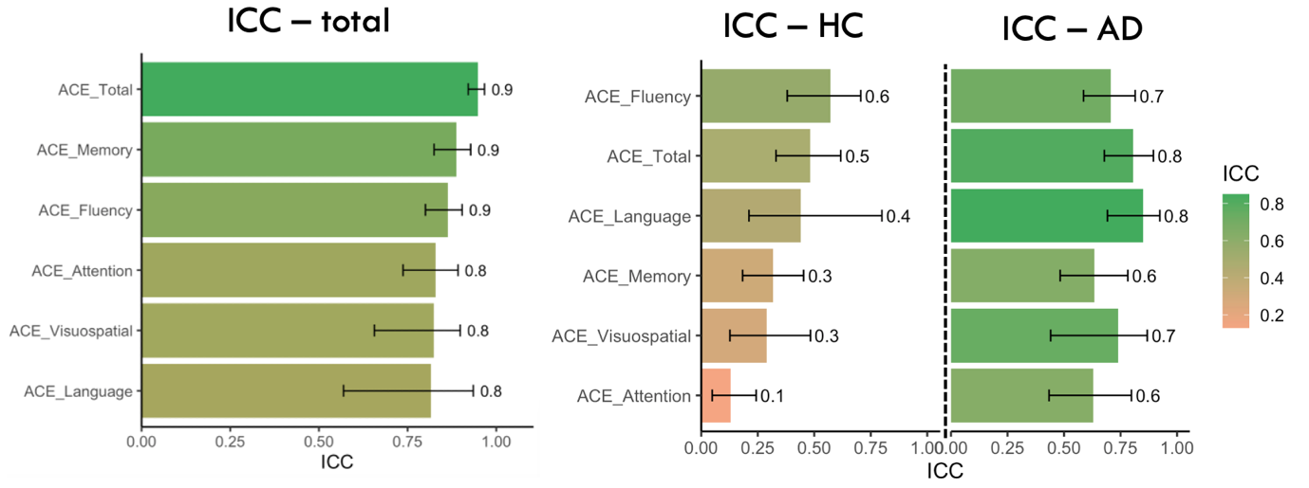
Figure 4S | Intraclass Correlation Coefficient of ACE

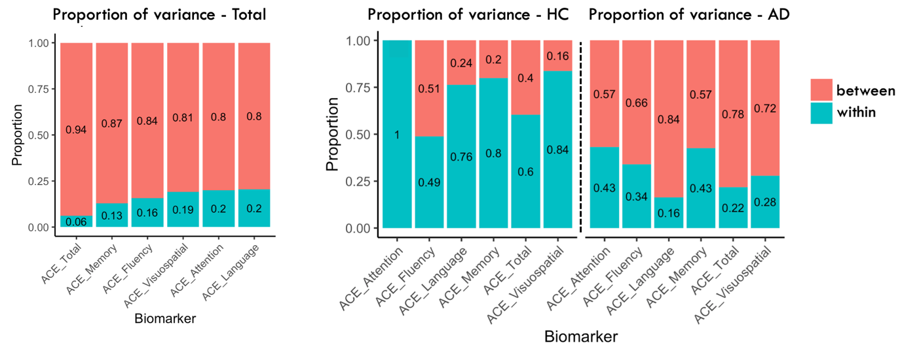
Figure 5S | Proportion of variance (between subjects and within subjects) of ACE
Proportion of variance of in the whole sample and within groups (HC and AD).

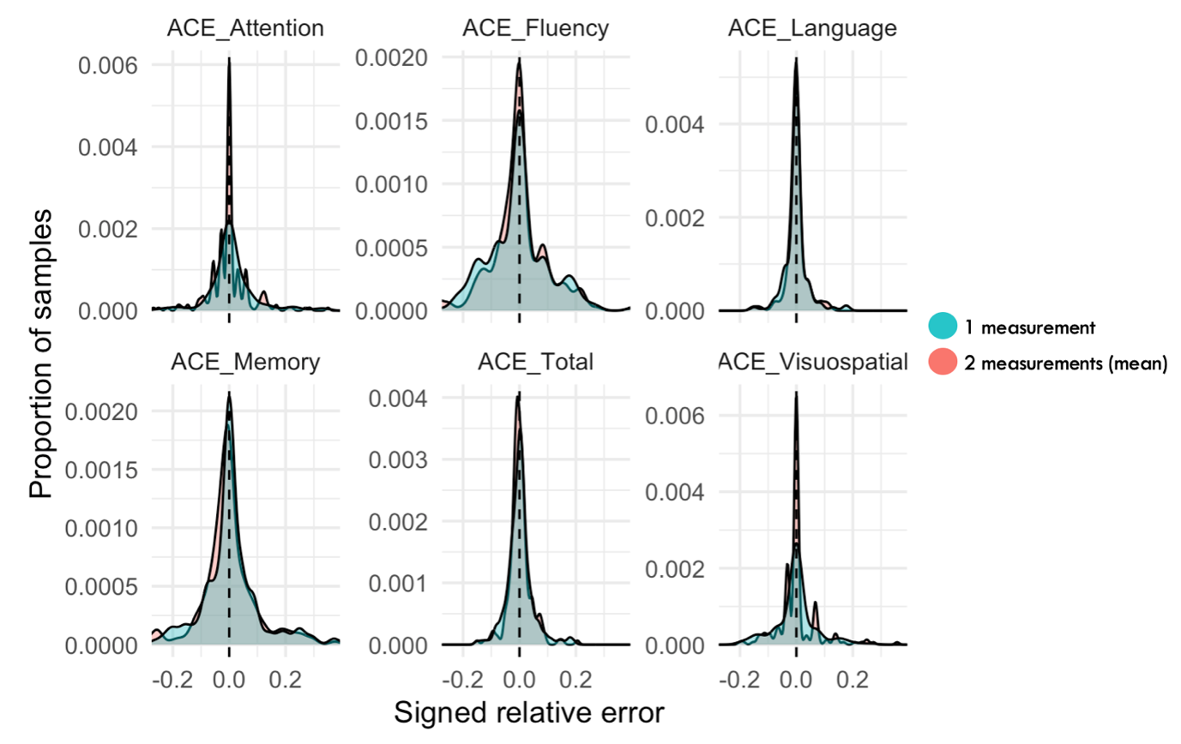
Figure 6S | Distribution plots of signed relative error with one or two measurements.
One measurement is represented by a light blue area whilst the mean of two measurements is represented in salmon. Best reliability is indexed by a narrower curve, more centered around 0 and showing less discrepancy between measurements. 1st and 99th percentile across all data was chosen for x-axis limits.

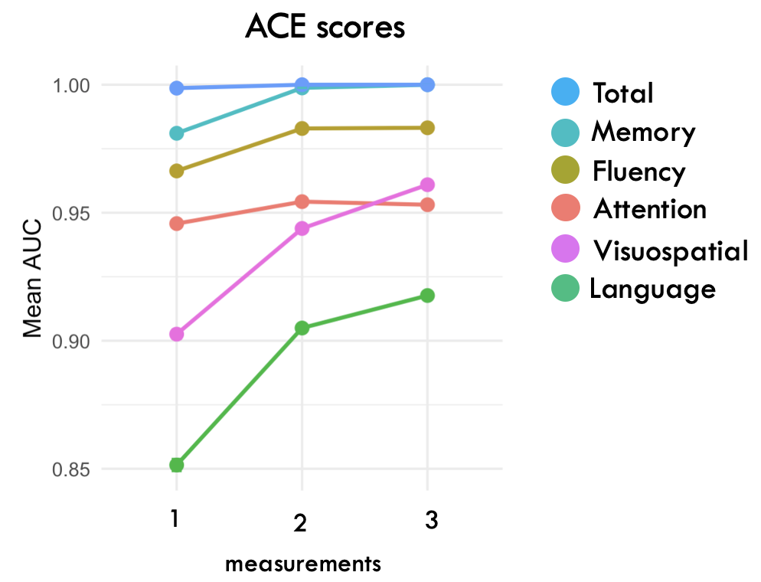
Figure 7S | Impact on clinical accuracy – ROC curves for ACE
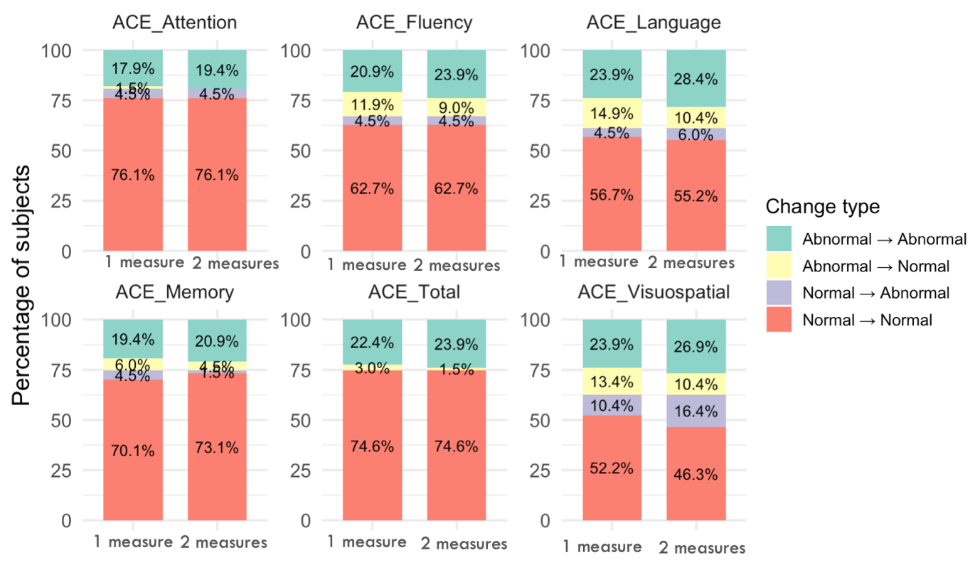
Figure 8S | Impact on clinical accuracy (ACE) – class change

