Suppimentary Materials:

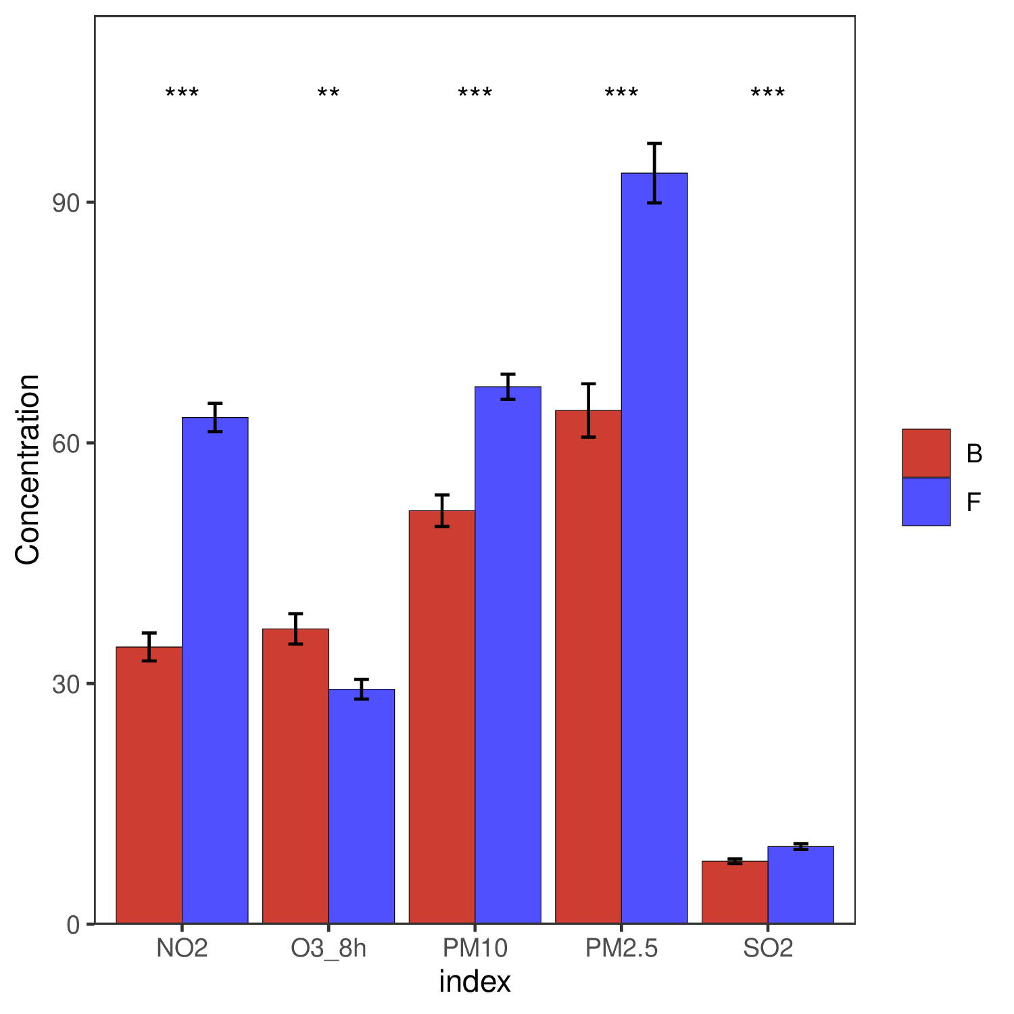
Fig. S1 One-way ANOVA (left) and spearman analysis (right) for the five pollutants in Wuhan before (F) and during the Covid-19 lockdown period (B)
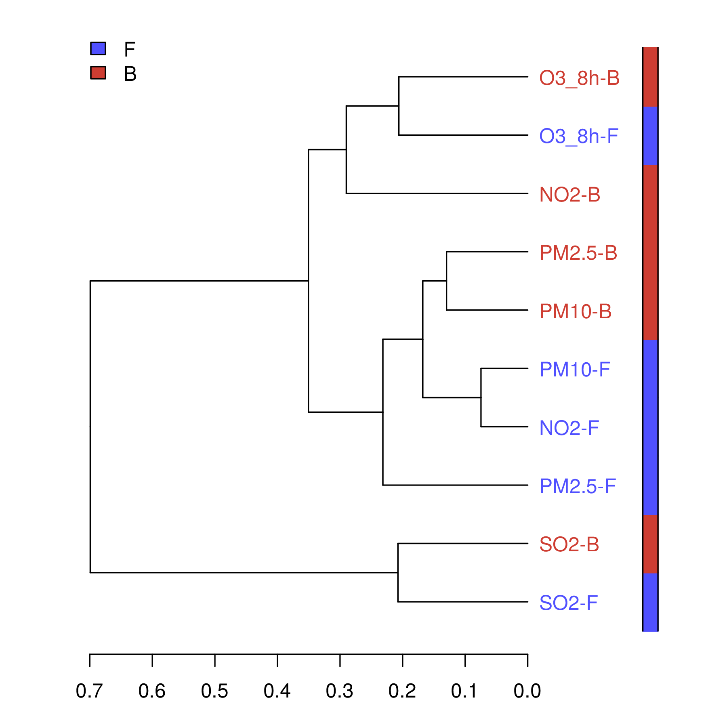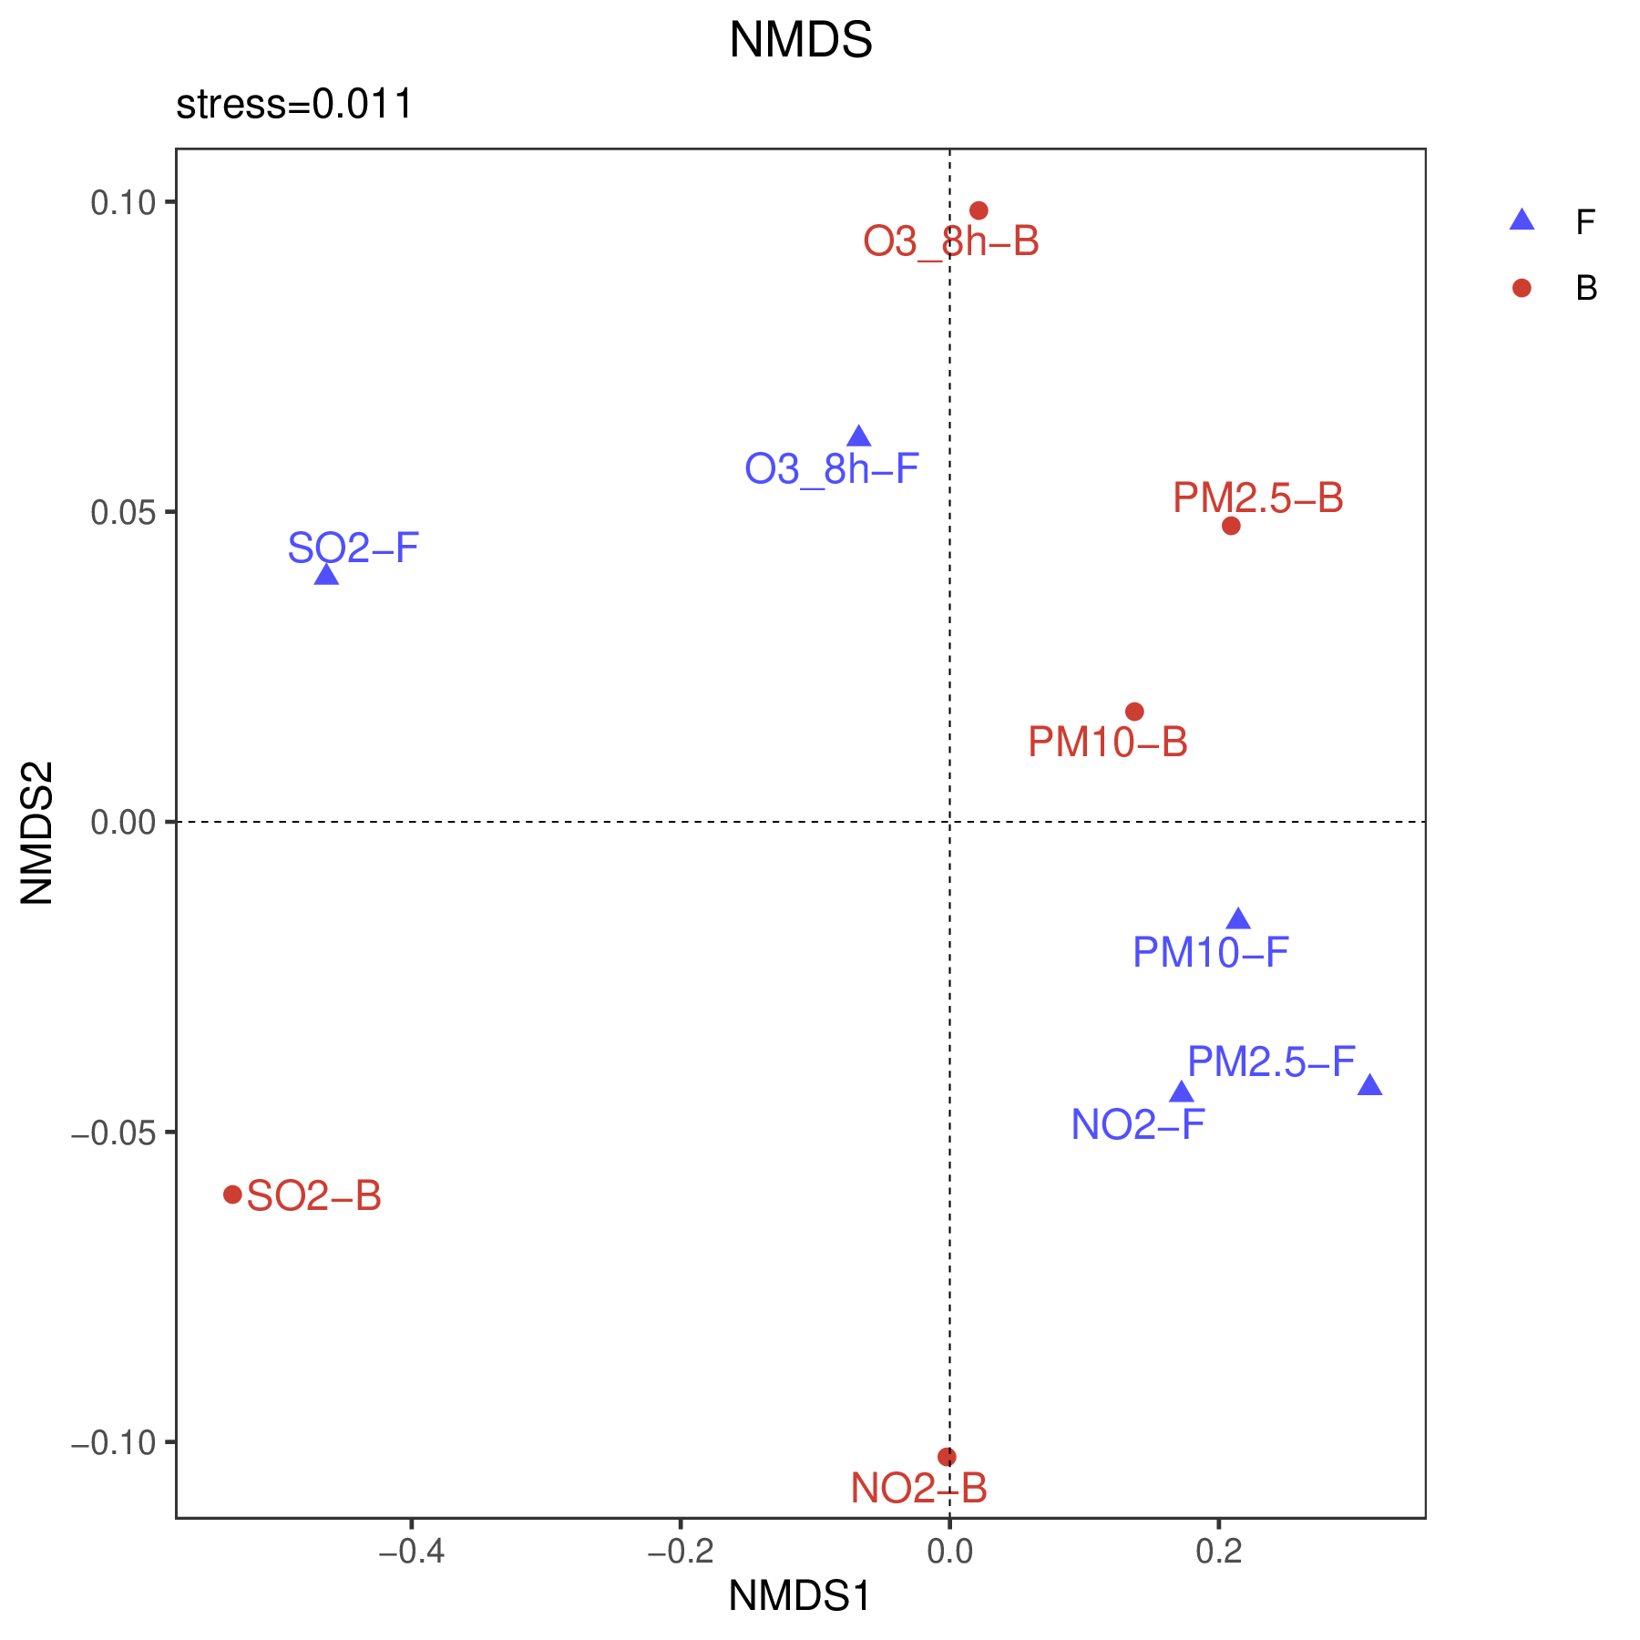
Fig. S2 Clustering analysis (left) and NMDS (right) of different pollutants before (F) and during lockdown (B) in Wuhan

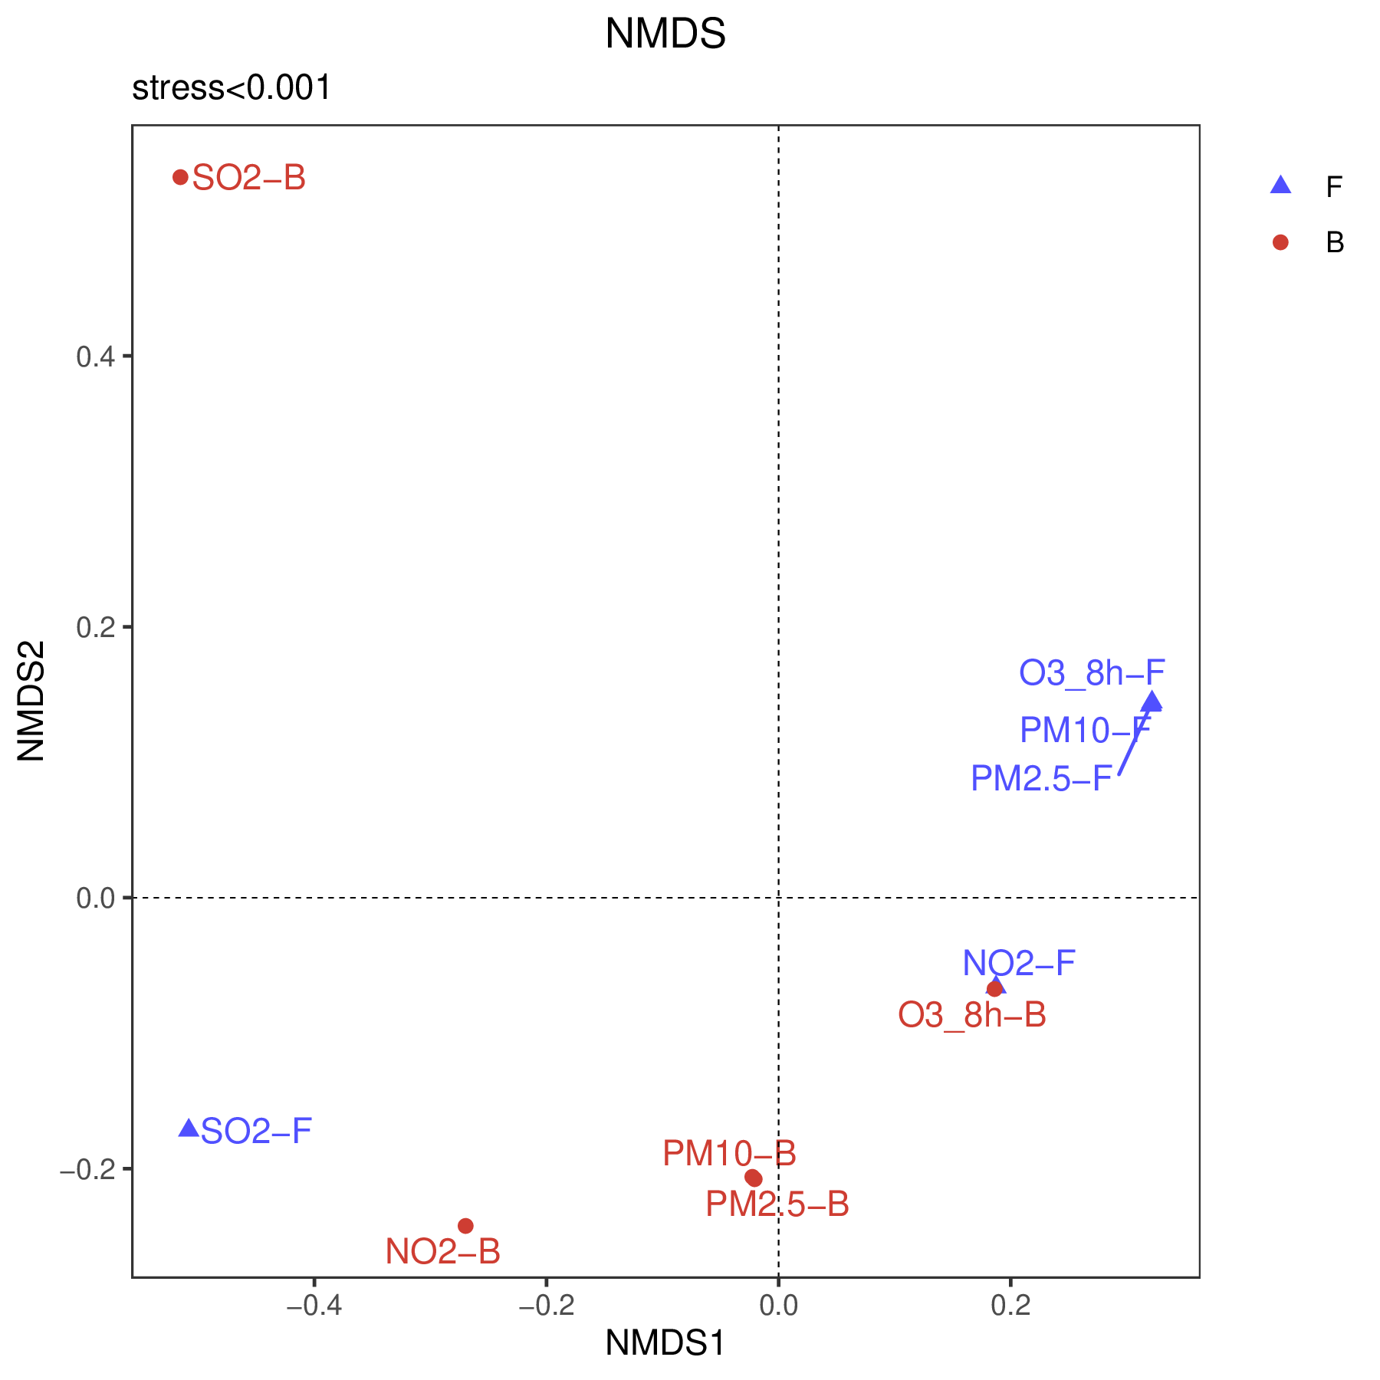
Fig. S3 Clustering analysis (left) and NMDS (right) of different pollutants before (F) and during lockdown (B) in Shanghai

