Supplementary Information
Supplementary Figure 1: Cryo-EM and single particle analysis workflow

Supplementary Table 1: Cryo-EM statistics

 | Ffp1 filament
 | PDB 9Y6O/ EMD-72625
Data collection
Microscope | FEI Titan Krios
Voltage (kV) | 300
Camera | Gatan K3 Continuum
Mode | Counting
Magnification | 64,000
Pixel size (Å) | 1.32
Electron dose (e–/Å²) | 54
Defocus range (μm) | -0.6 to -2.0
Exposure (s) | 5.3
Reconstruction
Software | CryoSPARC-4.1.1
Frames | 40
Symmetry | C33
Initial particle images (no.) | 305,884
Final particle images (no.) | 18,821
Map resolution, FSC_{0.143} (Å) | 3.20
Map-sharpening B factor (Å) | -60.7
Refinement
Software | Phenix-1.20.1
Model composition
Non-hydrogen atoms | 3310
Protein residues | 426
R.m.s. deviations
Bond lengths (Å) | 0.005
Bond angles (°) | 0.771
Validation
MolProbity score | 1.67
Clashscore | 7.92
Poor rotamers (%) | 0
Ramachandran plot
Favored (%) | 96.46
Allowed (%) | 3.54
Disallowed (%) | 0
Supplementary Table 2: List of primers used in this study
Supplementary Figure 2: Abundance of FimA, Mfa1 and Ffp1 in 33277 P. gingivalis cells
P. gingivalis 33277 WT cells were lysed and electrophoresed on a gel for a short time. The whole proteome was excised as a single band from the gel and subjected to trypsin digestion and mass spectrometry analysis. MS/MS spectra were analyzed using Maxquant software and the iBAQ intensities were plotted for PGN_0180 (FimA), PGN_0287 (Mfa1) and PGN_1808 (Ffp1).
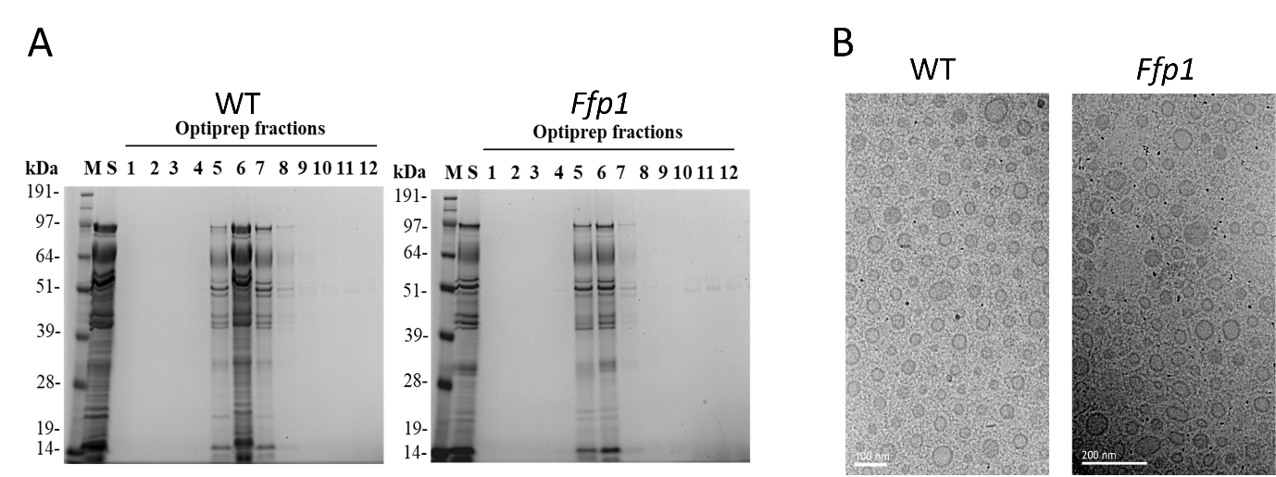
Supplementary Figure 3: Quantitation of OMVs
(A) Twelve fractions obtained by OptiPrep density-gradient centrifugation of OMVs from wild-type (WT) and the ΔFfp1 mutant (Ffp1) were separated by SDS–PAGE to compare protein distribution and amount across fractions (B) Representative cryo-electron micrographs of purified OMVs from WT and ΔFfp1. Scale bars: WT, 100 nm; ΔFfp1, 200 nm.

