SUPPLEMENTARY INFORMATION
Fig.S1. Biomass of flue-cured tobacco at maturity stage under different treatments. Using one-way analysis of variance, different lowercase letters indicated significant differences between treatments (P < 0.05).
Table.S1. Nutrient accumulation during the maturing period of baked cigarettes
 | Treatment | N（mg/Plant） | P（mg/Plant） | K（mg/Plant）
Root | CK | 322.12±18.6cd | 7.03±0.16b | 7.14±0.19ab
Root | T1 | 511.77±9.66a | 8.38±0.19a | 7.85±0.06a
Root | T2 | 376.9±21.53bc | 6.09±0.14c | 6.99±0.31ab
Root | T3 | 427.77±23.72b | 7.1±0.2b | 7.33±0.13ab
Root | T4 | 295.89±16.74d | 4.65±0.1d | 6.55±0.29b
Stem and leaf | CK | 4819.79±255.86a | 24.47±1.58b | 196.48±2a
Stem and leaf | T1 | 4720.23±109.44a | 22.01±0.56b | 176.19±3.65b
Stem and leaf | T2 | 4291.8±133.77ab | 21.08±1.65b | 156.09±2.59c
Stem and leaf | T3 | 3827.1±119.95b | 16.04±0.69c | 138.77±1.92d
Stem and leaf | T4 | 4046.42±60.8b | 31.97±1.86a | 142.88±3.19d
Note：Using one-way analysis of varianc e, different lowercase letters indicated significant differences between treatments (p < 0.05). The same below.

Fig. S2. The accumulation of N (A), P (B), and K (C) during the maturity period of tobacco under different treatments. CK: tobacco monoculture, T1: relay cropping of silage corn during the later growth stage of tobacco plants, T2: relay cropping of waxy corn during the later growth stage of tobacco plants, T3: relay cropping of soybean during the later growth stage of tobacco plants, T4: relay cropping of broad bean during the later growth stage of tobacco plants. Using one-way analysis of variance, different lowercase letters indicated significant differences between treatments (p < 0.05). The same below.

Table.S2. Analysis of the Yield of Relay-Cropping Crops
inter-planting crops | Yield（Kg/Plant）
Feed corn | 5.1 × 10⁻¹a
Waxy corn | 2.0 × 10⁻¹b
Soybean | 1.5 × 10⁻²c
Broad bean | 2.4 × 10⁻²c
Note：“—” Indicates that tobacco is grown alone without intercropping with other crops.

Fig.S3. Relative abundance of bacterial phyla (A), bacterial genera (B), fungal phyla (C), and fungal genera (D) at the maturity stage of flue-cured tobacco under different treatments

Fig.S4. The composition and abundance of bacterial genus community (A) and fungal genus community (B) in rhizosphere soil of tobacco after different planting patterns.

Fig.S5. Microbial community difference analysis. The evolutionary branch diagram of LEfSe analysis of different species in bacterial community (A), and the evolutionary branch diagram of LEfSe analysis of different species in fungal community (B).

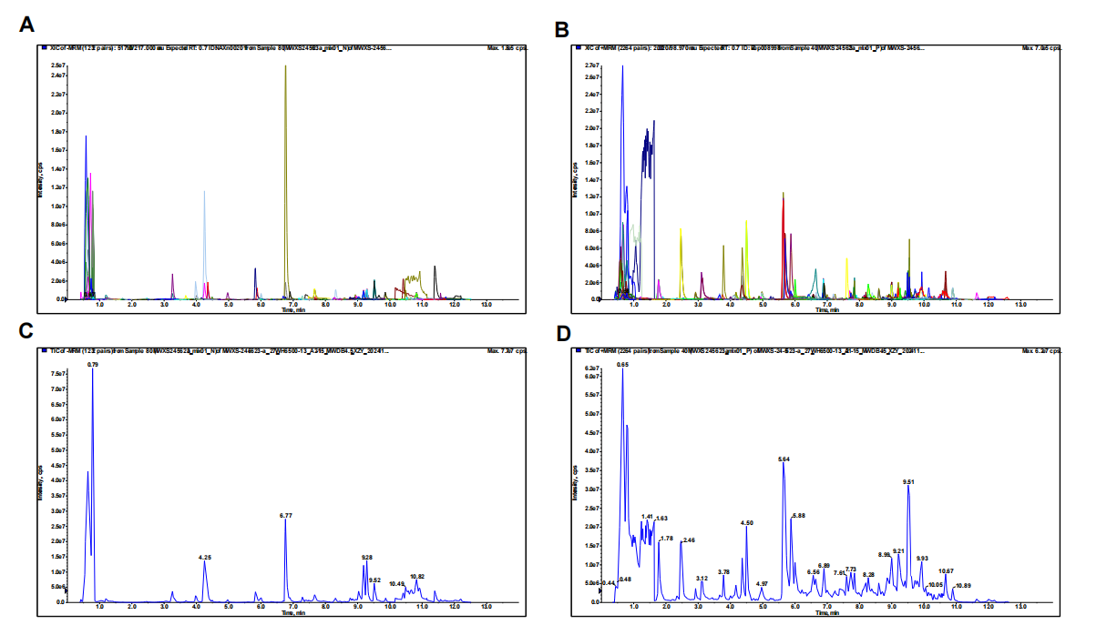
Fig.S6. Overlay of total ion chromatograms for multi-peak metabolite detection and quality control sample analysis by mass spectrometry. (A) Multi-peak of metabolite detection under positive ion mode; (B) multi-peak of metabolite detection under negative ion mode; (C) QC sample mass spectrometry detection TIC overlay under positive ion mode; and (D) QC sample mass spectrometry detection TIC overlay under negative ion mode.

Fig.S7. Correlation analysis of chemical properties of the rhizosphere soil of tobacco plants and key microbial genera (A) and key metabolites (B). “ B ” represents bacteria and “ F ” represents fungi. * indicates P < 0.05; ** indicates P < 0.01; *** indicates P < 0.001.

