Supplementary figures

Chromosome-scale genome of a twig-girdler longhorn beetle reveals clustered genomic organization of herbivory-linked functions

Diego de S. Souza ^{1, 2, 3,} *, Tatiana A. Sepúlveda ⁴, Rowan L. K. French ⁵, Bruno A. S. de Medeiros ¹, José O. Silva Júnior ⁶, Dayanna do N. Machado ⁷, Terrence Sylvester ⁸, Luciane Marinoni ⁹, Eugenio H. Nearns ⁴, Marcela L. Monné ^{3, +} & Felix A. H. Sperling ^{2, +}

¹ Negaunee Integrative Research Center, Field Museum of Natural History, Chicago, Illinois, USA
² Department of Biological Sciences, University of Alberta, Edmonton, Alberta, Canada
³ Department of Entomology, National Museum, Federal University of Rio de Janeiro, Rio de Janeiro, Rio de Janeiro, Brazil
⁴ Gantz Family Collections Center, Field Museum of Natural History, Chicago, Illinois, USA
⁵ Department of Ecology and Evolutionary Biology, University of Toronto, Toronto, Ontario, Canada
⁶ Department of General Biology, Universidade Estadual de Montes Claros, Montes Claros, Minas Gerais, Brazil
⁷ Instituto Federal do Mato Grosso, Sorriso, Mato Grosso, Brazil
⁸ Department of Biological Sciences, University of Memphis, Memphis, Tennessee, 38152, USA
⁹ Department of Zoology, Federal University of Paraná, Curitiba, Paraná, Brazil
* Corresponding author: Diego de S. Souza, dsouza@fieldmuseum.org

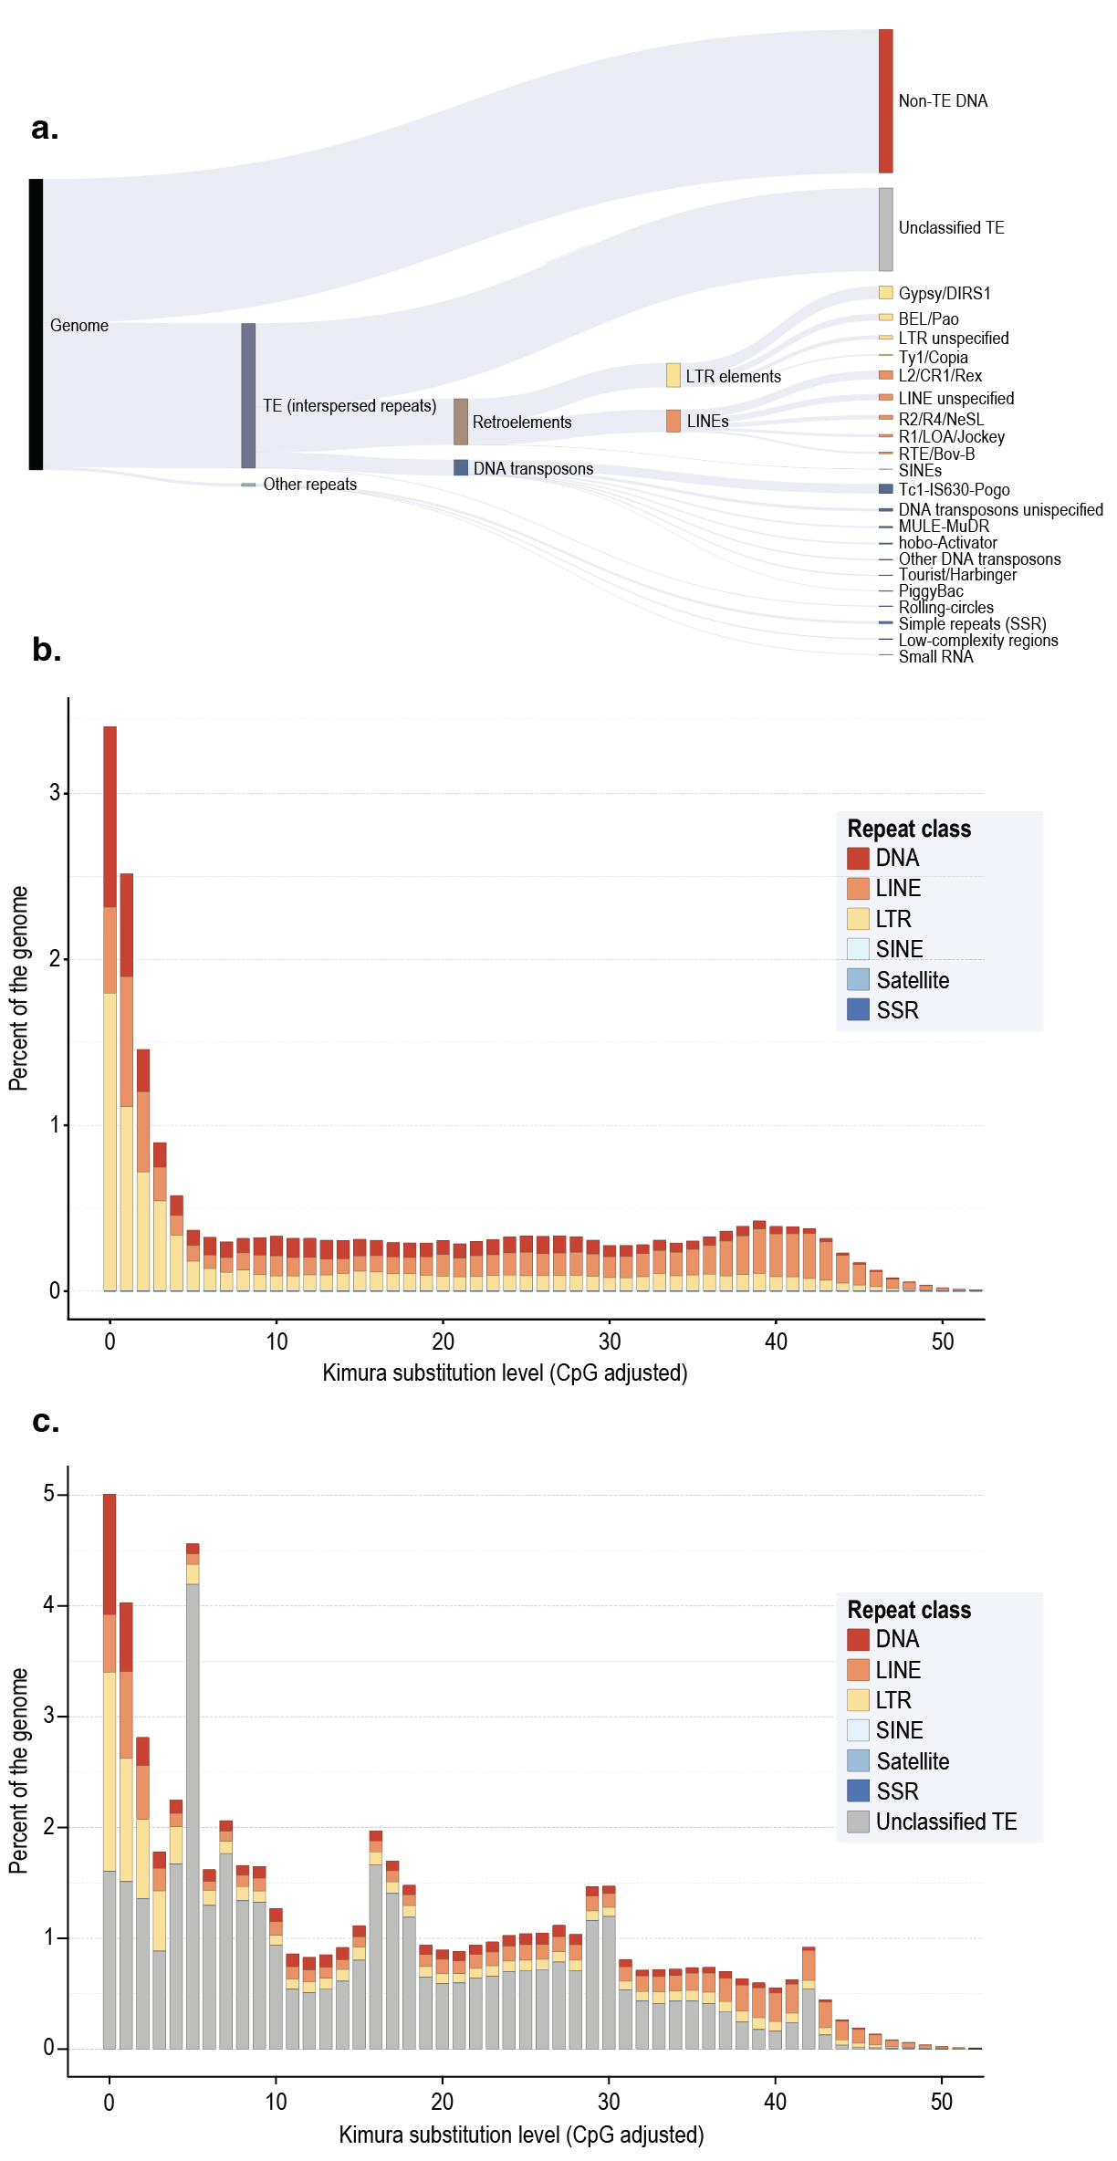
Figure S1. Repeat composition and divergence landscape of the Oncideres impluviata genome.
(a) Sankey diagram summarizing the hierarchical composition of repetitive and non-repetitive sequence in the O. impluviata genome. Flow widths are proportional to the genomic contribution of each category. (b) Repeat landscape including only classified repeat elements. (c) Repeat landscape including unclassified transposable elements. Repeat annotation was generated using a combined de novo and homology-based approach with RepeatModeler and RepeatMasker.

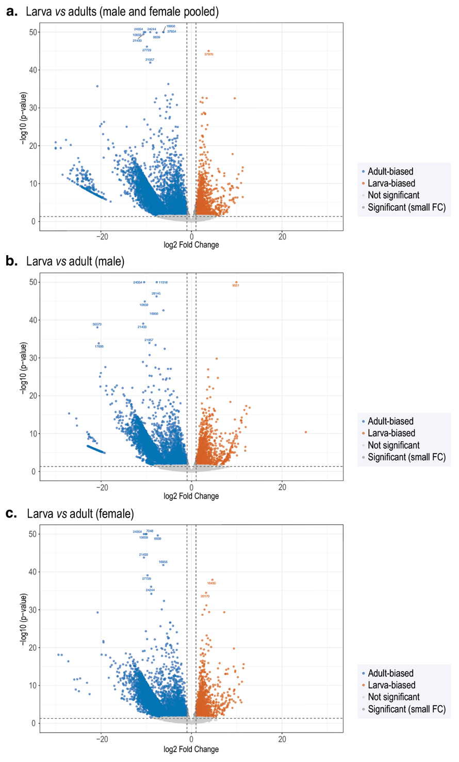
Figure S2. Genome-wide differential expression between larvae and adults in Oncideres impluviata.
Volcano plots showing genome-wide differential expression for three developmental contrasts: (a) larvae vs adults with males and females pooled, (b) larvae vs adult males, and (c) larvae vs adult females. Each point represents a gene. Differential expression was assessed with DESeq2 using Benjamini-Hochberg correction. Numbers correspond to gene identifiers with the “FUN_” prefix removed. Gene identifications are provided in Table S3.

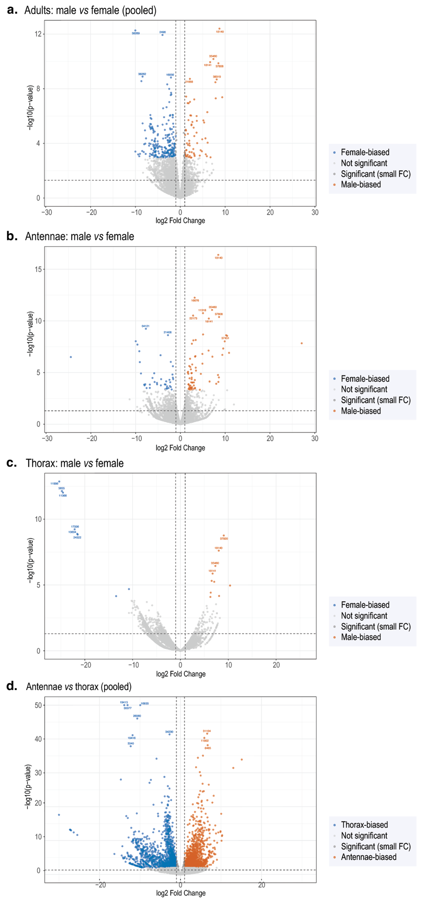
Figure S3. Genome-wide differential expression by sex and adult tissue in Oncideres impluviata.
Volcano plots showing genome-wide differential expression for adult sex and tissue contrasts: (a) adult males vs females with antennae and thorax pooled, (b) male vs female antennae, (c) male vs female thorax, and (d) adult antennae vs thorax with males and females pooled. Each point represents a gene. Differential expression was assessed with DESeq2 using Benjamini-Hochberg correction. Numbers correspond to gene identifiers with the “FUN_” prefix removed. Gene identifications are provided in Table S3.

