Immune-neurovascular bone regeneration of triple ions incorporated CaTiO₃ coated porous scaffold — Supplementary Information
Dongmei Yu^{a,b,1}, Zhen Tang ^{c,a,1}, Tonglei Yang ^{a, 1}, Shuo Guo^{d,e,1}, Shusen Bao^{a,f}, Chenyu Li^{a,}, Qi Wuª, Changchen Chenª, Yingxiang Liuª, Xiaokang Liª, Hai Huang^{a, *}, Hao Wu^{a,*}, Zheng Guo ^{a,*}
ª Department of Orthopedics, Tangdu Hospital, Air Force Medical University, Xi’an, 710038, China
^{b} Institute of Orthopaedic and Musculoskeletal Science, University College London, Royal National Orthopaedic Hospital, Stanmore, London HA7 4LP, UK
^{c} Department of Orthopaedics, General Hospital of Central Theater Command (Wuhan General Hospital of Guangzhou Command, previously), Wuhan 430030, China
^{d} Department of Biomedical Engineering, Air Force Medical University, Xi’an 710032, China
^{e} Department of Radiology, Tangdu Hospital, Air Force Medical University, Xi’an 710038, China
^{f} Department of Orthopedics, No. 903 Hospital of PLA Joint Logistic Support Force, Hangzhou, 310000, China

Experimental methods
Murine-derived macrophage cell line (RAW 264.7), human umbilical vein endothelial cells (HUVECs), neural stem cell line (NE-4C) and mouse embryo osteoblast precursor cell line (MC3T3-E1) from Chinese Academy of Sciences were applied in following biological assays in vitro. Macrophages and MC3T3-E1 cells were cultured using complete Dulbecco’s modified Eagle’s medium (DMEM with 10% fetal bovine serum (FBS) and 1% penicillin/streptomycin, HyClone, UStates). HUVECs were cultured in complete endothelial cell medium (ECM with 5% FBS, 1% endothelial cell growth supplementation factor and 1% penicillin/streptomycin, ScienCell, US). NE-4C cells were cultured in complete Eagle's Minimum Essential Medium (EMEM with 10% FBS and 1% penicillin/streptomycin, HyClone, UStates). All the cells were incubated in a humidified environment at a temperature of 37 °C, with 5% CO₂ and 95% air.

Results and discussion

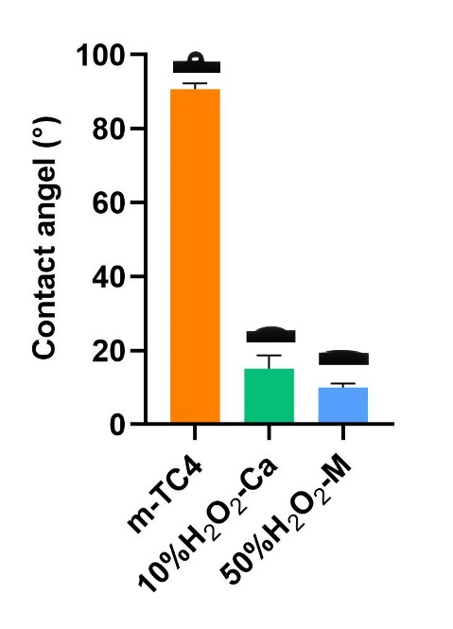
Fig. S1 Contact angles and corresponding digital photographs of water droplets on different surfaces
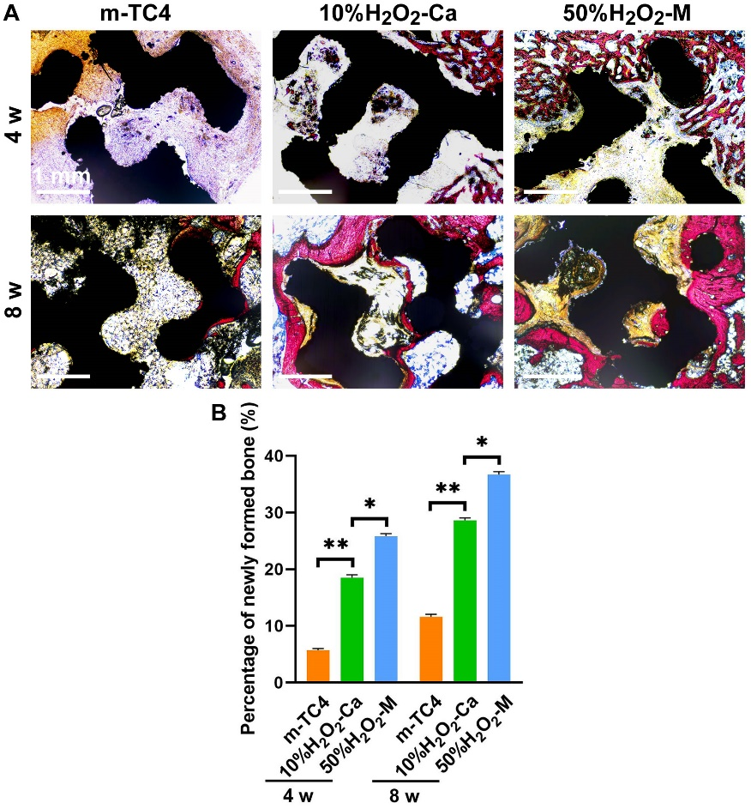
Fig. S2 (A) Representative Van Geison stained sections and (B) percentage of newly formed bone in scaffold-contained femoral condyle tissue.

∗ Corresponding author: guozheng@fmmu.edu.cn. Tel.: +86 02984777433. * Corresponding author: 15619421671@163.com. * Corresponding author: haihuang_snow@126.com. ¹ Co-first authors: These authors contributed equally to this work.

