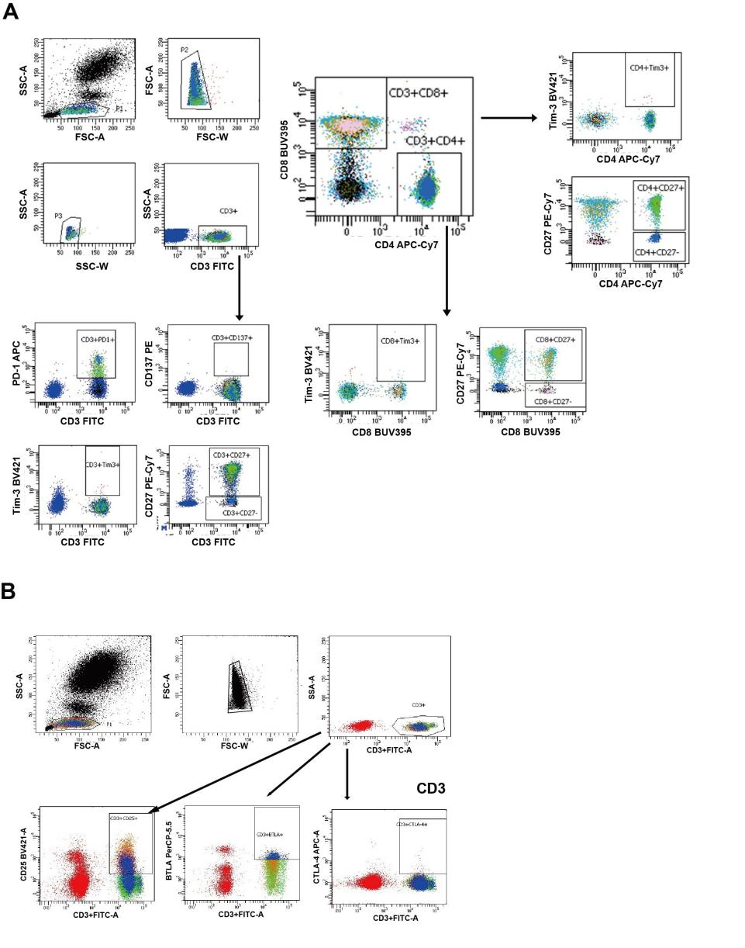
Supplementary fig. 1. Flow cytometry gating strategy for CD3+T cell subset.
The gating strategy is shown, including initial QC gates (SSC singlets, FSC singlets) followed by immune cell subsets. The frequencies referenced for each subgated cell population shown are from the parental gate. A, Flow cytometry gating strategy for CD3+ T, CD4+ T, CD8+ T cells, CD137+CD3+T+, CD27+CD3+T, Tim-3+CD3+T PD-1+CD3+T, Tim-3+CD4+T, Tim-3+CD8+T, Tim-3+CD27+CD3+T, Tim-3+ CD27+CD4+T, and Tim-3+ CD27+CD8+T cells. B,Flow cytometry gating strategy for BTLA+CD3+ T, CD25+CD3+T+, CTLA-4+CD3+T.

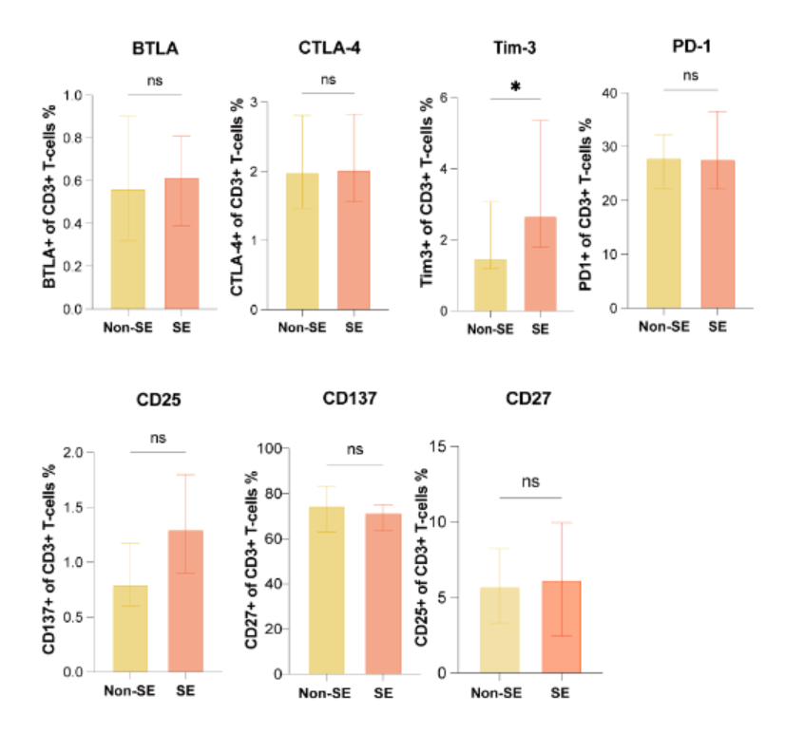
Supplementary fig. 2. Comparison of the frequencies of CD3+T cell subset between SE and non-SE patients
Flow cytometry was employed to analyze peripheral blood CD3+T cell subsets in 48 PTB patients, including 36 non-SE and 12 SE patients. Unpaired t test and Mann-Whitney U were used to get the P-value.*P˂0.05, ns, P>0.05.

Supplementary Table 1. Association of cytokines and soluble checkpoints with the prognosis of PTB in univariate analysis

Influence factors | Cases | Death cases | P value | Log Rank value
sCD25 (cut off=4370pg/ml) |  |  | < 0.0001 | 14.38(4.592-45.06)
low | 51 | 1 | < 0.0001 | 14.38(4.592-45.06)
high | 35 | 11 | < 0.0001 | 14.38(4.592-45.06)
sCD27 (cut off=69512pg/ml) |  |  | < 0.0001 | -
low | 45 | 0 | < 0.0001 | -
high | 41 | 12 | < 0.0001 | -
PD-L1 (cut off=40.13pg/ml) |  |  | 0.0063 | 9.735(3.133-30.25)
low | 45 | 1 | 0.0063 | 9.735(3.133-30.25)
high | 41 | 11 | 0.0063 | 9.735(3.133-30.25)
Tim-3 (cut off=29637pg/ml) |  |  | < 0.0001 | -
low | 48 | 0 | < 0.0001 | -
high | 38 | 12 | < 0.0001 | -
Gal-9 (cut off=58575pg/ml) |  |  | < 0.0001 | 0.05(0.01-0.42)
low | 51 | 1 | < 0.0001 | 0.05(0.01-0.42)
high | 35 | 11 | < 0.0001 | 0.05(0.01-0.42)
IP-10 (cut off=417.2pg/ml) |  |  | 0.0029 | 0.14(0.03-0.63)
low | 48 | 2 | 0.0029 | 0.14(0.03-0.63)
high | 38 | 10 | 0.0029 | 0.14(0.03-0.63)
IL-6 (cut off=31.83pg/ml) |  |  | 0.0009 | 0.07(0.01-0.55)
low | 45 | 1 | 0.0009 | 0.07(0.01-0.55)
high | 41 | 11 | 0.0009 | 0.07(0.01-0.55)
IFN-γ (cut off=18.46pg/ml) |  |  | 0.0502 | 0.34(0.11-1.07)
low | 57 | 5 | 0.0502 | 0.34(0.11-1.07)
high | 29 | 7 | 0.0502 | 0.34(0.11-1.07)
IL-8 (cut off=2.93pg/ml) |  |  | 0.0088 | 0.11(0.01-0.82)
low | 37 | 1 | 0.0088 | 0.11(0.01-0.82)
high | 49 | 11 | 0.0088 | 0.11(0.01-0.82)

Supplementary Table 2 LASSO Regression Analysis of Peripheral Blood, Soluble Checkpoints, and Cytokines Disease Severity

Feature | Coefficient
Neutrophil | 0.6947
Lymphocyte | -0.4704
sTim-3 | 0.4633
sLAG-3 | 0.3935
sCD25 | 0.3466
IP-10 | 0.2857
LDH | 0.2710
sCD27 | 0.0003
sPD-L1 | 0.0000
sPD-L2 | 0.0000
sGalectin-9 | 0.0000
IL-6 | 0.0000
IFN-γ | 0.0000
IL-8 | 0.0000
WBC | 0.0000
Hemoglobin | 0.0000
D-Dimer | 0.0000
ALB | 0.0000
CRP | 0.0000

