Supplementary results
Differential expression of ferroptosis-related genes and their molecular subtyping analysis
To characterize ferroptosis-related molecular features in gastric cancer, transcriptomic data from TCGA and ferroptosis-related genes from FerrDB were analyzed. Twenty-eight differentially expressed ferroptosis-related genes were identified, and consensus clustering based on these genes classified gastric cancer samples into two molecular subtypes, C1 and C2, with optimal clustering observed at k = 2 (FigureS1 A–C). Survival analysis showed that patients in the C1 subtype had significantly better overall survival than those in the C2 subtype (FigureS1 D). Comparison of clinicopathological features between the two subtypes revealed significant differences in T stage and tumor grade (FigureS1 E).To further identify ferroptosis-related genes associated with tumor progression, WGCNA was performed. After excluding outlier samples and constructing a scale-free co-expression network, 13 gene modules were identified, among which the brown module showed the strongest association with tumor traits and was selected for further analysis (Figure S1 F–J). The brown module contained 171 genes, and univariate Cox regression identified 26 prognosis-related genes (FigureS1 K). These genes were then subjected to multiple machine learning algorithms to establish a ferroptosis-related risk prognostic model. The combination of CoxBoost and random survival forest achieved the highest C-index and identified seven key ferroptosis-related risk genes: SAC3D1, KIF24, CHAF1A, GAD1, RNF43, VSNL1, and ASCL2 (FigureS1 L). Based on the corresponding model coefficients, a ferroptosis-related risk score (FRRS) was calculated for each patient, and patients in both the TCGA discovery cohort and the external GSE84437 validation cohort were stratified into high- and low-FRRS groups.The prognostic performance of the FRRS was subsequently evaluated. PCA and t-SNE analyses showed clear separation between the high- and low-FRRS groups, indicating distinct molecular characteristics (FigureS1 M–P). Univariate and multivariate Cox regression analyses confirmed that the FRRS was an independent prognostic factor in both the TCGA and validation cohorts (FigureS1 Q–T). Kaplan–Meier survival analysis further demonstrated that patients with high FRRS had significantly worse overall survival than those with low FRRS in both cohorts (FigureS1 U,V). Time-dependent ROC analysis showed favorable predictive accuracy of the model for 1-, 3-, and 5-year overall survival (FigureS1W,X).

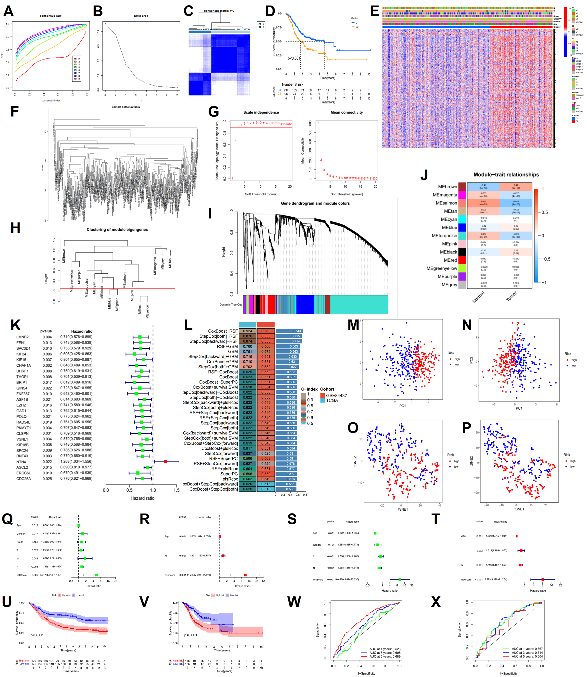
FigureS1. Development and Validation of a Prognostic Model for GC
(A) Cumulative distribution function (CDF) for k=2 to k=9.(B) Relative change in area under the CDF curve according to different k values.(C) Consensus clustering matrix of samples from TCGA dataset for k=2. (D) Survival analysis of patients in the C1 group and C2 group in TCGA cohort. (E) Heatmap of two clusters .(F) sample clustering to detect outliers.(G) the correlation coefficient R² and mean connectivity in the scale-free network. (H) Calculate similarity between modules and merge modules with high similarity.(I) Hierarchical clustering of gene modules. (J) Heatmap of the correlationship between gene modules and normal or cancer tissue. (K) Univariate Cox analysis of the prognostic value of genes suitable for model construction.(L) Multiple machine learning algorithms to develop the FRRPM.(M) PCA assessed the ability of FRRS to differentiate between high and low FRRS groups of patients in the TCGA cohorts.(N) PCA assessed the ability of FRRS to differentiate between high and low FRRS groups of patients in the GEO cohorts.(O) tSNE assessed the ability of FRRS to differentiate between high and low FRRS groups of patients in the TCGA cohorts.(P) tSNE assessed the ability of FRRS to differentiate between high and low FRRS groups of patients in the GEO cohorts.(Q and R) Univariate and Multivariate Cox analysis of FRRS and clinical characteristics in TCGA.(S and T) Univariate and Multivariate Cox analysis of FRRS and clinical characteristics in GEO.(U) The patient samples from TCGA were divided into high and low FRRS groups based and the OS of the groups were analyzed.(V) OS analysis of high and low risk groups from the GEO samples.(W) ROC curve analysis in TCGA.(X) ROC curve analysis in GEO.

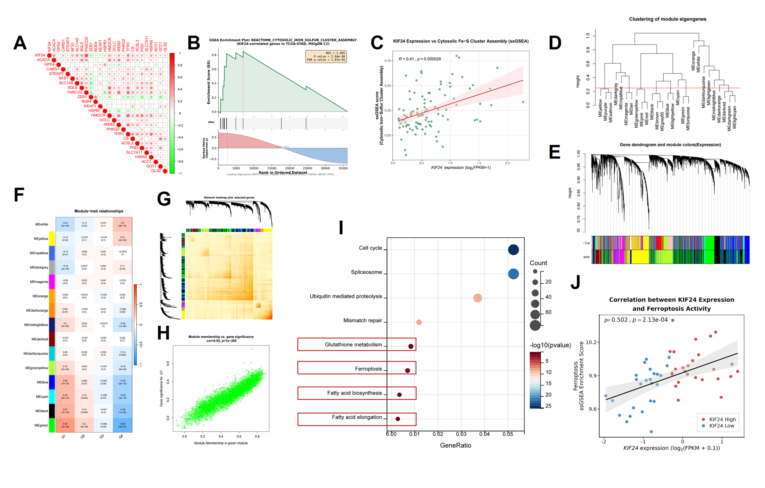

Figure S2. mechanistic analyses of KIF24 in ferroptosis regulation.
(A) Correlation analysis between KIF24 and ferroptosis-related genes.(B) GSEA based on KIF24 expression in TCGA cohort.(C)We validated the GSEA analysis results using RNA‑seq data from our independently collected cohort.(D) Merging of similar gene modules in the co-expression network.(E) Hierarchical clustering dendrogram of gene modules identified by WGCNA.(F) Heatmap comparing gene expression patterns between high-KIF24 (Q1, top 25%) and low-KIF24 (Q4, bottom 25%) groups.(G) Heatmap of the weighted gene co-expression network.(H) Correlation analysis between module membership (MM) and gene significance (GS) within the green module.(I) Functional enrichment analysis of genes in the green module associated with KIF24 expression and ferroptosis regulation.(J)Validation of the correlation between KIF24 expression and the ferroptosis pathway in our own cohort.
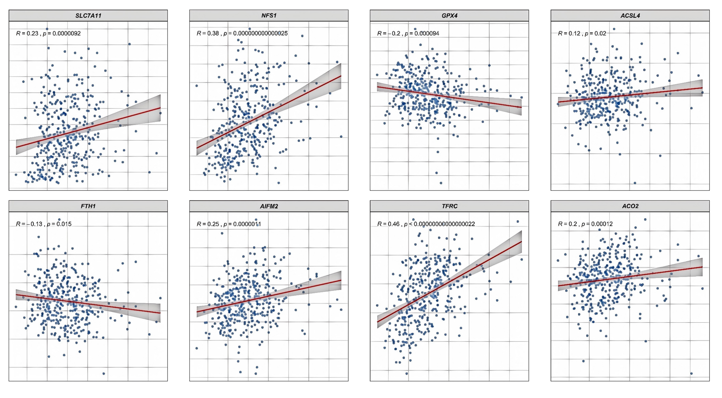
Figure S3 KIF24 expression is associated with ferroptosis-defense and Fe–S-dependent mitochondrial function-related genes in gastric cancer.
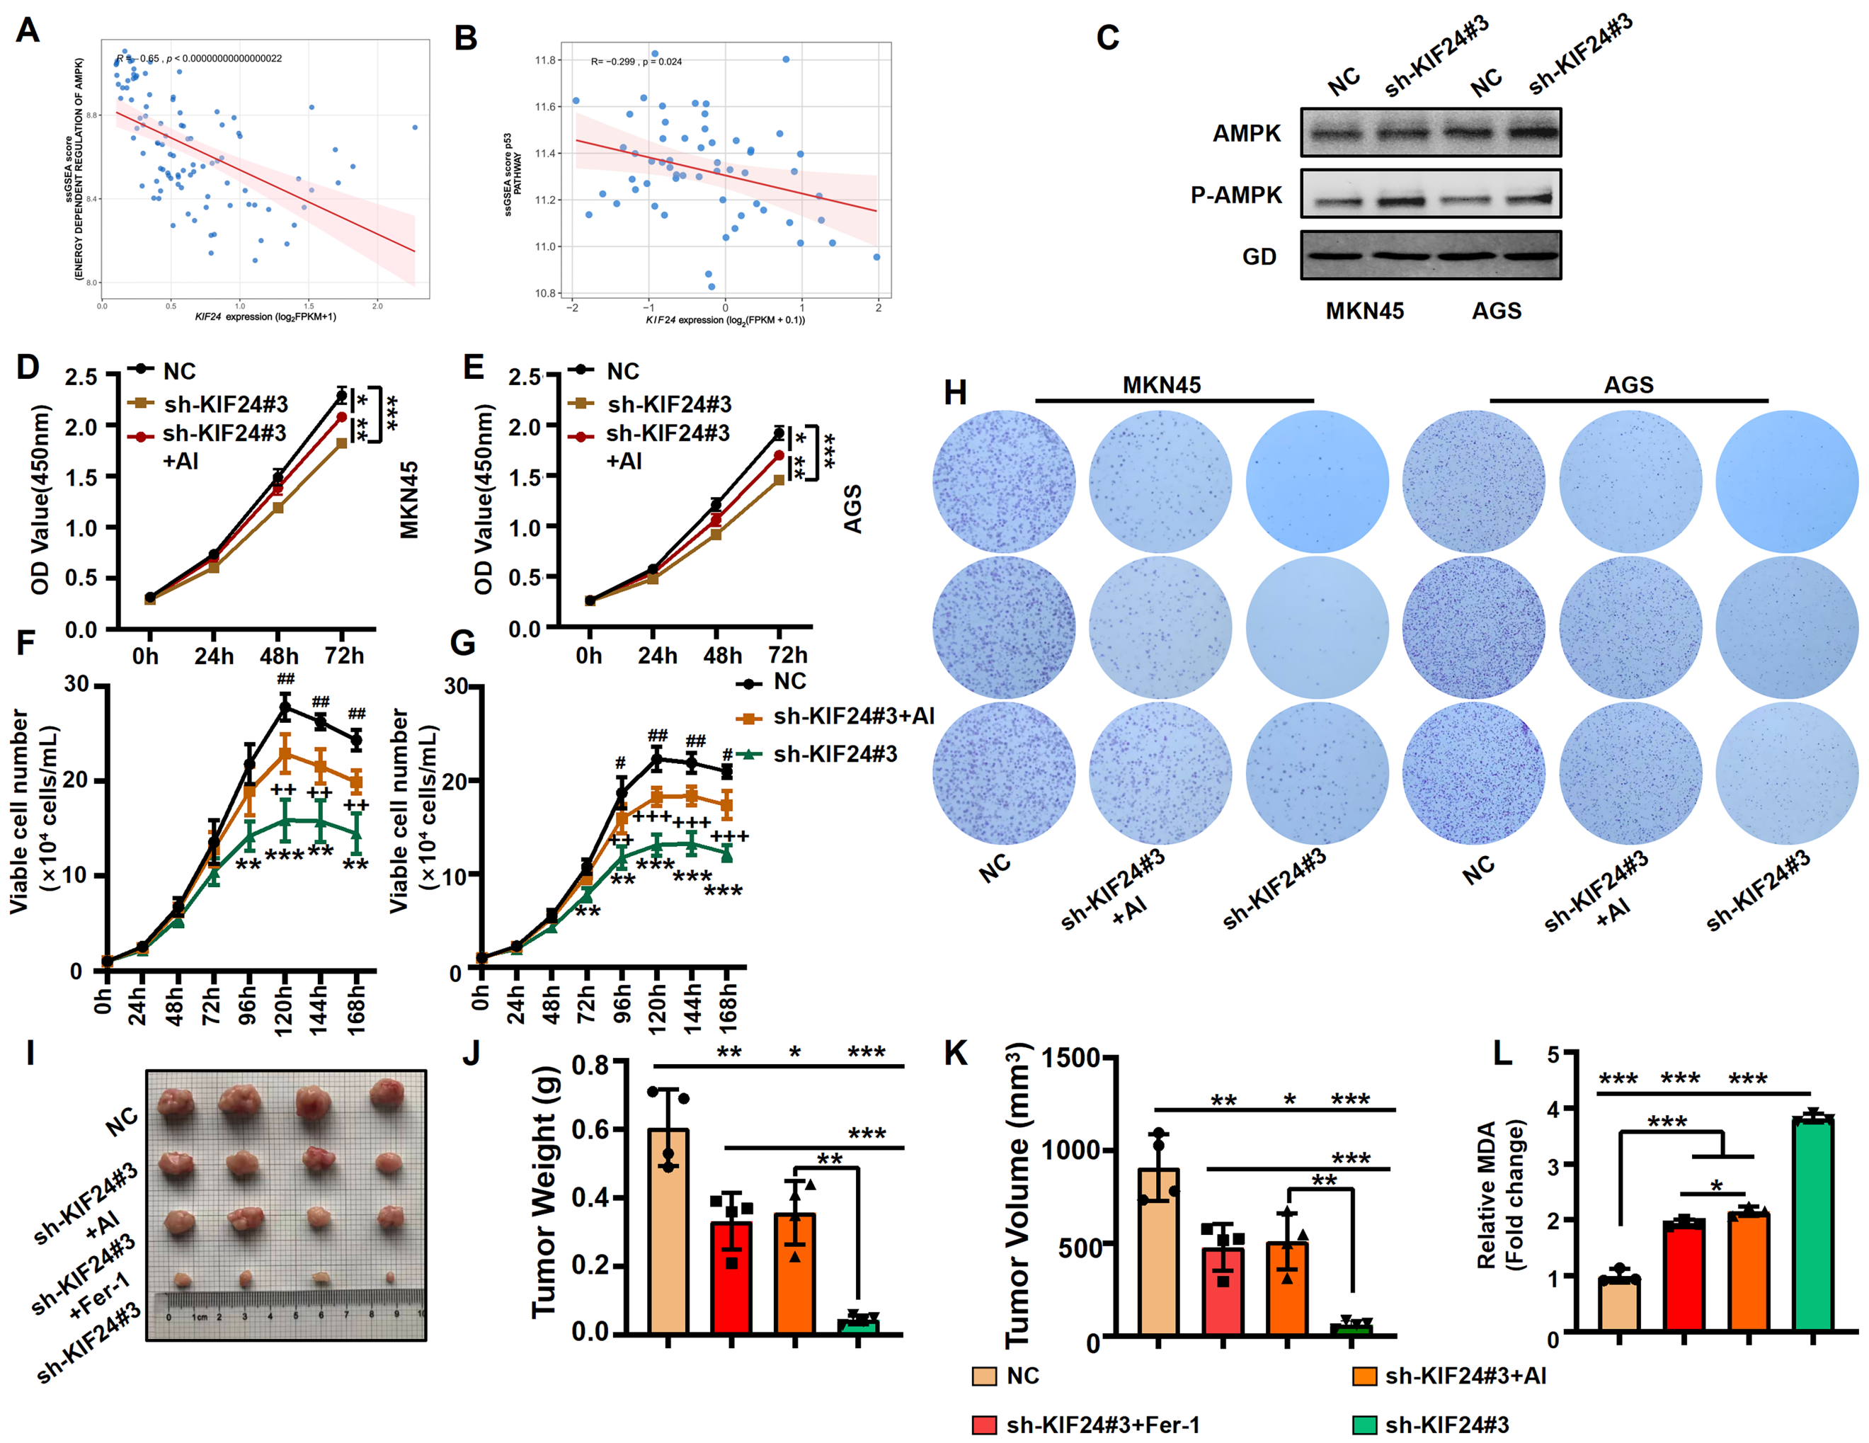
Figure S4 KIF24 modulates gastric cancer progression via AMPK signaling
(A,B) Scatter plot depicting the correlation between the ssGSEA enrichment score of the AMPK/P53 pathway and the expression level of KIF24 (log₂‑transformed TPM) in our independently collected cohort.(C) Western blot analysis to detect the activation of the AMPK pathway in cells with different treatments.(D, E) CCK-8 assays measuring cell viability in different groups.(F, G) Cell growth curves comparing cell proliferation in different experimental groups.(H) Colony formation assays evaluating the clonogenic ability of cells in different groups.(I) Xenograft tumor models comparing tumor formation between different experimental groups.(J) Comparison of tumor sizes in different experimental groups.(K) Comparison of tumor volumes over time in different groups.(L) Intratumoral MDA levels in different experimental groups.Data are presented as the mean ± SD (D-G n=3;J-Ln=4). Statistical significance was determined by one-way ANOVA followed by Tukey’s post hoc test. *P < 0.05, **P < 0.01, ***P < 0.001; ns, not significant.

Table S1
Name | Sequence (5' to 3') | Application
qRT-PCR Primers
SLC7A11
Forward | ATGGTCAGAAAGCCAGTTGTG | Target Gene (qRT-PCR)
Reverse | GCTCCAGGGCGTATTACGAG | Target Gene (qRT-PCR)
siRNA Sequences
si-P53 (TP53)
Target Sequence | GACTCCAGTGGTAATCTAC
Sense Strand | GACUCCAGUGGUAAUCUACdTdT
Antisense Strand | GUAGAUUACCACUGGAGUCdTdT
si-NC | UUCUCCGAACGUGUCACGU | Negative Control
shRNA
sh-KIF24#1 | GCAAGATCTTCGACGTGAA | KIF24 Knockdown
sh-KIF24#2 | GCAGATCTTCGAGCTGTAT | KIF24 Knockdown
sh-KIF24#3 | GCTGCAGATCAAGCTCAAT | KIF24 Knockdown
sh-NC | TTCTCCGAACGTGTCACGT | Negative Control

