Appendices

Table A1 English and Chinese version of five bolt-on items
Table A2 Cognitive interview guide for the EQ-5D-5L and bolt-on items
Table A3 Coding framework for assessing content validity
Table A4 Characteristics of caregiver interview participants (N=31)
Table A5 Frequency distribution of participants’ preferred combinations in the “choose 3 out of 5” task
Table A6 Appropriateness of Response Options of EQ-5D-5L and bolt-on

Table A1 English and Chinese version of five bolt-on items
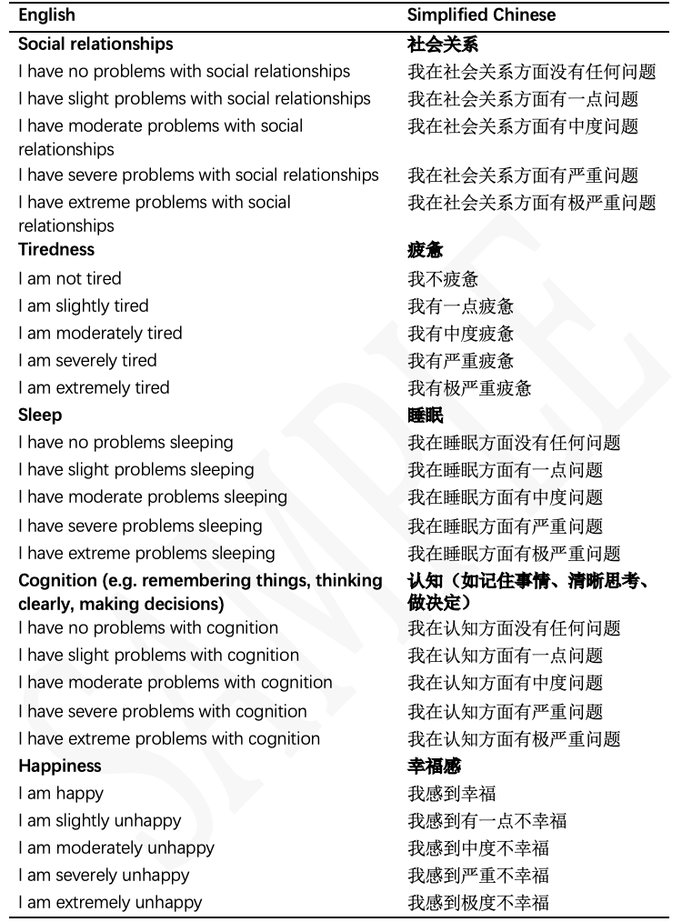
© EuroQol Research Foundation. EQ-5DTM is a trade mark of the EuroQol Research Foundation. This is a modified EQ-5D. Reproduced by permission of EuroQol Research Foundation. Reproduction of this version is not allowed. For reproduction, use or modification of the EQ-5D (any version), please register your study by using the online EQ registration page: www.euroqol.org
Table A2 Cognitive interview guide for the EQ-5D-5L and bolt-on items
Step and theme | Procedure | Interviewer script | Rationale / notes
Before 1. Preparation | Confirm consent; check internet, recording, screen sharing, and materials; restate flow and timing | Today’s interview will last about 45 minutes. We will first discuss your caregiving experience, then complete the questionnaire using think-aloud, and finally discuss the questions themselves. Everything will be kept confidential. | Builds safety; ensures smooth setup.
Before 2. Ground rules | Explain no right/wrong answers; encourage honest responses; allow pauses/rest | There are no right or wrong answers. What matters is how you understand the questions and why you respond as you do. We can pause at any time. | Reduces pressure; supports authentic feedback.
1. Warm-up | Brief self-introduction and daily caregiving routine | Could you briefly introduce yourself and describe a typical day caring for your child? | Ice-breaker; sets caregiving context.
2. Concept elicitation | Explore caregiving impacts on health, HRQoL, and well-being | How does caring for your child affect your life, such as your health or emotions? How do you understand health, HRQoL, and well-being? What are the best and worst health states? | Identifies spontaneous concepts.
3. VAS | Present VAS | Please rate your health TODAY on this 0–100 scale, where 100 is the best health you can imagine and 0 the worst. | Standardizes VAS administration.
4. Explain think-aloud | Briefly explain the method; provide instructions if needed | As you read each question, please say out loud what comes to mind, including how you understand it and why you choose your answer. | Clarifies task focus.
5. Think-aloud practice | Demonstrate once; complete one practice item | Let’s do one practice first. Please keep talking as you answer. | Familiarizes participants with the method.
6. Formal think-aloud — EQ-5D-5L | Present items one by one; participant answers aloud | Please read each question aloud and tell me your answer and why you chose it. | Captures immediate response process.
- Process probes  — EQ-5D-5L | Probe pauses, unclear answers, or hesitation | How did you arrive at that answer? What is this question asking? Why were you hesitating? | Clarifies cognitive processes.
8. Probe “no problems” responses | Confirm whether “no problems/no difficulties” reflects intended meaning | You selected “no problems.” What do you think this question is measuring? | Detects hidden relevance/wording issues.
9. Transition to cognitive interview | Shift from answering to evaluating items | Now I’d like to discuss the questions themselves—whether they are relevant, clear, and complete. | Signals change in task.
- Relevance  — EQ-5D-5L | Assess relevance to health, QoL, well-being, and caregiving | Is this question relevant to you? Is it important in your caregiving experience? | Assesses content relevance.
11. Comprehensibility — EQ-5D-5L | Assess clarity of wording, examples, and options | What does this question mean to you? Was anything unclear? How could it be clearer? | Identifies ambiguity/misunderstanding.
- Item-level comprehensiveness  — EQ-5D-5L | Assess whether each item misses important content | Is anything important missing from this question? | Assesses item coverage.
- Overall comprehensiveness  — EQ-5D-5L | Assess whether the 5 dimensions miss important areas | Apart from these five areas, is anything important missing? | Assesses overall coverage.
14. Short break | Offer a brief break if needed | Let’s take a short break if needed. | Reduces fatigue.
15. Formal think-aloud — bolt-ons | Present five bolt-ons one by one; participant answers aloud | Now let’s look at some additional items. Please answer as before and say out loud how you understand them. | Captures immediate understanding of bolt-ons.
- Process probes  — bolt-ons | Probe pauses, hesitation, or unclear answers | How did you understand this item? How is it similar to or different from the earlier questions? Why did you choose that answer? | Clarifies response processes for bolt-ons.
- Relevance  — bolt-ons | Assess relevance and importance of each bolt-on | Is this additional question relevant or important to you? | Assesses bolt-on relevance.
- Comprehensibility  — bolt-ons | Assess clarity of wording and meaning | Is this question easy to understand? What could be clearer? | Assesses wording clarity.
- Comprehensiveness/overlap — bolt-ons | Assess added value and overlap with core items or other bolt-ons | Does this add important content? Does it overlap with other questions? | Assesses added value and redundancy.
20. Priority ranking | Rank five bolt-ons by importance | Please rank these five additional questions by importance and relevance. Why? | Identifies perceived priorities.
- Reduction task  (5 choose 3) | Select three bolt-ons to retain and explain why | If only three could be kept, which would you choose? Why? | Identifies priority items and trade-offs.
22. Overall supplementary assessment | Ask whether anything remains missing after considering both sets | Overall, is anything still missing? | Detects remaining gaps.
23. Acceptability/completion experience | Assess clarity, burden, repetition, and suitability | Were these questions clear and easy to answer? Was anything repetitive or difficult? | Assesses acceptability and feasibility.
24. Summary | Summarise feedback; invite correction or addition | You mentioned several key points, including … Have I understood correctly? Is anything else important? | Member checking.
End of interview | Thank participant; restate confidentiality; explain incentive | Thank you for sharing your experiences. Your feedback is very valuable. We will keep everything confidential, and the incentive will be sent via WeChat later. | Warm, formal closure.

Table A3 Coding framework for assessing content validity
Comprehensibility (Understanding/Interpretation)
Understanding or interpretation correct including value of examples
U1 Understanding or interpretation problems Wrong or ambiguous interpretation
U2 Understanding or interpretation problems Difficulty interpreting/ odd wording
U3 Understanding or interpretation problems Narrow interpretation
U4 Understanding or interpretation problems Word means a different thing in translation
U5 Understanding or interpretation problems - Different answers for different aspects of items
U6 Understanding or interpretation problems - Issues with examples
UX New themes not already identified
Unclear - unclear if respondent understands
Relevance / Acceptability
Number reporting relevance or acceptability
AR1 Lack of acceptability/relevance: item not relevant for them
AR2 Lack of acceptability/relevance: respondent says item not relevant because they misunderstood item
ARX Use to identify new themes
Unclear - unclear whether item is relevant to respondent e.g. talks in general terms, refers to time period in the past or specific events or is answering a different question etc.
Comprehensiveness
Number reporting instrument comprehensiveness
COM1 Issues with coverage: missing items. List items with accompanying quote
COM2 Issues with coverage: overlap in items - item covered by another item (note any suggestions e.g. combine items)
COMX Issues with coverage: new themes

Table A4 Characteristics of caregiver interview participants (N=31)
Characteristics | N (%)
Caregiver
Role
Father | 11 (35.5)
Mother | 20 (64.5)
Educational level
Secondary or below | 1 (3.2)
Tertiary or above | 30 (96.8)
Number of children
= 1 | 20 (64.5)
> 1 | 11 (35.5)
Years caring for a child with ASD (years)
≤ 10 | 23 (74.2)
> 10 | 8 (25.8)
Diagnosed chronic disease
Yes | 4 (12.9)
No | 27 (87.1)
Diagnosed mental health problem
Yes | 7 (22.6)
No | 24 (77.4)
Self-reported financial status
Below local average | 16 (51.6)
Equal to local average | 11 (35.5)
Above local average | 4 (12.9)
Children
Age group (years)
≤ 12 | 22 (71.0)
13-17 | 9 (29.0)
Sex
Male | 25 (80.6)
Female | 6 (19.4)
ASD severity level
Mild | 8 (25.8)
Moderate | 11 (35.5)
Severe | 12 (38.7)
Comorbidities
ADHD | 13 (41.9)
Epilepsy | 2 (6.5)
None | 16（51.6）

Table A5 Frequency distribution of participants’ preferred combinations in the “choose 3 out of 5” task
Rank | Preferred 5 choose 3 combinations | N | %
1 | Cognition + Happiness + Sleep | 6 | 19%
2 | Social relationships + Happiness + Cognition | 5 | 16%
3 | Tiredness + Sleep + Happiness | 5 | 16%
4 | Tiredness + Sleep + Cognition | 4 | 13%
5 | Sleep + Happiness + Social relationships | 4 | 13%
6 | Social relationships + Sleep + Cognition | 3 | 10%
7 | Tiredness + Happiness + Social relationships | 2 | 6%
8 | Tiredness + Happiness + Cognition | 1 | 3%
9 | Any three except Happiness | 1 | 3%

Table A6 Appropriateness of Response Options of EQ-5D-5L and bolt-on
Feedback | Frequency | Representative quote
Part 1. First nine items (uniform increasing-severity response options)
No problems reported | 27/31 | F07_B08: “…I tend to understand it in percentage terms, for example: 0%, 20%, 25%, 50%, 80%.”
Difficult to understand | 2/31 | F02_B10: “It is a bit difficult to understand, because it is not really something that can be quantified.”
Suggested adding quantifiable examples | 2/31 | M05_G08: “You could give an example to show what counts as slight, moderate, or severe. Quantifying it like you just described would be helpful. ”
Part 2. Happiness item (different response structure)
No problems reported | 20/31 | F02_B10: “I think this kind of distinction is fine.”
Suggested adding a neutral option | 11/31 | F06_B08: “Some people may feel neither happy nor unhappy, just living in the present. They may feel nothing in particular. Some people do not think they are very happy, but they are not very unhappy either. So a neutral option should be added.”
Considered “severe” and “extreme” redundant | 4/31 | F06_B08: “If someone is already severely unhappy, do you still need ‘extremely unhappy’? There may not be much difference—they are basically the same kind of state.”
Suggested adding “very happy” | 4/31 | M07_B10: “You could add ‘very happy’! That way the contrast would be stronger and the options would be more differentiated.”
Considered “mild/moderate/severe” overly medicalized and suggested alternative wording | 2/31 | M20_B08: “We usually think of terms like ‘moderate’ or ‘severe’ as being used more for illness, so they do not feel very appropriate here.”
Suggested changing it to a rating-scale item | 2/31 | M05_G08: “I think it could be made open-ended, for example, asking people to rate themselves out of 100.”

