Assessing Risk and Economic Losses from Coconut Rhinoceros Beetle in the Americas
Sulav Paudel^{1*}, Trevor A. Jackson¹, Jhony A. Benavides-Bolaños², Ilse A. Huerta-Arredondo³ Wilson Vásquez-Castillo ⁴ & John M. Kean¹
¹ Bioeconomy Science Institute, Tuhiraki, 19 Ellesmere Junction Road, Lincoln 7608, New Zealand
² Universidad del Valle, Calle 13 No. 100-00, Cali, 760032, Colombia
³University of Guanajuato, Ex Hacienda El Copal k.m. 9; carretera Irapuato-Silao; C.P. 36500; Irapuato, Guanajuato, Mexico
⁴ Universidad de Las Americas, Vía Nayon l Redondel del Ciclista Quito, PC 170137 Ecuador

* Corresponding author: sulav.paudel@agresearch.co.nz
ORCID ID: 0000-0002-7562-2846

Supplementary Information
Figure S1. Key predictor variables used in the coconut rhinoceros beetle (CRB) risk model for Vanuatu. (A) Coconut palm density, (B) Oil palm density, (C) Population density, (D) Proximity to roads, (E) Proximity to ports and (F) Climate Suitability

- Coconut palm density

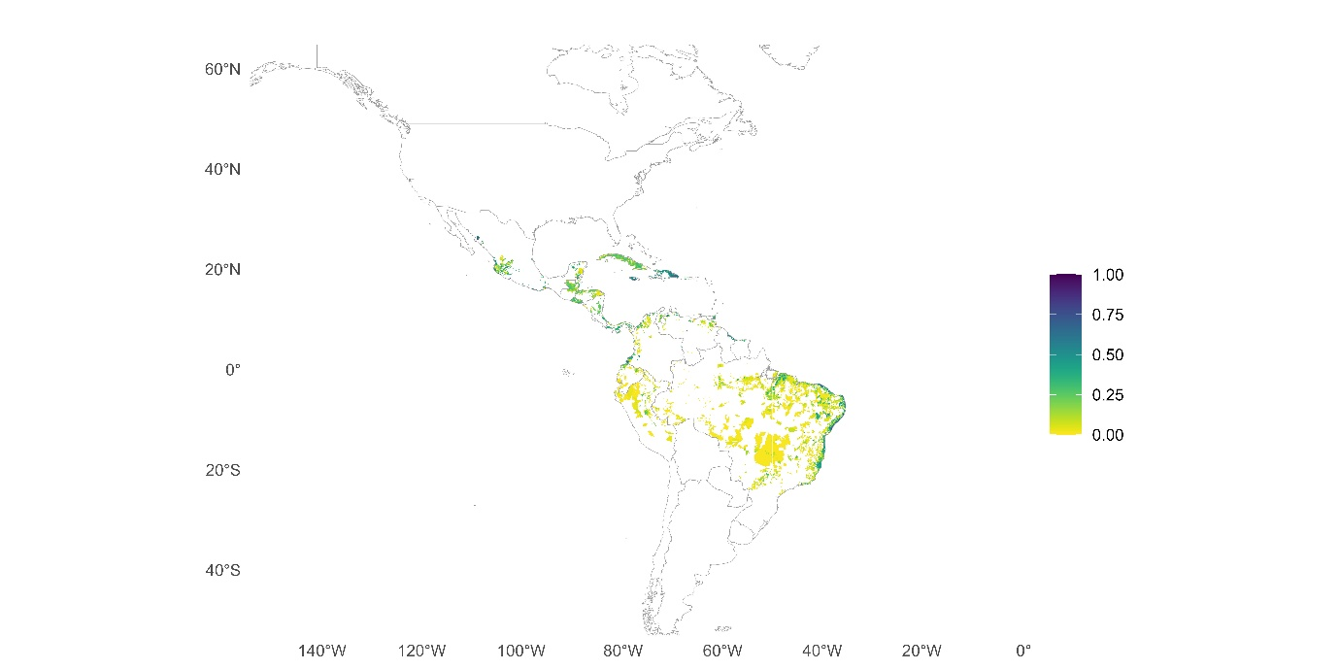

- Oil palm density

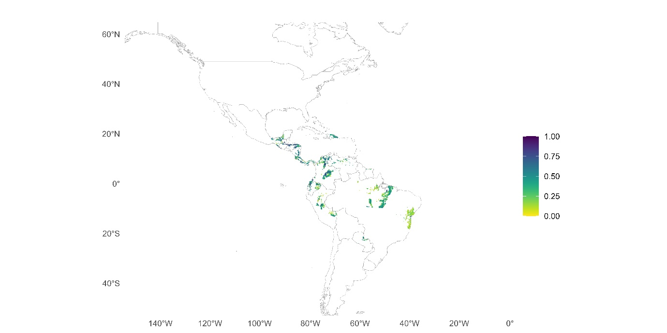

- Population density
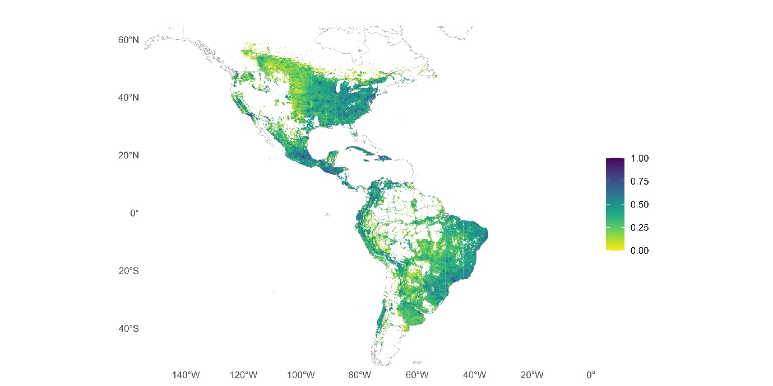

- Proximity to roads

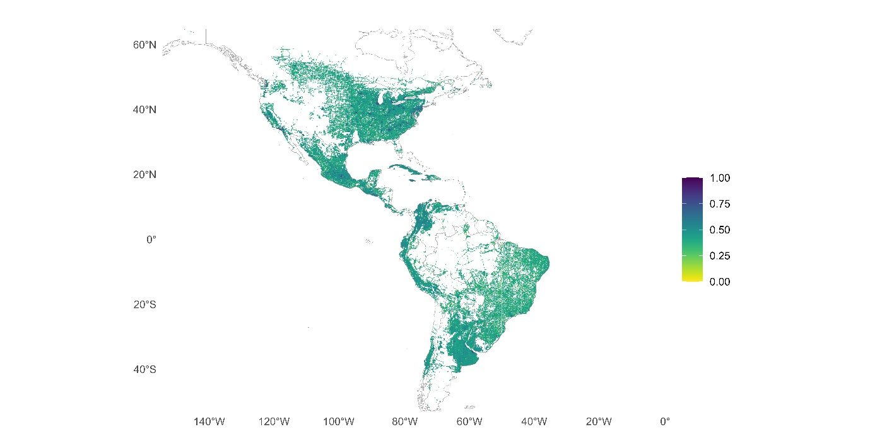

- Proximity to ports
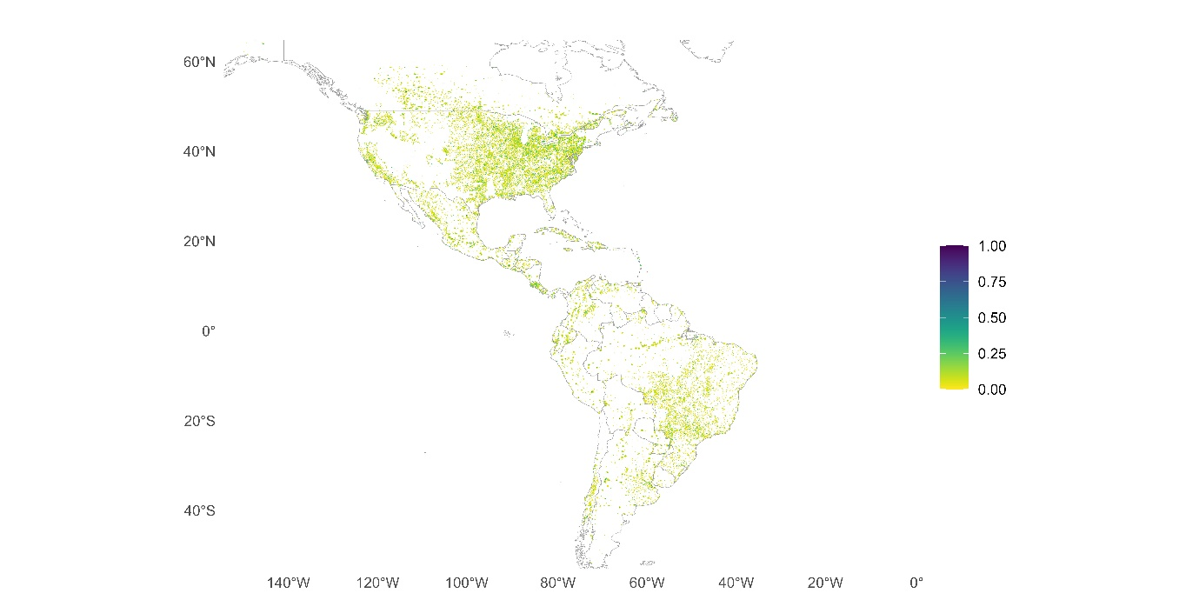

- Climate Suitability

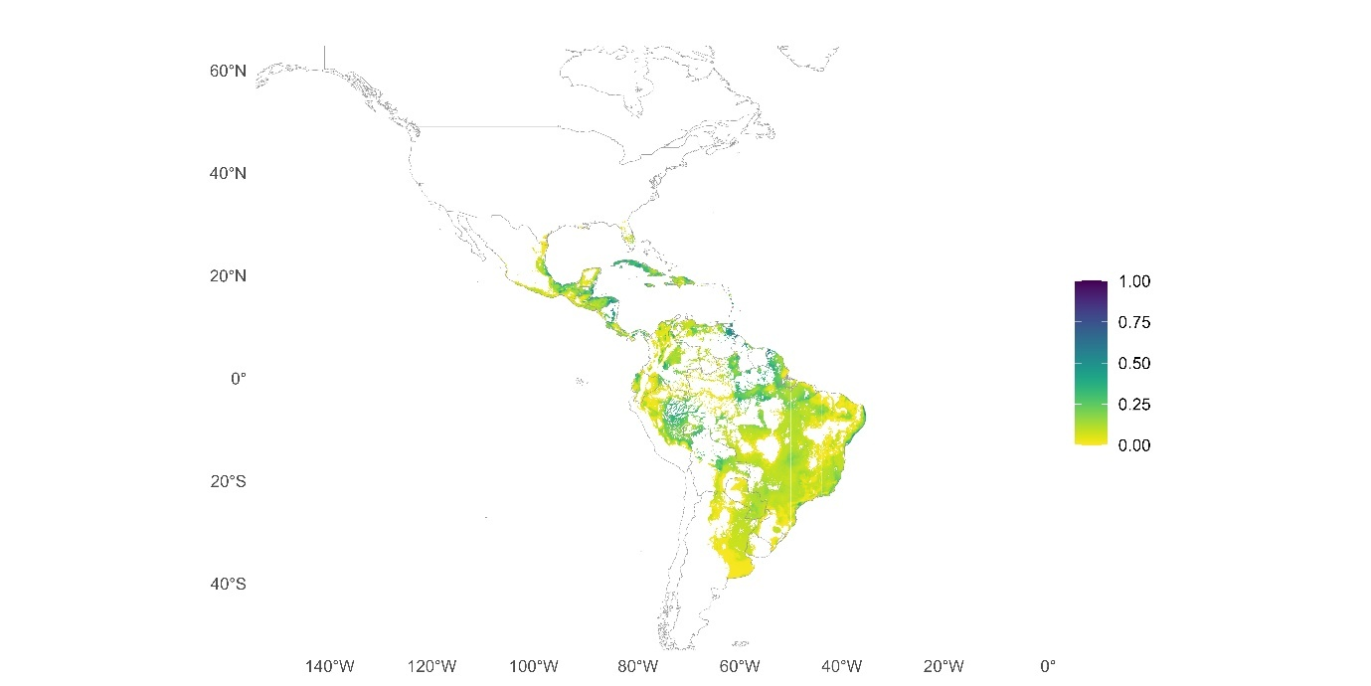

Table S1: Coconut and oil palm production per year along with copra/palm-oil prices across countries in the Americas. Country-level coconut and oil palm production data for the Americas (2022/2023) were sourced from Our World in Data (https://ourworldindata.org). Copra and palm oil prices were obtained from Selina Wamucii (https://www.selinawamucii.com).

Country: Americas | Coconut production (tonnes/yr) | Palm Oil (tonnes/yr) | Copra price/kg (USD) | Palm oil price/kg (USD)
Colombia | 117677.9 | 1767624.0 | 2.2 | 4.0
Brazil | 2898423.0 | 587108.0 | 0.8 | 4.0
Guatemala | 19217.3 | 940000.0 | 2.3 | 2.2
Mexico | 1144985.0 | 357600.0 | 0.9 | 0.9
Ecuador | 14654.3 | 437192.0 | 2.2 | 0.7
Honduras | 13111.8 | 650000.0 | 0.8 | 1.2
Costa Rica | 20057.5 | 282268.2 | 8.0 | 2.3
Peru | 44531.6 | 280000.0 | 1.4 | 2.3
Venezuela | 174259.1 | 112100.0 | 0.8 | 1.2
Dominican Republic | 566648.0 | 45000.0 | 0.5 | 0.7
Nicaragua | 7626.4 | 155192.0 | 0.7 | 0.2
Panama | 20327.1 | 60000.0 | 25.4 | 0.4
Paraguay | 0.0 | 3875.9 | 0.3 | 1.6
Jamaica | 75981.4 | 6800.0 | 0.1 | 2.4
El Salvador | 71611.2 | 0.0 | 3.6 | 0.6
Haiti | 39008.1 | 0.0 | 0.3 | 0.7
Cuba | 25310.3 | 0.0 | 1.0 | 0.7
Trinidad and Tobago | 23304.1 | 0.0 | 0.2 | 0.4
Guyana | 35963.0 | 0.0 | 0.7 | 14.2
Suriname | 1329.2 | 125.3 | 0.7 | 0.2
Saint Lucia | 10979.1 | 0.0 | 2.0 | 5.3
Dominica | 9795.0 | 0.0 | 0.6 | 3.7
Grenada | 8410.7 | 0.0 | 1.2 | 3.7
Saint Kitts and Nevis | 3603.6 | 0.0 | 0.3 | 3.5
Saint Vincent and the Grenadines | 1983.0 | 0.0 | 0.4 | 2.7
Bahamas | 2861.8 | 0.0 | 2.9 | 4.0
Barbados | 2416.1 | 0.0 | 4.4 | 0.6
Belize | 2408.7 | 0.0 | 3.4 | 0.9
Puerto Rico | 70.2 | 0.0 | 1.5 | 3.1

