Table 1: Search strategy in Pubmed, Cochrane Library,Scopus
Electronic database | Search equation | Applied Filters
PubMed | (("Biological Therapy"[Mesh] OR "Guided Tissue Regeneration, Periodontal"[Mesh] OR "Anti-Bacterial Agents"[Mesh] OR "Probiotics"[Mesh] OR "Laser Therapy"[Mesh] OR "Stem Cells"[Mesh] OR "Growth Differentiation Factors"[Mesh] OR "Bone Substitutes"[Mesh] OR "Biocompatible Materials"[Mesh] OR "Enamel Matrix Proteins"[Supplementary Concept] OR "Platelet-Rich Fibrin"[Mesh] OR "Platelet-Rich Plasma"[Mesh]) AND ("Periodontal Diseases"[Mesh] OR "Periodontitis"[Mesh]) AND ("intrabony defects")) NOT "Furcation Defects"[Mesh] | Publication date of ten years ‘’2015-2025’’  Article type ‘randomized controlled trial’’  Text availability ‘’full text’’ Language ‘’English”
Cochrane Library | (("biological therapies" OR "biological therapy" OR "guided tissue regeneration" OR "antibacterial agents" OR "probiotics" OR "laser therapy" OR "stem cells" OR "growth differentiation factors" OR "bone substitutes" OR "biocompatible materials" OR "enamel matrix proteins" OR "platelet-rich fibrin" OR "platelet-rich plasma")):ti,ab,kw AND (("periodontal diseases" OR "periodontitis")):ti,ab,kw AND (("intrabony defects") NOT"furcation defects"):ti,ab,kw | Cochrane trials  Publication Date of ten years ‘2015-2025’  Language’ English’’
Scopus | (("biological therapies" OR "biological therapy" OR "guided tissue regeneration" OR "antibacterial agents" OR "probiotics" OR "laser therapy" OR "stem cells" OR "growth differentiation factors" OR "bone substitutes" OR "biocompatible materials" OR "enamel matrix proteins" OR "platelet-rich fibrin" OR "platelet-rich plasma")):ti,ab,kw AND (("periodontal diseases" OR "periodontitis")):ti,ab,kw AND (("intrabony defects") NOT "furcation defects"):ti,ab,kw | Publication date of ten years ‘’2015-2025’’  Article type ‘’Article’’ Language ‘’English”

Appendix 1: Customised data collection form
Date of data extraction : ………………
1. Basic information of the study:
Title :
First author :
Date of publication :
Number of centers
Study design :
Follow up :

2. Population
Sample size :
Age :
Sexe (Male / Female) :
Smokers :
Health status :
Intrabony defects configuration :

3. Intervention :
Type of intervention :
Surgical procedure/Grafting materials
4. Outcomes :
Clinical attachment level gain :
Pocket depth reduction:
Gingival recession :
Inflammatory parameters :
Patient related outcomes :
Radigraphic parameters:

Appendix 2. Joanna Briggs Institute (JBI) Critical Appraisal Checklist for Randomized Controlled Trials
Criteria | Yes | No | Unclear | NA
1. Was true randomization used for assignment of participants to treatment groups? | ☐ | ☐ | ☐ | ☐
2. Was allocation to treatment groups concealed? | ☐ | ☐ | ☐ | ☐
3. Were treatment groups similar at baseline? | ☐ | ☐ | ☐ | ☐
4. Were participants blind to treatment assignment? | ☐ | ☐ | ☐ | ☐
5. Were those delivering treatment blind to treatment assignment? | ☐ | ☐ | ☐ | ☐
6. Were outcome assessors blind to treatment assignment? | ☐ | ☐ | ☐ | ☐
7. Were treatment groups treated identically other than the intervention? | ☐ | ☐ | ☐ | ☐
8. Was follow-up complete and adequately described? | ☐ | ☐ | ☐ | ☐
9. Were participants analyzed in the groups to which they were randomized? | ☐ | ☐ | ☐ | ☐
10. Were outcomes measured in the same way for treatment groups? | ☐ | ☐ | ☐ | ☐
11. Were outcomes measured in a reliable way? | ☐ | ☐ | ☐ | ☐
12. Was appropriate statistical analysis used? | ☐ | ☐ | ☐ | ☐
13. Was the trial design appropriate? | ☐ | ☐ | ☐ | ☐
Overall appraisal:
☐ Include ☐ Exclude ☐ Seek further information
Comments:
.................................................................

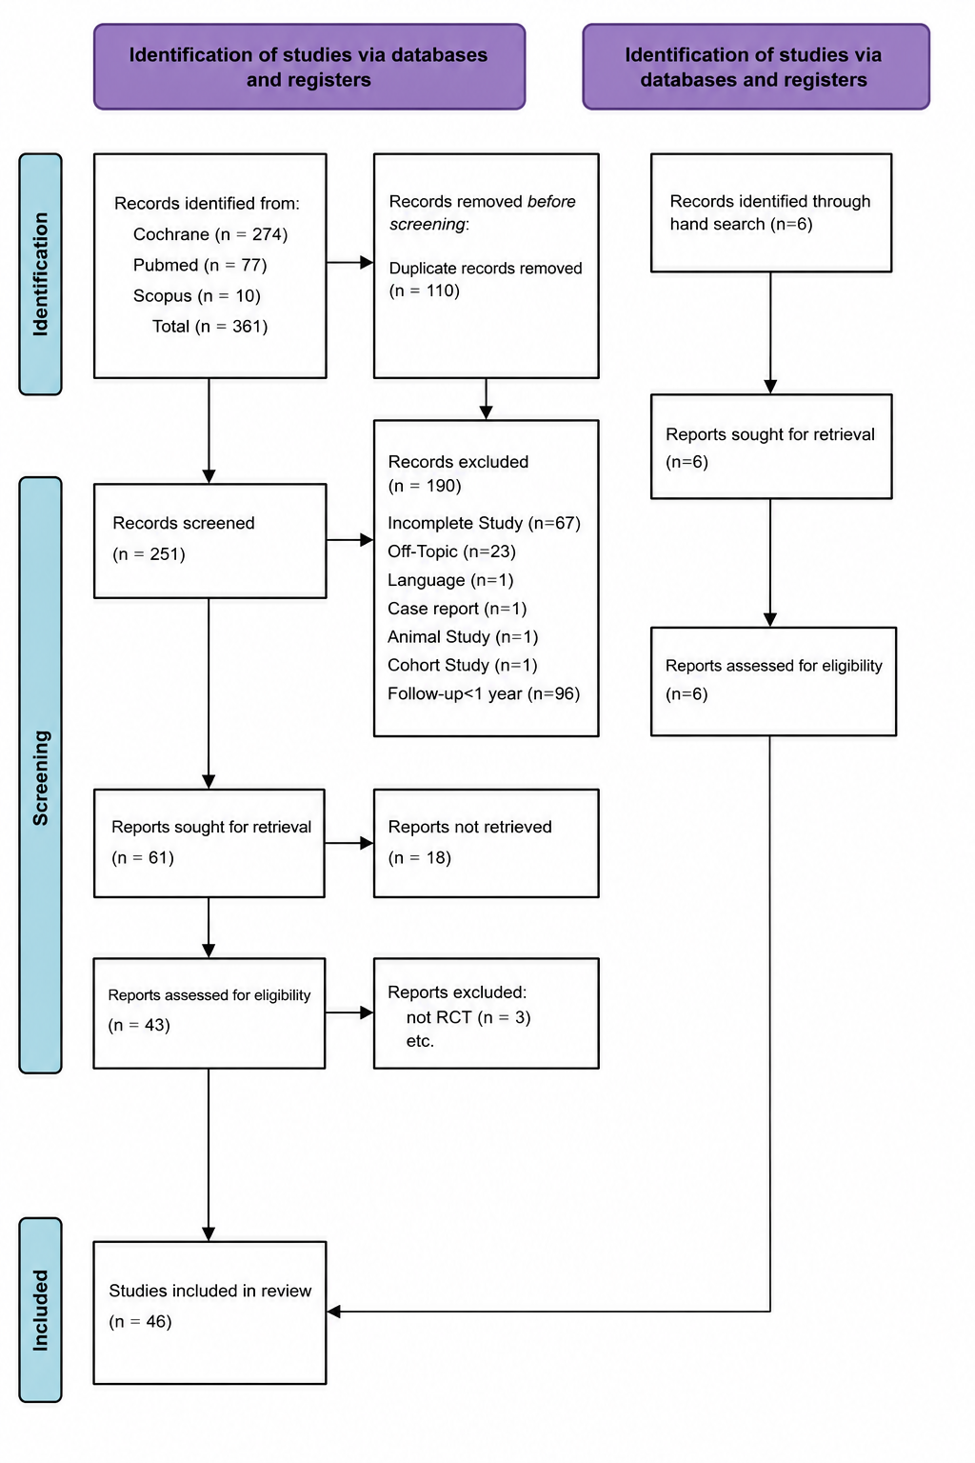
Figure 1 : Flowchart of the study according to the 2020 PRISMA checklist

Table 2: Characteristics of the included studies

Authors | Study design | a: No. of  patients (BL/  FE)  b: No. of sites  (BL/FE) | a: Diagnosis  b: Age range  c: m/f  d: Systemic condition  e: No. of smokers/former smokers | Intervention  Group I  Group II  Group III  Group IV | a: Minimum defect depth  b: No. of defect walls  c: Tooth type  d: FI | follow-up
Agarwal et al.,2016 (1) | DB,SM,P,RCT | a.32/30 b.64/60 | a. moderate/severe chronic periodontitis b.mean age = 52 ±7 c.17/13 d.healthy patients e.0 | I:DFDBA+saline II:DFDBA+PRF | a.≥4 mm b.2,3 wall or combined c.maxillary,mandibular premolars,molars d.without FI | a.12 months
Agarwal et al.,2016 (2) | RCT:CCT | a.10/8 b.30/28 | a.chronic advanced periodontitis b.NM c.7/3 d.good general health e.0 | I:A-PRP+OFD II:A-PRP+DFDBA+OFD III: OFD alone | a.≥4mm b.3 wall c.maxillary,mandibular posterior teeth d.NM | a.12 months
Anoixiadou et al.,2021 (3) | PA,Pr,DB,RCT | a.36/36 b.36/36 | a.Periodontal patients b.NM c.11/25 d.good general health e.NM | l:MINST ll:MINST+EMD | a.3 to 7 mm b.NM c.single-rooted tooth or mandibular molar d.without FI | a.12 months
Aoki et al.,2021 (4) | A 2-year FU of a RCT | a.32/30 b.44/38 | a.moderate,severe chronic periodontitis b.20 to 79 c.13/19 d.systematically healthy patients e.0 | l:rhFGF-2+DBBM ll:rhFGF-2 | a. ≥3 mm b. 1,2,3 wall,combination c.anterior teeth, premolars,molars d.NM | a.24 months
Table 2: (Conntinued)
Apatzidou et al.,2021 (5) | Pr,RCT | a.29/27 b.29/27 | a.advanced periodontitis b.20-68 c.9/18 d.systemically healthy e.16 | l:cell-based therapy+MAF ll:collagen fleece/FPL+MAF lll:MAF | a.≥3mm b. 1,2,3 wall c. maxillary,mandibular sites d.without FI | a.12 months
Aslan et al.,2020 (6) | SC,PG,RCT | a.30/30 b.30/30 | a.advanced periodontitis b.≥18 c.18/12 d.Systemically healthy individuals e.0 | l: EPPT+EMD+BS ll:EPPT | a.≥4 mm b.1,2,3 wall c.incisors/canines/premolars/molars d.NM | a.12 months
Balice et al.,2024 (7) | M,P,TA, NI,RCT | a.64/64 b.64/64 | a.stage III-IV periodontitis b.≥ 18 c.NM d.systematically healthy patients e.NM | l: L-PRF+ABG ll:CM+ABG | a.≥ 4 mm b.1,2,combined 1–2 wall, circumferential c.NM d.NM | a.12 months
Brodzikowska et al.,2023  (8) | Pi,SM, DB,RCT | a.15/15 b.30/29 | a.stage III or IV periodontitis b.≥18 years mean age of 38.7± 7.6 c.6/9 d.systematically healthy e.0 | l:FRSABG+ bioabsorbable collagen ll:DBBM+bioabsorbable collagen | a.≥ 4 mm. b. 1,2,3 wall defects c. Incisors,canines,premolars, molars d.without FI | a.12 months
Chen et al.,2016 (9) | single-center, randomized trial | a.30/38 b.41/38 | a.periodontitis b.18 to 65 c.8/33 d.NM e.NM | l:GTR+PDLSC+Bio-oss ll:GTR+Bio-oss | a.NM b.NM c.NM d.NM | a.12 months
Cieplik et al.,2017 (10) | 13-year FU of a Pr, SM,RCT | a.25/15 b.50/30 | a.agressive,chronic periodontitis b.26 to 62 mean age 42 c.10/15 d.systemically healthy patients e.5 | l: GTR:β-TCP +bio-resorbable membrane ll:GTR:β-TCP +bio-resorbable membrane +APC | a.≥4 mm b.1,2,3 wall /combined 1/2,1/3,2/3,1/2/3 c. incisor,canine,premolar,molar d.without FI | a.13 years
Table 2 : (Continued)
Cortellini et al.,2017 (11) | 20-year FU of a RCT | a.45/41 b.45/41 | a.NM b.25 to 61 mean age 42.8 ± 8.9 c.21/24 d.good general health e.6 | l:Ti-R e-PTFE membranes+MPPT ll:access flap+e-PTFE membrane lll:access flap alone | a.deep interproximal IBD b.1,2,3 wall c.incisors,cuspids,bicuspids,molars d.without FI | a.20 years
Cortellini et al.,2022 (12) | 10-year FU of a RCT | a.45/42 b.45/42 | a.advanced periodontal disease b.28–71 years mean age 49.9 ± 9.8 c.21/21 d.good general health e.5 | l:M-MIST ll:M-MIST+EMD lll:M-MIST+EMD+ BMDX | a.deep interdental IBD b. 1, 2, 3-wall or combination defects c.incisors,cuspids,bicuspids,molars d.without FI | a.10 years
De Santana et al.,2015  (14) | Pr,SM, RCT | a.30/30 b.60/60 | a.moderate to advanced chronic periodontitis b.39 to 66 mean age of 49.2 years c.11/19 d.Systemically healthy patients e.NM | l:MPPT ll:MPPT+rhFGF-2/HA | a.≥4mm b.1,2,3 wall c.incisors,canines,premolars,lower molars d.without FI | a.12 months
Elkhatat et al.,2015 (15) | PA,RCT | a. 16/16 b.16/16 | a.moderate to severe chronic periodontitis b. 25 to 35mean range of 30 c. 8/8 d.Systemically healthy patients e. 0 | I:bioresorbable membrane+OFD II:OFD alone | a.3 mm b.NM c.NM d.NM | a.12 months
Ferrarotti et al.,2018 (16) | P,DB,Pr,RCT | a.29/29 b. 29/29 | a.advanced chronic periodontitis b.39–69 mean age 50.7 ± 8.5 years c.14/15 d. healthy patients e.0 | l:MIST+DPSCs+collagen sponge ll:MIST+collagen sponge alone | a.≥3 mm b.1,2,3 wall c.incisor,canine,premolar,molar d.without FI | a.12 months
Table 2 : (Continued)

Górski et al.,2018 (18) | Pr,DB,SM,RCT | a.15/15 b.30/30 | a.agressive periodontitis b.22–49 mean age 37.9 ± 7.95 c.5/10 d.systematically healthy patients e.0 | l:DBBA+MPM ll:DBBA+CM | a.≥3mm b.1,2,3 wall or combination c.Maxillary,mandibular teeth d.without FI | a.12 month
Górski et al.,2020 (19) | 4-year FU of a DB, SM, RCT | a.15/14 b.30/27 | a.agressive periodontitis b.22–49 mean age 37.9 ± 7.95 years c.4/10 d.good general health e.0 | l:DBBM+MPM ll:DBBM+CM | a.≥ 3 mm b. 1,2,3 wall c.Maxillary,mandibular teeth d.without FI | a.48 months
Hoffmann et al.,2015 (20) | PG, Pr, MC RCT | a.73/30 b.73/30 | a.severe periodontitis b.18 to 70 c.13/17 d.good general health e.4 | l:EMD+synthetic bone graft ll:EMD | a..≥4mm b.1,2 wall,combined 1-2 wall, circumferential c.NM d.without FI | a.36 months
Imamura et al.,2024 (21) | Pr, PA, DB,RCT | a.38/38 b.48/48 | a.Stage III Grade B or C periodontitis b.NM c. 21/17 d.healthy patients e.0 | l:rhFGF-2+ CO3Ap granules ll:rhFGF-2 | a.≥ 3 mm at an interproximal area b.2 or 3 wall c. mandibular,maxillaty teeth d.NM | a.12 months
Kojima et al.,2024 (22) | SC,DB, superiority RCT | a.66/63 b.66/63 | a.stage III periodontitis b.≥20 mean age 51 c.23/40 d.systematically healthy patients e.0 | I:ABG+rhFGF-2 II:rhFGF-2 alone III:ABG alone | a.≥4mm b.1,2,3 wall c.anterior teeth,premolars,molars d.without FI | a.12 months
Table 2: (Continued)
Lee et al.,2020 (23) | Pr,P, RCT | a.46/42 b.46/42 | a.NM b.≥ 19 mean age of 54.6 ± 11.4 years c.20/22 d.healthy or well-controlled systemic conditions or well-controlled diabetes e.0 | l:DPBM+EMD ll:DPBM | a. > 3 mm b.1 wall c.molar teeth d.without FI | a.24 months
Lee et al.,2022 (24) | 4-year FU of RCT | a.46/34 b.46/34 | a.NM b.≥ 19 mean age of 54.6 ± 11.4 years c.16/18 d. healthy or well-controlled systemic conditions or well-controlled diabetes e.0 | l:DPBM†EMD ll:DPBM | a. > 3 mm b.1 wall c.molar regions d.without FI | a.48months
Liu B et al.,2022 (25) | DM,RCT | a.14/28 b.14/28 | a.periodontitis Stage IV Grade C b.24 to 60 mean age 36.0 ± 8.6 years c. 4/11 d.systematically healthy patients e.0 | l:BPBM-PRF complex+CM ll:BPBM+CM | a.≥3 mm b.NM c.NM d.NM | a.24 months
Liu K et al.,2021 (26) | SB,RCT | a.36/31 b.36/31 | a.chronic or aggressive periodontitis b.24 to 63 c.14/17 d.good general health e.3 | l:MISTms ll:MISTms+DBBM+CM | a.≥ 3 mm b. 1,2,3 walls or combination c.single-rooted/mesial aspect first molar d.without class III FI | a.12 months
Losada et al.,2017 (27) | Pr,DB,RCT | a.52/46 b.52/46 | a.moderate/severe chronic periodontitis b.35 to 70 c.29/17 d.systematically healthy patients  e.7 | I:EMD+BC II:EMD | a.≥3mm b.1,2 wall or combination c.anterior teeth,premolars,molars d.without class II/III FI | a.12 months
Mamajiwala et al.,2021  (28) | SC,DB,SM,RCT | a.20/20 b.40/40 | a.periodontitis stage II/III (grade A/B) b. 30–58 years mean age of 39.9 ± 4.18 c. 11/9 d.Systemically healthy subjects e.0 | I:0.8% HA gel+OFD II:OFD + placebo | a.≥ 3mm b.2,3 wall c.maxillary, mandibular premolars, molars d.grade I and grade II FI | a.12 months
Mazzonetto et al.,2021  (17) | DB,Pr,RCT | a.60/60 b.60/60 | a.Generalized AgP or CP b.NM c.19/41 d. Systemically healthy individuals e.0 | l:AgP+CS ll:AgP+CS/EMD lll:CP+CS/EMD | a.≥4 mm b. 1,2,3 wall c.anterior,posterior teeth d.without FI | a.12 months
Ojha et al.,2023 (30) | DB,PA,RCT | a.12/11 b.24/22 | a.chronic periodontitis b.35–55 mean age of 41.36 c.3/8 d.Systemically healthy subjects e. 0 | I: Calcium phosphate cement II:CPC-PLGA composite graft | a.vertical bone loss in the radiograph b.NM c.NM d.NM | a.12 months
Pal et al.,2022 (33) | in vivo RCT | a.29/29 b.40/40 | a.stage II/III periodontitis b.≥18 mean age 33.7 ± 3.1 c.16/13 d.systematically healthy patients e.0 | I:BCP II:BCP+EMD | a.≥ 3 mm b.2,3 wall c.mandibular premolars,molars d.NM | a.12 months
Paolantonio et al.,2020  (34) | Pr,RCT | a.44/44 b.44/44 | a.stage III - stage IV Periodontitis b.42-64 years mean: 53±12 c.15/29 d.systemically healthy e.0 | l:SPPF+L-PRF+ABG ll:SPPF+EMD+ABG | a.≥4mm b.1,combined 1-2, 2,circumferential c.NM d.NM | a.12 months
Patel et al.,2017 (35) | DB,SC,SM,RCT | a.13/13 b.26/26 | a.NM b.mean age 44 ± 9 years c.4/9 d.systemically healthy patients e.0 | l:OFD ll:OFD+PRF | a.≥ 3 mm b.3 wall c.mandibular single,multi-rooted teeth d.NM | a.12 months
Petsos et al.,2019 (36) | 20 year FU of a RCT | a.16/12 b.44/38 | a.severe periodontitis b.29 to 61 mean age: 43.6 c.8/8 d.NM e.8 | I:OFD II:GTR | a.NM b.2,3 wall c.anterior teeth,premolars,molars d.NM | a.20 years
Pham et al.,2021 (37) | DM,RCT | a.32/30 b.96/90 | a.chronic periodontitis b.32 to 60 mean age of 47.9 years c.22/8 d.systemically healthy patients e.0 | l:PRF+OFD ll:GTR lll:OFD alone | a.≥ 3 mm b.2,3 wall c.vital teeth d.without FI | a.12 months
Pietruska et al.,2020 (38) | Pr,RCT with reentry procedures | a.41/41 b.41/41 | a.stage III periodontitis b.≥18 mean age 41.78 c.14/27 d.Systemically healthy e.0 | l:GTR/DBBM+AB ll:GTR/DBBM | a.depth of ≥3mm/width of ≥ 2 mm b.1,2,3 wall c.incisors/Canines/premolars/molars d.NM | a.12 months
Pilloni et al.,2021 (39) | RCT | a.32/32 b.32/32 | a.periodontal disease b.28 to 60 mean age 41.47 years ± 9.25 c. 15/17 d.systematically healthy patients e.0 | l: SFA+cross-linked HA ll:SFA+EMD | a.≥ 3 mm b.NM c. single-rooted teeth d.NM | a.24 months
PSG et al.,2025 (40) | DB,RCT | a.NM/64 b.NM/64 | a. Periodontitis b.NM c.NM d. Systemically healthy individuals e.0 | l:only SPPF ll:SPPF+LLLT | a.> 2 mm b. 2 or 3 wall c.NM d.NM | a.12 months
Rakmanee et al.,2016  (41) | SB,SM RCT | a.18/16 b.36/32 | a.aggressive periodontitis b.15–39 Mean 28.7 years c.4/14 d.healthy patients e.3 | l:SPPF ll:GTR | a.≥3 mm b.1,2,3 wall c.maxillary mandibular premolars molars d.NM | a.12 months
Rakmanee et al.,2016  (42) | SB,SM RCT | a.18/16 b.36/32 | a.agressive periodontitis b.15–39 Mean 28.7 years c.4/14 d.medically healthy e.3 | l:SPPF ll:GTR | a.≥3mm b. 1,2,3 wall c.maxillary mandibular premolars molars d.NM | a.12 months
Rexhepi et al.,2021 (44) | M, P, TA,NI RCT | a.62/62 b.62/62 | a. stage III-IV periodontitis b.43 to 66 mean age 55 ± 12 c.26/36 d.systemically healthy e.NM | l:L-PRF+IBB ll:CM+IBB | a.≥4 mm b.1,2,combined 1/2,craters,circumferential c.NM d.NM | a.12 months
Rodríguez-A et al.,2025  (45) | P,RCT | a.86/53 b.86/53 | a.periodontitis stage III or IV, grade A or B b. 35 to 55 c.28/25 d. systemically healthy patients e.24 | l:HA ll:EMD | a.≥ 3 mm b. 3-, 2-, and 1-wall c.NM d.NM | a.18 months
Sali et al.,2016 (46) | Pr,SC,SM,SB RCT | a.10/10 b.20/20 | a.moderate/severe localized periodontitis b.25 to 45 c.6/4 d.healthy individuals e.0 | l:OFD+DFDBA+AM ll:OFD+DFDBA | a.≥3 mm b.NM c.vital/endodontically treated teeth d.without FI | a.12 months
Samarth et al.,2022 (47) | DM,RCT | a.10/10 b.60/60 | a.stage III grade B periodontitis b.30 to 60 c.3/7 d.systemically healthy patients e.0 | l:DFDBA Il:DFDBA+CGF membrane | a.≥ 3 mm b.NM c.NM d.NM | a.12 months
Seshima et al.,2022 (49) | A 4-year extended FU of a RCT | a.32/25 b.44/32 | a.Stage III periodontitis b.20 to 79 c.13/19 d.systematically healthy patients e.0 | l:rhFGF-2+DBBM ll:rhFGF-2 | a.≥3 mm b.1,2,3 wall,combination c.Anterior teeth,premolars,molars d.NM | a.48 months
Shalini et al.,2018 (50) | Pr,SB,P RCT | a.28/28 b.28/28 | a.periodontitis b.30-50 c.12/16 d.Systemically healthy e.0 | l:only OFD ll:OFD+A-PDLSc Ni | a.radiographic angular bone loss b.NM c. vital, asymptomatic tooth d.NM | a.12 months
Thorat et al.,2017 (53) | P,Pr,SM RCT | a.15/15 b.30/30 | a.localized aggressive periodontitis b.mean age 25±1,5 c.8/10 d. systemically healthy e. 0 | I:MFO II:MFO+autologous PRF | a.≥3 mm b.2 or 3-wall c. permanent molars, molars d.without FI | a.12 months
Xu et al.,2019 (56) | RCT | a.58/54 b.120/110 | a.moderate-to-severe chronic periodontitis b.mean age=55.2±8.3 c. 32/26 d.systemically healthy patients e.0 | l:flap surgery alone ll:flap surgery+ autologous CGF lll:flap surgery+ Bio-Oss lV:flap surgery+ CGF+Bio-Oss | a.NM b.1 wall c.NM d. without furcation involvement | a.12 months

RCT : randomized controlled trial, CCT: comparative clinical trial, NM: not mentioned, DB: double blinded, SM: split mouth, P: parallel, FI: furcation involvement, PA: parallel arm, Pr: prospective, FU: follow-up, FPL: fibrin platelet lysate, MAF: minimal access flap, SC: single center, MC: multi center, PG: parallel group, OFD: open flap debridement, DFDBA: demineralized freeze-dried bone allograft, PRP: platelet rich plasma, PRF: platelet rich fibrin, MINST: minimally invasive non-surgical technique, EMD: enamel matrix derivatives, rhFGF-2: recombinant human fibroblast growth factor 2, DBBM: deproteinized bovine bone mineral, EPPT: entire papilla preservation technique, BS: Bone substitute, M : masked, TA : two-arm, NI : non-inferiority, L-PRF: Leukocyte platelet rich fibrin, ABG: autogenous bone graft, CM: collagen membrane, Pi: pilot, FRSABG: frozen radiation-sterilized allogenic bone graft, GTR: guided tissue regeneration, PDLSC: periodontal ligament stem cells, β-TCP : Beta-tricalcium phosphate, IBD: intrabony defects, MPPT: modified papilla preservation technique, Ti-R e-PTFE: Titanium reinforced expanded polytetrafluoroethylene, M-MIST: modified minimally invasive surgical technique, BMDX: bone-mineral-derived xenograft, BL: baseline, FE: final evaluation, HA: hyaluronic acid, MIST: minimally invasive surgical technique, DPSCs: dental pulp stem cells, MPM: modified perforated membrane DBBA: deproteinized bovine bone allograft, CO3Ap: carbonate apatite, DPBM :demineralized porcine bone matrix, DM: double masked, BPBM: bovine porous bone mineral, SB :single blinded, MISTms : minially invasive surgical techninique modified in sutures, BC: Biphasic calcium phosphate, AgP : aggressive periodontitis, CP : chronic periodontitis, CS : conservative surgery, CPC: Calcium phosphate cement, PLGA: polylactic-co-glycolic acid, BCP: biphasic calcium phosphate, SPPF: simplified papilla preservation flap, AB: antibiotic, SFA: single flap approach, LLLT: low level laser therapy, IBB: inorganic bovine bone, AM: amniotic membrane, CGF: concentrated growth factor, MFO: modified flap operation
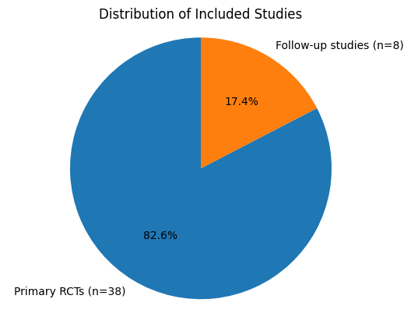
Figure 2: Studies’ distribution
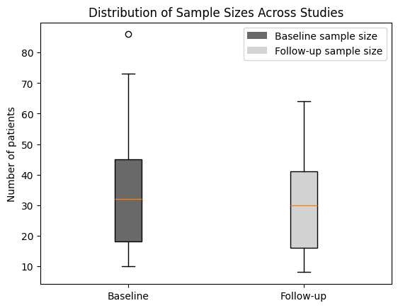
Figure 3: Distribution of sample sizes across studies at baseline and follow-up
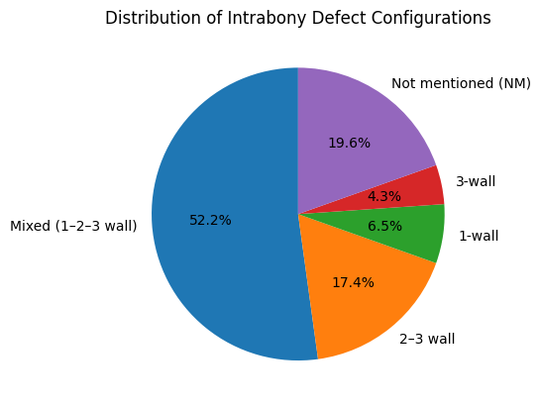
Figure 4: Distribution of intrabony defects across studies
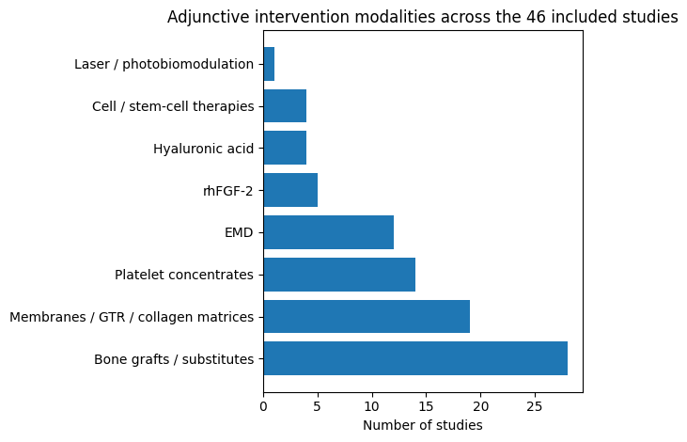
Figure 5: Distribution of intervention modalities across studies

Table3: Primary outcomes : clinical attachment level (CAL) gain and probing depth (PD) reduction in test and control groups
Study (author, year) | Test intervention | Control | CAL gain (test vs control) | PD reduction (test vs control) | Significance
Agarwal et al.,2016 (1) | PRF+DFDBA | DFDBA+saline | Test: +3.73 ± 0.74 mm; Control: +2.61 ± 0.68 mm | Test:-4.15±0.84 mm;Control:-3.60±0.51 mm | test superior for CAL/PD
Agarwal et al.,2016 (2) | A-PRP+OFD; A-PRP+DFDBA+OFD | OFD alone | Test: +4.10 ± 1.47 mm; Test: +4.26 ± 1.85 mm; control: +1.27 ± 0.89 mm | Test: -4.86 ± 2.12 mm;Test: -4.88 ± 1.12 mm ; Control: -2.69 ± 1.37 mm | both PRP arms superior to OFD
Anoixiadou et al.,2022 (3) | MINST+EMD | MINST | Test: +3.4 ± 1.6 mm;Control : +3.5 ± 1.4 mm | Test: -4.2 ± 1.7 mm; Control: -4.0 ± 1.4 mm | MINST+EMD did not improve mean CAL/PD versus MINST
Aoki et al.,2021 (4) | rhFGF-2+DBBM | rhFGF-2 | Test: +3.35 ± 1.28 mm; Control: +3.11 ± 1.46 mm | Test:3.58 ± 1.21 mm; Control:3.58 ± 1.53 mm | no significant inter-group difference for PD/CAL
Apatzidou et al. , 2021 (5) | cell-based therapy+MAF; collagenfleece/FPL+MAF | MAF | mean across 3 groups: +3.0 mm (95% CI 1.9–4.1) | mean across 3 groups: -3.7 mm (95% CI 2.7–4.8) | no clinical inter-group difference in CAL/PD
Aslan et al.,2020  (6) | EPPT+EMD+BS | EPPT | Test:+6.3 ± 2.5 mm; Control: +5.83 ± 1.12 mm | Test:-6.5 ± 2.65 mm;Control:-6.2 ± 1.33 mm | no significant between-group difference in CAL/PD
Balice et al.,2024  (7) | ABG+L-PRF | ABG+CM | Test: +3.38 ± 0.67 mm; Control: +3.32 ± 0.76 mm | Test: 3.93 ± 0.65 mm; Control: 4.16 ± 0.66 mm | Non-inferior for CAL,PPD
Brodzikowska et al ., 2023 (8) | FRSABG + bioabsorbable collagen | DBBM+bioabsorbable collagen | Test:5.54 (4.40–6.55) ± 1.18; Control: 4.54 (3.95–5.22) ± 1.11 | Test: 4.66 (3.78–5.51) ± 1.24; Control: 3.57 (3.18–5.22) ± 1.11 | significant for PPD,non significant for CAL
Chen et al.,2016 (9) | GTR+Bio-Oss+PDLSC | GTR+Bio-Oss | No results for 12 months | No results for 12 months | Non significant
Cieplik et al.,2018  (10) | GTR:β-TCP+bio-resorbable memnrane+APC | GTR:β-TCP+bio-resorbable membrane | Test: 7.0 mm; Control:7.0 mm | Test: 5.0 mm; Control: 5.0 mm | Non significant
Cortellini et al.,2017 (11) | Ti-R e-PTFEmembranes+MPPT; access flap+e-PTFE membrane | Access flap alone | Test:4.9±2 ; Test:6.7 ±2.1; Control:8.9 ±3.2 | Test:3±0.9;Test:3.6±1; Control:5.5±2.7 | non significant for PPD Test superior for CAL
Cortellini et al.,2022 (12) | M-MIST+EMD; M-MIST+EMD+BMDX | M-MIST | Test:6.0 ± 1.4;Test:6.5 ± 2.4;Control: 5.5 ± 2.0 | Test:3.4 ± 1.0;Test:3.2 ± 0.7;Control:3.0 ± 1.8 | Not significant for CAL,PPD

Table V : (Continued)
De Santana et al.,2016 (14) | MPPT+rhFGF-2/HA | MPPT | Test:5.7±1.4 ; Control:8.0±1.9 mm | Test:4.2±0.8 mm; Control:6.6±1.3 mm | Test superior for CAL/PD
Elkhatat et al.,2015 (15) | OFD+Bioresorbable membrane | OFD | Test:5.14±0.69 mm; Control:6.00±0.48 mm | Test:3.57±0.53 mm; Control:4.87±0.78 mm | Test superior for CAL/PD
Ferrarotti et al.,2018 (16) | MIST+DPSCs+collagen sponge | MIST+collagen sponge alone | Test:5.5 ± 1.1 mm; Control:6.5 ± 1.2 mm | Test:3.4 ± 0.9 mm; Control: 4.5 ± 1.0 mm | test superior for CAL/PD
Górski et al.,2018  (18) | DBBA+MPM | DBBA+CM | Test:4.7 [2.0–8.0] ± 2.1 mm; Control:4.3 [2.0–7.0] ± 1.3 mm | Test:4.0 [0–8.0] ± 2.1 mm;Control:3.5 [2.0–6.0] ± 1.2 mm | Non significant
Górski et al.,2020  (19) | DBBM+MPM | DBBM+CM | Test: 3.8–5.8; Control:2.9–5.0 | Test:3.2–4.6 mm; Control:2.2–4.3 mm | Non significant
Hoffmann et al., 2016 (20) | EMD+synthetic bone graft | EMD | Test: 5.8 ± 2.9 mm; Control:6.2 ± 2.4 mm | Test:3.3 ± 1.3 mm; Control:3.3 ± 1.9 mm | Non significant
Imamura et al., 2024 (21) | rhFGF-2+CO3Ap granules | rhFGF-2 | Test:3.96±1.45 mm; Control:4.13±1.32 mm | Test:3.17±0.87 mm; Control:3.00±0.67 mm | Non significant for CAL/PPD
Kojima et al.,2024  (22) | rhFGF-2+ABG | rhFGF-2 alone; ABG alone | Test:5.6 ± 1.9 mm; Control:5.8 ± 1.7 mm; Control: 5.2 ± 1.6 mm | Test:4.0 ± 1.9 mm; Control:4.0 ± 1.3 mm; Control:4.0 ± 1.2 mm | Non significant
Lee et al.,2020 (23) | DPBM+EMD | DPBM | Test: 6.9±0.8 mm;Control: 6.7 ±0.9 mm | Test: 5.4±0.7 mm;Control: 5.4±0.8 mm | Non significant inter-group difference
Lee et al.,2022 (24) | DPBM+EMD | DPBM | Test:6.6±0.8 mm; Control: 6.6± 1.0 mm | Test: 5.3 ± 0.8 mm; Control:5.4± 1.1 mm | Non significant inter-group difference
Liu B et al.,2022 (25) | MISTms+DBBM+CM | MISTms | Test:2.00±1.38 mm; Control:2.53±1.80 mm | Test:2.31±1.47 mm; Control:2.50±1.22 mm | No significant inter-group difference
Liu K et al.,2021  (26) | BPBM-PRF complex+CM | BPBM+CM | Test:3.1 ± 0.6 mm; Control:2.05 ± 0.95 mm | Test: 2.3 ± 0.55 mm; Control: 2.9 ± 0.7 mm | Test superior for CAL/PPD
Losada et al.,2016  (27) | EMD+BC | EMD | Test: 2.38 ± 2.17 mm; Control: 2.65 ± 2.18 mm | Test: 3.14 ± 1.95 mm; Control: 3.30 ± 1.89 mm | Non inter-group significance
Mamajiwala et al., 2021 (28) | 0.8% HA gel+OFD | OFD+placebo | Test: 5.1 ± 0.74 (4.8–5.4) mm; Control: 3.9 ± 0.9 (3.8–4.7) mm | Test: 5.4 ± 1.09 (4.8–5.9) mm; Control 4.1 ± 0.58 (3.8–4.4) | Test superior for CAL/PD
Mazzonetto et al., 2021 (17) | AgP +CS+EMD; CP +CS+ EMD | AgP+CS | Test:2.4 ± 1.0 mm ; Control:1.6 ± 1.6 mm | Test:2.3 ± 1.2 mm; Control:1.9 ± 1.5 mm | Test superior for CAL
Table V: (Continued)
Ojha et al.,2023 (30) | CPC-PLGA composite graft | Calcium phosphate cement | Test: 3.2 ± 1.43 mm; Control:2.17 ± 0.75 mm | Test: 3 ± 1.73 mm; Control: 2.42 ± 0.49 mm | Non inter-group significance
Pal et al.,2022 (33) | BCP+EMD | BCP | Test:5.13±0.92 mm; Control:2.60±0.63 mm | Test:5.00±1.31 mm; Control:2.87±0.83 mm | Test superior for CAL/PD
Paolantonio et al., 2021 (34) | SPPF+L-PRF+ABG | SPPF+EMD+ABG | Test:3.481 ± 0.105 mm; Control: 3.233 ± 0.105 mm | Test:4.214 ± 1.1 mm; Control:3.964 ± 1.035 mm | Test is not inferior to control for CAL/PD
Patel et al.,2017 (35) | PRF+OFD | OFD | Test:3.4±0.69 mm; Control: 4.7±0.67 mm | Test: 4.1±0.31 mm; Control: 5.5±0.52 mm | Test superior for CAL/PD
Petsos et al.,2019 (36) | GTR | OFD | Test:3.80 ± 2.69 mm; Control:3.60 ± 2.55 mm | Test:−4.75 ± 3.36 mm;Control:−4.40 ± 3.11 mm | No intergroup significance
Pham et al.,2021  (37) | PRF+OFD | GTR ; OFD alone | Test:5.00 ± 0.46 mm; Control: +4.53 ± 0.57 mm; Control: +3.37 ± 1.22 mm | Test: -4.80 ± 0.71 mm; Control: -4.63 ± 0.67 mm; Control: -3.37 ± 1.00 mm | PRF ≈ GTR; both superior to OFD for CAL/PD
Pietruska et al. ,2020 (38) | Test: GTR/DBBM+AB | Control: GTR/DBBM | Test: 3.6 ± 1.6 mm; Control: 2.7 ± 1.6 mm | Test: -3.8±1.3 mm; Control: -3.3±1.7 mm | Non inter-group significance for CAL/PD
Pilloni et al.,2021 (39) | SFA+ cross-linked HA | SFA+EMD | Test: +2.19 ± 1.11 mm; Control: +2.94 ± 1.12 mm | Test: -3.31 ± 0.70 mm; Control: -4.5 ± 0.97 mm | control superior for PD Non significance for CAL
PSG et al.,2025 (40) | SPPF+LLLT | SPPF only | Test:3.90±0.30 mm; Control:5.40±0.20 mm | Test:3.0±0.04 mm; Control:4.20±0.10 mm | Test superior for CAL/PD
Rakmanee et al., 2016 (41) | GTR | SPPF | Test: 1.6 [0.9, 2.1] mm; Control:2.1 [1.4, 2.7] mm | Test:2.4 [1.9, 2.8] mm; Control:2.5 [2.0, 3.0] mm | No intergroup significance
Rakmanee et al., 2016 (42) | GTR | SPPF | No clinical parameters mentionned | No clinical parameters mentionned | No clinical parameters mentionned
Rexhepi et al.,2021  (44) | IBB+L-PRF | IBB+CM | Test:3.582 ± 0.157 mm; Control: 2.773 ± 0.157 | Difference:0.499 ± 0.161 | Test non inferior for CAL, inferior for PD reduction
Rodríguez et al., 2025 (45) | HA | EMD | Test:3.43±1.62 mm; Control:3.50±1.81 mm | Test:3.96±1.41 mm; Control:4.38±1.50 mm | No intergroup significance
Sali et al.,2016  (46) | OFD+DFDBA+AM | OFD+DFDBA | Test: 4.6 ± 2.366 mm; Control:2.4 ± 2.366 mm | Tzst:4.6 ± 2.319 mm; Control: 2.5 ± 2.461 mm | No intergroup significance

Table V : (Continued)
Samarth et al., 2023 (47) | DFDBA+CGF membrane | DFDBA | Test:3.13 ± 0.57 mm ;Control:3.77 ± 0.77 mm | Test:2.40 ± 0.50 mm ;Control:2.87 ± 0.57 mm | Test superior for CAL/PPD
Seshima et al.,2022  (49) | rhFGF-2+DBBM | rhFGF-2 | Test: +3.5 ± 1.4 mm; Control: +2.72 ± 1.43 mm | Test:3.18 ± 1.55 mm; Control:3.25 ± 1.38 mm | No intergroup significance
Shalini et al,,2018  (50) | OFD+A-PDLSc Ni | OFD | Test:29% to 45%; Control:16% to 25% | Test:23.39% to 28.4%; Control: 5.8% to 9.2% | Test superior for CAL/PPD
Thorat et al.,2017  (53) | MFO+autologous PRF | MFO | Test:4.0±0.63 mm ;Control:0.33±1.21 mm | Test:4;0±0;63 mm; Control:1.5±0±0.34 mm | Test superior for CAL/PD
Xu et al.,2019  (56) | Flap surgery+autologous CGF(G2); flap surgery+Bio-Oss(G3);flap surgery+CGF+Bio-Oss(G4) | Flap surgery alone(G1) | Test(G4):4.45 ± 1.13 mm; Control(G3):4.18 ± 1.08 mm | Test(G4):4.36 ± 1.03 mm ;Control (G3) : 3.72 ± 0.90 mm | No statistically significant difference between CGF + Bio-Oss and Bio-Oss alone

CAL: clinical attachment level, PD: pocket depth, G1: group 1, G2:group 2, G3:group 3, G4:group 4, MISTms : minially invasive surgical techninique modified in sutures, BC: Biphasic calcium phosphate, AgP : aggressive periodontitis, CP : chronic periodontitis, CS : conservative surgery, CPC: Calcium phosphate cement , PLGA: polylactic-co-glycolic acid, BCP: biphasic calcium phosphate, SPPF: simplified papilla preservation flap, AB: antibiotic, SFA: single flap approach, LLLT: low level laser therapy, IBB: inorganic bovine bone, AM: amniotic membrane, CGF: concentrated growth factor, MFO: modified flap operation, HA: hyaluronic acid, MIST: minimally invasive surgical technique, DPSCs: dental pulp stem cells, MPM: modified perforated membrane, DBBA: deproteinized bovine bone allograft, CO3Ap: carbonate apatite, DPBM :demineralized porcine bone matrix, BPBM: bovine porous bone mineral, FRSABG: frozen radiation-sterilized allogenic bone graft, GTR: guided tissue regeneration, PDLSC: periodontal ligament stem cells, β-TCP : Beta-tricalcium phosphate, IBD: intrabony defects, MPPT: modified papilla preservation technique, Ti-R e-PTFE: Titanium reinforced expanded polytetrafluoroethylene, M-MIST: modified minimally invasive surgical technique, BMDX: bone-mineral-derived xenograft, L-PRF: Leukocyte platelet rich fibrin, ABG: autogenous bone graft, CM: collagen membrane, OFD: open flap debridement, DFDBA: demineralized freeze-dried bone allograft, PRP: platelet rich plasma, PRF: platelet rich fibrin, MINST: minimally invasive non-surgical technique, EMD: enamel matrix derivatives, rhFGF-2: recombinant human fibroblast growth factor 2, DBBM: deproteinized bovine bone mineral, EPPT: entire papilla preservation technique, BS: Bone substitute, FPL: fibrin platelet lysate, MAF: minimal access flap

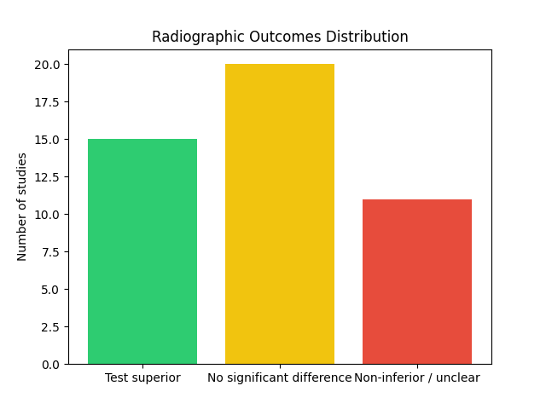
Figure 6: Distribution of radiographic outcomes across the included studies

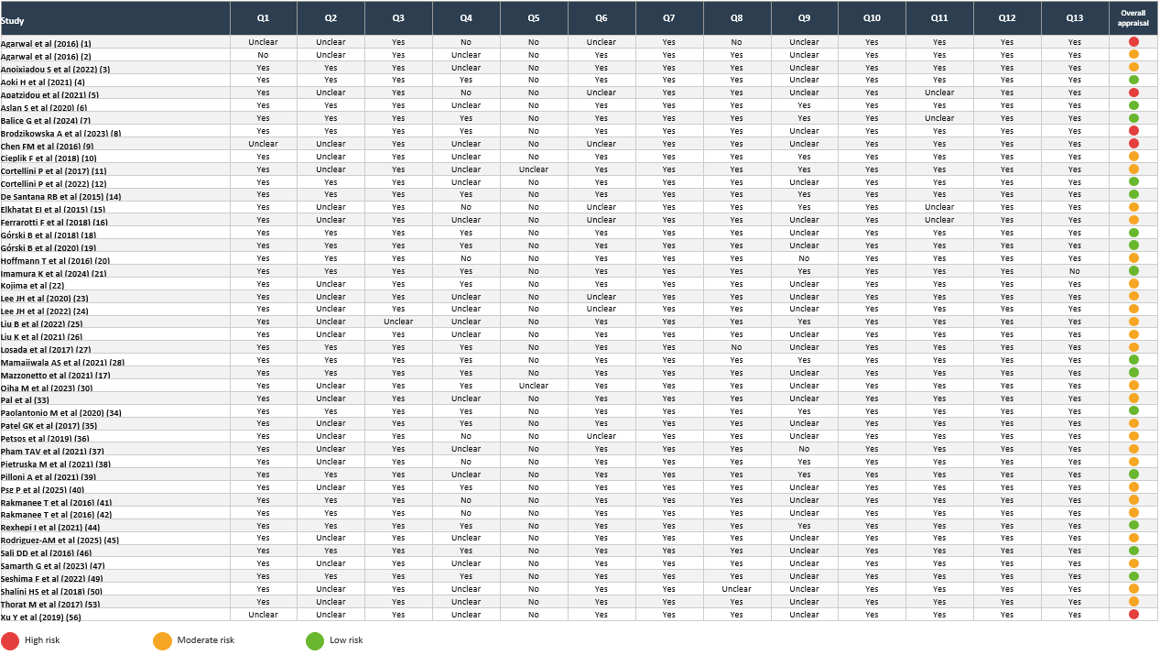
Figure 7: Risk of bias of the included randomized controlled trials

