A Myosoft error:
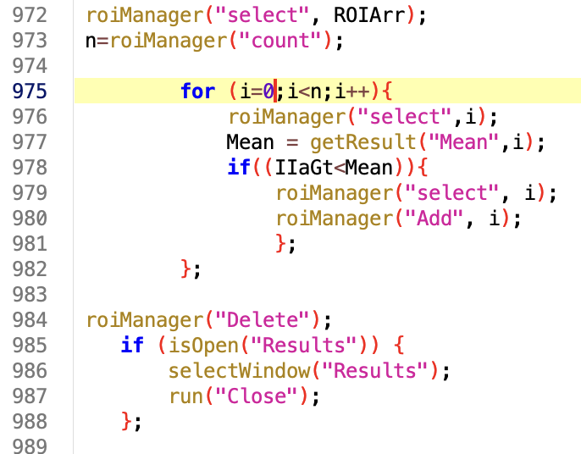
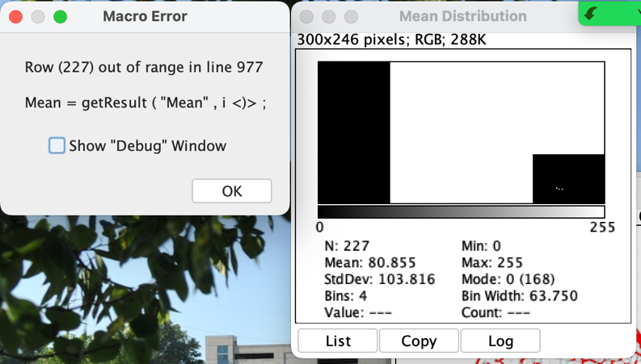

B TRUEFAD ReadAndWriteExcel no longer available.
Auto-saved images could not be found.
