Sparse-Observation Multi-Horizon Glaucoma Progression Forecasting with Biologically Constrained Temporal Consistency: A Glaucoma Case Study
Mousa Moradi¹, Jerry Cao-Xue¹, Asahi Fujita², Daniel L. Liebman², Alessandro Jammal², Mengyu Wang¹, Tobias Elze¹, Mohammad Eslami¹, Nazlee Zebardast^{2*}
¹Harvard Ophthalmology AI Lab, Schepens Eye Research Institute, Massachusetts Eye and Ear, Harvard Medical School, Boston, MA, United States
²Massachusetts Eye and Ear, Harvard Medical School, Boston, MA, United States
* Corresponding author: Nazlee Zebardast (Nazlee_Zebardast@MEEI.HARVARD.EDU)

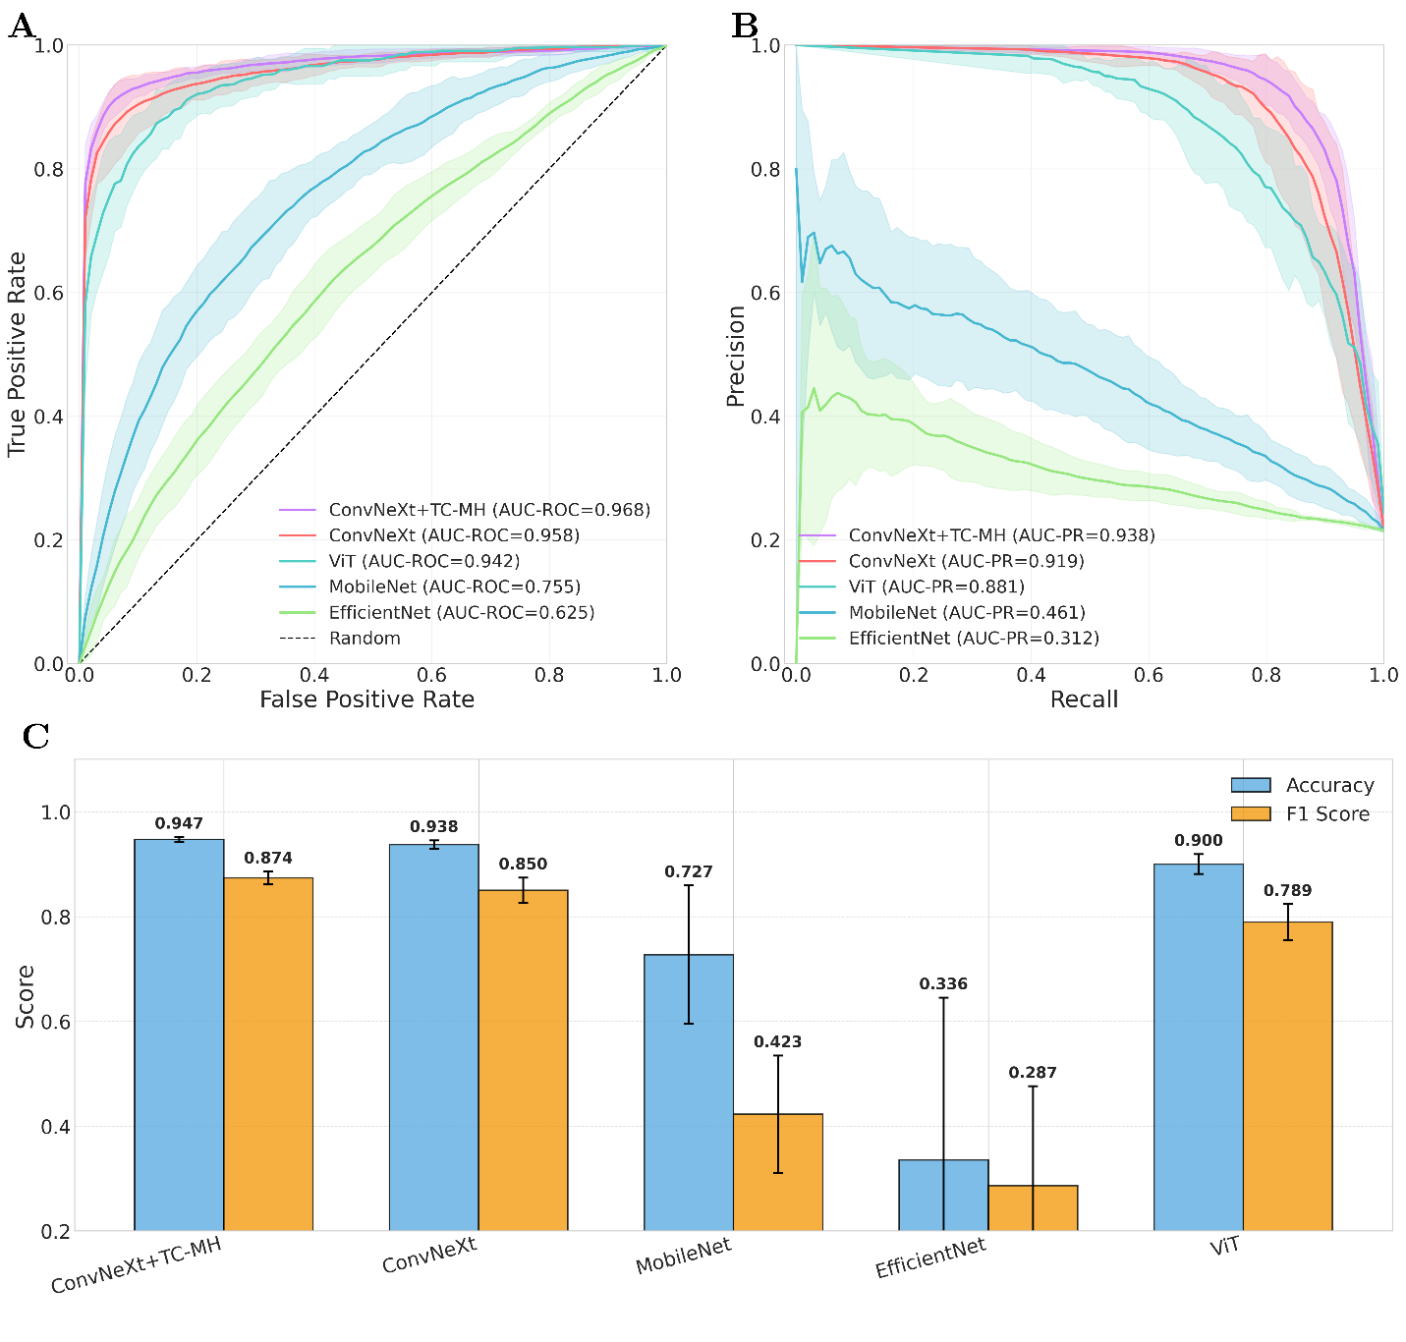
Supplementary Fig. S1. Overall performance comparison across models. Receiver operating characteristic (A) and precision–recall (B) curves demonstrate that ConvNeXt+TCMH achieves the highest AUROC and AUPRC among all architectures. (C) Summary of accuracy and F1-score confirm consistent performance gains, with ConvNeXt+TCMH outperforming baseline models across both metrics.
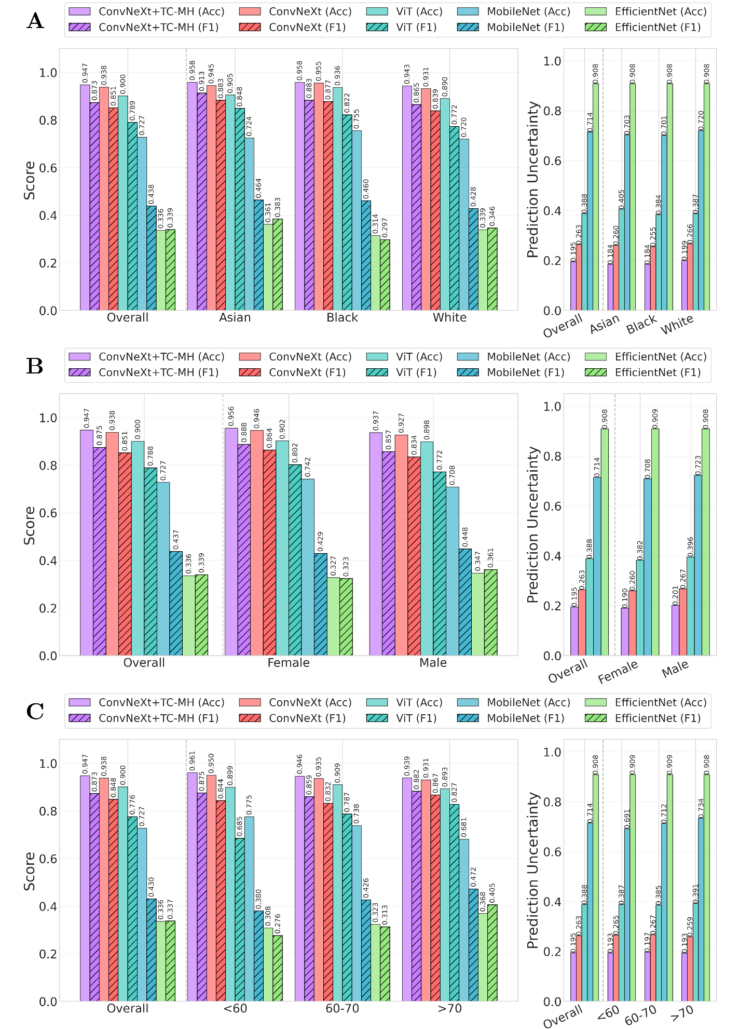
Supplementary Fig. S2. Subgroup performance and uncertainty across demographic strata. Accuracy and F1-score (left) and prediction uncertainty (right) are shown across race (A), gender (B), and age groups (C) for all models. ConvNeXt+TCMH consistently achieves the highest accuracy and F1-score with the lowest uncertainty across all subgroups, demonstrating improved performance and reliability compared to baseline architectures.
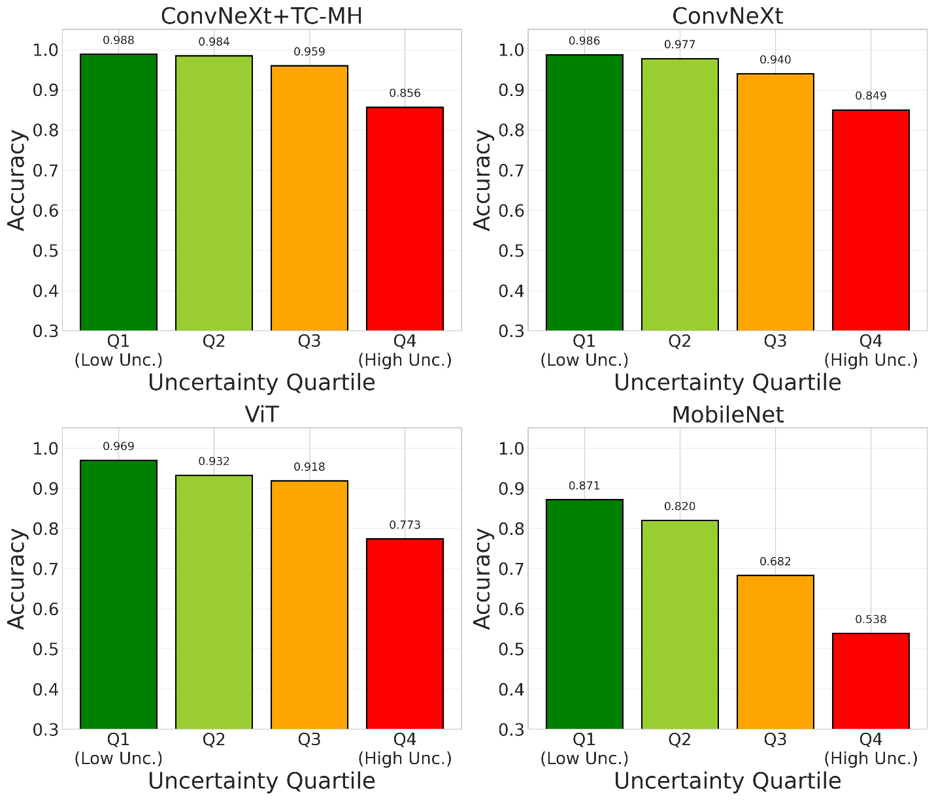
Supplementary Fig. S3. Accuracy stratified by prediction uncertainty. Accuracy across uncertainty quartiles (Q1: lowest uncertainty to Q4: highest uncertainty) for each model. ConvNeXt+TCMH shows the highest accuracy and the most consistent decline with increasing uncertainty, indicating a stronger uncertainty–error relationship and more reliable confidence estimation compared to baseline architectures.

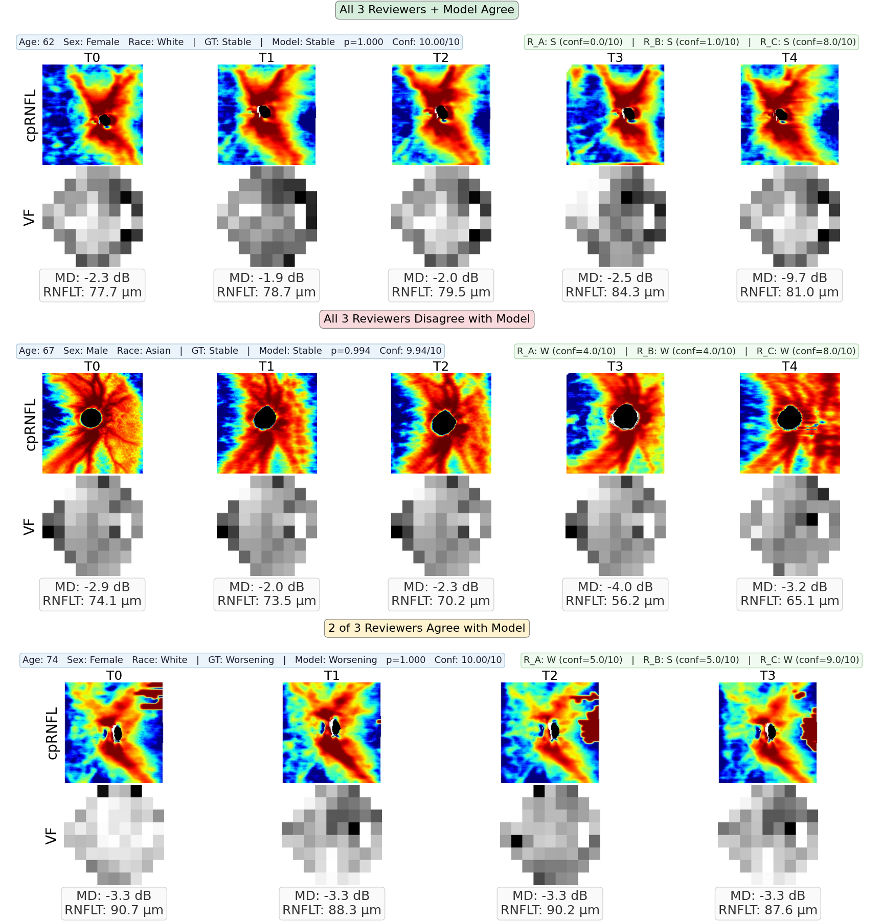
Supplementary Fig. S4. Representative longitudinal sequences for three agreement conditions between the model and specialist reviewers. Each panel shows cpRNFL thickness maps (top, with optic cup overlay) and visual field total deviation maps (bottom) across available timepoints. Mean deviation (MD, dB) and RNFL thickness (RNFLT, µm) at each visit are shown below the corresponding images.

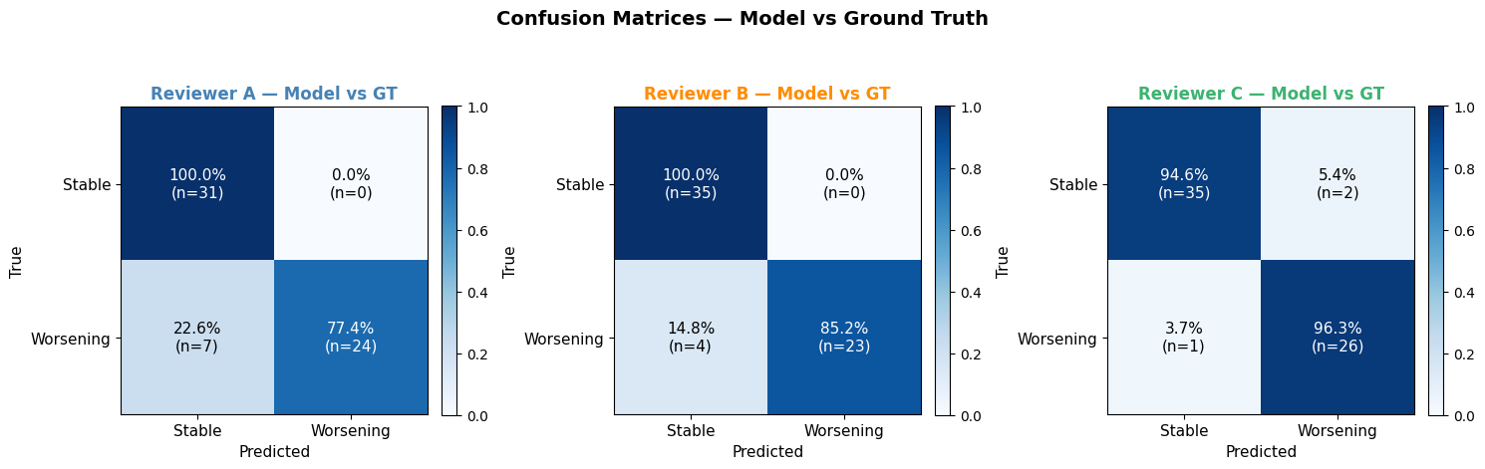
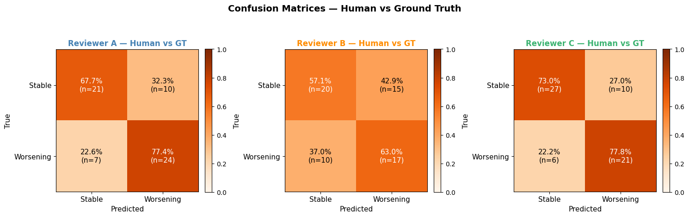
Supplementary Fig. S5. Confusion matrices for human graders and model classifications against ground truth labels across reviewer-specific test sets. Upper panels show human grader vs. ground truth classifications for Reviewer A (n = 62), Reviewer B (n = 62), and Reviewer C (n = 64); lower panels show model vs. ground truth classifications on the same subsets. Rows represent true labels (Stable, Worsening) and columns represent predicted labels. Cell values indicate the percentage and absolute count (n) of eyes in each category. Color intensity reflects normalized classification frequency within each true-label row

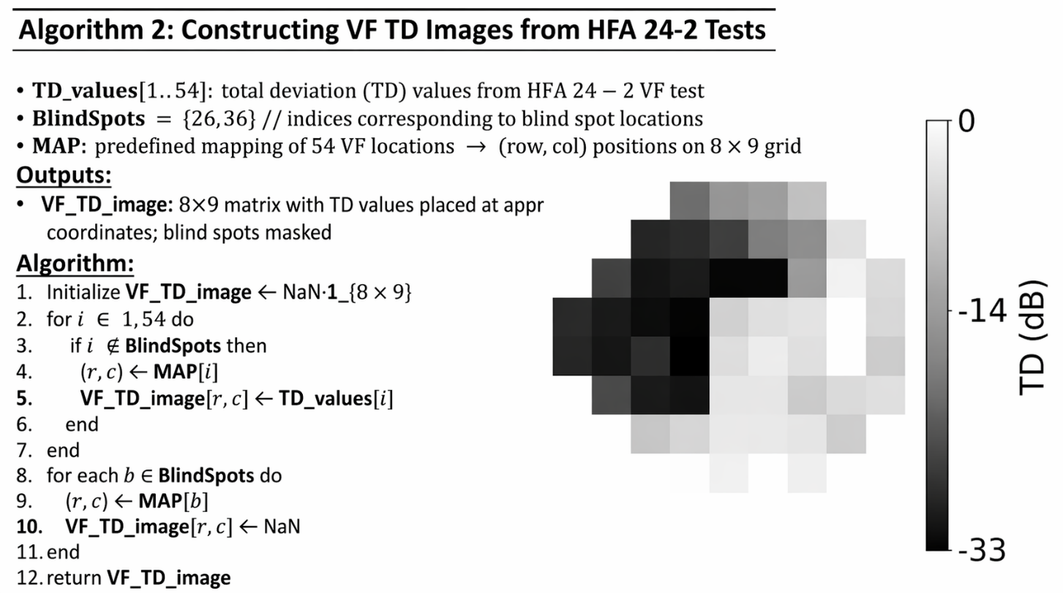
Supplementary Fig. S6. Construction of visual field total deviation (TD) images from HFA 24-2 tests. Pointwise TD values are mapped onto an 8×9 grid according to the 24-2 test layout, with blind spot locations masked, preserving the spatial topology of functional loss for image-based modeling.

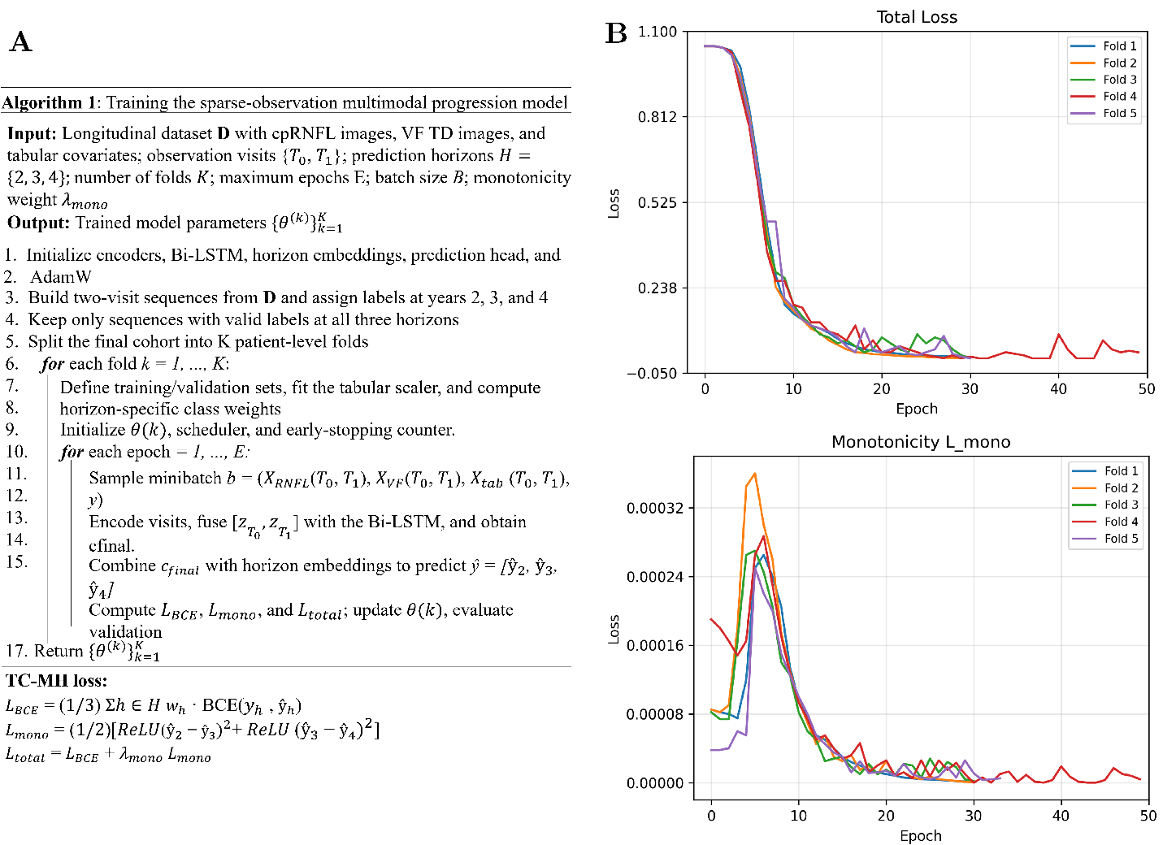
Supplementary Fig. S7. Training procedure and convergence of the TCMH model. (A) Pseudocode of the sparse-observation multimodal training pipeline with temporally consistent multi-horizon (TCMH) loss, illustrating cohort construction, patient-level cross-validation, and joint optimization across prediction horizons. (B) Training dynamics across five folds showing (top) total loss and (bottom) monotonicity penalty (Lₘₒₙₒ) as a function of epoch. The monotonicity term exhibits an early peak followed by rapid stabilization toward zero, indicating effective enforcement of the temporal constraint without dominating the optimization. Consistent convergence across folds demonstrates stable training behavior of the proposed framework.

Supplementary Table S1. Model architecture and training configuration. All models use identical temporal fusion (Bi-LSTM), tabular encoding, and classification heads. Only the image encoder backbone differs between models. All models used the same classifier head: FC(512→128) + ReLU + dropout(0.5) + FC(128→1).
Component | ConvNeXt-V2 | ViT | MobileNet-V3 | EfficientNet-B0
Image Encoder Backbone | convnextv2_base | vit_base_patch16_224 | mobilenetv3_small | efficientnet_b0
Backbone Parameters | 89M | 86M | 2.5M | 5.3M
Image Feature Dimension | 1024 | 768 | 1024 | 1280
Input Image Size (Pixels) | 224×224 | 224×224 | 224×224 | 224×224
Combined Feature Dim | 2176 (1024×2 + 128) | 1664 (768×2 + 128) | 2176 (1024×2 + 128) | 2688 (1280×2 + 128)
LSTM Layers | 2 (bidirectional) | 2 (bidirectional) | 2 (bidirectional) | 2 (bidirectional)
LSTM Dropout | 0.3 | 0.3 | 0.3 | 0.3
LSTM Output Dimension | 512 (256×2) | 512 (256×2) | 512 (256×2) | 512 (256×2)
Total Trainable Parameters | 91M | 88M | 5M | 8M
Sequence Length | 5 time points (0, 1, 2, 3, 4) | 5 time points (0, 1, 2, 3, 4) | 5 time points (0, 1, 2, 3, 4) | 5 time points (0, 1, 2, 3, 4)
Observation Window | 1 year | 1 year | 1 year | 1 year
Prediction Horizon | 2-4 years | 2-4 years | 2-4 years | 2-4 years
Optimizer | AdamW | AdamW | AdamW | AdamW
Learning Rate | $$2×{10}^{-5}$$ | $$2×{10}^{-5}$$ | $$2×{10}^{-5}$$ | $$2×{10}^{-5}$$
Weight Decay | $$1×{10}^{-2}$$ | $$1×{10}^{-2}$$ | $$1×{10}^{-2}$$ | $$1×{10}^{-2}$$
Batch Size | 16 | 16 | 16 | 16
GPU Memory (H100 80GB) | ~12-14 GB | ~10-12 GB | ~6-8 GB | ~8-10 GB

