Supplementary Information
for
Hidden Mononuclear Catalysis within Dirhodium(II)/Phosphine Systems: Mechanism, Active Species, and Stereoselectivity

Sapna Rawat,^{[a]} Debopam Sarkar, ^{[b]} Priyotosh Das,^{[a]} Abhishake Mondal,^{[b]} and Garima Jindal*^{[a]}

^{[a]}Department of Organic Chemistry, Chemical Sciences Building, Indian Institute of Science, Bengaluru, Karnataka-560012, India
^{[b]}Solid State and Structural Chemistry Unit, Chemical Sciences Building, Indian Institute of Science, Bengaluru, Karnataka-560012, India
email: gjindal@iisc.ac.in

Contents
Experimental Studies
1. General Information S3
2. Synthesis and Characterization of Active Species (X₁) S3
3. ³¹P{¹H} VT-NMR experiments S7
3.1 ³¹P{¹H} VT-NMR with Dirhodium(II) and Josiphos S7
3.2. ³¹P{¹H) VT-NMR with Phenylboronic Acid S8
3.3. ³¹P{¹H} VT-NMR with [Rh(C₂H₄)₂Cl]₂, Josiphos and Phenylboronic Acid S9
4. Control experiments with [Rh(C₂H₄)₂Cl]₂ and Josiphos S10
5. Investigation of the Chloride Source in X₁ S11
5.1. Identification of Chloride source in BLD Pharma Dirhodium(II) S11
5.2. Detection of Transmetalated Complex (X₂) with TCI Dirhodium (II) S12
5.3. Experiments to Detect the Active Species Forming with TCI Dirhodium(II) S13
6. Role of Additives in Dissociation of Rh-Rh bonds S14
7. Detection and Characterization of Transmetalated Complex (X₂) S18
8. Synthesis of Compound 1a S19
9. Catalytic activity of X₁ S20
10. ESI-HRMS data of X₁ and X₂ S27
11. Prior reported Dirhodium/phosphine complexes with their ³¹P chemical shift S28
12. X-ray Crystallography data of X₁ S30
Computation Section
13. Computational details S32
14. Probable Catalytic Dirhodium(II) Active Species S32
15. Additional DFT calculations S33
16. Conformational Sampling for TSs corresponding to Enantioselective Step S35
17. Activation Strain Analysis S36
18. Benchmark Studies of the Lowest Energy Pathway S37
19. Electronic Energies of all the Stationary Points S39
20. References S41
21. Cartesian Coordinates of all Optimized Geometries S43

- General Information
All reactions were carried out with distilled and dried solvent under an inert nitrogen and argon atmosphere. All the reagents were purchased at the highest commercial quality and used without further purification. (R)-1-[(Sp)-2-(Di-1-naphthylphosphino)ferrocenyl]ethyldi-3,5-xylylphosphine (Josiphos ligand) and 9,10-phenthraquinoline were purchased from BLD pharma. Dirhodium(II) tetracarboxylate were purchased from different supplier (BLD pharma, TCI and Sigma Aldrich). BLD dirhodium(II) was used throughout all experiments in this study. Whenever dirhodium(II) from other commercially available sources was used, it is explicitly indicated. Phenylboronic acid and K₂CO₃ were acquired from Sigma Aldrich. Distilled water was used in reactions, where required. 4,5-dimethylphenanthrene-9,10-dione was synthesized by following the literature procedure. Progress of reactions were monitored by thin-layer chromatography (TLC) carried out on Merck silica gel 60 F254 precoated plates (0.25 mm) and visualized with UV light (254 nm) or KMnO₄ staining solutions followed by heating. Yields were reported after purification via column chromatography using silica gel (100-200 mesh). Organic solvents used for carrying out reactions were dried using standard methods. All work up and purification were carried out with reagent grade solvents in air.
All ¹H, ¹³C, and ³¹P-NMR spectra were recorded on a Bruker Ultrashield spectrometer at 400 MHz and calibrated using residual deuterated solvents as an internal reference (CDCl₃: ¹H NMR = 7.26 ppm, ¹³C NMR = 77.16 ppm; Toluene-d8: ¹H NMR = 2.09 ppm). ³⁵Cl NMR was recorded on Bruker Ultrashield spectrometer at 600 MHz in CD₃CN solvent. The following abbreviations were used to explain NMR peak multiplicities: s = singlet, d = doublet, t = triplet, dd = doublet of doublet, br = broad). All ³¹P{¹H} VT-NMR and controlled experiment monitored in undeuterated toluene without locking and shimming. All spectra were processed with MestReNova x64 software package. Electrospray ionization high resolution mass spectrometry (ESI-HRMS) was performed on a Waters XEVO G3 Q-tof instrument in acetonitrile solvent. Optical rotations were measured on JASCO P-2000 polarimeter at 25 °C using 50 mm cell of 1.0 mL capacity. HPLC analysis was performed on either Agilent Technologies 1260 Infinity with a VWD or Agilent Technologies 1260 Infinity with a DAD.
- Synthesis and Characterization of Active Species X₁
An oven-dried 25 mL Schlenk tube equipped with a magnetic stir bar was charged with TCI Rh₂(OAc)₄ (97.2 mg, 0.22 mmol, 1.0 equiv), Josiphos ligand (162.5 mg, 0.22 mmol, 1.0 equiv) and KCl (32.80 mg, 0.44 mmol, 2.0 equiv) under a nitrogen atmosphere. Anhydrous toluene (7.4 mL) and acetic acid (1.8 mL) were then added under inert conditions. The resulting reaction mixture was stirred and heated at 80 °C for 3.5 h. Single crystals suitable for X-ray diffraction revealed that X₁ crystallizes as a 1:1 with toluene solvent.
¹H NMR (400 MHz, CDCl₃): δ 8.85 (d, J = 8.5 Hz, 1H), 8.44 (dd, J = 10.1, 7.0 Hz, 1H), 8.04 (dt, J = 13.4, 7.1 Hz, 3H), 7.93 (d, J = 8.1 Hz, 1H), 7.86 – 7.77 (m, 1H), 7.67 (t, J = 7.4 Hz, 1H), 7.58 (t, J = 7.4 Hz, 1H), 7.53 – 7.39 (m, 2H), 7.26 (s, 1H), 7.20 (d, J = 7.6 Hz, 4H), 7.11 (s, 2H), 6.93 (d, J = 10.5 Hz, 2H), 6.83 (t, J = 7.7 Hz, 1H), 6.62 (d, J = 7.4 Hz, 1H), 6.44 (s, 2H), 4.13 (s, 1H), 4.09 (s, 5H), 3.90 (d, J = 10.9 Hz, 1H), 3.80 (s, 1H), 2.51 – 2.43 (m, 1H), 2.38 (s, 3H), 2.33 (s, 6H), 2.28 (s, 6H), 1.66 (s, 3H), 1.02 (dd, J = 13.0, 6.8 Hz, 3H).
³¹P{¹H} NMR (162 MHz, CDCl₃): δ 68.49 (dd, J = 136.1, 25.4 Hz), 61.41 (dd, J = 131.6, 25.1 Hz).
³⁵Cl (59 MHz, CD₃CN) δ 34.77.
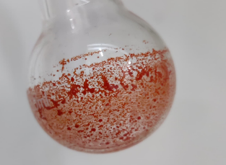
Complex X₁
Scheme S1. Synthesis of X₁ complex
Purification: -
After completion of the reaction, the mixture was allowed to cool to room temperature and filtered to remove unreacted Rh₂(OAc)₄. The filtrate was concentrated under reduced pressure after to afford a crude solid. This solid was dissolved in a minimal amount of DCM, followed by slow addition of hexane until a reddish-brown precipitate formed. The resulting suspension was filtered, and the orange-colored filtrate was concentrated to yield an orange solid (16 %). Crystallization of this material by vapor diffusion of n-pentane into a toluene solution afforded red crystals of X₁. The ³¹P{¹H} NMR spectra of the reddish-brown and orange solids are shown below. The ³¹P{¹H}, ¹H, and ³⁵Cl-NMR spectra of X₁ are also provided below.
³¹P{¹H} NMR (162 MHz, Toluene) δ 97.40 (dd, J = 148.4, 21.9 Hz), 85.83 – 79.63 (m), 67.44 (dd, J = 134.0, 23.5 Hz), 61.01 (dd, J = 132.3, 24.3 Hz), 44.68 (dd, J = 77.7, 21.5 Hz).
Figure S1. ³¹P{¹H} NMR of orange colored solid

³¹P{¹H} NMR (162 MHz, Toluene) δ 67.62 (dd, J = 133.8, 24.9 Hz), 61.19 (dd, J = 132.1, 24.7 Hz), 54.12 (dd, J = 232.4, 140.9 Hz), 51.41 (dt, J = 140.9, 40.2 Hz), 26.99 (dt, J = 130.6, 40.2 Hz), 23.65 (dd, J = 232.4, 130.0 Hz).
Figure S2. ³¹P{¹H} NMR of reddish brown colored solid

¹H NMR (400 MHz, CDCl₃)
Figure S3. ¹H NMR of X₁

³¹P{¹H} NMR (162 MHz, Toluene)
Figure S4. ³¹P{¹H} NMR of X₁

³⁵Cl NMR (59 MHz, CD₃CN)
Figure S5. ³⁵Cl NMR of X₁

- ³¹P{¹H} VT-NMR experiments
3.1. ³¹P{¹H} VT-NMR with Dirhodium(II) and Josiphos
Rh₂(OAc)₄ (11.0 mg, 0.025 mmol, 1.0 equiv) and the Josiphos ligand (37.0 mg, 0.05 mmol, 2.0 equiv) were charged into an oven-dried 2.5 mL vial under a nitrogen atmosphere, followed by the addition of 0.75 mL of toluene. The resulting mixture was stirred for 10 minutes at room temperature and then transferred to an oven-dried NMR tube for ³¹P{¹H} VT-NMR measurements over a temperature range from room temperature to 80 °C. At 40 °C, the spectrum was dominated by intense signals corresponding to the free Josiphos ligand, with the P₁ and P₂ nuclei resonating at 6.1 ppm and –50.3 ppm, respectively. After 2.5 h at 60 °C, two new intense signals appeared at 62.8 ppm (doublet), together with a signal at -41.6 ppm (singlet), highlighted by circles.
Based on the axial-equatorial coordination trends of phosphine ligands discussed above, these resonances may correspond to a species in which the P₁ nucleus is equatorially coordinated to Rh, while the P₂ nucleus remains uncoordinated, as indicated by its proximity to the chemical shift of free P₂. Several pairs of dd signals (highlighted in the same color) shared a common second coupling constant, consistent with a P–Rh–P arrangement in which two chemically inequivalent phosphorus nuclei are coupled via the same Rh atom. Peaks corresponding to the X₁ complex appeared at 80 °C and were highlighted in blue.
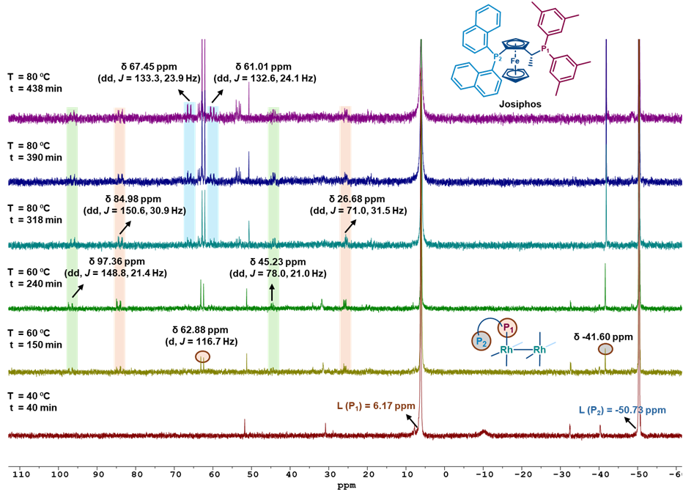
Figure S6. ³¹P{¹H} VT-NMR with dirhodium(II)/Josiphos

  - ³¹P{¹H) VT-NMR with Phenylboronic Acid

Rh₂(OAc)₄ (11.0 mg, 0.025 mmol, 1.0 equiv), Josiphos (37.0 mg, 0.05 mmol, 2.0 equiv), PhB(OH)₂ (30.5 mg, 0.25 mmol, 10.0 equiv), and K₂CO₃ (13.8 mg, 0.10 mmol, 4.0 equiv) were charged into an oven-dried 2.5 mL vial under a nitrogen atmosphere, followed by the addition of 0.75 mL toluene and 75.0 μL of distilled H₂O. The resulting mixture was stirred for 10 minutes at room temperature and then transferred to an oven-dried NMR tube for 31P{1H} VT-NMR measurements over a temperature range from room temperature to 80 °C. The spectra displayed the peaks corresponding to transmetalated complex, X₂ after 1.5 h at 60 °C.
³¹P{¹H} NMR (162 MHz, Toluene)
δ 85.05 (dd, J = 150.6, 31.7 Hz), 65.25 (dd, J = 154.7, 20.7 Hz), 54.17 (dd, J = 233.1, 141.7 Hz), 44.82 (dd, J = 73.1, 19.6 Hz), 26.90 (dd, J = 70.9, 32.2 Hz), 23.99 (dd, J = 233.0, 131.4 Hz), δ 97.60 (dd, J = 148.8, 21.8 Hz).
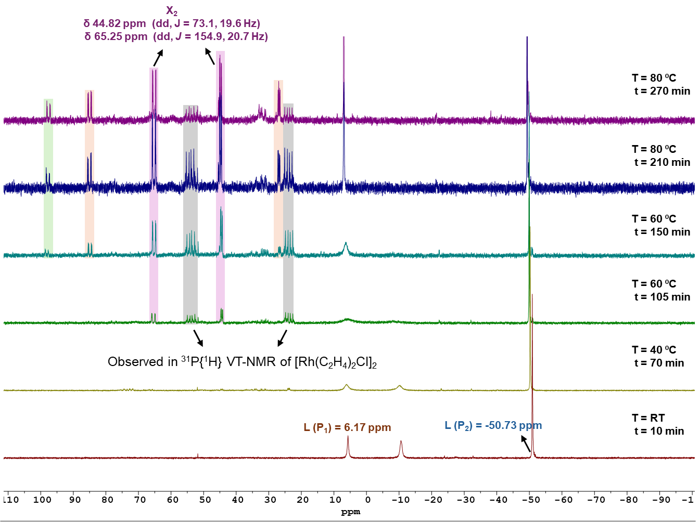
Figure S7. ³¹P{¹H} VT-NMR in the presence of PhB(OH)₂

3.3. ³¹P{¹H} VT-NMR with [Rh(C₂H₄)₂Cl]₂, Josiphos and Phenylboronic Acid
[Rh(C₂H₄)(Cl)]₂ (9.7 mg, 0.025 mmol, 1.0 equiv), Josiphos (18.4 mg, 0.025 mmol, 1.0 equiv), PhB(OH)₂ (30.5 mg, 0.25 mmol, 10.0 equiv), and K₂CO₃ (13.8 mg, 0.10 mmol, 4.0 equiv) were charged into an oven-dried 2.5 mL vial under a nitrogen atmosphere, followed by the addition of 0.75 mL toluene and 75.0 μL of distilled H₂O. The resulting mixture was stirred for 10 minutes at room temperature and then transferred to an oven-dried NMR tube for ³¹P{¹H} VT-NMR measurements over a temperature range from room temperature to 60 °C. Peaks highlighted in grey color were also observed in the above ³¹P{¹H} VT-NMR (Section 3.2.) and, during the synthesis of X₁ complex (Section 2). These results indicate that the dirhodium(II) most likely undergoes disproportionation to generate monorhodium(I) and monorhodium(III) species under the reaction conditions.
³¹P{¹H} NMR (162 MHz, Toluene)
δ 74.09 (dd, J = 208.3, 41.8 Hz), 67.50 (dd, J = 205.7, 44.9 Hz), 53.87 (dd, J = 233.3, 141.6 Hz), 35.27 (dd, J = 207.9, 42.0 Hz), 23.70 (dd, J = 233.0, 131.5 Hz).
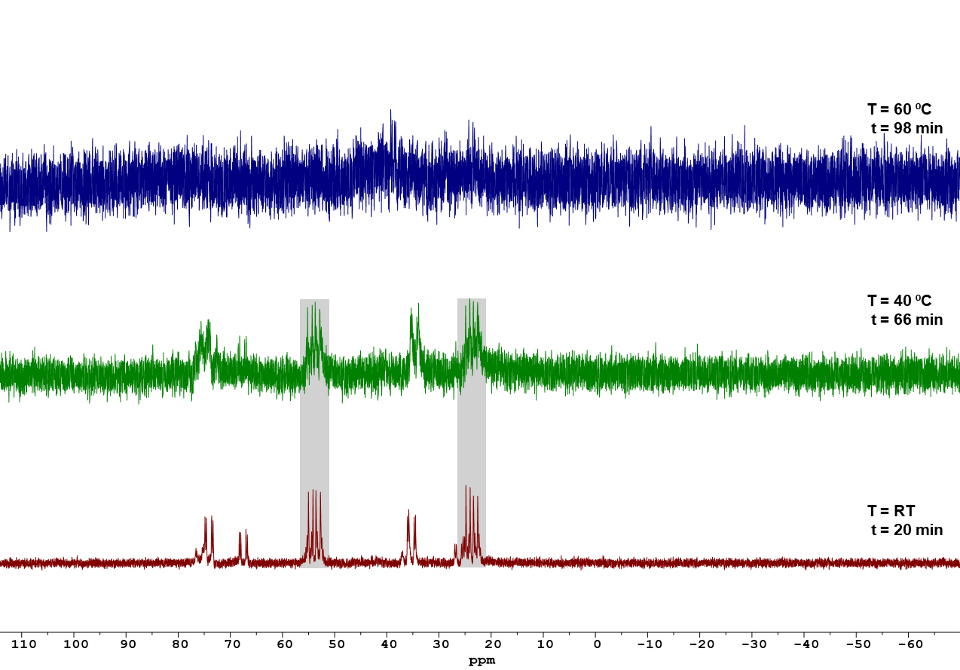
Figure S8. ³¹P{¹H} VT-NMR with [Rh(C₂H₄)₂Cl]₂/Josiphos in the presence of PhB(OH)₂

- Control Experiments with [Rh(C₂H₄)₂Cl]₂ and Josiphos
[Rh(C₂H₄)(Cl)]₂ (9.7 mg, 0.025 mmol, 1.0 equiv) and Josiphos (18.4 mg, 0.025 mmol, 1.0 equiv) were charged into an oven-dried 2.5 mL vial under a nitrogen atmosphere, followed by the addition of 0.75 mL toluene. The resulting mixture was stirred for 30 minutes at room temperature and then transferred to an oven-dried NMR tube for ³¹P{¹H} NMR analysis. In the same solution, K₂CO₃ (13.8 mg, 0.10 mmol, 4.0 equiv) and 75.0 µL of H₂O were added and the reaction was monitored for 40 min; no change in the spectra was observed. ³¹P{¹H} NMR spectrum was recorded in non-deuterated toluene. Moreover, no common signals were detected when compared with the control experiment performed with the dirhodium(II) tetracarboxylate system.
³¹P{¹H} NMR (162 MHz, Toluene)

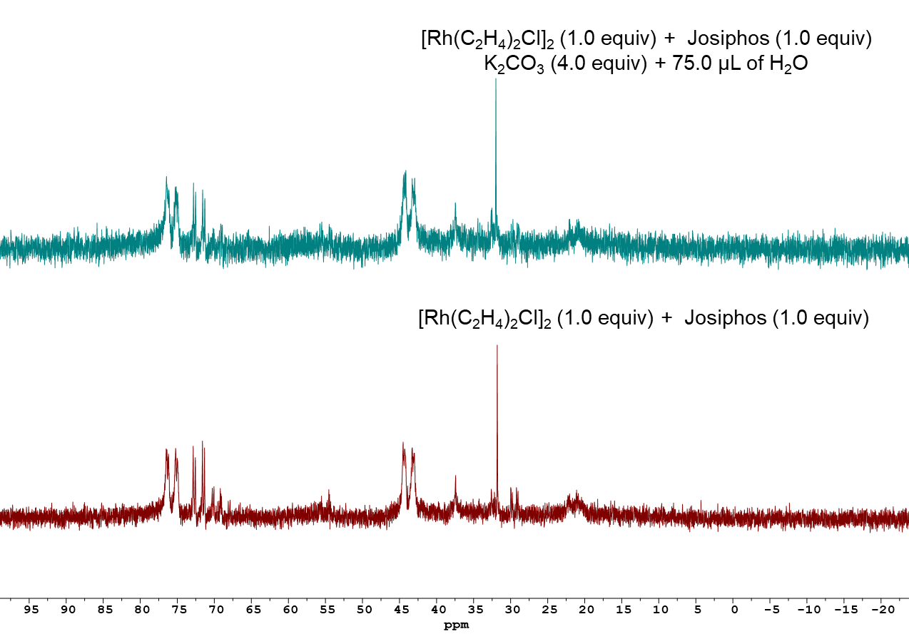
Figure S9. ³¹P{¹H} NMR of reaction mixture

5. Investigation of the Chloride Source in X₁
5.1. Identification of Chloride Contamination in BLD Dirhodium(II)
Surprisingly, the electron density map at the sixth coordination site in the X₁ complex corresponds to a chloride ligand in the X-ray diffraction data, despite no chlorine-containing reagents being used during the synthesis. The ³⁵Cl NMR spectrum of the X₁ complex was recorded, confirming the presence of a chloride ligand with a resonance at 34.77 ppm, as given above in Section 2. This observation is most likely due to the incorporation of a chlorine impurity from the commercially purchased dirhodium(II) tetracarboxylate precursor, which is commonly synthesized from RhCl₃. To support this hypothesis, several experiments were performed using dirhodium(II) tetracarboxylate purchased from TCI and Sigma-Aldrich.
First, the reaction for the synthesis of X₁ was set up using dirhodium(II) tetracarboxylate purchased from both TCI and Sigma-Aldrich. The procedure was the same as described in Section 2, and no peaks corresponding to the X₁ complex were observed in the ³¹P{¹H} NMR spectra of the reaction mixture. However, the addition of 2.0 equiv of KCl to the TCI dirhodium(II) tetracarboxylate afforded the X₁ complex, as shown below, confirming the incorporation of an external chlorine atom.
³¹P{¹H} NMR (162 MHz, Toluene)
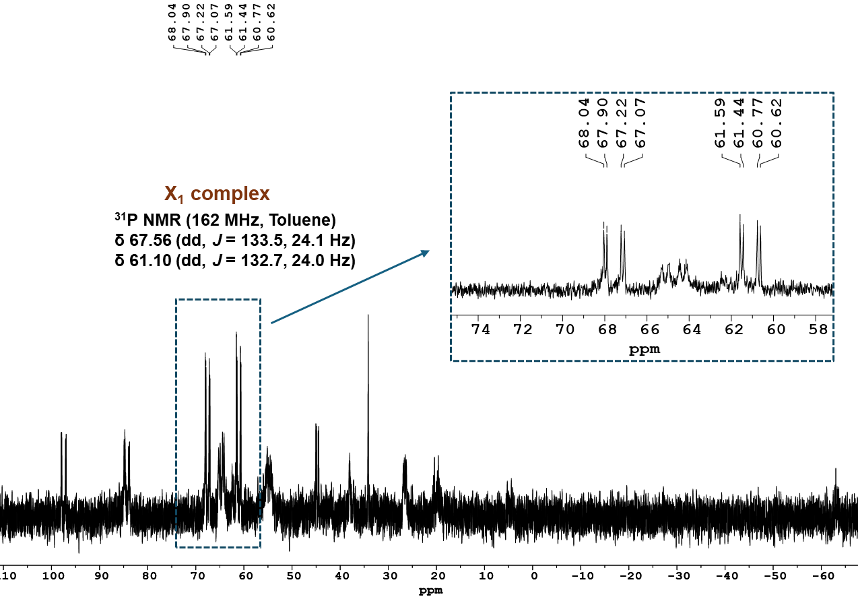
Figure S10. ³¹P{¹H} NMR of reaction mixture

5.2. Detection of Transmetalated Complex (X₂) with TCI Dirhodium(II)
³¹P{¹H} VT-NMR, as performed in Section 3.2, was also monitored using TCI-sourced dirhodium(II) tetracarboxylate. The procedure was the same as described in Section 3.2. Both the transmetalated complex (X₂) (green diamond) and the complex exhibiting peaks at 54.16 ppm and 23.96 ppm (orange diamond) were also observed in this experiment. The latter complex was also detected in the experiment with [Rh(C₂H₄)₂Cl]₂ in Section 3.2 and during the synthesis of the X₁ complex described in Section 2.
This experiment indicates that, with both BLD- and TCI dirhodium(II) tetracarboxylate, the same C–H metalated monorhodium(III) species is formed, with the only difference being the identity of the sixth ligand. In the case of the BLD dirhodium(II) precursor, the sixth ligand is a chloride ligand, whereas for the TCI dirhodium(II) precursor it is most likely an acetate ligand, or alternatively a cationic complex with acetate as the counteranion.

³¹P{¹H} NMR (162 MHz, Toluene)
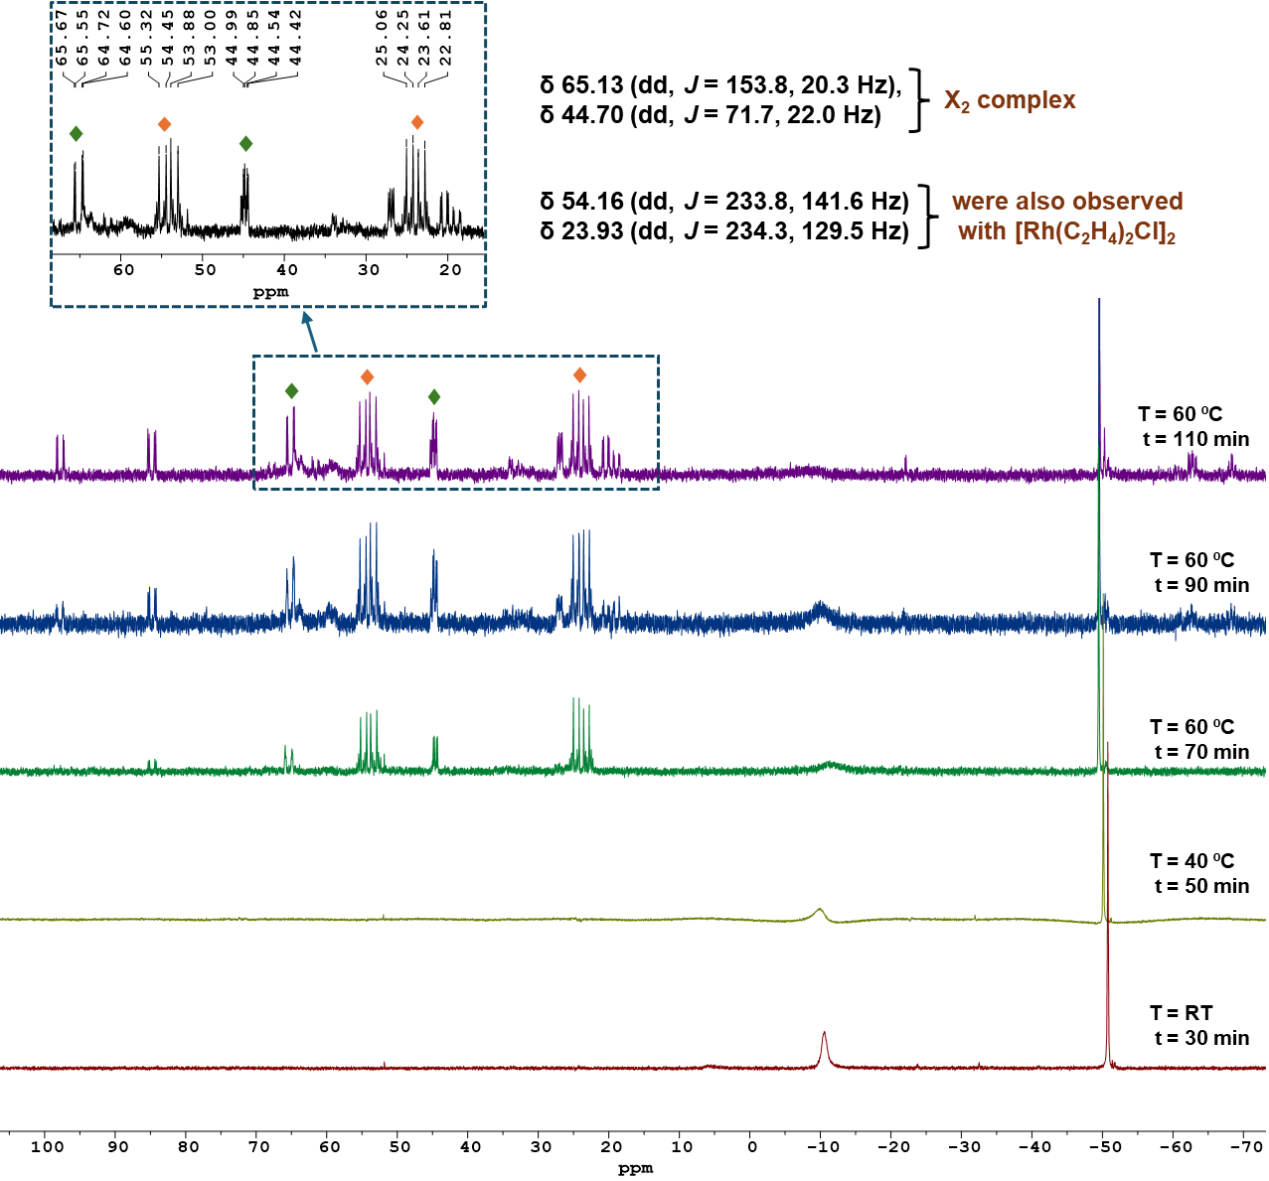
Figure S11. ³¹P{¹H} VT-NMR
  - Experiments to Detect the Active Species Forming with TCI Dirhodium(II)
Two experiments were performed to detect the possible active species formed with TCI dirhodium(II) tetracarboxylate: (1) in the presence of KCl and (2) in the absence of KCl.
Common Procedure.
(1) An oven-dried 5 mL Schlenk tube equipped with a magnetic stir bar was charged with Rh₂(OAc)₄ (22.0 mg, 0.05 mmol, 1.0 equiv), Josiphos ligand (73.8 mg, 0.10 mmol, 2.0 equiv), phenylboronic acid (61.0 mg, 0.50 mmol, 10.0 equiv), and KCl (13.8 mg, 0.10 mmol, 2.0 equiv) under a nitrogen atmosphere. Toluene (1.5 mL) and water (0.15 mL) were then added under an inert atmosphere. The resulting mixture was stirred at 60 °C for 2 h. An 0.6 mL of the reaction mixture was transferred to a flame-dried NMR tube, and the ³¹P{¹H} NMR spectrum was recorded in non-deuterated toluene and observed peaks corresponding to X₁ (yellow diamond).
(2) The same experiment was performed under identical conditions without KCl, and the reaction mixture was stirred for 4 h and ³¹P{¹H} NMR spectrum was recorded in non-deuterated toluene.
Upon comparison of the ³¹P{¹H} NMR spectra, it was observed that in the presence of KCl, peaks corresponding to the X₁ complex were detected. In contrast, in the absence of KCl, two new resonances appeared at 57.63 and 62.54 ppm (red diamond) in the 50–65 ppm region. Notably, these signals are absent in the previously recorded ³¹P{¹H} VT-NMR spectrum obtained with TCI dirhodium in the presence of phenylboronic acid (Section 5.2).
Collectively, these results suggest that the resonances at 57.63 ppm and 62.54 ppm (red diamond) most likely correspond to an active species bearing an acetate ligand instead of chloride. Alternatively, the species may be cationic in nature, with acetate acting as the counteranion as shown in Figure S12.
³¹P{¹H} NMR (162 MHz, Toluene)
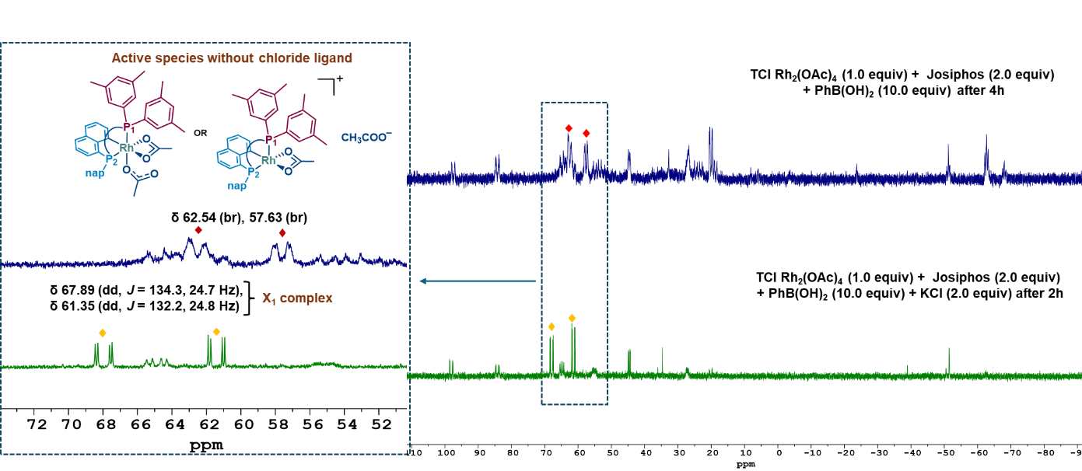Figure S12. ³¹P{¹H} NMR of reaction mixture

6. Role of Additives in Dissociation of Rh-Rh bonds
A series of additive-controlled experiments with phenylboronic acid, K₂CO₃, H₂O were monitored over a 4 h period. Procedure is same as experiments given in section 5.3. All ³¹P{¹H} NMR were recorded in non-deuterated toluene.
6.1. Rh₂(OAc)₄ (22.0 mg, 0.05 mmol, 1.0 equiv) + Josiphos ligand (73.8 mg, 0.10 mmol, 2.0 equiv) + Phenylboronic acid (61.0 mg, 0.50 mmol, 10.0 equiv) + Toluene (1.5 mL).
No peaks correspond to X₁ complex were detected.
³¹P{¹H} NMR (162 MHz, Toluene)

Figure S13. ³¹P{¹H} NMR of reaction mixture

  - Rh₂(OAc)₄ (22.0 mg, 0.05 mmol, 1.0 equiv) + Josiphos ligand (73.8 mg, 0.10 mmol, 2.0 equiv) + Toluene (1.5 mL)
No peaks correspond to X₁ complex were detected.
³¹P{¹H} NMR (162 MHz, Toluene)
Figure S14. ³¹P{¹H} NMR of reaction mixture
  - Rh₂(OAc)₄ (22.0 mg, 0.05 mmol, 1.0 equiv) + Josiphos ligand (73.8 mg, 0.10 mmol, 2.0 equiv) + Phenylboronic acid (61.0 mg, 0.50 mmol, 10.0 equiv) + Toluene (1.5 mL) + H₂O (0.15 mL)
Peaks correspond to X₁ complex were detected highlighting the importance of water and phenylboronic acid for the formation of X₁ complex.
³¹P{¹H} NMR (162 MHz, Toluene)
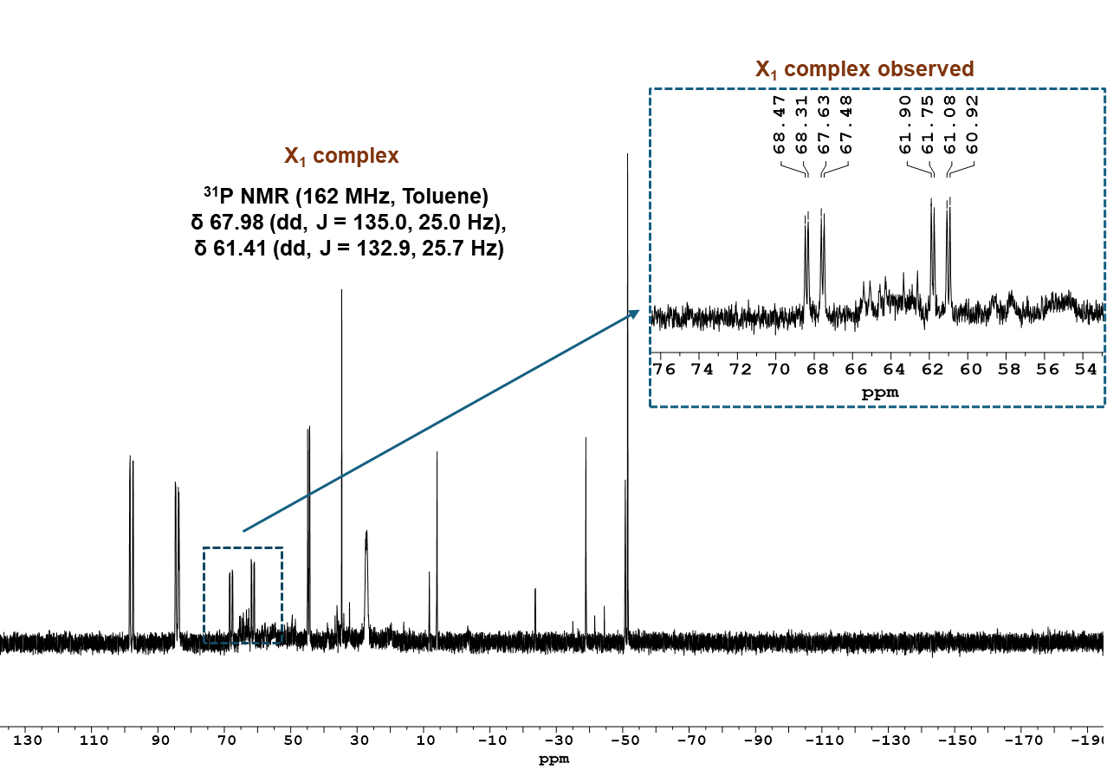
Figure S15. ³¹P{¹H} NMR of reaction mixture

  - Rh₂(OAc)₄ (11.0 mg, 0.025 mmol, 1.0 equiv) + Josiphos ligand (37.0 mg, 0.50 mmol, 2.0 equiv) + Toluene (0.75 mL) + H₂O (0.75 µL)
Very small Peaks correspond to X₁ complex (yellow diamond) were detected.
³¹P{¹H} NMR (162 MHz, Toluene)
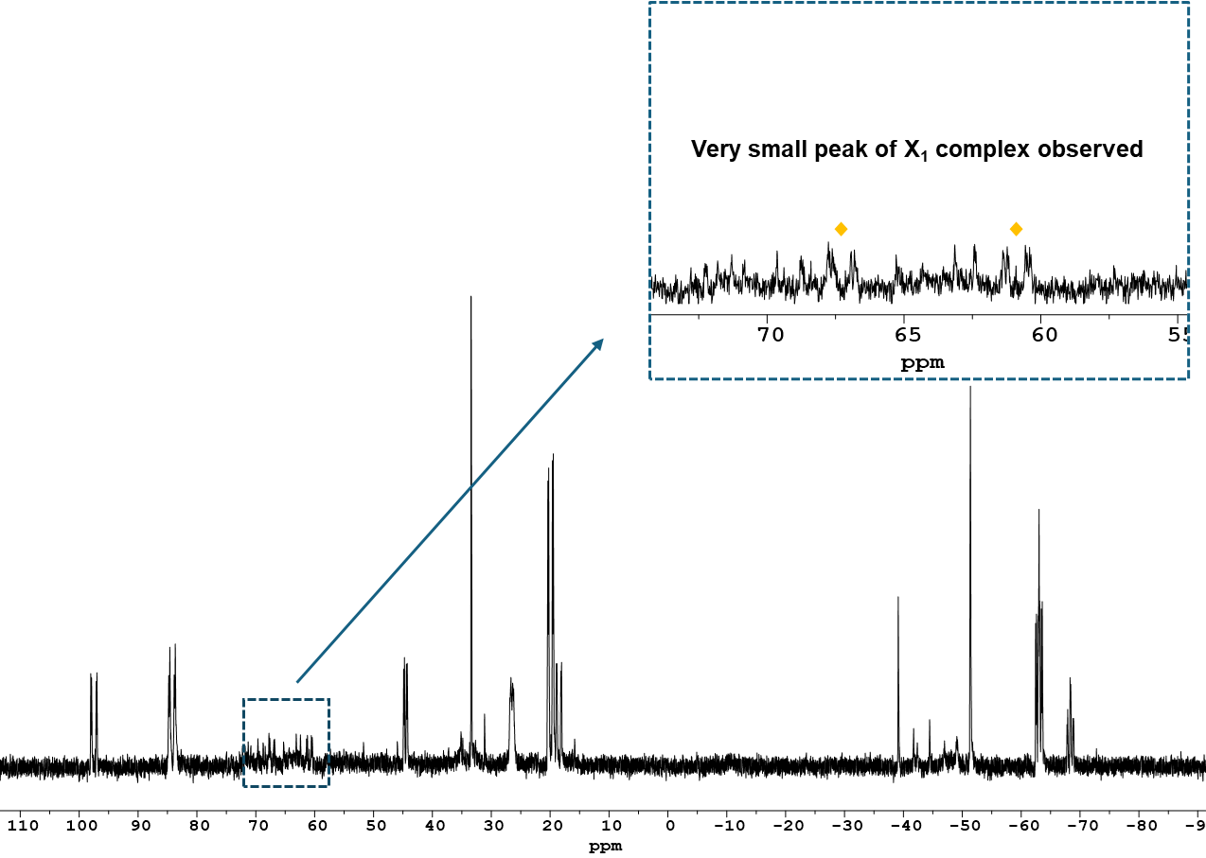
Figure S16. ³¹P{¹H} NMR of reaction mixture

  - Rh₂(OAc)₄ (11.0 mg, 0.025 mmol, 1.0 equiv) + Josiphos ligand (37.0 mg, 0.05 mmol, 2.0 equiv) + Phenylboronic acid (30.5 mg, 0.25 mmol, 10.0 equiv) + Toluene (0.75 mL) + H₂O (0.75 µL) + K₂CO₃ (13.8 mg, 0.10 mmol, 4.0 equiv)
Peaks correspond to X₂ complex were detected.
³¹P{¹H} NMR (162 MHz, Toluene)
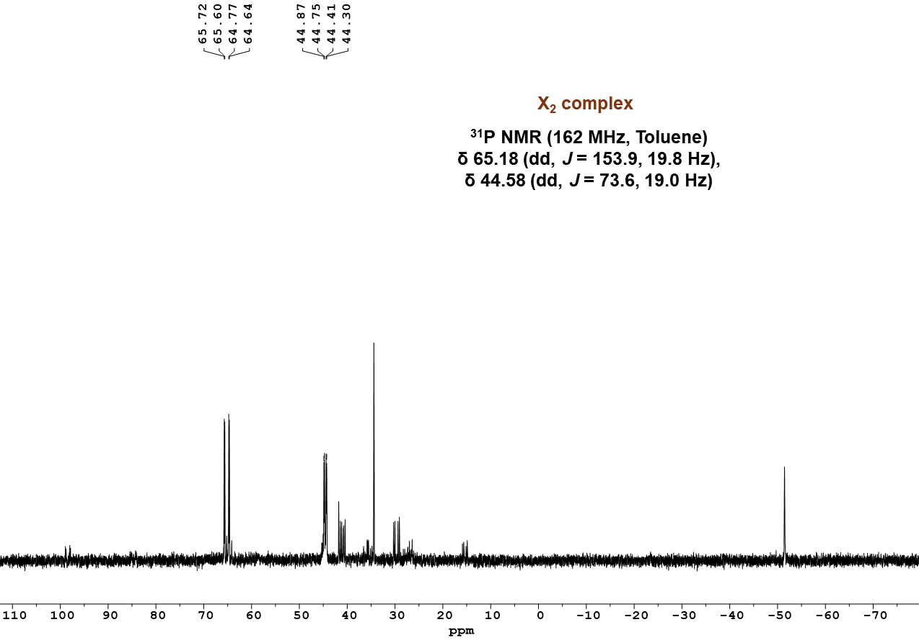

Figure S17. ³¹P{¹H} NMR of reaction mixture

  - Rh₂(OAc)₄ (11.0 mg, 0.025 mmol, 1.0 equiv) + Josiphos ligand (37 mg, 0.05 mmol, 2.0 equiv) + Toluene (0.75 mL) + H₂O (0.75 µL) + K₂CO₃ (13.8 mg, 0.10 mmol, 4.0 equiv)
No peaks correspond to X₁ complex were detected.
³¹P{¹H} NMR (162 MHz, Toluene)
Figure S18. ³¹P{¹H} NMR of reaction mixture

7. Detection and Characterization of Transmetalated Complex (X₂)
An oven-dried 5.0 mL round-bottom flask equipped with a magnetic stir bar was charged with the X1 complex (18.7 mg, 0.02 mmol, 1.0 equiv), PhB(OH)₂ (4.88 mg, 0.04 mmol, 2.0 equiv), and K₂CO₃ (5.52 mg, 0.04 mmol, 2.0 equiv) under a nitrogen atmosphere. Toluene (0.8 mL) was added, followed by H₂O (80 μL). The reaction mixture was stirred for 10 min at room temperature, after which a 0.6 mL aliquot was transferred to an oven-dried NMR tube for ³¹P{¹H} NMR analysis.
The dd signals at δ 61.42 and 68.54 ppm (yellow diamond), assigned to X₁, disappeared completely. Concomitantly, a new pair of dd signals at δ 44.31 and 65.80 ppm (green diamond) emerged, corresponding to X₂. No additional phosphorus-containing species were detected, consistent with a direct transmetalation event at the rhodium center.
ESI-HRMS analysis of X₂ revealed a dominant peak at m/z 917.1806, consistent with a monorhodium(III) transmetalated complex. Collectively, these data unambiguously confirm that the resonances at δ 44.31 and 65.80 ppm arise from the monorhodium transmetalated species X₂.

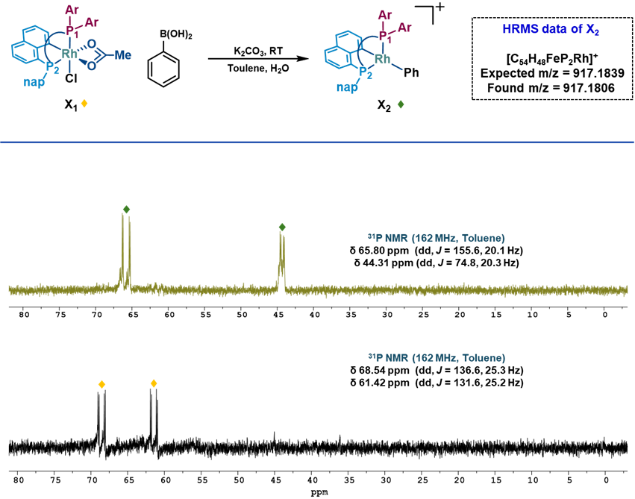
Figure S19. ³¹P{¹H} NMR of controlled experiment monitored for the formation of X₂ from X₁ complex

8. Synthesis of Compound 1a
4,5-dimethylphenanthrene-9,10-dione (1a) was prepared according to reported procedure.¹
¹H NMR (400 MHz, CDCl₃) δ 7.90 (d, J = 7.5 Hz, 2H), 7.59 (d, J = 7.7 Hz, 2H), 7.41 (td, J = 7.6, 1.5 Hz, 2H), 2.36 (s, 6H).
¹³C NMR (101 MHz, CDCl₃) δ 185.03, 138.05, 137.38, 137.37, 130.99, 128.41, 126.87, 20.75.

Figure S20. ¹H NMR of 1a

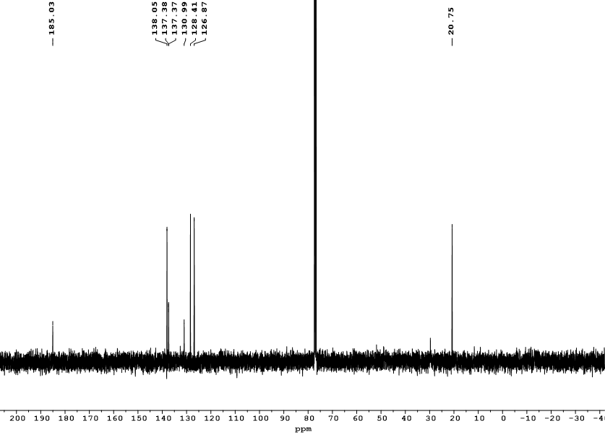
Figure S21. ¹³C NMR of 1a

9. Catalytic activity of X₁ complex
Table S1: Comparative catalytic evaluation of X₁ and other Rh catalysts
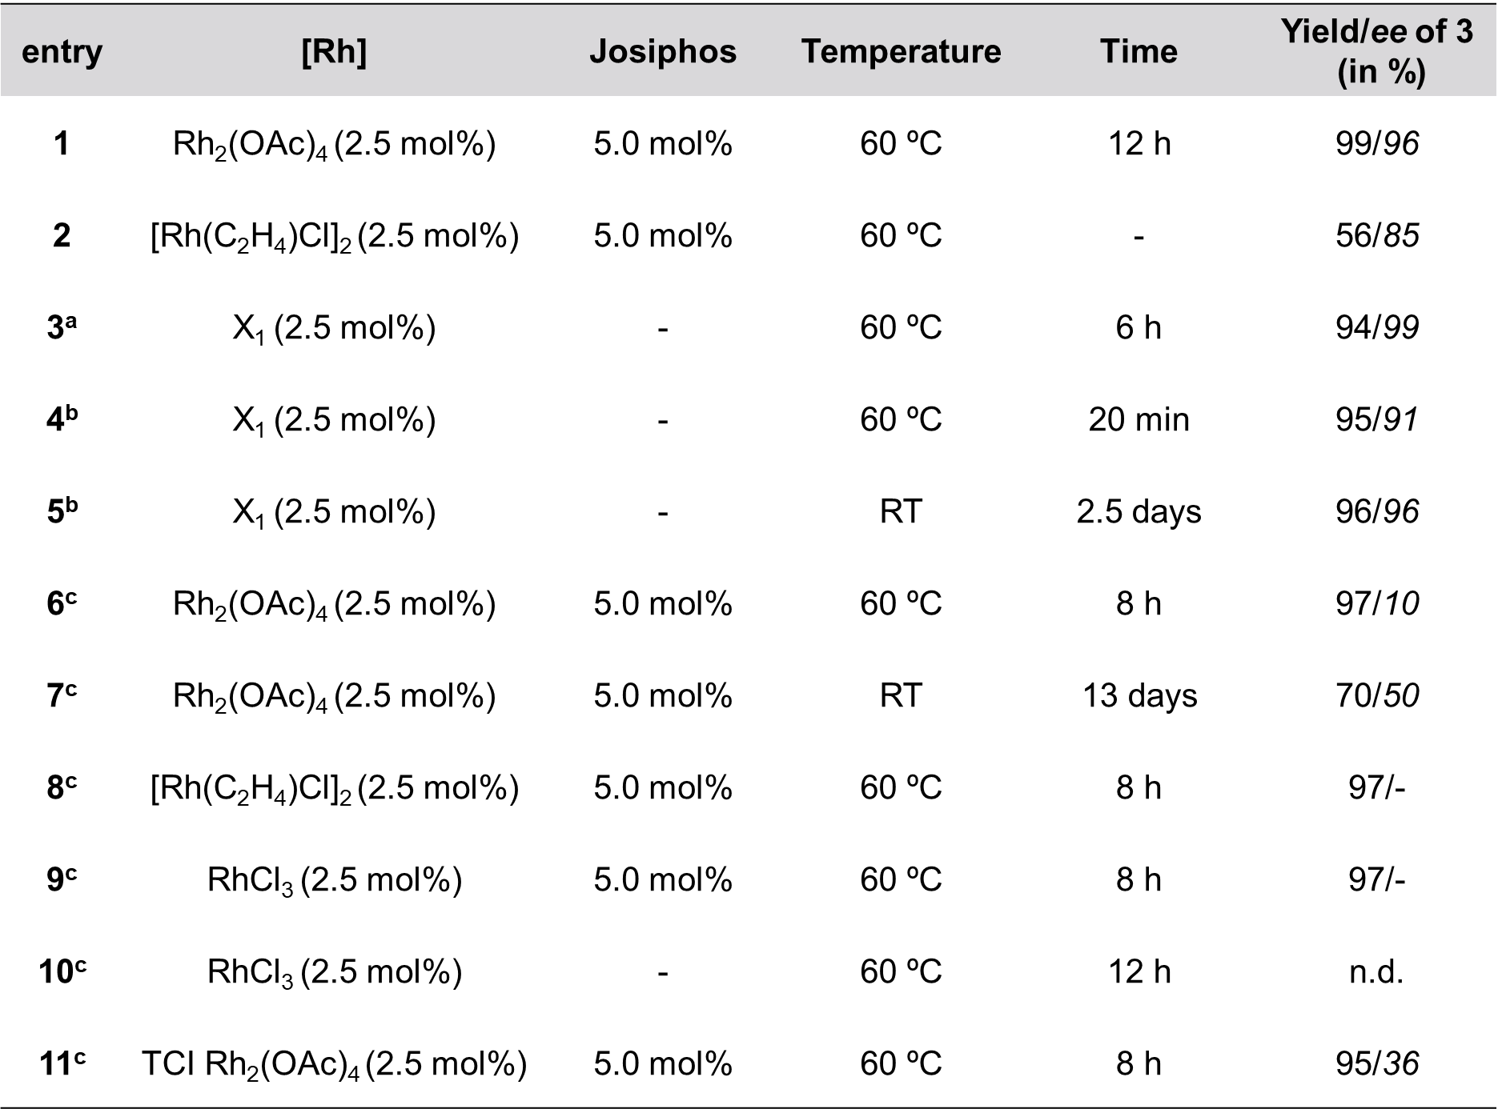
Entries 1& 2 were taken from Gu’ s work²⁸ where 1 is 1a. ªConditions: 1a (0.4 mmol), 2 (1.0 mmol), K₂CO₃ (0.40 mmol), Toluene (3.0 mL) and H₂O (0.3mL). ^{b}Conditions: 1b (R = H, 0.1 mmol), 2 (0.9 mmol), K₂CO₃ (0.1 mmol), Toluene (0.8 mL), H₂O (80 µL). ^{c}Conditions: 1b (0.3 mmol), 2 (0.75 mmol), K₂CO₃ (0.3 mmol), Toluene (2.0 mL), H₂O (0.2 mL). n.d. (not detected).
9.1. With substrate 1a
An oven-dried 5.0 mL Schlenk tube equipped with a magnetic stir bar was charged with 1a (94.5 mg, 0.40 mmol, 1.0 equiv), phenylboronic acid (122.0 mg, 1.0 mmol, 2.5 equiv), X₁ (9.2 mg, 2.5 mol%) and K₂CO₃ (55.3 mg, 0.40 mmol, 1.0 equiv) in toluene (3.0 mL) and deionized water (0.3 mL) was heated at 60 °C for 6 h. After being cooled to room temperature, the solvent was evaporated under reduced pressure. The crude product was purified by flash column chromatography on silica gel (Hexane/EtOAc = 100:10) to afford 3a (118.5 mg, 94 %, 99 % ee).
¹H NMR (400 MHz, CDCl₃): δ 7.65 (d,1H), 7.47-7.37(m,4H), 7.21- 7.17(m,1H), 7.11(m,5H), 4.81(s,1H), 2.34(s,3H), 2.30(s,3H). ¹³C NMR (101 MHz, CDCl₃): δ 201.56, 141.38, 137.08, 136.45, 136.04, 135.99, 135.39, 132.28, 131.30, 130.80, 128.39, 128.17, 127.97, 127.58, 126.48, 124.17, 124.12, 81.22, 20.62, 20.34. HRMS (ESI): calcd for C₂₂H₁₈O₂Na [M+Na]⁺ 337.1204, found 337.1206.

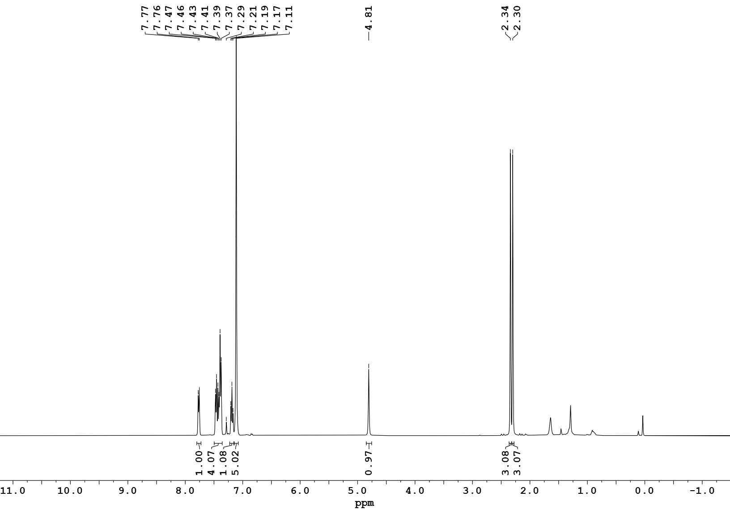

Figure S21. ¹H NMR of 3a

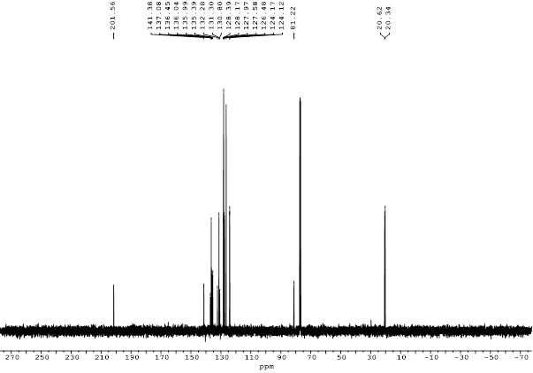
Figure S21. ¹³C NMR of 3a

< Chromatogram>
CHIRALPAK IA,10 % IPA-Hexane, 1 mL/min, 254 nm
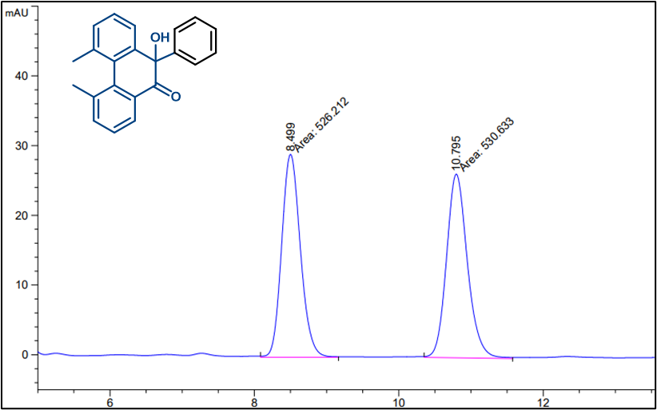
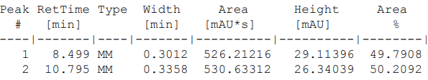
< Chromatogram>
CHIRALPAK IA,10% IPA-Hexane, 1 mL/min, 254 nm
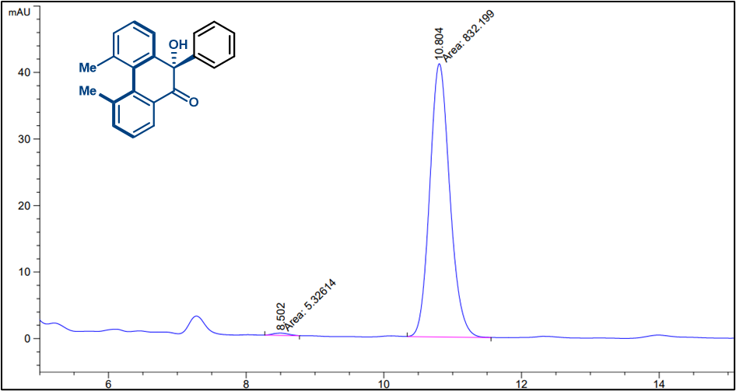
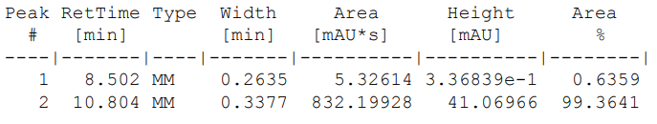

9.2. With substrate 1b
An oven-dried 5 mL Schlenk tube equipped with a magnetic stir bar was charged with 1a (20.8 mg, 0.10 mmol, 1.0 equiv), phenylboronic acid (30.5 mg, 0.25 mmol, 2.5 equiv), X₁ (2.3 mg, 2.5 mol%) and K₂CO₃ (13.8 mg, 0.10 mmol, 1.0 equiv) in toluene (0.8 mL) and deionized water (80 µL) was heated at 60 °C for 8 h. After being cooled to room temperature, the solvent was evaporated under reduced pressure. The crude product was purified by flash column chromatography on silica gel (Hexane/EtOAc = 100:10) to afford 3b (27.2 mg, 95 %, 91 % ee).
The same reaction was carried out using 2.5 mol% TCI dirhodium(II) together with 5.0 mol % of Josiphos ligand to examine the effect of dirhodium(II) purchased from different commercial sources on reactivity and enantioselectivity (Table S1, entry 11). The product, 3b, was obtained in 95% yield with 36.4% ee. Notably, similarly low enantioselectivities were observed irrespective of whether BLD or TCI dirhodium(II) was employed as the catalyst precursor.
¹H NMR (400 MHz, CDCl₃) δ 7.97 (dd, J = 11.6, 7.8 Hz, 2H), 7.83 (ddd, J = 16.8, 7.7, 1.7 Hz, 2H), 7.67 (td, J = 7.8, 1.6 Hz, 1H), 7.57 – 7.42 (m, 2H), 7.36 (t, J = 7.5 Hz, 1H), 7.19 (s, 4H), 4.93 (s, 1H). ¹³C NMR (101 MHz, CDCl₃) δ 201.38, 141.43, 139.53, 137.80, 135.20, 130.22, 129.69, 128.76, 128.51, 128.42, 128.12, 128.03, 127.83, 126.16, 123.81, 123.19, 80.38. HRMS (ESI): calcd for C₂₀H₁₄O₂Na [M+Na]⁺ 309.0982, found 309.0894.

¹H NMR
Figure S22. ¹H NMR of 3b

¹³C NMR
Figure S22. ¹³C NMR of 3b

< Chromatogram>
CHIRAL PAK AD-H ,10% IPA-Hexane, 1 mL/min, 254 nm
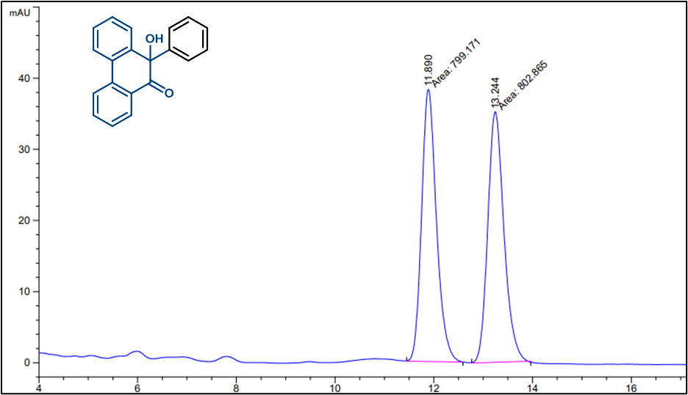
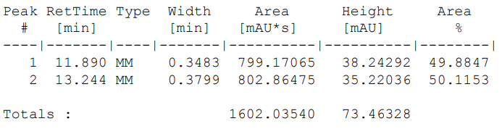
< Chromatogram>
CHIRAL PAK AD-H ,10% IPA-Hexane, 1 mL/min, 254 nm
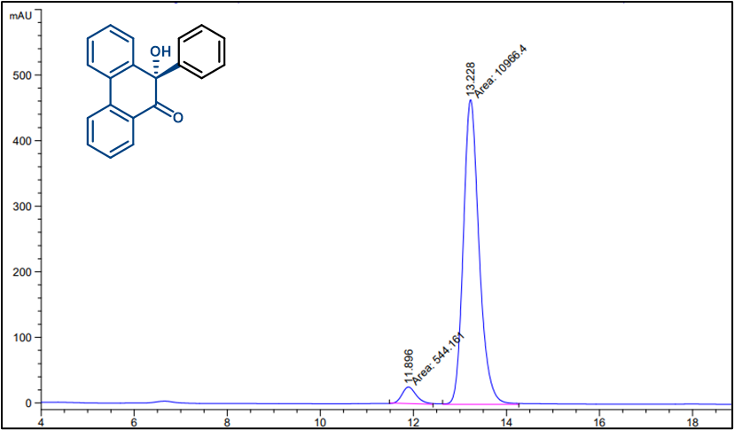
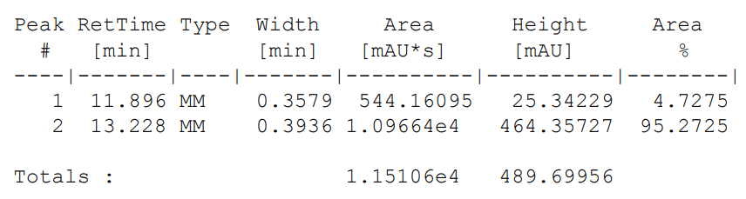
Other reactions mentioned in table S1 follow the same procedure as mentioned above in Section 9.1 & 9.2.

10. ESI-HRMS data of X₁ and X₂ Complex

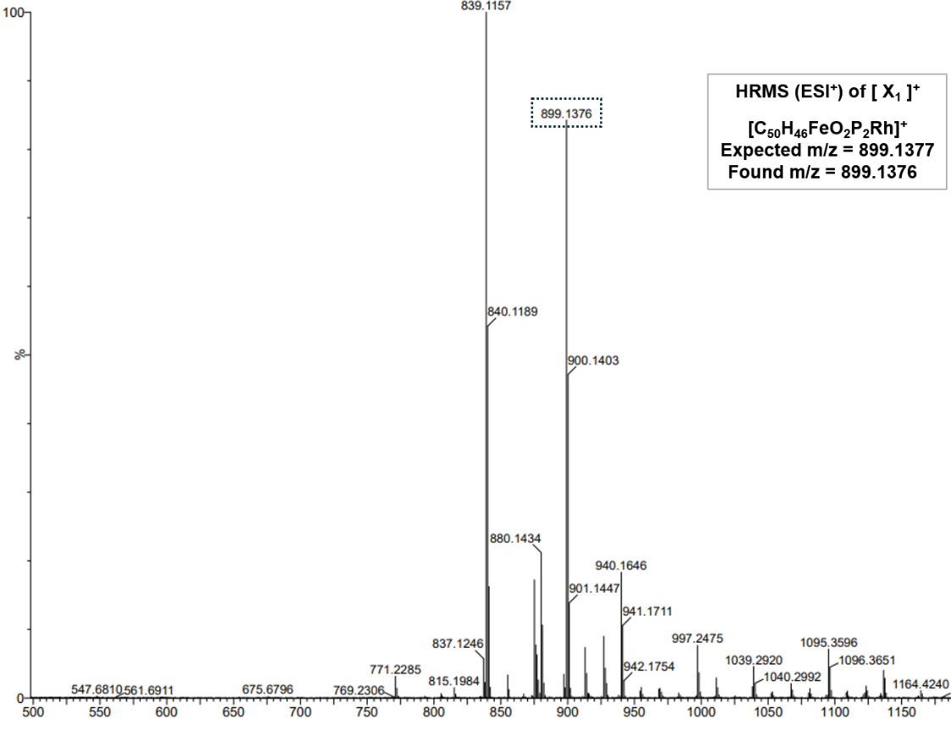
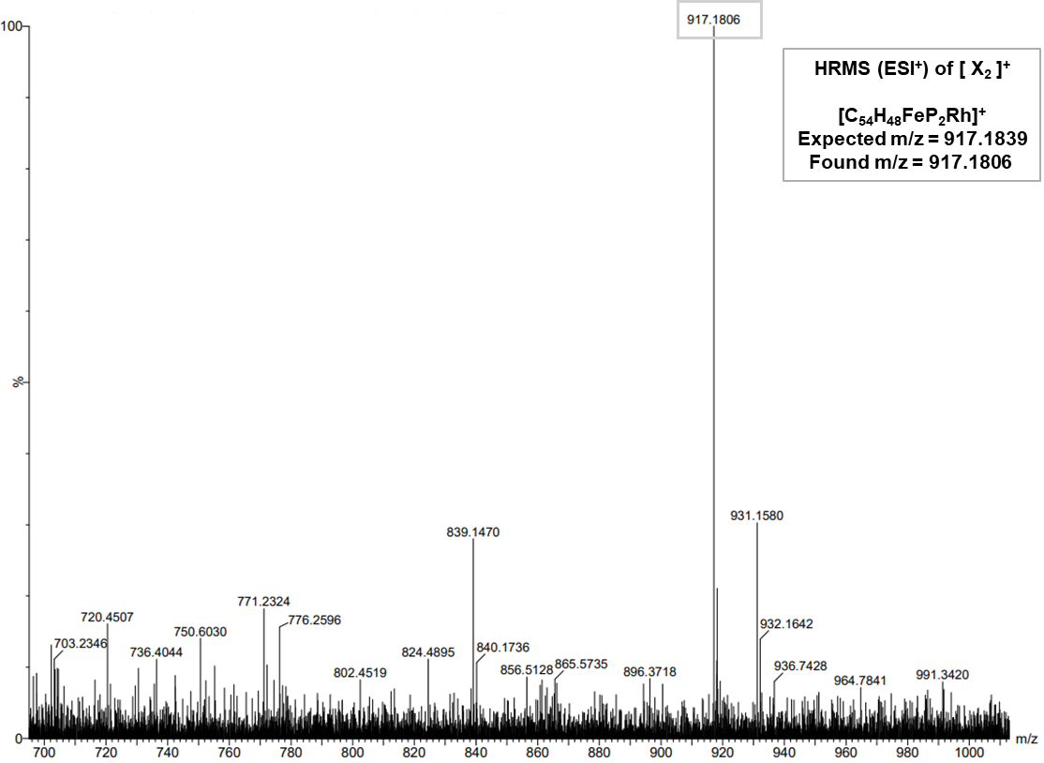

11. Prior reported Dirhodium/phosphine complexes with their ³¹P chemical shift values
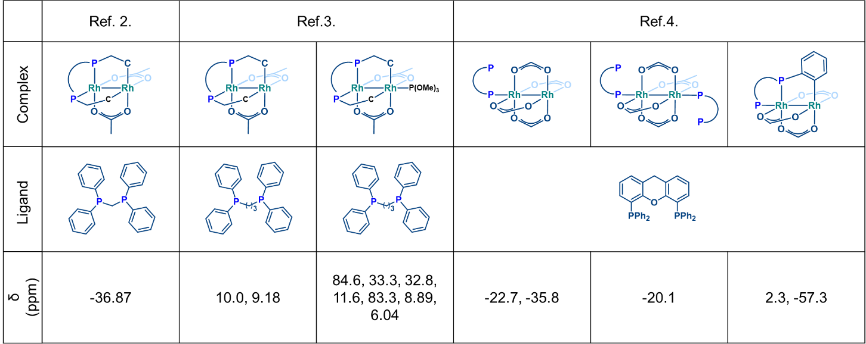
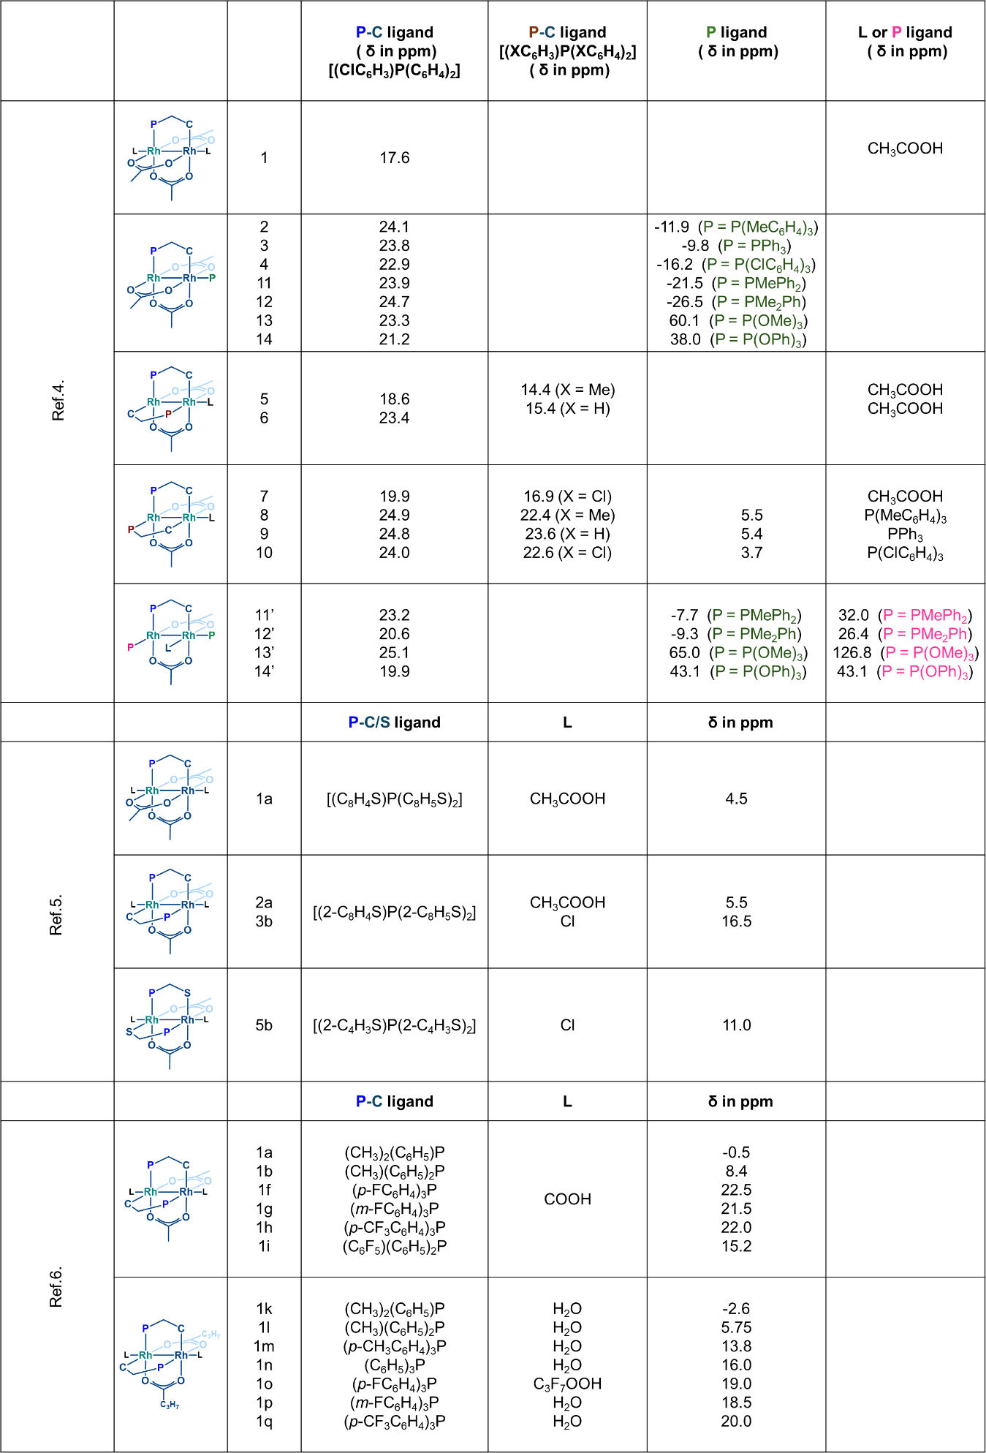

12. X-ray Crystallography data of X₁
Table S2: Crystallographic parameters for X₁ at 150 K
Complex | X₁
CCDC No | 2535072
Temperature, K | 150
Empirical Formula | C₅₇H₅₄ClFeO₂P₂Rh
Formula weight (g. mol⁻¹) | 1027.15
Crystal system | Monoclinic
Space group | P 2₁ (4)
Color and shape | Brownish red block
Wavelength | 0.71073 Å
a, Å | 9.569 (14)
b, Å | 19.01 (3)
c, Å | 13.374 (19)
α, º | 90
β, º | 105.94 (2)
γ, º | 90
V, $Å^{3}$ | 2340 (6)
Z | 2
d_{cal,} g cm⁻³ | 1.458
μ, mm⁻¹ | 0.832
F(000) | 1060
θ max | 24.499
Completeness, % | 99.4
Reflections collected | 7744
unique reflections | 4038
GOF on F² | 0.982
No. of Parameters | 585
R₁[I>2s(I)] | 9.71
wR₂[I>2s(I)] | 25.50
R₁ = Σ⃓⃓Fo⃓-⃓Fc⃓⃓/Σ⃓Fo⃓ and wR₂ = ⃓Σw(⃓Fo⃓²-⃓Fc⃓²)⃓/Σ⃓w(Fo)²⃓^{1/2}

Table S3: Selected bond distances for X₁ at 150 K
Bond | X₁
Rh1-Cl1 | 2.353 (7)
Rh1-P1 | 2.209 (7)
Rh1-P2 | 2.272 (7)
Rh1-O2 | 2.234 (16)
Rh1-O1 | 2.177 (17)
Rh1-C17 | 1.97 (2)
Rh1-C37 | 2.51 (2)
Fe1-C47 | 2.03 (3)
Fe1-C41 | 2.01 (3)
Fe1-C40 | 2.03 (3)
Fe1-C42 | 2.04 (3)
Fe1-C49 | 2.04 (3)
Fe1-C44 | 2.06 (2)
Fe1-C43 | 2.04 (2)
Fe1-C48 | 2.06 (3)
Fe1-C50 | 2.03 (3)
Fe1-C46 | 2.03 (3)

Table S4: CShM³ parameters for X₁ at 150 K.⁸⁻¹⁰
 | C.N. No. | HP | PPY | OC | TPR | JPPY
Rh1 | 6 | 25.996 | 23.183 | 2.667 | 16.020 | 25.375

HP: Hexagon
PPY: Pentagonal pyramid
OC: Octahedron
TPR: Trigonal prism
JPPY: Johnson pentagonal pyramid J2

 | C. N. No. | DP | EPY | OBPY | PPR | PAPR | JBCCU | JBCSAPR | JMBIC | JATDI | JSPC
Fe1 | 10 | 32.554 | 28.160 | 22.636 | 18.119 | 19.787 | 22.519 | 22.100 | 19.314 | 20.605 | 19.993

DP: Decagon
EPY: Enneagonal pyramid
OBPY: Octagonal bipyamid
PPR: Pentagonal prism
PAPR: Pentagonal antiprism
JBCCU: Bicapped cube J15
JBCSAPR: Bicapped square antiprism J17
JMBIC: Metabidiminished icosahedron J62
JATDI: Augmented tridiminished icosahedron J64
JSPC: Sphenocorona J87
Computational Studies
13. Computational details
All calculations were performed using the DFT method implemented in Gaussian 16 software.¹¹ Geometries of transition states and intermediates were optimized with the hybrid functional B3LYP with Grimme’s dispersion GD3BJ, using the standard split-valence Pople basis set 6-31G(d,p) for all atoms except Rh and Fe.^{12,15,16} For Rh and Fe, the SDD basis set was used with an effective core potential (ECP).^{13,17}To ensure that each optimized geometry is either an energy minimum (with no imaginary frequencies) or a transition state (with only one imaginary frequency), frequency analyses were conducted at the same level of theory for all stationary points. IRC (Intrinsic Reaction Coordinate) calculations were performed to connect the TS to its corresponding minima.^{14,18} Single-point calculations were performed on the optimized structures using the triple-zeta basis set 6-311++G(d,p) for all atoms except Rh and Fe, for which SDD was used. All these single-point calculations were carried out using the B3LYP functional with Grimme’s dispersion GD3BJ, employing the SMD (Solvation Model Density) solvation model to simulate the solvation effects of toluene and water.¹⁹ The SMD model was parameterized using a weighted average of the dielectric constants of toluene and water (v/v = 10:1, ε = 9.2) from the Minnesota solvent descriptor database.²⁰ The thermal corrections obtained from the geometry optimizations were added to the single-point electronic energies to give the thermochemical values (in this case, the free energies). Single-point calculations for key TSs and intermediates were also performed with different functionals and basis sets to check whether the trend is the same. The high-level ab initio DLPNO-CCSD(T) (domain-based local pair natural orbital coupled cluster method with single, double, and perturbative triple excitations) calculations were carried out for the stereodetermining TSs using the ORCA 5.0.4 software.²¹ Distortion and interaction (activation strain) analysis was performed by computing the energies at the PCM_{(solvent)}/DLPNO-CCSD(T)/def2-TZVP//B3LYP-D3(BJ)/6-31G(d,p),SDD(Rh, Fe) level of theory.^{22,23} The PCM model was parameterized using a weighted average of the dielectric constants and refractive index of toluene and water (v/v = 10:1, ε = 9.2, n =1.47 ). Additional Single points were carried out at M06 and PBE1PBE functionals.²⁴⁻²⁷ QTAIM (Quantum Theory of Atoms in Molecules) analyses were performed on the diastereomeric transition states using AIMAII (version 19.10.12) to visualize bonding paths and identify bond critical points.²⁸ CYLView was used to illustrate the optimized structures.²⁹
14. Probable Catalytic Dirhodium (II) Active Species
All possible coordination modes of the ligand to identify the most stable species were considered. Our results showed that Type II complexes were energetically more stable than complexes featuring monocoordination of the ligand at the dirhodium (II) core. Among the Type II complexes, A₉, in which one of the bridging carboxylate ligands dissociates resulting in a κ¹ fashion coordination, with a base occupying the axial position is stabilized by 48.5 kcal mol⁻¹ relative to A₁ as shown in Figure S1. Since diaxial coordination blocks the reactive site, A₉ is most likely the resting state of the catalyst. The catalytic cycle progresses by dissociation of one of the ligands upon substrate coordination.

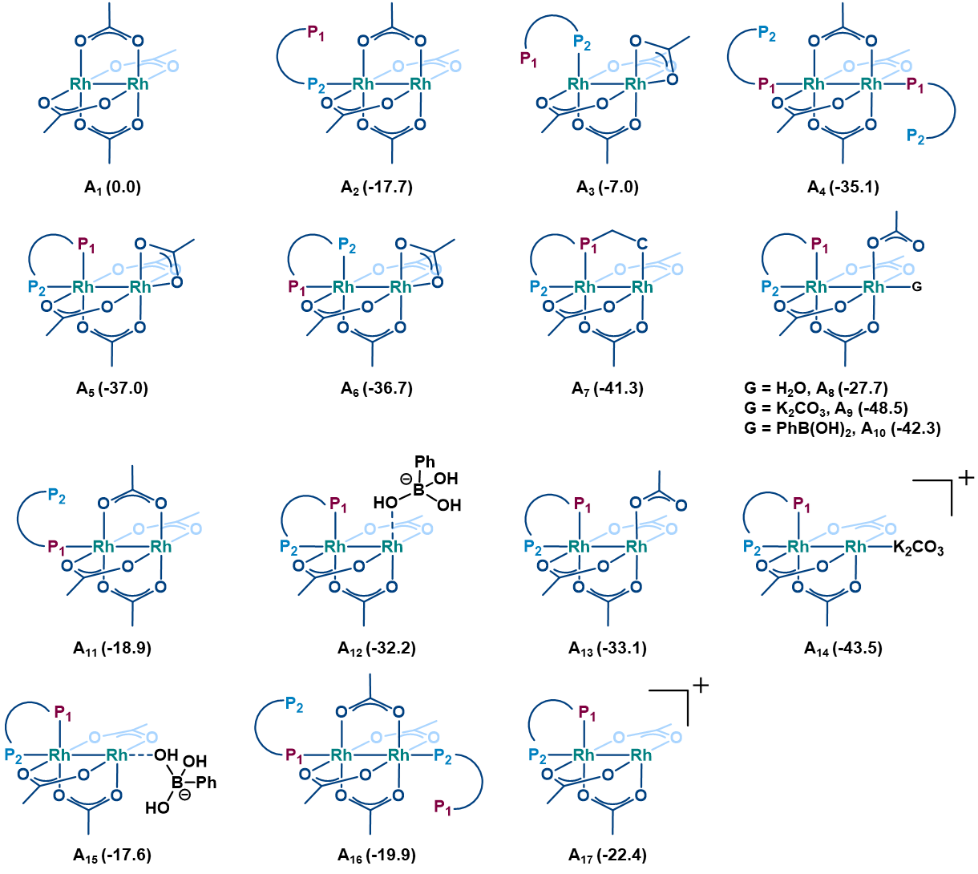
Figure S23. Possible catalytic active species. The relative free energies (kcal mol⁻¹) are given at the SMD_{(toluene:water)}/B3LYP-D3(BJ)/6-311++G(d,p),SDD(Rh,Fe)//B3LYP-D3(BJ)/6-31G(d,p),SDD(Rh, Fe) level of theory with relative to A₁.
15. Additional DFT calculations
To identify the most stable transmetalated intermediate, all possible structures were evaluated. Among them, intermediate E with only the substrate coordinated to the metal center (without any additional ligand coordination) was found to be the most stable, with a relative free energy of −27.2 kcal mol⁻¹ with respect to complex B.
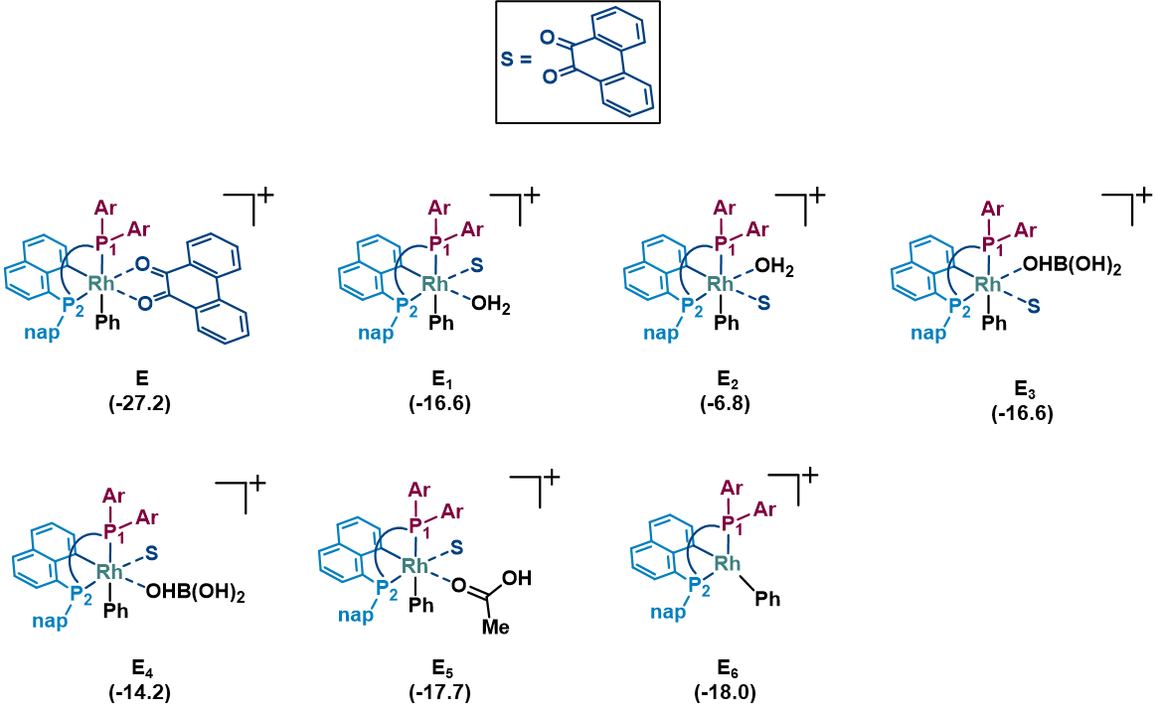
Figure S24. Possible transmetalated complex. The relative free energies (kcal mol⁻¹) are given at the SMD_{(toluene:water)}/B3LYP-D3(BJ)/6-311++G(d,p),SDD(Rh,Fe)//B3LYP-D3(BJ)/6-31G(d,p),SDD(Rh, Fe) level of theory with relative to B.
Alternative transition states were also located and evaluated computationally. All of them were found to be higher in energy than TS(E-F_{S}). The located transition states are summarized as follows:
TS(E-G_{S}): water and substrate coordination to Rh center
TS(E-H_{S}): boronic acid and substrate coordinated to Rh center
TS(E-I_{S}): only substrate is coordinated through H-bonding interactions with boronic acid
TS(E-G_{S}): acetic acid and substrate coordinated to Rh center
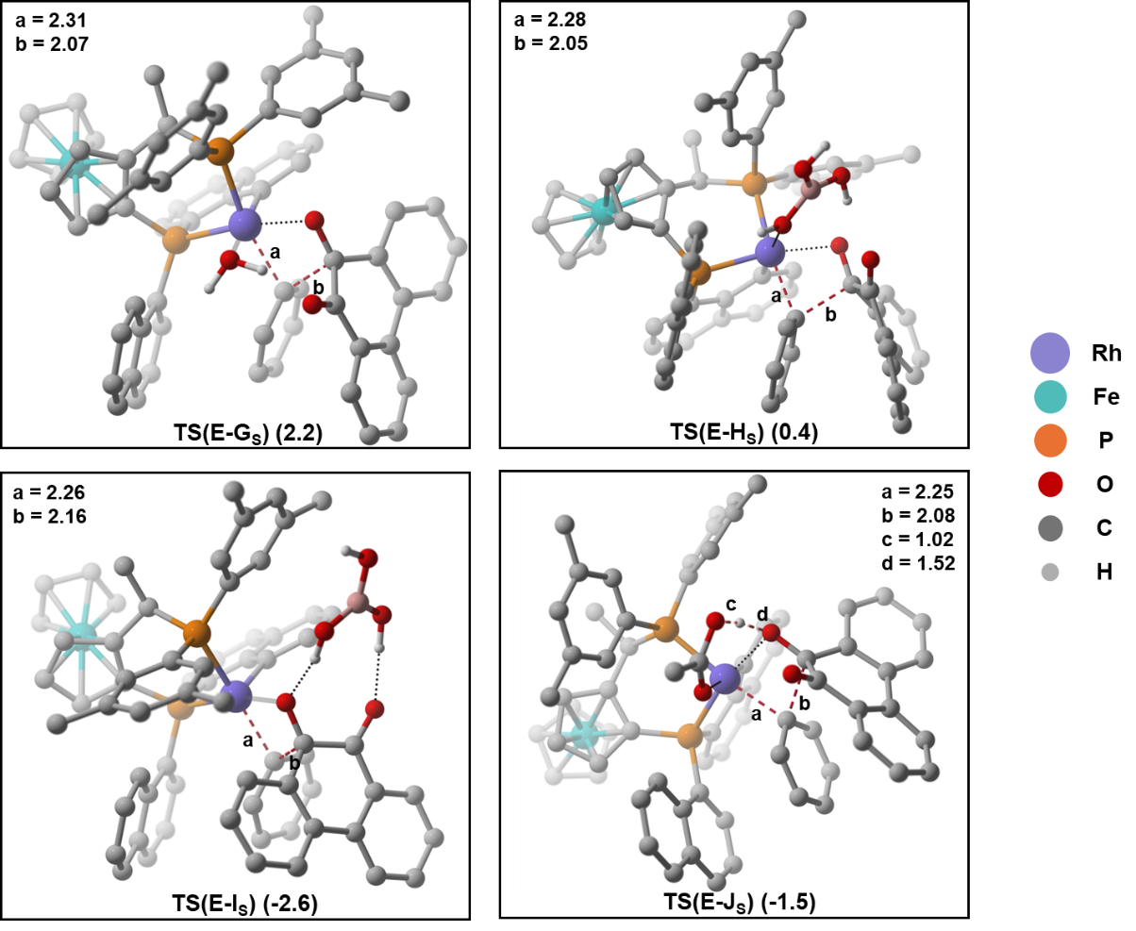
Figure S25. Competing Transition-State Pathways for Formation of the Major S Enantiomeric Product. Hydrogen atoms are omitted in the CYL view images for clarity, except those of the boronic acid and acetic acid. The relative free energies (kcal mol⁻¹) are given at the SMD_{(toluene: water)}/B3LYP-D3(BJ)/6-311++G(d,p),SDD(Rh,Fe)//B3LYP-D3(BJ)/6-31G(d,p),SDD(Rh,Fe) level of theory with relative to B.

16. Conformational sampling of diastereomeric TSs: TS(E-F_{S}) and TS(E-F_{R})
Due to the rigid structure of the X₁ complex, fewer conformations are possible; therefore, manual conformational sampling was performed to identify the most stable diastereomeric transition state for both TS, as listed below.
Table S5. Total electronic energies (a.u.) and relative free energies (kcal mol⁻¹) computed at the SMD_{(toluene: water)}/B3LYP-D3(BJ)/6-311++G(d,p),SDD(Rh,Fe)//B3LYP-D3(BJ)/6-31G(d,p), SDD (Rh, Fe) level of theory. Gibbs free energies are reported relative to B.

Conformers | ∆E (a.u.) | ∆G (kcal/mol) | Conformers | ∆E (a.u.) | ∆G (kcal/mol)
TS(E-F_{S}) | -3693.778532 | -6.2 | TS(E-F_{R}) | -3693.77497 | -5.8
TS(E-F_{S})-1 | -3693.774779 | -3.9 | TS(E-F_{R})-1 | -3693.82789 | -1.8
TS(E-F_{S})-2 | -3693.769505 | -2.0 | TS(E-F_{R})-2 | -3693.77034 | -1.2
 |  |  | TS(E-F_{R})-3 | -3693.76589 | -0.7

17. Activation Strain Analysis (ASA)
To understand the origin of enantioselectivity, we performed ASA using a fragmentation-based approach. To quantify the distortion and interaction energies, the transition state was dissected into two fragments: phenanthrene-9,10-dione and the Rh complex. These fragments were then subjected to single-point calculations. The interaction energy was computed as the difference between the total electronic energy of the transition state and the sum of the electronic energies of its fragments. The distortion energy differences were obtained by comparing the fragment energies between the two diastereomeric transition states. As given in Table S7, ASA reveals that the interaction energy in TS(E-F_{S}) is 8.5 kcal mol⁻¹ greater than in TS(E-F_{R}) (Table S7). Although TS(E-F_{S}) exhibits a 2.3 kcal mol⁻¹ greater distortion energy compared to TS(E-F_{R}), the stronger interaction between the fragments in TS(E-F_{S}) compensates for this distortion, resulting in the major product (S enantiomer).
The interaction energies were calculated using the following expressions:
∆E_{int} in TS(E-F_{S}) = E₁ – (E₁₋₁ + E₁₋₂)
∆E_{int} in TS(E-F_{R}) = E₂ – (E₂₋₁ + E₂₋₂)
Here, E₁ and E₂ are the electronic energies of TS(E-F_{S}) and TS(E-F_{R}), and E₁₋₁, E₁₋₂, E₂₋₁, and E₂₋₂ represent the energies of the phenanthrene-9,10-dione and Rh complex fragments from their corresponding transition states.
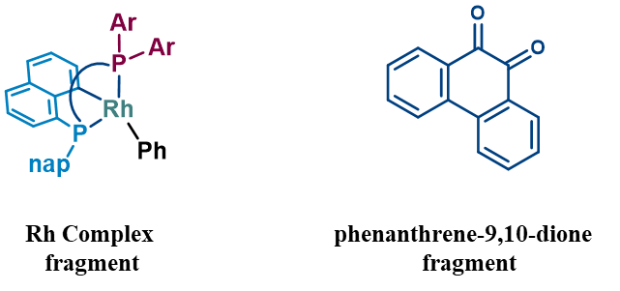
Table S6. Total electronic energy (∆E) in a.u. of both diastereomeric TSs and their fragments at the PCM_{(toluene: water)}/DLPNO-CCSD(T)/def2-TZVP//B3LYP-D3(BJ)/6-31G(d,p),SDD(Rh, Fe) level of theory.
TS(E-F_{S}) (1) |  | TS(E-F_{R}) (2)
-4825.1389 |  | -4825.1292
phenanthrene-9,10-dione (1-1) | Rh complex (1-2) | phenanthrene-9,10-dione (2-1) | Rh complex (2-2)
-687.5256 | -4137.5156 | -687.5264 | -4137.5185

Table S7.
TSs | Distortion Energy  (kcal mol⁻¹) |  | Interaction Energy  (kcal mol⁻¹)
 | phenanthrene-9,10-dione | Rh complex
TS(E-F_{S}) | 0.5 | 1.8 | -61.2
TS(E-F_{R}) | 0.0 | 0.0 | -52.7

Table S8. Approximate strength of important noncovalent interactions in the lowest energy TSs TS(E-F_{S}) and TS(E-F_{R})
TS(E-F_{S})
NCIs | ρ | ∆²ρ | G | V=1/4∆²ρ-2G | E=1/2(V)  (kcal/mol)
1 | 0.00767 | 0.02987 | 0.00614 | -0.00481 | -1.5
2 | 0.01222 | 0.04678 | 0.01000 | -0.00830 | -5.2
3 | 0.01018 | 0.04237 | 0.00868 | -0.00678 | -4.3
4 | 0.00961 | 0.03653 | 0.00764 | -0.00616 | -3.9

TS(E-F_{R})
NCIs | Ρ | ∆²ρ | G | V=1/4∆²ρ-2G | E=1/2(V)  (kcal/mol)
1 | 0.00956 | 0.03156 | 0.00677 | -0.00565 | -3.5
2 | 0.01019 | 0.03796 | 0.00817 | -0.00685 | -4.3
3 | 0.01027 | 0.04037 | 0.00839 | -0.00669 | -4.2

18. Benchmarks Studies
BS1 = B3LYP-D3(BJ)/6-31G(d,p), SDD (Rh, Fe)
BS2 = B3LYP-D3(BJ)/6-311++G(d,p), SDD (Rh, Fe) (given in table S8)
BS3 = M06-D3/def-2TZVP
BS4 = M06-D3/6-311++G(d,p), SDD (Rh, Fe)
BS5 = PBE1PBE/def-2TZVP
BS6 = PBE1PBE/6-311++G(d,p), SDD (Rh, Fe)
BS7 = DLPNO-CCSD(T)/def2-TZVP (used only for diastereomeric TSs)
Table S9. Total electronic energies (∆E) in a.u. of the key stationary points at the different level of theories.
 | SMD_{(Toluene: water)}  /BS3//BS1 | SMD_{(Toluene: water)}  /BS4//BS1 | SMD_{(Toluene: water)}  /BS5//BS1 | SMD_{(Toluene: water)}  /BS6//BS1 | PCM_{(Toluene: water)}  /BS7//BS1
B | -4139.6481 | -2999.6163 | -4138.4730 | -2998.5572 | -4135.5511
C | -4395.1768 | -3255.1270 | -4393.8865 | -3253.9506 | -4389.7208
TS(C-D) | -4395.1698 | -3255.1198 | -4393.8794 | -3253.9432 | -4389.7149
D | -4395.2128 | -3255.1623 | -4393.9198 | -3253.9829 | -4389.7513
E | -4831.2730 | -3691.1722 | -4829.8410 | -3689.8574 | -4825.1672
TS(E-F_{S}) | -4831.2388 | -3691.1376 | -4829.8102 | -3689.8260 | -4825.1389
F_{S} | -4831.2764 | -3691.1751 | -4829.8501 | -3689.8657 | -4825.1792
PhB(OH)₃ ̶ | -484.1097 | -484.0668 | -483.8696 | -483.8222 | -483.444
Substrate | -688.5357 | -688.4586 | -688.2384 | -688.1619 | -687.5468
CH₃COO ̶ | -228.5682 | -228.5502 | -228.4434 | -228.4239 | -228.2714
PhB(OH)₂ | -252.4912 | -252.4660 | -252.3350 | -252.3061 | -252.1601

Table S10. Relative free energies (∆G) in kcal/mol (a.u.) of the key stationary points at the different level of theories.
 | SMD_{(Toluene: water)}  /BS3//BS1 | SMD_{(Toluene: water)}  /BS4//BS1 | SMD_{(Toluene: water)}  /BS5//BS1 | SMD_{(Toluene: water)}  /BS6//BS1 | PCM_{(Toluene: water)}  /BS7//BS1
B | 0.0 | 0.0 | 0.0 | 0.0 | 0.0
C | 11.4 | 7.1 | 11.4 | 6.5 | 5.1
TS(C-D) | 16.0 | 11.7 | 16.0 | 11.3 | 9.0
D | -11.3 | -15.2 | -9.7 | -13.8 | -14.1
E | -17.8 | -22.7 | -17.4 | -22.2 | -29.1
`TS(E-F_{S}) | 3.4 | -1.2 | 1.7 | -2.7 | -11.5
F_{S} | -18.4 | -23.0 | -21.6 | -26.0 | -35.1

19. Electronic Energies of all the Stationary Points
Table S11. Toal Electronic energies (∆E) of all stationary points at SMD_{(toluene: water)}/B3LYP-D3(BJ)/6-311++G(d,p),SDD(Rh, Fe)//B3LYP-D3(BJ)/6-31G(d,p),SDD(Rh, Fe) level of theory.

species | ∆E (a.u.)
L(Josiphos) | -2663.089366
K₂CO₃ | -1463.93074287
PhB(OH)₂ | -252.5933451
PhB(OH)₃ ̶ | -484.4111989
H₂O | -76.4648446958
CH₃COO ̶ | -228.690380401
CH₃COOH | -229.1785734
A₁ | -1135.63794535
A₂ | -3798.78386736
A₃ | -3798.76481818
A₄ | -6461.92931081
A₅ | -3798.81496323
A₆ | -3798.81466642
A₇ | -3569.62339398
A₈ | -3875.28784288
A₉ | -5262.78974703
A₁₀ | -4207.27930130
A₁₁ | -3798.78571379
A₁₂ | -4054.53443953
A₁₃ | -3798.81335220
A₁₄ | -5034.06763012
A₁₅ | -4054.51097102
A₁₆ | -6461.90232128
A₁₇ | -3570.07938902
B | -3001.623644
C | -3257.345097
C’ | -3410.083138
C’’ | -3410.062128
D | -3257.378073
D’ | -3410.083018
D’’ | -3410.07495
E | -3693.81236361
E₁ | -3770.28169287
E₂ | -3770.26366828
E₃ | -3946.414594
E₄ | -3946.405943
E₅ | -3922.99858018
E₆ | -3004.755997
TS(C-D) | -3257.335797
TS(C’-D’) | -3410.060229
TS(C’’-D’’) | -3410.044684
TS(E-G_{S}) | -3770.25296
TS(E-H_{S}) | -3946.3889
TS(E-I_{S}) | -3946.39081
TS(E-J_{S}) | -3922.97652
TS(E-F_{S}) | -3693.778532
F_{S} | -3693.8157

20. References
- Shi, L.; Xue, X.; Hong, B.; Li, Q.; Gu, Z. Dirhodium(II)/Phosphine Catalyst with Chiral Environment at Bridging Site and Its Application in Enantioselective Atropisomer Synthesis. ACS Cent. Sci. 2023, 9 (4), 748–755.
- Yang, L.; Wu, X.; Lu, W.; Lu, Y.; Zhang, Z. Dirhodium(II)/DPPM Catalyzed 1,2-Hydrosilylation of Conjugated Dienes with Tertiary Silanes. Org. Lett. 2024, 26 (11), 2287–2291.
- Lu, W. K.; Zhu, X. Y.; Yang, L. Q.; Wu, X. Y.; Xie, X. M.; Zhang, Z. G. Distinct Catalytic Performance of Dirhodium(II) Complexes with ortho-Metalated DPPP in Dehydrosilylation of Styrene Derivatives with Alkoxysilanes. ACS Catal. 2021, 11, 10190– 10197.
- Lu, B.; Liang, X.; Zhang, J.; Wang, Z.; Peng, Q.; Wang, X. Dirhodium(II)/Xantphos-Catalyzed Relay Carbene Insertion and Allylic Alkylation Process: Reaction Development and Mechanistic Insights. J. Am. Chem. Soc. 2021, 143 (30), 11799–11810.
- Lahuerta, P.; Paya, J.; Solans, X.; Ubeda, M. A. Ortho-Metalation Reactions in Binuclear Dirhodium Compounds. Molecular Structure and Reactivity of a Monometalated Compound with the Phosphine P(o-ClC₆H₄)(C₆H₅)₂. Inorg. Chem. 1992, 31, 385–391.
- Lloret, J.; Estevan, F.; Lahuerta, P.; Hirva, P.; Pérez-Prieto, J.; Sanaú, M. Dirhodium(II) Compounds with Bridging Thienylphosphines: Studies on Reversible P,C/P,S Coordination Chem. - Eur. J. 2009, 15, 7706– 7716.
- Estevan, F.; Lahuerta, P.; Pérez-Prieto, J.; Sanaú, M.; Stiriba, S.-E.; Ubeda, M. A. Ligand Effects on the Chemoselectivity of Ortho-Metalated Rhodium(II) Catalyzed α-Diazo Ketone Transformations. Organometallics 1997, 16, 880–886.
- Sheldrick, G., SHELXT - Integrated space-group and crystal-structure determination. Acta Crystallographica Section A 2015, 71, 3-8.
- Sheldrick, G., Crystal structure refinement with SHELXL. Acta Crystallographica Section C 2015, 71, 3-8.
- Llunell, M.; Casanova, D.; Cirera, J.; Alemany, P.; Alvarez, S. J. U. d. B., Barcelona, Spain, SHAPE, version 2.1. 2013, 2103.
- Gaussian 16, Revision C.01, Frisch, M. J.; Trucks, G. W.; Schle-gel, H. B.; Scuseria, G. E.; Robb, M. A.; Cheeseman, J. R.; Scal-mani, G.; Barone, V.; Petersson, G. A.; Nakatsuji, H.; Li, X.; Caricato, M.; Marenich, A. V.; Bloino, J.; Janesko, B. G.; Gom-perts, R.; Mennucci, B.; Hratchian, H. P.; Ortiz, J. V.; Izmaylov, A. F.; Sonnenberg, J. L.; Williams-Young, D.; Ding, F.; Lippa-rini, F.; Egidi, F.; Goings, J.; Peng, B.; Petrone, A.; Henderson, T.; Ranasinghe, D.; Zakrzewski, V. G.; Gao, J.; Rega, N.; Zheng, G.; Liang, W.; Hada, M.; Ehara, M.; Toyota, K.; Fukuda, R.; Ha-segawa, J.; Ishida, M.; Nakajima, T.; Honda, Y.; Kitao, O.; Nakai, H.; Vreven, T.; Throssell, K.; Montgomery, J. A., Jr.; Peralta, J. E.; Ogliaro, F.; Bearpark, M. J.; Heyd, J. J.; Brothers, E. N.; Kudin, K. N.; Staroverov, V. N.; Keith, T. A.; Kobayashi, R.; Normand, J.; Raghavachari, K.; Rendell, A. P.; Burant, J. C.; Iyengar, S. S.; Tomasi, J.; Cossi, M.; Millam, J. M.; Klene, M.; Adamo, C.; Cammi, R.; Ochterski, J. W.; Martin, R. L.; Morokuma, K.; Farkas, O.; Foresman, J. B.; Fox, D. J. Gaussian, Inc., Wallingford CT, 2016.
- Grimme, S.; Antony, J.; Ehrlich, S.; Krieg, H. A Consistent and Accurate Ab Initio Parametrization of Density Functional Dispersion Correction (DFT-D) for the 94 Elements H-Pu. J. Chem. Phys. 2010, 132, 154104.
- Becke, A. D. Density‐functional Thermochemistry. III. The Role of Exact Exchange. J. Chem. Phys. 1993, 98 (7), 5648–5652.
- Lee, C.; Yang, W.; Parr, R. G. Development of the Colle-Salvetti Correlation-Energy Formula into a Functional of the Electron Density. Phys. Rev. B 1988, 37, 785–789.
- Hay, P. J.; Wadt, W. R. Ab Initio Effective Core Potentials for Molecular Calculations. Potentials for K to Au Including the Outermost Core Orbitals. J. Chem. Phys. 1985, 82, 299–310.
- Dolg, M.; Wedig, U.; Stoll, H.; Preuss, H. Energy‐adjusted Ab Initio Pseudopotentials for the First Row Transition Elements. J. Chem. Phys. 1987, 86, 866–872.
- Gonzalez, C.; Schlegel, H. B. An Improved Algorithm for Reaction Path Following. J. Chem. Phys. 1989, 90, 2154–2161.
- Fukui, K. The Path of Chemical Reactions - the IRC Approach. Acc. Chem. Res. 1981, 14, 363–36.
- Marenich, A. V.; Cramer, C. J.; Truhlar, D. G. Universal Solvation Model Based on Solute Electron Density and on a Continuum Model of the Solvent Defined by the Bulk Dielectric Constant and Atomic Surface Tensions. J. Phys. Chem. B 2009, 113, 6378–639.
- P. Winget, D. M. Dolney, D. J. Giesen, C. J. Cramer, D. G. Truhlar. Minnesota Solvent Descriptor Database, version 2010. University of Minnesota: Minneapolis, MN.
- Riplinger, C.; Neese, F. An efficient and near linear scaling pair natural orbital based local coupled cluster method. J. Chem. Phys. 2013, 138, 034106.
- Weigend, F.; Ahlrichs, R. Balanced basis sets of split valence, triple zeta valence and quadruple zeta valence quality for H to Rn: Design and assessment of accuracy. Phys. Chem. Chem. Phys. 2005, 7, 3297– 3305.
- Tomasi, J.; Mennucci, B.; Cammi, R. Chem. Rev. 2005, 105, 2999-3094.
- Zhao, Y.; Truhlar, D. The M06 suite of density functionals for main group thermochemistry, thermochemical kinetics, noncovalent interactions, excited states, and transition elements: two new functionals and systematic testing of four M06-class functionals and 12 other functionals. Theor. Chem. Acc. 2008, 120, 215– 241.
- Perdew, J. P.; Burke, K.; Ernzerhof, M. Generalized Gradient Approximation Made Simple. Phys. Rev. Lett. 1996, 77, 3865– 3868.
- Perdew, J. P.; Burke, K.; Ernzerhof, M. Generalized Gradient Approximation Made Simple [Phys. Rev. Lett. 77, 3865 (1996)] Phys. Rev. Lett. 1997, 78, 1396– 1396.
- Adamo, C.; Barone, V. Toward reliable density functional methods without adjustable parameters: The PBE0 model J. Chem. Phys. 1999, 110, 6158– 6170.
- AIMAll (Version 19.10.12), Todd A. Keith, TK Gristmill Software, Overland Park KS, USA, 2019.
- Legault, C. Y. CYLview, 1.0b; Université de Sherbrooke: 2009.

21. Cartesian Coordinates of all Optimized Geometries
----------------------------------------------------------------------------------------------------------------
K₂CO₃
----------------------------------------------------------------------------------------------------------------
Number of imaginary frequencies: 0
Electronic energy: HF=-1463.7007749
Zero-point correction = 0.016688 (Hartree/Particle)
Thermal correction to Energy = 0.023368
Thermal correction to Enthalpy = 0.024312
Thermal correction to Gibbs Free Energy = -0.016326
Sum of electronic and zero-point Energies = -1463.684087
Sum of electronic and thermal Energies = -1463.677407
Sum of electronic and thermal Enthalpies = -1463.676463
Sum of electronic and thermal Free Energies = -1463.717101
......................................................................................................................................................
Cartesian Coordinates
......................................................................................................................................................
6 -0.000262 0.803567 0.000616
8 -0.000345 -0.548546 0.000895
8 1.127303 1.414502 0.018638
8 -1.127220 1.415234 -0.018979
19 2.475823 -0.607048 -0.003820
19 -2.475630 -0.607211 0.003392
----------------------------------------------------------------------------------------------------------------
CH₃COO ̶
----------------------------------------------------------------------------------------------------------------
Number of imaginary frequencies: 0
Electronic energy: HF = -228.5036264
Zero-point correction = 0.048100 (Hartree/Particle)
Thermal correction to Energy = 0.052589
Thermal correction to Enthalpy = 0.053534
Thermal correction to Gibbs Free Energy = 0.020120
Sum of electronic and zero-point Energies = -228.455526
Sum of electronic and thermal Energies = -228.451037
Sum of electronic and thermal Enthalpies = -228.450093
Sum of electronic and thermal Free Energies = -228.483507
......................................................................................................................................................
Cartesian Coordinates
......................................................................................................................................................
8 0.805088 -1.110289 -0.000167
6 0.220276 0.001713 0.000002
8 0.697686 1.165237 -0.000092
6 -1.353051 -0.053013 0.000025
1 -1.732288 -1.081680 -0.008864
1 -1.745951 0.466605 0.884928
1 -1.747302 0.483293 -0.874150
----------------------------------------------------------------------------------------------------------------
CH₃COOH
----------------------------------------------------------------------------------------------------------------
Number of imaginary frequencies: 0
Electronic energy: HF=-229.0944138
Zero-point correction = 0.062036 (Hartree/Particle)
Thermal correction to Energy = 0.066590
Thermal correction to Enthalpy = 0.067534
Thermal correction to Gibbs Free Energy = 0.034886
Sum of electronic and zero-point Energies = -229.032378
Sum of electronic and thermal Energies = -229.027824
Sum of electronic and thermal Enthalpies = -229.026879
Sum of electronic and thermal Free Energies = -229.059528
......................................................................................................................................................
Cartesian Coordinates
......................................................................................................................................................
6 -0.092302 0.125138 0.000007
6 1.396211 -0.109856 0.000011
1 1.914992 0.847599 -0.000166
1 1.681174 -0.691819 0.881246
1 1.681117 -0.691956 -0.881192
8 -0.644661 1.202007 0.000005
8 -0.778048 -1.046031 0.000008
1 -1.719074 -0.803329 -0.000099
----------------------------------------------------------------------------------------------------------------
PhB(OH)₂
----------------------------------------------------------------------------------------------------------------

Number of imaginary frequencies: 0
Electronic energy: HF = -252.4862696
Zero-point correction = 0.048655 (Hartree/Particle)
Thermal correction to Energy = 0.053236
Thermal correction to Enthalpy = 0.054181
Thermal correction to Gibbs Free Energy = 0.022039
Sum of electronic and zero-point Energies = -252.437614
Sum of electronic and thermal Energies = -252.433033
Sum of electronic and thermal Enthalpies = -252.432089
Sum of electronic and thermal Free Energies = -252.464230
......................................................................................................................................................
Cartesian Coordinates
......................................................................................................................................................
5 -0.008788 -0.032123 -0.000019
8 1.087026 -0.857775 -0.000109
1 1.932939 -0.401749 0.000610
8 -1.231143 -0.639078 0.000114
1 -1.937601 0.015773 -0.000924
8 0.035397 1.348931 0.000175
1 0.918359 1.729972 -0.001037
----------------------------------------------------------------------------------------------------------------
PhB(OH)₃ ̶
----------------------------------------------------------------------------------------------------------------
Number of imaginary frequencies: 0
Electronic energy: HF = -484.1650157
Zero-point correction = 0.136490 (Hartree/Particle)
Thermal correction to Energy = 0.146583
Thermal correction to Enthalpy = 0.147527
Thermal correction to Gibbs Free Energy = 0.100795
Sum of electronic and zero-point Energies = -484.028526
Sum of electronic and thermal Energies = -484.018432
Sum of electronic and thermal Enthalpies = -484.017488
Sum of electronic and thermal Free Energies = -484.064221
......................................................................................................................................................
Cartesian Coordinates
......................................................................................................................................................
5 1.574822 0.011879 -0.034644
6 -0.072462 0.009505 -0.068485
6 -0.832862 1.192582 -0.025133
6 -0.801705 -1.191867 -0.075019
6 -2.229749 1.184294 0.025180
1 -0.304388 2.144223 -0.049604
6 -2.197347 -1.222771 -0.025837
1 -0.236252 -2.119605 -0.137380
6 -2.923184 -0.029155 0.029280
1 -2.782979 2.123276 0.055350
1 -2.725693 -2.176435 -0.034656
1 -4.011392 -0.044350 0.066826
8 2.006316 1.160985 -0.848038
1 2.965180 1.064385 -0.901861
8 2.038268 0.107558 1.388633
8 2.144964 -1.253639 -0.540622
1 2.431672 -1.716115 0.254524
1 1.617207 0.890472 1.760324
----------------------------------------------------------------------------------------------------------------
L(Josiphos)
----------------------------------------------------------------------------------------------------------------
Number of imaginary frequencies: 0
Electronic energy: HF = -2662.5915546
Zero-point correction = 0.779029 (Hartree/Particle)
Thermal correction to Energy = 0.825641
Thermal correction to Enthalpy = 0.826585
Thermal correction to Gibbs Free Energy = 0.697667
Sum of electronic and zero-point Energies = -2661.812526
Sum of electronic and thermal Energies = -2661.765914
Sum of electronic and thermal Enthalpies = -2661.764969
Sum of electronic and thermal Free Energies = -2661.893888
......................................................................................................................................................
Cartesian Coordinates
......................................................................................................................................................
26 1.962136 2.743455 0.221125
6 2.401346 1.305215 -1.172380
6 2.206052 2.562887 -1.809599
6 0.880489 2.995567 -1.521827
6 0.235270 1.996923 -0.725991
6 1.186440 0.938242 -0.497377
15 0.888416 -0.774213 0.074035
6 2.559226 -1.197572 0.762699
6 2.891840 -1.004364 2.090453
6 4.185820 -1.297238 2.578466
6 5.154228 -1.781175 1.730862
6 4.858435 -2.025578 0.364981
6 5.839300 -2.540184 -0.524920
6 5.537908 -2.791344 -1.843105
6 4.230321 -2.548149 -2.326539
6 3.258241 -2.045753 -1.491657
6 3.538211 -1.753960 -0.127673
1 2.253155 -1.881423 -1.863505
1 3.989847 -2.764670 -3.362891
1 6.297237 -3.184599 -2.512286
1 6.836602 -2.735148 -0.139636
1 6.155475 -1.993986 2.095604
1 4.410621 -1.127215 3.627365
1 2.147379 -0.618489 2.777083
6 -0.117184 -0.672091 1.618133
6 -0.193209 0.465529 2.401177
6 -0.971643 0.504747 3.579841
6 -1.659778 -0.612430 3.990929
6 -1.624041 -1.804826 3.222179
6 -2.344611 -2.961009 3.623932
6 -2.339785 -4.100905 2.854451
6 -1.613113 -4.128733 1.640414
6 -0.894906 -3.028997 1.228629
6 -0.864577 -1.837013 2.004636
1 -0.358015 -3.050317 0.287393
1 -1.625401 -5.023800 1.026141
1 -2.898465 -4.976631 3.170377
1 -2.911408 -2.921875 4.550191
1 -2.245700 -0.598647 4.906011
1 -1.009534 1.419327 4.164463
1 0.353447 1.345627 2.093462
6 -1.211600 2.003769 -0.339938
6 -1.716512 3.356840 0.173672
1 -1.597552 4.142235 -0.578536
1 -1.158614 3.654630 1.065722
1 -2.778069 3.298153 0.431071
1 -1.370230 1.258996 0.435923
15 -2.285575 1.509596 -1.832421
6 -3.804643 0.943758 -0.946730
6 -3.795617 0.199631 0.241049
6 -4.990562 -0.185269 0.861695
6 -6.201839 0.188461 0.272403
6 -6.246280 0.929192 -0.914302
6 -5.038047 1.304174 -1.508585
1 -5.050835 1.891834 -2.423066
6 -7.568063 1.295283 -1.544479
1 -8.318593 1.540187 -0.786425
1 -7.466129 2.154512 -2.213166
1 -7.966131 0.463059 -2.138075
1 -7.134506 -0.102349 0.751412
6 -4.959598 -0.989564 2.137636
1 -4.459584 -1.952026 1.988934
1 -5.968859 -1.184144 2.510744
1 -4.400099 -0.465458 2.919354
1 -2.856097 -0.102274 0.693792
6 -1.498303 -0.076225 -2.362437
6 -0.370695 0.035954 -3.187018
6 0.314501 -1.095154 -3.640195
6 -0.171681 -2.357049 -3.285201
6 -1.318547 -2.502532 -2.496256
6 -1.969115 -1.355042 -2.034428
1 -2.848623 -1.464406 -1.410017
6 -1.853253 -3.874005 -2.160904
1 -2.464137 -3.848727 -1.254832
1 -2.478920 -4.265938 -2.972322
1 -1.040829 -4.591399 -2.004141
1 0.348962 -3.245427 -3.636911
6 1.556979 -0.940048 -4.483657
1 2.378843 -0.515413 -3.896308
1 1.381805 -0.266292 -5.328973
1 1.891778 -1.901981 -4.882736
1 -0.006733 1.020900 -3.466340
1 0.435646 3.931050 -1.829866
1 2.953785 3.118773 -2.358292
1 3.314252 0.729695 -1.173330
6 3.675466 2.974444 1.354198
6 2.595672 2.583353 2.197646
6 1.570582 3.572547 2.091135
6 2.019004 4.576656 1.181840
6 3.321992 4.208964 0.729833
1 3.915944 4.746070 0.003459
1 1.456279 5.443267 0.864285
1 0.617308 3.560754 2.600364
1 2.554661 1.678336 2.783228
1 4.581163 2.409057 1.185681
----------------------------------------------------------------------------------------------------------------
A₁
----------------------------------------------------------------------------------------------------------------
Number of imaginary frequencies: 0
Electronic energy: HF= -1135.3604063
Zero-point correction= 0.211272 (Hartree/Particle)
Thermal correction to Energy = 0.232733
Thermal correction to Enthalpy = 0.233677
Thermal correction to Gibbs Free Energy = 0.158558
Sum of electronic and zero-point Energies = -1135.149134
Sum of electronic and thermal Energies = -1135.127674
Sum of electronic and thermal Enthalpies = -1135.126729
Sum of electronic and thermal Free Energies = -1135.201849
......................................................................................................................................................
Cartesian Coordinates
......................................................................................................................................................
45 -0.000017 1.193507 0.000000
8 -1.450615 1.133962 1.450589
8 -1.450615 -1.133858 1.450615
6 -1.865542 0.000046 1.856988
6 -2.967090 0.000076 2.886006
1 -3.931296 0.000313 2.366590
1 -2.908820 0.898476 3.501703
1 -2.909110 -0.898501 3.501466
45 0.000017 -1.193507 0.000000
8 1.450615 -1.133962 1.450589
8 1.450615 1.133858 1.450615
6 1.865542 -0.000046 1.856988
6 2.967090 -0.000076 2.886006
1 3.931296 -0.000313 2.366590
1 2.908820 -0.898476 3.501703
1 2.909110 0.898501 3.501466
8 1.450615 -1.133962 -1.450589
8 1.450615 1.133858 -1.450615
6 1.865542 -0.000046 -1.856988
6 2.967090 -0.000076 -2.886006
1 3.931296 -0.000313 -2.366590
1 2.908820 -0.898476 -3.501703
1 2.909110 0.898501 -3.501466
8 -1.450615 1.133962 -1.450589
8 -1.450615 -1.133858 -1.450615
6 -1.865542 0.000046 -1.856988
6 -2.967090 0.000076 -2.886006
1 -3.931296 0.000313 -2.366590
1 -2.908820 0.898476 -3.501703
1 -2.909110 -0.898501 -3.501466
----------------------------------------------------------------------------------------------------------------
A₂
----------------------------------------------------------------------------------------------------------------
Number of imaginary frequencies: 0
Electronic energy: HF = -3798.0237157
Zero-point correction = 0.993445 (Hartree/Particle)
Thermal correction to Energy = 1.062419
Thermal correction to Enthalpy = 1.063363
Thermal correction to Gibbs Free Energy = 0.885623
Sum of electronic and zero-point Energies = -3797.030271
Sum of electronic and thermal Energies = -3796.961297
Sum of electronic and thermal Enthalpies = -3796.960353
Sum of electronic and thermal Free Energies = -3797.138093
......................................................................................................................................................
Cartesian Coordinates
......................................................................................................................................................
45 -1.434326 -1.124656 -0.123115
45 -1.900691 -3.402062 -0.876312
26 1.120018 3.571863 -0.872776
15 3.095865 -0.433563 0.888137
15 -1.130581 1.194727 0.634494
8 0.256230 -1.868462 0.799158
8 -3.257214 -0.622572 -0.950653
8 -0.438118 -0.859606 -1.933214
8 -0.779750 -3.008450 -2.564680
8 -0.252391 -3.997772 0.203192
8 -3.561442 -2.675661 -1.861693
6 1.728377 1.803768 0.083461
6 2.821082 -2.606348 -0.941613
6 -1.378078 1.101750 2.456433
6 4.698465 -2.704238 0.566998
1 5.309844 -2.250903 1.342494
6 1.846806 3.927678 1.018262
1 2.224392 4.893856 1.323970
6 3.595680 -1.999724 0.053446
6 6.866417 1.140963 0.024594
6 2.171226 0.487490 -0.491797
1 1.285026 -0.124151 -0.657943
6 4.912490 1.335371 2.019076
1 4.148952 1.409908 2.789451
6 3.117235 -3.892951 -1.416069
6 -0.323551 -1.842889 -2.742220
6 4.709677 0.466275 0.941694
6 -3.893338 -1.468263 -1.664051
6 2.599739 2.895525 0.388430
1 3.651126 2.935939 0.149705
6 6.063843 2.128957 2.111025
6 5.704758 0.369777 -0.044033
1 5.573335 -0.320084 -0.871101
6 0.552753 3.368591 -2.862607
1 0.200898 2.449189 -3.304814
6 -2.660866 0.839425 3.047968
6 6.257935 3.061383 3.282192
1 7.066568 3.773644 3.096592
1 6.508696 2.505353 4.193504
1 5.345659 3.629245 3.492620
6 2.926031 0.630356 -1.817394
1 3.752031 1.339937 -1.734094
1 2.241419 0.990081 -2.589596
1 3.338747 -0.327606 -2.141537
6 1.932594 5.042417 -2.075418
1 2.818170 5.601145 -1.805441
6 -2.824766 2.476107 -1.300622
6 -2.277506 1.656561 -2.322776
1 -1.491960 0.955933 -2.083245
6 4.218230 -4.564164 -0.881990
1 4.453981 -5.564626 -1.237813
6 2.244459 -4.536893 -2.464201
1 2.568246 -5.559901 -2.673771
1 2.276645 -3.977606 -3.406271
1 1.199948 -4.561656 -2.142108
6 -2.905326 3.334780 0.972419
1 -2.580837 3.305188 2.005590
6 -4.354045 4.313760 -0.692603
1 -5.119276 5.026663 -0.987173
6 -1.563031 0.804772 5.256984
1 -1.644557 0.703280 6.335845
6 0.455837 -1.569533 -4.006262
1 0.082087 -0.658092 -4.480036
1 0.380099 -2.412184 -4.692802
1 1.505319 -1.398518 -3.748550
6 -5.150170 0.385394 4.331920
1 -6.110797 0.220955 4.810704
6 -4.007973 0.501214 5.087122
1 -4.050232 0.423778 6.170227
6 -0.340620 0.998663 4.660620
1 0.564143 1.046725 5.258643
6 0.588452 5.379968 -1.734113
1 0.275526 6.241635 -1.160667
6 -5.067391 0.462191 2.920521
1 -5.963933 0.337164 2.320624
6 -3.859622 0.677175 2.297687
1 -3.822806 0.688159 1.217131
6 -0.263523 4.350173 -2.222191
1 -1.332702 4.306065 -2.099583
6 -5.147380 -0.952254 -2.324775
1 -5.853076 -0.628757 -1.554011
1 -5.603310 -1.725094 -2.943180
1 -4.896830 -0.074734 -2.927437
6 -3.837994 3.423923 -1.669375
6 -3.744708 2.656303 -3.976788
1 -4.088573 2.712549 -5.005067
6 -3.884379 4.281077 0.598412
1 -4.271143 4.968940 1.343887
6 0.493726 3.503831 1.080590
1 -0.336451 4.072578 1.470052
6 0.405047 2.180750 0.517520
6 -2.385009 2.430655 0.062383
6 7.024349 2.023883 1.103054
1 7.921933 2.636458 1.159313
6 5.024515 -3.979123 0.105346
6 -0.251739 1.154363 3.260010
1 0.722940 1.312406 2.813599
6 7.940429 1.019973 -1.029367
1 8.325071 2.001920 -1.323719
1 7.563315 0.519685 -1.925405
1 8.792735 0.436876 -0.659862
6 1.908575 3.801658 -2.777896
1 2.773632 3.263152 -3.135410
6 0.403941 -3.136034 0.868102
6 1.421963 -3.662021 1.847241
1 2.098148 -4.354068 1.341705
1 0.888557 -4.214478 2.627565
1 1.984065 -2.843019 2.291629
6 6.227166 -4.714375 0.645112
1 5.995382 -5.765658 0.844532
1 6.586640 -4.262915 1.573800
1 7.055911 -4.697542 -0.073227
6 -2.743827 0.721052 4.474476
6 -2.722293 1.743811 -3.621607
1 -2.282407 1.104975 -4.382162
6 -4.286209 3.478792 -3.017586
1 -5.059105 4.197149 -3.276662
1 1.950027 -2.095388 -1.332025
8 -2.399648 -1.656639 1.609374
8 -3.017085 -3.689999 0.821021
6 -2.990806 -2.781202 1.707125
6 -3.705863 -3.033925 3.010079
1 -2.967753 -3.073995 3.816748
1 -4.258463 -3.972369 2.968534
1 -4.374327 -2.197170 3.225457
----------------------------------------------------------------------------------------------------------------
A₃
----------------------------------------------------------------------------------------------------------------
Number of imaginary frequencies: 0
Electronic energy: HF = -3798.0041253
Zero-point correction = 0.992399 (Hartree/Particle)
Thermal correction to Energy =1.061990
Thermal correction to Enthalpy = 1.062934
Thermal correction to Gibbs Free Energy = 0.882618
Sum of electronic and zero-point Energies = -3797.011726
Sum of electronic and thermal Energies = -3796.942135
Sum of electronic and thermal Enthalpies = -3796.941191
Sum of electronic and thermal Free Energies = -3797.121507
......................................................................................................................................................
Cartesian Coordinates
...................................................................................................................................................... 45 2.022339 1.125471 0.841727
45 1.319035 2.384671 -1.154447
26 -0.826199 -3.322895 -1.346922
15 -2.894475 0.545200 0.703183
15 1.199531 -1.069073 0.748010
8 0.358724 1.848284 1.804879
8 3.755607 0.683855 -0.195720
8 0.389866 3.048930 -3.166076
8 0.289988 1.012087 -2.337426
8 -0.335710 2.944713 -0.057449
8 3.094438 1.828691 -2.043463
6 -1.569708 -1.687266 -0.247840
6 -3.116176 2.646408 -1.164675
6 1.028700 -1.183691 2.585791
6 -4.991561 2.403530 0.332219
1 -5.501069 1.873370 1.131859
6 -1.628286 -3.903093 0.456780
1 -1.974741 -4.910532 0.642040
6 -3.761213 1.930259 -0.144510
6 -6.299249 -1.855814 0.581337
6 -2.054705 -0.356322 -0.748295
1 -1.185975 0.262682 -0.976310
6 -4.090313 -1.411116 2.240242
1 -3.230600 -1.230918 2.880594
6 -3.679496 3.800002 -1.714751
6 0.007711 1.856979 -3.275371
6 -4.264658 -0.619241 1.101487
6 3.927385 1.141693 -1.372926
6 -2.398628 -2.842133 -0.094331
1 -3.438861 -2.901395 -0.375941
6 -4.982080 -2.444891 2.554652
6 -5.384628 -0.843409 0.284902
1 -5.543906 -0.219360 -0.588365
6 -0.195390 -2.895265 -3.279583
1 0.116906 -1.912073 -3.597407
6 2.054264 -0.623574 3.426571
6 -4.740150 -3.314794 3.763977
1 -5.557726 -4.023780 3.919223
1 -4.639373 -2.711929 4.673307
1 -3.813289 -3.890073 3.653973
6 -2.899116 -0.491708 -2.020805
1 -3.696676 -1.227955 -1.899590
1 -2.258231 -0.814652 -2.842743
1 -3.359516 0.457010 -2.297196
6 -1.508839 -4.709115 -2.720606
1 -2.372011 -5.336734 -2.546540
6 3.044721 -2.186073 -1.079862
6 2.498130 -1.340123 -2.079665
1 1.683727 -0.668024 -1.842741
6 -4.913947 4.241392 -1.223695
1 -5.360290 5.143237 -1.637727
6 -2.965424 4.540945 -2.819380
1 -3.034016 5.624422 -2.678852
1 -3.411703 4.315770 -3.796651
1 -1.907641 4.268403 -2.863117
6 3.116100 -3.075600 1.185981
1 2.745272 -3.090422 2.205180
6 4.662354 -3.937305 -0.461228
1 5.474585 -4.600071 -0.746937
6 0.493493 -0.771825 5.330974
1 0.287723 -0.594349 6.382953
6 -0.819714 1.392342 -4.443921
1 -0.562122 1.965461 -5.336078
1 -1.876109 1.567128 -4.214764
1 -0.680155 0.323958 -4.619116
6 3.953982 0.614671 5.130405
1 4.683600 1.099025 5.771804
6 2.734364 0.223781 5.637240
1 2.492789 0.392076 6.683230
6 -0.455572 -1.334851 4.515192
1 -1.425652 -1.618844 4.911930
6 -0.162447 -5.009204 -2.355081
1 0.176159 -5.906625 -1.855819
6 4.260131 0.368133 3.775970
1 5.224974 0.658711 3.373455
6 3.344597 -0.252013 2.949570
1 3.647596 -0.493819 1.938195
6 0.648590 -3.893809 -2.703096
1 1.708431 -3.811516 -2.532769
6 5.257271 0.837635 -2.016585
1 6.044477 1.370375 -1.473818
1 5.257186 1.149496 -3.060478
1 5.460024 -0.232740 -1.942062
6 4.113571 -3.068655 -1.441751
6 4.041201 -2.227424 -3.724803
1 4.414516 -2.233191 -4.744176
6 4.172939 -3.943489 0.823197
1 4.592730 -4.611791 1.568596
6 -0.300440 -3.433066 0.624548
1 0.537544 -3.997694 1.003208
6 -0.251623 -2.047891 0.214257
6 2.558801 -2.208524 0.266187
6 -6.075184 -2.655747 1.712807
1 -6.776245 -3.455372 1.942992
6 -5.581257 3.553818 -0.204917
6 -0.192203 -1.521638 3.138710
1 -0.980252 -1.911635 2.509693
6 -7.515003 -2.079555 -0.285136
1 -7.704693 -3.146356 -0.441729
1 -7.397932 -1.606804 -1.264048
1 -8.413825 -1.656408 0.179679
6 -1.526001 -3.406287 -3.299746
1 -2.406318 -2.883887 -3.642770
6 -0.398573 2.661678 1.183605
6 -1.420746 3.404934 2.004704
1 -2.277002 3.680618 1.390278
1 -0.948294 4.320864 2.378289
1 -1.732111 2.797153 2.853681
6 -6.925756 4.027810 0.292802
1 -7.015193 5.116231 0.226084
1 -7.091844 3.735341 1.333822
1 -7.742111 3.597411 -0.300741
6 1.760200 -0.393932 4.812060
6 2.986823 -1.354946 -3.365476
1 2.558989 -0.683736 -4.102869
6 4.591097 -3.065002 -2.781136
1 5.400063 -3.740523 -3.045409
1 -2.141534 2.331147 -1.511500
8 2.989769 2.863235 1.451482
8 2.272024 4.006331 -0.345227
6 2.898604 3.917619 0.754599
6 3.556379 5.168187 1.284130
1 2.902291 5.615351 2.039875
1 3.710267 5.888620 0.480365
1 4.503092 4.916796 1.766066
----------------------------------------------------------------------------------------------------------------
A₄
----------------------------------------------------------------------------------------------------------------
Number of imaginary frequencies: 0
Electronic energy: HF = -6460.6865754
Zero-point correction = 1.774366 (Hartree/Particle)
Thermal correction to Energy = 1.891697
Thermal correction to Enthalpy = 1.892641
Thermal correction to Gibbs Free Energy = 1.610623
Sum of electronic and zero-point Energies = -6458.912210
Sum of electronic and thermal Energies = -6458.794879
Sum of electronic and thermal Enthalpies = -6458.793935
Sum of electronic and thermal Free Energies = -6459.075953
......................................................................................................................................................
Cartesian Coordinates
......................................................................................................................................................
45 -1.283069 1.815714 0.117295
45 1.138330 1.873075 -0.420510
8 -1.304327 3.843823 -0.297062
8 -1.042151 -0.229966 0.431310
8 -1.583741 1.434009 -1.897984
8 0.590261 1.804940 -2.420828
8 0.953443 3.938328 -0.444845
8 1.076511 -0.189324 -0.373199
6 -0.622717 1.583899 -2.718583
6 0.029563 -0.786849 0.033287
6 -0.973133 1.514262 -4.187246
1 -1.766035 0.782840 -4.351387
1 -0.091557 1.267138 -4.779970
1 -1.344311 2.494930 -4.503509
6 0.095743 -2.292773 0.032245
1 -0.886536 -2.740316 0.144376
1 0.744999 -2.621002 0.847113
1 0.532407 -2.613761 -0.910443
6 -0.203222 4.460439 -0.441322
6 -0.279433 5.954980 -0.654249
1 -1.216872 6.349116 -0.259654
1 -0.236784 6.158860 -1.729400
1 0.577586 6.444732 -0.188077
8 -0.752560 2.201809 2.086566
8 1.451162 1.931519 1.630832
6 0.473057 2.144870 2.413581
6 0.804912 2.376665 3.870423
1 0.974405 3.447865 4.024648
1 1.716865 1.842706 4.140729
1 -0.027476 2.066458 4.503963
26 -6.442862 -0.600918 -2.680037
15 -3.731392 1.841396 0.557196
15 -4.396000 -1.708156 -0.013044
6 -5.797850 0.523347 -1.049587
6 -3.633942 4.397052 1.629254
6 -4.996591 -2.593790 1.496486
6 -5.806409 3.797614 0.758482
1 -6.464547 3.080612 0.278379
6 -7.980442 -0.187209 -1.373708
1 -9.022623 -0.199061 -1.662527
6 -4.460444 3.472451 0.986729
6 -6.166123 0.081778 3.411897
6 -4.529924 1.325387 -1.072822
1 -3.750191 0.665396 -1.455132
6 -3.430882 0.338219 2.859163
1 -2.375645 0.432953 2.632477
6 -4.129456 5.643257 2.036005
6 -4.374021 0.852421 1.961420
6 -7.102456 0.936548 -1.454199
1 -7.365810 1.916286 -1.826943
6 -3.836012 -0.294052 4.038600
6 -5.739868 0.723401 2.247366
1 -6.480907 1.119090 1.561939
6 -4.949492 -0.860118 -4.098295
1 -3.896299 -0.728049 -3.897259
6 -3.991672 -3.149988 2.360419
6 -2.815571 -0.831840 5.010751
1 -3.029607 -1.871849 5.272253
1 -2.807714 -0.248076 5.939218
1 -1.811747 -0.798413 4.580133
6 -4.553628 2.540829 -2.010378
1 -5.349492 3.244816 -1.761984
1 -4.697136 2.201865 -3.038146
1 -3.602926 3.075581 -1.955100
6 -7.162410 -0.443742 -4.615497
1 -8.077206 0.070413 -4.876221
6 -3.031075 -3.110603 -2.068053
6 -2.184486 -1.975047 -2.213291
1 -2.345144 -1.112276 -1.579064
6 -5.467486 5.947985 1.781657
1 -5.859796 6.916189 2.086645
6 -3.224263 6.621670 2.744921
1 -3.666958 7.620804 2.787521
1 -2.254672 6.699527 2.241419
1 -3.026389 6.301309 3.774964
6 -4.888991 -4.308701 -1.052554
1 -5.690935 -4.362568 -0.323686
6 -3.616823 -5.389789 -2.801755
1 -3.421377 -6.242286 -3.446685
6 -5.766566 -4.122184 3.759245
1 -6.059548 -4.727530 4.612924
6 -2.047428 -4.332582 4.043368
1 -1.288757 -4.785306 4.674949
6 -3.383342 -4.540945 4.299262
1 -3.696742 -5.158282 5.137262
6 -6.712736 -3.522693 2.963228
1 -7.769643 -3.641180 3.184509
6 -7.044943 -1.817433 -4.246867
1 -7.857325 -2.527401 -4.173881
6 -1.657020 -3.494061 2.972805
1 -0.605312 -3.287337 2.811859
6 -2.605947 -2.914073 2.162634
1 -2.309308 -2.212448 1.392952
6 -5.680827 -2.075203 -3.928209
1 -5.280432 -3.013614 -3.579380
6 -2.776373 -4.251123 -2.903548
6 -0.875357 -3.112851 -3.911215
1 -0.036064 -3.106103 -4.598562
6 -4.652471 -5.417290 -1.896589
1 -5.287917 -6.294619 -1.818259
6 -7.221198 -1.307848 -0.928351
1 -7.589831 -2.317572 -0.824308
6 -5.869049 -0.878029 -0.701446
6 -4.115747 -3.165156 -1.127671
6 -5.203516 -0.417251 4.297067
1 -5.529760 -0.929751 5.199408
6 -6.321439 5.035019 1.145699
6 -6.325688 -2.765535 1.832775
1 -7.098087 -2.308226 1.230721
6 -7.635887 -0.073218 3.713912
1 -7.870457 -1.106836 3.987486
1 -8.248102 0.196256 2.848710
1 -7.941544 0.564822 4.551632
6 -5.865175 0.144823 -4.529451
1 -5.630113 1.181280 -4.724015
6 -7.763514 5.392657 0.877814
1 -8.255720 5.770964 1.780233
1 -8.328391 4.525192 0.524936
1 -7.844453 6.175650 0.114314
6 -4.386019 -3.950658 3.481419
6 -1.133872 -1.979583 -3.104559
1 -0.477538 -1.118487 -3.167961
6 -1.685592 -4.219875 -3.813942
1 -1.502221 -5.094495 -4.432577
1 -2.594226 4.144733 1.805972
26 6.594218 -0.054114 2.511363
15 3.604125 1.914865 -0.869689
15 4.449688 -1.713558 0.176122
6 5.734135 0.762811 0.787210
6 3.862088 4.690097 -0.776926
6 5.113216 -2.855428 -1.123167
6 5.104423 3.675462 -2.574638
1 5.412592 2.804343 -3.138586
6 7.981009 0.236539 1.018909
1 9.041574 0.329839 1.209036
6 4.287705 3.529202 -1.445378
6 6.005571 -0.274163 -3.442664
6 4.435616 1.516529 0.795697
1 3.680231 0.858259 1.228176
6 3.287381 -0.051205 -2.798110
1 2.239887 0.035883 -2.539553
6 4.269009 5.959350 -1.190475
6 4.230011 0.709895 -2.098248
6 7.036107 1.305862 1.003877
1 7.260227 2.347178 1.185343
6 3.684483 -0.934725 -3.808497
6 5.592189 0.567945 -2.408686
1 6.336574 1.125217 -1.849818
6 5.278493 -0.085157 4.118047
1 4.208368 0.035057 4.026493
6 4.181877 -3.753200 -1.756603
6 2.658161 -1.796162 -4.500746
1 3.080079 -2.301943 -5.373304
1 1.799955 -1.200168 -4.831208
1 2.282274 -2.565829 -3.818905
6 4.479958 2.774395 1.669934
1 5.184521 3.515637 1.286077
1 4.784512 2.495602 2.679041
1 3.491355 3.229198 1.727358
6 7.537938 0.362296 4.306665
1 8.477063 0.893030 4.380798
6 3.230187 -2.603151 2.570576
6 2.361352 -1.477923 2.479630
1 2.439324 -0.817085 1.625033
6 5.111044 6.068546 -2.302452
1 5.432374 7.053720 -2.634819
6 3.759786 7.191860 -0.482218
1 2.868840 7.592158 -0.982300
1 4.509969 7.988749 -0.470214
1 3.482390 6.969728 0.552432
6 5.032064 -4.014130 1.744835
1 5.788875 -4.236815 0.999350
6 3.908795 -4.628564 3.797827
1 3.779390 -5.293306 4.647531
6 5.951468 -4.458580 -3.317924
1 6.267684 -5.071514 -4.157665
6 2.364526 -5.470381 -3.094636
1 1.655321 -6.115191 -3.604562
6 3.668730 -5.389937 -3.525234
1 4.006118 -5.974964 -4.376819
6 6.831150 -3.613862 -2.689386
1 7.861855 -3.545946 -3.024318
6 7.377127 -1.047371 4.153379
1 8.174327 -1.774908 4.086656
6 1.945615 -4.708518 -1.979612
1 0.915986 -4.772815 -1.642746
6 2.835047 -3.880634 -1.329980
1 2.502085 -3.301196 -0.481067
6 5.985056 -1.323649 4.039147
1 5.548770 -2.296009 3.882246
6 3.065157 -3.492866 3.685432
6 1.239590 -2.122319 4.532653
1 0.465636 -1.932179 5.269694
6 4.866900 -4.887029 2.844358
1 5.503315 -5.762663 2.932557
6 7.267298 -0.981740 0.827418
1 7.693407 -1.973799 0.843935
6 5.874337 -0.670538 0.654974
6 4.251955 -2.882338 1.600498
6 5.039725 -1.015573 -4.133570
1 5.357930 -1.697219 -4.918006
6 5.528561 4.937213 -3.007391
6 6.404651 -2.803232 -1.611088
1 7.111995 -2.104376 -1.190482
6 7.466053 -0.369875 -3.809346
1 7.687970 -1.315801 -4.310048
1 8.102135 -0.295186 -2.921623
1 7.758784 0.440634 -4.488198
6 6.240337 0.954704 4.292315
1 6.033224 2.012596 4.366014
6 6.446189 5.062709 -4.200152
1 6.291203 6.009093 -4.726886
1 6.286185 4.246880 -4.911223
1 7.499790 5.028062 -3.895533
6 4.605285 -4.542160 -2.875725
6 1.389445 -1.249004 3.428816
1 0.717093 -0.406485 3.314248
6 2.060814 -3.219289 4.653558
1 1.951559 -3.900805 5.492982
1 3.167895 4.608674 0.047917
----------------------------------------------------------------------------------------------------------------
A₅
----------------------------------------------------------------------------------------------------------------
Number of imaginary frequencies: 0
Electronic energy: HF = -3798.0505652
Zero-point correction = 0.993120 (Hartree/Particle)
Thermal correction to Energy =1.062567
Thermal correction to Enthalpy = 1.063512
Thermal correction to Gibbs Free Energy = 0.884979
Sum of electronic and zero-point Energies = -3797.057445
Sum of electronic and thermal Energies = -3796.987998
Sum of electronic and thermal Enthalpies = -3796.987054
Sum of electronic and thermal Free Energies = -3797.165586
......................................................................................................................................................
Cartesian Coordinates
......................................................................................................................................................
45 -0.515427 0.487355 -0.759195
45 -2.632588 1.242875 -1.875531
26 2.643808 -3.288095 0.063388
15 -1.324513 -0.990756 0.822739
15 1.730032 0.096680 0.128699
8 -0.730531 2.184639 0.398507
8 0.391445 1.785714 -2.187279
8 -0.513098 -1.054418 -2.185623
8 -2.619052 -0.571380 -2.896404
8 -2.395574 3.034986 -0.890076
8 -1.460920 1.918722 -3.443001
6 1.038112 -2.548109 1.102164
6 -3.571939 -2.142389 -0.355694
6 2.040596 1.293629 1.489583
6 -3.926516 -1.304675 1.879575
1 -3.553923 -0.821652 2.775223
6 3.023158 -3.228318 2.103519
1 3.761160 -3.841367 2.602178
6 -3.073899 -1.526000 0.793972
6 -0.380700 -0.967746 4.849679
6 -0.376788 -2.603644 0.565628
1 -0.313332 -2.621079 -0.526131
6 -1.401465 0.812182 2.941021
1 -1.774217 1.500143 2.196260
6 -4.912563 -2.517710 -0.450362
6 -1.550417 -1.238615 -2.921508
6 -1.062227 -0.491001 2.562054
6 -0.234480 2.134455 -3.235470
6 1.667818 -3.590833 1.854538
1 1.211003 -4.526935 2.137775
6 -1.215734 1.248628 4.255817
6 -0.564404 -1.377378 3.526270
1 -0.295557 -2.389128 3.256880
6 2.355849 -3.261719 -1.978988
1 1.717413 -2.538035 -2.463607
6 2.165123 2.698426 1.218977
6 -1.489506 2.685308 4.620433
1 -1.664759 2.804816 5.693395
1 -2.360743 3.074048 4.084782
1 -0.628890 3.309300 4.350090
6 -1.111671 -3.874352 1.014836
1 -1.266209 -3.908262 2.096311
1 -0.527221 -4.752579 0.724436
1 -2.089831 -3.948735 0.543017
6 3.051210 -5.123088 -0.799538
1 3.042193 -6.059278 -0.258560
6 4.465944 0.532840 -0.832722
6 4.982282 0.804240 0.464571
1 4.308010 0.832248 1.307781
6 -5.746623 -2.286095 0.647126
1 -6.793871 -2.575215 0.587535
6 -5.442305 -3.102739 -1.735694
1 -6.444081 -3.520860 -1.605355
1 -4.789281 -3.895770 -2.115270
1 -5.493996 -2.328724 -2.510176
6 2.688903 0.009295 -2.417404
1 1.647148 -0.196420 -2.621545
6 4.937693 0.279510 -3.247324
1 5.658321 0.288918 -4.060500
6 2.279394 3.097912 3.650619
1 2.377458 3.796774 4.477146
6 -1.478303 -2.420688 -3.862257
1 -0.518482 -2.426192 -4.384363
1 -2.299772 -2.389451 -4.577533
1 -1.541093 -3.347066 -3.280232
6 2.426985 5.485822 0.788047
1 2.527884 6.551986 0.608643
6 2.421303 4.995588 2.073284
1 2.517576 5.667443 2.922065
6 2.145323 1.750714 3.881772
1 2.123267 1.362413 4.894464
6 4.171941 -4.253082 -0.954061
1 5.160405 -4.414035 -0.546386
6 2.294170 4.595187 -0.302851
1 2.282707 4.982526 -1.317223
6 2.167367 3.239781 -0.093419
1 2.026414 2.591432 -0.946646
6 3.744705 -3.102672 -1.679329
1 4.350651 -2.243074 -1.920965
6 0.554227 2.875986 -4.289085
1 0.706871 3.906711 -3.951927
1 0.012341 2.892220 -5.235011
1 1.538178 2.416830 -4.411310
6 5.396625 0.538965 -1.929604
6 7.231155 1.048053 -0.412732
1 8.284099 1.246070 -0.237870
6 3.610157 0.019121 -3.486813
1 3.260034 -0.185582 -4.493948
6 3.252127 -1.958190 1.514623
1 4.187117 -1.420439 1.500540
6 2.027899 -1.513287 0.905489
6 3.085514 0.251617 -1.112634
6 -0.706808 0.348318 5.195909
1 -0.551756 0.681136 6.220081
6 -5.270836 -1.679663 1.814847
6 2.024557 0.850585 2.799872
1 1.907852 -0.202930 3.014676
6 0.145471 -1.935090 5.882228
1 0.728026 -1.419769 6.651646
1 0.784627 -2.694859 5.422859
1 -0.674014 -2.458123 6.390163
6 1.929909 -4.510212 -1.437896
1 0.921409 -4.900019 -1.461816
6 -1.527811 3.111476 0.026524
6 -1.396429 4.413958 0.778105
1 -1.497947 4.226855 1.850815
1 -2.152679 5.125744 0.447622
1 -0.394174 4.819378 0.614513
6 -6.204382 -1.395252 2.965786
1 -6.811018 -0.504119 2.763105
1 -5.652373 -1.213402 3.892004
1 -6.896268 -2.225969 3.137490
6 2.291640 3.603648 2.323778
6 6.321268 1.052414 0.668839
1 6.678786 1.260981 1.672676
6 6.771463 0.798521 -1.683570
1 7.455045 0.795918 -2.528283
1 -2.928266 -2.305281 -1.208568
8 -5.019521 1.688582 -2.264262
8 -4.062194 0.804858 -0.472829
6 -5.108436 1.226915 -1.106541
6 -6.434762 1.098984 -0.392052
1 -7.159859 1.793956 -0.818134
1 -6.308609 1.280688 0.677797
1 -6.804643 0.076258 -0.513453
----------------------------------------------------------------------------------------------------------------
A₆
----------------------------------------------------------------------------------------------------------------
Number of imaginary frequencies: 0
Electronic energy: HF = -3798.0502597
Zero-point correction = 0.993060 (Hartree/Particle)
Thermal correction to Energy = 1.062611
Thermal correction to Enthalpy = 1.063555
Thermal correction to Gibbs Free Energy = 0.885037
Sum of electronic and zero-point Energies = -3797.057200
Sum of electronic and thermal Energies = -3796.987649
Sum of electronic and thermal Enthalpies = -3796.986705
Sum of electronic and thermal Free Energies = -3797.165223
......................................................................................................................................................
Cartesian Coordinates
......................................................................................................................................................
45 0.649361 -0.984295 -0.072141
45 -0.582479 -3.182849 -0.349425
26 -0.860010 3.062997 -2.461302
15 2.307999 0.777526 -0.055247
15 -1.023003 0.631958 0.113292
8 0.729179 -0.968485 -2.169482
8 2.356914 -2.229883 0.014823
8 0.569970 -1.348459 1.959399
8 -0.414240 -3.383118 1.695711
8 -0.546950 -2.832773 -2.404541
8 1.258488 -4.073945 -0.623055
6 0.680448 2.720722 -1.147282
6 4.066617 -0.605650 -1.691223
6 -1.206913 1.039327 1.903541
6 5.080684 0.322464 0.301115
1 4.999161 0.890626 1.222303
6 -0.754131 4.540483 -1.011445
1 -1.163412 5.534416 -1.127353
6 3.957414 0.135381 -0.502817
6 2.830973 3.846430 2.679453
6 1.898369 1.900396 -1.483218
1 1.600874 1.153848 -2.226922
6 2.511223 1.059126 2.661282
1 2.319852 -0.008897 2.646722
6 5.287251 -1.153759 -2.078171
6 0.108880 -2.462692 2.387200
6 2.558403 1.765815 1.451931
6 2.315279 -3.449817 -0.324022
6 0.553620 4.123521 -1.389224
1 1.306590 4.748873 -1.845195
6 2.625573 1.727413 3.883371
6 2.715003 3.157526 1.468095
1 2.725383 3.718876 0.542218
6 -1.283832 1.550030 -3.796179
1 -1.172055 0.507247 -3.549920
6 -1.931495 0.182018 2.798000
6 2.479427 0.967654 5.177085
1 2.911875 1.515321 6.019256
1 2.959784 -0.013610 5.120579
1 1.417327 0.800751 5.393298
6 3.050889 2.716901 -2.077324
1 3.433963 3.472678 -1.387591
1 2.712810 3.226624 -2.985732
1 3.880393 2.061193 -2.345006
6 -0.795729 3.717396 -4.421133
1 -0.257827 4.596876 -4.747216
6 -3.925825 1.037856 -0.189985
6 -4.042236 1.931053 0.911565
1 -3.175333 2.145014 1.517043
6 6.405371 -0.953620 -1.253038
1 7.362140 -1.381882 -1.544153
6 5.394831 -1.988496 -3.331520
1 6.305692 -1.756625 -3.892582
1 4.537599 -1.825566 -3.990792
1 5.425356 -3.058015 -3.090659
6 -2.745049 -0.501430 -1.658207
1 -1.852490 -1.043871 -1.918272
6 -5.088274 -0.122823 -2.045701
1 -6.006877 -0.303812 -2.597258
6 -1.342127 1.708345 4.644254
1 -1.402555 1.963029 5.699172
6 0.190217 -2.665886 3.880960
1 1.182772 -2.383233 4.240431
1 -0.027025 -3.703250 4.135216
1 -0.542527 -2.014173 4.364661
6 -3.347229 -1.440104 4.635610
1 -3.889860 -2.073702 5.330685
6 -2.713483 -0.302745 5.083376
1 -2.751973 -0.023871 6.133087
6 -0.654515 2.510040 3.767284
1 -0.148044 3.404557 4.112350
6 -2.146253 3.682741 -3.959501
1 -2.807317 4.533877 -3.871832
6 -3.284847 -1.783985 3.266566
1 -3.764455 -2.689431 2.909268
6 -2.601901 -0.991110 2.370921
1 -2.570492 -1.306173 1.336942
6 -2.449081 2.344373 -3.569729
1 -3.374839 1.996711 -3.136053
6 3.624554 -4.202766 -0.345171
1 4.437870 -3.530506 -0.624150
1 3.562961 -5.052557 -1.026578
1 3.826344 -4.583240 0.661790
6 -5.123053 0.772593 -0.943936
6 -6.406677 2.269769 0.485440
1 -7.345031 2.745281 0.753328
6 -3.920974 -0.753251 -2.394305
1 -3.888609 -1.457717 -3.219030
6 -1.452497 3.404631 -0.529402
1 -2.476247 3.391171 -0.194545
6 -0.574893 2.262950 -0.588420
6 -2.711827 0.378565 -0.595753
6 2.789476 3.116329 3.873709
1 2.867621 3.647066 4.820305
6 6.319988 -0.222563 -0.067442
6 -0.586400 2.171358 2.396327
1 -0.033224 2.822146 1.734032
6 3.019043 5.344019 2.694598
1 2.572146 5.793844 3.586083
1 2.565704 5.809562 1.814561
1 4.083318 5.609517 2.694744
6 -0.263451 2.395492 -4.321343
1 0.749468 2.097483 -4.555656
6 0.188955 -1.910050 -2.851815
6 0.473939 -1.898038 -4.336517
1 0.570182 -0.875364 -4.705900
1 -0.308458 -2.431789 -4.876910
1 1.424500 -2.414816 -4.509318
6 7.536023 0.005730 0.797199
1 8.349577 -0.673816 0.529421
1 7.303456 -0.142713 1.856533
1 7.911294 1.030670 0.689480
6 -1.994933 0.532500 4.187475
6 -5.240106 2.527394 1.238342
1 -5.284991 3.198086 2.091092
6 -6.341096 1.406834 -0.582070
1 -7.227367 1.188892 -1.171916
1 3.180845 -0.782643 -2.293471
6 -3.101809 -3.892226 -0.305949
8 -2.570902 -2.720612 -0.130874
8 -2.398918 -4.891973 -0.541644
6 -4.609838 -3.953308 -0.205366
1 -4.918142 -3.735695 0.822477
1 -5.051813 -3.185058 -0.846358
1 -4.970455 -4.942082 -0.490701
----------------------------------------------------------------------------------------------------------------
A₇
----------------------------------------------------------------------------------------------------------------

Number of imaginary frequencies: 0
Electronic energy: HF=-3568.9304432
Zero-point correction = 0.929126 (Hartree/Particle)
Thermal correction to Energy = 0.992670
Thermal correction to Enthalpy = 0.993614
Thermal correction to Gibbs Free Energy = 0.830090
Sum of electronic and zero-point Energies = -3568.001317
Sum of electronic and thermal Energies = -3567.937774
Sum of electronic and thermal Enthalpies = -3567.936829
Sum of electronic and thermal Free Energies = -3568.100353
......................................................................................................................................................
Cartesian Coordinates
......................................................................................................................................................
45 0.648288 -0.189444 -0.970524
45 2.871418 -0.144402 -2.086319
26 -2.492341 3.021447 0.853549
15 1.525558 0.766250 0.895989
15 -1.494859 -0.243690 0.084387
8 0.331505 1.682598 -1.858926
8 2.384168 1.721663 -2.828334
8 1.148867 -2.089719 -0.356065
8 3.170798 -2.069260 -1.387943
6 1.238342 2.196246 -2.607441
6 -2.709145 0.308715 -2.287792
1 -1.696848 0.582420 -2.551011
6 -2.401429 3.419641 -1.167972
1 -1.817945 2.812861 -1.842019
6 -2.755197 2.488751 2.839427
1 -3.490252 2.935908 3.494238
6 -1.759100 1.136045 1.238668
6 -0.797857 2.151965 1.627684
6 -2.954521 4.991616 0.432691
1 -2.881249 5.795180 1.152498
6 -2.962773 -0.211329 -1.029336
6 2.381562 -4.093939 -0.394221
1 1.511733 -4.642024 -0.766658
1 2.384836 -4.202175 0.694446
1 3.301768 -4.502887 -0.811042
6 1.369152 3.481648 1.854544
1 1.505474 3.254855 2.915272
6 -1.430760 2.965736 2.619831
1 -0.991831 3.834256 3.087813
6 1.405945 -0.122260 2.494463
6 0.795840 -0.263945 4.848175
6 -3.756375 3.192879 -0.775834
1 -4.392081 2.395822 -1.130987
6 -1.907614 4.530489 -0.422873
1 -0.899580 4.920955 -0.458725
6 -2.964265 1.372887 1.988933
1 -3.878652 0.808946 1.892935
6 2.234505 -2.634342 -0.754099
6 -5.341186 -0.418222 -1.654177
6 -3.739846 0.487986 -3.235806
1 -3.501549 0.908084 -4.208045
6 -6.675957 -0.784377 -1.335217
1 -7.446970 -0.622648 -2.083701
6 2.299250 -3.604964 3.758400
1 1.505760 -4.254763 3.368886
1 2.536927 -3.940626 4.771795
1 3.184727 -3.752851 3.132910
6 -4.663679 -1.198371 0.560548
1 -3.900353 -1.391857 1.299696
6 -1.593835 -1.749933 1.126454
6 -1.565435 -1.646316 2.505052
1 -1.572801 -0.671854 2.974382
6 -1.557081 -3.044790 0.508036
6 -1.443907 -5.641142 -0.613569
1 -1.401234 -6.631464 -1.057106
6 1.284960 -1.572946 4.874717
1 1.223446 -2.145016 5.798042
6 -1.501004 -4.497437 -1.444488
1 -1.490397 -4.613353 -2.524108
6 0.220990 0.377821 6.087762
1 0.998469 0.892978 6.665166
1 -0.234486 -0.366006 6.748210
1 -0.541822 1.119412 5.832023
6 -1.556866 -3.234147 -0.899801
1 -1.554485 -2.380766 -1.564870
6 -1.480185 -4.047187 2.759543
1 -1.437880 -4.936342 3.383163
6 -4.096722 4.164780 0.210813
1 -5.038798 4.231542 0.737399
6 -4.298234 -0.613890 -0.683506
6 1.918109 -1.423218 2.560666
1 2.353893 -1.868239 1.678009
6 0.608010 2.381860 1.107351
1 0.523156 2.689541 0.062929
6 0.855727 0.450943 3.647255
1 0.445825 1.450656 3.622695
6 1.844967 -2.167637 3.739128
6 -5.030603 0.138975 -2.922294
1 -5.834590 0.278264 -3.639892
6 -5.967499 -1.545737 0.836994
1 -6.208648 -1.995373 1.795506
6 -1.496506 -4.204380 1.348433
6 -1.512962 -2.795374 3.324696
1 -1.486760 -2.674202 4.402236
6 -1.440769 -5.493124 0.753927
1 -1.395551 -6.362381 1.404682
6 -6.990113 -1.333497 -0.115010
1 -8.013888 -1.611034 0.115952
6 3.295451 1.050924 0.678649
6 4.080182 1.551476 1.738850
6 3.854803 0.668963 -0.555656
6 5.447047 1.729137 1.579429
6 5.256356 0.854179 -0.704626
6 6.012859 1.377595 0.338952
1 7.085467 1.507025 0.198224
6 0.866940 3.491189 -3.293554
1 0.173939 3.273387 -4.112996
1 0.352675 4.157169 -2.596938
1 1.755785 3.974358 -3.698972
6 0.679575 -1.322249 -3.760532
8 -0.094292 -1.070920 -2.775111
8 1.903875 -1.046778 -3.821162
6 0.037440 -2.044078 -4.929173
1 0.653709 -1.952250 -5.824134
1 -0.058193 -3.105298 -4.674492
1 -0.967535 -1.655908 -5.110289
1 0.824147 4.427997 1.776429
1 2.357151 3.622445 1.413297
6 5.914601 0.460416 -2.008006
1 5.778429 -0.609583 -2.207668
1 5.476995 1.007988 -2.851723
1 6.989805 0.665300 -1.996683
6 6.309702 2.272172 2.692174
1 6.777456 3.223195 2.410226
1 5.723820 2.445670 3.599455
1 7.120599 1.579421 2.945504
1 3.617306 1.782467 2.694867
----------------------------------------------------------------------------------------------------------------
A₈
----------------------------------------------------------------------------------------------------------------
Number of imaginary frequencies: 0
Electronic energy: HF=-3874.508847
Zero-point correction = 1.019621 (Hartree/Particle)
Thermal correction to Energy = 1.090840
Thermal correction to Enthalpy = 1.091785
Thermal correction to Gibbs Free Energy = 0.911121
Sum of electronic and zero-point Energies = -3873.489226
Sum of electronic and thermal Energies = -3873.418007
Sum of electronic and thermal Enthalpies = -3873.417062
Sum of electronic and thermal Free Energies = -3873.597726
......................................................................................................................................................
Cartesian Coordinates
......................................................................................................................................................
45 0.451435 -0.760088 -0.563577
45 2.467797 -2.033272 -1.297849
26 -2.675647 3.181043 -1.029993
15 1.360043 1.191756 0.306556
15 -1.776876 0.011098 0.164823
8 0.622702 -1.897384 1.157103
8 -0.545818 -2.445371 -1.402644
8 0.481533 0.114539 -2.469135
8 2.545512 -0.719859 -2.922454
8 2.114258 -3.346295 0.247464
8 1.256989 -3.156961 -2.537245
6 -1.006099 2.793142 0.100222
6 3.788374 1.519183 -1.102612
6 -2.060537 -0.640924 1.861947
6 3.661466 2.642999 1.029207
1 3.131899 2.868035 1.947721
6 -2.901125 3.862975 0.916769
1 -3.591974 4.641732 1.209157
6 3.084346 1.800160 0.068799
6 0.516670 2.555385 4.125824
6 0.363596 2.586614 -0.505254
1 0.223187 2.155723 -1.500656
6 1.597896 0.272134 2.906567
1 2.017437 -0.600952 2.426159
6 5.067570 2.042983 -1.318626
6 1.502490 -0.071413 -3.221578
6 1.161927 1.342537 2.117317
6 0.024271 -3.191765 -2.255918
6 -1.563269 4.060049 0.466157
1 -1.072987 5.016525 0.364601
6 1.463014 0.309957 4.296246
6 0.637907 2.484954 2.734105
1 0.307093 3.326420 2.140306
6 -2.524070 2.445809 -2.952741
1 -1.919256 1.587474 -3.205079
6 -2.252936 -2.045095 2.095759
6 1.822845 -0.894727 5.127892
1 2.147058 -0.612670 6.133973
1 2.620716 -1.478464 4.660087
1 0.949216 -1.550481 5.232442
6 1.123154 3.908649 -0.673784
1 1.380335 4.367382 0.284768
1 0.503838 4.612679 -1.237623
1 2.051830 3.757262 -1.223168
6 -3.152569 4.610277 -2.447109
1 -3.114232 5.675356 -2.264547
6 -4.550379 -0.645678 -0.520015
6 -5.028763 -0.420310 0.800166
1 -4.326455 -0.169433 1.581675
6 5.614111 2.897448 -0.356496
1 6.604922 3.316555 -0.518277
6 5.852014 1.613162 -2.532780
1 6.723058 2.253015 -2.699153
1 5.233094 1.627686 -3.435258
1 6.199813 0.582699 -2.397047
6 -2.812790 -0.776880 -2.224793
1 -1.772390 -0.692431 -2.509894
6 -5.092766 -1.252564 -2.854780
1 -5.838755 -1.526924 -3.595632
6 -2.208302 -1.590565 4.520623
1 -2.270440 -1.962014 5.540089
6 1.443908 0.550111 -4.597033
1 1.079792 -0.202797 -5.304213
1 2.444499 0.848858 -4.913897
1 0.761908 1.401810 -4.611282
6 -2.658104 -4.792663 2.659990
1 -2.817193 -5.847565 2.862343
6 -2.546340 -3.895574 3.696975
1 -2.613782 -4.231445 4.728353
6 -2.007884 -0.255508 4.269487
1 -1.896283 0.450936 5.085124
6 -4.274717 3.758628 -2.218138
1 -5.235020 4.066138 -1.827724
6 -2.555467 -4.336403 1.325142
1 -2.625484 -5.045563 0.505750
6 -2.359029 -3.000787 1.051160
1 -2.245247 -2.690405 0.022500
6 -3.888603 2.422052 -2.527649
1 -4.503736 1.542311 -2.419220
6 -0.842075 -4.206488 -2.964265
1 -1.053053 -5.029478 -2.273172
1 -0.331128 -4.604850 -3.841186
1 -1.796632 -3.753089 -3.241794
6 -5.515560 -1.012562 -1.521144
6 -7.309588 -0.889016 0.119242
1 -8.360263 -0.978078 0.377405
6 -3.768100 -1.135666 -3.200503
1 -3.446400 -1.312272 -4.222370
6 -3.190846 2.475940 0.837164
1 -4.132208 2.006400 1.075660
6 -2.021281 1.796840 0.349734
6 -3.173983 -0.526910 -0.911216
6 0.923675 1.456652 4.889161
1 0.812802 1.492383 5.970988
6 4.924507 3.204595 0.822283
6 -1.938323 0.216839 2.939816
1 -1.772326 1.272436 2.775296
6 -0.033506 3.799174 4.781078
1 -0.534815 3.564797 5.724773
1 -0.752653 4.304147 4.129210
1 0.765170 4.516582 5.006351
6 -2.071785 3.797042 -2.906123
1 -1.070673 4.138259 -3.131070
6 1.308645 -2.969810 1.154291
6 1.120470 -3.869044 2.350849
1 1.203862 -3.278146 3.266070
1 1.855679 -4.673892 2.348991
1 0.109405 -4.284850 2.324743
6 5.552078 4.087186 1.873928
1 6.249793 3.517663 2.500021
1 4.795781 4.518117 2.536116
1 6.117893 4.907665 1.421784
6 -2.339591 -2.512605 3.448696
6 -6.365283 -0.536845 1.110399
1 -6.694525 -0.363222 2.130426
6 -6.886912 -1.123429 -1.167347
1 -7.597914 -1.399848 -1.941230
1 3.383453 0.833392 -1.830619
8 5.649724 -1.626988 -0.694940
8 3.609503 -1.084756 0.119910
6 4.895582 -1.113227 0.158669
6 5.506631 -0.424906 1.366407
1 6.291042 -1.058147 1.788384
1 4.751953 -0.195543 2.119168
1 5.968869 0.509127 1.036361
8 4.229533 -3.274283 -2.094477
1 4.199796 -4.095068 -1.585676
1 4.903597 -2.684489 -1.635343
----------------------------------------------------------------------------------------------------------------
A₉
----------------------------------------------------------------------------------------------------------------
Number of imaginary frequencies: 0
Electronic energy: HF=-5261.8296389
Zero-point correction = 1.011271 (Hartree/Particle)
Thermal correction to Energy = 1.088453
Thermal correction to Enthalpy = 1.089397
Thermal correction to Gibbs Free Energy = 0.894343
Sum of electronic and zero-point Energies = -5260.818367
Sum of electronic and thermal Energies = -5260.741186
Sum of electronic and thermal Enthalpies = -5260.740242
Sum of electronic and thermal Free Energies = -5260.935295
......................................................................................................................................................
Cartesian Coordinates
......................................................................................................................................................
45 0.260572 -0.375450 -0.092446
45 2.694158 -1.081078 0.072385
26 -3.747598 2.009624 -2.143418
15 0.402723 1.900089 0.061664
15 -2.224843 -0.247220 0.069611
8 0.256423 -0.652991 1.950116
8 -0.055187 -2.479905 -0.274017
8 0.583885 -0.309778 -2.181851
8 2.831103 -0.597709 -1.983156
8 2.278235 -1.684317 1.985631
8 2.099229 -2.984490 -0.666212
6 -2.316084 2.515821 -0.759466
6 2.463311 2.593643 -1.700833
6 -2.662421 -0.435735 1.850228
6 2.393673 3.886252 0.332711
1 1.953505 4.098454 1.300167
6 -4.574668 3.031009 -0.535112
1 -5.510500 3.571368 -0.574014
6 1.893076 2.842804 -0.448225
6 -1.239840 3.742420 3.382198
6 -0.854723 2.670410 -1.133457
1 -0.669977 2.039226 -2.010181
6 0.916487 2.054668 2.766111
1 1.753773 1.414792 2.507879
6 3.537105 3.350470 -2.164976
6 1.759149 -0.477589 -2.647277
6 0.066225 2.511390 1.744925
6 0.869862 -3.280915 -0.567085
6 -3.292525 3.561176 -0.858049
1 -3.103992 4.573973 -1.178506
6 0.693742 2.425968 4.090373
6 -0.992992 3.365002 2.054173
1 -1.653508 3.727695 1.276159
6 -2.983916 0.894860 -3.702071
1 -2.122226 0.251859 -3.596873
6 -2.519495 -1.688444 2.538018
6 1.597322 1.922959 5.189880
1 2.043624 2.751102 5.751917
1 2.407121 1.311956 4.783693
1 1.040937 1.308831 5.907262
6 -0.543330 4.124296 -1.522985
1 -0.631472 4.800354 -0.667814
1 -1.244292 4.452397 -2.295897
1 0.463360 4.221316 -1.922848
6 -4.296373 2.774640 -3.985647
1 -4.603448 3.798906 -4.146103
6 -4.491337 -1.963784 -0.675876
6 -5.279173 -1.575383 0.442341
1 -4.853163 -0.912830 1.182210
6 4.022651 4.390633 -1.365224
1 4.861856 4.986277 -1.717573
6 4.204964 3.010243 -3.472603
1 4.529217 3.905926 -4.011727
1 3.540103 2.439218 -4.127646
1 5.099462 2.401324 -3.288607
6 -2.459255 -1.962142 -2.021531
1 -1.444290 -1.619762 -2.185440
6 -4.327331 -3.310620 -2.741841
1 -4.790179 -4.000084 -3.442774
6 -3.002637 -0.523089 4.658975
1 -3.128928 -0.564470 5.737489
6 1.887434 -0.529818 -4.156331
1 2.064232 -1.566959 -4.460460
1 2.750176 0.059373 -4.477845
1 0.981205 -0.164821 -4.640686
6 -2.261979 -4.115069 3.980813
1 -2.160615 -5.051095 4.521764
6 -2.583823 -2.957020 4.650077
1 -2.735948 -2.964793 5.726113
6 -3.110390 0.666464 3.982252
1 -3.315601 1.589179 4.515647
6 -5.151199 1.686540 -3.635318
1 -6.219691 1.744268 -3.479861
6 -2.054384 -4.080069 2.582624
1 -1.786627 -4.990847 2.054904
6 -2.184646 -2.901322 1.881841
1 -1.988590 -2.896452 0.819974
6 -4.342995 0.525652 -3.457452
1 -4.688585 -0.448795 -3.148226
6 0.472439 -4.727556 -0.806550
1 0.856401 -5.346008 0.012346
1 0.895050 -5.090907 -1.749901
1 -0.612470 -4.825650 -0.846676
6 -5.077356 -2.880876 -1.615555
6 -7.137566 -2.934831 -0.320986
1 -8.150361 -3.296960 -0.173529
6 -3.043432 -2.862313 -2.939665
1 -2.472268 -3.190040 -3.803254
6 -4.414369 1.655653 -0.228691
1 -5.200630 0.963500 0.027789
6 -3.021308 1.323444 -0.349408
6 -3.154842 -1.498573 -0.916413
6 -0.394676 3.262774 4.382432
1 -0.582958 3.546720 5.415967
6 3.466446 4.666949 -0.115751
6 -2.950128 0.704207 2.579512
1 -3.038767 1.657095 2.077101
6 -2.425408 4.618123 3.708063
1 -2.393409 4.966519 4.743917
1 -3.367698 4.073387 3.568808
1 -2.466172 5.496953 3.055854
6 -2.956167 2.282488 -4.030348
1 -2.069852 2.869932 -4.227643
6 1.188535 -1.318892 2.512147
6 0.932804 -1.715054 3.945753
1 0.443709 -0.891706 4.470106
1 1.865979 -1.994639 4.435287
1 0.244567 -2.565806 3.957025
6 4.023037 5.761033 0.761031
1 4.669430 5.340487 1.540573
1 3.224685 6.313666 1.266408
1 4.619982 6.472795 0.184088
6 -2.712626 -1.723369 3.958774
6 -6.562184 -2.044703 0.614626
1 -7.133953 -1.733150 1.483515
6 -6.404612 -3.343534 -1.409623
1 -6.829006 -4.033011 -2.134553
1 2.068567 1.802883 -2.320607
6 5.025342 -2.964733 -0.097917
8 5.364988 -3.131922 -1.353687
8 4.903909 -3.946154 0.693756
8 4.766988 -1.725191 0.300496
19 3.890120 -5.163084 -1.216444
19 5.528819 -0.613455 -1.884103
6 4.335641 1.314560 0.765828
6 4.777449 2.156658 1.955515
1 5.323349 1.504083 2.645948
1 5.440377 2.957839 1.625432
1 3.919239 2.569374 2.489888
8 4.999537 1.317096 -0.279690
8 3.255499 0.639592 1.001516
----------------------------------------------------------------------------------------------------------------
A₁₀
----------------------------------------------------------------------------------------------------------------
Number of imaginary frequencies: 0
Electronic energy: HF=-4206.4043732
Zero-point correction = 1.121527 (Hartree/Particle)
Thermal correction to Energy = 1.199504
Thermal correction to Enthalpy = 1.200448
Thermal correction to Gibbs Free Energy = 1.003797
Sum of electronic and zero-point Energies = -4205.282846
Sum of electronic and thermal Energies = -4205.204869
Sum of electronic and thermal Enthalpies = -4205.203925
Sum of electronic and thermal Free Energies = -4205.400576
......................................................................................................................................................
Cartesian Coordinates
......................................................................................................................................................
45 0.084422 -0.498934 0.429963
45 2.336294 -1.139523 1.271582
26 -2.997603 0.424169 -3.435466
15 0.487938 1.579231 -0.525171
15 -2.301454 -0.226383 -0.065989
8 -0.224670 0.182222 2.350790
8 -0.421489 -2.435328 1.193839
8 0.655599 -1.412284 -1.378072
8 2.819120 -1.539043 -0.715325
8 1.609617 -0.871712 3.178081
8 1.708650 -3.117445 1.302524
6 -1.792846 1.592475 -2.254498
6 3.198086 1.486902 -1.329940
6 -3.080197 0.575423 1.394884
6 2.299574 3.690054 -0.921896
1 1.490384 4.336496 -0.602947
6 -3.939823 2.197003 -2.909007
1 -4.754753 2.638550 -3.465820
6 2.138617 2.298810 -0.917121
6 -1.701637 4.950393 0.464106
6 -0.285700 1.473867 -2.251226
1 -0.035500 0.439293 -2.502923
6 -0.070705 3.061150 1.745075
1 0.565086 2.331810 2.227584
6 4.419356 2.039071 -1.726769
6 1.882851 -1.744447 -1.539455
6 -0.317631 2.951454 0.371822
6 0.457818 -3.328316 1.360056
6 -2.551641 2.416021 -3.146348
1 -2.142805 3.056058 -3.913516
6 -0.662466 4.079255 2.496195
6 -1.120091 3.906912 -0.263359
1 -1.311418 3.844514 -1.326154
6 -2.128353 -1.385721 -3.912543
1 -1.401421 -1.869798 -3.277311
6 -3.218447 -0.122315 2.642626
6 -0.488326 4.119174 3.992962
1 -0.546523 5.139859 4.382249
1 0.471221 3.689822 4.294746
1 -1.280545 3.533989 4.476798
6 0.365393 2.380517 -3.303893
1 0.230701 3.442140 -3.079976
1 -0.078409 2.175107 -4.282634
1 1.436476 2.193237 -3.370901
6 -3.075901 0.036974 -5.466350
1 -3.194307 0.801807 -6.221433
6 -4.609414 -2.016147 -0.285438
6 -5.522359 -1.052353 0.224522
1 -5.149931 -0.094841 0.558135
6 4.549869 3.433090 -1.740579
1 5.492489 3.875008 -2.056321
6 5.582144 1.137828 -2.052381
1 6.299256 1.624943 -2.719334
1 5.256973 0.201369 -2.512937
1 6.109659 0.859228 -1.134775
6 -2.395516 -2.806787 -0.931320
1 -1.332549 -2.634374 -1.033468
6 -4.278694 -4.290883 -1.197126
1 -4.704639 -5.245458 -1.493596
6 -4.021471 1.976799 3.661213
1 -4.385403 2.508659 4.536283
6 2.240438 -2.439262 -2.829636
1 2.052805 -3.511702 -2.709061
1 3.301579 -2.303209 -3.041709
1 1.623623 -2.073392 -3.652881
6 -3.548021 -1.413319 5.144014
1 -3.672033 -1.920661 6.095915
6 -3.863468 -0.079974 5.021012
1 -4.238493 0.480354 5.873279
6 -3.868962 2.622673 2.459099
1 -4.098486 3.678572 2.364308
6 -4.130668 -0.654227 -4.798228
1 -5.189267 -0.501204 -4.956641
6 -3.051972 -2.121601 4.024799
1 -2.787269 -3.170011 4.124167
6 -2.892609 -1.493973 2.809037
1 -2.477046 -2.053348 1.983569
6 -3.548517 -1.531286 -3.837455
1 -4.085870 -2.161267 -3.145766
6 -0.016624 -4.726223 1.672592
1 -0.244675 -4.784451 2.742251
1 0.758308 -5.459222 1.444522
1 -0.932227 -4.943633 1.118814
6 -5.144804 -3.290047 -0.684371
6 -7.389864 -2.571051 -0.078523
1 -8.453845 -2.769126 0.005739
6 -2.930863 -4.053877 -1.319982
1 -2.270011 -4.816646 -1.720287
6 -4.061435 1.238830 -1.869455
1 -4.982233 0.835369 -1.478531
6 -2.740307 0.867007 -1.440700
6 -3.197585 -1.796043 -0.428141
6 -1.471333 5.014707 1.841976
1 -1.937237 5.809628 2.420669
6 3.503881 4.268666 -1.337734
6 -3.401726 1.918669 1.326971
1 -3.284196 2.456828 0.396773
6 -2.549664 5.986248 -0.233586
1 -3.316935 6.389537 0.433839
1 -3.048642 5.563355 -1.110635
1 -1.941270 6.831490 -0.577985
6 -1.837804 -0.420231 -4.920473
1 -0.853894 -0.060559 -5.188418
6 0.523187 -0.230825 3.299691
6 0.036207 0.081922 4.692449
1 -0.217782 1.142694 4.758561
1 0.795997 -0.174135 5.430753
1 -0.880115 -0.483315 4.883393
6 3.679752 5.767545 -1.304181
1 4.083521 6.093373 -0.337643
1 2.726931 6.285216 -1.449303
1 4.374487 6.106086 -2.078439
6 -3.707672 0.597297 3.782491
6 -6.869450 -1.319921 0.323772
1 -7.536901 -0.562327 0.723128
6 -6.539679 -3.533026 -0.568999
1 -6.921081 -4.502248 -0.878622
1 3.111624 0.413076 -1.286398
8 5.094032 0.513196 1.754536
8 2.869218 0.821894 1.467637
6 4.067743 1.223140 1.714104
6 4.197576 2.717417 1.944965
1 4.838181 2.896900 2.811788
1 3.223102 3.186208 2.083710
1 4.679440 3.161669 1.069775
6 7.141139 -2.557841 -2.467899
6 6.153833 -2.934795 -1.558039
6 6.112675 -2.398206 -0.259363
6 7.110388 -1.478341 0.102381
6 8.113624 -1.110775 -0.795605
6 8.126428 -1.643933 -2.085640
1 7.149470 -2.977980 -3.470289
1 5.393244 -3.654229 -1.846831
1 7.096957 -1.032354 1.091772
1 8.878942 -0.401294 -0.493028
1 8.901327 -1.351355 -2.789058
5 4.935598 -2.792869 0.700688
8 4.518251 -1.979008 1.732434
8 4.281967 -3.972398 0.486509
1 3.452425 -3.987622 0.991767
1 4.883369 -1.038748 1.740892
----------------------------------------------------------------------------------------------------------------
A₁₁
----------------------------------------------------------------------------------------------------------------
Number of imaginary frequencies: 0
Electronic energy: HF=-3798.0257866
Zero-point correction = 0.993135 (Hartree/Particle)
Thermal correction to Energy = 1.062405
Thermal correction to Enthalpy = 1.063349
Thermal correction to Gibbs Free Energy = 0.884512
Sum of electronic and zero-point Energies = -3797.032651
Sum of electronic and thermal Energies = -3796.963382
Sum of electronic and thermal Enthalpies = -3796.962437
Sum of electronic and thermal Free Energies = -3797.141274
......................................................................................................................................................
Cartesian Coordinates
......................................................................................................................................................
45 -2.262396 0.439016 -0.316584
45 -3.848090 2.117194 -1.151295
26 3.688639 -2.161286 -1.506924
15 -0.796023 -1.419507 0.355179
15 2.313493 0.529048 0.400969
8 -0.770487 1.833132 -0.737231
8 -3.910474 -0.730431 0.072892
8 -2.521308 1.333232 1.528766
8 -4.107540 2.770580 0.782814
8 -2.276715 3.424405 -1.330101
8 -5.350101 0.727078 -0.901691
6 1.883661 -2.106485 -0.460091
6 -2.679495 -3.218699 -0.645907
6 2.706885 0.946501 2.152547
6 -1.720022 -3.881648 1.467192
1 -1.054977 -3.696171 2.302267
6 3.737583 -3.336598 0.178020
1 4.433044 -4.155737 0.300167
6 -1.777219 -2.976201 0.401870
6 1.523729 -2.254204 3.695921
6 0.537791 -1.707086 -0.990327
1 0.626489 -0.702520 -1.406159
6 -0.399387 -0.382161 2.897230
1 -1.127358 0.354720 2.587699
6 -3.492511 -4.352396 -0.651337
6 -3.374574 2.268894 1.685630
6 0.014977 -1.370243 1.999776
6 -5.066760 -0.362261 -0.317440
6 2.449362 -3.416873 -0.432475
1 1.997277 -4.309444 -0.840492
6 0.118954 -0.326149 4.198455
6 0.969401 -2.315236 2.418779
1 1.296028 -3.097764 1.747840
6 3.621473 -1.196616 -3.347612
1 2.865904 -0.481908 -3.636457
6 1.983514 2.053760 2.719807
6 -0.375775 0.726966 5.157796
1 0.330160 0.881609 5.977852
1 -1.339553 0.437260 5.594579
1 -0.517300 1.683563 4.649511
6 0.048333 -2.631022 -2.109352
1 -0.142294 -3.645677 -1.752904
1 0.819992 -2.674043 -2.881550
1 -0.865744 -2.241191 -2.553771
6 4.745375 -3.178114 -2.964540
1 4.978132 -4.232459 -2.906152
6 3.281896 1.948266 -1.838766
6 2.016052 1.723148 -2.447484
1 1.226257 1.271954 -1.859998
6 -3.406317 -5.246482 0.422576
1 -4.047058 -6.125850 0.435654
6 -4.442542 -4.603752 -1.798068
1 -3.960827 -5.186026 -2.593385
1 -4.782335 -3.663505 -2.242970
1 -5.323859 -5.164919 -1.473312
6 4.837699 1.796925 0.024995
1 5.069633 1.486489 1.038368
6 5.553458 2.883075 -2.016166
1 6.308331 3.399221 -2.602996
6 3.308140 1.816234 4.781512
1 3.550210 2.164109 5.782180
6 -3.496499 2.814671 3.088210
1 -3.792765 2.009324 3.766312
1 -4.227592 3.621955 3.124822
1 -2.517549 3.175053 3.416803
6 0.633414 4.259063 3.875713
1 0.116171 5.112562 4.303749
6 1.635893 3.631573 4.579044
1 1.911893 3.975396 5.572344
6 3.932710 0.713765 4.250543
1 4.671907 0.169587 4.831256
6 5.535992 -2.112032 -2.439918
1 6.473152 -2.217254 -1.910775
6 0.259228 3.773009 2.599873
1 -0.557226 4.243639 2.059728
6 0.915917 2.700310 2.038836
1 0.588564 2.306811 1.084060
6 4.843044 -0.890056 -2.674521
1 5.168913 0.088868 -2.361760
6 -6.197324 -1.319687 -0.024649
1 -5.826031 -2.345621 -0.013400
1 -6.995836 -1.197399 -0.757842
1 -6.602657 -1.091435 0.966844
6 4.286774 2.629725 -2.604087
6 2.769299 2.768797 -4.502341
1 2.562683 3.073383 -5.523770
6 5.818749 2.484531 -0.726180
1 6.787400 2.688739 -0.279404
6 3.984001 -1.972834 0.511392
1 4.904005 -1.584890 0.922680
6 2.831516 -1.201768 0.142934
6 3.595960 1.508016 -0.508192
6 1.082676 -1.257837 4.577394
1 1.514973 -1.201621 5.573759
6 -2.527498 -5.025632 1.485903
6 3.637002 0.288915 2.934073
1 4.154296 -0.575833 2.542575
6 2.612424 -3.213300 4.107883
1 3.578269 -2.696393 4.166115
1 2.718900 -4.028112 3.387026
1 2.418323 -3.647796 5.094251
6 3.564816 -2.609923 -3.529758
1 2.754842 -3.162691 -3.984332
6 -1.100948 3.018533 -1.083821
6 0.005076 4.037730 -1.232310
1 0.885340 3.755098 -0.657059
1 -0.361718 5.017068 -0.919983
1 0.292721 4.099893 -2.285395
6 -2.430397 -6.007784 2.628565
1 -3.375652 -6.536400 2.782867
1 -2.164255 -5.505167 3.562992
1 -1.660611 -6.765427 2.435404
6 2.320300 2.511011 4.036189
6 1.766725 2.120155 -3.742502
1 0.786994 1.944564 -4.178301
6 3.997730 3.023773 -3.938241
1 4.771435 3.531870 -4.507405
1 -2.772801 -2.497378 -1.448287
8 -2.152605 -0.262280 -2.262501
8 -3.489184 1.393379 -3.049889
6 -2.746855 0.380547 -3.194860
6 -2.514256 -0.131180 -4.597287
1 -1.457062 -0.010048 -4.853401
1 -3.130720 0.414136 -5.311378
1 -2.740850 -1.199858 -4.641753
----------------------------------------------------------------------------------------------------------------
A₁₂
----------------------------------------------------------------------------------------------------------------
Number of imaginary frequencies: 0
Electronic energy: HF = -4053.6934541
Zero-point correction = 1.082383 (Hartree/Particle)
Thermal correction to Energy = 1.156970
Thermal correction to Enthalpy = 1.157914
Thermal correction to Gibbs Free Energy = 0.971910
Sum of electronic and zero-point Energies = -4052.611071
Sum of electronic and thermal Energies = -4052.536484
Sum of electronic and thermal Enthalpies = -4052.535540
Sum of electronic and thermal Free Energies = -4052.721544
......................................................................................................................................................
Cartesian Coordinates
......................................................................................................................................................
45 0.327202 -0.557332 -0.157753
45 2.664274 -1.464957 -0.318415
26 -3.373176 2.274994 -2.066773
15 0.663509 1.706164 0.182817
15 -2.071104 -0.178386 0.076611
8 0.432113 -1.147462 1.824760
8 -0.171012 -2.594744 -0.550243
8 0.497823 -0.214772 -2.219301
8 2.738034 -0.613143 -2.211847
8 2.303248 -2.382805 1.489037
8 1.875898 -3.096370 -1.317107
6 -1.884717 2.606747 -0.695812
6 2.862536 2.342382 -1.396893
6 -2.498871 -0.403262 1.850454
6 3.062517 3.002649 0.917784
1 2.653623 3.059491 1.920409
6 -4.074736 3.335498 -0.424904
1 -4.954103 3.964424 -0.439220
6 2.316472 2.426791 -0.113799
6 -0.914036 3.923124 3.296262
6 -0.419958 2.608422 -1.072886
1 -0.300897 1.953005 -1.940703
6 0.583408 1.580215 2.961215
1 1.125120 0.655048 2.828355
6 4.154808 2.795955 -1.661150
6 1.651362 -0.328663 -2.778981
6 0.189759 2.316371 1.838518
6 0.655744 -3.363972 -1.131024
6 -2.751330 3.744304 -0.758665
1 -2.465209 4.738480 -1.066673
6 0.224248 1.984212 4.249872
6 -0.549070 3.493366 2.017237
1 -0.866535 4.078438 1.165507
6 -2.741874 1.142300 -3.671872
1 -1.941118 0.421134 -3.599783
6 -2.478465 -1.701061 2.465252
6 0.570642 1.121383 5.436151
1 0.616454 1.703374 6.360957
1 1.532638 0.619337 5.297950
1 -0.192657 0.344394 5.566921
6 0.062632 4.011460 -1.469712
1 0.033425 4.715650 -0.634630
1 -0.578237 4.399342 -2.267011
1 1.085400 3.988122 -1.839775
6 -3.874025 3.145660 -3.875406
1 -4.084596 4.198876 -3.999900
6 -4.493846 -1.636538 -0.684313
6 -5.223439 -1.210919 0.459940
1 -4.730017 -0.609967 1.209783
6 4.885934 3.363767 -0.612152
1 5.897293 3.717576 -0.800827
6 4.753747 2.606965 -3.032199
1 5.670198 3.189821 -3.156587
1 4.052781 2.901206 -3.820702
1 4.998394 1.549806 -3.188527
6 -2.505426 -1.766258 -2.090128
1 -1.472504 -1.505131 -2.278073
6 -4.502069 -2.920564 -2.797767
1 -5.041676 -3.543524 -3.505777
6 -2.931345 -0.615542 4.634208
1 -3.104084 -0.705247 5.703404
6 1.689051 -0.086583 -4.270499
1 1.563357 -1.046894 -4.781899
1 2.660026 0.320672 -4.556399
1 0.881434 0.579393 -4.579974
6 -2.489617 -4.217159 3.768329
1 -2.494059 -5.187888 4.254661
6 -2.714116 -3.073326 4.498737
1 -2.896652 -3.127316 5.568634
6 -2.923346 0.615062 4.024630
1 -3.075954 1.520722 4.601985
6 -4.823009 2.132830 -3.543303
1 -5.878811 2.286308 -3.367702
6 -2.241594 -4.123698 2.379077
1 -2.044786 -5.023967 1.804714
6 -2.235801 -2.900460 1.745548
1 -2.000322 -2.859399 0.691744
6 -4.126419 0.896048 -3.414878
1 -4.559771 -0.050510 -3.131261
6 0.131420 -4.696630 -1.610229
1 -0.017050 -5.347416 -0.742078
1 0.842497 -5.168902 -2.288402
1 -0.838999 -4.563268 -2.094610
6 -5.182094 -2.463726 -1.638685
6 -7.213597 -2.371127 -0.301108
1 -8.252228 -2.643718 -0.142061
6 -3.190427 -2.577214 -3.020583
1 -2.673136 -2.920178 -3.911384
6 -4.047482 1.944565 -0.147645
1 -4.895102 1.328339 0.107254
6 -2.694361 1.480726 -0.293506
6 -3.124483 -1.292283 -0.945405
6 -0.523033 3.155915 4.399508
1 -0.815579 3.475166 5.397548
6 4.359184 3.466062 0.681766
6 -2.708059 0.718778 2.632168
1 -2.698169 1.703284 2.183878
6 -1.699727 5.199183 3.476773
1 -2.338652 5.152420 4.363449
1 -2.335049 5.398667 2.608814
1 -1.032259 6.060571 3.600792
6 -2.587741 2.530321 -3.959103
1 -1.652985 3.036972 -4.156757
6 1.299577 -2.022475 2.169273
6 1.086356 -2.662958 3.516777
1 0.852506 -1.892642 4.255712
1 1.971469 -3.224102 3.815304
1 0.219743 -3.327581 3.457201
6 5.216208 3.957856 1.818203
1 5.820364 3.117804 2.179985
1 4.610626 4.329326 2.649692
1 5.895849 4.754429 1.500583
6 -2.712753 -1.796745 3.876682
6 -6.541068 -1.565091 0.645459
1 -7.065446 -1.226482 1.533865
6 -6.541720 -2.810471 -1.416533
1 -7.040838 -3.434837 -2.152577
1 2.287342 1.912500 -2.205209
6 5.132929 -3.614565 -1.376065
6 5.030596 -2.775585 -0.254588
6 5.414361 -1.416947 -0.313435
6 5.932609 -0.952430 -1.537043
6 6.039158 -1.778954 -2.651428
6 5.626692 -3.115865 -2.577211
1 4.820630 -4.652711 -1.302514
1 4.697115 -3.182680 0.695597
1 6.262266 0.081611 -1.608166
1 6.443268 -1.390075 -3.583511
1 5.704524 -3.760747 -3.448353
5 5.173803 -0.426162 0.956843
8 5.981307 0.766080 0.992030
8 3.643784 0.012319 0.725185
1 5.764762 1.328105 0.240944
8 5.193422 -1.086148 2.240149
1 5.844440 -0.624666 2.779496
1 3.294281 0.032602 1.627161
----------------------------------------------------------------------------------------------------------------
A₁₃
----------------------------------------------------------------------------------------------------------------Number of imaginary frequencies: 0
Electronic energy: HF = -3798.0472645
Zero-point correction = 0.994130 (Hartree/Particle)
Thermal correction to Energy = 1.062887
Thermal correction to Enthalpy = 1.063831
Thermal correction to Gibbs Free Energy = 0.889511
Sum of electronic and zero-point Energies = -3797.053135
Sum of electronic and thermal Energies = -3796.984378
Sum of electronic and thermal Enthalpies = -3796.983433
Sum of electronic and thermal Free Energies = -3797.157753
......................................................................................................................................................
Cartesian Coordinates
......................................................................................................................................................
45 -0.393842 0.327535 -0.828905
45 -2.363402 1.111943 -2.151151
26 2.489101 -3.203774 1.199858
15 -1.438052 -0.748301 0.922231
15 1.760200 0.070132 0.192448
8 -0.518307 2.162201 0.086056
8 0.672907 1.267451 -2.436051
8 -0.499863 -1.423665 -1.980210
8 -2.521167 -0.837951 -2.853578
8 -1.945711 3.007986 -1.463906
8 -1.119382 1.398831 -3.780134
6 0.933973 -2.089071 1.949068
6 -3.098769 -2.616706 -0.323639
6 2.082656 1.591214 1.178813
6 -4.210565 -1.203292 1.286701
1 -4.198977 -0.383675 1.992137
6 2.904760 -2.507969 3.114315
1 3.620055 -2.960438 3.787005
6 -3.053904 -1.555941 0.594886
6 -1.052262 0.999594 4.633490
6 -0.484806 -2.284297 1.454667
1 -0.421043 -2.798418 0.490203
6 -2.500623 1.426329 2.268292
1 -3.058059 1.583247 1.350057
6 -4.288887 -3.294116 -0.580209
6 -1.522035 -1.598681 -2.741399
6 -1.647823 0.320425 2.378233
6 0.120258 1.505056 -3.552790
6 1.529451 -2.859271 3.000832
1 1.035404 -3.624210 3.579027
6 -2.652580 2.313220 3.336285
6 -0.929784 0.109563 3.561488
1 -0.256425 -0.733874 3.657440
6 2.179398 -3.799773 -0.750020
1 1.581871 -3.230029 -1.447539
6 2.352110 2.861955 0.567376
6 -3.589514 3.487497 3.190780
1 -3.994459 3.802416 4.157160
1 -4.418723 3.231232 2.525121
1 -3.072568 4.350588 2.753352
6 -1.282820 -3.182957 2.415956
1 -1.366894 -2.732876 3.407923
1 -0.779075 -4.148660 2.516444
1 -2.286726 -3.370730 2.042659
6 2.781752 -5.237894 0.955759
1 2.725617 -5.957603 1.760668
6 4.518404 0.076157 -0.782149
6 5.029290 0.710608 0.383945
1 4.345047 1.030607 1.156321
6 -5.445391 -2.898744 0.105952
1 -6.382919 -3.412721 -0.093915
6 -4.340270 -4.403412 -1.602017
1 -5.011132 -5.208537 -1.287002
1 -3.349848 -4.834091 -1.775816
1 -4.709894 -4.030451 -2.565129
6 2.734494 -0.808140 -2.192079
1 1.685062 -1.011295 -2.360674
6 5.008009 -0.919558 -2.991997
1 5.739389 -1.194121 -3.747180
6 2.229369 3.897569 2.804589
1 2.283154 4.790164 3.421899
6 -1.499473 -2.848626 -3.590564
1 -0.962408 -2.627555 -4.519398
1 -2.516017 -3.149148 -3.844838
1 -0.974292 -3.657557 -3.078789
6 2.874961 5.417806 -0.538880
1 3.075193 6.391279 -0.975999
6 2.704897 5.288033 0.820211
1 2.766252 6.156231 1.470798
6 1.959087 2.673046 3.362468
1 1.789761 2.575185 4.429765
6 3.947927 -4.524738 0.546033
1 4.930105 -4.606939 0.990639
6 2.783798 4.276013 -1.367596
1 2.909828 4.378162 -2.441318
6 2.534721 3.032743 -0.829053
1 2.437150 2.184656 -1.490467
6 3.578493 -3.634582 -0.504483
1 4.229017 -2.929292 -0.998682
6 1.022388 1.964598 -4.673952
1 1.337305 2.993305 -4.469447
1 0.498650 1.936827 -5.629716
1 1.921013 1.343402 -4.706217
6 5.463031 -0.297831 -1.800164
6 7.300676 0.562611 -0.455745
1 8.360232 0.753662 -0.317331
6 3.670495 -1.167889 -3.185425
1 3.323300 -1.645657 -4.096374
6 3.184830 -1.515272 2.142220
1 4.143051 -1.057837 1.954992
6 1.972206 -1.235418 1.420133
6 3.128975 -0.208959 -1.007064
6 -1.915444 2.092863 4.505434
1 -2.018959 2.785755 5.338176
6 -5.423595 -1.861140 1.038284
6 1.893738 1.521764 2.547050
1 1.677932 0.571726 3.014481
6 -0.280228 0.764981 5.909741
1 -0.027944 1.708986 6.402375
1 0.650409 0.221511 5.717620
1 -0.861503 0.171213 6.625870
6 1.689773 -4.791473 0.150690
1 0.660906 -5.112257 0.244022
6 -1.182491 3.107808 -0.458559
6 -0.995754 4.466248 0.167894
1 -0.962502 4.362081 1.254325
1 -1.798432 5.139181 -0.134411
1 -0.032844 4.874633 -0.154545
6 -6.676486 -1.397299 1.733940
1 -6.915205 -0.384862 1.391700
1 -6.536584 -1.354716 2.819518
1 -7.521756 -2.058177 1.523106
6 2.436782 4.022600 1.405761
6 6.376720 0.945135 0.543211
1 6.730423 1.437064 1.444162
6 6.846591 -0.042938 -1.602749
1 7.541108 -0.337465 -2.384788
1 -2.196344 -2.934998 -0.830213
8 -5.633020 1.329788 0.324171
8 -3.619536 1.084798 -0.569041
6 -4.922632 1.003596 -0.628819
6 -5.514307 0.443429 -1.914323
1 -6.600549 0.384997 -1.832152
1 -5.096152 -0.548817 -2.106013
1 -5.250618 1.078688 -2.768367
----------------------------------------------------------------------------------------------------------------
A₁₄
----------------------------------------------------------------------------------------------------------------
Number of imaginary frequencies: 0
Electronic energy: HF=-5033.1677881
Zero-point correction = 0.960850 (Hartree/Particle)
Thermal correction to Energy = 1.032744
Thermal correction to Enthalpy = 1.033688
Thermal correction to Gibbs Free Energy = 0.850399
Sum of electronic and zero-point Energies = -5032.206938
Sum of electronic and thermal Energies = -5032.135044
Sum of electronic and thermal Enthalpies = -5032.134100
Sum of electronic and thermal Free Energies = -5032.317389
......................................................................................................................................................
Cartesian Coordinates
......................................................................................................................................................
45 0.275288 -0.717783 -0.401003
45 2.486640 -1.787199 -0.924998
26 -3.405267 2.465845 -1.743286
15 0.799551 1.504367 0.013315
15 -2.065164 -0.157191 0.160243
8 0.604678 -1.419606 1.517263
8 -0.440272 -2.670778 -0.796183
8 0.185546 -0.286974 -2.448229
8 2.356656 -0.860886 -2.794396
8 2.360509 -2.723794 0.910484
8 1.440043 -3.314147 -1.829604
6 -1.737261 2.628769 -0.567340
6 3.257035 1.810104 -1.348099
6 -2.288673 -0.425981 1.966317
6 2.910169 3.338367 0.492526
1 2.293397 3.721008 1.298079
6 -3.802116 3.529842 -0.004411
1 -4.619116 4.229479 0.104391
6 2.451517 2.271694 -0.303559
6 -0.294123 3.649394 3.385282
6 -0.333438 2.511983 -1.112409
1 -0.367470 1.855651 -1.986321
6 0.995995 1.236534 2.775649
1 1.430204 0.274495 2.536290
6 4.529197 2.352841 -1.574204
6 1.219039 -0.464403 -3.184893
6 0.503766 2.041487 1.739320
6 0.231657 -3.487998 -1.497062
6 -2.500692 3.837528 -0.497353
1 -2.170164 4.812832 -0.822271
6 0.835151 1.608511 4.112699
6 -0.132268 3.247889 2.053256
1 -0.525410 3.880756 1.268878
6 -3.097404 1.344866 -3.448900
1 -2.363118 0.555619 -3.510126
6 -2.257851 -1.746502 2.531069
6 1.253708 0.674028 5.219967
1 1.553464 1.215919 6.121546
1 2.083208 0.028772 4.912875
1 0.415909 0.019049 5.487475
6 0.238398 3.861670 -1.561576
1 0.379824 4.556354 -0.729194
1 -0.447743 4.322004 -2.277914
1 1.203321 3.734037 -2.052880
6 -4.067500 3.440686 -3.445282
1 -4.201552 4.511225 -3.515066
6 -4.665593 -1.399019 -0.329611
6 -5.213135 -0.960122 0.907193
1 -4.588026 -0.422091 1.604351
6 4.962690 3.415659 -0.772340
1 5.945637 3.848943 -0.946700
6 5.444096 1.715013 -2.589186
1 6.144959 2.436616 -3.018578
1 4.877015 1.247563 -3.397964
1 6.025396 0.924273 -2.098584
6 -2.887071 -1.619594 -1.985223
1 -1.871053 -1.424249 -2.300200
6 -5.039226 -2.597899 -2.460909
1 -5.710585 -3.151751 -3.110992
6 -2.394626 -0.726981 4.774480
1 -2.445756 -0.850446 5.852954
6 1.047009 -0.170666 -4.655389
1 0.740910 -1.093369 -5.160101
1 1.994480 0.151337 -5.089914
1 0.272010 0.580970 -4.814191
6 -2.227707 -4.308042 3.743794
1 -2.221515 -5.295427 4.194950
6 -2.297527 -3.183878 4.533567
1 -2.347511 -3.270961 5.615480
6 -2.418540 0.524448 4.208666
1 -2.479112 1.411645 4.830144
6 -5.047471 2.498786 -3.012080
1 -6.053029 2.732882 -2.691273
6 -2.165301 -4.172947 2.337082
1 -2.104677 -5.059505 1.713024
6 -2.179702 -2.927766 1.747683
1 -2.099991 -2.857725 0.672641
6 -4.450734 1.204995 -3.011045
1 -4.923774 0.287772 -2.696099
6 -0.465608 -4.750851 -1.937344
1 -0.551997 -5.422579 -1.076820
1 0.102205 -5.252733 -2.720977
1 -1.477057 -4.517548 -2.278016
6 -5.529806 -2.137554 -1.211237
6 -7.366213 -1.944117 0.374193
1 -8.394842 -2.144645 0.656074
6 -3.744523 -2.341125 -2.843125
1 -3.374353 -2.683369 -3.804594
6 -3.862250 2.133138 0.239095
1 -4.722766 1.583057 0.586303
6 -2.583618 1.560932 -0.086342
6 -3.316604 -1.149061 -0.755288
6 0.194582 2.819818 4.399850
1 0.054609 3.113678 5.437591
6 4.156930 3.934673 0.253826
6 -2.364456 0.671948 2.804686
1 -2.381258 1.670206 2.389327
6 -0.976453 4.956328 3.707019
1 -1.408699 4.944260 4.711004
1 -1.776704 5.169530 2.992388
1 -0.269032 5.793136 3.665144
6 -2.862796 2.724839 -3.719782
1 -1.924573 3.159439 -4.036701
6 1.464602 -2.339922 1.721249
6 1.379928 -3.018554 3.066079
1 1.281307 -2.268821 3.855338
1 2.250948 -3.650911 3.239391
1 0.469894 -3.625137 3.091509
6 4.607930 5.125267 1.067301
1 4.110544 5.157925 2.041272
1 4.370558 6.062037 0.549876
1 5.689995 5.116345 1.231738
6 -2.316363 -1.885922 3.957393
6 -6.521345 -1.222753 1.247881
1 -6.904838 -0.876370 2.202667
6 -6.873944 -2.391797 -0.828170
1 -7.507583 -2.950407 -1.511262
1 2.941660 0.967156 -1.944416
6 4.958493 -1.184721 -0.300501
8 6.066635 -0.765874 0.193082
8 3.841371 -0.543547 -0.012590
8 4.858367 -2.211968 -1.064230
19 4.811759 0.853143 1.866317
19 7.319200 -2.703455 -1.036368
----------------------------------------------------------------------------------------------------------------
A₁₅
----------------------------------------------------------------------------------------------------------------
Number of imaginary frequencies: 0
Electronic energy: HF = -4053.670289
Zero-point correction = 1.082243 (Hartree/Particle)
Thermal correction to Energy = 1.156916
Thermal correction to Enthalpy =1.157860
Thermal correction to Gibbs Free Energy = 0.971720
Sum of electronic and zero-point Energies = -4052.588046
Sum of electronic and thermal Energies = -4052.513373
Sum of electronic and thermal Enthalpies = -4052.512429
Sum of electronic and thermal Free Energies = -4052.698569
......................................................................................................................................................
Cartesian Coordinates
......................................................................................................................................................
45 0.407804 -0.547483 -0.403529
45 2.682787 -1.452892 -1.064436
26 -3.492020 2.521304 -1.517203
15 0.726722 1.637329 0.290848
15 -2.011599 -0.216517 0.122110
8 0.758756 -1.515999 1.392826
8 -0.184961 -2.488547 -1.069896
8 0.344819 0.146641 -2.393963
8 2.555544 -0.234861 -2.755846
8 2.489289 -2.720421 0.542333
8 1.687119 -2.776664 -2.258705
6 -1.873129 2.644512 -0.261017
6 3.048806 2.417458 -1.065587
6 -2.328227 -0.717788 1.863701
6 2.765216 3.429269 1.109339
1 2.201999 3.551272 2.027087
6 -4.012967 3.337252 0.317047
1 -4.878606 3.965572 0.475282
6 2.308325 2.557336 0.109676
6 -0.671044 3.357661 3.781437
6 -0.451492 2.677498 -0.767389
1 -0.420810 2.116944 -1.704899
6 0.637756 1.004093 3.003220
1 1.093970 0.073624 2.696077
6 4.260421 3.097831 -1.247167
6 1.401367 0.137866 -3.117171
6 0.276111 1.947105 2.037547
6 0.507722 -3.105746 -1.926871
6 -2.719006 3.783711 -0.080829
1 -2.443186 4.809792 -0.273192
6 0.359631 1.219856 4.357613
6 -0.373734 3.124954 2.437029
1 -0.660703 3.868112 1.705160
6 -3.031104 1.650968 -3.331660
1 -2.229138 0.937926 -3.451810
6 -2.235179 -2.094087 2.264157
6 0.707634 0.158687 5.370155
1 0.669959 0.547091 6.391641
1 1.709792 -0.244661 5.194128
1 0.000431 -0.675497 5.298914
6 0.033271 4.103141 -1.059499
1 0.123979 4.711251 -0.155577
1 -0.674691 4.593718 -1.734112
1 1.009975 4.091062 -1.542177
6 -4.173778 3.646407 -3.114215
1 -4.393867 4.703447 -3.056236
6 -4.497725 -1.572707 -0.654232
6 -5.135063 -1.333221 0.594572
1 -4.587340 -0.837902 1.382277
6 4.695308 3.954542 -0.234157
1 5.637719 4.483476 -0.357103
6 5.093896 2.820829 -2.471295
1 5.915852 3.535989 -2.564800
1 4.488667 2.871516 -3.382897
1 5.510148 1.805982 -2.411326
6 -2.640098 -1.440835 -2.225992
1 -1.631827 -1.126634 -2.460043
6 -4.680151 -2.515326 -2.934095
1 -5.274531 -3.032426 -3.682315
6 -2.665109 -1.388895 4.588856
1 -2.802786 -1.654395 5.633639
6 1.247563 0.628946 -4.537264
1 1.018874 -0.228638 -5.179267
1 2.183872 1.068906 -4.883727
1 0.428422 1.346099 -4.614287
6 -2.090011 -4.781964 3.148934
1 -2.032187 -5.816191 3.474488
6 -2.332934 -3.779934 4.059451
1 -2.470315 -4.010799 5.112457
6 -2.727170 -0.078385 4.182567
1 -2.900855 0.716094 4.900841
6 -5.085708 2.582481 -2.843811
1 -6.117662 2.693459 -2.540653
6 -1.910206 -4.459648 1.783569
1 -1.705224 -5.248231 1.065734
6 -1.980923 -3.152921 1.353571
1 -1.800588 -2.936790 0.310509
6 -4.382248 1.350061 -2.975053
1 -4.786290 0.366109 -2.794515
6 -0.096721 -4.320789 -2.584883
1 -0.053628 -5.155194 -1.877028
1 0.462490 -4.593690 -3.480160
1 -1.146596 -4.132645 -2.820373
6 -5.259439 -2.258169 -1.664296
6 -7.173036 -2.406935 -0.167283
1 -8.192903 -2.720426 0.032744
6 -3.397449 -2.108971 -3.212146
1 -2.958787 -2.293120 -4.188163
6 -3.985112 1.919866 0.390048
1 -4.816051 1.277053 0.635259
6 -2.659712 1.475917 0.053647
6 -3.156234 -1.168061 -0.970058
6 -0.293796 2.396226 4.729008
1 -0.524702 2.568101 5.778227
6 3.959806 4.133773 0.945007
6 -2.553615 0.255453 2.821138
1 -2.594269 1.298385 2.536476
6 -1.360807 4.631960 4.204332
1 -2.036283 4.458527 5.047430
1 -1.944381 5.057150 3.382861
1 -0.634427 5.390323 4.521042
6 -2.904292 3.068122 -3.420802
1 -1.994110 3.611002 -3.635665
6 1.628374 -2.451285 1.432265
6 1.602534 -3.313172 2.669211
1 1.669926 -2.671736 3.551745
1 2.432151 -4.019231 2.658808
1 0.647171 -3.842788 2.717242
6 4.465201 5.056009 2.027651
1 5.409821 4.690650 2.445888
1 3.746757 5.138860 2.847548
1 4.652682 6.062545 1.637794
6 -2.413432 -2.422847 3.648755
6 -6.430512 -1.735687 0.830636
1 -6.882666 -1.539902 1.798199
6 -6.593064 -2.661509 -1.386780
1 -7.147535 -3.177478 -2.165940
1 2.731798 1.724555 -1.830857
6 3.750299 0.024035 1.596435
6 4.289637 -0.241847 0.317202
6 5.232233 -1.283516 0.123067
6 5.573732 -2.059468 1.240829
6 5.018303 -1.814829 2.492779
6 4.098211 -0.769614 2.677374
1 3.088991 0.865697 1.737836
1 4.175213 0.501101 -0.464720
1 6.296283 -2.859680 1.108972
1 5.301940 -2.432435 3.342354
1 3.685137 -0.568911 3.662027
5 5.758292 -1.636083 -1.379790
8 6.899049 -2.523978 -1.432824
1 6.575053 -3.430069 -1.402276
8 6.017548 -0.421954 -2.140660
1 6.825844 -0.586136 -2.639470
8 4.516338 -2.359064 -1.954417
1 4.448921 -2.109838 -2.887222
----------------------------------------------------------------------------------------------------------------
A₁₆
----------------------------------------------------------------------------------------------------------------
Number of imaginary frequencies: 0
Electronic energy: HF = -6460.6605986
Zero-point correction = 1.773691 (Hartree/Particle)
Thermal correction to Energy = 1.891089
Thermal correction to Enthalpy = 1.892033
Thermal correction to Gibbs Free Energy = 1.607826
Sum of electronic and zero-point Energies = -6458.886907
Sum of electronic and thermal Energies = -6458.769510
Sum of electronic and thermal Enthalpies = -6458.768565
Sum of electronic and thermal Free Energies = -6459.052773
......................................................................................................................................................
Cartesian Coordinates
......................................................................................................................................................
45 1.015544 0.586054 -0.262494
45 -1.299288 -0.217524 0.076175
8 1.483285 -0.359319 1.524467
8 0.337055 1.427672 -2.030107
8 1.354838 -1.194665 -1.267674
8 -0.748177 -1.936205 -0.910567
8 -0.651861 -1.074800 1.811472
8 -1.800440 0.763853 -1.698975
6 0.425188 -2.055243 -1.378998
6 -0.880027 1.329363 -2.369564
6 0.726537 -3.327660 -2.125627
1 1.677539 -3.251090 -2.650344
1 -0.087099 -3.539382 -2.822439
1 0.785550 -4.152499 -1.410655
6 -1.254635 1.918706 -3.709541
1 -0.623213 2.780701 -3.928508
1 -2.309789 2.195564 -3.726152
1 -1.081868 1.163063 -4.483578
6 0.563817 -0.974313 2.159033
6 0.938589 -1.637339 3.463794
1 1.927810 -2.092260 3.396089
1 0.185582 -2.377588 3.732633
1 0.991017 -0.875540 4.247808
8 0.531187 2.237421 0.865163
8 -1.578185 1.493245 1.207915
6 -0.627899 2.307462 1.390934
6 -0.886500 3.491670 2.291349
1 0.038574 3.803593 2.779327
1 -1.648374 3.243031 3.030374
1 -1.262068 4.320211 1.684641
26 7.516459 0.906937 0.933067
15 3.150379 1.796430 -1.007012
15 4.591226 -1.071685 0.465759
6 5.875427 1.351374 -0.273024
6 2.045867 4.330538 -0.515435
6 4.551852 -2.483980 -0.714689
6 2.506744 3.887777 -2.839450
1 2.855478 3.225944 -3.623020
6 7.957425 0.711231 -1.067926
1 8.966100 0.759312 -1.455223
6 2.547149 3.470715 -1.503169
6 5.547237 1.366620 -4.355150
6 4.676036 2.178096 0.115568
1 4.335109 1.830579 1.095089
6 3.353680 0.060398 -3.194265
1 2.524715 -0.457871 -2.732578
6 1.562775 5.601453 -0.835410
6 3.897650 1.184973 -2.570531
6 7.089333 1.823817 -0.859991
1 7.330994 2.854868 -1.072557
6 3.877065 -0.414351 -4.405680
6 4.980508 1.844400 -3.174093
1 5.383425 2.745241 -2.726616
6 7.195598 1.178041 2.972131
1 6.224900 1.174044 3.443799
6 3.738917 -3.620739 -0.381288
6 3.249622 -1.613297 -5.073456
1 3.701790 -1.811295 -6.049616
1 2.174625 -1.463617 -5.221718
1 3.368880 -2.510460 -4.457038
6 5.035836 3.664615 0.225821
1 5.239709 4.111346 -0.751009
1 5.929200 3.769192 0.846547
1 4.233159 4.242467 0.680480
6 9.094544 1.872258 1.856067
1 9.807239 2.488806 1.325669
6 4.981189 -1.375491 3.252588
6 4.083415 -0.285310 3.432633
1 3.562385 0.111044 2.569342
6 1.573257 6.005680 -2.174148
1 1.200659 6.994278 -2.434905
6 0.984452 6.489816 0.238844
1 1.069596 7.548030 -0.026179
1 1.487839 6.336529 1.198125
1 -0.079589 6.273169 0.392224
6 6.165117 -2.985177 1.867537
1 6.399654 -3.397907 0.891822
6 6.467280 -3.057369 4.267032
1 6.919114 -3.491065 5.154943
6 4.456576 -4.706205 -2.470275
1 4.438668 -5.569588 -3.129749
6 2.247684 -5.933584 0.282196
1 1.681309 -6.819269 0.554110
6 2.978457 -5.907289 -0.884101
1 2.987100 -6.766565 -1.549393
6 5.157953 -3.573799 -2.809936
1 5.697538 -3.524219 -3.751095
6 9.192567 0.463533 2.064281
1 9.992168 -0.175326 1.715079
6 2.219250 -4.793563 1.120176
1 1.627858 -4.800773 2.028677
6 2.936209 -3.666868 0.789315
1 2.873597 -2.790950 1.421980
6 8.020895 0.034673 2.751741
1 7.782964 -0.981980 3.020977
6 5.589251 -1.952984 4.417686
6 4.455413 -0.327257 5.829550
1 4.251424 0.088677 6.811592
6 6.741132 -3.568533 3.018574
1 7.409483 -4.417689 2.909903
6 7.296104 -0.455412 -0.591365
1 7.698391 -1.457707 -0.573229
6 5.997061 -0.073178 -0.119023
6 5.310916 -1.902553 1.961408
6 4.979188 0.236439 -4.961395
1 5.402270 -0.132394 -5.893605
6 2.024677 5.154437 -3.187112
6 5.212463 -2.467062 -1.928958
1 5.789773 -1.599069 -2.219677
6 6.759831 2.041690 -4.947702
1 6.851660 1.837848 -6.018412
1 7.677726 1.686913 -4.462791
1 6.719858 3.126723 -4.809480
6 7.860827 2.312656 2.422723
1 7.484766 3.325925 2.410854
6 2.021274 5.603057 -4.629123
1 1.132181 6.198171 -4.860547
1 2.045450 4.747681 -5.310320
1 2.895511 6.226322 -4.854650
6 3.730748 -4.759210 -1.250645
6 3.831200 0.226151 4.685896
1 3.137564 1.054526 4.797816
6 5.306763 -1.399169 5.695254
1 5.781319 -1.840157 6.567720
1 2.000421 3.995387 0.513185
26 -6.650145 -0.912442 -2.216179
15 -4.560854 1.731663 1.066273
15 -3.829062 -1.515006 -0.019538
6 -6.242565 0.182397 -0.519572
6 -3.120697 3.616672 -0.346667
6 -4.050397 -2.041212 1.742003
6 -4.292357 4.566667 1.537136
1 -4.957020 4.456824 2.388056
6 -7.874682 -1.464294 -0.642761
1 -8.829482 -1.954598 -0.775159
6 -3.969764 3.450238 0.757386
6 -7.842058 1.503777 3.619768
6 -5.599023 1.540962 -0.497433
1 -4.804680 1.533829 -1.253377
6 -5.132025 2.177256 3.728369
1 -4.068467 2.399057 3.778106
6 -2.611153 4.871721 -0.688666
6 -5.721252 1.907128 2.479825
6 -7.647973 -0.058318 -0.635763
1 -8.402996 0.703803 -0.763640
6 -5.870792 2.132200 4.910665
6 -7.078609 1.568210 2.446245
1 -7.554661 1.318590 1.507157
6 -5.437247 -0.502449 -3.845925
1 -4.410801 -0.180621 -3.768503
6 -3.121112 -2.905349 2.416422
6 -5.207006 2.381713 6.243122
1 -5.902299 2.828012 6.960554
1 -4.346189 3.048842 6.141174
1 -4.842856 1.443568 6.679642
6 -6.557439 2.691025 -0.822817
1 -7.308256 2.833554 -0.041769
1 -7.079749 2.503773 -1.766960
1 -6.001448 3.625305 -0.916749
6 -7.744019 -0.482400 -3.915791
1 -8.769829 -0.140858 -3.894118
6 -3.191237 -3.175336 -2.268489
6 -2.700845 -2.023428 -2.939257
1 -2.711845 -1.071342 -2.428196
6 -2.940503 5.969547 0.116116
1 -2.547474 6.951827 -0.137172
6 -1.716910 5.019329 -1.894779
1 -1.367527 6.047488 -2.012491
1 -2.244996 4.737775 -2.812687
1 -0.832277 4.380749 -1.815078
6 -4.195923 -4.302832 -0.369448
1 -4.599545 -4.283174 0.636110
6 -3.627588 -5.600947 -2.327074
1 -3.582708 -6.545320 -2.862889
6 -4.348880 -2.497086 4.521297
1 -4.453597 -2.677658 5.588008
6 -1.449553 -4.730512 3.804786
1 -0.812113 -5.443077 4.320553
6 -2.441402 -4.064969 4.486290
1 -2.597048 -4.239730 5.547732
6 -5.217617 -1.665258 3.858386
1 -6.020257 -1.157108 4.384063
6 -7.311855 -1.842469 -3.947089
1 -7.954668 -2.711982 -3.951964
6 -1.254984 -4.473684 2.427463
1 -0.465856 -4.982421 1.886106
6 -2.047804 -3.568955 1.760816
1 -1.838249 -3.358683 0.721826
6 -5.887770 -1.857332 -3.902933
1 -5.261056 -2.734975 -3.879714
6 -3.142068 -4.429861 -2.963465
6 -2.149687 -3.339253 -4.900842
1 -1.749784 -3.387016 -5.909245
6 -4.144776 -5.537035 -1.055307
1 -4.516300 -6.432690 -0.566407
6 -6.614888 -2.105769 -0.531521
1 -6.443954 -3.170107 -0.541474
6 -5.586288 -1.103962 -0.437267
6 -3.732495 -3.131642 -0.942656
6 -7.228721 1.791805 4.840846
1 -7.813229 1.741576 5.757011
6 -3.771718 5.830184 1.234535
6 -5.078105 -1.463383 2.468119
1 -5.801826 -0.831893 1.973448
6 -9.308024 1.150459 3.548618
1 -9.678742 0.783821 4.510006
1 -9.492067 0.378426 2.794824
1 -9.913096 2.023371 3.274053
6 -6.581971 0.345599 -3.857513
1 -6.572340 1.424431 -3.789871
6 -4.088624 7.018893 2.109747
1 -3.328459 7.148398 2.890363
1 -5.052668 6.897422 2.612008
1 -4.119757 7.946671 1.530375
6 -3.303781 -3.152994 3.818976
6 -2.196421 -2.100716 -4.216382
1 -1.828863 -1.202677 -4.704159
6 -2.612276 -4.477157 -4.282735
1 -2.583073 -5.435452 -4.794399
1 -2.837796 2.750658 -0.936463
----------------------------------------------------------------------------------------------------------------
A₁₇
----------------------------------------------------------------------------------------------------------------
Number of imaginary frequencies: 0
Electronic energy: HF = -3569.3548137
Zero-point correction = 0.942731 (Hartree/Particle)
Thermal correction to Energy = 1.006453
Thermal correction to Enthalpy = 1.007397
Thermal correction to Gibbs Free Energy = 0.842799
Sum of electronic and zero-point Energies = -3568.412082
Sum of electronic and thermal Energies = -3568.348361
Sum of electronic and thermal Enthalpies = -3568.347417
Sum of electronic and thermal Free Energies = -3568.512015
......................................................................................................................................................
Cartesian Coordinates
......................................................................................................................................................
45 -0.716412 0.030859 -0.734781
45 -3.106241 0.003672 -1.560972
26 2.651479 -2.733190 1.398096
15 -1.351507 -0.566505 1.358382
15 1.528393 0.239612 -0.042668
8 -1.033690 2.039504 -0.448358
8 -0.236246 0.498724 -2.762737
8 -0.641966 -1.990004 -1.238137
8 -2.750861 -1.956931 -2.094864
8 -3.207457 2.019428 -1.102656
8 -2.401809 0.565662 -3.380105
6 1.109354 -1.639839 2.180684
6 -3.265759 -2.591303 0.830625
6 1.706893 1.954065 0.567816
6 -4.009017 -0.296868 0.568757
1 -3.940771 0.741314 0.860244
6 3.246893 -1.682610 3.092533
1 4.089557 -1.950994 3.713928
6 -3.022266 -1.229251 0.998211
6 -0.515460 1.631390 4.726522
6 -0.352625 -1.997010 1.979068
1 -0.408814 -2.662648 1.112099
6 -2.134898 1.903244 2.455299
1 -2.743294 2.038841 1.573575
6 -4.465430 -3.050908 0.259194
6 -1.645079 -2.516043 -1.842191
6 -1.396406 0.724627 2.642364
6 -1.156409 0.701501 -3.606911
6 1.915028 -2.162278 3.242762
1 1.584081 -2.854544 4.001957
6 -2.077857 2.942792 3.383980
6 -0.584724 0.604740 3.778258
1 0.034613 -0.268642 3.925012
6 2.221536 -3.674288 -0.385182
1 1.517201 -3.272565 -1.097217
6 1.642606 3.069073 -0.334006
6 -2.841636 4.223299 3.157030
1 -3.390740 4.524098 4.054321
1 -3.558462 4.123759 2.338076
1 -2.157948 5.042434 2.905626
6 -0.953679 -2.715979 3.201103
1 -0.798839 -2.153509 4.122073
1 -0.478220 -3.694141 3.316900
1 -2.026135 -2.875594 3.095315
6 3.090052 -4.756299 1.462373
1 3.167810 -5.332504 2.373768
6 4.134058 0.347540 -1.317679
6 4.668794 1.237833 -0.346615
1 4.028442 1.628383 0.431186
6 -5.414442 -2.124438 -0.172463
1 -6.330091 -2.476134 -0.639306
6 -4.680769 -4.525795 0.048458
1 -5.741816 -4.784509 0.081348
1 -4.155855 -5.120806 0.800532
1 -4.301188 -4.823188 -0.936281
6 2.344802 -0.961586 -2.348458
1 1.316646 -1.295056 -2.362411
6 4.531557 -0.986118 -3.362430
1 5.217982 -1.319735 -4.135324
6 1.618758 4.561699 1.630225
1 1.583220 5.570359 2.032388
6 -1.472533 -3.954592 -2.262469
1 -0.575001 -4.055201 -2.878399
1 -2.344474 -4.299141 -2.817283
1 -1.328424 -4.577009 -1.373916
6 1.466882 5.341861 -2.013836
1 1.404697 6.204156 -2.670052
6 1.513580 5.509399 -0.649341
1 1.486810 6.504160 -0.213630
6 1.682149 3.475896 2.469773
1 1.694830 3.608525 3.546181
6 4.151310 -4.047986 0.824986
1 5.172618 -3.989539 1.174626
6 1.506594 4.038448 -2.562529
1 1.472024 3.907514 -3.639888
6 1.594777 2.932609 -1.746161
1 1.599019 1.949268 -2.196024
6 3.617750 -3.377171 -0.313665
1 4.161541 -2.725744 -0.980868
6 -0.753565 1.171871 -4.981788
1 -0.507982 2.237503 -4.922163
1 -1.566711 1.034865 -5.694150
1 0.142815 0.641369 -5.308843
6 5.017333 -0.112134 -2.355006
6 6.854357 1.165881 -1.399418
1 7.890962 1.485978 -1.417087
6 3.220897 -1.398869 -3.364132
1 2.852568 -2.064713 -4.137878
6 3.290305 -0.855034 1.943122
1 4.163765 -0.364140 1.544186
6 1.970926 -0.801833 1.368071
6 2.775152 -0.120730 -1.334958
6 -1.265219 2.789673 4.513870
1 -1.208717 3.598685 5.238283
6 -5.214655 -0.745417 -0.017176
6 1.726377 2.170231 1.934365
1 1.770968 1.329877 2.613904
6 0.351803 1.477303 5.951281
1 0.748939 2.440653 6.282674
1 1.194753 0.806936 5.760193
1 -0.219815 1.056652 6.786780
6 1.897664 -4.526922 0.711169
1 0.913302 -4.902602 0.956826
6 -2.133285 2.606051 -0.752023
6 -2.129725 4.108978 -0.659617
1 -1.728119 4.412666 0.309572
1 -3.130804 4.511950 -0.810050
1 -1.449582 4.500836 -1.422060
6 -6.286735 0.245676 -0.388605
1 -5.867076 1.238543 -0.565088
1 -7.019184 0.326565 0.423568
1 -6.824641 -0.071499 -1.285782
6 1.598696 4.390056 0.220794
6 5.987745 1.633243 -0.385819
1 6.362555 2.318647 0.367896
6 6.372382 0.313422 -2.363693
1 7.021718 -0.049356 -3.155204
1 -2.515897 -3.326220 1.094316
----------------------------------------------------------------------------------------------------------------
B
----------------------------------------------------------------------------------------------------------------
Number of imaginary frequencies = 0
Electronic energy: HF = -3001.0228474
Zero-point correction = 0.822847 (Hartree/Particle)
Thermal correction to Energy = 0.875667
Thermal correction to Enthalpy = 0.876612
Thermal correction to Gibbs Free Energy = 0.732685
Sum of electronic and zero-point Energies = -3000.200000
Sum of electronic and thermal Energies = -3000.147180
Sum of electronic and thermal Enthalpies = -3000.146236
Sum of electronic and thermal Free Energies = -3000.290163
......................................................................................................................................................
Cartesian Coordinates
......................................................................................................................................................
45 -0.539207 0.241985 -1.532020
26 2.568644 -0.353404 2.736933
15 1.386524 -0.623678 -0.666134
15 -1.541588 0.322512 0.473027
8 -0.409008 2.434627 -1.996437
8 -2.217197 1.267713 -2.441835
6 -0.264482 -2.712538 -1.084715
6 -1.063183 -1.688053 -1.676046
6 -1.593925 2.391158 -2.451064
6 -5.374370 -2.112666 -0.055155
1 -6.261330 -2.713550 -0.240614
6 0.969884 -2.381525 -0.457420
6 -1.900602 -4.388025 -1.797769
1 -2.232732 -5.421364 -1.835801
6 -3.102961 -0.587659 0.399810
6 3.805900 -2.019328 2.722910
1 4.257688 -2.449700 1.840636
6 -2.283868 3.632738 -2.931269
1 -2.700577 4.147457 -2.057661
1 -3.097397 3.387238 -3.614859
1 -1.567339 4.303546 -3.408286
6 -1.856338 2.041178 0.952984
6 -0.692756 -4.076219 -1.118416
6 -3.085834 2.437654 1.503649
1 -3.898714 1.726676 1.594195
6 -2.225107 -2.036094 -2.337636
1 -2.855958 -1.264818 -2.768119
6 0.115734 -5.049779 -0.474840
1 -0.205630 -6.087470 -0.487123
6 -2.196505 4.649213 1.835225
6 -0.961319 4.272274 1.300704
6 -0.800107 2.954878 0.860229
1 0.146467 2.651426 0.432931
6 1.296914 -4.699840 0.147828
1 1.904982 -5.460252 0.627048
6 1.279263 1.263265 2.862596
6 -2.632482 -3.392121 -2.408552
1 -3.550186 -3.639571 -2.932994
6 0.791338 0.306166 1.925858
6 -5.324571 -0.805591 -0.555210
6 1.789624 0.159243 0.895657
6 -4.312911 -2.676896 0.661101
6 -3.266699 3.749571 1.947498
6 -0.544702 -0.375308 1.901230
1 -0.397715 -1.431678 1.656360
6 -1.314787 -0.241260 3.220312
1 -1.522966 0.806110 3.449521
1 -0.707821 -0.657866 4.028631
1 -2.264677 -0.775925 3.188305
6 1.739567 -3.356624 0.146632
1 2.686816 -3.099658 0.600622
6 3.472919 -0.681875 4.571193
1 3.605453 0.084276 5.322113
6 2.890715 1.018334 1.223730
1 3.800278 1.119100 0.651731
6 2.333232 -1.527542 4.428785
1 1.456809 -1.520069 5.061553
6 4.383718 -0.988989 3.518220
1 5.328480 -0.498327 3.331144
6 -3.176170 -1.898259 0.888968
1 -2.338267 -2.344043 1.413047
6 -4.362170 -4.110393 1.124292
1 -3.820451 -4.247432 2.064434
1 -3.894942 -4.763163 0.377702
1 -5.390297 -4.451087 1.268942
6 -4.171470 -0.048863 -0.330873
1 -4.088287 0.941472 -0.762625
6 -6.488834 -0.222912 -1.316045
1 -7.005562 -0.988980 -1.900467
1 -6.161827 0.566537 -1.997851
1 -7.224103 0.214822 -0.630610
6 2.533797 -2.352829 3.284159
1 1.836676 -3.082528 2.898892
6 2.567226 1.697172 2.430387
1 3.215482 2.377851 2.964025
6 -4.581974 4.194331 2.537601
1 -4.448005 4.584214 3.552029
1 -5.030204 4.996047 1.940914
1 -5.298020 3.370357 2.584876
1 -2.331768 5.672155 2.178558
6 0.177088 5.252550 1.169618
1 -0.002502 6.158261 1.753556
1 1.119064 4.807836 1.505957
1 0.313947 5.549315 0.123302
6 4.359920 3.260407 -3.096876
6 4.980163 2.088016 -3.461317
6 4.475473 0.832211 -3.032503
6 3.309875 0.790364 -2.196362
6 2.691197 2.019635 -1.849255
6 3.200040 3.220832 -2.290032
1 5.975584 -0.329379 -4.065656
1 4.751852 4.214450 -3.433901
1 5.865477 2.103036 -4.090001
6 5.097274 -0.380105 -3.428783
6 2.832315 -0.495031 -1.763667
1 1.788935 2.022594 -1.254139
1 2.697174 4.143656 -2.019891
6 3.459487 -1.653723 -2.195110
6 4.596701 -1.596670 -3.029038
1 3.081723 -2.621576 -1.890278
1 5.070287 -2.519559 -3.346449
1 0.781842 1.570682 3.770378
----------------------------------------------------------------------------------------------------------------
C
----------------------------------------------------------------------------------------------------------------
Number of imaginary frequencies = 0
Electronic energy: HF = -3256.6663518
Zero-point correction = 0.912247 (Hartree/Particle)
Thermal correction to Energy = 0.970435
Thermal correction to Enthalpy = 0.971379
Thermal correction to Gibbs Free Energy = 0.818699
Sum of electronic and zero-point Energies = -3255.754105
Sum of electronic and thermal Energies = -3255.695917
Sum of electronic and thermal Enthalpies = -3255.694972
Sum of electronic and thermal Free Energies = -3255.847653 ......................................................................................................................................................
Cartesian Coordinates
......................................................................................................................................................
45 0.869452 -0.506456 -0.863920
26 -2.824075 2.336504 1.659026
15 -1.361941 0.055789 -0.705987
15 1.389385 0.406460 1.135181
6 -0.190900 1.913559 -2.258755
6 1.003513 1.234588 -1.865420
6 5.676138 2.016332 0.893233
1 6.693537 2.383702 0.784644
6 -1.474162 1.447640 -1.858492
6 1.174744 3.542485 -3.493520
1 1.242624 4.423909 -4.123722
6 3.080818 1.059556 1.136132
6 -4.064100 3.453011 0.423069
1 -4.635376 3.061330 -0.404874
6 1.294020 -1.029315 2.251941
6 -0.104680 3.077176 -3.092667
6 0.627041 -0.989572 3.482401
1 0.186841 -0.071901 3.843387
6 2.225295 1.700750 -2.295439
1 3.136306 1.165292 -2.077194
6 -1.309325 3.704333 -3.504845
1 -1.245569 4.579743 -4.144670
6 1.046629 -3.341562 3.782570
6 1.711086 -3.411462 2.552715
6 1.836273 -2.244783 1.792392
1 2.361227 -2.279030 0.843615
6 -2.540605 3.217715 -3.117658
1 -3.449945 3.709483 -3.446893
6 -1.862844 1.295976 3.142653
6 2.305440 2.863215 -3.106461
1 3.284429 3.197325 -3.435983
6 -1.102853 1.264016 1.932208
6 5.467784 0.762850 1.481776
6 -1.911947 0.612385 0.931191
6 4.617286 2.808796 0.434350
6 0.501447 -2.144516 4.261768
6 0.293118 1.785562 1.730218
1 0.285987 2.458260 0.864390
6 0.856935 2.548094 2.936755
1 0.986762 1.905842 3.810203
1 0.168772 3.353630 3.205726
1 1.826442 2.987396 2.701486
6 -2.625519 2.087848 -2.275151
1 -3.595483 1.743428 -1.938468
6 -3.455803 4.091302 2.554278
1 -3.471792 4.246470 3.624018
6 -3.172168 0.289072 1.537319
1 -3.998854 -0.191388 1.036442
6 -2.356769 4.356008 1.682965
1 -1.397969 4.761510 1.974660
6 -4.511591 3.536887 1.773331
1 -5.467558 3.198971 2.148100
6 3.315525 2.316534 0.560072
1 2.491762 2.908445 0.177314
6 4.862387 4.161520 -0.185374
1 4.804079 4.955109 0.568777
1 4.116813 4.382752 -0.954710
1 5.853933 4.216227 -0.641656
6 4.156195 0.287800 1.597121
1 3.977778 -0.686225 2.038562
6 6.628860 -0.052633 1.992327
1 6.931609 0.284529 2.990506
1 7.499397 0.043785 1.337825
1 6.371375 -1.112295 2.064487
6 -2.729326 3.960048 0.367117
1 -2.105684 4.012954 -0.511786
6 -3.132800 0.698692 2.894934
1 -3.946148 0.624171 3.602723
6 -0.193283 -2.090381 5.598960
1 0.526526 -1.911210 6.406150
1 -0.932189 -1.285079 5.630129
1 -0.703680 -3.031367 5.820746
1 0.945097 -4.243635 4.381567
6 2.237244 -4.722281 2.025042
1 3.023419 -4.565335 1.282018
1 2.640230 -5.346631 2.827082
1 1.432671 -5.290326 1.541767
6 -2.775688 -4.841236 1.145679
6 -3.657095 -4.620775 0.112928
6 -3.613097 -3.416564 -0.639038
6 -2.638233 -2.418158 -0.312119
6 -1.752582 -2.676194 0.767269
6 -1.815739 -3.856112 1.474377
1 -5.248031 -3.956672 -1.946746
1 -2.816064 -5.766505 1.711237
1 -4.400758 -5.368010 -0.147976
6 -4.505934 -3.196478 -1.720861
6 -2.588671 -1.226545 -1.110836
1 -1.003302 -1.945006 1.043039
1 -1.121970 -4.022807 2.290456
6 -3.446546 -1.076669 -2.184170
6 -4.422738 -2.054654 -2.480491
1 -3.368225 -0.209287 -2.825300
1 -5.093905 -1.899258 -3.318674
1 -1.551378 1.750030 4.072127
6 1.262561 -2.144070 -2.640410
6 0.599222 -3.235431 -2.017445
6 0.544875 -1.453258 -3.644993
6 -0.646490 -3.679499 -2.448900
1 1.101551 -3.775489 -1.215840
6 -0.711894 -1.889445 -4.076322
1 1.033003 -0.613159 -4.128073
6 -1.290805 -3.018957 -3.501018
1 -1.118021 -4.534147 -1.974708
1 -1.225427 -1.361626 -4.874542
1 -2.255071 -3.373028 -3.847432
5 2.876348 -1.866413 -2.406836
8 3.434116 -0.863782 -3.268415
1 4.085923 -1.293666 -3.832634
8 3.675469 -3.047634 -2.380913
1 3.160684 -3.843906 -2.224973
8 2.839031 -1.203976 -0.967142
1 3.580425 -0.593617 -0.848860
----------------------------------------------------------------------------------------------------------------
C₁
----------------------------------------------------------------------------------------------------------------

Number of imaginary frequencies = 0
Electronic energy: HF = -3409.3777479
Zero-point correction = 0.951864 (Hartree/Particle)
Thermal correction to Energy = 1.012578
Thermal correction to Enthalpy = 1.013522
Thermal correction to Gibbs Free Energy = 0.856390
Sum of electronic and zero-point Energies = -3408.425884
Sum of electronic and thermal Energies = -3408.365170
Sum of electronic and thermal Enthalpies = -3408.364226
Sum of electronic and thermal Free Energies = -3408.521358
......................................................................................................................................................
Cartesian Coordinates
......................................................................................................................................................
45 0.730120 -0.070267 0.928924
26 -3.446988 -0.805488 -2.181461
15 -1.526112 0.242636 0.638041
15 1.112598 -0.342576 -1.296521
6 -1.200430 -2.260996 1.581004
6 0.175893 -1.979360 1.303778
6 4.519507 -3.348924 -2.013199
1 5.324312 -4.066802 -2.152285
6 -2.199395 -1.265482 1.385440
6 -0.595657 -4.522628 2.318419
1 -0.887578 -5.493221 2.708085
6 2.475048 -1.506200 -1.621114
6 -4.985709 -1.861030 -1.271558
1 -5.497014 -1.561976 -0.369370
6 1.584004 1.269032 -1.999106
6 -1.593184 -3.536501 2.101531
6 0.870707 1.876237 -3.043017
1 0.020190 1.383955 -3.490670
6 1.111696 -2.962664 1.558769
1 2.161501 -2.761513 1.384315
6 -2.962570 -3.751792 2.410165
1 -3.259749 -4.716016 2.812702
6 2.314935 3.798211 -2.909339
6 3.039921 3.218060 -1.862945
6 2.661372 1.950020 -1.415032
1 3.191422 1.514185 -0.581324
6 -3.905121 -2.763196 2.217302
1 -4.946236 -2.947140 2.461403
6 -2.230258 0.342953 -3.366784
6 0.723743 -4.233565 2.056695
1 1.490024 -4.980712 2.243094
6 -1.507677 -0.161900 -2.239749
6 4.757456 -1.998195 -2.290879
6 -2.143865 0.356777 -1.056590
6 3.272222 -3.803193 -1.568226
6 1.227971 3.146621 -3.505440
6 -0.306845 -1.065727 -2.265759
1 -0.538863 -1.960018 -1.676402
6 0.092647 -1.505772 -3.681279
1 0.438472 -0.667818 -4.290114
1 -0.774614 -1.953187 -4.174339
1 0.889020 -2.248672 -3.647918
6 -3.524644 -1.509541 1.688014
1 -4.280298 -0.755256 1.501927
6 -4.411889 -2.077444 -3.495313
1 -4.396963 -1.953372 -4.569129
6 -3.269896 1.143626 -1.472844
1 -3.953524 1.652765 -0.809921
6 -3.459618 -2.805517 -2.719845
1 -2.602034 -3.339890 -3.104964
6 -5.356276 -1.497033 -2.599001
1 -6.182675 -0.857499 -2.875793
6 2.253075 -2.867701 -1.377421
1 1.292751 -3.208437 -1.009627
6 3.021884 -5.267118 -1.304407
1 3.926652 -5.768016 -0.949605
1 2.701841 -5.781905 -2.218016
1 2.236089 -5.404765 -0.556176
6 3.721806 -1.078468 -2.089262
1 3.897497 -0.030413 -2.299296
6 6.096068 -1.542253 -2.817351
1 6.265927 -0.481543 -2.613994
1 6.157280 -1.682579 -3.902827
1 6.915334 -2.112293 -2.370260
6 -3.812118 -2.671846 -1.346779
1 -3.272990 -3.088908 -0.510289
6 -3.311741 1.140853 -2.890955
1 -4.065143 1.615352 -3.503514
6 0.424259 3.817397 -4.591848
1 1.055709 4.442111 -5.229213
1 -0.081529 3.084098 -5.225555
1 -0.348302 4.464933 -4.159737
1 2.596498 4.787473 -3.262139
6 4.196889 3.930071 -1.208785
1 5.154351 3.505522 -1.532584
1 4.205861 4.993254 -1.460264
1 4.145494 3.833022 -0.119913
6 -0.967825 5.628261 0.198934
6 -1.836573 5.476925 1.254287
6 -2.270516 4.188965 1.666331
6 -1.800146 3.029188 0.965615
6 -0.918351 3.226186 -0.132516
6 -0.507040 4.489529 -0.500457
1 -3.499337 4.921304 3.286776
1 -0.636243 6.617134 -0.099876
1 -2.200632 6.343499 1.798058
6 -3.151856 4.032886 2.767944
6 -2.226280 1.734998 1.422943
1 -0.555903 2.380343 -0.700006
1 0.179111 4.599955 -1.332608
6 -3.077452 1.633836 2.509263
6 -3.551162 2.783853 3.178560
1 -3.373158 0.660448 2.876560
1 -4.220588 2.668961 4.024429
1 -2.025367 0.114094 -4.402290
6 1.454388 0.610517 3.403899
6 0.047437 0.657808 3.530065
6 2.110201 -0.458915 4.055802
6 -0.669532 -0.322287 4.238016
1 -0.479446 1.523148 3.148732
6 1.406828 -1.436424 4.745288
1 3.193483 -0.521947 4.015566
6 0.006479 -1.379704 4.826434
1 -1.748740 -0.250917 4.318330
1 1.939868 -2.250815 5.226731
1 -0.539353 -2.152503 5.358018
5 2.201075 1.786894 2.549228
8 2.313567 3.061364 3.139042
1 2.473826 3.013353 4.086264
8 1.528228 1.942500 1.220840
1 0.964088 2.726136 1.187790
6 3.769625 0.136395 1.542638
8 2.834763 -0.567883 1.079637
8 3.621559 1.242283 2.177006
6 5.179120 -0.361927 1.370233
1 5.888685 0.464138 1.424102
1 5.402572 -1.062027 2.182856
1 5.267781 -0.901213 0.426132
----------------------------------------------------------------------------------------------------------------
C₂
----------------------------------------------------------------------------------------------------------------
Number of imaginary frequencies = 0
Electronic energy: HF = -3409.3518773
Zero-point correction = 0.951624 (Hartree/Particle)
Thermal correction to Energy = 1.012336
Thermal correction to Enthalpy = 1.013280
Thermal correction to Gibbs Free Energy = 0.857018
Sum of electronic and zero-point Energies = -3408.400253
Sum of electronic and thermal Energies = -3408.339541
Sum of electronic and thermal Enthalpies = -3408.338597
Sum of electronic and thermal Free Energies = -3408.494859
......................................................................................................................................................
Cartesian Coordinates
......................................................................................................................................................
45 0.706902 -0.413698 0.646978
26 -3.966158 0.182386 -1.467570
15 -1.346457 0.432633 0.912972
15 0.611713 -0.476132 -1.605187
6 -1.561617 -2.177619 1.507118
6 -0.262963 -2.186459 0.910125
6 3.241937 -4.227503 -1.765357
1 3.855409 -5.124752 -1.737238
6 -2.235586 -0.943050 1.696027
6 -1.511104 -4.614979 1.729742
1 -1.977097 -5.541746 2.050676
6 1.664360 -1.935483 -1.849455
6 -5.493353 -0.596731 -0.298480
1 -5.711878 -0.299121 0.715530
6 1.365222 0.955012 -2.443783
6 -2.189444 -3.385740 1.944489
6 2.743882 0.992526 -2.679988
1 3.371278 0.144873 -2.446561
6 0.353708 -3.407789 0.723903
1 1.345730 -3.465244 0.295598
6 -3.452933 -3.293539 2.586149
1 -3.930480 -4.205582 2.932807
6 2.547284 3.234656 -3.527269
6 1.158359 3.208995 -3.341583
6 0.578777 2.073099 -2.774545
1 -0.487044 2.071074 -2.598722
6 -4.072829 -2.074443 2.776319
1 -5.036758 -2.026406 3.272211
6 -2.784906 1.163097 -2.824926
6 -0.274690 -4.616670 1.127096
1 0.247997 -5.555235 0.965910
6 -1.991077 0.366567 -1.937992
6 3.721600 -3.054798 -1.170280
6 -2.212964 0.878536 -0.602572
6 1.989767 -4.282081 -2.389839
6 3.351740 2.141127 -3.200670
6 -1.059100 -0.750720 -2.355132
1 -1.386385 -1.686622 -1.888648
6 -0.999259 -0.909094 -3.881816
1 -0.675649 0.019349 -4.356241
1 -1.991903 -1.166488 -4.261885
1 -0.306331 -1.693857 -4.184745
6 -3.470126 -0.882527 2.313529
1 -3.985398 0.063837 2.432975
6 -5.467463 -0.670174 -2.604054
1 -5.646378 -0.424958 -3.641599
6 -3.167274 1.946135 -0.693399
1 -3.543281 2.515863 0.143314
6 -4.583771 -1.681238 -2.119148
1 -3.981811 -2.342834 -2.727067
6 -6.031261 -0.003016 -1.477309
1 -6.712749 0.835350 -1.513229
6 1.199094 -3.127193 -2.415194
1 0.211041 -3.186784 -2.854920
6 1.500422 -5.555783 -3.031206
1 1.774075 -5.588157 -4.092293
1 0.411730 -5.639791 -2.970165
1 1.939024 -6.435832 -2.554063
6 2.921383 -1.909909 -1.214363
1 3.294607 -1.006648 -0.743595
6 5.054315 -3.016605 -0.465231
1 5.814440 -3.575953 -1.017816
1 4.980097 -3.468927 0.531132
1 5.400619 -1.987472 -0.342478
6 -4.598404 -1.636625 -0.695833
1 -4.015476 -2.260811 -0.036659
6 -3.506692 2.122904 -2.058372
1 -4.228515 2.827878 -2.445498
6 4.848342 2.171123 -3.376253
1 5.202368 3.174732 -3.623025
1 5.338563 1.841670 -2.454927
1 5.165381 1.496292 -4.179403
1 3.010359 4.129321 -3.935877
6 0.297300 4.375664 -3.759814
1 -0.638958 4.402426 -3.195906
1 0.814193 5.328034 -3.611128
1 0.043230 4.309125 -4.824219
6 0.177212 5.679423 0.822829
6 -0.388533 5.513926 2.064800
6 -0.897634 4.251998 2.467988
6 -0.849186 3.147545 1.555325
6 -0.249055 3.353106 0.291123
6 0.256994 4.582270 -0.063901
1 -1.444146 4.908844 4.450308
1 0.576911 6.643989 0.527155
1 -0.440251 6.342129 2.765238
6 -1.419366 4.061460 3.771159
6 -1.370606 1.884160 1.993426
1 -0.133780 2.524400 -0.389676
1 0.744050 4.698068 -1.025123
6 -1.830551 1.734055 3.296012
6 -1.863194 2.825822 4.184938
1 -2.170004 0.767746 3.645197
1 -2.242613 2.682944 5.191180
1 -2.860196 1.030477 -3.893366
6 2.144455 -0.270794 2.607800
6 2.938002 -1.421123 2.354511
6 0.987885 -0.462468 3.401698
6 2.623307 -2.658609 2.904818
1 3.833811 -1.323546 1.749621
6 0.665662 -1.713513 3.953768
1 0.389161 0.408566 3.643231
6 1.483954 -2.807857 3.709737
1 3.262557 -3.516027 2.714448
1 -0.222678 -1.821499 4.568474
1 1.240323 -3.777798 4.130429
5 2.515648 1.238083 2.049132
8 1.986826 1.323445 0.644603
1 2.751905 1.198708 0.041625
6 4.840178 1.116657 1.048295
8 4.465752 0.736220 -0.075969
8 4.039692 1.383567 2.042500
6 6.300555 1.308298 1.371599
1 6.471675 2.340140 1.691088
1 6.578972 0.662860 2.209928
1 6.915666 1.079463 0.501987
8 1.925062 2.287880 2.797329
1 2.233833 2.277304 3.709340

----------------------------------------------------------------------------------------------------------------
D
----------------------------------------------------------------------------------------------------------------
Number of imaginary frequencies = 0
Electronic energy = HF=-3256.7039866
Zero-point correction = 0.912667 (Hartree/Particle)
Thermal correction to Energy = 0.970854
Thermal correction to Enthalpy = 0.971798
Thermal correction to Gibbs Free Energy = 0.818503
Sum of electronic and zero-point Energies = -3255.791319
Sum of electronic and thermal Energies = -3255.733133
Sum of electronic and thermal Enthalpies = -3255.732189
Sum of electronic and thermal Free Energies = -3255.885484
......................................................................................................................................................
Cartesian Coordinates
......................................................................................................................................................
45 0.798500 -0.503859 -0.801951
26 -2.967530 2.322760 1.495597
15 -1.404242 -0.059070 -0.671818
15 1.310322 0.518610 1.288230
6 -0.352961 1.747443 -2.353228
6 0.869002 1.166202 -1.888843
6 5.603628 1.966444 0.618521
1 6.614953 2.267384 0.358351
6 -1.604990 1.206201 -1.952472
6 0.928303 3.413141 -3.618759
1 0.956726 4.262594 -4.294053
6 3.005492 1.180456 1.249401
6 -4.228473 3.282848 0.159616
1 -4.783652 2.794796 -0.627228
6 1.245959 -0.793586 2.552843
6 -0.327797 2.865138 -3.245916
6 0.789061 -0.617197 3.863332
1 0.478317 0.359258 4.209781
6 2.069003 1.726583 -2.276057
1 3.011473 1.317154 -1.937156
6 -1.566185 3.357622 -3.737810
1 -1.555606 4.198012 -4.425855
6 1.101894 -2.966848 4.291314
6 1.553582 -3.177784 2.983931
6 1.618821 -2.078535 2.122525
1 1.958153 -2.234887 1.100795
6 -2.764810 2.781878 -3.368156
1 -3.697933 3.167612 -3.765335
6 -2.021007 1.406692 3.082271
6 2.090763 2.857231 -3.136470
1 3.052263 3.269471 -3.427950
6 -1.220990 1.333849 1.901769
6 5.401256 0.722527 1.228121
6 -1.984190 0.597964 0.913621
6 4.541323 2.828595 0.326950
6 0.712040 -1.700781 4.745564
6 0.159862 1.912460 1.725100
1 0.160519 2.496526 0.796668
6 0.611905 2.828736 2.867386
1 0.682017 2.305723 3.822323
1 -0.103059 3.647306 2.985553
1 1.593269 3.255753 2.655945
6 -2.790664 1.704551 -2.453213
1 -3.740137 1.288960 -2.135220
6 -3.642582 4.140380 2.219753
1 -3.665612 4.398634 3.269226
6 -3.252679 0.270495 1.502948
1 -4.046295 -0.269639 1.008604
6 -2.548475 4.347693 1.326757
1 -1.601009 4.803819 1.577365
6 -4.682024 3.486300 1.495725
1 -5.630024 3.161853 1.901398
6 3.239344 2.416590 0.633208
1 2.409116 3.056875 0.354659
6 4.778544 4.171140 -0.316671
1 4.799486 4.967306 0.436633
1 3.981601 4.413535 -1.026315
1 5.733158 4.196483 -0.847810
6 4.092584 0.342574 1.556071
1 3.921547 -0.605697 2.058015
6 6.554160 -0.217286 1.468119
1 7.480045 0.326869 1.670899
1 6.718430 -0.834963 0.577296
1 6.357668 -0.888474 2.308415
6 -2.907324 3.817014 0.055457
1 -2.282623 3.800134 -0.824247
6 -3.266605 0.761034 2.833418
1 -4.098166 0.702930 3.521269
6 0.242850 -1.502584 6.164906
1 1.094112 -1.354582 6.839660
1 -0.403267 -0.625040 6.252487
1 -0.311540 -2.372717 6.526752
1 1.041566 -3.812783 4.971886
6 1.891525 -4.560338 2.488049
1 2.660235 -4.531097 1.710714
1 2.246620 -5.202480 3.298010
1 1.002914 -5.034483 2.053488
6 -2.495510 -4.880783 1.599161
6 -3.180906 -4.912313 0.406545
6 -3.172765 -3.796392 -0.470795
6 -2.450696 -2.614261 -0.100379
6 -1.744527 -2.622502 1.132167
6 -1.767059 -3.724675 1.959500
1 -4.384331 -4.749027 -1.985808
1 -2.511024 -5.739446 2.262649
1 -3.737907 -5.797307 0.113027
6 -3.846916 -3.843681 -1.719132
6 -2.451507 -1.505533 -1.013417
1 -1.178064 -1.754601 1.442572
1 -1.221542 -3.694811 2.895959
6 -3.096859 -1.607853 -2.231960
6 -3.804802 -2.777612 -2.584089
1 -3.037635 -0.798132 -2.947386
1 -4.302829 -2.827529 -3.546399
1 -1.753866 1.926376 3.990677
6 0.319454 -1.657085 -2.438402
6 0.217010 -3.019331 -2.101034
6 0.037209 -1.279582 -3.758665
6 -0.179176 -3.970635 -3.041689
1 0.419788 -3.347822 -1.081210
6 -0.349543 -2.233567 -4.708246
1 0.110457 -0.238275 -4.054605
6 -0.468114 -3.575885 -4.350614
1 -0.265268 -5.014143 -2.753346
1 -0.560230 -1.921842 -5.727406
1 -0.776316 -4.312311 -5.086044
5 3.768361 -1.305121 -2.105912
8 5.102419 -1.094548 -1.909398
1 5.617259 -1.288723 -2.701939
8 3.254156 -1.715925 -3.278170
1 2.282475 -1.768179 -3.292456
8 2.960154 -1.044051 -0.983735
1 3.493630 -0.634654 -0.275382
......................................................................................................................................................
Cartesian Coordinates
......................................................................................................................................................
45 0.841342 0.317346 0.648551
26 -3.907706 -1.360781 -0.625338
15 -1.343712 0.765621 0.682621
15 0.717558 -1.443492 -0.975717
6 -0.903914 -0.775564 2.824480
6 0.363554 -0.901624 2.181173
6 3.976277 -3.942000 1.072132
1 4.745224 -4.472888 1.627859
6 -1.875305 0.108161 2.288251
6 -0.232278 -2.417946 4.512685
1 -0.450942 -2.991813 5.407991
6 1.992946 -2.572534 -0.329951
6 -5.256506 -1.328986 0.949509
1 -5.487854 -0.462940 1.550610
6 1.100502 -1.183607 -2.745532
6 -1.210081 -1.521934 4.005413
6 2.196913 -1.792420 -3.364633
1 2.853518 -2.440979 -2.795991
6 1.286110 -1.778418 2.714123
1 2.266071 -1.897906 2.267689
6 -2.471500 -1.310996 4.621470
1 -2.708901 -1.861847 5.527098
6 1.593282 -0.766891 -5.456875
6 0.477399 -0.158636 -4.865932
6 0.248530 -0.362982 -3.504521
1 -0.614519 0.101007 -3.045575
6 -3.386137 -0.420541 4.094925
1 -4.343061 -0.271916 4.584415
6 -2.888880 -1.411225 -2.413317
6 0.981433 -2.537783 3.875479
1 1.735933 -3.214723 4.265540
6 -1.984498 -1.317370 -1.310410
6 4.306112 -2.737592 0.430826
6 -2.281880 -0.072823 -0.625011
6 2.684762 -4.470204 1.026209
6 2.458232 -1.584061 -4.725947
6 -0.915830 -2.330315 -0.971713
1 -1.038968 -2.633064 0.074555
6 -0.954565 -3.555810 -1.890105
1 -0.794456 -3.263950 -2.930609
1 -1.924907 -4.055131 -1.815835
1 -0.178468 -4.276002 -1.628455
6 -3.098066 0.287754 2.906382
1 -3.845501 0.945741 2.479090
6 -5.293912 -2.891760 -0.746755
1 -5.541572 -3.405126 -1.665321
6 -3.399255 0.533988 -1.296973
1 -3.868569 1.462141 -1.008882
6 -4.249668 -3.247312 0.159415
1 -3.572475 -4.083149 0.051408
6 -5.918288 -1.708417 -0.254310
1 -6.722772 -1.169340 -0.734748
6 1.694969 -3.771338 0.318796
1 0.683506 -4.160679 0.325470
6 2.328579 -5.737678 1.760920
1 1.863640 -6.468823 1.091526
1 1.610463 -5.528655 2.562332
1 3.209328 -6.202414 2.209756
6 3.302943 -2.058909 -0.262417
1 3.549481 -1.117839 -0.743326
6 5.708865 -2.185655 0.485333
1 6.379352 -2.757243 -0.166729
1 6.118660 -2.244755 1.498533
1 5.732113 -1.142966 0.159020
6 -4.223419 -2.282795 1.205901
1 -3.529111 -2.261165 2.031681
6 -3.758311 -0.283996 -2.397243
1 -4.583977 -0.110586 -3.072676
6 3.629207 -2.265778 -5.389628
1 3.973409 -1.706765 -6.263615
1 4.470743 -2.375022 -4.699752
1 3.354018 -3.270888 -5.730645
1 1.786558 -0.604149 -6.514660
6 -0.456493 0.695059 -5.688578
1 -1.306433 1.041745 -5.095547
1 0.058966 1.574753 -6.090633
1 -0.848103 0.136663 -6.545261
6 -1.261492 4.720326 -3.073631
6 -1.846179 5.315621 -1.980695
6 -2.029643 4.595907 -0.770148
6 -1.618315 3.225193 -0.698188
6 -1.006528 2.651501 -1.839748
6 -0.827294 3.377121 -2.994139
1 -2.896580 6.258597 0.304079
1 -1.121324 5.280518 -3.992453
1 -2.171260 6.351061 -2.022649
6 -2.589059 5.219176 0.374738
6 -1.817476 2.515469 0.533413
1 -0.626157 1.642717 -1.787667
1 -0.335098 2.916811 -3.843797
6 -2.331310 3.178502 1.638151
6 -2.724651 4.531623 1.558148
1 -2.430120 2.662352 2.583988
1 -3.135959 5.018472 2.436082
1 -2.943466 -2.233803 -3.109811
6 1.492927 1.616042 2.090951
6 2.767004 1.195102 2.516920
6 1.020490 2.847394 2.554619
6 3.553355 1.991467 3.355322
1 3.163544 0.229663 2.204467
6 1.801869 3.645579 3.397735
1 0.049281 3.211366 2.243644
6 3.069997 3.223826 3.798638
1 4.527875 1.635747 3.679768
1 1.412729 4.599113 3.745154
1 3.669498 3.841028 4.460589
5 2.249237 2.956706 -0.445199
8 1.845091 1.735684 -0.946326
1 2.661805 1.217844 -1.131633
6 4.543642 2.216797 -0.115617
8 4.364652 1.129247 -0.648004
8 3.593554 3.176620 -0.080920
6 5.810990 2.641802 0.553847
1 6.172441 3.571245 0.104855
1 5.593190 2.848531 1.605730
1 6.563608 1.860033 0.466120
8 1.380701 3.977216 -0.339764
1 1.748785 4.728437 0.140449
----------------------------------------------------------------------------------------------------------------
D₁
----------------------------------------------------------------------------------------------------------------
Number of imaginary frequencies = 0
Electronic energy: HF=-3409.376748
Zero-point correction = 0.951435 (Hartree/Particle)
Thermal correction to Energy = 1.012480
Thermal correction to Enthalpy = 1.013424
Thermal correction to Gibbs Free Energy = 0.853985
Sum of electronic and zero-point Energies = -3408.425313
Sum of electronic and thermal Energies = -3408.364268
Sum of electronic and thermal Enthalpies = -3408.363324
Sum of electronic and thermal Free Energies = -3408.522763
......................................................................................................................................................
Cartesian Coordinates
......................................................................................................................................................
45 0.631035 0.252858 0.972494
26 -3.674296 -0.755376 -1.814203
15 -1.320976 1.044250 0.179287
15 0.784151 -1.548310 -0.645710
6 -1.946137 -0.307038 2.389351
6 -0.586614 -0.728661 2.240436
6 2.385966 -5.530238 1.061224
1 2.753258 -6.459575 1.490400
6 -2.482587 0.681925 1.519078
6 -2.240766 -1.854693 4.266458
1 -2.863684 -2.278357 5.048271
6 1.460890 -3.132163 -0.021555
6 -5.423849 -0.495304 -0.731828
1 -5.738185 0.431186 -0.275879
6 1.840864 -1.059103 -2.057335
6 -2.779046 -0.852935 3.416215
6 1.335539 -0.828605 -3.341231
1 0.294370 -1.018793 -3.563670
6 -0.104659 -1.695963 3.100585
1 0.927868 -2.018101 3.030469
6 -4.099330 -0.345931 3.551086
1 -4.732809 -0.745203 4.338020
6 3.493243 -0.041611 -4.069227
6 4.028028 -0.258099 -2.791255
6 3.189234 -0.761376 -1.796121
1 3.584940 -0.902137 -0.795777
6 -4.579236 0.640153 2.712876
1 -5.588819 1.016959 2.840242
6 -2.223504 -0.967904 -3.254915
6 -0.936004 -2.262956 4.103084
1 -0.519686 -3.019949 4.761714
6 -1.639732 -0.958136 -1.947727
6 3.159013 -4.870464 0.100331
6 -1.967015 0.316867 -1.349285
6 1.146854 -5.029951 1.476162
6 2.155815 -0.322922 -4.360498
6 -0.875005 -2.094378 -1.316465
1 -1.389053 -2.356695 -0.384701
6 -0.813312 -3.347800 -2.197430
1 -0.242120 -3.177380 -3.112790
1 -1.824917 -3.655855 -2.476918
1 -0.343016 -4.170609 -1.658416
6 -3.771726 1.151179 1.670624
1 -4.178291 1.887701 0.985836
6 -5.098572 -2.181493 -2.272859
1 -5.106717 -2.746705 -3.194363
6 -2.773832 1.047404 -2.289515
1 -3.183228 2.033132 -2.123462
6 -4.414489 -2.540939 -1.072334
1 -3.819569 -3.431408 -0.922616
6 -5.724683 -0.918293 -2.059984
1 -6.291422 -0.360455 -2.792274
6 0.695429 -3.827506 0.926387
1 -0.256963 -3.430690 1.256089
6 0.304082 -5.771915 2.483992
1 0.924320 -6.243421 3.251706
1 -0.275171 -6.568195 2.001732
1 -0.404489 -5.101298 2.977949
6 2.684503 -3.668183 -0.437815
1 3.274833 -3.165020 -1.194034
6 4.466636 -5.458832 -0.369966
1 5.085545 -4.710171 -0.871563
1 4.295452 -6.275500 -1.080993
1 5.040250 -5.872683 0.464668
6 -4.614250 -1.500674 -0.120663
1 -4.202421 -1.465118 0.876015
6 -2.919188 0.259282 -3.459965
1 -3.501814 0.519232 -4.332368
6 1.593686 -0.103434 -5.743782
1 2.193194 0.612756 -6.311641
1 1.578045 -1.040443 -6.312411
1 0.565192 0.267817 -5.700508
1 4.134197 0.358903 -4.851001
6 5.477118 0.041052 -2.495594
1 6.114888 -0.812459 -2.753676
1 5.834628 0.898148 -3.072887
1 5.632467 0.256876 -1.434301
6 1.640718 4.310208 -2.947826
6 0.969252 5.171899 -2.108694
6 -0.041780 4.703703 -1.224953
6 -0.362754 3.307080 -1.199596
6 0.301665 2.455658 -2.131664
6 1.284919 2.939469 -2.973066
1 -0.464215 6.650148 -0.379751
1 2.413080 4.681967 -3.613282
1 1.208308 6.231456 -2.104006
6 -0.704488 5.592104 -0.336084
6 -1.266433 2.831002 -0.188219
1 0.032343 1.409106 -2.196707
1 1.781349 2.257520 -3.655188
6 -1.861978 3.729911 0.675590
6 -1.612693 5.117578 0.577989
1 -2.488939 3.368722 1.480912
1 -2.107077 5.795693 1.265148
1 -2.193288 -1.795017 -3.948622
6 0.719229 1.809846 2.374071
6 1.000492 3.129831 1.983746
6 0.723483 1.545075 3.754700
6 1.279352 4.135881 2.914199
1 0.994210 3.407507 0.937537
6 0.997233 2.546366 4.691064
1 0.513271 0.546239 4.117167
6 1.278525 3.848968 4.277039
1 1.493412 5.142211 2.564791
1 0.987857 2.302579 5.750177
1 1.492461 4.625336 5.005038
5 3.240268 2.014384 0.466248
8 3.813525 3.179769 0.105370
1 3.352400 3.657979 -0.595230
8 2.199378 1.406407 -0.187042
1 1.855826 1.857436 -0.980504
6 3.530156 0.202434 2.129369
8 2.494130 -0.429263 1.931640
8 3.871670 1.339099 1.518863
6 4.545311 -0.237858 3.136305
1 5.552768 -0.173104 2.719378
1 4.496811 0.451476 3.986706
1 4.323459 -1.248804 3.474019
----------------------------------------------------------------------------------------------------------------
D₂
----------------------------------------------------------------------------------------------------------------
Number of imaginary frequencies = 0
Electronic energy: HF = -3409.3682424
Zero-point correction = 0.950432 (Hartree/Particle)
Thermal correction to Energy = 1.012003
Thermal correction to Enthalpy = 1.012947
Thermal correction to Gibbs Free Energy = 0.852351
Sum of electronic and zero-point Energies = -3408.417810
Sum of electronic and thermal Energies = -3408.356239
Sum of electronic and thermal Enthalpies = -3408.355295
Sum of electronic and thermal Free Energies = -3408.515891
......................................................................................................................................................
Cartesian Coordinates
......................................................................................................................................................
45 -0.571686 1.088809 -0.279175
26 2.581907 -3.202843 0.018952
15 1.468606 0.175598 -0.682527
15 -1.527467 -0.978523 0.548342
6 0.027740 -0.142492 -2.944670
6 -0.990341 0.446418 -2.136871
6 -5.689729 -1.214100 -1.386968
1 -6.657935 -1.210388 -1.881710
6 1.337194 -0.319703 -2.424875
6 -1.573226 -0.405059 -4.785939
1 -1.796156 -0.720366 -5.800776
6 -3.202843 -1.210037 -0.126305
6 3.915392 -3.460420 -1.550014
1 4.513818 -2.676098 -1.989822
6 -1.667492 -1.152806 2.366195
6 -0.255938 -0.568427 -4.282492
6 -2.781640 -1.716069 3.007257
1 -3.639642 -2.030992 2.424149
6 -2.258869 0.578807 -2.665310
1 -3.057676 1.001900 -2.069081
6 0.799521 -1.125520 -5.050101
1 0.592948 -1.439729 -6.069314
6 -1.665728 -1.506845 5.132932
6 -0.536101 -0.957367 4.521645
6 -0.551782 -0.783018 3.132710
1 0.331949 -0.392414 2.643562
6 2.069310 -1.262928 -4.527676
1 2.865562 -1.684110 -5.132833
6 1.399164 -3.112772 1.708390
6 -2.544988 0.154891 -3.989131
1 -3.555129 0.277773 -4.368444
6 0.836192 -2.325380 0.659108
6 -5.521665 -0.468279 -0.210447
6 1.799861 -1.297839 0.325482
6 -4.644865 -1.952252 -1.943998
6 -2.793646 -1.892103 4.393975
6 -0.535914 -2.492282 0.065021
1 -0.457114 -2.427424 -1.025983
6 -1.206580 -3.807080 0.471894
1 -1.366774 -3.845460 1.552258
1 -0.573577 -4.652342 0.189521
1 -2.176555 -3.924865 -0.012048
6 2.341445 -0.867517 -3.198840
1 3.335269 -1.001629 -2.790535
6 3.226732 -5.162373 -0.154476
1 3.195559 -5.877203 0.655878
6 2.960350 -1.515947 1.145697
1 3.868491 -0.935860 1.110156
6 2.181542 -4.910391 -1.092469
1 1.224353 -5.411251 -1.125363
6 4.300160 -4.269053 -0.442307
1 5.224715 -4.188193 0.111995
6 -3.399231 -1.938119 -1.302309
1 -2.575360 -2.471454 -1.763720
6 -4.821118 -2.729333 -3.224029
1 -4.718162 -3.806418 -3.051465
1 -4.059553 -2.441815 -3.956645
1 -5.804639 -2.554742 -3.666529
6 -4.271321 -0.470814 0.407418
1 -4.126357 0.118023 1.307300
6 -6.673559 0.312188 0.373459
1 -7.411495 -0.355719 0.832284
1 -7.197568 0.885840 -0.397660
1 -6.334591 1.007902 1.146344
6 2.601998 -3.856882 -1.952444
1 2.020637 -3.417768 -2.748510
6 2.701754 -2.617949 2.002054
1 3.399169 -3.048249 2.706873
6 -3.994022 -2.487101 5.087440
1 -4.504235 -1.736904 5.702193
1 -4.717867 -2.878190 4.368398
1 -3.701363 -3.304213 5.754211
1 -1.667334 -1.650020 6.210970
6 0.672319 -0.543620 5.324240
1 1.588803 -0.643629 4.735756
1 0.593749 0.504443 5.638397
1 0.777493 -1.147174 6.229457
6 4.225745 2.703820 3.316223
6 4.951250 2.984365 2.182073
6 4.534942 2.507671 0.910442
6 3.361255 1.689510 0.814786
6 2.629046 1.439633 2.004891
6 3.042721 1.935999 3.219657
1 6.124988 3.483790 -0.181189
1 4.548365 3.081986 4.280759
1 5.850252 3.591177 2.237703
6 5.239576 2.860993 -0.269541
6 2.956160 1.218448 -0.480729
1 1.707842 0.879262 1.952076
1 2.450017 1.742523 4.107502
6 3.648199 1.631029 -1.605593
6 4.795303 2.448277 -1.502088
1 3.307911 1.338093 -2.589833
1 5.318421 2.744871 -2.405035
1 0.937897 -3.977106 2.161766
6 0.032386 2.932563 -1.037242
6 -0.688246 3.533535 -2.086263
6 1.022355 3.708584 -0.415332
6 -0.433138 4.847555 -2.487303
1 -1.455713 2.973169 -2.607569
6 1.279125 5.026697 -0.809835
1 1.604072 3.304883 0.401246
6 0.553634 5.602962 -1.850396
1 -1.003178 5.277510 -3.306843
1 2.056271 5.592456 -0.302352
1 0.755515 6.622174 -2.165753
5 -0.851722 3.337158 1.874845
8 -0.524313 1.998621 1.984374
1 -1.212827 1.396508 2.303656
6 -2.864262 3.119757 0.476515
8 -2.567370 2.048577 -0.043656
8 -2.082509 3.779493 1.337394
6 -4.143861 3.828416 0.167260
1 -4.570147 4.277227 1.066461
1 -3.915329 4.638589 -0.535047
1 -4.844457 3.138094 -0.300807
8 -0.016084 4.252219 2.386433
1 -0.226909 5.156382 2.121707
----------------------------------------------------------------------------------------------------------------
E
----------------------------------------------------------------------------------------------------------------
Number of imaginary frequencies = 0
Electronic energy: HF=-3693.0596654
Zero-point correction = 1.045066 (Hartree/Particle)
Thermal correction to Energy = 1.109842
Thermal correction to Enthalpy = 1.110786
Thermal correction to Gibbs Free Energy = 0.944070
Sum of electronic and zero-point Energies = -3692.014599
Sum of electronic and thermal Energies = -3691.949823
Sum of electronic and thermal Enthalpies = -3691.948879
Sum of electronic and thermal Free Energies = -3692.115595
......................................................................................................................................................
Cartesian Coordinates
......................................................................................................................................................
45 0.200610 -0.050698 -1.005168
26 -4.094213 0.485702 2.093194
15 -1.944432 -0.648444 -0.588812
15 0.319740 1.535802 0.824974
6 -2.062467 1.433565 -2.303033
6 -0.646415 1.399070 -2.109004
6 2.475253 5.236189 -0.853498
1 2.989283 6.082809 -1.302330
6 -2.885345 0.453736 -1.685024
6 -1.829406 3.380698 -3.773971
1 -2.276002 4.132452 -4.417924
6 1.158568 3.063723 0.294406
6 -5.922062 0.423062 1.116278
1 -6.190059 -0.293437 0.353816
6 1.160024 1.023482 2.367555
6 -2.666425 2.421366 -3.144088
6 1.838821 1.938196 3.189305
1 1.936661 2.973334 2.881456
6 0.126869 2.345842 -2.753998
1 1.203806 2.341676 -2.633480
6 -4.071905 2.374409 -3.336925
1 -4.535839 3.118517 -3.978377
6 2.244255 0.193237 4.796723
6 1.565184 -0.734645 4.004494
6 1.026920 -0.304003 2.786022
1 0.502975 -1.012614 2.158307
6 -4.843133 1.394581 -2.744925
1 -5.914189 1.365944 -2.917398
6 -2.398742 0.492972 3.276591
6 -0.466596 3.333326 -3.582027
1 0.174735 4.059422 -4.073053
6 -2.064143 0.789366 1.921108
6 3.233368 4.197541 -0.290964
6 -2.459085 -0.350441 1.122007
6 1.080445 5.211444 -0.852270
6 2.390797 1.532119 4.406289
6 -1.385155 2.036592 1.421710
1 -1.898189 2.373169 0.513913
6 -1.361199 3.161534 2.459282
1 -0.787591 2.868626 3.341821
1 -2.380080 3.397235 2.776742
1 -0.907480 4.065776 2.051621
6 -4.248064 0.425176 -1.905983
1 -4.863524 -0.332472 -1.435940
6 -5.599813 1.404274 3.178536
1 -5.559927 1.558856 4.247713
6 -3.076697 -1.303225 2.002446
1 -3.499222 -2.248862 1.700172
6 -5.106820 2.298390 2.181866
1 -4.641175 3.256570 2.363569
6 -6.109030 0.247860 2.517805
1 -6.521754 -0.627909 2.998737
6 0.431199 4.111746 -0.274160
1 -0.652118 4.073174 -0.309406
6 0.269577 6.322359 -1.470017
1 -0.274646 6.887578 -0.704913
1 -0.472562 5.917223 -2.165661
1 0.903504 7.025540 -2.015459
6 2.562911 3.111451 0.271861
1 3.140723 2.300820 0.704392
6 4.740550 4.272117 -0.277897
1 5.134813 4.530980 -1.266151
1 5.186316 3.322085 0.025759
1 5.088581 5.044143 0.417761
6 -5.299936 1.693121 0.908056
1 -5.003278 2.107223 -0.043341
6 -3.021818 -0.787386 3.324307
1 -3.439703 -1.255891 4.204230
6 3.127747 2.509677 5.288348
1 2.698897 2.535620 6.295538
1 4.181470 2.228695 5.394636
1 3.090765 3.522404 4.879556
1 2.667716 -0.129550 5.745079
6 1.424284 -2.175682 4.429280
1 1.637318 -2.302994 5.493468
1 0.411245 -2.544487 4.239570
1 2.119887 -2.815916 3.873505
6 -0.725655 -5.689255 1.190619
6 -1.509850 -5.899966 0.080827
6 -2.057340 -4.810607 -0.647674
6 -1.799362 -3.468622 -0.212760
6 -0.967503 -3.291187 0.924294
6 -0.450809 -4.367649 1.610651
1 -3.011073 -6.055737 -2.134657
1 -0.317868 -6.530291 1.742175
1 -1.722867 -6.908697 -0.260750
6 -2.833908 -5.033337 -1.813972
6 -2.364491 -2.384865 -0.967577
1 -0.734578 -2.291692 1.258924
1 0.165315 -4.197627 2.488289
6 -3.094309 -2.652667 -2.111807
6 -3.334360 -3.977624 -2.535042
1 -3.465659 -1.838457 -2.719776
1 -3.908288 -4.149445 -3.439365
1 -2.260293 1.156271 4.117124
6 0.080861 -1.351714 -2.642487
6 -0.330489 -0.971008 -3.927765
6 0.429494 -2.700980 -2.447447
6 -0.395594 -1.897827 -4.973073
1 -0.609218 0.054728 -4.133924
6 0.360711 -3.629193 -3.488458
1 0.720075 -3.055345 -1.465911
6 -0.055740 -3.232901 -4.758891
1 -0.717479 -1.568525 -5.957546
1 0.622167 -4.666555 -3.296673
1 -0.116189 -3.953549 -5.568863
6 5.040924 -2.042334 0.283037
6 3.656008 -2.295473 0.463536
6 3.204649 -3.399978 1.205654
6 4.116672 -4.265216 1.790776
6 5.485264 -4.022813 1.630331
6 5.937976 -2.933354 0.887789
1 2.136123 -3.561358 1.289897
1 3.774147 -5.123380 2.358831
1 6.209875 -4.693147 2.081343
6 5.497645 -0.882869 -0.516582
6 6.855730 -0.580546 -0.681573
6 4.560425 -0.026561 -1.154973
6 7.266711 0.511281 -1.444991
6 4.981218 1.072604 -1.923023
6 6.333071 1.343499 -2.071113
1 8.327771 0.713204 -1.550866
1 4.225352 1.698956 -2.382622
1 6.662091 2.191004 -2.662139
6 2.679324 -1.406747 -0.129534
6 3.141259 -0.270680 -0.998349
8 1.453103 -1.511780 0.054036
8 2.258720 0.446069 -1.507059
1 7.614705 -1.194156 -0.213268
1 7.006135 -2.792984 0.781639
----------------------------------------------------------------------------------------------------------------
E₁
----------------------------------------------------------------------------------------------------------------
Number of imaginary frequencies: 0
Electronic energy: HF = -3769.5041674
Zero-point correction = 1.071312 (Hartree/Particle)
Thermal correction to Energy = 1.138253
Thermal correction to Enthalpy = 1.139197
Thermal correction to Gibbs Free Energy = 0.969198
Sum of electronic and zero-point Energies = -3768.432856
Sum of electronic and thermal Energies = -3768.365914
Sum of electronic and thermal Enthalpies = -3768.364970
Sum of electronic and thermal Free Energies = -3768.534969
......................................................................................................................................................
Cartesian Coordinates
......................................................................................................................................................
45 0.425031 -0.204496 0.131269
26 -4.733282 -0.118470 -1.079468
15 -1.368590 -1.346052 -0.637896
15 -0.805995 1.831781 0.628306
6 -0.256000 -0.217694 -2.809490
6 0.548191 0.404442 -1.802610
6 1.953481 5.328046 -0.551561
1 2.637038 6.125301 -0.834731
6 -1.221248 -1.189879 -2.439005
6 0.854612 1.094189 -4.560543
1 0.980820 1.349605 -5.608389
6 0.193416 3.291943 0.178500
6 -5.251599 -1.130028 -2.813545
1 -4.921812 -2.125577 -3.070086
6 -1.449024 2.209038 2.297986
6 -0.103152 0.112046 -4.195026
6 -1.625611 3.529573 2.743426
1 -1.277555 4.357673 2.135960
6 1.462194 1.353801 -2.216934
1 2.088588 1.847742 -1.490906
6 -0.901864 -0.575941 -5.145508
1 -0.780505 -0.336984 -6.198379
6 -2.716439 2.714366 4.727013
6 -2.557224 1.393208 4.306099
6 -1.911868 1.153883 3.086883
1 -1.763271 0.137502 2.752271
6 -1.809501 -1.539885 -4.755681
1 -2.404700 -2.060872 -5.498596
6 -4.486687 0.870665 0.719323
6 1.615333 1.696474 -3.585289
1 2.356187 2.443663 -3.855984
6 -3.241988 0.768465 0.028497
6 2.030915 4.789600 0.742246
6 -2.958949 -0.642033 -0.133013
6 1.021552 4.867611 -1.484169
6 -2.251314 3.794465 3.962994
6 -2.370287 1.917451 -0.407054
1 -2.027923 1.729490 -1.430630
6 -3.093490 3.264808 -0.335561
1 -3.383810 3.500365 0.690558
1 -3.997751 3.236489 -0.948769
1 -2.458654 4.075561 -0.694390
6 -1.983316 -1.843744 -3.387037
1 -2.720791 -2.579001 -3.087653
6 -6.480829 0.605545 -1.920937
1 -7.228457 1.157088 -1.368256
6 -4.069316 -1.373603 0.413789
1 -4.166381 -2.448526 0.419200
6 -5.352250 1.162847 -2.593167
1 -5.102637 2.212651 -2.650738
6 -6.420548 -0.811953 -2.063367
1 -7.114888 -1.522565 -1.637221
6 0.143083 3.844047 -1.103871
1 -0.559524 3.465271 -1.837384
6 0.947477 5.443934 -2.875876
1 0.876539 4.647398 -3.623732
1 1.825357 6.053391 -3.104688
1 0.062886 6.080226 -2.994096
6 1.148706 3.765644 1.092418
1 1.206443 3.330387 2.085265
6 3.079340 5.273670 1.713799
1 2.829308 4.997013 2.741146
1 3.192358 6.360873 1.670720
1 4.058409 4.835702 1.483309
6 -4.589092 0.093722 -3.140775
1 -3.660686 0.188492 -3.682540
6 -4.994164 -0.439811 0.950795
1 -5.947849 -0.679632 1.399464
6 -2.422616 5.210561 4.454877
1 -1.755454 5.416108 5.299923
1 -2.196524 5.936144 3.669386
1 -3.445317 5.391032 4.800747
1 -3.215544 2.912591 5.672709
6 -3.055165 0.239040 5.140835
1 -3.701511 0.580696 5.952925
1 -3.625086 -0.470531 4.531571
1 -2.219057 -0.308321 5.592694
6 -1.839270 -4.523516 3.808871
6 -1.585766 -5.405338 2.784534
6 -1.458158 -4.957334 1.442604
6 -1.618475 -3.563131 1.143878
6 -1.896468 -2.685462 2.227653
6 -1.995171 -3.148102 3.522985
1 -1.026334 -6.918941 0.643643
1 -1.925543 -4.877657 4.830714
1 -1.466899 -6.465669 2.987501
6 -1.141591 -5.866749 0.400466
6 -1.435510 -3.124160 -0.211997
1 -2.063592 -1.636668 2.028724
1 -2.206903 -2.449697 4.325388
6 -1.092660 -4.047738 -1.184328
6 -0.962567 -5.420991 -0.885796
1 -0.883078 -3.717319 -2.192668
1 -0.699945 -6.113323 -1.678573
1 -4.990264 1.791670 0.970957
6 1.649435 -1.833064 -0.347059
6 2.650465 -1.730055 -1.333679
6 1.627945 -3.023264 0.398342
6 3.562222 -2.766324 -1.574168
1 2.718013 -0.837697 -1.944604
6 2.534218 -4.059301 0.168482
1 0.889258 -3.171716 1.176833
6 3.506605 -3.939393 -0.828860
1 4.317913 -2.643921 -2.345199
1 2.473519 -4.964465 0.766754
1 4.212726 -4.743598 -1.009394
6 5.997150 -0.924644 0.297627
6 5.051468 -1.492025 1.185944
6 5.241807 -2.769607 1.725882
6 6.357624 -3.519812 1.370856
6 7.280082 -2.984387 0.471592
6 7.105097 -1.702171 -0.053602
1 4.490315 -3.158228 2.402034
1 6.501878 -4.514478 1.778542
1 8.148038 -3.564563 0.174838
6 5.808099 0.453705 -0.202984
6 6.811388 1.141826 -0.897747
6 4.577742 1.129118 0.003761
6 6.608239 2.440644 -1.362939
6 4.378289 2.436613 -0.471048
6 5.391685 3.097007 -1.149302
1 7.411585 2.945896 -1.889756
1 3.431040 2.922463 -0.273847
1 5.240772 4.111636 -1.502076
6 3.827892 -0.770581 1.525465
6 3.478615 0.449384 0.675699
8 3.107854 -1.070828 2.477969
8 2.315964 0.874546 0.620933
1 7.843629 -1.321336 -0.748447
1 7.773244 0.674653 -1.069302
8 0.484207 -0.761097 2.309826
1 0.137122 -1.645983 2.494599
1 1.457602 -0.799805 2.482184
----------------------------------------------------------------------------------------------------------------
E₂
----------------------------------------------------------------------------------------------------------------
Number of imaginary frequencies: 0
Electronic energy: HF = -3769.4832103
Zero-point correction = 1.070782 (Hartree/Particle)
Thermal correction to Energy = 1.138257
Thermal correction to Enthalpy = 1.139201
Thermal correction to Gibbs Free Energy = 0.966838
Sum of electronic and zero-point Energies = -3768.412429
Sum of electronic and thermal Energies = -3768.344953
Sum of electronic and thermal Enthalpies = -3768.344009
Sum of electronic and thermal Free Energies = -3768.516372
......................................................................................................................................................
Cartesian Coordinates
......................................................................................................................................................
45 0.101242 0.595262 -0.808152
26 -4.160783 -2.078103 0.457147
15 -0.725862 -1.498833 -0.458495
15 -1.395415 1.633357 0.781886
6 -1.641492 -0.734263 -2.847070
6 -1.194322 0.531099 -2.354568
6 -1.537143 5.949316 -0.811174
1 -1.513440 6.949198 -1.237228
6 -1.380691 -1.913515 -2.102980
6 -2.687475 0.364954 -4.772274
1 -3.239339 0.304641 -5.705343
6 -1.590477 3.375179 0.267832
6 -4.823512 -3.351504 -1.035313
1 -4.255921 -4.180337 -1.430882
6 -0.947224 1.760577 2.548143
6 -2.364233 -0.830091 -4.077683
6 -1.701728 2.571691 3.412112
1 -2.537586 3.146251 3.028561
6 -1.538761 1.667913 -3.059654
1 -1.198768 2.640763 -2.734127
6 -2.723881 -2.122440 -4.545436
1 -3.251098 -2.206397 -5.491369
6 -0.244954 1.985820 5.230965
6 0.546374 1.202937 4.386093
6 0.176878 1.085071 3.038347
1 0.795966 0.497238 2.374007
6 -2.425113 -3.254931 -3.816158
1 -2.711544 -4.232533 -4.190296
6 -3.764195 -1.130196 2.247506
6 -2.296749 1.579348 -4.258101
1 -2.542046 2.496111 -4.787199
6 -2.985199 -0.564641 1.190340
6 -0.614429 5.611901 0.189108
6 -2.147455 -1.623531 0.667431
6 -2.488201 5.035301 -1.272115
6 -1.368649 2.680076 4.763724
6 -3.087637 0.857208 0.692069
1 -3.268837 0.824118 -0.388287
6 -4.220251 1.634374 1.367864
1 -4.090141 1.662772 2.450996
1 -5.177030 1.148975 1.155574
1 -4.270126 2.662025 1.004300
6 -1.771531 -3.153270 -2.565995
1 -1.592870 -4.046160 -1.976877
6 -6.220729 -2.081415 0.292469
1 -6.887128 -1.780121 1.088636
6 -2.481667 -2.829312 1.375621
1 -2.032740 -3.795749 1.204192
6 -5.654081 -1.225680 -0.700082
1 -5.824761 -0.162372 -0.796308
6 -5.709331 -3.396179 0.081775
1 -5.920722 -4.263060 0.692116
6 -2.501039 3.744360 -0.726220
1 -3.212942 3.022599 -1.110890
6 -3.488178 5.416178 -2.334575
1 -3.672529 4.583061 -3.019752
1 -3.144712 6.273098 -2.919146
1 -4.450906 5.687226 -1.885594
6 -0.646040 4.317220 0.719902
1 0.047782 4.044761 1.510759
6 0.373890 6.631325 0.698679
1 1.193899 6.157018 1.244882
1 -0.112534 7.334833 1.384038
1 0.798303 7.220226 -0.119973
6 -4.792267 -2.008749 -1.518928
1 -4.199121 -1.643926 -2.341352
6 -3.458371 -2.517012 2.354986
1 -3.928991 -3.219107 3.028408
6 -2.197765 3.521948 5.702037
1 -1.565597 4.141749 6.345255
1 -2.875465 4.181694 5.153917
1 -2.807617 2.891754 6.359743
1 0.032277 2.078116 6.279037
6 1.800813 0.540929 4.903494
1 2.583879 1.288364 5.079572
1 1.620650 0.039164 5.859820
1 2.187713 -0.190059 4.192783
6 1.542284 -3.599978 4.116843
6 2.066440 -4.350933 3.091360
6 1.696918 -4.104034 1.742329
6 0.765229 -3.052009 1.443546
6 0.266524 -2.285598 2.529893
6 0.633995 -2.557664 3.826859
1 2.950530 -5.667962 0.936011
1 1.824980 -3.802637 5.144824
1 2.767991 -5.154686 3.296619
6 2.244814 -4.879724 0.688529
6 0.394868 -2.843283 0.070458
1 -0.410310 -1.465771 2.346074
1 0.227740 -1.953228 4.630583
6 0.968188 -3.622420 -0.923791
6 1.893727 -4.641845 -0.618601
1 0.725948 -3.434939 -1.961619
1 2.320259 -5.231163 -1.423450
1 -4.516327 -0.610317 2.821123
6 1.537218 -0.106436 -2.132295
6 1.710666 0.484587 -3.396224
6 2.511091 -1.029868 -1.720767
6 2.817780 0.179941 -4.195458
1 0.974582 1.187041 -3.772558
6 3.613309 -1.349493 -2.520328
1 2.408622 -1.538347 -0.772463
6 3.776000 -0.738310 -3.761445
1 2.923917 0.658009 -5.165722
1 4.341108 -2.071845 -2.162179
1 4.630311 -0.978378 -4.387094
6 5.736940 -0.380465 -0.133123
6 4.827136 -1.089945 0.684860
6 5.051143 -2.427234 1.031402
6 6.172653 -3.093624 0.550822
6 7.072393 -2.410291 -0.270940
6 6.860710 -1.071931 -0.602634
1 4.319832 -2.921758 1.660659
1 6.344193 -4.134234 0.804864
1 7.947426 -2.921137 -0.659925
6 5.490472 1.040970 -0.464346
6 6.447008 1.827452 -1.121862
6 4.259060 1.658932 -0.129106
6 6.202683 3.164433 -1.426297
6 4.026676 3.011556 -0.427169
6 4.991773 3.769509 -1.073689
1 6.969702 3.742740 -1.931278
1 3.091980 3.457183 -0.103515
1 4.817361 4.817806 -1.290874
6 3.584350 -0.454607 1.144959
6 3.195654 0.876299 0.499612
8 2.848006 -0.924828 1.998262
8 2.023625 1.257397 0.560530
1 7.577124 -0.580867 -1.249468
1 7.406043 1.404263 -1.392935
8 0.768416 2.610762 -1.508297
1 1.725042 2.530118 -1.637460
1 0.613924 3.281684 -0.819385
----------------------------------------------------------------------------------------------------------------
E₃
----------------------------------------------------------------------------------------------------------------
Number of imaginary frequencies: 0
Electronic energy: HF = -3945.5758979
Zero-point correction = 1.096980 (Hartree/Particle)
Thermal correction to Energy = 1.167125
Thermal correction to Enthalpy = 1.168069
Thermal correction to Gibbs Free Energy = 0.991924
Sum of electronic and zero-point Energies = -3944.478918
Sum of electronic and thermal Energies = -3944.408773
Sum of electronic and thermal Enthalpies = -3944.407829
Sum of electronic and thermal Free Energies = -3944.583973
......................................................................................................................................................
Cartesian Coordinates
......................................................................................................................................................
45 -0.512732 0.275062 -1.199853
26 -3.005112 -1.748851 2.951480
15 -1.286990 -1.596993 -0.205347
15 -0.675802 1.678158 0.802265
6 -3.401902 -0.476651 -1.414083
6 -2.469478 0.600246 -1.572499
6 -2.122620 5.668013 -1.002042
1 -2.462608 6.569762 -1.504106
6 -2.969419 -1.715755 -0.872004
6 -5.191201 0.893142 -2.381967
1 -6.221573 1.003422 -2.706103
6 -1.257478 3.328635 0.264174
6 -4.624984 -2.932504 2.433738
1 -4.580623 -3.774954 1.760615
6 0.737950 2.037380 1.908476
6 -4.762163 -0.346716 -1.839139
6 0.931312 3.305063 2.479247
1 0.230286 4.105608 2.272929
6 -2.935355 1.776850 -2.126380
1 -2.267382 2.606444 -2.312221
6 -5.612771 -1.479849 -1.739792
1 -6.642009 -1.389048 -2.075081
6 2.927859 2.514659 3.560363
6 2.741439 1.235318 3.035310
6 1.639120 1.010431 2.200442
1 1.501896 0.036148 1.749147
6 -5.148380 -2.683329 -1.249771
1 -5.810605 -3.541355 -1.197481
6 -1.399332 -0.751180 3.782515
6 -4.292199 1.925134 -2.517428
1 -4.608357 2.868171 -2.953680
6 -1.603284 -0.346670 2.426622
6 -0.751677 5.381342 -0.971405
6 -1.443165 -1.526934 1.602012
6 -3.062456 4.824579 -0.402972
6 2.031965 3.559867 3.298325
6 -1.983925 1.041163 1.971520
1 -2.874314 0.957026 1.338643
6 -2.259654 1.987447 3.143965
1 -1.364910 2.120725 3.756315
1 -3.051559 1.579929 3.777611
1 -2.572645 2.972308 2.795069
6 -3.815517 -2.803105 -0.795480
1 -3.467275 -3.742723 -0.381007
6 -4.528261 -1.649590 4.348923
1 -4.382230 -1.346857 5.376402
6 -1.209273 -2.640265 2.480742
1 -1.066022 -3.662075 2.164339
6 -4.818543 -0.785093 3.250739
1 -4.942432 0.287497 3.302110
6 -4.414717 -2.977904 3.842851
1 -4.166011 -3.857228 4.420430
6 -2.616793 3.650344 0.218512
1 -3.355757 2.973448 0.630453
6 -4.536123 5.139500 -0.439891
1 -5.110515 4.269408 -0.774216
1 -4.751550 5.972820 -1.112594
1 -4.905190 5.410077 0.555868
6 -0.333336 4.209151 -0.330012
1 0.729229 4.000322 -0.264451
6 0.263584 6.298386 -1.606148
1 0.950291 5.732520 -2.243286
1 0.860267 6.809402 -0.841392
1 -0.219385 7.065451 -2.215808
6 -4.875090 -1.574100 2.067711
1 -5.048234 -1.207240 1.067948
6 -1.164525 -2.155851 3.813585
1 -1.033509 -2.756710 4.702379
6 2.267916 4.932231 3.877936
1 3.190685 5.371531 3.481706
1 1.445534 5.612437 3.643117
1 2.373483 4.892259 4.966908
1 3.792916 2.705635 4.191009
6 3.708146 0.122038 3.350147
1 4.615242 0.504688 3.824129
1 3.258364 -0.606948 4.034291
1 4.006186 -0.414848 2.446002
6 3.344340 -4.245680 1.206611
6 2.801289 -4.999368 0.194792
6 1.569024 -4.634618 -0.412360
6 0.877536 -3.460727 0.036739
6 1.490554 -2.690012 1.060487
6 2.680683 -3.073728 1.635419
1 1.565603 -6.296649 -1.791688
1 4.281257 -4.536583 1.669715
1 3.302680 -5.896127 -0.157613
6 1.021218 -5.417616 -1.459311
6 -0.379317 -3.134922 -0.577486
1 1.002152 -1.793686 1.410548
1 3.110093 -2.474983 2.430092
6 -0.862578 -3.921120 -1.611158
6 -0.167736 -5.066215 -2.050905
1 -1.775170 -3.641136 -2.120867
1 -0.576789 -5.655249 -2.864679
1 -1.482433 -0.111464 4.647992
6 -0.452138 -0.786456 -2.999991
6 -1.332766 -0.543701 -4.069654
6 0.599005 -1.693353 -3.222131
6 -1.169190 -1.182248 -5.302082
1 -2.153196 0.153262 -3.960280
6 0.768768 -2.325155 -4.460054
1 1.302436 -1.922165 -2.435057
6 -0.117929 -2.077234 -5.505600
1 -1.867626 -0.970585 -6.107219
1 1.598316 -3.014410 -4.590165
1 0.008668 -2.567925 -6.465870
6 5.705610 -0.277371 0.217194
6 5.144948 -1.428265 -0.383226
6 5.836841 -2.646039 -0.392442
6 7.078404 -2.753148 0.221472
6 7.629312 -1.630798 0.845632
6 6.954949 -0.411107 0.839645
1 5.365069 -3.493316 -0.875616
1 7.612062 -3.697637 0.221111
1 8.593833 -1.702137 1.338187
6 4.990648 1.017401 0.156564
6 5.579229 2.210139 0.598415
6 3.667011 1.090452 -0.346423
6 4.895126 3.422364 0.536738
6 2.989751 2.316431 -0.405618
6 3.596298 3.484910 0.025436
1 5.386128 4.326485 0.882691
1 1.983379 2.319096 -0.795765
1 3.071672 4.432236 -0.030895
6 3.808549 -1.387617 -1.002515
6 2.964811 -0.121210 -0.767756
8 3.352204 -2.294413 -1.678288
8 1.749980 -0.185863 -0.952859
1 7.415970 0.436089 1.332109
1 6.590810 2.208407 0.984136
5 1.216701 2.229197 -3.255039
8 0.134428 2.065872 -2.384081
1 -0.153318 2.910053 -1.992066
8 1.673182 3.513349 -3.384639
1 2.393735 3.570598 -4.023678
8 1.796130 1.189533 -3.883933
1 1.344311 0.335297 -3.754043
----------------------------------------------------------------------------------------------------------------
E₄
----------------------------------------------------------------------------------------------------------------
Number of imaginary frequencies: 0
Electronic energy: HF = -3945.5691713
Zero-point correction = 1.095937 (Hartree/Particle)
Thermal correction to Energy = 1.166619
Thermal correction to Enthalpy = 1.167563
Thermal correction to Gibbs Free Energy = 0.986263
Sum of electronic and zero-point Energies = -3944.473234
Sum of electronic and thermal Energies = -3944.402552
Sum of electronic and thermal Enthalpies = -3944.401608
Sum of electronic and thermal Free Energies = -3944.582909
......................................................................................................................................................
Cartesian Coordinates
......................................................................................................................................................
45 0.146150 -0.186929 -0.571573
26 -4.887092 0.681440 0.929419
15 -2.024078 -0.829370 -0.691776
15 -0.281937 1.663749 0.929275
6 -1.642776 0.933040 -2.705016
6 -0.358995 1.044239 -2.087954
6 2.140512 5.135256 -0.863049
1 2.730538 5.903860 -1.356608
6 -2.593851 0.007986 -2.200194
6 -1.043005 2.676358 -4.323717
1 -1.296492 3.291682 -5.181816
6 0.628936 3.145538 0.379695
6 -6.321933 0.453065 -0.551908
1 -6.387999 -0.387720 -1.226309
6 0.108865 1.375734 2.693187
6 -1.991883 1.740063 -3.835955
6 0.913290 2.222908 3.456182
1 1.300956 3.138134 3.023966
6 0.525614 1.977521 -2.595107
1 1.498982 2.109417 -2.140653
6 -3.267681 1.555154 -4.429552
1 -3.532109 2.156992 -5.294553
6 0.739045 0.716932 5.330752
6 -0.092247 -0.139160 4.599860
6 -0.408056 0.207270 3.282921
1 -1.111656 -0.409835 2.733272
6 -4.159652 0.625475 -3.934940
1 -5.127321 0.492412 -4.407784
6 -3.691818 0.885469 2.596755
6 0.182760 2.787348 -3.708404
1 0.909836 3.508114 -4.071310
6 -2.911375 0.984820 1.404475
6 2.787903 4.182809 -0.062446
6 -3.049951 -0.270077 0.695777
6 0.758177 5.112308 -1.052710
6 1.238855 1.900590 4.780333
6 -2.083997 2.171919 0.985549
1 -2.328148 2.409242 -0.055877
6 -2.321922 3.394348 1.878571
1 -2.014751 3.187334 2.906797
1 -3.383128 3.657074 1.883612
1 -1.754309 4.257901 1.531438
6 -3.827143 -0.149258 -2.801285
1 -4.543468 -0.857918 -2.403483
6 -6.590953 1.793955 1.305414
1 -6.873946 2.141532 2.289162
6 -3.962413 -1.090311 1.445459
1 -4.290845 -2.077500 1.160605
6 -5.754066 2.485189 0.378843
1 -5.300807 3.454212 0.533076
6 -6.945928 0.540414 0.725941
1 -7.544983 -0.228043 1.194173
6 0.011140 4.106143 -0.425913
1 -1.054050 4.062078 -0.622972
6 0.067895 6.109751 -1.948715
1 -0.448094 5.596507 -2.767822
1 0.778486 6.816406 -2.384006
1 -0.684730 6.685308 -1.399047
6 2.021889 3.191616 0.551217
1 2.510102 2.431278 1.146411
6 4.283908 4.226513 0.132624
1 4.659724 3.284020 0.541232
1 4.569440 5.023436 0.829031
1 4.803524 4.421205 -0.810691
6 -5.583084 1.658045 -0.766554
1 -4.979323 1.887590 -1.630867
6 -4.337226 -0.384258 2.618233
1 -5.040872 -0.724968 3.364617
6 2.140037 2.807883 5.579764
1 3.190837 2.640534 5.314840
1 1.920288 3.861284 5.382904
1 2.037363 2.631352 6.653321
1 0.994374 0.459560 6.355629
6 -0.604992 -1.426417 5.194043
1 -0.741803 -1.344560 6.275467
1 -1.560984 -1.716782 4.748468
1 0.110919 -2.237619 5.012751
6 -1.626340 -5.479605 2.217488
6 -2.073893 -5.886803 0.982859
6 -2.324898 -4.947086 -0.052133
6 -2.136609 -3.547265 0.201887
6 -1.669473 -3.169628 1.488242
6 -1.414316 -4.104357 2.465883
1 -2.858662 -6.442712 -1.517958
1 -1.430237 -6.207538 2.997972
1 -2.232201 -6.940547 0.772774
6 -2.723154 -5.379333 -1.343224
6 -2.373561 -2.618010 -0.868647
1 -1.496863 -2.126277 1.698519
1 -1.047088 -3.781262 3.433945
6 -2.722227 -3.095399 -2.120374
6 -2.908550 -4.473698 -2.358519
1 -2.830486 -2.410199 -2.950039
1 -3.187845 -4.807071 -3.352370
1 -3.819633 1.666780 3.330400
6 0.579785 -1.707047 -1.938375
6 0.981167 -1.427581 -3.255687
6 0.589929 -3.056738 -1.543952
6 1.380876 -2.443241 -4.128986
1 0.977126 -0.406200 -3.616376
6 0.991270 -4.078688 -2.412442
1 0.252155 -3.335366 -0.553134
6 1.391176 -3.775118 -3.712597
1 1.683808 -2.188792 -5.141441
1 0.979600 -5.108486 -2.066419
1 1.699706 -4.563041 -4.392741
6 6.145245 -0.719000 0.176935
6 5.194393 -0.495563 1.199926
6 5.488909 -0.776900 2.541247
6 6.729052 -1.294885 2.891387
6 7.677048 -1.524624 1.890160
6 7.390023 -1.240054 0.555936
1 4.718069 -0.589666 3.280887
1 6.959653 -1.520118 3.927219
1 8.649404 -1.932271 2.147733
6 5.814696 -0.410325 -1.232959
6 6.762113 -0.518887 -2.258813
6 4.502348 -0.012490 -1.598306
6 6.424357 -0.258727 -3.586464
6 4.165345 0.232932 -2.940079
6 5.123268 0.113870 -3.936116
1 7.186077 -0.351507 -4.354150
1 3.144773 0.514592 -3.168118
1 4.866525 0.308040 -4.971819
6 3.861148 0.028182 0.886204
6 3.459463 0.118268 -0.588198
8 3.063060 0.398424 1.738001
8 2.285068 0.335377 -0.895451
1 8.149731 -1.442506 -0.188567
1 7.781643 -0.805434 -2.033764
5 2.070370 -2.243846 1.384127
8 0.915662 -1.498708 1.175252
1 0.651137 -1.070024 2.008868
8 2.429718 -2.479148 2.680220
1 3.232894 -3.010754 2.730690
8 2.833086 -2.684117 0.347853
1 2.373625 -2.640121 -0.510107
----------------------------------------------------------------------------------------------------------------
E₅
----------------------------------------------------------------------------------------------------------------
Number of imaginary frequencies: 0
Electronic energy: HF = -3922.1804331
Zero-point correction = 1.109140 (Hartree/Particle)
Thermal correction to Energy = 1.179645
Thermal correction to Enthalpy = 1.180589
Thermal correction to Gibbs Free Energy = 1.001821
Sum of electronic and zero-point Energies = -3921.071293
Sum of electronic and thermal Energies = -3921.000788
Sum of electronic and thermal Enthalpies = -3920.999844
Sum of electronic and thermal Free Energies = -3921.178612
......................................................................................................................................................
Cartesian Coordinates
......................................................................................................................................................
45 0.419473 -0.074184 0.163836
26 -4.519935 -0.286610 -1.630535
15 -1.210649 -1.360454 -0.705247
15 -0.930314 1.923337 0.451758
6 0.052357 -0.273460 -2.816585
6 0.694900 0.454671 -1.766565
6 1.889089 5.384829 -0.660390
1 2.607910 6.153477 -0.935268
6 -0.875135 -1.294032 -2.490171
6 1.275105 1.017883 -4.505035
1 1.510829 1.222637 -5.545109
6 0.052734 3.405021 0.042315
6 -4.758801 -1.369161 -3.383168
1 -4.366100 -2.359741 -3.555478
6 -1.754868 2.290867 2.045175
6 0.344395 -0.009155 -4.192525
6 -1.820102 3.579483 2.590731
1 -1.320260 4.404553 2.096219
6 1.573476 1.454207 -2.128317
1 2.055529 2.041234 -1.364476
6 -0.289494 -0.808007 -5.179655
1 -0.065489 -0.620768 -6.226137
6 -3.207858 2.757857 4.379103
6 -3.177424 1.466165 3.844545
6 -2.436083 1.244728 2.680088
1 -2.407273 0.251018 2.254920
6 -1.164586 -1.817045 -4.829629
1 -1.631683 -2.423415 -5.598908
6 -4.575569 0.760962 0.145666
6 1.870134 1.729390 -3.488536
1 2.588733 2.511483 -3.717240
6 -3.242783 0.703119 -0.364648
6 1.898968 4.876694 0.648637
6 -2.873495 -0.697406 -0.427415
6 0.981955 4.928045 -1.617466
6 -2.533964 3.822957 3.768837
6 -2.389256 1.893715 -0.725605
1 -1.939491 1.717220 -1.708707
6 -3.185764 3.202088 -0.731091
1 -3.570834 3.427720 0.266149
1 -4.033500 3.123963 -1.416647
1 -2.567238 4.043731 -1.043411
6 -1.471886 -2.059973 -3.472180
1 -2.177569 -2.839196 -3.209837
6 -6.151782 0.350410 -2.733292
1 -6.985667 0.892936 -2.310272
6 -4.014442 -1.465913 -0.011664
1 -4.059836 -2.543302 0.023288
6 -4.955765 0.924763 -3.259005
1 -4.729869 1.980170 -3.315351
6 -6.030747 -1.067968 -2.816300
1 -6.757138 -1.788214 -2.466673
6 0.065131 3.932545 -1.251140
1 -0.607741 3.547351 -2.008606
6 0.984302 5.464347 -3.026973
1 1.005064 4.645630 -3.754182
1 1.848662 6.107590 -3.209609
1 0.082823 6.053992 -3.228023
6 0.979154 3.883369 0.985324
1 0.991739 3.470564 1.988610
6 2.900689 5.380120 1.658852
1 2.796683 4.861481 2.615118
1 2.775834 6.452745 1.841615
1 3.927403 5.231926 1.305640
6 -4.092281 -0.134456 -3.656491
1 -3.099783 -0.025421 -4.065714
6 -5.048067 -0.565724 0.355466
1 -6.042585 -0.840773 0.677268
6 -2.571497 5.204557 4.373664
1 -1.846510 5.292845 5.191480
1 -2.327123 5.971018 3.633589
1 -3.557564 5.432082 4.788832
1 -3.779847 2.943353 5.285256
6 -3.911303 0.327549 4.509264
1 -4.788661 0.682555 5.056232
1 -4.243645 -0.409891 3.772935
1 -3.267494 -0.190338 5.231094
6 -2.432793 -4.508500 3.660880
6 -1.960586 -5.389963 2.717712
6 -1.550532 -4.938953 1.434704
6 -1.646673 -3.543975 1.109298
6 -2.113763 -2.664016 2.119723
6 -2.500291 -3.129883 3.356006
1 -0.953093 -6.898901 0.749478
1 -2.745629 -4.863979 4.637286
1 -1.888514 -6.450676 2.939600
6 -1.025339 -5.848646 0.481997
6 -1.239867 -3.118514 -0.201486
1 -2.149322 -1.605767 1.918810
1 -2.862711 -2.430915 4.102609
6 -0.700382 -4.042654 -1.082054
6 -0.597087 -5.407647 -0.746231
1 -0.314340 -3.717974 -2.038265
1 -0.169897 -6.099223 -1.464538
1 -5.152158 1.661602 0.291003
6 1.649750 -1.736655 -0.114490
6 2.514952 -1.893629 -1.210395
6 1.634015 -2.760801 0.849499
6 3.305321 -3.041643 -1.355995
1 2.574671 -1.125774 -1.972765
6 2.413309 -3.906103 0.705049
1 0.992563 -2.670852 1.717706
6 3.247456 -4.058267 -0.408107
1 3.965403 -3.131400 -2.214288
1 2.362806 -4.686964 1.458969
1 3.854903 -4.950767 -0.521135
6 5.784225 -1.051361 0.095503
6 4.970856 -1.443622 1.184841
6 5.180892 -2.662073 1.836110
6 6.183131 -3.526064 1.403937
6 6.967807 -3.166456 0.309235
6 6.773323 -1.942808 -0.334203
1 4.535228 -2.914347 2.668521
1 6.341271 -4.475040 1.905022
1 7.742341 -3.837278 -0.048579
6 5.609074 0.283176 -0.514980
6 6.518971 0.806730 -1.442908
6 4.504225 1.102334 -0.156929
6 6.359381 2.087180 -1.970635
6 4.363631 2.403595 -0.677154
6 5.288839 2.900069 -1.580379
1 7.090839 2.460672 -2.680495
1 3.533166 3.011227 -0.338054
1 5.187603 3.906316 -1.972426
6 3.866955 -0.590584 1.643444
6 3.498152 0.598329 0.754048
8 3.261416 -0.742679 2.693938
8 2.385449 1.152464 0.885999
8 1.166529 1.140955 3.293809
8 0.148221 -0.611873 2.321056
6 0.415637 0.058030 3.324811
6 -0.094933 -0.299279 4.685350
1 1.638018 1.161240 2.421635
1 -0.755663 -1.161626 4.618225
1 0.753835 -0.526459 5.336956
1 -0.623618 0.558664 5.108675
1 7.404616 -1.696557 -1.179254
1 7.380361 0.226208 -1.748215
----------------------------------------------------------------------------------------------------------------
E₆
----------------------------------------------------------------------------------------------------------------
Number of imaginary frequencies: 0
Electronic energy: HF = -3004.1511441
Zero-point correction = 0.860137 (Hartree/Particle)
Thermal correction to Energy = 0.913565
Thermal correction to Enthalpy = 0.914510
Thermal correction to Gibbs Free Energy = 0.767485
Sum of electronic and zero-point Energies = -3003.291007
Sum of electronic and thermal Energies = -3003.237579
Sum of electronic and thermal Enthalpies = -3003.236634
Sum of electronic and thermal Free Energies = -3003.383659
......................................................................................................................................................
Cartesian Coordinates
......................................................................................................................................................
45 -0.166521 0.504507 -1.397780
26 0.824489 -2.292925 2.879514
15 1.366733 -0.572531 -0.194924
15 -1.896263 0.464696 0.252006
6 0.307166 -2.360525 -1.905564
6 -0.561292 -1.265660 -2.187897
6 -6.183588 0.036652 -1.346735
1 -7.184232 -0.068058 -1.759331
6 1.389329 -2.197517 -0.998771
6 -0.982284 -3.756686 -3.451611
1 -1.143363 -4.708782 -3.947456
6 -3.618596 0.316796 -0.314783
6 1.936515 -4.011998 2.554190
1 2.893443 -4.047982 2.055172
6 -1.722265 2.083553 1.074434
6 0.108266 -3.620149 -2.551118
6 -1.713961 2.285650 2.456909
1 -1.891212 1.460448 3.133358
6 -1.605868 -1.428691 -3.071153
1 -2.278496 -0.606844 -3.298641
6 1.032383 -4.662461 -2.273985
1 0.897189 -5.623312 -2.762070
6 -1.209192 4.616721 2.117648
6 -1.202245 4.445466 0.726851
6 -1.464542 3.171047 0.219315
1 -1.469945 3.025676 -0.860435
6 2.095040 -4.468795 -1.413765
1 2.794202 -5.276692 -1.224949
6 -0.140088 -0.613019 3.587465
6 -1.812495 -2.686312 -3.701218
1 -2.638132 -2.790677 -4.398617
6 -0.343958 -0.757927 2.181974
6 -5.816670 1.251526 -0.756427
6 0.963829 -0.711113 1.558766
6 -5.300339 -1.047158 -1.424553
6 -1.459408 3.555071 2.993232
6 -1.672394 -0.917172 1.490553
1 -1.604086 -1.788737 0.827909
6 -2.854416 -1.136674 2.440765
1 -3.046822 -0.269767 3.076199
1 -2.655535 -1.994742 3.088852
1 -3.764737 -1.336778 1.873849
6 2.276366 -3.228452 -0.759258
1 3.095294 -3.101841 -0.060561
6 0.331509 -3.809361 4.198959
1 -0.143579 -3.643543 5.155712
6 1.940950 -0.569297 2.605425
1 3.008788 -0.515237 2.455646
6 -0.335533 -4.011553 2.953232
1 -1.405570 -4.036732 2.801605
6 1.735402 -3.814691 3.951525
1 2.509760 -3.652548 4.688138
6 -4.012311 -0.894057 -0.905276
1 -3.312291 -1.719968 -0.978501
6 -5.724809 -2.354421 -2.046492
1 -6.259767 -2.979180 -1.321570
1 -4.860466 -2.924684 -2.398703
1 -6.397657 -2.192378 -2.893178
6 -4.521497 1.383390 -0.241656
1 -4.219753 2.320874 0.214108
6 -6.804599 2.387274 -0.657728
1 -7.506266 2.223584 0.168521
1 -7.397368 2.479120 -1.572378
1 -6.301410 3.341064 -0.479543
6 0.653195 -4.134745 1.936831
1 0.465357 -4.269342 0.882730
6 1.257196 -0.503057 3.844567
1 1.718797 -0.436977 4.819538
6 -1.478429 3.768003 4.485901
1 -2.500604 3.942228 4.841880
1 -1.091813 2.893015 5.016354
1 -0.879050 4.635198 4.773983
1 -1.005456 5.602707 2.528385
6 -0.855787 5.588357 -0.192631
1 -1.263743 5.435602 -1.195289
1 -1.233685 6.540127 0.190109
1 0.232879 5.682352 -0.289533
6 3.516176 4.216887 1.168777
6 4.551190 3.555014 0.549294
6 4.389949 2.225777 0.078059
6 3.134233 1.561001 0.263830
6 2.087782 2.275127 0.906767
6 2.272779 3.568786 1.344853
1 6.389158 2.075411 -0.728985
1 3.651011 5.233649 1.523267
1 5.510344 4.043158 0.403778
6 5.444437 1.556226 -0.597137
6 2.993132 0.228222 -0.252809
1 1.123643 1.808725 1.067634
1 1.453177 4.084880 1.831879
6 4.034484 -0.372976 -0.935133
6 5.272326 0.287238 -1.095142
1 3.901056 -1.351002 -1.379649
1 6.076436 -0.210935 -1.625983
1 -0.915219 -0.647593 4.338912
6 1.254246 0.929051 -2.776812
6 1.634768 2.280157 -2.688465
6 1.811575 0.133598 -3.786445
6 2.535168 2.831821 -3.603499
1 1.255166 2.911221 -1.883615
6 2.712415 0.684309 -4.699711
1 1.542189 -0.914310 -3.868912
6 3.077618 2.030153 -4.609023
1 2.819760 3.876812 -3.521847
1 3.131188 0.061868 -5.485521
1 3.783954 2.451264 -5.317703
----------------------------------------------------------------------------------------------------------------
F_{S}
----------------------------------------------------------------------------------------------------------------
Number of imaginary frequencies: 0
Electronic energy: HF = -3693.0668541
Zero-point correction = 1.046423 (Hartree/Particle)
Thermal correction to Energy = 1.110552
Thermal correction to Enthalpy = 1.111496
Thermal correction to Gibbs Free Energy = 0.946463
Sum of electronic and zero-point Energies = -3692.020431
Sum of electronic and thermal Energies = -3691.956302
Sum of electronic and thermal Enthalpies = -3691.955358
Sum of electronic and thermal Free Energies = -3692.120392
......................................................................................................................................................
Cartesian Coordinates
......................................................................................................................................................
45 0.317901 0.201624 -0.744073
26 -4.332987 -0.688582 1.769579
15 -1.749684 -0.798415 -0.780128
15 -0.249243 1.610417 0.926185
6 -1.925039 1.400210 -2.355028
6 -0.533173 1.498866 -2.047544
6 0.825520 5.725321 -0.763136
1 1.090430 6.669708 -1.232383
6 -2.714941 0.346150 -1.810178
6 -1.753591 3.389622 -3.782248
1 -2.220077 4.118779 -4.438280
6 0.145734 3.302469 0.409870
6 -5.994187 -0.996692 0.561493
1 -5.993063 -1.541780 -0.371440
6 0.628021 1.254016 2.480698
6 -2.549902 2.359100 -3.218279
6 1.381705 2.230274 3.140977
1 1.483763 3.221270 2.715565
6 0.203997 2.507959 -2.638111
1 1.257329 2.604581 -2.400659
6 -3.939270 2.230711 -3.480565
1 -4.415588 2.959019 -4.131122
6 1.841191 0.671664 4.915517
6 1.075512 -0.316644 4.282718
6 0.478376 -0.017638 3.058845
1 -0.099628 -0.779963 2.556305
6 -4.679026 1.200714 -2.937646
1 -5.738104 1.113824 -3.158312
6 -2.773441 -0.346023 3.074773
6 -0.405491 3.447542 -3.505386
1 0.203904 4.234261 -3.939895
6 -2.454404 0.171078 1.783028
6 1.846430 4.853860 -0.365526
6 -2.484993 -0.934014 0.856525
6 -0.526923 5.406290 -0.599790
6 2.005458 1.943804 4.362532
6 -2.060145 1.578447 1.430275
1 -2.602247 1.880811 0.528280
6 -2.332714 2.567679 2.570553
1 -1.755718 2.305207 3.459958
1 -3.395174 2.537449 2.826616
1 -2.071820 3.588842 2.292637
6 -4.061565 0.244755 -2.099256
1 -4.642830 -0.571576 -1.691401
6 -6.111685 -0.530035 2.816530
1 -6.188634 -0.650902 3.887991
6 -2.839916 -2.113494 1.590161
1 -2.960549 -3.099978 1.168415
6 -5.840101 0.689183 2.127628
1 -5.687911 1.655782 2.587014
6 -6.209727 -1.570862 1.847041
1 -6.376775 -2.618593 2.053919
6 -0.857691 4.186063 -0.004933
1 -1.905010 3.919386 0.081140
6 -1.610868 6.319262 -1.114319
1 -2.465483 6.353097 -0.432066
1 -1.978161 5.959713 -2.082809
1 -1.244779 7.339466 -1.252851
6 1.494549 3.633300 0.216111
1 2.265994 2.908947 0.448574
6 3.299565 5.203526 -0.569085
1 3.425272 5.936697 -1.370119
1 3.884049 4.313191 -0.819792
1 3.732531 5.634703 0.341294
6 -5.762676 0.403210 0.733933
1 -5.541413 1.114459 -0.047836
6 -3.007389 -1.747358 2.954324
1 -3.322593 -2.406079 3.751262
6 2.852656 2.986432 5.049210
1 2.861157 2.844027 6.133047
1 3.891819 2.934148 4.703170
1 2.489643 3.996495 4.840027
1 2.317178 0.443818 5.866560
6 0.896845 -1.674954 4.915437
1 0.335298 -1.604280 5.853480
1 0.351861 -2.352878 4.252701
1 1.863493 -2.131074 5.154440
6 0.553852 -5.705424 -0.104563
6 -0.220513 -5.856879 -1.231775
6 -1.011447 -4.785197 -1.723928
6 -1.009415 -3.531269 -1.027020
6 -0.212697 -3.419081 0.141376
6 0.555909 -4.471624 0.584976
1 -1.779772 -5.886895 -3.417634
1 1.159346 -6.529854 0.258206
1 -0.235991 -6.801019 -1.768614
6 -1.783731 -4.929012 -2.905342
6 -1.792815 -2.450894 -1.558934
1 -0.180739 -2.485192 0.681080
1 1.172920 -4.349264 1.469571
6 -2.505984 -2.630553 -2.731836
6 -2.510751 -3.874046 -3.402059
1 -3.068446 -1.808244 -3.155372
1 -3.091360 -3.984513 -4.312082
1 -2.865248 0.232188 3.981824
6 2.414751 -1.216744 -2.015229
6 1.557525 -0.711558 -3.005856
6 2.638922 -2.599463 -1.948652
6 0.893874 -1.587483 -3.881011
1 1.460501 0.356257 -3.136931
6 1.988473 -3.459234 -2.827319
1 3.303763 -3.007440 -1.193721
6 1.098908 -2.957681 -3.786200
1 0.227227 -1.180008 -4.634539
1 2.149677 -4.528884 -2.746856
1 0.572302 -3.637442 -4.446516
6 5.133853 -1.295701 0.804098
6 3.780983 -1.493291 1.186964
6 3.443823 -2.232689 2.335474
6 4.433211 -2.805110 3.115286
6 5.772867 -2.635646 2.739369
6 6.114672 -1.897751 1.611069
1 2.394860 -2.340233 2.581001
1 4.178791 -3.383503 3.997203
1 6.560875 -3.086962 3.334395
6 5.474168 -0.469084 -0.374419
6 6.809673 -0.150324 -0.685143
6 4.459218 0.053451 -1.201197
6 7.125517 0.652663 -1.774028
6 4.782974 0.865062 -2.289827
6 6.108758 1.167295 -2.582329
1 8.164238 0.881773 -1.988786
1 3.977552 1.262576 -2.897301
1 6.350275 1.799276 -3.430971
6 2.720279 -0.944435 0.370766
6 2.994290 -0.236457 -0.951353
8 1.516993 -1.046847 0.683580
8 2.248219 0.951822 -0.924840
1 7.617553 -0.518204 -0.064427
1 7.162790 -1.798594 1.359485
----------------------------------------------------------------------------------------------------------------
TS(C-D)
----------------------------------------------------------------------------------------------------------------
Number of imaginary frequencies = 1
Electronic energy: HF = -3256.6607262
Zero-point correction = 0.910946 (Hartree/Particle)
Thermal correction to Energy = 0.968583
Thermal correction to Enthalpy = 0.969527
Thermal correction to Gibbs Free Energy = 0.818902
Sum of electronic and zero-point Energies = -3255.749781
Sum of electronic and thermal Energies = -3255.692143
Sum of electronic and thermal Enthalpies = -3255.691199
Sum of electronic and thermal Free Energies = -3255.841825
......................................................................................................................................................
Cartesian Coordinates
......................................................................................................................................................
45 -0.766813 0.650788 -0.835120
26 2.360440 -2.749757 1.681928
15 1.346243 -0.157276 -0.577546
15 -1.543369 -0.297085 1.103745
6 0.114733 -1.790121 -2.305767
6 -1.026932 -1.024912 -1.914111
6 -5.961053 -1.297372 0.360087
1 -6.999299 -1.515558 0.122808
6 1.414058 -1.458688 -1.833318
6 -1.342151 -3.249211 -3.639616
1 -1.465449 -4.093084 -4.311401
6 -3.301444 -0.726200 0.941742
6 3.510440 -3.929858 0.421572
1 4.180872 -3.557001 -0.337745
6 -1.376556 1.046171 2.324653
6 -0.039345 -2.903177 -3.194734
6 -0.846944 0.860459 3.605576
1 -0.559702 -0.124142 3.946122
6 -2.272391 -1.387184 -2.373995
1 -3.150058 -0.810800 -2.124423
6 1.126038 -3.602009 -3.606100
1 1.015473 -4.437945 -4.290814
6 -1.003068 3.228230 4.014784
6 -1.519706 3.446314 2.731570
6 -1.706107 2.345043 1.891593
1 -2.110826 2.501402 0.896153
6 2.378875 -3.234603 -3.159409
1 3.256521 -3.779979 -3.490313
6 1.475563 -1.682916 3.200175
6 -2.426169 -2.507883 -3.232123
1 -3.422451 -2.758223 -3.583652
6 0.782427 -1.479100 1.966987
6 -5.643530 -0.067626 0.951208
6 1.720418 -0.883440 1.041506
6 -4.982313 -2.251684 0.063442
6 -0.658925 1.949471 4.465532
6 -0.657109 -1.823505 1.683312
1 -0.681775 -2.447311 0.781845
6 -1.354499 -2.585101 2.817606
1 -1.437210 -1.991392 3.729841
1 -0.785535 -3.488795 3.051605
1 -2.362710 -2.879665 2.524828
6 2.526082 -2.164544 -2.249060
1 3.508379 -1.919519 -1.862795
6 2.682550 -4.642639 2.453227
1 2.607370 -4.883616 3.504382
6 2.981660 -0.768426 1.717603
1 3.886336 -0.371427 1.282143
6 1.616291 -4.676218 1.504751
1 0.593202 -4.959990 1.708823
6 3.853564 -4.185211 1.781150
1 4.820818 -4.019369 2.234429
6 -3.648099 -1.951701 0.356350
1 -2.881321 -2.672036 0.093110
6 -5.342203 -3.575954 -0.561884
1 -5.435925 -4.357610 0.201048
1 -4.572383 -3.899153 -1.269162
1 -6.295539 -3.520193 -1.093041
6 -4.302172 0.211599 1.236862
1 -4.042111 1.159590 1.695017
6 -6.726851 0.925350 1.290406
1 -7.242515 0.637625 2.213835
1 -7.481102 0.975942 0.499966
1 -6.318610 1.928350 1.438494
6 2.124908 -4.234249 0.250413
1 1.558385 -4.125568 -0.661532
6 2.824196 -1.250415 3.042179
1 3.605099 -1.328319 3.785246
6 -0.114065 1.736032 5.855208
1 -0.921684 1.505300 6.559742
1 0.592267 0.901404 5.880188
1 0.397421 2.628317 6.224941
1 -0.855176 4.078291 4.676677
6 -1.816019 4.841758 2.243779
1 -2.521278 4.832047 1.408554
1 -2.234542 5.464873 3.038859
1 -0.896541 5.328957 1.896752
6 3.138318 4.388311 1.796755
6 4.010134 4.203022 0.748491
6 3.873250 3.094260 -0.127561
6 2.816697 2.151403 0.091050
6 1.938696 2.372290 1.184605
6 2.092191 3.462849 2.013055
1 5.556691 3.634312 -1.372814
1 3.251722 5.240761 2.458688
1 4.817583 4.907352 0.570682
6 4.754171 2.916927 -1.227735
6 2.684616 1.051346 -0.823731
1 1.129012 1.681091 1.381401
1 1.403069 3.602611 2.838033
6 3.534670 0.946142 -1.907580
6 4.584079 1.873673 -2.103373
1 3.395665 0.155502 -2.632217
1 5.245337 1.754715 -2.955228
1 1.064396 -2.147429 4.084525
6 -0.293610 1.995918 -2.544895
6 0.378213 3.119455 -1.999092
6 0.251771 1.436418 -3.720415
6 1.482100 3.691829 -2.619139
1 0.014442 3.565108 -1.072332
6 1.362752 1.994180 -4.348028
1 -0.242937 0.574411 -4.157044
6 1.972024 3.127040 -3.801045
1 1.971080 4.557571 -2.184600
1 1.751941 1.557963 -5.263403
1 2.837079 3.565741 -4.288560
5 -2.198055 2.162264 -2.620010
8 -2.736472 1.257671 -3.548250
1 -2.913949 1.723368 -4.373197
8 -2.466251 3.509179 -2.910050
1 -2.031377 4.123947 -2.312916
8 -2.545622 1.728294 -1.213644
1 -3.394422 1.263484 -1.185746
----------------------------------------------------------------------------------------------------------------
TS(C’-D’)
----------------------------------------------------------------------------------------------------------------
Number of imaginary frequencies = 1
Electronic energy: HF = -3409.35519
Zero-point correction = 0.950351 (Hartree/Particle)
Thermal correction to Energy = 1.010850
Thermal correction to Enthalpy = 1.011794
Thermal correction to Gibbs Free Energy = 0.854816
Sum of electronic and zero-point Energies = -3408.404839
Sum of electronic and thermal Energies = -3408.344340
Sum of electronic and thermal Enthalpies = -3408.343396
Sum of electronic and thermal Free Energies = -3408.500374
......................................................................................................................................................
Cartesian Coordinates
......................................................................................................................................................
45 0.700267 0.203029 0.956129
26 -3.132546 -1.538175 -2.187446
15 -1.521035 0.301688 0.423185
15 1.308844 -0.609009 -1.149926
6 -1.207897 -1.886466 1.944039
6 0.173688 -1.609646 1.693164
6 4.861561 -3.508484 -0.687685
1 5.694591 -4.190285 -0.533796
6 -2.218586 -0.998121 1.478288
6 -0.593106 -3.960022 3.105331
1 -0.882476 -4.851582 3.653270
6 2.733289 -1.748323 -1.053356
6 -4.694957 -2.436733 -1.159448
1 -5.301501 -1.956043 -0.407219
6 1.801213 0.791671 -2.210756
6 -1.599220 -3.059623 2.667234
6 1.169048 1.086880 -3.426339
1 0.379509 0.453688 -3.804277
6 1.114313 -2.514776 2.143900
1 2.168082 -2.323490 1.982721
6 -2.979718 -3.266372 2.926772
1 -3.277655 -4.147187 3.488351
6 2.534518 3.055911 -3.666394
6 3.178624 2.790042 -2.452960
6 2.795188 1.657486 -1.729605
1 3.261310 1.465117 -0.772264
6 -3.934035 -2.377094 2.477992
1 -4.984520 -2.556472 2.682315
6 -1.883633 -0.625265 -3.536055
6 0.729683 -3.689855 2.840505
1 1.501848 -4.373559 3.182018
6 -1.226830 -0.799947 -2.277170
6 5.114171 -2.224489 -1.184660
6 -1.980609 -0.059707 -1.294859
6 3.564463 -3.940870 -0.393390
6 1.524685 2.222728 -4.161956
6 0.008865 -1.619450 -2.020825
1 -0.236902 -2.357738 -1.249068
6 0.518062 -2.364731 -3.261299
1 0.863793 -1.680827 -4.039181
1 -0.288330 -2.976039 -3.676005
1 1.347781 -3.022762 -3.003497
6 -3.555540 -1.242114 1.726589
1 -4.321821 -0.591179 1.322718
6 -3.904804 -3.165934 -3.200638
1 -3.795162 -3.316270 -4.265565
6 -3.109396 0.526156 -1.964177
1 -3.870117 1.128670 -1.490765
6 -2.994716 -3.603964 -2.191579
1 -2.078849 -4.154198 -2.357486
6 -4.957014 -2.447565 -2.560780
1 -5.784535 -1.960056 -3.056925
6 2.505526 -3.047969 -0.580959
1 1.502998 -3.372981 -0.329823
6 3.299296 -5.338696 0.108048
1 4.154843 -5.732130 0.663405
1 3.107503 -6.025348 -0.724995
1 2.422761 -5.363862 0.762093
6 4.038028 -1.349086 -1.364042
1 4.228555 -0.356218 -1.752520
6 6.516937 -1.800534 -1.544821
1 6.613307 -0.711608 -1.566091
1 6.796209 -2.174430 -2.536759
1 7.248115 -2.195352 -0.833421
6 -3.480626 -3.153543 -0.931296
1 -3.001384 -3.304498 0.023471
6 -3.039083 0.185558 -3.339288
1 -3.764767 0.448495 -4.095775
6 0.799683 2.559793 -5.441314
1 1.443782 3.107179 -6.134382
1 0.441556 1.658881 -5.946811
1 -0.075031 3.189490 -5.237824
1 2.820065 3.937655 -4.234993
6 4.262768 3.695091 -1.923609
1 5.255735 3.266134 -2.102183
1 4.237247 4.675016 -2.406372
1 4.158254 3.842438 -0.844133
6 -1.011958 5.417261 -1.317100
6 -2.003212 5.496620 -0.366788
6 -2.478249 4.333445 0.297112
6 -1.915875 3.055227 -0.031442
6 -0.915229 3.008571 -1.043411
6 -0.468189 4.157905 -1.661638
1 -3.916282 5.390902 1.517910
1 -0.653170 6.314381 -1.810603
1 -2.438767 6.456020 -0.103498
6 -3.494006 4.417714 1.285598
6 -2.369259 1.899390 0.690914
1 -0.500725 2.059580 -1.356056
1 0.303972 4.083525 -2.419440
6 -3.352119 2.034618 1.654447
6 -3.930098 3.291421 1.941581
1 -3.651823 1.179726 2.244893
1 -4.703729 3.360119 2.699132
1 -1.586524 -1.080217 -4.469471
6 0.435303 1.049339 3.038116
6 -0.709301 1.783187 3.413991
6 0.971865 0.194153 4.026680
6 -1.295902 1.671568 4.670810
1 -1.138665 2.491789 2.716209
6 0.398330 0.065706 5.289450
1 1.845098 -0.407683 3.800733
6 -0.747531 0.796674 5.611494
1 -2.171627 2.264815 4.917871
1 0.837731 -0.606952 6.019761
1 -1.201320 0.694746 6.592650
5 1.702176 2.426622 2.159061
8 1.519216 3.625622 2.811125
1 0.606187 3.923304 2.844734
8 1.419576 2.299743 0.749910
1 0.785124 2.938108 0.391585
6 3.478493 0.754216 2.050554
8 2.774709 -0.096689 1.471166
8 3.044450 1.910290 2.452522
6 4.915205 0.458673 2.358856
1 5.534444 1.330076 2.135799
1 5.009942 0.256526 3.431158
1 5.245253 -0.411958 1.793256
----------------------------------------------------------------------------------------------------------------
TS(C’’-D’’)
----------------------------------------------------------------------------------------------------------------
Number of imaginary frequencies = 1
Electronic energy: HF = -3409.3345938
Zero-point correction = 0.949744 (Hartree/Particle)
Thermal correction to Energy = 1.010417
Thermal correction to Enthalpy = 1.011362
Thermal correction to Gibbs Free Energy = 0.854468
Sum of electronic and zero-point Energies = -3408.384849
Sum of electronic and thermal Energies = -3408.324176
Sum of electronic and thermal Enthalpies = -3408.323232
Sum of electronic and thermal Free Energies = -3408.480126
......................................................................................................................................................
Cartesian Coordinates
......................................................................................................................................................
45 -0.859659 -0.333407 -0.424001
26 4.049750 -0.211302 1.136572
15 1.235829 0.154191 -1.010255
15 -0.498014 -0.058358 1.819964
6 1.043179 -2.508755 -1.230958
6 -0.159966 -2.248111 -0.506150
6 -3.557361 -3.357566 2.732428
1 -4.274099 -4.162562 2.874577
6 1.839776 -1.421826 -1.676597
6 0.672311 -4.921852 -1.045318
1 0.978282 -5.941648 -1.258033
6 -1.708889 -1.299526 2.375405
6 5.297953 -1.393797 -0.023690
1 5.454403 -1.273456 -1.084632
6 -0.980997 1.579826 2.466358
6 1.461756 -3.844538 -1.525655
6 -2.334342 1.904838 2.627292
1 -3.104787 1.158960 2.486666
6 -0.894394 -3.330642 -0.064036
1 -1.827146 -3.187383 0.465710
6 2.640292 -4.024565 -2.296839
1 2.956697 -5.035357 -2.538175
6 -1.737130 4.167917 3.183429
6 -0.376597 3.864691 3.056735
6 -0.008923 2.570843 2.676140
1 1.041044 2.351761 2.538915
6 3.380461 -2.945690 -2.737711
1 4.278575 -3.106584 -3.325099
6 3.224996 1.162551 2.415246
6 -0.472018 -4.660938 -0.327737
1 -1.082888 -5.482495 0.035479
6 2.205741 0.393513 1.765848
6 -3.925152 -2.243596 1.966823
6 2.331980 0.643612 0.344860
6 -2.288232 -3.469439 3.308991
6 -2.726229 3.202751 2.972416
6 1.181463 -0.470748 2.472567
1 1.309186 -1.508978 2.145019
6 1.297991 -0.384021 4.000765
1 1.176843 0.644420 4.346132
1 2.281214 -0.743032 4.318197
1 0.540074 -0.988142 4.499772
6 2.992027 -1.626321 -2.411443
1 3.610614 -0.791758 -2.721419
6 5.498643 -1.160873 2.262886
1 5.821361 -0.818015 3.236010
6 3.451267 1.522613 0.154043
1 3.803851 1.879249 -0.802191
6 4.415645 -2.054025 2.002203
1 3.779163 -2.514241 2.745701
6 6.044900 -0.756147 1.009605
1 6.854535 -0.053827 0.868784
6 -1.363198 -2.434522 3.112671
1 -0.366815 -2.548965 3.521836
6 -1.912882 -4.675517 4.131973
1 -2.000836 -4.459540 5.203097
1 -0.878549 -4.978073 3.943426
1 -2.563295 -5.525782 3.913391
6 -2.991115 -1.219809 1.792827
1 -3.279326 -0.368431 1.185403
6 -5.280801 -2.157413 1.310847
1 -6.079503 -2.408501 2.015210
1 -5.353739 -2.864794 0.476000
1 -5.465539 -1.152860 0.923040
6 4.290762 -2.198366 0.590959
1 3.548276 -2.789616 0.078496
6 3.988042 1.845735 1.425274
1 4.857374 2.460915 1.608867
6 -4.191375 3.530635 3.115132
1 -4.365497 4.608030 3.061238
1 -4.776587 3.045853 2.327936
1 -4.579761 3.179872 4.078370
1 -2.032320 5.179157 3.451832
6 0.682433 4.903162 3.335248
1 1.581319 4.724684 2.738477
1 0.320908 5.911792 3.117068
1 0.976973 4.885370 4.391122
6 0.557287 5.558737 -1.402999
6 0.964228 5.178193 -2.660105
6 1.230806 3.816000 -2.956062
6 1.103237 2.830889 -1.922937
6 0.672105 3.258915 -0.643852
6 0.399983 4.584476 -0.391717
1 1.680518 4.175302 -5.037539
1 0.344617 6.600954 -1.187969
1 1.074350 5.912408 -3.452688
6 1.591269 3.414638 -4.267212
6 1.379242 1.461494 -2.254658
1 0.511030 2.535957 0.141841
1 0.042042 4.874796 0.589110
6 1.692016 1.112022 -3.560481
6 1.805799 2.090165 -4.568957
1 1.857148 0.074970 -3.820905
1 2.067174 1.787991 -5.577668
1 3.416721 1.181874 3.477351
6 -1.929621 -0.738506 -2.326576
6 -2.996144 -1.601396 -1.977593
6 -1.203264 -1.063414 -3.486726
6 -3.312297 -2.724728 -2.735634
1 -3.590943 -1.392487 -1.090623
6 -1.501578 -2.190674 -4.251276
1 -0.394914 -0.408483 -3.794431
6 -2.553454 -3.027097 -3.870951
1 -4.139214 -3.367306 -2.446927
1 -0.919542 -2.420325 -5.139056
1 -2.787853 -3.908009 -4.460935
5 -2.321404 1.252269 -2.077477
8 -1.895380 1.557049 -0.736231
1 -2.696123 1.596029 -0.166360
6 -4.675529 1.126335 -1.309187
8 -4.396751 1.140169 -0.104239
8 -3.781992 1.251081 -2.274506
6 -6.075986 0.933932 -1.816715
1 -6.297847 1.660995 -2.601252
1 -6.146886 -0.061901 -2.268031
1 -6.790877 1.019350 -0.999431
8 -1.616275 1.906731 -3.069451
1 -1.995986 1.745562 -3.939578
----------------------------------------------------------------------------------------------------------------
TS(E-F_{S})
----------------------------------------------------------------------------------------------------------------
Number of imaginary frequencies = 1
Electronic energy: HF = -3693.0312698
Zero-point correction = 1.043928 (Hartree/Particle)
Thermal correction to Energy = 1.108238
Thermal correction to Enthalpy = 1.109183
Thermal correction to Gibbs Free Energy = 0.943734
Sum of electronic and zero-point Energies = -3691.987342
Sum of electronic and thermal Energies = -3691.923031
Sum of electronic and thermal Enthalpies = -3691.922087
Sum of electronic and thermal Free Energies = -3692.087535
......................................................................................................................................................
Cartesian Coordinates
......................................................................................................................................................
45 0.516658 0.372269 -0.364254
26 -4.499692 -1.262061 0.489151
15 -1.130241 -1.146068 -0.849573
15 -0.868850 1.716125 0.912987
6 -1.236930 0.761347 -2.772197
6 -0.186093 1.333209 -1.992702
6 0.103071 5.987657 -0.426364
1 0.376187 6.973692 -0.794225
6 -1.827262 -0.475054 -2.388899
6 -1.121693 2.658676 -4.326459
1 -1.476637 3.165567 -5.218874
6 -0.585170 3.458825 0.499768
6 -5.496289 -2.083593 -1.134231
1 -5.069426 -2.790253 -1.831003
6 -0.619190 1.531847 2.706587
6 -1.714373 1.424770 -3.949680
6 -0.664932 2.626516 3.582680
1 -0.777853 3.631409 3.191441
6 0.356689 2.537773 -2.395720
1 1.137246 3.000636 -1.803507
6 -2.756229 0.813457 -4.694549
1 -3.117492 1.311303 -5.590123
6 -0.446180 1.126480 5.453203
6 -0.405921 0.020245 4.600492
6 -0.493438 0.238371 3.222979
1 -0.467896 -0.608033 2.551950
6 -3.303495 -0.391652 -4.304684
1 -4.096158 -0.846085 -4.890306
6 -3.669187 -0.522581 2.231274
6 -0.108367 3.193878 -3.563873
1 0.342096 4.140845 -3.846648
6 -2.942338 -0.058677 1.094212
6 0.953648 5.340943 0.480282
6 -2.425091 -1.221725 0.409927
6 -1.077554 5.396275 -0.884586
6 -0.573268 2.433901 4.963949
6 -2.699029 1.374599 0.704134
1 -2.881628 1.484960 -0.370433
6 -3.571026 2.356674 1.493731
1 -3.340205 2.312017 2.560687
1 -4.625638 2.102374 1.359519
1 -3.417620 3.383881 1.162577
6 -2.840347 -1.041103 -3.138415
1 -3.283745 -1.981062 -2.833938
6 -6.557003 -1.209551 0.717703
1 -7.052041 -1.128650 1.675295
6 -2.884128 -2.382884 1.118808
1 -2.685600 -3.405622 0.838427
6 -6.130577 -0.121813 -0.101169
1 -6.258335 0.927948 0.122021
6 -6.168631 -2.421828 0.075426
1 -6.318313 -3.420701 0.460667
6 -1.411153 4.122735 -0.412943
1 -2.298515 3.639106 -0.807214
6 -1.958912 6.079183 -1.900010
1 -2.975389 6.219073 -1.516781
1 -2.033874 5.474224 -2.810557
1 -1.566106 7.060718 -2.175517
6 0.601813 4.067594 0.934303
1 1.267864 3.536462 1.604901
6 2.218940 6.004059 0.964613
1 2.619363 6.693068 0.215992
1 2.989394 5.263493 1.196733
1 2.034300 6.584396 1.876501
6 -5.471374 -0.658426 -1.243524
1 -5.009467 -0.088564 -2.035312
6 -3.635185 -1.946718 2.242898
1 -4.147266 -2.585991 2.948203
6 -0.602491 3.607513 5.911802
1 -1.287755 3.428217 6.746091
1 0.389312 3.789381 6.341492
1 -0.916992 4.522931 5.404366
1 -0.381732 0.969540 6.527517
6 -0.246369 -1.381837 5.134687
1 -0.586276 -1.459537 6.170623
1 -0.813453 -2.099462 4.533818
1 0.806561 -1.690007 5.111890
6 1.134288 -5.307676 1.884601
6 0.970008 -5.799058 0.610550
6 0.385890 -5.003501 -0.411247
6 -0.051915 -3.672575 -0.104941
6 0.143307 -3.198523 1.218843
6 0.719934 -3.989979 2.186195
1 0.587790 -6.507429 -1.951494
1 1.582551 -5.924998 2.656370
1 1.290208 -6.806726 0.362135
6 0.254955 -5.496183 -1.735839
6 -0.624394 -2.877643 -1.156102
1 -0.143659 -2.188820 1.467908
1 0.851874 -3.597272 3.189314
6 -0.697063 -3.390689 -2.438825
6 -0.264234 -4.703401 -2.729930
1 -1.078533 -2.779669 -3.246052
1 -0.344928 -5.075336 -3.746017
1 -4.203794 0.099004 2.933575
6 2.197340 -0.696811 -1.494979
6 2.365674 -0.230200 -2.813620
6 2.439346 -2.060961 -1.234666
6 2.676699 -1.106042 -3.847644
1 2.236157 0.824120 -3.027709
6 2.780830 -2.937126 -2.261609
1 2.338787 -2.451841 -0.230036
6 2.889548 -2.462173 -3.569981
1 2.772492 -0.736222 -4.864089
1 2.946177 -3.986842 -2.043756
1 3.153364 -3.143385 -4.373516
6 5.309737 -0.857416 0.857007
6 4.041290 -1.049327 1.465313
6 3.855944 -1.996025 2.487598
6 4.917906 -2.768745 2.926933
6 6.172317 -2.600129 2.328044
6 6.362487 -1.666616 1.313721
1 2.862107 -2.108537 2.903747
1 4.780162 -3.499677 3.716458
1 7.012325 -3.205377 2.654309
6 5.497634 0.154129 -0.204353
6 6.761259 0.424177 -0.755954
6 4.404877 0.923516 -0.665757
6 6.934232 1.415797 -1.716009
6 4.588631 1.938256 -1.610521
6 5.847635 2.184856 -2.142315
1 7.923511 1.597712 -2.123278
1 3.726217 2.520165 -1.913904
1 5.986880 2.969220 -2.878991
6 2.886367 -0.320255 0.975344
6 3.047253 0.683606 -0.138729
8 1.724320 -0.526428 1.379493
8 2.185235 1.655904 -0.141316
1 7.630997 -0.131190 -0.427689
1 7.348417 -1.577558 0.875844
----------------------------------------------------------------------------------------------------------------
TS(E-F_{S})-1
----------------------------------------------------------------------------------------------------------------
Number of imaginary frequencies = 1
Electronic energy: HF = -3693.028844
Zero-point correction = 1.044163 (Hartree/Particle)
Thermal correction to Energy = 1.108338
Thermal correction to Enthalpy = 1.109282
Thermal correction to Gibbs Free Energy = 0.943643
Sum of electronic and zero-point Energies = -3691.984681
Sum of electronic and thermal Energies = -3691.920506
Sum of electronic and thermal Enthalpies = -3691.919562
Sum of electronic and thermal Free Energies = -3692.085201
......................................................................................................................................................
Cartesian Coordinates
......................................................................................................................................................
45 0.358221 0.463654 -0.400994
26 -4.557932 -1.213835 0.347130
15 -1.172640 -1.170605 -0.813109
15 -0.818337 1.405409 1.348423
6 -1.584349 0.751685 -2.651367
6 -0.662934 1.463273 -1.818365
6 -0.747982 6.013396 1.343458
1 -0.734903 7.100532 1.321758
6 -1.904013 -0.609699 -2.377371
6 -1.859819 2.746399 -4.054750
1 -2.311686 3.237481 -4.911368
6 -0.768292 3.228470 1.393530
6 -5.586261 -1.565653 -1.419178
1 -5.279072 -2.258459 -2.187788
6 -0.052687 0.773264 2.872915
6 -2.181537 1.389246 -3.786370
6 -0.714489 -0.117324 3.725613
1 -1.751788 -0.373815 3.558205
6 -0.369357 2.776667 -2.128530
1 0.340032 3.325716 -1.519948
6 -3.053413 0.627280 -4.608581
1 -3.503127 1.105263 -5.474323
6 1.312900 -0.416572 4.989089
6 2.002295 0.460748 4.142335
6 1.306776 1.054300 3.088512
1 1.835686 1.704162 2.399619
6 -3.326115 -0.696519 -4.330570
1 -3.991827 -1.261593 -4.974873
6 -3.832619 -1.105744 2.268001
6 -0.973931 3.417304 -3.241681
1 -0.720280 4.452068 -3.454282
6 -2.965872 -0.417631 1.360608
6 0.012593 5.342523 2.306728
6 -2.495294 -1.389116 0.402911
6 -1.532585 5.323508 0.412722
6 -0.039509 -0.714701 4.797721
6 -2.651088 1.055641 1.378797
1 -2.956140 1.469801 0.411259
6 -3.389818 1.819960 2.485427
1 -3.070558 1.503371 3.480876
1 -4.465377 1.643232 2.397459
1 -3.211507 2.891972 2.399476
6 -2.757573 -1.321293 -3.197505
1 -3.013640 -2.348986 -2.965667
6 -6.554000 -0.692179 0.484410
1 -7.089936 -0.610660 1.419716
6 -3.107122 -2.648591 0.720772
1 -2.955290 -3.568280 0.175707
6 -5.817943 0.350171 -0.156040
1 -5.706598 1.363187 0.205611
6 -6.412817 -1.874770 -0.299337
1 -6.824185 -2.845767 -0.061521
6 -1.533122 3.927370 0.447641
1 -2.128184 3.390437 -0.280827
6 -2.374188 6.058233 -0.601132
1 -1.935503 7.026636 -0.856270
1 -3.382003 6.248775 -0.213299
1 -2.480485 5.475350 -1.520785
6 -0.009859 3.943375 2.327352
1 0.559098 3.420682 3.085874
6 0.860720 6.108873 3.291418
1 1.831535 6.367166 2.851993
1 1.054000 5.521655 4.193167
1 0.379353 7.044370 3.589772
6 -5.219063 -0.187804 -1.330886
1 -4.578454 0.343463 -2.018079
6 -3.918817 -2.472026 1.870427
1 -4.537383 -3.228090 2.332842
6 -0.773684 -1.650478 5.726616
1 -1.489788 -2.270623 5.178817
1 -0.083095 -2.312300 6.255919
1 -1.336417 -1.091867 6.483665
1 1.846361 -0.885648 5.812534
6 3.480488 0.706906 4.315980
1 3.769873 1.688609 3.930893
1 3.777809 0.649877 5.366573
1 4.061978 -0.044265 3.767489
6 1.388432 -4.801381 2.323588
6 1.377427 -5.392981 1.081230
6 0.750386 -4.757920 -0.023169
6 0.118296 -3.483174 0.161112
6 0.149565 -2.905629 1.458418
6 0.768776 -3.544352 2.509400
1 1.223298 -6.331114 -1.429333
1 1.869014 -5.297316 3.161142
1 1.848207 -6.359137 0.924307
6 0.747960 -5.361793 -1.309130
6 -0.485684 -2.850680 -0.981358
1 -0.296541 -1.937519 1.635155
1 0.787930 -3.064084 3.481825
6 -0.440833 -3.466134 -2.217649
6 0.163806 -4.733028 -2.381644
1 -0.844928 -2.964597 -3.087344
1 0.172128 -5.195153 -3.363364
1 -4.377541 -0.653577 3.083381
6 1.920300 -0.236842 -1.953706
6 1.901797 0.475904 -3.169361
6 2.247832 -1.606526 -1.987774
6 2.124113 -0.167106 -4.379798
1 1.700717 1.540587 -3.159133
6 2.496758 -2.252090 -3.198080
1 2.284326 -2.183066 -1.070537
6 2.428780 -1.535192 -4.393465
1 2.080603 0.391039 -5.310095
1 2.730986 -3.311374 -3.205722
1 2.626704 -2.034960 -5.337104
6 5.353003 -0.518728 -0.095049
6 4.190270 -0.931617 0.604861
6 4.197967 -2.055864 1.449997
6 5.362708 -2.785110 1.624477
6 6.519357 -2.393565 0.938009
6 6.513359 -1.287164 0.093838
1 3.271838 -2.337395 1.939193
1 5.376678 -3.653763 2.273991
1 7.436890 -2.960969 1.059063
6 5.324361 0.670770 -0.972857
6 6.480111 1.140881 -1.618520
6 4.129876 1.408136 -1.150696
6 6.456471 2.294287 -2.395796
6 4.119035 2.583945 -1.908036
6 5.275386 3.028335 -2.535993
1 7.366878 2.628701 -2.882609
1 3.188611 3.133818 -1.988132
1 5.262424 3.938341 -3.126735
6 2.938517 -0.228971 0.402740
6 2.873150 0.964538 -0.514221
8 1.864524 -0.600484 0.914918
8 1.959668 1.849225 -0.231720
1 7.419735 0.613935 -1.508429
1 7.429556 -1.029197 -0.421811
----------------------------------------------------------------------------------------------------------------
TS(E-F_{S})-2
----------------------------------------------------------------------------------------------------------------
Number of imaginary frequencies = 1
Electronic energy: HF = -3693.0216288
Zero-point correction = 1.043516 (Hartree/Particle)
Thermal correction to Energy = 1.107944
Thermal correction to Enthalpy = 1.108888
Thermal correction to Gibbs Free Energy = 0.941406
Sum of electronic and zero-point Energies = -3691.978113
Sum of electronic and thermal Energies = -3691.913685
Sum of electronic and thermal Enthalpies = -3691.912741
Sum of electronic and thermal Free Energies = -3692.080223
......................................................................................................................................................
Cartesian Coordinates
......................................................................................................................................................
45 -0.523329 0.204613 0.322377
26 4.544988 -0.663297 -1.136640
15 1.147575 -1.308202 -0.002360
15 0.827308 2.028721 -0.079546
6 1.228607 -0.628828 2.613559
6 0.150524 0.226165 2.223478
6 -0.333727 5.066494 3.145946
1 -0.651191 5.737923 3.940038
6 1.853962 -1.482509 1.661532
6 1.060780 0.199206 4.918004
1 1.403866 0.188658 5.948317
6 0.467251 3.335668 1.123899
6 5.549084 -2.180273 -0.135317
1 5.132755 -3.147272 0.106218
6 0.616870 2.731269 -1.744644
6 1.688367 -0.652693 3.970657
6 0.538131 1.848654 -2.827641
1 0.522137 0.780567 -2.654954
6 -0.426524 1.037443 3.180786
1 -1.224947 1.714651 2.898496
6 2.741588 -1.541618 4.310530
1 3.088378 -1.568045 5.339861
6 0.510693 3.712474 -4.344055
6 0.591453 4.618468 -3.277519
6 0.649572 4.114862 -1.975456
1 0.725879 4.803025 -1.140954
6 3.313739 -2.372237 3.367312
1 4.107680 -3.054913 3.652477
6 3.714880 0.860964 -2.255879
6 0.026989 1.019249 4.524944
1 -0.450128 1.674594 5.247853
6 2.956159 0.646014 -1.066671
6 -1.131913 4.942846 2.001076
6 2.458474 -0.711649 -1.107799
6 0.849950 4.340031 3.305267
6 0.484333 2.330567 -4.139006
6 2.661982 1.668736 -0.002455
1 2.820416 1.215437 0.981916
6 3.515489 2.933123 -0.148636
1 4.575236 2.665407 -0.136427
1 3.327345 3.638295 0.660892
1 3.300693 3.442319 -1.091227
6 2.869808 -2.341837 2.027200
1 3.308584 -3.007708 1.294516
6 6.601343 -0.479179 -1.282619
1 7.097313 0.079691 -2.063830
6 2.976025 -1.320497 -2.303074
1 2.826597 -2.346450 -2.600214
6 6.155053 0.042179 -0.031790
1 6.266805 1.062851 0.305739
6 6.230788 -1.854698 -1.342839
1 6.398308 -2.521494 -2.177073
6 1.240054 3.470305 2.282326
1 2.128347 2.864512 2.426332
6 1.677116 4.445436 4.561928
1 1.788286 3.462065 5.032070
1 1.217477 5.120018 5.288116
1 2.683880 4.819876 4.346773
6 -0.723613 4.065383 0.993505
1 -1.349064 3.927580 0.118896
6 -2.402195 5.742275 1.850679
1 -2.837893 5.984826 2.823671
1 -3.147417 5.193659 1.267822
1 -2.211563 6.689842 1.332786
6 5.500717 -1.004931 0.676932
1 5.027774 -0.918057 1.643106
6 3.729459 -0.345308 -3.010711
1 4.276155 -0.512182 -3.928139
6 0.376546 1.365704 -5.293875
1 -0.659879 1.032792 -5.429897
1 0.699356 1.823735 -6.232294
1 0.987003 0.473974 -5.120478
1 0.471854 4.097279 -5.360605
6 0.607729 6.105319 -3.533719
1 1.321479 6.365517 -4.321595
1 -0.377171 6.458065 -3.860657
1 0.877619 6.662734 -2.633233
6 -0.486971 -6.486643 1.327877
6 -0.546755 -6.417895 -0.043460
6 -0.212624 -5.221350 -0.731306
6 0.242146 -4.075381 0.010898
6 0.249942 -4.176400 1.428213
6 -0.103244 -5.344497 2.065095
1 -0.735802 -6.012641 -2.671998
1 -0.750883 -7.403995 1.844182
1 -0.869792 -7.275147 -0.627082
6 -0.386390 -5.134945 -2.135905
6 0.580213 -2.889231 -0.726485
1 0.493725 -3.314022 2.026103
1 -0.098975 -5.380610 3.149912
6 0.325311 -2.835577 -2.090465
6 -0.155798 -3.954481 -2.800594
1 0.493214 -1.913296 -2.634082
1 -0.327327 -3.876738 -3.869248
1 4.238184 1.769440 -2.512500
6 -2.255841 -1.272591 0.729763
6 -2.517152 -1.472309 2.100641
6 -2.495917 -2.344242 -0.155194
6 -2.938484 -2.706961 2.578197
1 -2.382479 -0.649089 2.792577
6 -2.952937 -3.573195 0.313606
1 -2.304483 -2.229911 -1.215861
6 -3.167505 -3.757172 1.680485
1 -3.106320 -2.852375 3.641103
1 -3.120165 -4.390501 -0.379468
1 -3.514025 -4.718131 2.047539
6 -5.230227 -0.226054 -1.620880
6 -3.922134 -0.121046 -2.162335
6 -3.663843 -0.413474 -3.513137
6 -4.690394 -0.815000 -4.351307
6 -5.983556 -0.938731 -3.827735
6 -6.246141 -0.652507 -2.491919
1 -2.644422 -0.318823 -3.870792
1 -4.497256 -1.036487 -5.395441
1 -6.797146 -1.261981 -4.469575
6 -5.496546 0.114893 -0.207483
6 -6.796278 0.093373 0.326724
6 -4.447121 0.535541 0.640737
6 -7.045792 0.483613 1.637981
6 -4.708067 0.957884 1.947953
6 -6.001460 0.929610 2.452939
1 -8.060916 0.453254 2.020380
1 -3.877217 1.304130 2.551244
1 -6.199314 1.252723 3.469707
6 -2.808523 0.227777 -1.300119
6 -3.050809 0.562106 0.153233
8 -1.619598 0.204547 -1.678132
8 -2.222259 1.420071 0.675647
1 -7.633867 -0.216712 -0.285524
1 -7.260864 -0.765564 -2.132552
----------------------------------------------------------------------------------------------------------------
TS(E-F_{R})
----------------------------------------------------------------------------------------------------------------
Number of imaginary frequencies = 1
Electronic energy: HF = -3693.0169342
Zero-point correction = 1.043055 (Hartree/Particle)
Thermal correction to Energy = 1.107789
Thermal correction to Enthalpy = 1.108733
Thermal correction to Gibbs Free Energy = 0.940797
Sum of electronic and zero-point Energies = -3691.973879
Sum of electronic and thermal Energies = -3691.909145
Sum of electronic and thermal Enthalpies = -3691.908201
Sum of electronic and thermal Free Energies = -3692.076138
......................................................................................................................................................
Cartesian Coordinates
......................................................................................................................................................
45 0.458701 0.396213 -0.206511
26 -4.473172 -1.573148 0.231161
15 -1.014914 -1.249319 -0.796834
15 -1.164355 1.741876 0.749506
6 -0.982178 0.530139 -2.821089
6 -0.043648 1.189665 -1.977148
6 -1.572212 -0.706091 -2.435936
6 -0.712815 2.332484 -4.466910
1 -0.969297 2.775528 -5.424581
6 -5.217617 -2.568640 -1.428681
1 -4.657342 -3.265229 -2.035602
6 -1.328242 1.111235 -4.084518
6 0.550710 2.364247 -2.381489
1 1.285025 2.852448 -1.753852
6 -2.261558 0.424497 -4.904145
1 -2.529306 0.858799 -5.863268
6 -2.816312 -0.776043 -4.510009
1 -3.521707 -1.288420 -5.156148
6 -3.888084 -0.660076 1.991294
6 0.208571 2.930585 -3.637173
1 0.687637 3.858931 -3.932033
6 -3.094558 -0.198382 0.898636
6 -2.416399 -1.347800 0.341880
6 -2.935570 1.227039 0.443504
1 -3.046642 1.262353 -0.645981
6 -2.470846 -1.348950 -3.265042
1 -2.914778 -2.289454 -2.963308
6 -2.838853 -2.501933 1.085838
1 -2.526996 -3.516947 0.894946
6 -5.978028 -2.908559 -0.272846
1 -6.075191 -3.896438 0.155150
6 -5.311464 -1.154998 -1.620406
1 -4.824639 -0.583718 -2.396286
6 -3.732506 -2.071769 2.102291
1 -4.254041 -2.713006 2.798790
6 1.361373 -4.860958 2.505051
6 1.272075 -5.527187 1.304761
6 0.696337 -4.907172 0.163290
6 0.175923 -3.577576 0.274170
6 0.283779 -2.924804 1.530731
6 0.868635 -3.539662 2.613752
1 1.068136 -6.572976 -1.164246
1 1.814321 -5.341563 3.365985
1 1.656157 -6.538334 1.206031
6 0.672490 -5.563812 -1.095085
6 -0.370915 -2.953357 -0.897866
1 -0.068917 -1.906643 1.629490
1 0.964057 -3.001593 3.550563
6 -0.331311 -3.614620 -2.110906
6 0.186157 -4.926343 -2.210390
1 -0.693663 -3.125935 -3.006391
1 0.193613 -5.422319 -3.175354
6 2.311192 -0.667919 -0.970840
6 2.486188 -0.510552 -2.360048
6 2.690464 -1.887727 -0.386699
6 2.949975 -1.563670 -3.144725
1 2.268977 0.442136 -2.827075
6 3.171138 -2.936257 -1.163865
1 2.621833 -2.019391 0.685895
6 3.294101 -2.778335 -2.546586
1 3.067645 -1.427501 -4.215417
1 3.446631 -3.873602 -0.692525
1 3.677939 -3.593114 -3.152937
1 -4.541054 -0.050189 2.597289
6 3.144296 -0.506335 3.689175
6 2.700502 0.189085 2.569106
6 3.493789 0.264423 1.418227
6 4.766440 -0.349716 1.375486
6 5.199928 -1.030301 2.523169
6 4.399522 -1.117948 3.660716
6 2.955864 0.974889 0.231430
6 5.583564 -0.270146 0.147324
6 5.207158 0.597166 -0.905126
6 3.962737 1.395487 -0.831543
6 5.998121 0.717894 -2.052811
1 5.672616 1.406546 -2.824773
6 7.155861 -0.036629 -2.193146
6 7.525816 -0.916277 -1.171670
6 6.752994 -1.027994 -0.019461
1 2.528039 -0.549446 4.581278
1 1.743691 0.697276 2.579032
1 4.766573 -1.652485 4.531208
1 7.762792 0.050723 -3.088239
1 8.422788 -1.519259 -1.272472
8 3.711610 2.330218 -1.576664
8 1.916193 1.739618 0.399394
6 -0.978305 3.447044 0.165826
6 -1.800069 3.940021 -0.855977
6 0.153897 4.173486 0.560471
6 -1.510578 5.156148 -1.479043
1 -2.648378 3.364933 -1.211272
6 0.463167 5.392241 -0.051101
1 0.825077 3.769384 1.308829
6 -0.380885 5.867994 -1.060651
1 -0.143281 6.811608 -1.545213
6 -2.367977 5.647516 -2.618061
1 -2.182281 5.049371 -3.517930
1 -3.433789 5.563218 -2.384016
1 -2.154829 6.691577 -2.859182
6 1.710584 6.140688 0.346604
1 2.603656 5.575223 0.057518
1 1.760584 7.120499 -0.134042
1 1.757385 6.290362 1.430054
6 -3.934287 2.179016 1.110641
1 -3.780732 2.207218 2.192316
1 -3.830286 3.196188 0.732257
1 -4.955192 1.838988 0.917434
6 -0.990673 1.712437 2.562250
6 -0.993097 2.871464 3.344819
6 -0.883214 0.457538 3.181917
6 -0.869049 2.788345 4.737906
1 -1.092262 3.843651 2.875182
6 -0.774914 0.348323 4.569196
1 -0.915099 -0.444543 2.583881
6 -0.762774 1.524750 5.328956
1 -0.678664 1.454483 6.410920
6 -0.668186 -1.005392 5.227433
1 -1.295201 -1.063355 6.121929
1 -0.975242 -1.802363 4.545120
1 0.361046 -1.213204 5.544192
6 -0.833048 4.040027 5.578798
1 0.199765 4.373028 5.735705
1 -1.371625 4.860286 5.096946
1 -1.274948 3.871855 6.564541
6 -6.539571 -1.708608 0.254092
6 -6.131296 -0.627338 -0.582384
1 -7.136887 -1.627794 1.151442
1 -6.375804 0.415279 -0.435550
1 6.181038 -1.489297 2.542893
1 7.064710 -1.724497 0.749619
----------------------------------------------------------------------------------------------------------------
TS(E-F_{R})-1
---------------------------------------------------------------------------------------------------------------- Number of imaginary frequencies = 1
Electronic energy: HF = -3693.014838
Zero-point correction = 1.043842 (Hartree/Particle)
Thermal correction to Energy = 1.108314
Thermal correction to Enthalpy = 1.109258
Thermal correction to Gibbs Free Energy = 0.942447
Sum of electronic and zero-point Energies = -3691.970996
Sum of electronic and thermal Energies = -3691.906524
Sum of electronic and thermal Enthalpies = -3691.905580
Sum of electronic and thermal Free Energies = -3692.072391 ......................................................................................................................................................
Cartesian Coordinates
......................................................................................................................................................
45 0.383789 0.317275 -0.296547
26 -4.552255 -1.463690 0.141604
15 -1.008902 -1.488131 -0.351840
15 -1.186373 1.772439 0.588630
6 -0.972466 -0.520370 -2.835926
6 -0.240225 0.520427 -2.189137
6 -1.390743 -1.670701 -2.112087
6 -0.833807 0.727022 -4.943968
1 -1.052897 0.807051 -6.004424
6 -5.194228 -2.633645 -1.446041
1 -4.713407 -3.538704 -1.785553
6 -1.269116 -0.423253 -4.233053
6 0.178364 1.616956 -2.909560
1 0.771095 2.389606 -2.438738
6 -1.964061 -1.499484 -4.845206
1 -2.190168 -1.436675 -5.905849
6 -2.342361 -2.613471 -4.122940
1 -2.868811 -3.425668 -4.613439
6 -4.233947 -0.490446 1.923034
6 -0.126187 1.713352 -4.294442
1 0.223599 2.583686 -4.841215
6 -3.231216 -0.133489 0.966097
6 -2.537860 -1.346918 0.604636
6 -2.972770 1.248170 0.425693
1 -3.075392 1.207120 -0.664778
6 -2.063776 -2.700106 -2.739964
1 -2.404601 -3.560714 -2.176123
6 -3.145705 -2.429554 1.326456
1 -2.849581 -3.465746 1.257351
6 -6.211743 -2.554703 -0.450454
1 -6.619558 -3.384971 0.108902
6 -4.912451 -1.307148 -1.896089
1 -4.172975 -1.030492 -2.631959
6 -4.180160 -1.898590 2.138467
1 -4.847187 -2.468394 2.769742
6 1.420895 -2.870527 4.252213
6 1.510670 -4.015647 3.493870
6 0.934692 -4.081895 2.197139
6 0.245311 -2.938988 1.678563
6 0.143013 -1.786489 2.504178
6 0.725227 -1.745990 3.751510
1 1.566491 -6.112648 1.804045
1 1.875432 -2.830719 5.236840
1 2.033554 -4.888569 3.873835
6 1.056498 -5.246378 1.392424
6 -0.256054 -2.995478 0.333762
1 -0.397963 -0.914457 2.158571
1 0.640951 -0.843386 4.347557
6 -0.078288 -4.132568 -0.428082
6 0.562594 -5.272293 0.110400
1 -0.403815 -4.152167 -1.460142
1 0.676272 -6.158789 -0.504746
6 2.228400 -0.888470 -0.908822
6 2.322254 -1.126923 -2.294473
6 2.660871 -1.899641 -0.029714
6 2.776449 -2.351137 -2.780488
1 2.045145 -0.349168 -2.995861
6 3.137100 -3.112955 -0.510308
1 2.648385 -1.727412 1.039939
6 3.192003 -3.341886 -1.888818
1 2.835503 -2.517673 -3.851567
1 3.462190 -3.878749 0.185011
1 3.575912 -4.284880 -2.266415
1 -4.948626 0.186289 2.367501
6 4.048054 0.125105 3.261859
6 3.286995 0.565397 2.184318
6 3.805081 0.542382 0.885527
6 5.109043 0.052530 0.641943
6 5.867261 -0.364565 1.746104
6 5.346935 -0.335210 3.038041
6 2.933271 0.972517 -0.239491
6 5.626785 -0.024763 -0.738380
6 4.926951 0.600064 -1.795234
6 3.636738 1.283183 -1.557189
6 5.432382 0.584689 -3.100438
1 4.865663 1.094301 -3.871975
6 6.617048 -0.079605 -3.387998
6 7.303701 -0.728924 -2.357051
6 6.817924 -0.698009 -1.053582
1 3.633078 0.145668 4.264273
1 2.277215 0.921587 2.334588
1 5.959942 -0.669411 3.869055
1 7.002528 -0.101116 -4.401990
1 8.225155 -1.261774 -2.569971
8 3.122551 2.042526 -2.363397
8 1.878742 1.689048 0.049562
6 -1.214610 3.442033 -0.144044
6 -1.695308 3.558017 -1.457292
6 -0.808725 4.590157 0.544488
6 -1.751697 4.799490 -2.093968
1 -2.019246 2.679735 -2.002015
6 -0.849187 5.844098 -0.076253
1 -0.467837 4.523611 1.570007
6 -1.316607 5.928898 -1.391572
1 -1.347819 6.899808 -1.880116
6 -2.283539 4.909765 -3.501287
1 -2.118028 3.983197 -4.058449
1 -3.362068 5.107833 -3.500625
1 -1.803103 5.727824 -4.044740
6 -0.371836 7.074883 0.653827
1 0.673387 7.293495 0.405296
1 -0.962025 7.954421 0.382070
1 -0.431966 6.944762 1.737752
6 -3.950078 2.301910 0.962327
1 -3.838848 2.445343 2.039675
1 -3.787257 3.263213 0.474432
1 -4.977479 1.985269 0.762006
6 -0.759747 1.920571 2.357185
6 -1.544102 1.323615 3.354794
6 0.454483 2.532231 2.708126
6 -1.137295 1.344662 4.692507
1 -2.463642 0.814925 3.100877
6 0.870737 2.581794 4.044137
1 1.096344 2.939421 1.935319
6 0.067742 1.979083 5.018469
1 0.390722 1.999802 6.056529
6 2.163432 3.267949 4.409179
1 2.453755 3.050081 5.439910
1 2.977996 2.953838 3.749515
1 2.068770 4.355388 4.313720
6 -1.993134 0.707086 5.758616
1 -2.683694 1.437889 6.195614
1 -2.593058 -0.110175 5.348834
1 -1.383712 0.308505 6.574316
6 -6.556629 -1.181910 -0.280159
6 -5.754554 -0.412346 -1.175977
1 -7.270201 -0.790290 0.431228
1 -5.761243 0.664985 -1.268446
1 6.884343 -0.709500 1.604165
1 7.371518 -1.216405 -0.280012
----------------------------------------------------------------------------------------------------------------
TS(E-F_{R})-2
----------------------------------------------------------------------------------------------------------------
Number of imaginary frequencies = 1
Electronic energy: HF = -3693.0150548
Zero-point correction = 1.043931 (Hartree/Particle)
Thermal correction to Energy = 1.108330
Thermal correction to Enthalpy = 1.109275
Thermal correction to Gibbs Free Energy = 0.943510
Sum of electronic and zero-point Energies = -3691.970983
Sum of electronic and thermal Energies = -3691.906584
Sum of electronic and thermal Enthalpies = -3691.905639
Sum of electronic and thermal Free Energies = -3692.071404
......................................................................................................................................................
Cartesian Coordinates
......................................................................................................................................................
45 0.382956 0.321514 -0.294909
26 -4.555159 -1.453950 0.125810
15 -1.011447 -1.482576 -0.358270
15 -1.184702 1.772163 0.602845
6 -0.974912 -0.503383 -2.837711
6 -0.243446 0.534730 -2.185700
6 -1.392182 -1.657649 -2.119629
6 -0.837634 0.754861 -4.939425
1 -1.056953 0.840067 -5.999428
6 -5.195567 -2.611887 -1.471376
1 -4.716033 -3.515816 -1.815606
6 -1.271731 -0.399432 -4.234310
6 0.173975 1.635270 -2.900650
1 0.766433 2.405829 -2.426126
6 -1.965659 -1.473175 -4.851941
1 -2.191812 -1.405205 -5.912253
6 -2.343087 -2.591031 -4.135247
1 -2.868982 -3.401142 -4.629772
6 -4.240937 -0.493248 1.914290
6 -0.130980 1.738575 -4.284968
1 0.217989 2.611998 -4.827331
6 -3.234440 -0.131685 0.962980
6 -2.541751 -1.343920 0.596265
6 -2.972045 1.253528 0.433506
1 -3.073657 1.221784 -0.657402
6 -2.064598 -2.684288 -2.752699
1 -2.405417 -3.547728 -2.193239
6 -3.153890 -2.430159 1.309027
1 -2.859381 -3.466420 1.234094
6 -6.215586 -2.537074 -0.478044
1 -6.626933 -3.370018 0.074703
6 -4.909319 -1.283135 -1.911827
1 -4.167226 -1.003351 -2.643863
6 -4.190238 -1.902715 2.120833
1 -4.860045 -2.475337 2.746566
6 1.420067 -2.889560 4.239093
6 1.502482 -4.033147 3.477631
6 0.925339 -4.092498 2.181066
6 0.240581 -2.944921 1.666637
6 0.145214 -1.794305 2.495534
6 0.730399 -1.759740 3.741847
1 1.549020 -6.124370 1.780527
1 1.876646 -2.854503 5.222951
1 2.021251 -4.909840 3.854518
6 1.042524 -5.254544 1.372129
6 -0.261600 -2.994353 0.321819
1 -0.390848 -0.918428 2.152331
1 0.656569 -0.856546 4.338337
6 -0.087699 -4.129223 -0.444202
6 0.548890 -5.273433 0.089931
1 -0.412959 -4.143852 -1.476378
1 0.659326 -6.157900 -0.528721
6 2.224911 -0.883709 -0.915152
6 2.315775 -1.117584 -2.301762
6 2.656337 -1.898965 -0.040235
6 2.766047 -2.341267 -2.792755
1 2.039081 -0.336795 -2.999972
6 3.128226 -3.112003 -0.525782
1 2.646356 -1.730195 1.030023
6 3.180227 -3.336275 -1.905186
1 2.822898 -2.504266 -3.864496
1 3.452169 -3.881189 0.166352
1 3.560772 -4.279062 -2.286685
1 -4.956033 0.181788 2.360649
6 4.064745 0.110550 3.252719
6 3.298824 0.555843 2.180710
6 3.810445 0.537432 0.879301
6 5.112684 0.047208 0.627347
6 5.875825 -0.375291 1.726034
6 5.361933 -0.350470 3.020642
6 2.933742 0.973387 -0.239663
6 5.623811 -0.024453 -0.755716
6 4.920204 0.606956 -1.806104
6 3.632030 1.290598 -1.558609
6 5.419612 0.597462 -3.113676
1 4.850290 1.112040 -3.879986
6 6.601699 -0.067541 -3.410098
6 7.291836 -0.723508 -2.385699
6 6.812182 -0.698335 -1.079835
1 3.654951 0.127921 4.257334
1 2.290177 0.912410 2.337215
1 5.978688 -0.688604 3.847281
1 6.982477 -0.084530 -4.425951
1 8.211250 -1.257029 -2.605638
8 3.115526 2.055104 -2.358407
8 1.880510 1.688598 0.057572
6 -1.208238 3.450172 -0.109835
6 -1.682271 3.582188 -1.423998
6 -0.807335 4.589792 0.595474
6 -1.736351 4.831509 -2.045243
1 -2.002857 2.710434 -1.981041
6 -0.845737 5.851466 -0.009615
1 -0.472043 4.510529 1.621970
6 -1.306077 5.952376 -1.326261
1 -1.335600 6.929361 -1.802656
6 -2.260885 4.959478 -3.453814
1 -1.771080 5.778542 -3.987356
1 -2.100747 4.036895 -4.019061
1 -3.337654 5.166850 -3.456048
6 -0.373666 7.073349 0.738624
1 0.673403 7.294687 0.500480
1 -0.961725 7.956180 0.473045
1 -0.441836 6.930283 1.820445
6 -3.947075 2.305152 0.978344
1 -3.836260 2.438810 2.057035
1 -3.781385 3.270281 0.499074
1 -4.975145 1.992994 0.774362
6 -0.756167 1.896336 2.372642
6 0.459406 2.502846 2.729815
6 -1.539599 1.287573 3.363083
6 0.876082 2.536787 4.065578
1 1.098038 2.924043 1.961882
6 -1.126762 1.283875 4.699627
1 -2.463022 0.788084 3.104756
6 0.074867 1.919429 5.033109
1 0.396519 1.931438 6.071636
6 -1.945174 0.567053 5.744369
1 -1.767663 0.974305 6.742876
1 -3.015344 0.637454 5.530715
1 -1.688474 -0.499055 5.770071
6 2.163613 3.227375 4.440278
1 2.974056 2.949072 3.759930
1 2.052840 4.316224 4.386537
1 2.469619 2.976135 5.458849
6 -6.557612 -1.164611 -0.299585
6 -5.751221 -0.391070 -1.188090
1 -7.272153 -0.775985 0.412474
1 -5.755015 0.686882 -1.273352
1 6.891828 -0.720708 1.577651
1 7.368322 -1.221710 -0.311455
----------------------------------------------------------------------------------------------------------------
TS(E-F_{R})-3
----------------------------------------------------------------------------------------------------------------
Number of imaginary frequencies = 1
Electronic energy: HF = -3693.0075587
Zero-point correction = 1.042766 (Hartree/Particle)
Thermal correction to Energy = 1.107499
Thermal correction to Enthalpy = 1.108443
Thermal correction to Gibbs Free Energy = 0.939753
Sum of electronic and zero-point Energies = -3691.964690
Sum of electronic and thermal Energies = -3691.899957
Sum of electronic and thermal Enthalpies = -3691.899013
Sum of electronic and thermal Free Energies = -3692.067703
......................................................................................................................................................
Cartesian Coordinates
......................................................................................................................................................
45 0.422457 -0.334345 0.200109
26 -4.593319 1.060915 -0.994031
15 -1.075961 1.374326 -0.080109
15 -1.166663 -1.979154 0.042255
6 -1.017422 0.826115 2.554856
6 -0.048990 -0.133497 2.136440
6 -1.647446 1.685569 1.613947
6 -0.698127 0.092420 4.875490
1 -0.943810 0.177071 5.929857
6 -5.377249 2.710344 -0.007200
1 -4.853340 3.639733 0.162759
6 -1.348417 0.945115 3.943894
6 0.571645 -0.940385 3.064837
1 1.315729 -1.663225 2.754977
6 -2.299503 1.928320 4.321961
1 -2.553559 2.028378 5.373484
6 -2.886244 2.759166 3.387328
1 -3.599380 3.514050 3.702263
6 -3.998023 -0.573340 -2.109053
6 0.241174 -0.815092 4.440750
1 0.744458 -1.462021 5.152649
6 -3.156422 -0.411488 -0.967962
6 -2.515449 0.882835 -1.078333
6 -2.943808 -1.425572 0.124556
1 -3.037257 -0.925291 1.094731
6 -2.559237 2.639278 2.018902
1 -3.002112 3.310534 1.293745
6 -3.034125 1.512506 -2.263340
1 -2.792919 2.507994 -2.600605
6 -6.164800 2.405926 -1.154298
1 -6.320056 3.051422 -2.007423
6 -5.392309 1.570195 0.855287
1 -4.869094 1.475330 1.794418
6 -3.925920 0.607970 -2.899263
1 -4.502793 0.810283 -3.790688
6 1.153275 6.428270 0.846001
6 1.152969 6.262825 -0.518337
6 0.652956 5.073582 -1.112092
6 0.111241 4.032892 -0.278167
6 0.161239 4.232116 1.128343
6 0.661389 5.393473 1.671955
1 1.139140 5.696828 -3.121823
1 1.539275 7.340704 1.288905
1 1.545989 7.038013 -1.169780
6 0.726753 4.895044 -2.516145
6 -0.392423 2.851221 -0.921424
1 -0.167631 3.450214 1.792024
1 0.689845 5.506913 2.751138
6 -0.236341 2.701987 -2.293709
6 0.315785 3.719482 -3.096493
1 -0.550558 1.783695 -2.776697
1 0.401971 3.568906 -4.167661
6 2.317139 0.908624 0.134290
6 2.603235 1.552131 1.353738
6 2.616706 1.580575 -1.064977
6 3.153917 2.831997 1.371763
1 2.410374 1.038490 2.289437
6 3.178488 2.851291 -1.050511
1 2.438860 1.089716 -2.017112
6 3.456236 3.474705 0.171218
1 3.363500 3.318457 2.318803
1 3.403178 3.356487 -1.983481
1 3.902841 4.463473 0.183697
1 -4.633169 -1.423557 -2.306792
6 3.362387 -1.824935 -3.645517
6 2.832030 -1.764408 -2.359945
6 3.552562 -1.164486 -1.321936
6 4.838727 -0.625509 -1.553700
6 5.357252 -0.705993 -2.854165
6 4.628212 -1.287716 -3.889921
6 2.933958 -1.092779 0.028342
6 5.595099 -0.018582 -0.440075
6 5.168078 -0.213569 0.893455
6 3.907426 -0.930526 1.192290
6 5.915676 0.284248 1.966212
1 5.554639 0.093689 2.971023
6 7.073924 1.015457 1.736818
6 7.488315 1.245426 0.421188
6 6.762336 0.732050 -0.649397
1 2.802823 -2.305461 -4.441513
1 1.863431 -2.193777 -2.138643
1 5.059980 -1.337563 -4.884547
1 7.646835 1.411299 2.568903
1 8.384649 1.826530 0.228143
8 3.617405 -1.352008 2.301122
8 1.864600 -1.810834 0.240563
6 -0.910321 -3.254748 1.296166
6 -1.625286 -3.195138 2.499263
6 0.172652 -4.136338 1.169043
6 -1.282946 -4.021649 3.572575
1 -2.429464 -2.478004 2.629766
6 0.533110 -4.969994 2.231269
1 0.760236 -4.146914 0.258912
6 -0.207939 -4.903002 3.417357
1 0.069766 -5.545999 4.248736
6 -2.036576 -3.920809 4.875047
1 -1.916281 -2.921913 5.309490
1 -3.109366 -4.087452 4.731109
1 -1.677059 -4.651864 5.602834
6 1.730799 -5.878625 2.112334
1 2.655169 -5.317574 2.293001
1 1.689178 -6.694405 2.838387
1 1.804718 -6.313459 1.111361
6 -3.916678 -2.607070 0.042957
1 -3.770891 -3.169042 -0.883359
1 -3.775340 -3.294076 0.877737
1 -4.946872 -2.242441 0.063348
6 -0.972082 -2.688505 -1.619906
6 -1.093298 -4.057632 -1.893095
6 -0.685768 -1.794283 -2.659142
6 -0.916711 -4.536197 -3.194329
1 -1.313243 -4.753012 -1.090137
6 -0.508557 -2.248402 -3.970710
1 -0.601794 -0.731154 -2.450103
6 -0.621981 -3.619075 -4.215182
1 -0.480084 -3.987897 -5.228269
6 -0.183720 -1.267519 -5.069724
1 -0.142928 -1.756740 -6.045694
1 -0.935756 -0.472751 -5.121395
1 0.786688 -0.790298 -4.890810
6 -1.042540 -6.006897 -3.504028
1 -0.137145 -6.386474 -3.988910
1 -1.211570 -6.593140 -2.597766
1 -1.877592 -6.194911 -4.187678
6 -6.663385 1.078313 -1.007084
6 -6.190196 0.566108 0.237687
1 -7.261962 0.541191 -1.729446
1 -6.379517 -0.423226 0.629675
1 6.352468 -0.332256 -3.063857
1 7.107148 0.930509 -1.657322
----------------------------------------------------------------------------------------------------------------
TS(E-G_{S})
----------------------------------------------------------------------------------------------------------------
Number of imaginary frequencies = 1
Electronic energy: HF = -3769.475485
Zero-point correction = 1.070867 (Hartree/Particle)
Thermal correction to Energy = 1.136776
Thermal correction to Enthalpy = 1.137720
Thermal correction to Gibbs Free Energy = 0.970529
Sum of electronic and zero-point Energies = -3768.404618
Sum of electronic and thermal Energies = -3768.338709
Sum of electronic and thermal Enthalpies = -3768.337765
Sum of electronic and thermal Free Energies = -3768.504956
......................................................................................................................................................
Cartesian Coordinates
......................................................................................................................................................
45 0.469818 0.208229 0.175151
26 -4.562438 -0.948704 -1.031476
15 -0.992230 -1.334905 -0.684948
15 -1.156706 1.756766 0.769856
6 -0.232354 0.187626 -2.769375
6 0.385328 0.947575 -1.723230
6 0.754665 5.711040 -0.540928
1 1.271756 6.601835 -0.888875
6 -0.919252 -1.018533 -2.469268
6 0.474157 1.853560 -4.431412
1 0.522651 2.191210 -5.462378
6 -0.549339 3.412872 0.330903
6 -4.870082 -1.844060 -2.876747
1 -4.342726 -2.713867 -3.239171
6 -1.651022 1.826028 2.524433
6 -0.182055 0.630050 -4.132197
6 -1.700084 3.032788 3.232114
1 -1.372177 3.953248 2.763664
6 0.971447 2.145825 -2.069101
1 1.394210 2.769828 -1.300762
6 -0.788960 -0.175345 -5.130215
1 -0.740167 0.153461 -6.164579
6 -2.643395 1.884240 5.125796
6 -2.615562 0.666938 4.434774
6 -2.111450 0.651931 3.134523
1 -2.092755 -0.280659 2.590035
6 -1.433814 -1.352460 -4.808262
1 -1.895533 -1.952525 -5.585643
6 -4.546187 -0.166398 0.877140
6 1.027218 2.594087 -3.413993
1 1.519009 3.538213 -3.629249
6 -3.324266 0.132216 0.199118
6 1.220719 5.059571 0.608166
6 -2.702132 -1.131486 -0.131589
6 -0.347446 5.240474 -1.261893
6 -2.187709 3.071204 4.544304
6 -2.792532 1.511229 -0.105065
1 -2.538969 1.562556 -1.169724
6 -3.805567 2.605406 0.256460
1 -4.024985 2.589992 1.326213
1 -4.738231 2.440951 -0.289540
1 -3.433109 3.599416 0.010910
6 -1.515834 -1.771785 -3.462773
1 -2.060792 -2.674625 -3.213506
6 -6.426990 -0.512639 -1.816377
1 -7.269639 -0.194111 -1.218805
6 -3.580956 -2.178947 0.308160
1 -3.400504 -3.236176 0.184716
6 -5.441295 0.338594 -2.399987
1 -5.412333 1.416936 -2.331023
6 -6.075242 -1.861474 -2.116194
1 -6.605692 -2.743624 -1.785943
6 -0.990809 4.081723 -0.816252
1 -1.803900 3.682196 -1.411252
6 -0.809160 5.921370 -2.526049
1 -1.861889 6.215671 -2.459955
1 -0.713364 5.246545 -3.384476
1 -0.222268 6.819010 -2.734428
6 0.557675 3.906140 1.037615
1 0.937041 3.364256 1.896008
6 2.421360 5.569159 1.366088
1 2.976262 6.309503 0.784444
1 3.101350 4.748895 1.616921
1 2.122280 6.043319 2.307768
6 -4.477359 -0.481088 -3.052312
1 -3.591971 -0.136071 -3.563733
6 -4.703224 -1.580734 0.939521
1 -5.557780 -2.105332 1.342973
6 -2.207014 4.367605 5.315956
1 -2.253083 5.230517 4.646116
1 -3.063008 4.415665 5.994775
1 -1.301352 4.472482 5.925064
1 -3.035851 1.908812 6.139775
6 -3.097623 -0.607408 5.083357
1 -3.981714 -0.432459 5.703214
1 -3.353633 -1.361208 4.333030
1 -2.325511 -1.031653 5.737123
6 -0.502796 -4.836846 3.498654
6 -0.101353 -5.565669 2.403282
6 -0.139871 -5.011647 1.095536
6 -0.602826 -3.667025 0.912463
6 -1.042588 -2.959765 2.063736
6 -0.987628 -3.520604 3.322224
1 0.607709 -6.791888 0.121072
1 -0.464112 -5.271313 4.491983
1 0.255319 -6.584742 2.521545
6 0.276626 -5.768624 -0.030609
6 -0.588347 -3.102713 -0.408941
1 -1.460612 -1.971220 1.944788
1 -1.334164 -2.950669 4.178353
6 -0.137558 -3.871360 -1.467093
6 0.272637 -5.210922 -1.284745
1 -0.064368 -3.441270 -2.456049
1 0.603634 -5.784467 -2.144246
1 -5.262203 0.558669 1.232427
6 2.374545 -0.999494 -0.364992
6 2.741757 -0.981103 -1.725061
6 2.466033 -2.223304 0.327988
6 3.152133 -2.142088 -2.370481
1 2.720592 -0.045203 -2.270350
6 2.898813 -3.383762 -0.305389
1 2.220884 -2.270987 1.382793
6 3.245569 -3.342382 -1.655643
1 3.422931 -2.110297 -3.421423
1 2.965802 -4.311516 0.251458
1 3.595770 -4.242214 -2.152442
6 5.657209 -0.678474 0.248195
6 4.924766 -0.934730 1.429875
6 5.287390 -1.982189 2.286262
6 6.344481 -2.820587 1.959217
6 7.040125 -2.610724 0.763578
6 6.705436 -1.551345 -0.075347
1 4.705321 -2.132347 3.188861
1 6.619446 -3.638877 2.616403
1 7.853710 -3.273899 0.486642
6 5.351438 0.528983 -0.540249
6 6.273929 1.072031 -1.443200
6 4.144590 1.230235 -0.309200
6 6.032390 2.291809 -2.074531
6 3.947460 2.486871 -0.885753
6 4.880742 3.017878 -1.772748
1 6.766732 2.692064 -2.766235
1 3.073947 3.050460 -0.594557
1 4.717444 3.996915 -2.211612
6 3.700592 -0.170898 1.732805
6 3.103643 0.676366 0.607377
8 3.120913 -0.266058 2.816707
8 2.067057 1.420771 0.877972
8 0.570691 -0.444501 2.314954
1 7.264526 -1.408889 -0.992789
1 7.214440 0.565141 -1.625282
1 1.475141 -0.176941 2.627564
1 0.477679 -1.391185 2.492729
----------------------------------------------------------------------------------------------------------------
TS(E-H_{S})
----------------------------------------------------------------------------------------------------------------
Number of imaginary frequencies = 1
Electronic energy: HF = -3945.554435
Zero-point correction = 1.096435 (Hartree/Particle)
Thermal correction to Energy = 1.165378
Thermal correction to Enthalpy = 1.166322
Thermal correction to Gibbs Free Energy = 0.993416
Sum of electronic and zero-point Energies = -3944.457324
Sum of electronic and thermal Energies = -3944.388381
Sum of electronic and thermal Enthalpies = -3944.387437
Sum of electronic and thermal Free Energies = -3944.560343
......................................................................................................................................................
Cartesian Coordinates
......................................................................................................................................................
45 0.459569 0.229548 0.094340
26 -4.509941 -1.193807 -1.217582
15 -0.939081 -1.408821 -0.715191
15 -1.266386 1.769070 0.491230
6 -0.140688 0.014175 -2.857665
6 0.421374 0.848373 -1.839173
6 0.571706 5.739943 -0.880367
1 1.074936 6.637106 -1.232622
6 -0.807959 -1.189790 -2.511490
6 0.600611 1.595571 -4.585982
1 0.685033 1.872632 -5.632533
6 -0.690980 3.424199 0.006242
6 -4.707772 -2.276037 -2.976090
1 -4.116568 -3.139589 -3.242169
6 -1.923049 1.922537 2.186480
6 -0.045214 0.378240 -4.240788
6 -2.143752 3.170706 2.783512
1 -1.875921 4.080066 2.259010
6 0.999554 2.035429 -2.228227
1 1.380299 2.707950 -1.479785
6 -0.593807 -0.498478 -5.211698
1 -0.511376 -0.229745 -6.261127
6 -3.057248 2.076875 4.724029
6 -2.859003 0.821081 4.144574
6 -2.297534 0.759668 2.866715
1 -2.154604 -0.205772 2.403189
6 -1.222536 -1.671275 -4.844943
1 -1.638586 -2.327822 -5.602164
6 -4.577755 -0.206594 0.593540
6 1.101867 2.404587 -3.594493
1 1.588848 3.341921 -3.846110
6 -3.342596 0.053711 -0.074942
6 0.926762 5.205648 0.365916
6 -2.674325 -1.217078 -0.245356
6 -0.404093 5.147757 -1.686876
6 -2.709196 3.259197 4.058625
6 -2.821006 1.405238 -0.491248
1 -2.487688 1.351527 -1.533308
6 -3.881228 2.501263 -0.324664
1 -4.171775 2.603836 0.723158
1 -4.770992 2.243203 -0.904736
1 -3.518640 3.471278 -0.662546
6 -1.346439 -2.014394 -3.481241
1 -1.876836 -2.916266 -3.200504
6 -6.376011 -0.958299 -2.081415
1 -7.253729 -0.642190 -1.535268
6 -3.539242 -2.238589 0.276375
1 -3.327790 -3.297144 0.271870
6 -5.431590 -0.101505 -2.721857
1 -5.475262 0.977854 -2.756565
6 -5.929918 -2.302745 -2.243916
1 -6.411066 -3.183669 -1.842562
6 -1.026745 3.980080 -1.232588
1 -1.733697 3.484231 -1.887626
6 -0.760656 5.715343 -3.037984
1 -0.670667 4.949916 -3.816563
1 -0.109377 6.550993 -3.305027
1 -1.794084 6.078765 -3.056635
6 0.286503 4.042518 0.801481
1 0.563387 3.608014 1.754668
6 1.972339 5.868844 1.227355
1 1.514259 6.589117 1.915417
1 2.700532 6.414714 0.621318
1 2.509777 5.133914 1.832862
6 -4.398662 -0.912130 -3.271649
1 -3.523791 -0.557322 -3.794237
6 -4.697849 -1.610000 0.804841
1 -5.551539 -2.114332 1.235086
6 -2.917430 4.601321 4.715160
1 -2.935832 5.408081 3.977893
1 -3.855511 4.629650 5.277013
1 -2.107787 4.818944 5.421650
1 -3.495929 2.138501 5.717205
6 -3.184903 -0.448350 4.888176
1 -3.950320 -0.287017 5.651443
1 -3.538745 -1.228694 4.207132
1 -2.284563 -0.824665 5.388284
6 -0.472250 -4.645839 3.682621
6 -0.020330 -5.423889 2.642322
6 -0.045866 -4.951118 1.302609
6 -0.549237 -3.637223 1.027826
6 -1.054228 -2.885575 2.123281
6 -1.007389 -3.365177 3.415485
1 0.783103 -6.760112 0.456000
1 -0.436988 -5.015669 4.701775
1 0.370577 -6.419727 2.830012
6 0.424479 -5.759049 0.234899
6 -0.504013 -3.146755 -0.322233
1 -1.524459 -1.932278 1.930994
1 -1.389391 -2.755578 4.226850
6 0.000975 -3.960910 -1.320406
6 0.439266 -5.276192 -1.049695
1 0.098160 -3.584621 -2.328817
1 0.811309 -5.888079 -1.864759
1 -5.323893 0.530751 0.847003
6 2.347963 -0.981608 -0.335383
6 2.731860 -1.118806 -1.686048
6 2.467785 -2.112146 0.501229
6 3.194131 -2.332233 -2.179499
1 2.691696 -0.257220 -2.341478
6 2.948874 -3.324533 0.017419
1 2.213845 -2.027350 1.550860
6 3.317852 -3.433411 -1.322170
1 3.483654 -2.417674 -3.222402
1 3.044728 -4.173486 0.684695
1 3.709555 -4.372453 -1.701259
6 5.611394 -0.636469 0.009622
6 4.974324 -0.811826 1.256871
6 5.389529 -1.814857 2.138514
6 6.397906 -2.696676 1.770073
6 6.994844 -2.570165 0.511189
6 6.613767 -1.547390 -0.352839
1 4.885166 -1.897432 3.095341
1 6.711744 -3.484161 2.447455
1 7.769322 -3.266876 0.205862
6 5.271918 0.548705 -0.800057
6 6.148621 1.054776 -1.766594
6 4.087960 1.273102 -0.519749
6 5.892538 2.266700 -2.408290
6 3.886148 2.527032 -1.102677
6 4.777233 3.023432 -2.051192
1 6.592547 2.639380 -3.149326
1 3.046833 3.119000 -0.767645
1 4.610890 4.000059 -2.494269
6 3.798845 0.015951 1.630433
6 3.102064 0.754173 0.473999
8 3.367869 0.073610 2.769664
8 2.059279 1.512598 0.738708
1 1.582444 1.789551 2.380754
8 1.090220 1.732109 3.233215
5 0.694774 0.452794 3.394221
8 0.576342 -0.395241 2.279581
1 0.297599 -1.290798 2.522216
8 0.330691 -0.095252 4.593696
1 0.489324 0.526680 5.313622
1 7.069037 0.526865 -1.988154
1 7.098644 -1.462147 -1.318776
----------------------------------------------------------------------------------------------------------------
TS(E-I_{S})
----------------------------------------------------------------------------------------------------------------
Number of imaginary frequencies = 1
Electronic energy: HF = -3945.5514645
Zero-point correction = 1.096256 (Hartree/Particle)
Thermal correction to Energy = 1.165946
Thermal correction to Enthalpy = 1.166891
Thermal correction to Gibbs Free Energy = 0.990459
Sum of electronic and zero-point Energies = -3944.455208
Sum of electronic and thermal Energies = -3944.385518
Sum of electronic and thermal Enthalpies = -3944.384574
Sum of electronic and thermal Free Energies = -3944.561005
......................................................................................................................................................
Cartesian Coordinates
......................................................................................................................................................
45 0.256740 0.163768 -0.461501
26 -4.889288 -0.277731 0.339408
15 -1.586006 -1.135852 -0.701150
15 -0.664233 1.501965 1.206979
6 -1.608906 0.583065 -2.760912
6 -0.574782 1.203742 -1.986144
6 0.614480 5.912180 0.854485
1 0.946535 6.939122 0.727296
6 -2.181376 -0.651625 -2.342935
6 -1.520495 2.424857 -4.381379
1 -1.872875 2.888272 -5.297947
6 -0.162155 3.252596 1.130112
6 -5.966601 -0.594280 -1.403664
1 -5.832191 -1.431484 -2.071626
6 -0.091242 0.835626 2.800234
6 -2.078020 1.184195 -3.973378
6 -0.949898 0.245903 3.734258
1 -2.019485 0.239682 3.573820
6 -0.065470 2.408693 -2.428290
1 0.710021 2.922644 -1.876599
6 -3.072119 0.504486 -4.725729
1 -3.421972 0.953900 -5.650781
6 0.946710 -0.394589 5.075994
6 1.828540 0.177845 4.150900
6 1.294542 0.794476 3.020064
1 1.966696 1.232671 2.293520
6 -3.590477 -0.703261 -4.304926
1 -4.348956 -1.205690 -4.896355
6 -4.184745 -0.122773 2.264782
6 -0.542124 3.019033 -3.618801
1 -0.110718 3.967197 -3.925743
6 -3.172544 0.246611 1.323285
6 1.131157 5.158066 1.908747
6 -2.923759 -0.907906 0.493394
6 -0.307858 5.375802 -0.052939
6 -0.438735 -0.366423 4.886167
6 -2.526023 1.601864 1.201707
1 -2.711260 1.970364 0.186341
6 -3.079889 2.630037 2.196374
1 -2.857025 2.357538 3.230432
1 -4.165734 2.698691 2.084998
1 -2.653935 3.615631 2.008305
6 -3.155170 -1.282932 -3.092413
1 -3.605168 -2.206669 -2.746123
6 -6.700358 0.718597 0.346136
1 -7.203290 1.043275 1.246302
6 -3.812497 -1.953234 0.918664
1 -3.868692 -2.938671 0.480667
6 -5.733116 1.465493 -0.392147
1 -5.380964 2.459635 -0.153245
6 -6.846230 -0.552983 -0.282144
1 -7.480097 -1.359456 0.059036
6 -0.695887 4.045786 0.100110
1 -1.399404 3.624032 -0.607031
6 -0.846129 6.209630 -1.188067
1 -1.455696 5.608896 -1.868278
1 -0.026970 6.649560 -1.766005
1 -1.463907 7.036037 -0.819500
6 0.734846 3.820969 2.038898
1 1.140726 3.235055 2.852750
6 2.105508 5.756351 2.891449
1 1.585800 6.155199 3.770430
1 2.666683 6.574006 2.433886
1 2.815776 5.001640 3.240607
6 -5.279042 0.655943 -1.472159
1 -4.527714 0.928467 -2.197156
6 -4.576638 -1.469753 2.011243
1 -5.357863 -2.009584 2.527313
6 -1.378470 -0.968636 5.902104
1 -2.235688 -1.444224 5.415880
1 -0.875112 -1.718594 6.517973
1 -1.770667 -0.200135 6.578383
1 1.349467 -0.877754 5.963041
6 3.323925 0.088247 4.326237
1 3.829524 0.932516 3.848590
1 3.606836 0.069732 5.382044
1 3.710079 -0.830008 3.866025
6 0.069184 -4.842717 2.944825
6 -0.017006 -5.550276 1.767977
6 -0.464757 -4.926016 0.573549
6 -0.830275 -3.538212 0.594701
6 -0.721689 -2.841024 1.827397
6 -0.285343 -3.474025 2.969555
1 -0.277219 -6.707188 -0.637532
1 0.407168 -5.330688 3.853647
1 0.250773 -6.602313 1.733292
6 -0.551557 -5.656175 -0.641652
6 -1.261563 -2.929168 -0.635314
1 -0.962867 -1.789401 1.881130
1 -0.199303 -2.905202 3.888458
6 -1.311347 -3.677530 -1.797062
6 -0.970724 -5.048608 -1.800141
1 -1.581207 -3.206415 -2.732962
1 -1.031743 -5.609638 -2.726873
1 -4.621522 0.529373 3.006526
6 1.526172 -0.992570 -1.956406
6 1.754723 -0.341071 -3.187687
6 1.555265 -2.402196 -1.936738
6 1.911052 -1.061254 -4.363154
1 1.801209 0.741568 -3.216381
6 1.733091 -3.131920 -3.110649
1 1.420831 -2.938667 -1.004905
6 1.903856 -2.463114 -4.323900
1 2.058665 -0.542914 -5.305561
1 1.734493 -4.216577 -3.076593
1 2.051564 -3.029484 -5.238624
5 3.526549 3.989865 0.186804
8 2.769315 3.763664 -0.936341
8 3.753901 3.010777 1.138521
1 3.304954 2.194565 0.875218
8 4.081234 5.228187 0.349700
1 4.617421 5.257700 1.149529
1 2.438114 2.851604 -0.916748
6 4.759792 -2.195381 -0.109503
6 3.544511 -2.187833 0.620528
6 3.200034 -3.235398 1.492868
6 4.059560 -4.308973 1.659677
6 5.260930 -4.336889 0.940661
6 5.602353 -3.303409 0.072058
1 2.246994 -3.187417 2.006990
1 3.797606 -5.122422 2.327598
1 5.938718 -5.177274 1.053576
6 5.101209 -1.077752 -1.014530
6 6.346810 -1.010022 -1.657403
6 4.193930 -0.007564 -1.224691
6 6.686676 0.068095 -2.468814
6 4.552232 1.085330 -2.026188
6 5.792491 1.126197 -2.648795
1 7.659202 0.088346 -2.949824
1 3.861761 1.910560 -2.142504
1 6.063460 1.977713 -3.263591
6 2.580926 -1.127470 0.405298
6 2.875402 -0.025168 -0.577732
8 1.464546 -1.105966 0.958608
8 2.221657 1.088134 -0.374978
1 7.076961 -1.796627 -1.514561
1 6.535667 -3.376124 -0.471468
----------------------------------------------------------------------------------------------------------------
TS(E-J_{S})
----------------------------------------------------------------------------------------------------------------
Number of imaginary frequencies = 1
Electronic energy: HF = -3922.1597556
Zero-point correction = 1.108793 (Hartree/Particle)
Thermal correction to Energy = 1.177839
Thermal correction to Enthalpy = 1.178783
Thermal correction to Gibbs Free Energy = 1.005456
Sum of electronic and zero-point Energies = -3921.050962
Sum of electronic and thermal Energies = -3920.981917
Sum of electronic and thermal Enthalpies = -3920.980973
Sum of electronic and thermal Free Energies = -3921.154299
......................................................................................................................................................
Cartesian Coordinates
......................................................................................................................................................
45 0.499565 0.283562 0.106960
26 -4.476706 -1.139998 -1.232305
15 -0.897834 -1.341415 -0.725992
15 -1.230451 1.825647 0.476510
6 -0.067759 0.103163 -2.854990
6 0.507731 0.910150 -1.824152
6 0.629466 5.816418 -0.813516
1 1.136484 6.718543 -1.147104
6 -0.765209 -1.086720 -2.521757
6 0.703692 1.696148 -4.558449
1 0.794652 1.987314 -5.600650
6 -0.646361 3.488861 0.028221
6 -4.671313 -2.248330 -2.976771
1 -4.065496 -3.102521 -3.240308
6 -1.922943 1.933468 2.164999
6 0.035327 0.485478 -4.232491
6 -2.122879 3.156637 2.813522
1 -1.814686 4.081343 2.339852
6 1.101634 2.096426 -2.193561
1 1.479538 2.757938 -1.432339
6 -0.534112 -0.363779 -5.215338
1 -0.445825 -0.083253 -6.261224
6 -3.146848 2.008923 4.666765
6 -2.974547 0.773375 4.030371
6 -2.354273 0.749313 2.780838
1 -2.219844 -0.199954 2.282854
6 -1.192325 -1.524615 -4.862659
1 -1.625236 -2.160965 -5.627719
6 -4.540662 -0.112137 0.551633
6 1.214403 2.483467 -3.554209
1 1.713898 3.417942 -3.792061
6 -3.304722 0.131303 -0.122157
6 0.952584 5.278099 0.439935
6 -2.634731 -1.142159 -0.259719
6 -0.317569 5.220648 -1.650195
6 -2.726184 3.205132 4.076871
6 -2.768956 1.476009 -0.539519
1 -2.415109 1.416000 -1.574293
6 -3.824258 2.579669 -0.395847
1 -4.126548 2.693953 0.647616
1 -4.708751 2.319082 -0.982932
1 -3.454097 3.544472 -0.740048
6 -1.324945 -1.882607 -3.503518
1 -1.875235 -2.775704 -3.235360
6 -6.357408 -0.957943 -2.076329
1 -7.235044 -0.655275 -1.522463
6 -3.498140 -2.149461 0.288798
1 -3.288875 -3.207552 0.308482
6 -5.440471 -0.087615 -2.737940
1 -5.508977 0.990096 -2.784048
6 -5.883140 -2.293885 -2.229189
1 -6.339292 -3.180774 -1.812095
6 -0.947151 4.047861 -1.217996
1 -1.631872 3.551184 -1.895419
6 -0.638647 5.790178 -3.009235
1 -0.528339 5.025446 -3.785733
1 0.019083 6.626381 -3.258014
1 -1.671418 6.153240 -3.053971
6 0.308226 4.108586 0.850386
1 0.564370 3.672910 1.808862
6 1.967107 5.947493 1.333046
1 2.440799 5.226870 2.005056
1 1.494779 6.717478 1.954475
1 2.750172 6.437995 0.748159
6 -4.396194 -0.881345 -3.291278
1 -3.536018 -0.512707 -3.828342
6 -4.658505 -1.509510 0.798700
1 -5.511889 -2.004601 1.240147
6 -2.900087 4.523694 4.788960
1 -2.018657 4.756433 5.398244
1 -3.032435 5.345558 4.079948
1 -3.764662 4.505973 5.457751
1 -3.627671 2.040713 5.641719
6 -3.425256 -0.509648 4.683570
1 -4.409717 -0.397657 5.147398
1 -3.481605 -1.324278 3.956628
1 -2.730220 -0.813312 5.476049
6 -0.839970 -4.868211 3.486228
6 -0.436329 -5.623696 2.410239
6 -0.310426 -5.047190 1.118439
6 -0.618096 -3.658005 0.931342
6 -1.014116 -2.909241 2.068509
6 -1.123858 -3.494993 3.309418
1 0.351061 -6.875224 0.172325
1 -0.934770 -5.319504 4.468541
1 -0.205161 -6.678009 2.530998
6 0.125535 -5.824501 0.014143
6 -0.501114 -3.098944 -0.388122
1 -1.195939 -1.851671 1.967777
1 -1.431804 -2.895233 4.159912
6 -0.035561 -3.890991 -1.422813
6 0.271981 -5.255422 -1.226303
1 0.119586 -3.466507 -2.403996
1 0.624321 -5.844887 -2.066445
1 -5.285962 0.631460 0.788666
6 2.314907 -1.008588 -0.252768
6 2.737715 -1.214267 -1.583416
6 2.349679 -2.107584 0.634331
6 3.168748 -2.463451 -2.008677
1 2.749201 -0.378593 -2.273460
6 2.792792 -3.357941 0.214227
1 2.029359 -1.970197 1.660648
6 3.212739 -3.533111 -1.102822
1 3.491041 -2.605625 -3.035682
1 2.811895 -4.187591 0.912195
1 3.575740 -4.502535 -1.430053
6 5.610423 -0.800595 0.082443
6 4.958489 -0.926260 1.327616
6 5.324704 -1.929795 2.230527
6 6.299110 -2.858043 1.887112
6 6.911169 -2.778507 0.631507
6 6.578082 -1.758272 -0.254457
1 4.809061 -1.975079 3.183618
1 6.574431 -3.645587 2.580885
1 7.659220 -3.511356 0.345619
6 5.323184 0.378780 -0.754672
6 6.216881 0.816003 -1.738790
6 4.173739 1.165038 -0.492547
6 6.011518 2.016502 -2.418867
6 4.023613 2.405973 -1.118403
6 4.930828 2.831629 -2.085316
1 6.724112 2.333714 -3.173568
1 3.211555 3.043779 -0.803070
1 4.803721 3.798307 -2.561685
6 3.822656 -0.039464 1.681677
6 3.173461 0.721491 0.516734
8 3.384621 0.052791 2.816829
8 2.163817 1.536783 0.763443
8 1.151188 1.678619 3.090092
8 0.489886 -0.311077 2.282230
6 0.678502 0.468002 3.234740
6 0.386982 0.068443 4.647053
1 1.618791 1.704447 2.181071
1 -0.142784 -0.882023 4.672043
1 1.339452 -0.022889 5.178116
1 -0.200132 0.849605 5.135041
1 7.072749 -1.712401 -1.217959
1 7.111829 0.241313 -1.947168
----------------------------------------------------------------------------------------------------------------
X₁
----------------------------------------------------------------------------------------------------------------
Number of imaginary frequencies: 0
Electronic energy: HF = -3461.4562822
Zero-point correction = 0.823453 (Hartree/Particle)
Thermal correction to Energy = 0.877922
Thermal correction to Enthalpy = 0.878867
Thermal correction to Gibbs Free Energy = 0.732500
Sum of electronic and zero-point Energies = -3460.632830
Sum of electronic and thermal Energies = -3460.578360
Sum of electronic and thermal Enthalpies = -3460.577416
Sum of electronic and thermal Free Energies = -3460.723782
......................................................................................................................................................
Cartesian Coordinates
......................................................................................................................................................
45 -0.470134 0.088249 -1.560398
26 2.462060 0.011779 2.869235
15 1.390546 -0.684653 -0.537623
15 -1.587013 0.385017 0.445732
8 -0.374767 2.315774 -2.015806
8 -2.169294 1.127405 -2.490339
6 -0.302858 -2.782164 -0.727970
6 -1.038706 -1.834734 -1.497301
6 -1.538107 2.238781 -2.511718
6 -5.391327 -2.163347 0.093539
1 -6.266834 -2.792168 -0.051742
6 0.923890 -2.398184 -0.111772
6 -1.982785 -4.495055 -1.223599
1 -2.354944 -5.509751 -1.111725
6 -3.139664 -0.567546 0.443054
6 3.699413 -1.641499 3.038389
1 4.134122 -2.166928 2.200174
6 -2.203309 3.468436 -3.072196
1 -2.496848 4.114949 -2.237537
1 -3.087813 3.203262 -3.652469
1 -1.494856 4.021359 -3.693105
6 -2.017523 2.107579 0.865489
6 -0.786995 -4.120001 -0.558787
6 -3.263948 2.466082 1.400076
1 -4.035468 1.714314 1.525347
6 -2.181742 -2.249272 -2.149213
1 -2.740572 -1.540614 -2.751217
6 -0.043709 -5.002746 0.267735
1 -0.410731 -6.015848 0.411752
6 -2.508699 4.741206 1.613843
6 -1.256389 4.405024 1.095073
6 -1.020775 3.077465 0.719088
1 -0.064945 2.806920 0.290212
6 1.127443 -4.598979 0.875034
1 1.684758 -5.291283 1.498943
6 1.124290 1.587600 2.784313
6 -2.649420 -3.578805 -2.009927
1 -3.560867 -3.871674 -2.523352
6 0.677438 0.519833 1.951833
6 -5.322149 -0.928779 -0.563719
6 1.695981 0.282301 0.961779
6 -4.354939 -2.620660 0.910810
6 -3.523621 3.786736 1.771932
6 -0.652192 -0.172638 1.981782
1 -0.487844 -1.243840 1.828831
6 -1.426455 0.059198 3.280996
1 -1.642042 1.120468 3.425003
1 -0.832721 -0.291868 4.130598
1 -2.377686 -0.475265 3.276635
6 1.626038 -3.290193 0.675184
1 2.560684 -2.996533 1.131051
6 3.386875 -0.089408 4.716305
1 3.524829 0.764701 5.364605
6 2.768135 1.201820 1.210954
1 3.686785 1.258719 0.648755
6 2.246486 -0.947091 4.690891
1 1.373318 -0.858776 5.322118
6 4.285419 -0.521298 3.695705
1 5.224531 -0.054060 3.434355
6 -3.230524 -1.807445 1.083006
1 -2.410125 -2.181114 1.685426
6 -4.406922 -3.984567 1.551408
1 -4.065638 -3.953286 2.591168
1 -3.751757 -4.678132 1.012185
1 -5.419396 -4.396689 1.537090
6 -4.183945 -0.139030 -0.388506
1 -4.082741 0.788324 -0.941209
6 -6.450604 -0.455417 -1.446359
1 -7.003872 -1.297500 -1.871811
1 -6.074494 0.158588 -2.269517
1 -7.166004 0.154746 -0.881236
6 2.435191 -1.905601 3.652187
1 1.730134 -2.668887 3.357340
6 2.409038 2.005222 2.328169
1 3.030345 2.760240 2.789407
6 -4.872562 4.185269 2.319796
1 -4.772291 4.812296 3.211815
1 -5.443761 4.761783 1.582459
1 -5.468271 3.308257 2.586614
1 -2.702678 5.771986 1.903064
6 -0.168133 5.434900 0.919522
1 -0.476439 6.414680 1.293767
1 0.742839 5.137291 1.450435
1 0.098572 5.541426 -0.137763
6 4.690496 2.846226 -3.052137
6 5.407904 1.673046 -3.049095
6 4.850529 0.480177 -2.516651
6 3.529514 0.509629 -1.960322
6 2.809012 1.732481 -2.002235
6 3.375410 2.868916 -2.532478
1 6.569024 -0.748010 -2.975093
1 5.123705 3.750937 -3.467943
1 6.411608 1.635514 -3.463634
6 5.572577 -0.741400 -2.541715
6 3.000163 -0.700536 -1.399907
1 1.783986 1.773472 -1.660231
1 2.792713 3.783724 -2.569505
6 3.727221 -1.873816 -1.471367
6 5.017943 -1.896598 -2.046888
1 3.307883 -2.796061 -1.090337
1 5.564016 -2.833707 -2.090230
1 0.597975 1.981130 3.641175
17 0.493020 -0.307774 -3.707618

.

