Additional Materials: (Additional Files 1-14)

Additional File 1. Primers and probes used in this study. Sequences of each primer and probe used for digital droplet PCR (ddPCR) and traditional PCR assays are reported with the target species and genes, positive control used, amplicon size (where available from prior study), and study from which primer sequences were obtained.
Target Species | Target Gene | Primer Name | Sequence | Ta (ºC) | Study
V. vulnificus | vcgC | VVC-FW | AAAACTCATTGARCAGTAACGAAA | 60 | Baker-Austin et al. 2010
V. vulnificus | vcgC | VVC-REV | AGCTGGATCTAAKCCCAATGC | 60 | Baker-Austin et al. 2010
V. vulnificus | vcgC | VVC-Probe | /5HEX/AATTAAAGC/ZEN/CGTCAAGCCACTTGACTGTAA/3IABkFQ/ | 60 | Baker-Austin et al. 2010
V. vulnificus | pilF | PILF-FW | GATTGACTACGAYCCACACCG | 60 | Baker-Austin et al. 2012
V. vulnificus | pilF | PILF-REV | GRCGCGCTTGGGTGTAG | 60 | Baker-Austin et al. 2012
V. vulnificus | pilF | PILF-PROBE | /56-FAM/TGCTCAACC/ZEN/TCGCTAAGTTGGAAATCGATA/3IABkFQ/ | 60 | Baker-Austin et al. 2012
V. parahaemolyticus | toxR | TOXR-FW | GAACCAGAAGCGCCAGTAGT | 58 | Taiwo et al. 2017
V. parahaemolyticus | toxR | TOXR-REV | AAACAAGCAGTACGCAAATCG | 58 | Taiwo et al. 2017
V. parahaemolyticus | toxR | TOXR-Probe | /5HEX/TCACAGCAG/ZEN/AAGCCACAGGTGC/3IABkFQ/ | 58 | Taiwo et al. 2017
V. vulnificus | vvhA | VVHA-FW | TGTTTATGGTGAGAACGGTGACA | 58 | Campbell and Wright 2003
V. vulnificus | vvhA | VVHA- REV | TTCTTTATCTAGGCCCCAAACTTG | 58 | Campbell and Wright 2003
V. vulnificus | vvhA | VVHA-Probe | /56-FAM/CCGTTAACC/ZEN/GAACCACCCGCAA/3IABkFQ/ | 58 | Campbell and Wright 2003
V. cholerae | ompW | ompW-F | TCAATGATAGCTGGTTCCTCAAC | 58 | Garrido-Maestu et al. 2014
V. cholerae | ompW | ompW-R | CGATGATAAATACCCAAGGATTGA | 58 | Garrido-Maestu et al. 2014
V. cholerae | ompW | ompW-Probe | /5HEX/TGGTATGCC/ZEN/AATATTGAAACAACG/3IABkFQ/ | 58 | Garrido-Maestu et al. 2014

Additional File 2. Vibrio target gene copies measured for each sample and target. Copy numbers are expressed in copies per 100ml, and samples with an “NA” value were not measured. Samples with high concentrations (i.e. >1000 copies/ 100 mL) are also noted.
Site | Month | toxR copies/  100 mL:  V. parahaemolyticus species | vvhA copies/ 100 mL:  V. vulnificus species | ompW copies/ 100 mL:  V. cholerae species | pilF copies/ 100 mL:  V. vulnificus virulence | vcgC copies/ 100mL:  V. vulnificus virulence | High abundance of one or more species (>1000 copies/ mL) | Isolate Shotgun Sequencing
LPL | December | 0 | 0 | 12 | NA | NA
LPL | January | 0 | 0 | 16 | NA | NA
LPL | February | 0 | 0 | 0 | NA | NA |  | Yes
LPL | March | 476 | 0 | 31824 | NA | NA | Yes | Yes
LPL | April | 756 | 560 | 1151 | 1162 | 0 | Yes
LPL | May | 788 | 1649 | 288864 | 74 | 168 | Yes | Yes
LPL | June | 1253 | 105 | 19 | 112 | 49 | Yes
LPL | July | 53 | 0 | 0 | NA | NA |  | Yes
LPL | August | 133 | 42 | 8 | 0 | 0 |  | Yes
LPL | September | 152 | 16 | 67 | 0 | 0
LPL | October | 179 | 0 | 0 | NA | NA
LPL | November | 215 | 0 | 0 | NA | NA
SDR1 | December | 203 | 0 | NA | NA | NA
SDR1 | January | 0 | 90 | 0 | 0 | 0
SDR1 | February | 0 | 0 | 0 | NA | NA |  | Yes
SDR1 | March | 641 | 0 | 29 | NA | NA |  | Yes
SDR1 | April | 1124 | 3675 | NA | 1250 | 210 | Yes
SDR1 | May | 3045 | 13020 | 0 | 7350 | 0 | Yes | Yes
SDR1 | June | 6510 | 1491 | 0 | 1155 | 0 | Yes
SDR1 | July | 2940 | 347 | 29 | 95 | 0 | Yes | Yes
SDR1 | August | 399 | 0 | 0 | NA | NA |  | Yes
SDR1 | September | 467 | 0 | 0 | NA | NA
SDR1 | October | 882 | 0 | 0 | NA | NA
SDR1 | November | 168 | 0 | 0 | NA | NA
SDR2 | December | 0 | 0 | 19 | NA | NA
SDR2 | January | 91 | 0 | 19 | NA | NA
SDR2 | February | 287 | 0 | 0 | NA | NA |  | Yes
SDR2 | March | 756 | 0 | 0 | 0 | 868 |  | Yes
SDR2 | April | 882 | 3780 | 29 | 872 | 0 | Yes
SDR2 | May | 1964 | 14175 | 286 | 7560 | 0 | Yes | Yes
SDR2 | June | 189 | 63 | 0 | 0 | 0
SDR2 | July | 959 | 0 | 19 | NA | NA |  | Yes
SDR2 | August | 0 | 47 | 0 | 0 | 0 |  | Yes
SDR2 | September | 53 | 0 | 0 | NA | NA
SDR2 | October | 205 | 0 | 0 | NA | NA
SDR2 | November | 142 | 0 | 0 | NA | NA
TJ1 | December | 32 | 0 | 50 | NA | NA
TJ1 | January | 0 | 0 | 0 | NA | NA
TJ1 | February | 1008 | 0 | 0 | NA | NA | Yes | Yes
TJ1 | March | 195 | 180 | 0 | 0 | 0 |  | Yes
TJ1 | April | 21630 | 126 | 0 | 0 | 0 | Yes
TJ1 | May | 284 | 0 | 0 | 0 | 0 |  | Yes
TJ1 | June | 1071 | 0 | 0 | NA | NA | Yes
TJ1 | July | 420 | 0 | 0 | NA | NA
TJ1 | August | 704 | 0 | 0 | NA | NA |  | Yes
TJ1 | September | 397 | 0 | 0 | NA | NA
TJ1 | October | 63 | 0 | 0 | 0 | 0
TJ1 | November | 21 | 0 | 0 | NA | NA
TJ2 | December | 32 | 0 | 0 | NA | NA
TJ2 | January | 0 | 0 | 0 | NA | NA
TJ2 | February | 105 | 0 | 0 | NA | NA |  | Yes
TJ2 | March | 126 | 98 | 0 | 0 | 0 |  | Yes
TJ2 | April | 15015 | 95 | 0 | 0 | 0 | Yes
TJ2 | May | 6930 | 63 | 0 | 0 | 84 | Yes | Yes
TJ2 | June | 3537 | 0 | 0 | NA | NA | Yes
TJ2 | July | 1218 | 0 | 0 | NA | NA | Yes
TJ2 | August | 788 | 0 | 0 | NA | NA |  | Yes
TJ2 | September | 33530 | 0 | 16 | 0 | 0 | Yes
TJ2 | October | 6825 | 74 | 0 | NA | NA | Yes
TJ2 | November | 0 | 0 | 0 | NA | NA

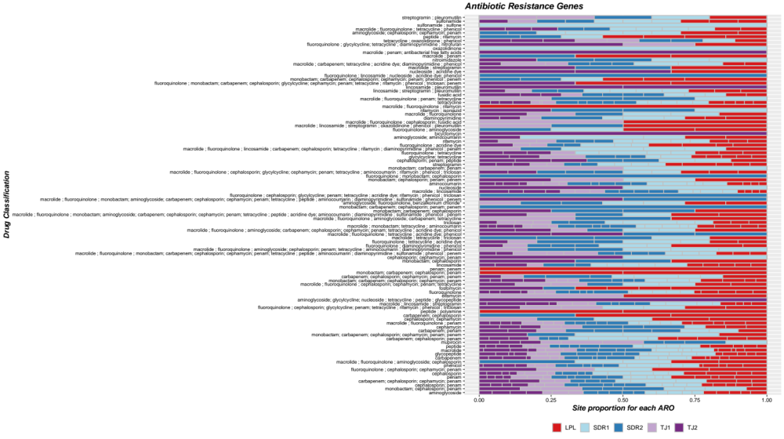

Additional File 4: Antibiotic resistance gene classes per site. Proportion of each antibiotic resistance gene class identified for each site (color) based on the Comprehensive Antibiotic Resistance Database (CARD). Separated bars represent individual samples within sites based on month.

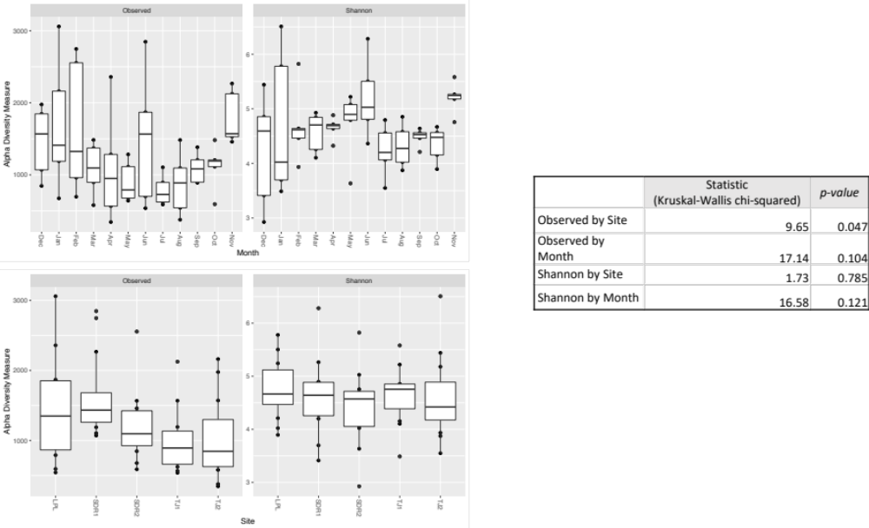
E
D
C
B
A

Additional File 5. Prokaryotic community alpha diversity. Box plots depicting the alpha diversity metrics observed ASVs (Observed) and Shannon Diversity (Shannon) for 16S sequences by Site (A,B) and Month (C, D). (E) shows Kruskal-Wallis test statistics for each analysis.

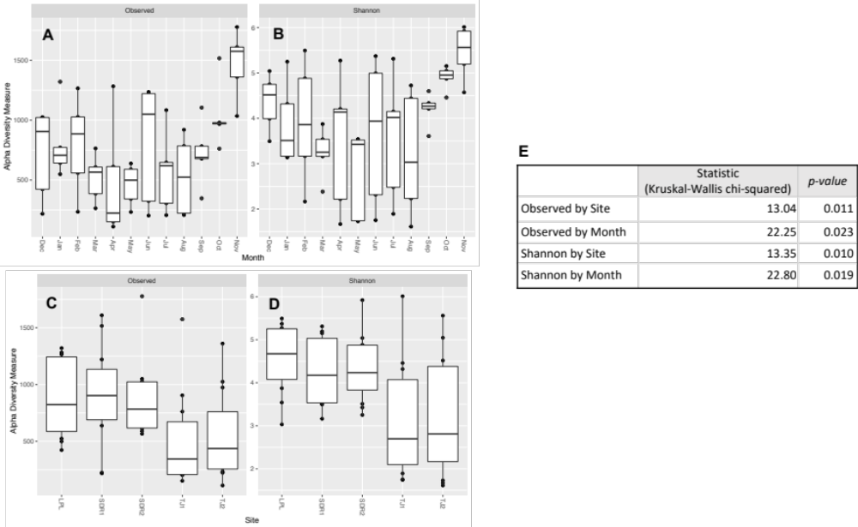

Additional File 6. Eukaryotic community alpha diversity. Box plots depicting the alpha diversity metrics observed ASVs (Observed) and Shannon Diversity (Shannon) for 18S sequences by Site (A,B) and Month (C, D). (E) shows Kruskal-Wallis test statistics for each analysis.

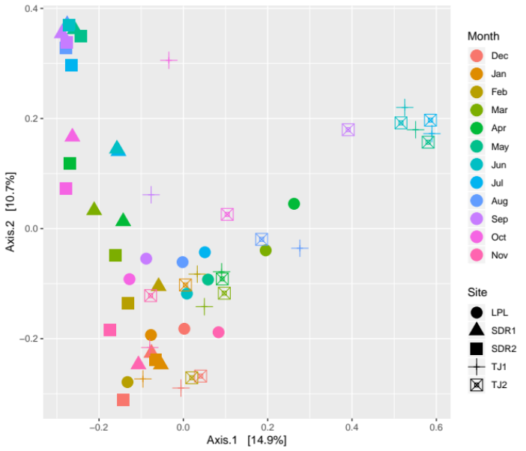
A
B
16S Community PCoA
18S Community PCoA
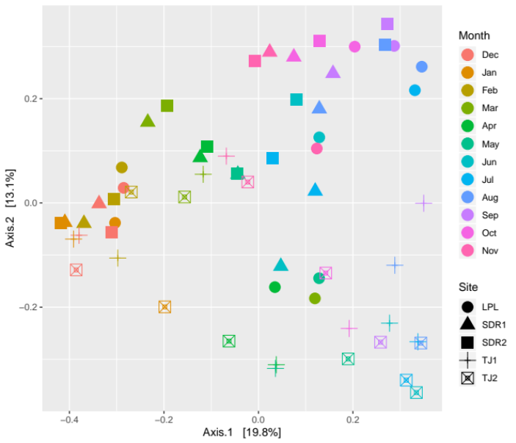

Additional File 7. PCoA plots of beta diversity based on Bray Curtis Dissimilarity. Community beta diversity is plotted for 16S (A) and 18S (B) communities, with marker color representing month and shape representing the site.

B
A
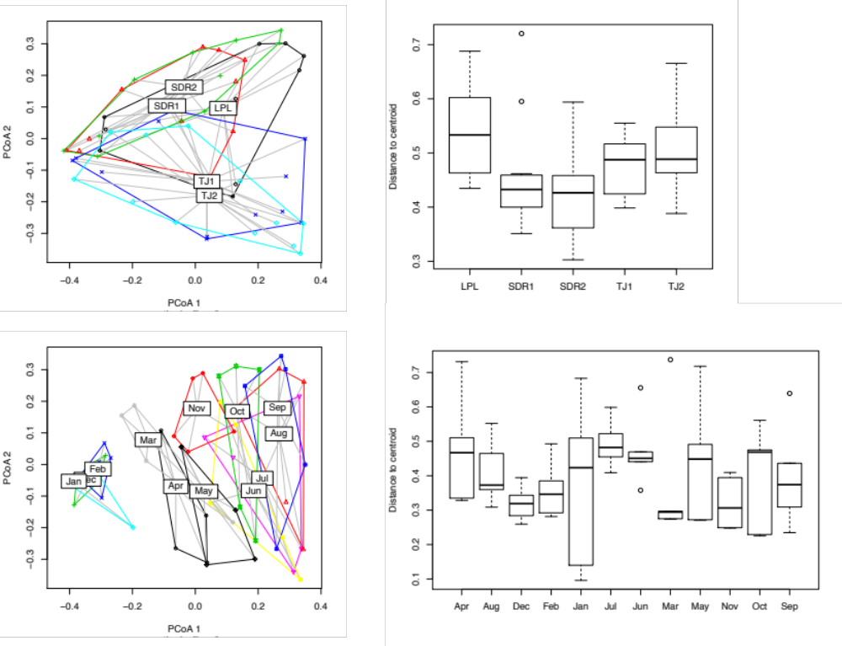

D
C

Additional File 8. 16S site and month group similarity. Beta dispersion PCoA plots showing distribution of communities within groups and boxplots depicting the distribution as the distance to the group centroid with the line representing mean distance. (A) and (B) depict beta dispersion PCoA and distance to centroid plots for the group “site,” respectively, while (C) and (D) show the same for the group “month.”

A
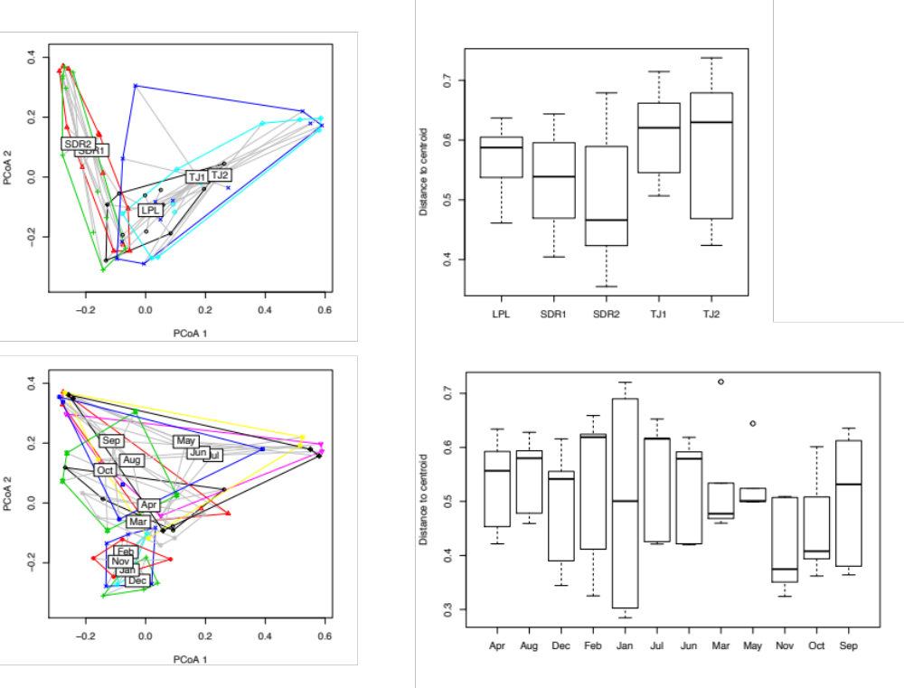
B

C
D

Additional File 9. 18S site and month group similarity. Beta dispersion PCoA plots showing distribution of communities within groups and boxplots depicting the distribution as the distance to the group centroid with the line representing mean distance. (A) and (B) depict beta dispersion PCoA and distance to centroid plots for the group “site,” respectively, while (C) and (D) show the same for the group “month.”

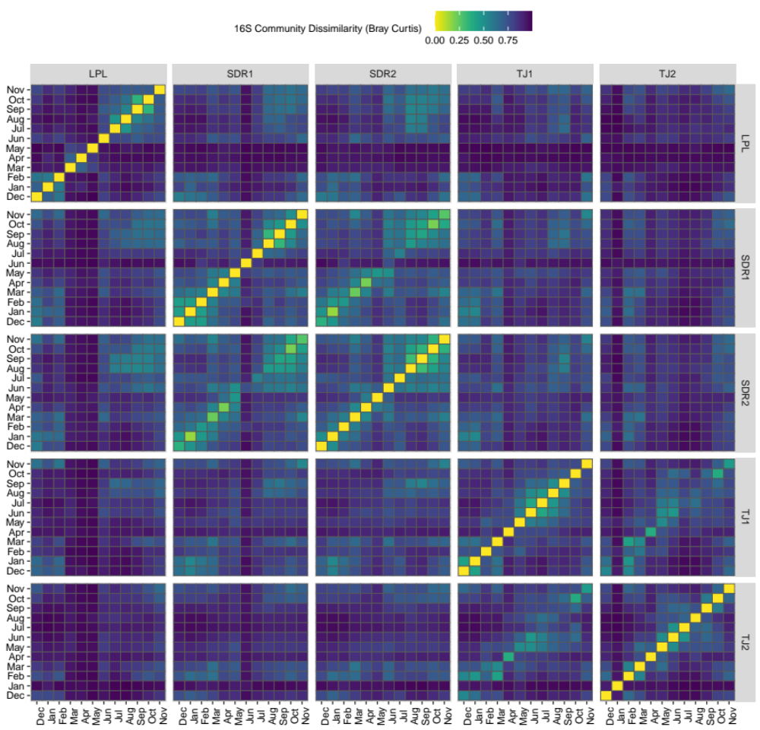

Additional File 10: 16S Bray Curtis dissimilarities of pair-wise comparisons between all samples grouped by site and month. Heat map temperature corresponds to a range of highly similar samples (yellow) to lower similarity samples (dark blue).

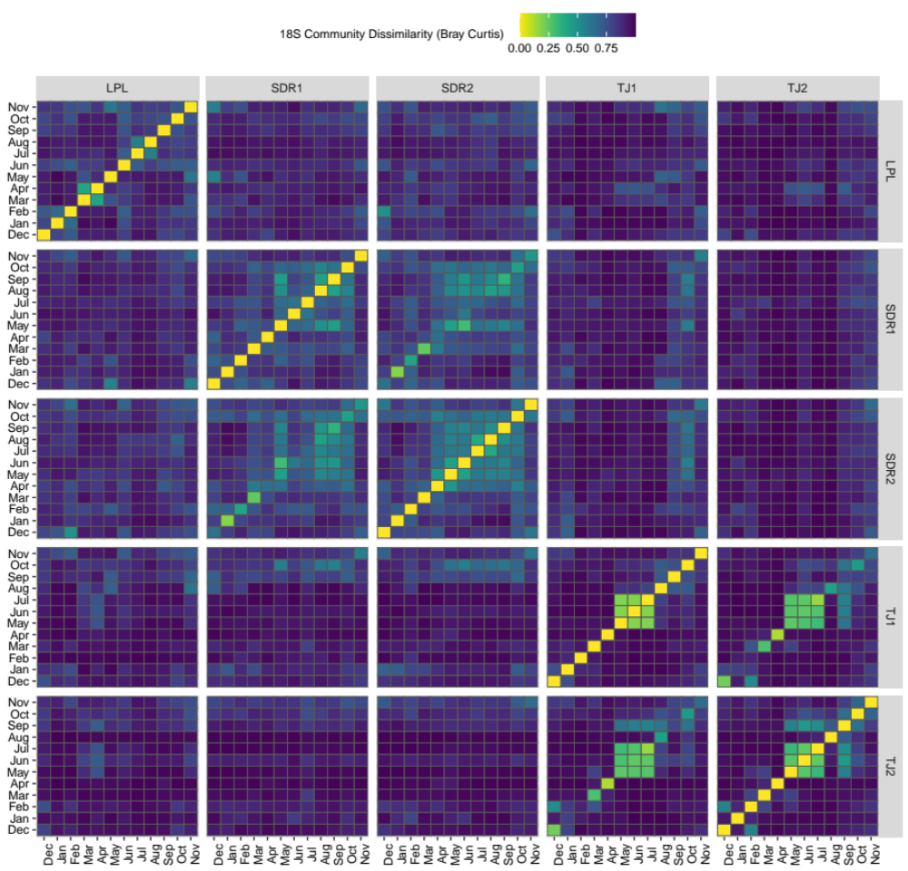

Additional File 11: 18S Bray Curtis dissimilarities of pair-wise comparisons between all samples grouped by site and month. Heat map temperature corresponds to a range of highly similar samples (yellow) to lower similarity samples (dark blue).

Additional File 12: Random forest classification and regression results for 16S and 18S amplicon data. Classification accuracy results are presented for categorical metadata (A) and continuous metadata (B) classes.

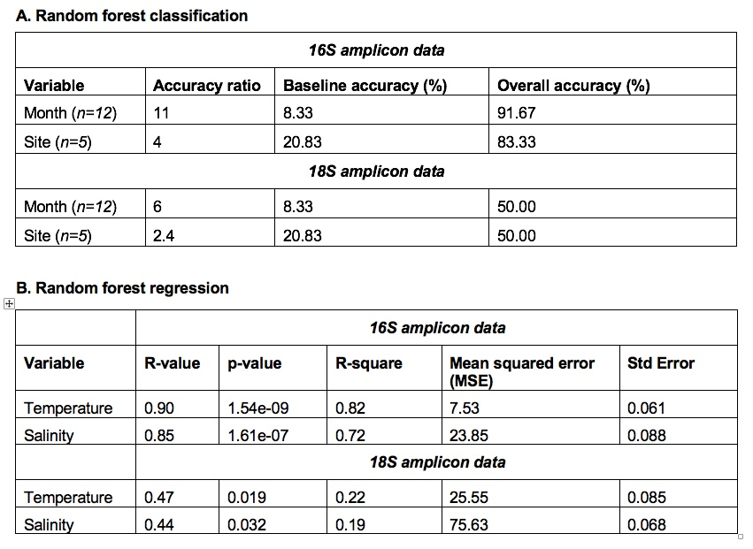

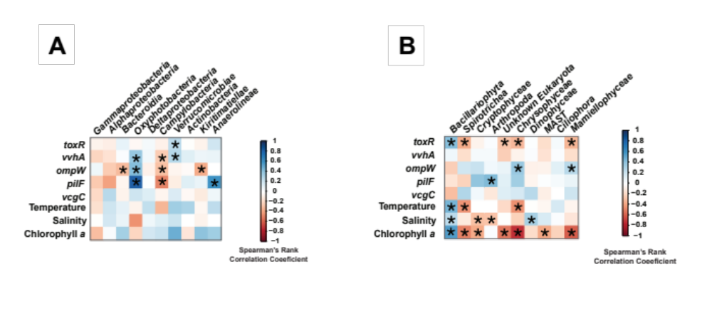
(Diatoms)
Additional File 13: Class-level associations between the top 10 most abundant prokaryotic genera (A) and eukaryotic genera (B), listed from left to right in order of total relative sequence abundance across all samples.

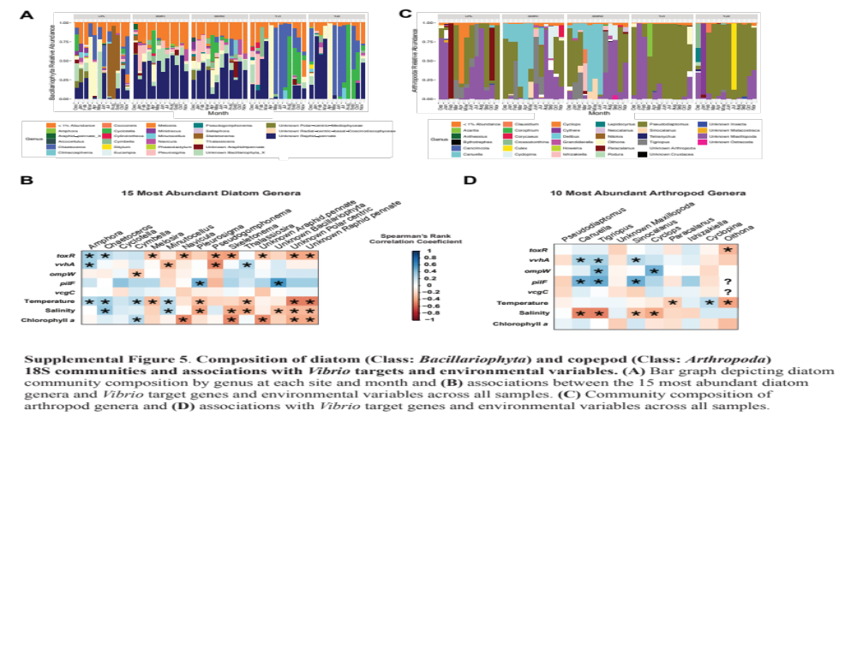

Additional File 14. Composition of diatom (Class: Bacillariophyta) and copepod (Class: Arthropoda)
18S communities and associations with Vibrio targets and environmental variables. (A) Bar graph depicting diatom community composition by genus at each site and month and (B) correlogram depicting associations between the 15 most abundant diatom genera and Vibrio target genes and environmental variables across all samples. (C) Community composition of arthropod genera and (D) correlogram depicting associations with Vibrio target genes and environmental variables across all samples. In the correlograms depicting associations, “*” represents a statistically significant association (p-value < 0.05) and “?” represents a correlation where the data was insufficient to establish a correlation.

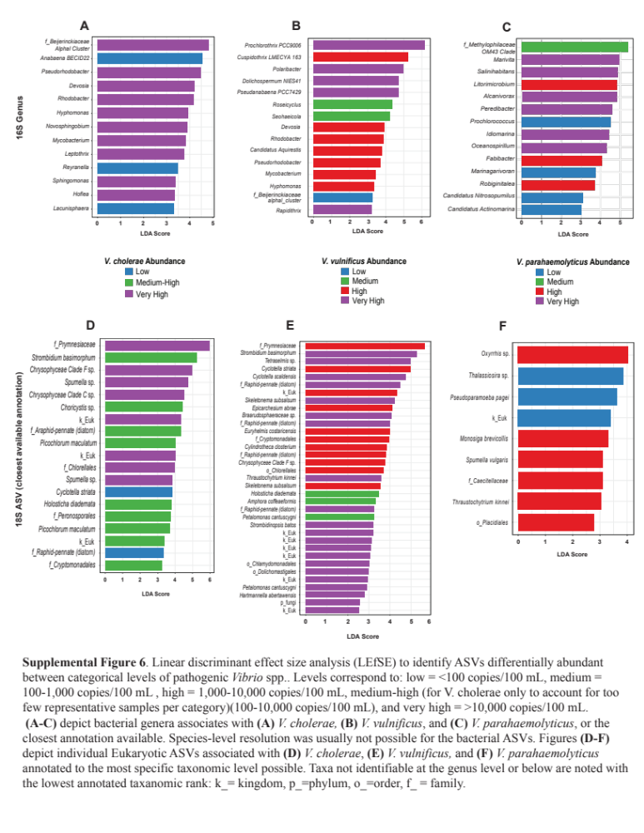Additional File 15: Linear discriminant effect size analysis (LEfSE) to identify ASVs differentially abundant between categorical levels of pathogenic Vibrio spp.. Levels correspond to: low = <100 copies/100mL, medium = 100-1,000 copies/ 100mL, high = 1,000-10,000 copies/100 mL, medium-high (100-10,000 copies/100 mL, for V. cholerae only to account too few representatives per sample category), and very high = >10,000 copies/100 mL. (A-C) depict bacterial genera associated with (A) V. cholerae (B) V. vulnificus and (C) V. parahaemolyticus, or the closest annotation possible. Species-level resolution was usually not possible for the bacterial ASVs. Figures (D-F) depict individual Eukaryotic ASVs associated with (D) V. cholerae (E) V. vulnificus and (F) V. parahaemolyticus annotated to the lowest taxonomic rank: k_=kingdom, p_=phylum, o_=order, f_=family. We employed an FDR-adjusted p-value cutoff of 0.05, and a Log LDA score of 2.

