Supplementary Information

Supplementary Methods

Vulnerability-targeted greening scenarios

Because the proximity-based InVEST Scenario Generator allocates new tree cover preferentially near existing vegetation, it cannot explicitly prioritize underserved neighborhoods or areas with high heat risk. To address this limitation, we developed an additional set of targeted greening scenarios that prioritize planting locations based on the joint distribution of heat exposure and social vulnerability. These scenarios represent targeted alternatives to the proximity-based greening pathways and are referred to as Target10, Target20 and Target30, corresponding to 10%, 20% and 30% relative increases in tree canopy cover, respectively. The targeted planting workflow consisted of four steps.
1) Identification of candidate planting locations. We first generated candidate tree-planting points along London’s street network using OpenStreetMap (OSM) road data. Different road classes were treated using separate spatial rules. For active transport routes, including pedestrian paths, footways and cycleways, candidate points were generated directly along road centerlines at 5 m intervals. For vehicle-accessible roads, specifically residential and unclassified streets, we first created parallel offset lines 3.5 m to both sides of the centerline to approximate sidewalk planting space, and then generated candidate points every 5 m along these offset lines.
2) Application of biophysical and spatial constraints. We then filtered candidate points to retain only physically suitable planting locations. To reduce competition with existing canopy and ensure sufficient growing space, new planting points were kept away from existing trees. We used a 1 m resolution tree canopy raster and buffered existing canopy pixels by 5 m using morphological dilation; candidate points falling within this buffered area were removed. To avoid conflicts with buildings, we excluded points located within 2 m of building footprints. Because the road-offset procedure often produced clustered points near intersections, we then applied a KD-tree nearest-neighbor filter and removed points located within 5 m of one another. This step produced a more realistic and spatially uniform planting density.
3) Prioritization by heat exposure and social vulnerability. Remaining candidate points were ranked using a composite priority score based on local heat exposure and social vulnerability. Heat exposure was represented by 1 m resolution Universal Thermal Climate Index (UTCI) values at 14:00 local time, extracted for each candidate point; points outside the valid simulation extent were excluded. To combine UTCI with the Social Vulnerability Index (SVI), UTCI values were rescaled to a 0–1 range using min–max normalization. We then assigned the tract-level SVI percentile to each candidate point using a spatial join. Because SVI percentile also ranges from 0 to 1, the final priority score was calculated as $Priority score={UTCI}_{norm}×SVI$. Candidate points were ranked in descending order of this score, such that higher-priority locations represent the co-occurrence of more severe heat stress and higher social vulnerability.
4) Generation of targeted greening scenarios. To construct the three targeted greening scenarios, we selected the highest-ranked candidate points and converted them to a 10 m × 10 m grid to match the resolution of the LULC and urban cooling models, using average crown-size assumptions to represent canopy extent. Candidate sites were added in rank order until each canopy expansion target was reached. For Target10, approximately 565,000 tree sites were selected, corresponding to the Mayor’s target of a 10% relative increase in tree canopy cover by 2050. For Target20 and Target30, approximately 1,129,000 and 1,819,000 tree sites were selected, respectively. These totals are approximate, as some projected tree crowns may overlap., using average crown-size assumptions to represent canopy extent. Together, Target10, Target20 and Target30 provide vulnerability-targeted alternatives to the proximity-based greening scenarios (Green10, Green20 and Green30), allowing direct comparison between spatially opportunistic and explicitly equity-oriented tree planting pathways.

Estimation of future relative humidity (RH)
Relative humidity (RH) is one of the key input data for Urban Cooling mode. We estimate future RH under projected climate by using near-surface air temperature (T, °C) and actual vapor pressure based on the WorldClim v2.1 1970–2000 monthly climatology (vapr, kPa):
$RH = 100 ×\frac{e_{a}}{e_{s}(T)}$
The temperature-dependent saturation vapor pressure ($e_{s}$, hPa)—representing the maximum moisture-holding capacity of the urban boundary layer at a given temperature—was computed using the improved Tetens-form approximation ^{1,2}.
$e_{s}(T)=6.112× exp(\frac{17.67× T}{T+243.5})$
where T is air temperature in degrees Celsius (°C), and T in future is estimated by using the average of (Tmax + Tmin) / 2, or to simplify, T = Tx from WorldClim v2.1 CMIP6 future temperature data. $e_{a}$ is actual water vapor pressure in hPa, and $e_{a}$ = 10 * vapr. This temperature-driven approach assumes constant atmospheric moisture (i.e., fixed dew point or specific humidity) and may therefore overestimate drying in regions where moisture increases under warming. However, it provides a transparent and internally consistent first-order estimate suitable for scenario comparison ³. For a hot London month, expect higher water vapor pressure—roughly ~1.5 kPa on average, with ~1.3–1.6 kPa typical on summer days.

Supplementary Tables and Figures

Urban Cooling Modeling

Sup. Table 1 | Land use and climate scenario combinations used in urban cooling modeling. The table shows all combinations of land use and land cover (LULC) scenarios and climate conditions evaluated in this study. Climate scenarios are defined by projected mean summer reference air temperature and urban heat island (UHI) intensity for the specified year (2021, 2050 and 2070). The temperature–UHI combinations are used to parameterize the urban cooling model (see Methods). An “x” indicates scenario combinations implemented in the modelling.
Year | 2021 (Baseline) | 2050 | 2070
LULC scenarios | Climate scenarios (Reference air temperature + UHI combinations)
LULC scenarios | 22°C + 2°C | 25°C + 5°C | 28°C + 5°C
S0 – Baseline | x | x | x
S1 – AllBuilt |  | x | x
S2 – TreeOpp |  | x | x
S3 – TreeRisk |  | x | x
S4 – Green10 |  | x | x
S5 – Green20 |  | x | x
S6 – Green30 |  | x | x
S7 – Target10 |  | x | x
S8 – Target20 |  | x | x
S9 – Target30 |  | x | x

Sup. Table 2 | Biophysical parameters used in the Urban Cooling Model (UCM). Parameters were compiled based on a UCM calibration study ⁴, FAO crop coefficient values (https://www.fao.org/4/x0490e/x0490e0b.htm#crop%20coefficients), and ECOTRESS Albedo data ⁵.
Land-use code | Description | Shade | Kc (Crop coefficient) | Albedo | Green area | Building intensity
1 | Deciduous woodland | 0 | 0.7 | 0.12 | 1 | 0
2 | Coniferous woodland | 0 | 0.7 | 0.11 | 1 | 0
3 | Arable | 0 | 0.3 | 0.12 | 0 | 0
4 | Improved Grassland | 0 | 0.8 | 0.13 | 1 | 0
5 | Neutral Grassland | 0 | 0.7 | 0.13 | 1 | 0
6 | Calcareous Grassland | 0 | 0.7 | 0.12 | 1 | 0
7 | Acid grassland | 0 | 0.7 | 0.12 | 0 | 0
8 | Fen, Marsh, and Swamp | 0 | 0.9 | 0.12 | 1 | 0
9 | Heather | 0 | 0.8 | 0.10 | 1 | 0
10 | Heather grassland | 0 | 0.8 | 0.13 | 1 | 0
11 | Bog | 0 | 0.8 | 0.12 | 1 | 0
12 | Inland Rock | 0 | 0.8 | 0.11 | 0 | 0
13 | Saltwater | 0 | 0 | 0.08 | 0 | 0
14 | Freshwater | 0 | 1 | 0.08 | 0 | 0
15 | Supralittoral Rock | 0 | 0.8 | 0.12 | 0 | 0
16 | Supralittoral Sediment | 0 | 0.8 | 0.12 | 0 | 0
17 | Littoral Rock | 0 | 0.8 | 0.12 | 0 | 0
18 | Littoral Sediment | 0 | 0.8 | 0.09 | 0 | 0
19 | Saltmarsh | 0 | 0.8 | 0.10 | 0 | 0
20 | Urban | 0 | 0.2 | 0.11 | 0 | 0.75
21 | Suburban | 0 | 0.3 | 0.11 | 0 | 0.5
100 | Tree Cover | 1 | 0.8 | 0.12 | 1 | 0
0 | Nothing | 0 | 0 | 0 | 0 | 0

Sup. Table 3 | Key climate parameters used in Urban Cooling Model. The table summarizes the climate inputs used to parameterize the Urban Cooling Model for baseline and future conditions. The year 2021 was selected as the baseline reference year, and simulations focus on July, historically the warmest month in London. Reference air temperature and urban heat island (UHI) intensity represent representative summer conditions for each time horizon. Air blending distance and maximum cooling distance were held constant across scenarios to isolate the effects of land-use change. Reference evapotranspiration (Ref ET) values were derived from CGIAR historical datasets for current conditions and from CGIAR future projections (2041–2060 and 2061–2080) under SSP370 and SSP585 for mid- and late-century scenarios. Average relative humidity reflects representative July conditions for each year.
Year | Reference air temperature (°C) | UHI effect (°C) | Air Blending distance (m) | Max cooling distance (m) | Ref ET (mm) | Average Relative Humidity (%)
2021  (Baseline year) | 22 | 2 | 500 | 450 | CGIAR (1980-2000) | 55
2050 | 25 | 5 | 500 | 450 | CGIAR model future (2041-2060) SSP 370 or 585) | 45
2070 | 28 | 5 | 500 | 450 | CGIAR model future (2061-2080) SSP 370 or 585) | 42

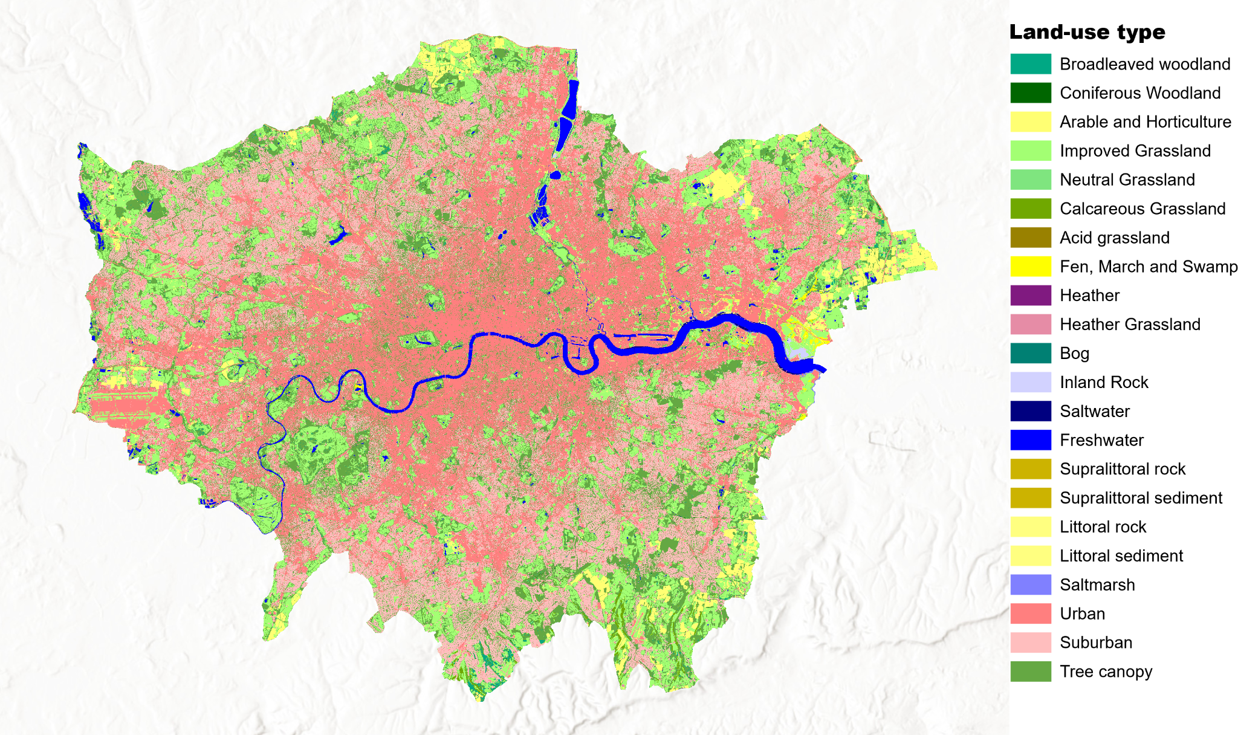

Sup. Fig. 1 | London land use and land cover (LULC) in 2021. This baseline LULC layer was used to parameterize the Urban Cooling Model and to generate alternative land-use scenarios (see Methods). Data source: UK Centre for Ecology & Hydrology (UKCEH).

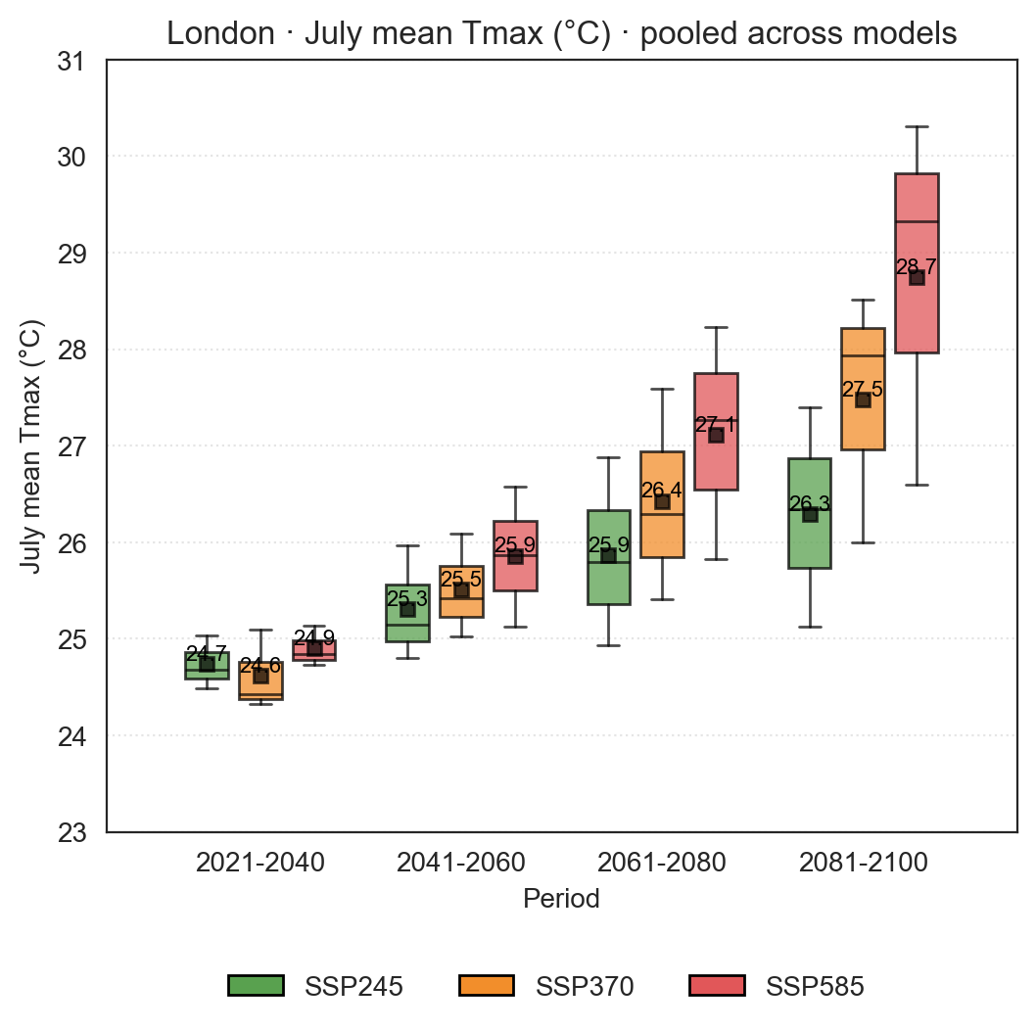

Sup. Fig. 2 | Projected changes in July mean maximum temperature (Tmax) in London under future climate scenarios. Box plots show model-pooled projections of July mean Tmax across four time periods under SSP245, SSP370, and SSP585. Boxes indicate the interquartile range, center lines denote the median, and whiskers represent 1.5× the interquartile range. Values are pooled across climate models (see Methods). Following common practice in climate projection studies, the periods 2021–2040, 2041–2060, 2061–2080 and 2081–2100 are used to represent conditions centered approximately on 2030, 2050, 2070 and 2090, respectively.

Land use and land cover scenarios

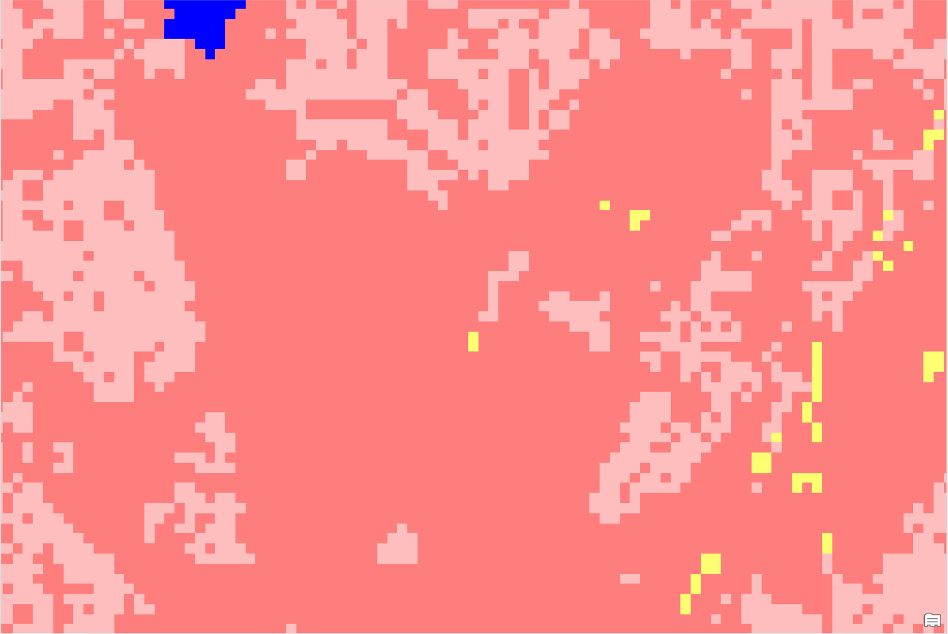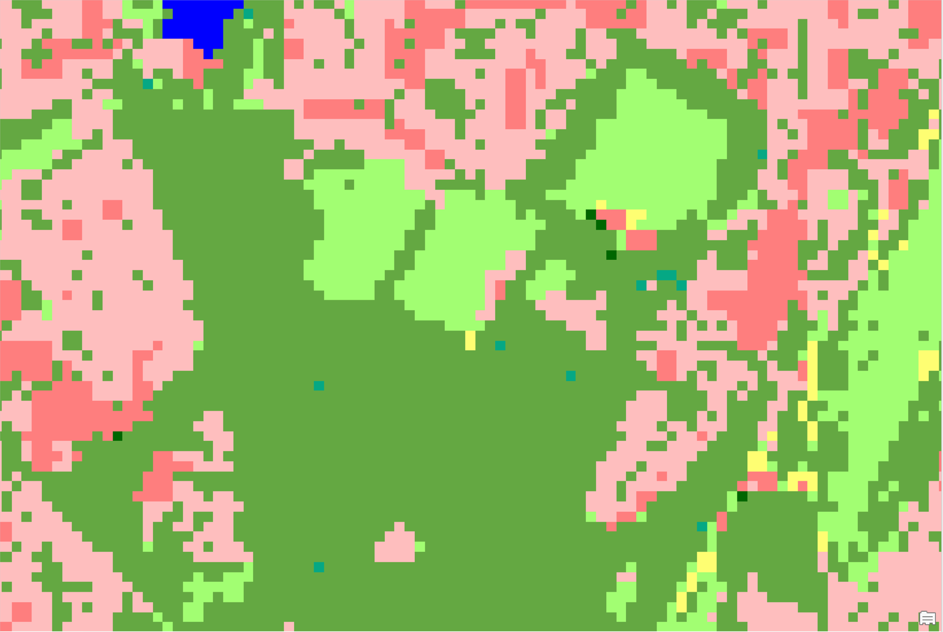
a
b

Sup. Fig. 3 | Example of the vegetation-to-impervious conversion scenario. The scenario converts all natural land-cover classes, including deciduous woodland, coniferous woodland, improved grassland, neutral grassland, calcareous grassland, acid grassland and heather grassland, to urban built-up land. a, Baseline LULC map. b, LULC scenario map after vegetation-to-impervious conversion. The LULC categories and color scheme are the same as in Sup. Fig. 2.

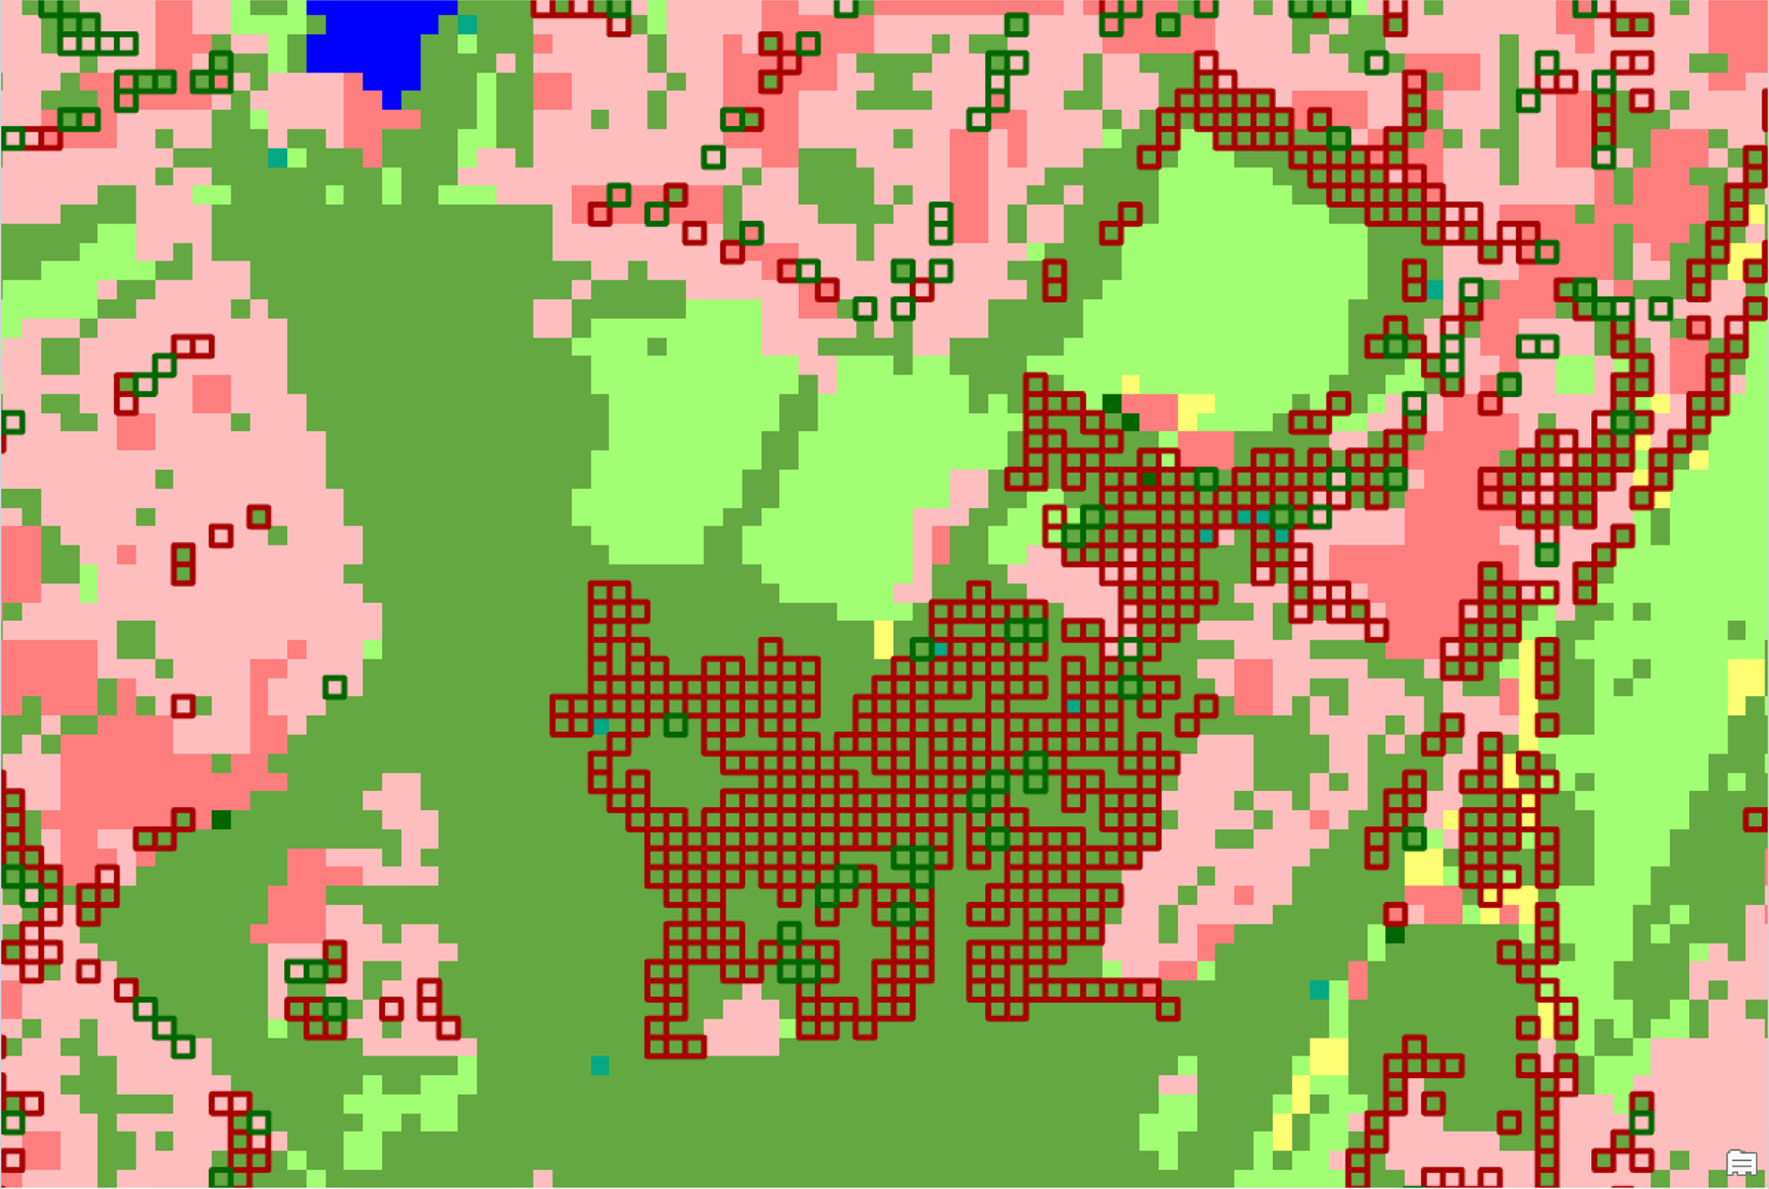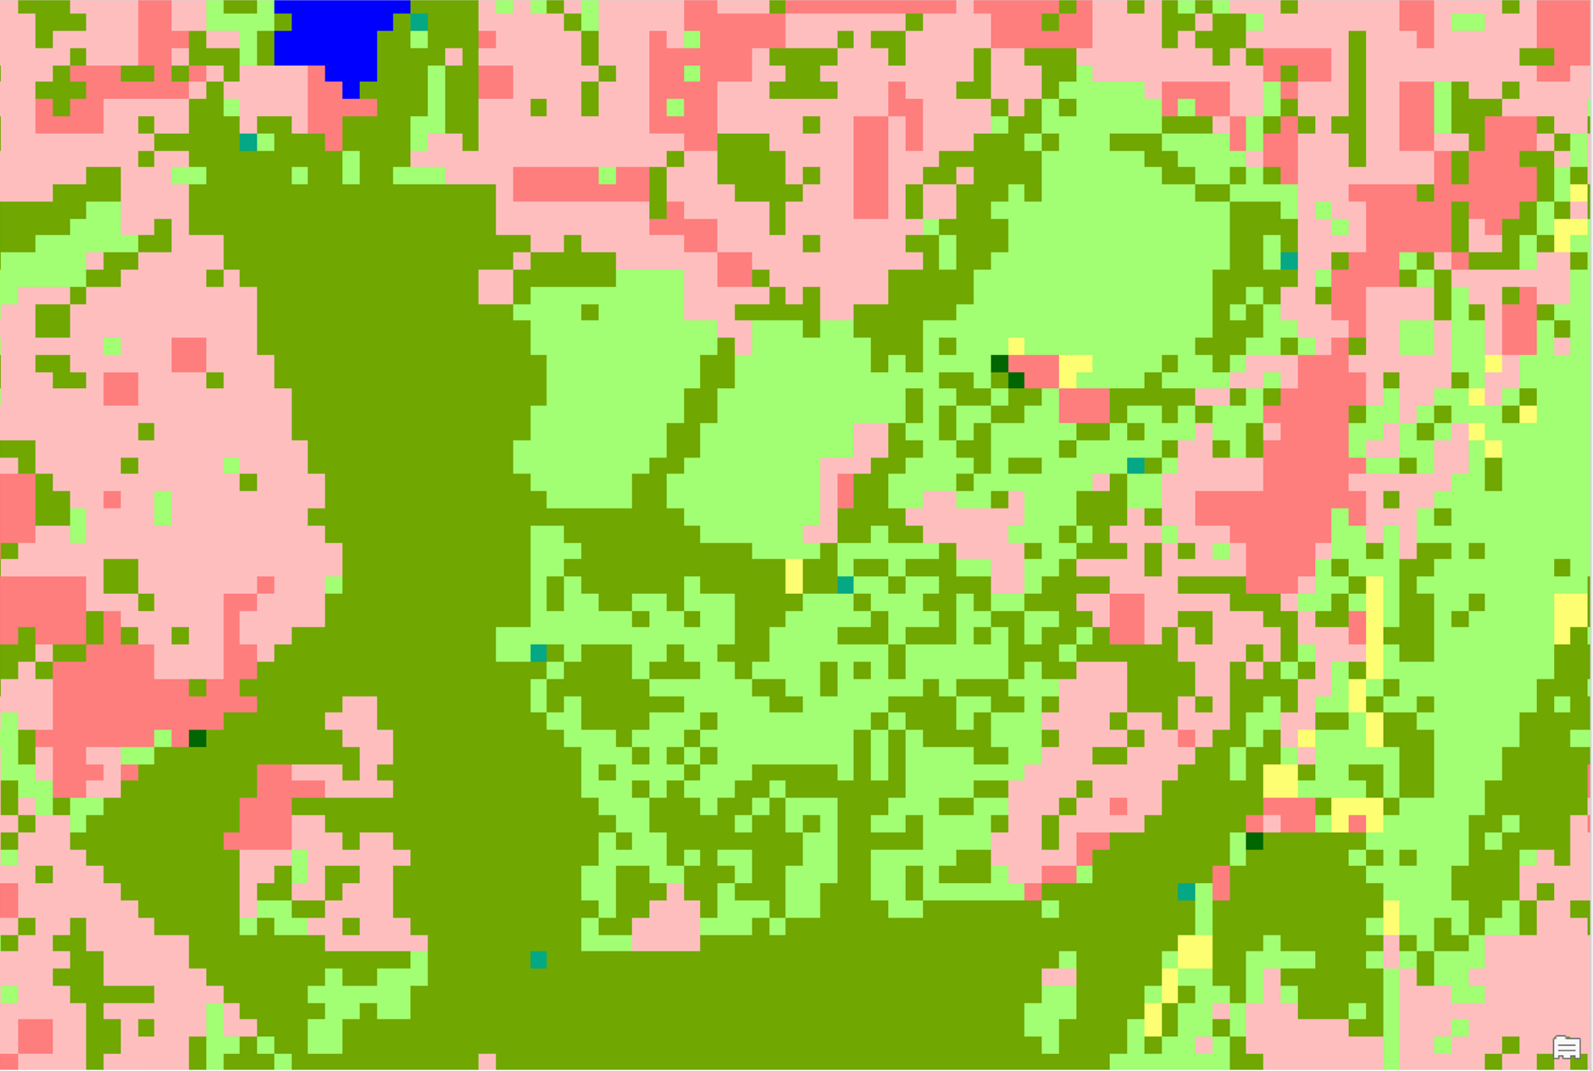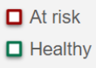
b
a

Sup. Fig. 4 | Example of the climate-driven tree canopy loss scenario. Areas in red squares denote individual trees will be at climate risk, and pixels within green squares represent individual trees would remain healthy under future climate change scenarios (a). Trees at future climate risks would degrade and be converted to grassland (b). The LULC categories and color scheme are the same as in Sup. Fig. 2.

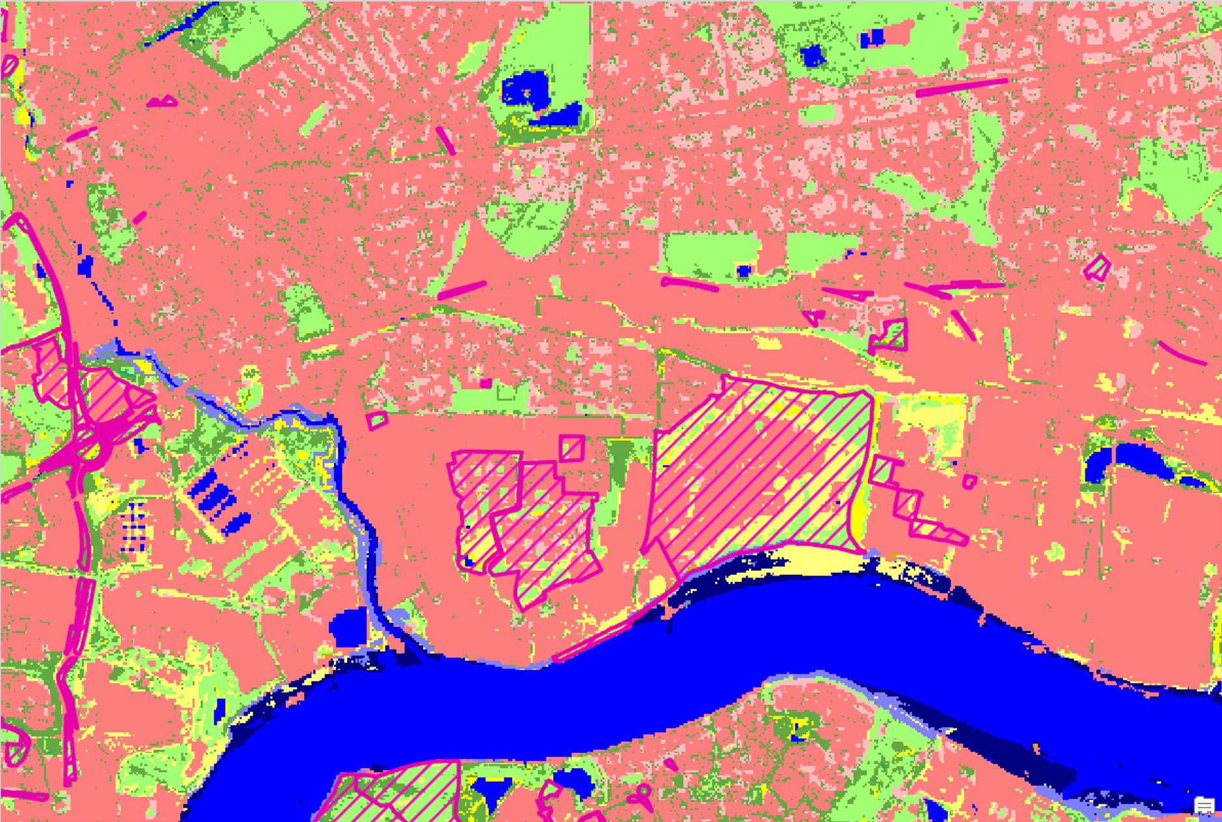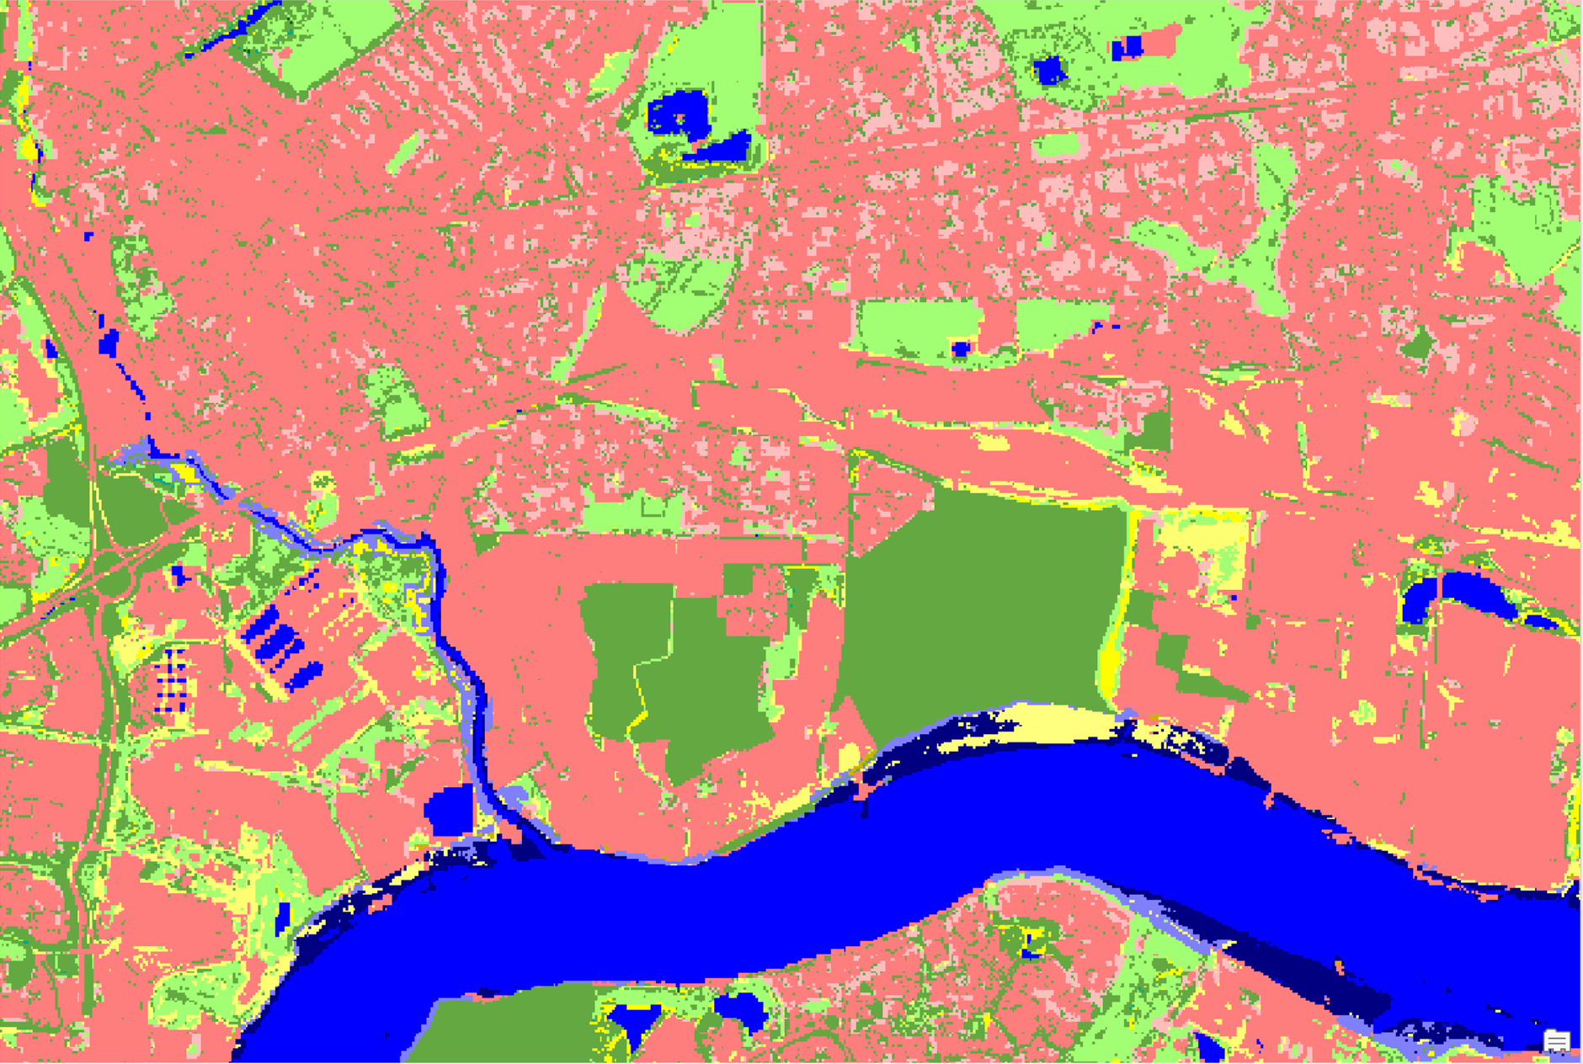
a
b

Sup. Fig. 5 | Example of the opportunity tree planting scenario. Increasing tree cover by converting opportunity land (primarily unused areas) to tree cover. Left (a): baseline LULC map (areas with magenta diagonal hatching indicate potential opportunity land for greening); right (b): scenario map. The LULC categories and color scheme are the same as in Sup. Fig. 2.

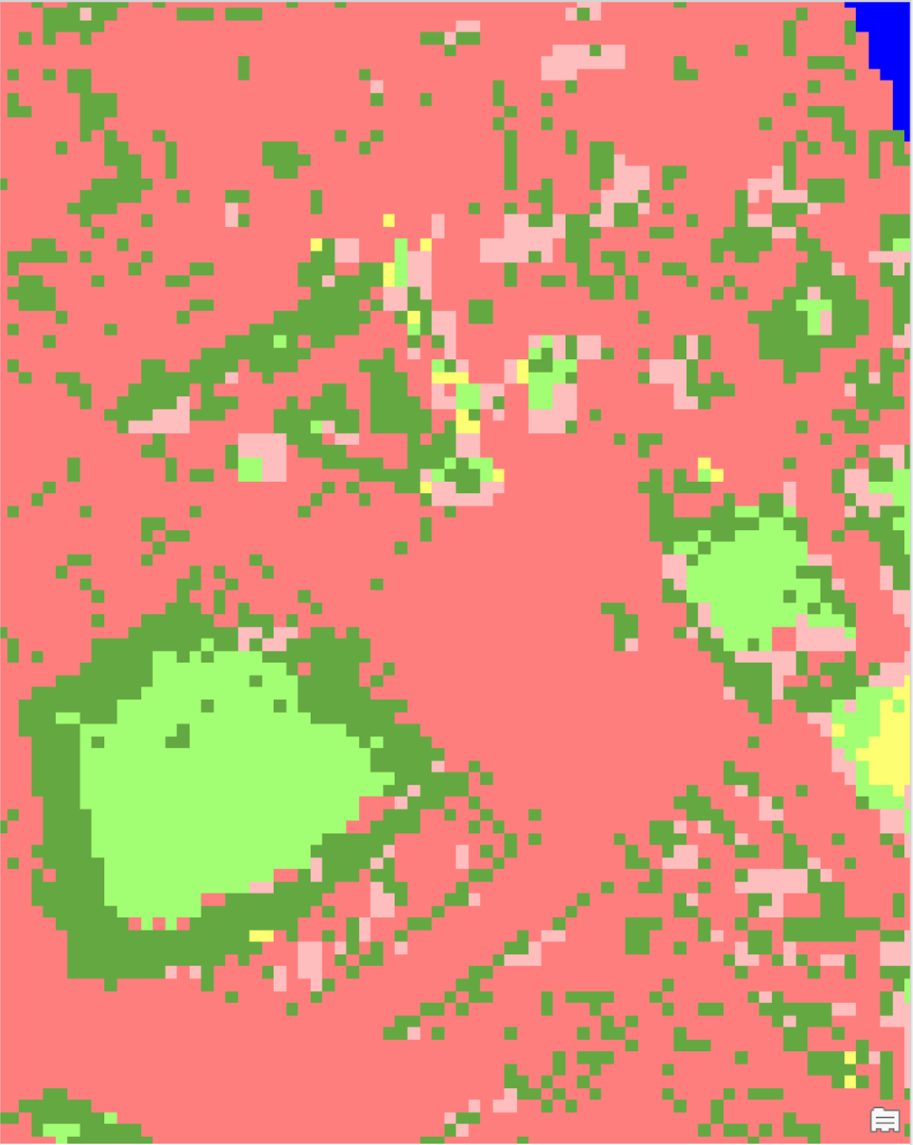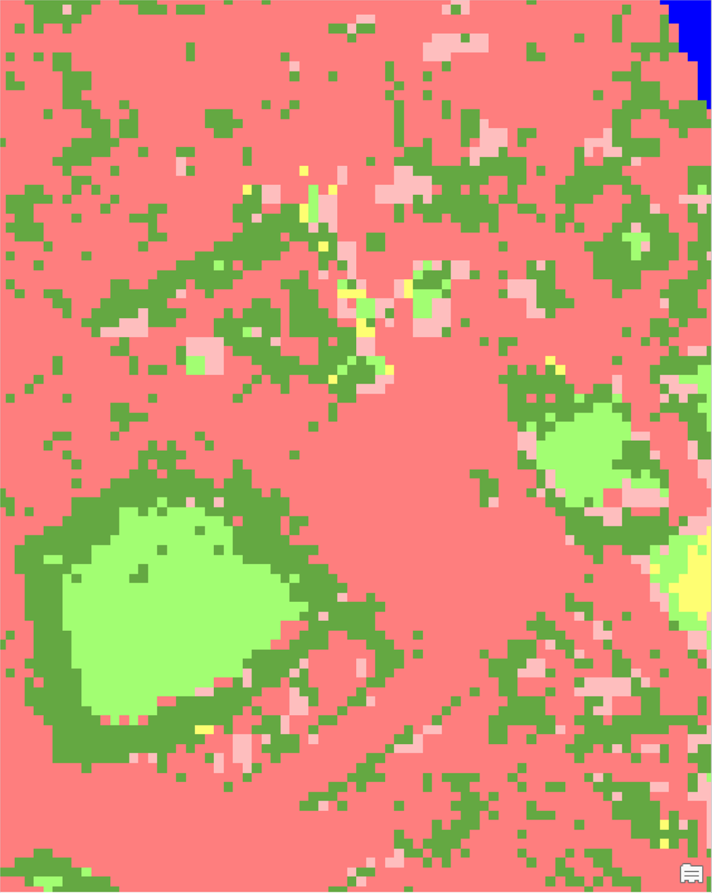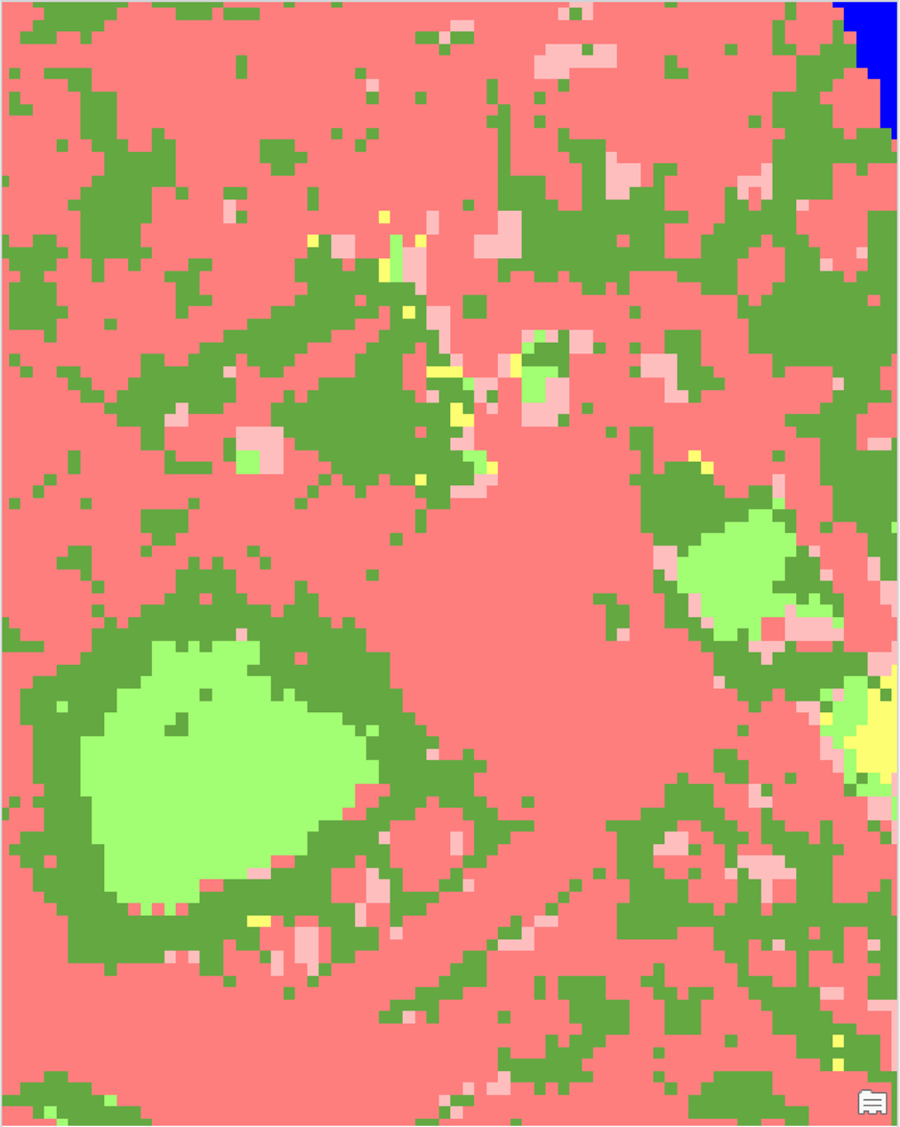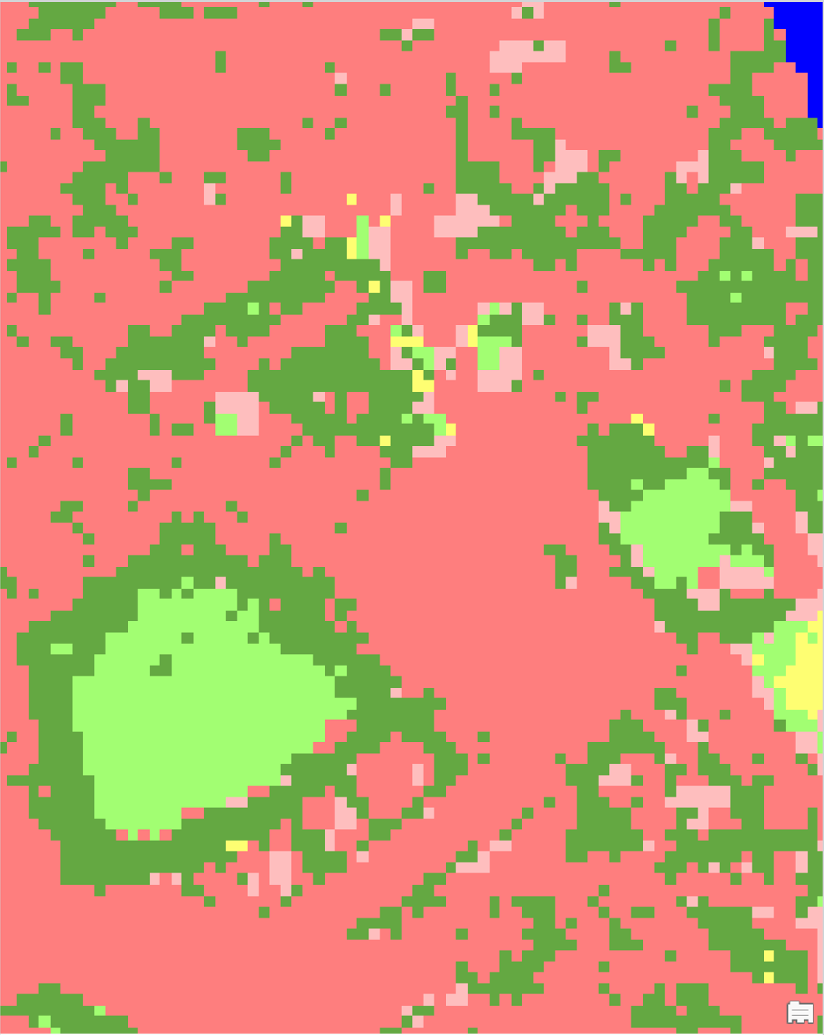
a
Baseline
b
+10%
d
+30%
+20%
c

Sup. Fig. 6 | Examples of the Policy target (+10% canopy), ambitious greening (+20% canopy), and transformative greening (+30% canopy) scenarios. The LULC categories and color scheme are the same as in Sup. Fig. 2.

Energy saving associated with urban cooling

Sup. Table 4 | Energy consumption parameters by building types in London.
Building Type ID | Building type name | Building category | Consumption  (kWh /m² / °C) per month * | Cost  (£ per kWh) | Area (m²) **
-1 | NA | Other | 0.00 | 0.0000 | 9,837,414
0 | Agriculture And Fisheries | Industry | 0.00 | 0.2700 | 25,083
1 | Community Services | Services - Leisure and community | 9.89 | 0.2800 | 12,238,412
2 | Defense | Services - Defense / Military | 0.00 | 0.2700 | 21,617
3 | Industry and Business | Industry | 0.00 | 0.2550 | 3,186,094
4 | Minerals | Industry | 0.00 | 0.2700 | 58
5 | Mixed Use | Services - Commercial | 0.00 | 0.2800 | 2,180,096
6 | Recreation And Leisure | Services - Leisure and community | 9.89 | 0.2800 | 806,529
7 | Residential | Domestic - Residential | 0.01 | 0.2563 | 221,990,513
8 | Retail | Services - Retail | 30.80 | 0.2700 | 1,538,350
9 | Transport | Transport | 0.00 | 0.2700 | 2,264,476
10 | Unclassified, presumed non-residential | Other | 0.00 | 0.2700 | 4,382,640
11 | Utilities And Infrastructure | Services - Commercial | 19.19 | 0.2800 | 183,840
12 | Vacant And Derelict | Other | 0.00 | 0.2700 | 66,633
* Energy consumption was estimated from https://www.drax.com/wp-content/uploads/2018/08/180809_Drax_Q2_Report.pdf
** Building area is calculated from the building footprint data (see Methods)

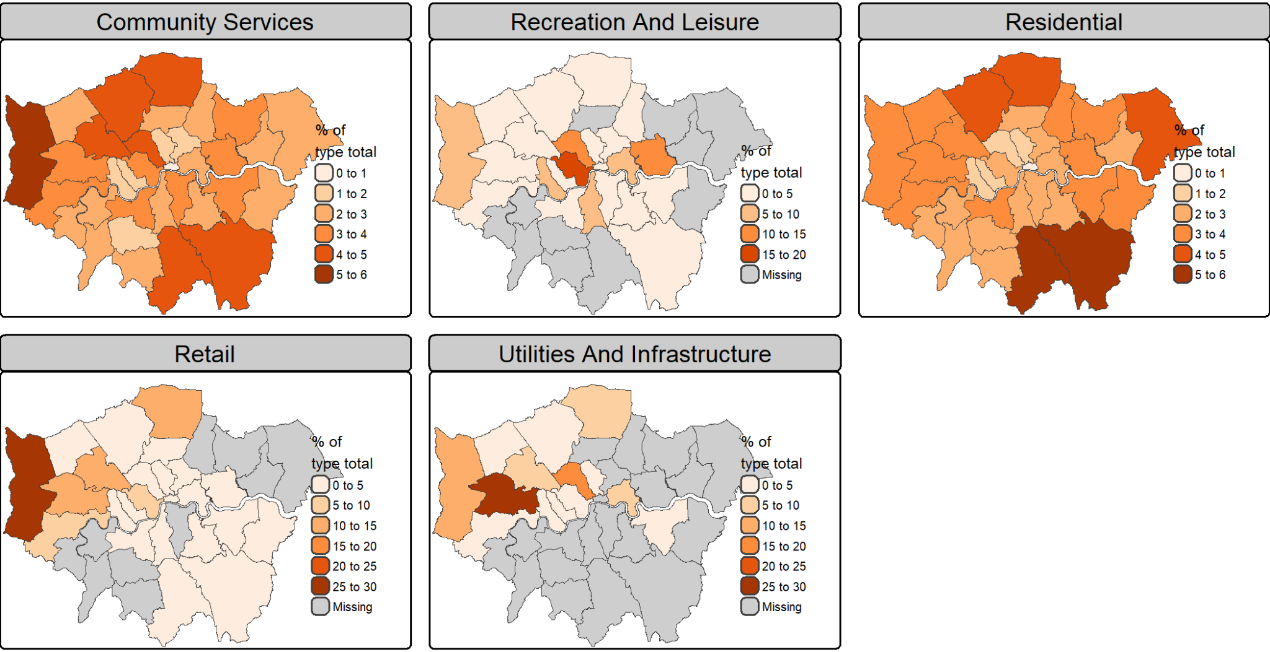

Sup. Fig. 7 | Spatial distribution of building types across London. Maps show, for each borough, the share of citywide building area (%) for five broad building-type categories (refer to Sup. Table 4 for the classification). Grey shading denotes boroughs with missing or unavailable data.

Work productivity
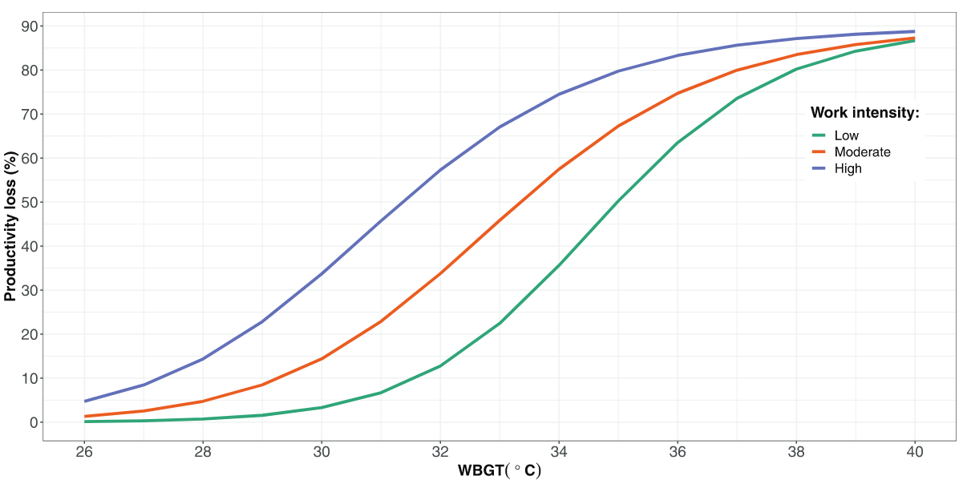

Sup. Fig. 8 | Exposure-response functions describing the relationships between heat (measured by wet-bulb globe temperature, WBGT) and productivity loss. The figure was adapted from Orlov et al ⁶.
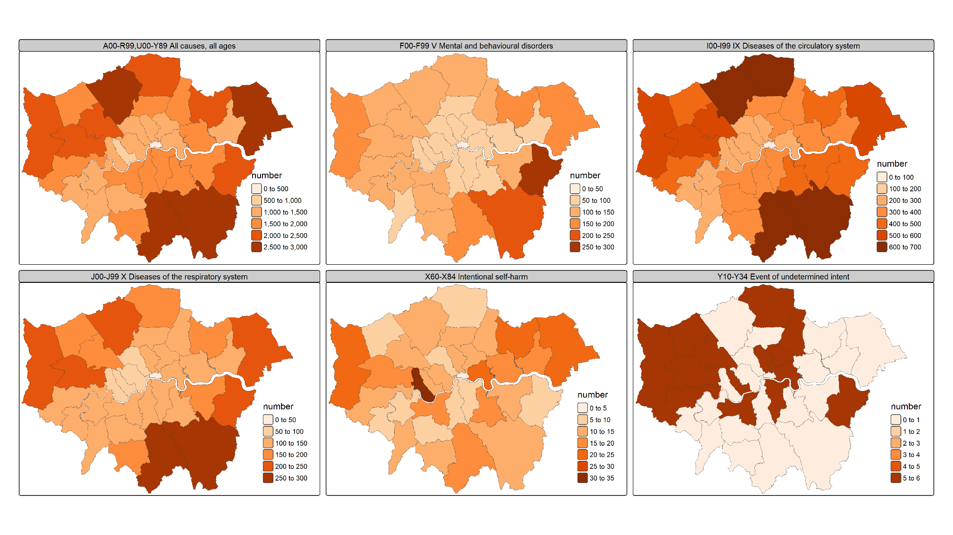

Sup. Fig. 9 | Baseline cause-specific mortality rates in 2021. The maps show baseline mortality rates in London for 2021 across selected ICD-10 categories: (1) all causes (A00–R99, U00–Y89; all ages), (2) mental and behavioral disorders (F00–F99), (3) diseases of the circulatory system (I00–I99), (4) diseases of the respiratory system (J00–J99), and (5) intentional self-harm (X60–X84). These baseline rates were used to parameterize health impact estimates under alternative land-use and climate scenarios.

Social vulnerability index

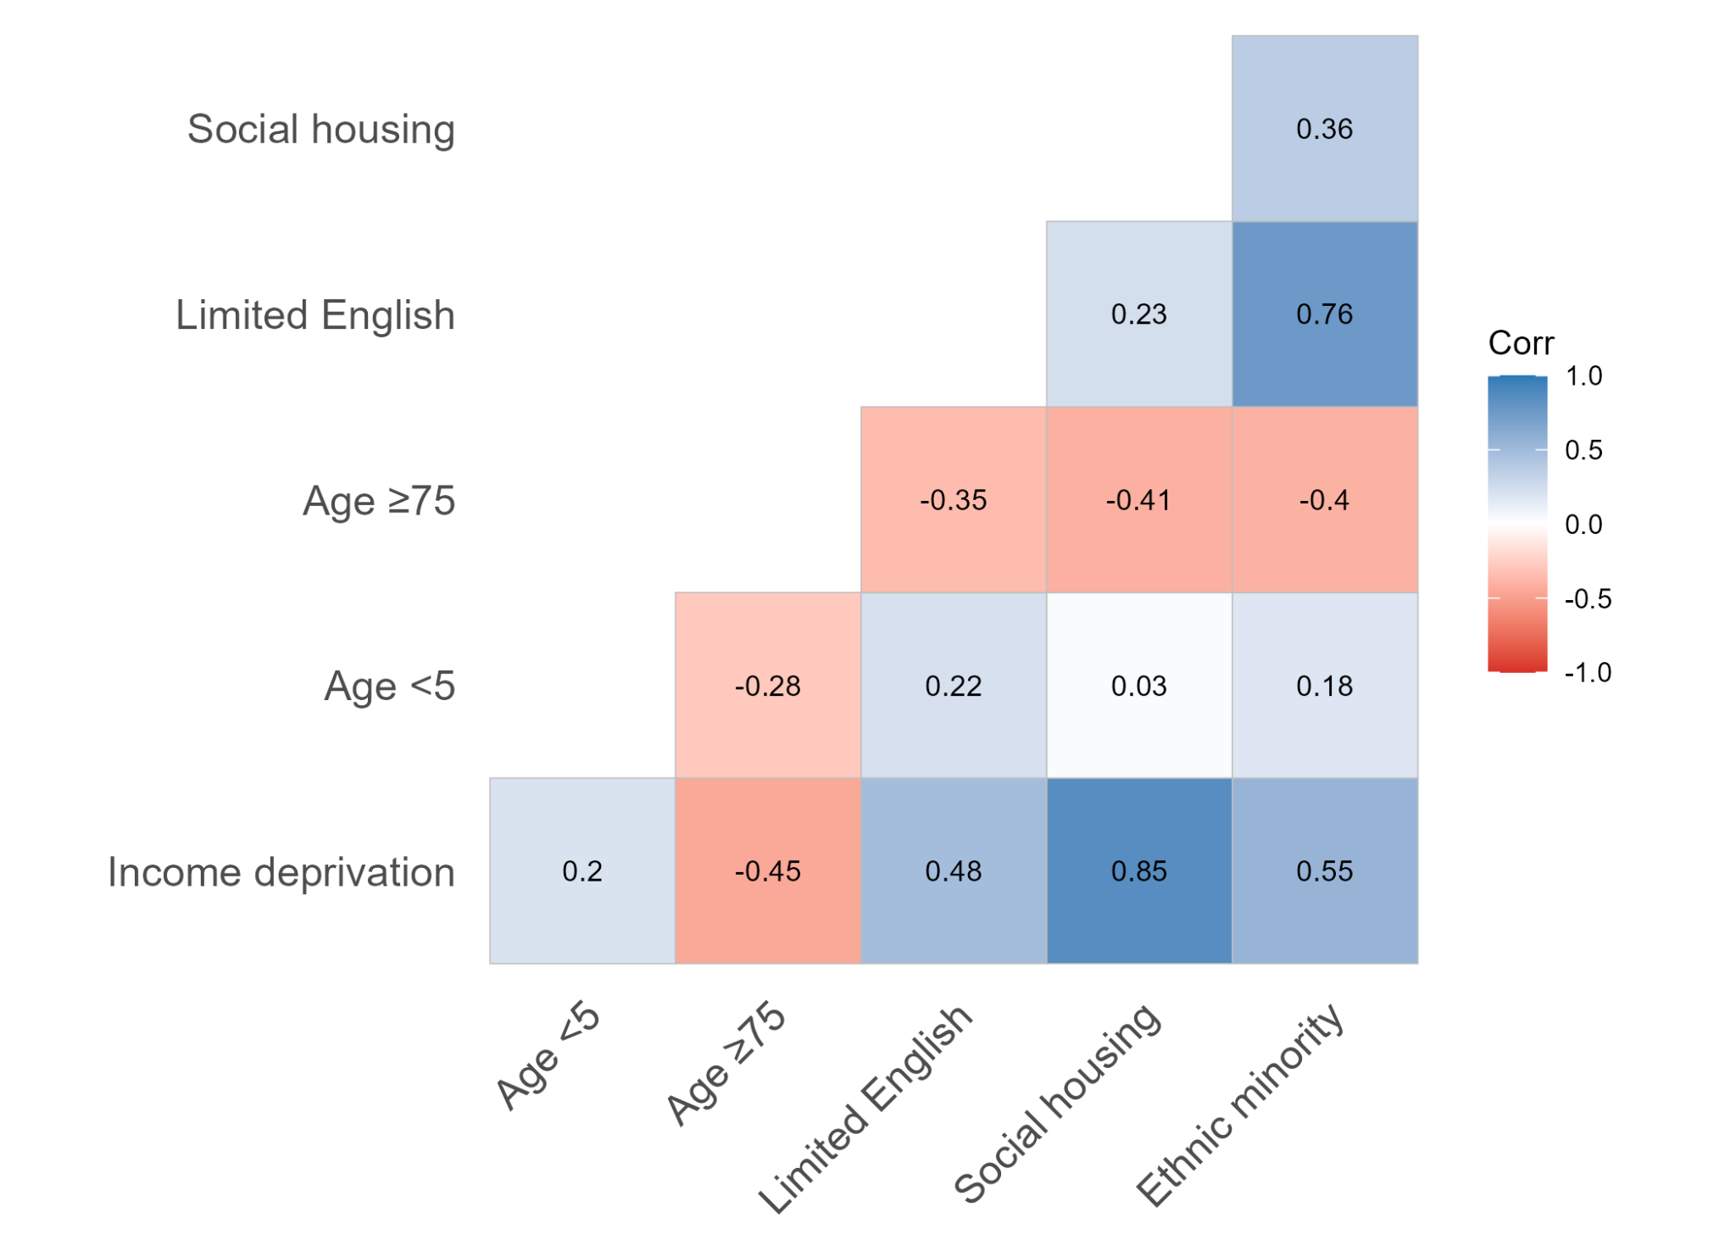

Sup. Fig. 10 | Correlations among neighborhood vulnerability metrics in London. Heatmap shows pairwise Pearson correlation coefficients between six sociodemographic vulnerability indicators at the Lower Layer Super Output Area (LSOA) level. Colors indicate the direction and magnitude of correlations (blue, positive; red, negative), and values are shown within each cell. Metrics include income deprivation, children aged <5, older adults aged ≥75, limited English proficiency, social housing, and ethnic minority population. Strong positive correlations indicate that several vulnerability dimensions co-occur spatially across London, whereas negative correlations reflect trade-offs in neighborhood age structure relative to socioeconomic and demographic vulnerability.

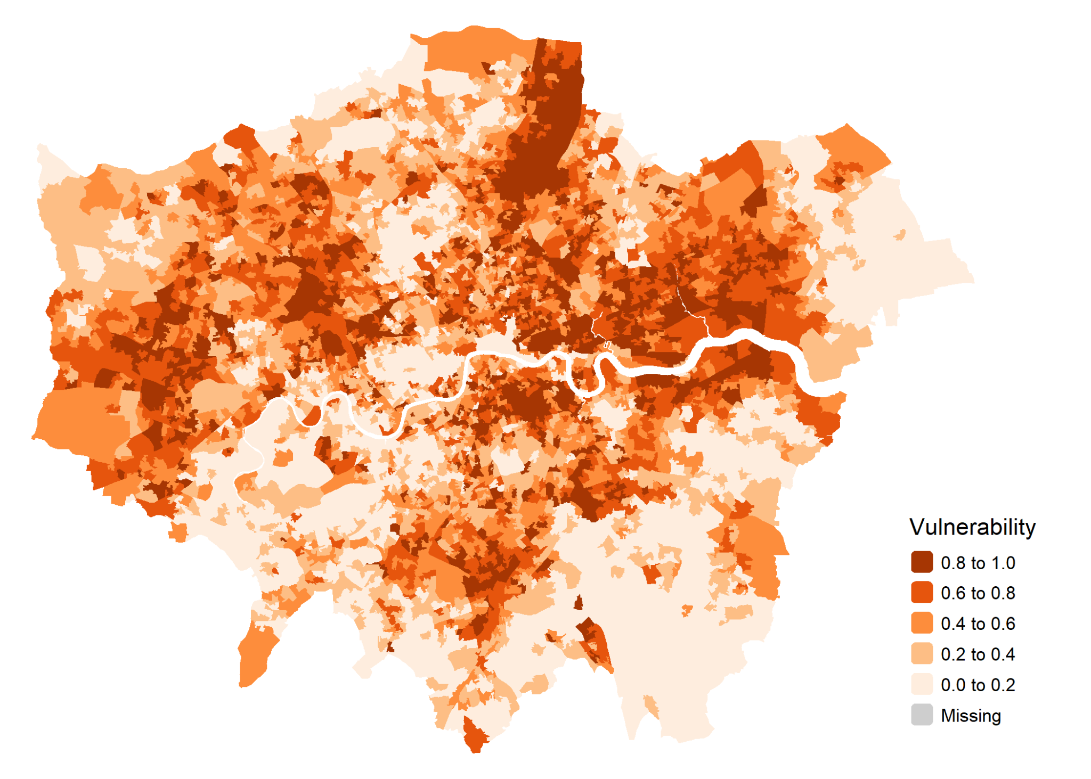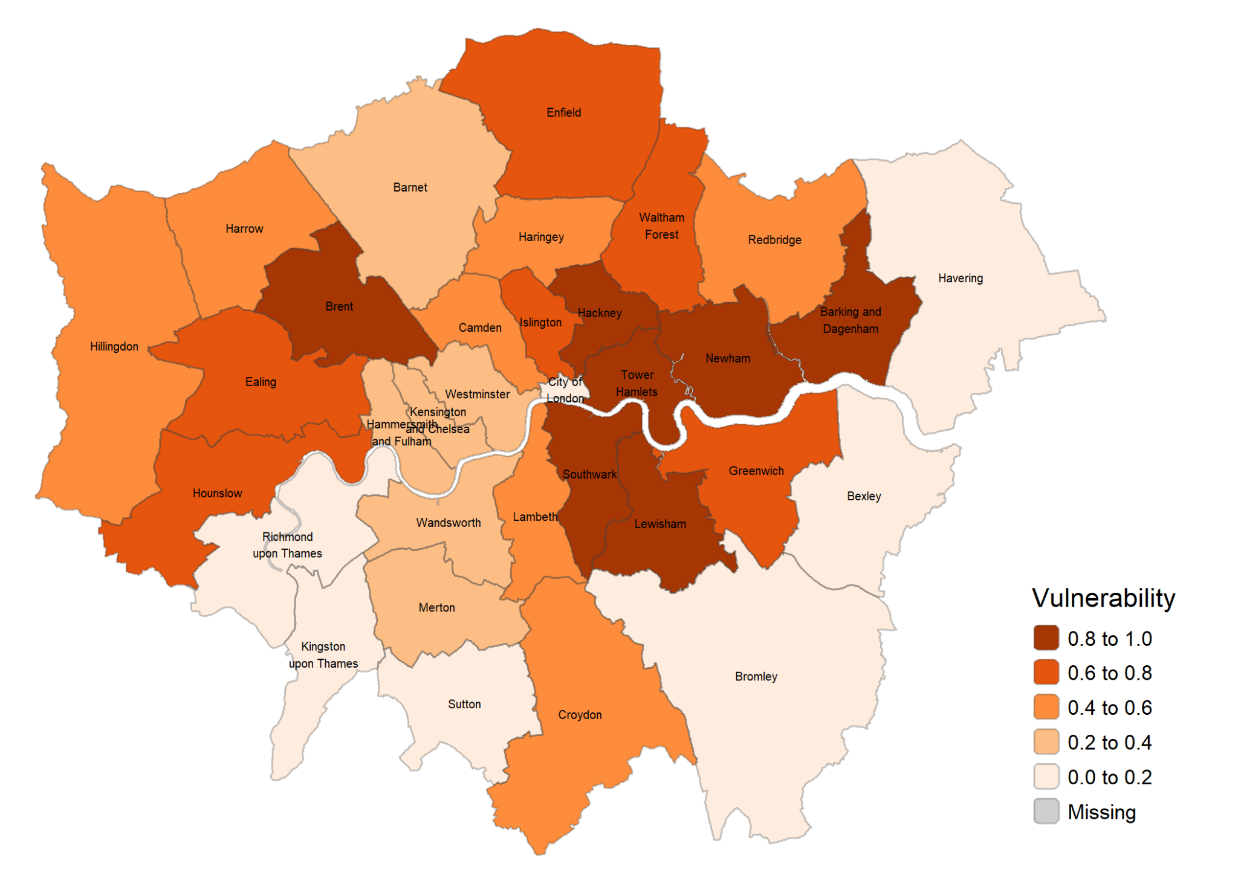
a
b

Sup. Fig. 11 | Social vulnerability index by LSOA (a) and by borough (b) in London.

Supplementary References
1. Bolton, D. The Computation of Equivalent Potential Temperature. https://journals.ametsoc.org/view/journals/mwre/108/7/1520-0493_1980_108_1046_tcoept_2_0_co_2.xml (1980).
2. Yuan, W. et al. Increased atmospheric vapor pressure deficit reduces global vegetation growth. Science Advances 5, eaax1396 (2019).
3. Lawrence, M. G. The Relationship between Relative Humidity and the Dewpoint Temperature in Moist Air: A Simple Conversion and Applications. https://doi.org/10.1175/BAMS-86-2-225 (2005) doi:10.1175/BAMS-86-2-225.
4. Hamel, P. et al. Calibrating and validating the Integrated Valuation of Ecosystem Services and Tradeoffs (InVEST) urban cooling model: case studies in France and the United States. Geoscientific Model Development 17, 4755–4771 (2024).
5. Hook, S., Halverson, G., Johnson, M. & Cawse-Nicholson, K. ECOSTRESS Tiled Ancillary NDVI and Albedo L2 Global 70 m v002. https://doi.org/https://doi.org/10.5067/ECOSTRESS/ECO_L2T_STARS.002 (2023).
6. Orlov, A., Sillmann, J., Aunan, K., Kjellstrom, T. & Aaheim, A. Economic costs of heat-induced reductions in worker productivity due to global warming. Global Environmental Change 63, 102087 (2020).

