Supporting Information

Rapid Self-Driven Formation of Conducting Polymers for Bioelectronics.
Rémy Cornuéjols¹, Tobias Abrahamsson¹, Venkata K. Perla¹, Nader Marzban¹, Jakob von Heideken¹, Donghak Byun¹, Marios Savvakis¹, Mary J. Donahue¹, Chiara Musumeci¹, Bernhard Burtscher¹, Mohsen Mohammadi¹, Johan Zötterman³, Simon Farnebo^{3,4}, Daniel T. Simon¹, Aiman Rahmanudin¹, Magnus Berggren¹, Klas Tybrandt^{1*}, Xenofon Strakosas^{1*}
Affiliations:
¹ Laboratory of Organic Electronics, Department of Science and Technology, Linköping University, 601 74 Norrköping, Sweden.
² Wallenberg Initiative Materials Science for Sustainability, Department of Science and Technology, Linköping University, 601 74 Norrköping, Sweden
³ Department of Hand and Plastic Surgery and Burns, Linköping University Hospital, Linköping 581 91, Sweden
⁴ Department of Biomedical and Clinical Sciences, Linköping University, Linköping 581 83, Sweden

* Corresponding authors email: klas.tybrandt@liu.se, xenofon.strakosas@liu.se

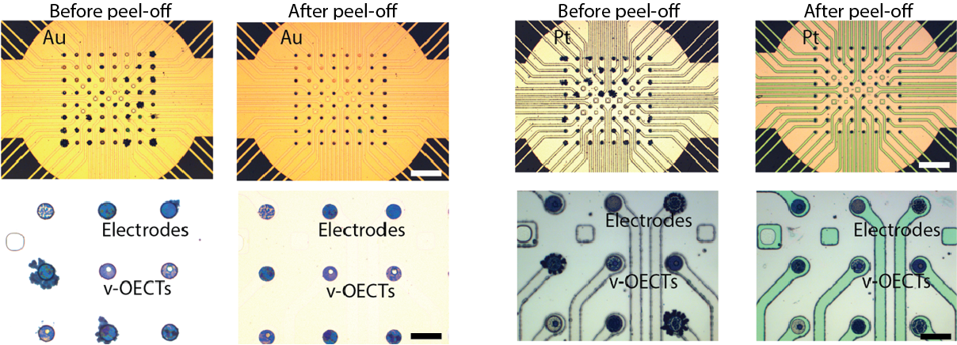
Figure S1. Self-driven polymerization on Au and Pt MEAs. Optical microscope images of MEAs before and after peel-off for Au (left) and Pt (right). For Au electrodes, an aqueous EEE-COONa solution (4 mg/mL, 0.94 mM, 5% DMSO) was drop-cast onto the electrodes, followed by immersion in water for 5 min. This process was repeated five times. For Pt electrodes, the same procedure was used but repeated three times. Scale bars: 200 µm (top), 40 µm (bottom).

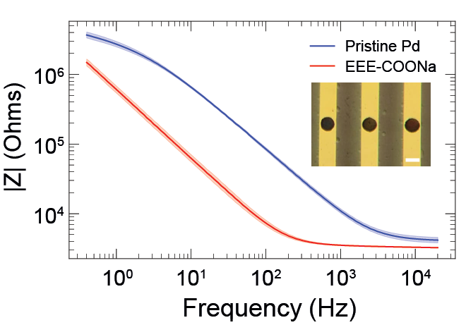
Figure S2. Self-driven polymerization on palladium electrodes. Impedance magnitude spectra of pristine Pd electrodes and Pd electrodes after self-driven polymerization of EEE-COONa (4 mg/mL, 7.51 mM), showing a pronounced impedance decrease following PEDOT-C polymer formation. Pd electrodes were prepared by electrodeposition of Pd onto Au electrodes prior to polymerization. Shaded regions represent standard deviation (n = 8). Inset: Optical microscope image of Pd electrodes after self-driven polymerization. Scale bar: 80 µm.

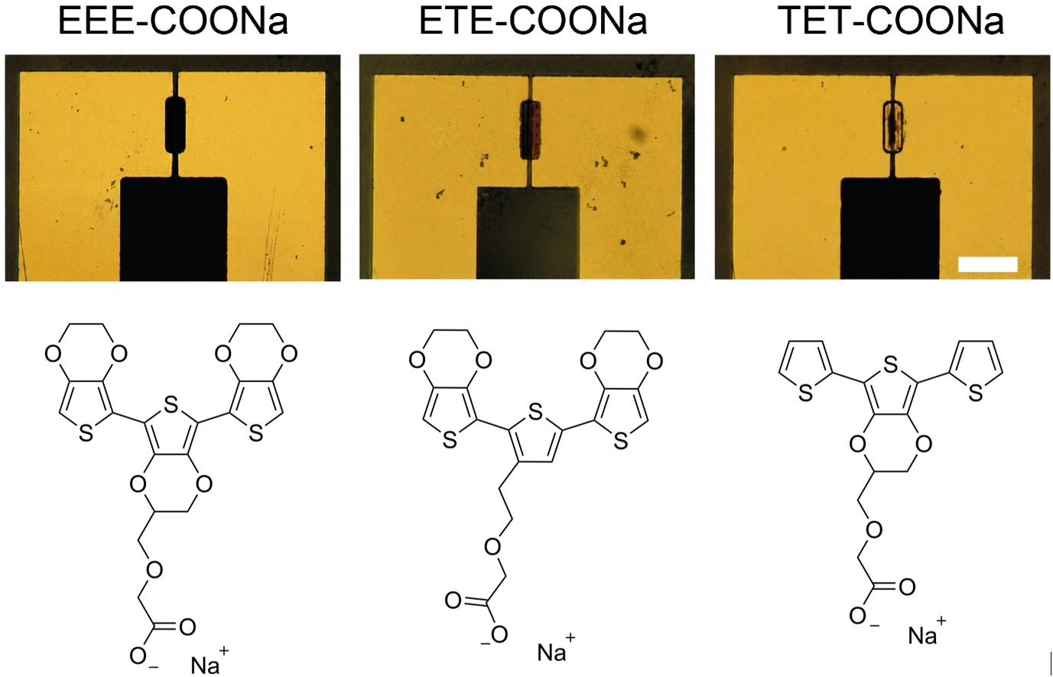
Figure S3. Optical images of 10 × 100 µm OECTs after self-driven polymerization using EEE-, ETE-, and TET-COONa monomers. EEE-COONa produced a thick and dark polymer coating, ETE-COONa resulted in a thinner and partially transparent deposition, while TET-COONa formed only a very thin coating. Monomer structure can be seen underneath. These observations are consistent with reduced extent of self-driven polymerization for higher-oxidation-potential backbones. Pads size were 3 mm², 1000 times bigger than the channel. The average measured thicknesses for EEE- & ETE-COONa was 480 nm and 360 nm respectively. Due to the very thin and discontinuous nature of the TET-COONa deposition, reliable thickness measurements could not be obtained. Scale bar: 100 µm.

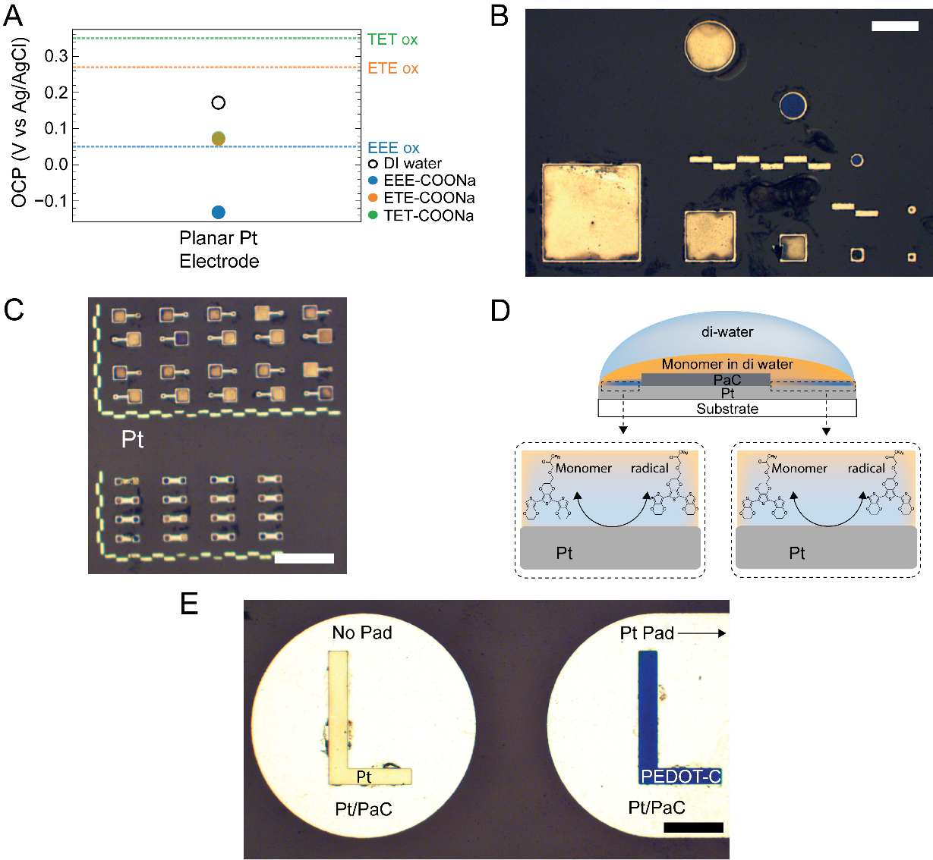
Figure S4. Self-driven polymerization behavior on Pt electrodes. (A) Open-circuit potentials (OCPs) of Pt electrodes measured in deionized water and in EEE-, ETE-, and TET-COONa monomer solutions. Horizontal dashed lines indicate the oxidation potentials of the corresponding monomers. Despite the different oxidation potentials of ETE- and TET-COONa, their OCPs converge near similar values, consistent with Pt’s strong catalytic activity toward the oxygen reduction reaction (ORR), which provides substantial cathodic current and dominates the mixed interfacial potential. In contrast, EEE-COONa shifts the OCP further negative because its significantly lower oxidation potential enables more facile monomer oxidation, thereby increasing the anodic current contribution and shifting the mixed potential to lower values. (B) Optical images of isolated Pt electrode geometries (square and circular patterns) immersed in monomer solution without electrically connected contact pads. In contrast to Au electrodes, spontaneous PEDOT-C formation is observed directly on isolated Pt structures, with thicker deposition on smaller features. This behavior is consistent with Pt’s strong catalytic activity toward the ORR, which provides sufficient local cathodic current to sustain monomer oxidation and polymer growth even in the absence of an external counter-electrode pathway. Scale bar: 100 μm. (C) Optical images of Pt electrode configurations where both electrodes and contact pads are immersed in monomer solution. PEDOT-C formation occurs on both Pt electrodes, consistent with Pt sustaining local cathodic oxygen reduction required for polymer growth. Scale bar: 250 μm. (D) Schematic illustration corresponding to (C). (E) Optical microscope images of Pt L-shaped electrodes under conditions where only one structure is electrically connected through an immersed contact pad. Left: isolated Pt structure without connected immersed pad, showing weak polymer formation visible as a slightly darker appearance. Right: electrically connected Pt structure exhibiting significantly darker and thicker PEDOT-C deposition, indicating enhanced polymerization when a spacially distinct connected pad is available for the galvanic process. Scale bar: 500 μm.
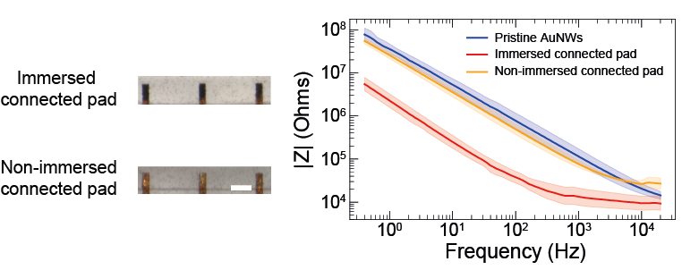
Figure S5. Requirement of connected immersed pad for self-driven polymerization on AuNW electrodes. Left: Optical images of AuNW electrodes after application of EEE-COONa monomer solution and immersion in deionized water, either with the connected conductive pad immersed (top) or not immersed (bottom). This pad corresponds to the exposed AuNW contact region used for electrical interfacing with external equipment. A visible dark PEDOT-C coating is observed only when the connected conductive pad is immersed. Right: Electrochemical impedance spectroscopy of pristine AuNWs, AuNWs with monomer and immersed connected pad, and AuNWs with monomer but without immersion of the connected pad. Shaded areas represent standard deviation (n=3). Electrodes with immersed pads exhibit a pronounced decrease in impedance, consistent with CP formation, whereas electrodes without immersed connected pads show only minor changes. Together, these results demonstrate that polymerization requires two half reactions at an electrode site and its connected pad and is not consistent with a mechanism based purely on local catalytic activity of the metal surface. Scale bar: 100 µm.
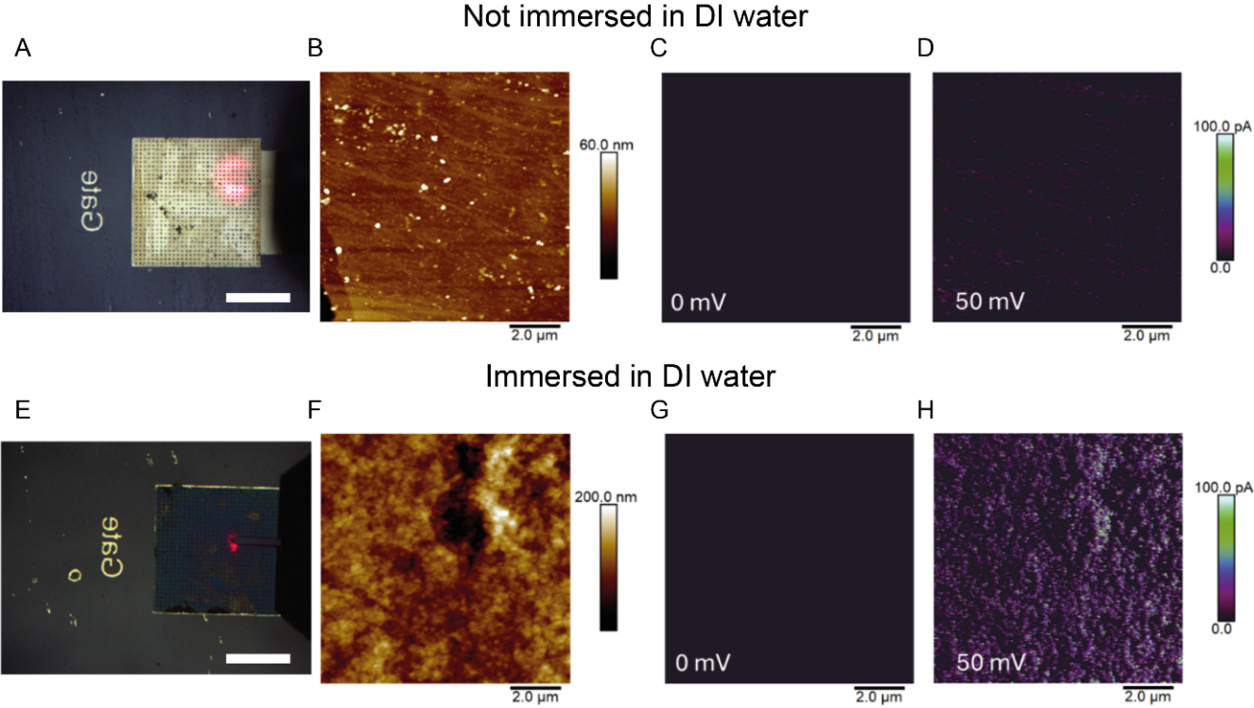
Figure S6. C-AFM of EEE-COONa samples (4 mg/mL). Electrode size: 500 x 500 µm. Monomer solutions were dried (A-D) or soaked in deionized water for self-driven polymerization and then dried (E-H). A, E) optical images. Scale bars: 250 µm. B, F) height images. C, G) current maps at 0 mV bias. D, H) current maps at 50 mV bias. The water-immersed samples show increased nanoscale conductivity compared to untreated films, indicating formation of conductive pathways associated with self-driven polymerization.

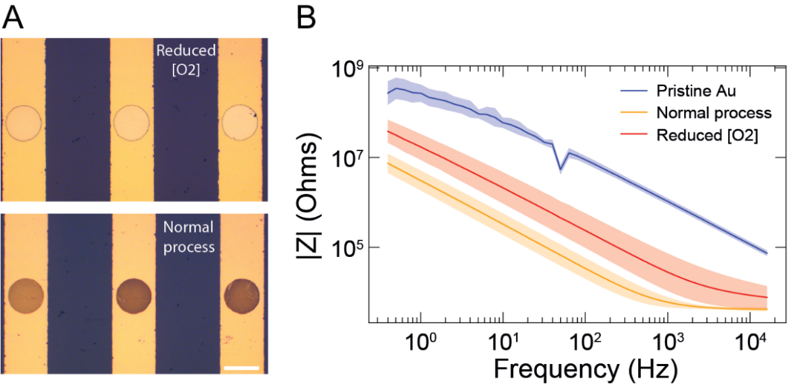
Figure S7. Effect of dissolved oxygen on self-driven polymerization. (A) Optical microscope images of Au electrodes after self-driven polymerization of EEE-COONa under reduced oxygen conditions (top) and ambient conditions (bottom). Shaded regions represent standard deviation (n = 3). Reduced oxygen conditions were achieved by sparging N₂-gas in the deionized water used prior to polymerization. Under reduced oxygen, little or no visible PEDOT-C coating was observed, whereas clear polymer deposition formed under ambient conditions. Scale bar: 80 µm. (B) Impedance magnitude spectra of pristine Au electrodes, electrodes polymerized under ambient conditions, and electrodes polymerized under reduced oxygen conditions. Reduced oxygen resulted in a smaller impedance decrease compared with ambient conditions, indicating suppressed polymer formation. The remaining impedance decrease under reduced oxygen conditions is likely due to residual dissolved oxygen and capacitive processes.
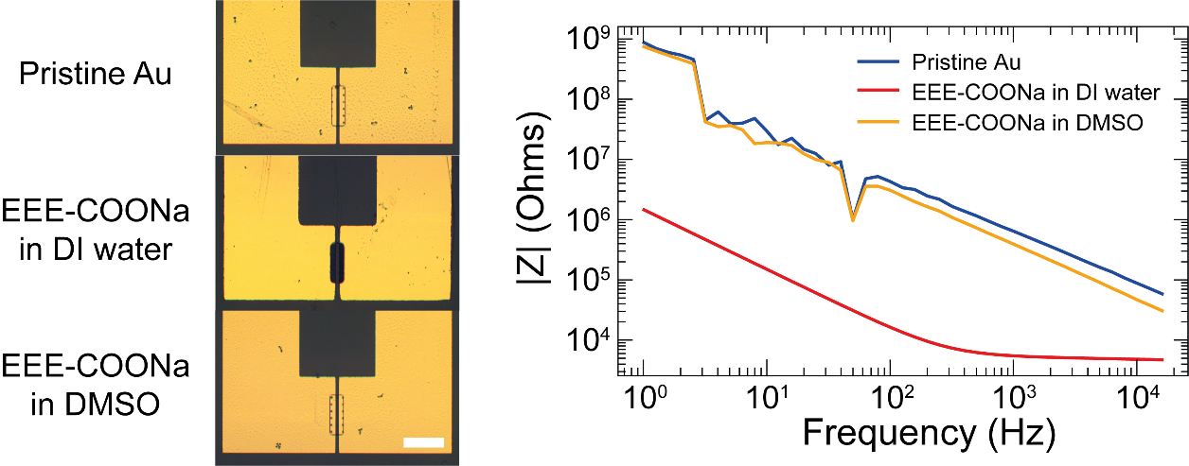
Figure S8. Self-driven polymerization of EEE-COONa on Au OECT channels in DI water and DMSO. (A) Optical microscope images of Au OECT channels for pristine Au, EEE-COONa in DI water, and EEE-COONa in DMSO. The channel opening is visible at the center. When EEE-COONa was dissolved in DMSO and the device subsequently immersed in DMSO, no visible polymer deposition was observed. In contrast, EEE-COONa in DI water formed a well-defined PEDOT-C channel, confirming that water and protons are essential for the self-driven polymerization process. Scale bar: 100 µm. (B) Corresponding impedance magnitude spectra. EEE-COONa in DI water exhibited a pronounced impedance decrease across all frequencies, consistent with formation of a CP layer, while the DMSO condition showed minimal change compared with pristine Au. Scale bar: 100 µm.
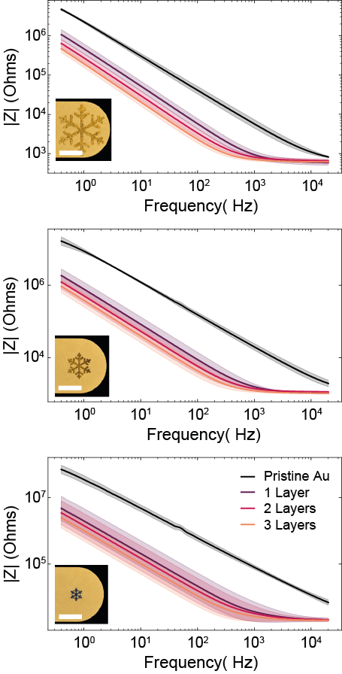
Figure S9. EIS of snowflake-patterned electrodes coated with PEDOT-C. Impedance magnitude spectra of pristine gold snowflake electrodes and after repeating the self-driven polymerization 1, 2, and 3 times ([EEE-COONa]=4 mg/mL), shown for the biggest structures (area 0.193 mm², top) and medium structures (area 0.048 mm², middle) and smallest structures (area = 0.012 mm²). Shaded regions represent standard deviation (n = 4). A progressive decrease in impedance is observed with each deposition step, consistent with increasing film thickness and enhanced interfacial conductivity. Inset: optical microscope image of a representative electrode after 3 PEDOT-C layers. Scale bars: 400 µm.

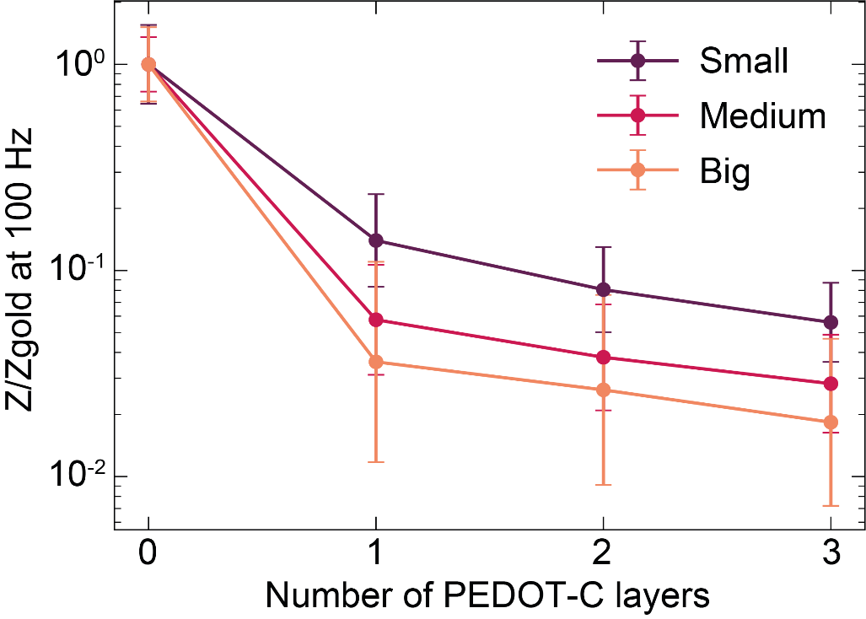
Figure S10. Relative impedance change as a function of the number of self-driven polymerization layers for different electrode sizes. Relative impedance change at 100 Hz compared to gold extracted from electrochemical impedance spectroscopy measurements after successive self-driven polymerization cycles on electrodes of different sizes. Error bars represent the standard deviation (n = 4). The first polymerization layer produced the largest decrease in impedance for all electrode geometries, indicating the formation of the initial conductive PEDOT-C pathway. Additional polymerization cycles led to incremental impedance reductions.
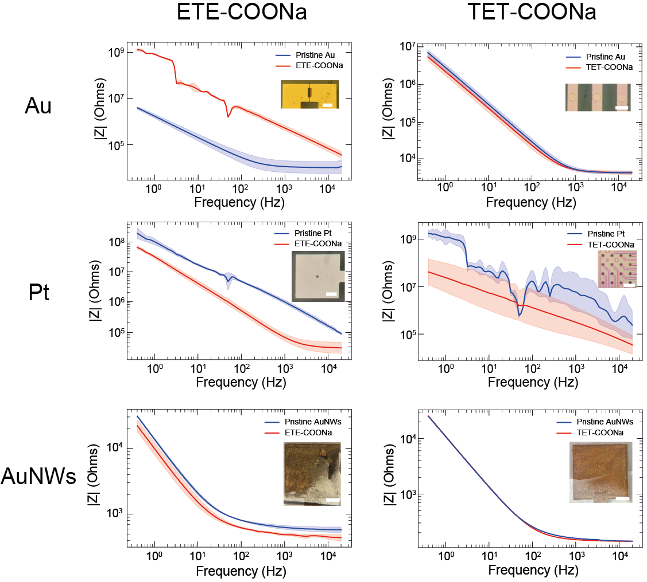
Figure S11. Self-driven polymerization for different monomer structure, electrode size and material. Impedance magnitude spectra of pristine electrodes and electrodes after exposure to ETE-COONa (left column) or TET-COONa (right column). First row: planar Au electrodes. Second row: planar Pt electrodes. Third row: AuNW electrodes. Shaded regions represent standard deviation (TET-COONa on Pt: n=8, ETE-COONa and TET-COONa on AuNWs: n=2, n=3 for the rest). Insets show optical microscope images of the corresponding electrodes after the self-driven polymerization process. On Au, ETE-COONa induced an impedance decrease and polymer coverage, whereas TET-COONa produced minimal impedance change and no visible polymer formation. On Pt, both ETE-COONa and TET-COONa resulted in pronounced impedance decreases and visible polymer coatings, consistent with successful self-driven polymerization. On AuNW electrodes, ETE-COONa produced moderate impedance reduction and partial polymer coverage, while TET-COONa showed no impedance change and no clear polymer deposition. These results demonstrate that polymerization efficiency depends on monomer oxidation potential, electrode material and size. Scale bars: Au and Pt: 100 µm, AuNWs: 0.5 mm. Pad-to-electrode surface area ratios: ETE-COONa and TET-COONA on Au: 1000 and 400 respectively; on Pt, 750; on AuNWs: 1.

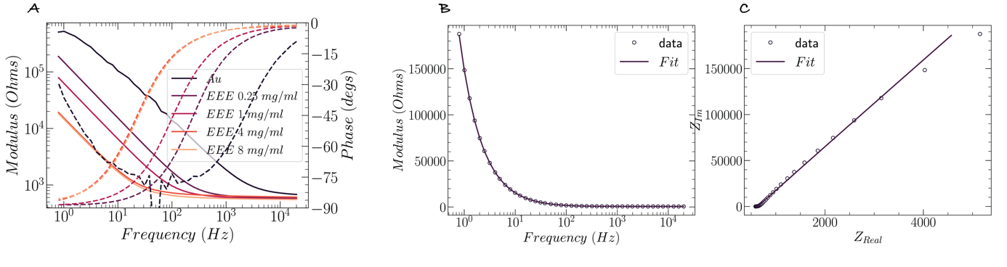
Figure S12. Electrochemical characterization of PEDOT-C films (A) Bode magnitude and phase plots of devices prepared with different EEE-COONa concentrations (0.25, 1, 4, and 8 mg/mL) after 15 min of self-driven polymerization in deionized water. Electrode area: 500 × 500 μm². B, C) Bode and Nyquist plot for 4 mg/mL EEE-COONa sample data and fit. Randles equivalent circuit was used a fitting model with Constant Phase Element (CPE). Specific capacitance was calculated from best fitting parameters and geometrical film characteristics.

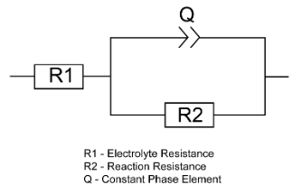
Figure S13. Equivalent circuit used to fit the EIS data. The circuit consists of R₁ (electrolyte and electronic resistance in series), Q (constant phase element representing the capacitive behavior of the porous electrode), and R₂ (charge-transfer/reaction resistance). For Au electrodes, all fitting parameters were obtained automatically from the equivalent circuit fit. For AuNW electrodes, the pseudocapacitance was estimated by fixing R₁ = 5.5 kΩ and R₂ = 91.3 MΩ, replacing Q with an ideal capacitor (C), and re-fitting the circuit. The equivalent circuit provided an excellent fit to the experimental data, as illustrated by the corresponding Bode plot in Fig. 5f, with minimal deviation and a goodness-of-fit value of α = 0.93.

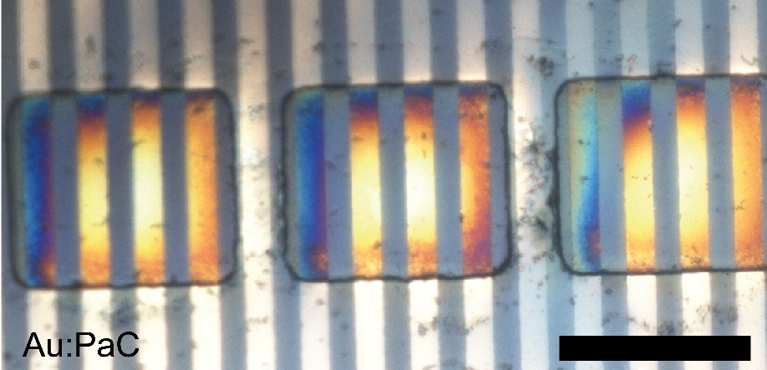
Figure S14. Planar metal electrodes patterned on PaC used for electrical characterization. Patterns of planar gold with known area (100x100 μm²). The rest of the gold is coated with PaC. The four lines were used to measure conductivity of EEE-COONa polymer in a 4-point probe configuration. Constant current was applied to the outer lines of each squares and voltage was measured on the inner Au lines. The conductivity was calculated considering the geometrical characteristics. Scale bar: 100 μm.

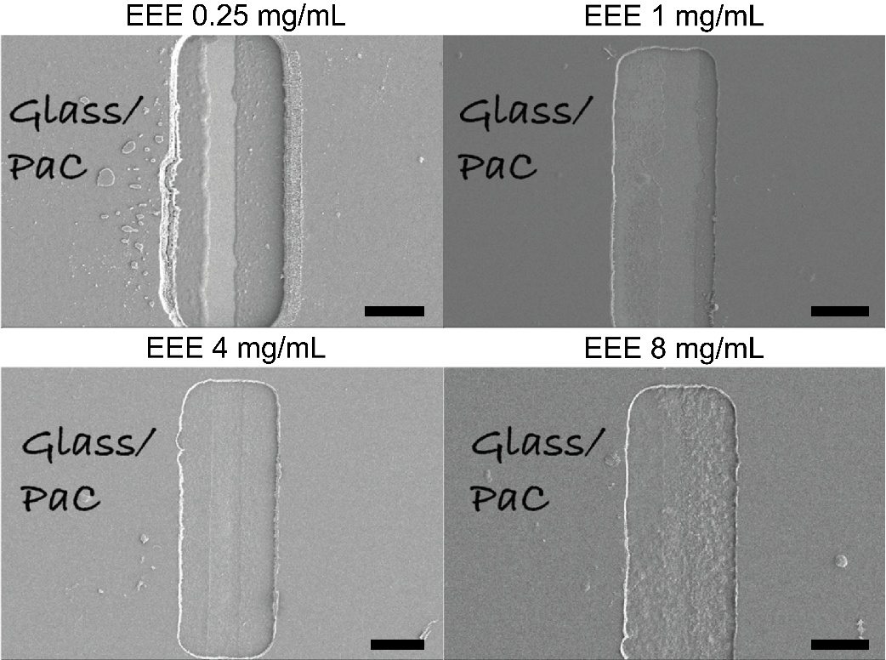
Figure S15. SEM on channels coated with EEE-COONa polymer after soaked in water. Top panel: 0.25 mg/ml (left), EEE 1 mg/ml (right). Bottom panel: 4 mg/ml (left) and 8 mg/ml (right). Scale bars: 20 μm.

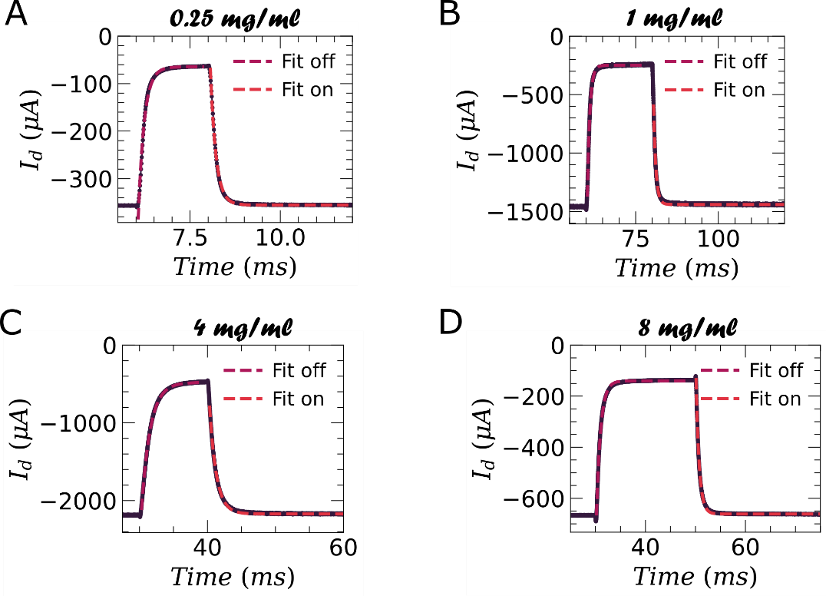
Figure S16. Step response for OECTs. with W = 100 µm and L = 10 µm at V_{D} = -500 mV and V_{G} = -400 mV with 200 mV pulses for A) 0.25 mg/ml (t_{ON} = (149 ± 1) µs; t_{OFF} = (155 ± 1) µs), B) 1 mg/ml (t_{ON} = (710 ± 2) µs; t_{OFF} = (746 ± 3) µs), C) 4 mg/ml (t_{ON} = (1060 ± 4) µs; t_{OFF} = (1330 ± 5) µs) and D) 8 mg/ml (t_{ON} = (643 ± 1) µs; t_{OFF} = (841 ± 2) µs).
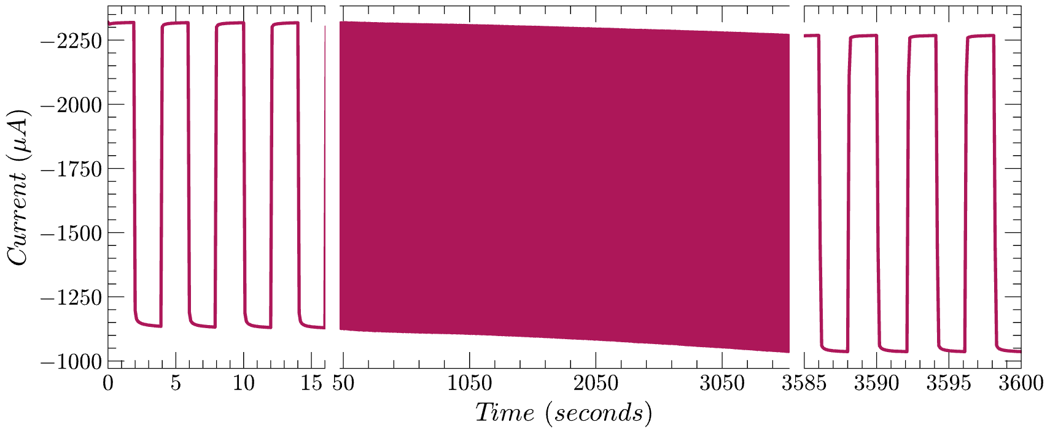
Figure S17. OECT cycling stability ([EEE-COONa] = 4 mg/mL) for 1h. This demonstrates the long-term stability of the OECT response under repeated cycling conditions. V_{D} = -200 mV and V_{G1} = -200 mV for 2s and V_{G2} = 200 mV for 2s.

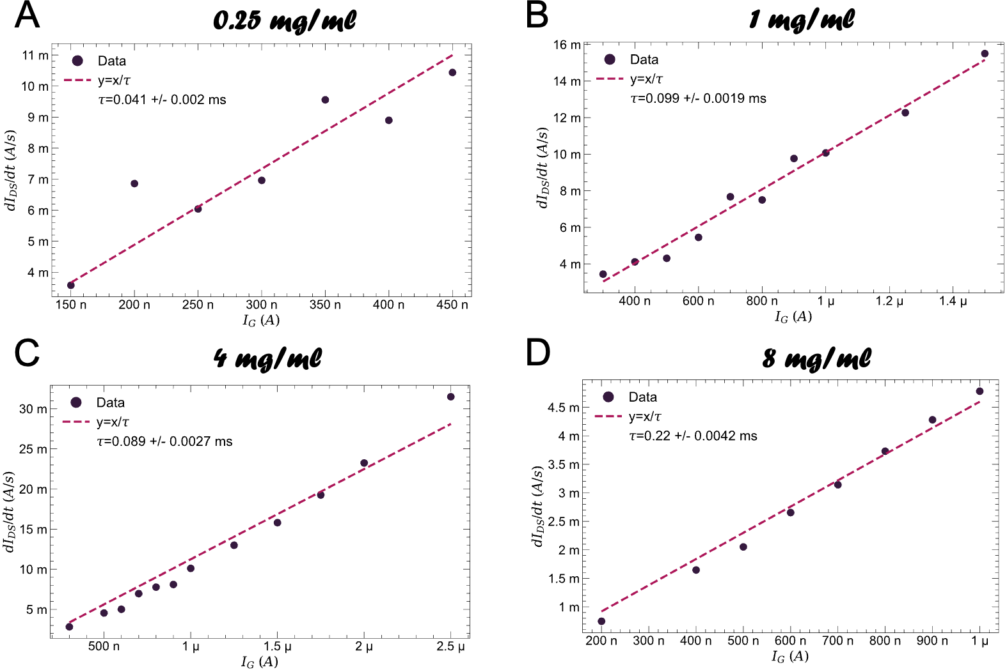
Figure S18. Time of flights mobility measurements as dI_{D}/dt vs. I_{G} for OECTs. With channel dimensions W = 100 µm and L = 10 µm at V_{D} = -500 mV to obtain τ for determining µ_{OECT}. Charge carrier mobility A) 0.25 mg/ml (one device): µ_{OECT} = (0.049 ± 0.003) cm² V⁻¹ s⁻¹; B) 1 mg/ml (one device): µ_{OECT} = (0.020 ± 0.001) cm² V⁻¹ s⁻¹; C) 4 mg/ml (three devices): µ_{OECT} = (0.011 ± 0.006) cm² V⁻¹ s⁻¹; D) 8 mg/ml (three devices): µ_{OECT} = (0.012 ± 0.005) cm² V⁻¹ s⁻¹.
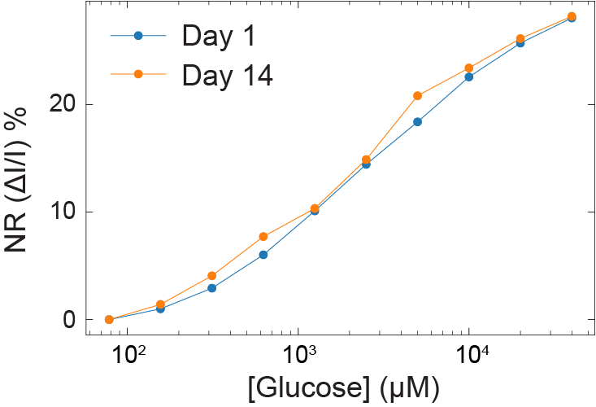
Figure S19. Long-term stability of glucose OECT sensors over two weeks. Calibration curves of glucose OECT biosensors measured on day 1 and day 14 after fabrication, showing minimal differences due to the stability of the sensors over time.
Figure S20. Recruitment curves across all 32 stimulation electrodes. Each subplot shows the amplitude–response relationship for a single stimulation electrode channel (Ch 1–32). EMG responses were quantified for gastrocnemius medialis (GM) and tibialis anterior (TA) as the time integral of the rectified EMG (|EMG|) within the 0–15 ms post stimulus window. Responses are normalized within each muscle to the maximum mean response observed across all electrodes–amplitude conditions in the dataset. Points show the mean across trials and error bars indicate ±1 SD; excluded electrode–amplitude combinations (if any) were omitted from the averages.

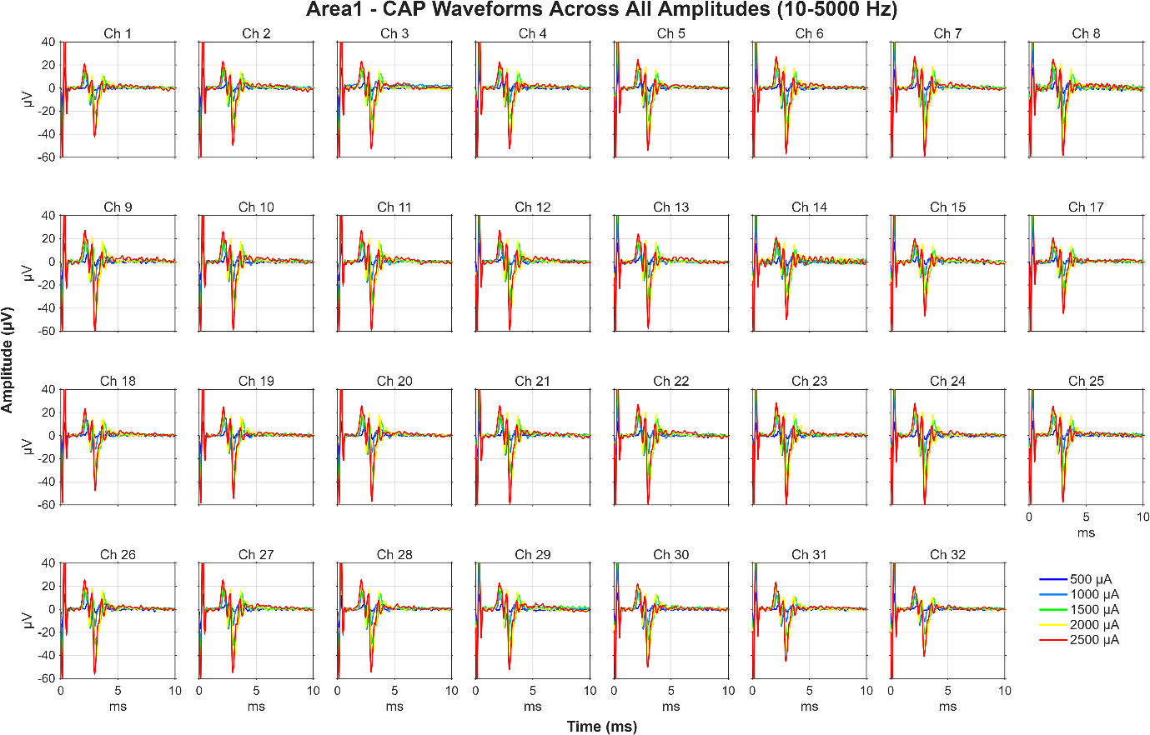
Figure S21. (Area 1). CAP waveforms across all recording channels for Area 1 stimulation, overlaid across amplitudes (500–2500 µA).
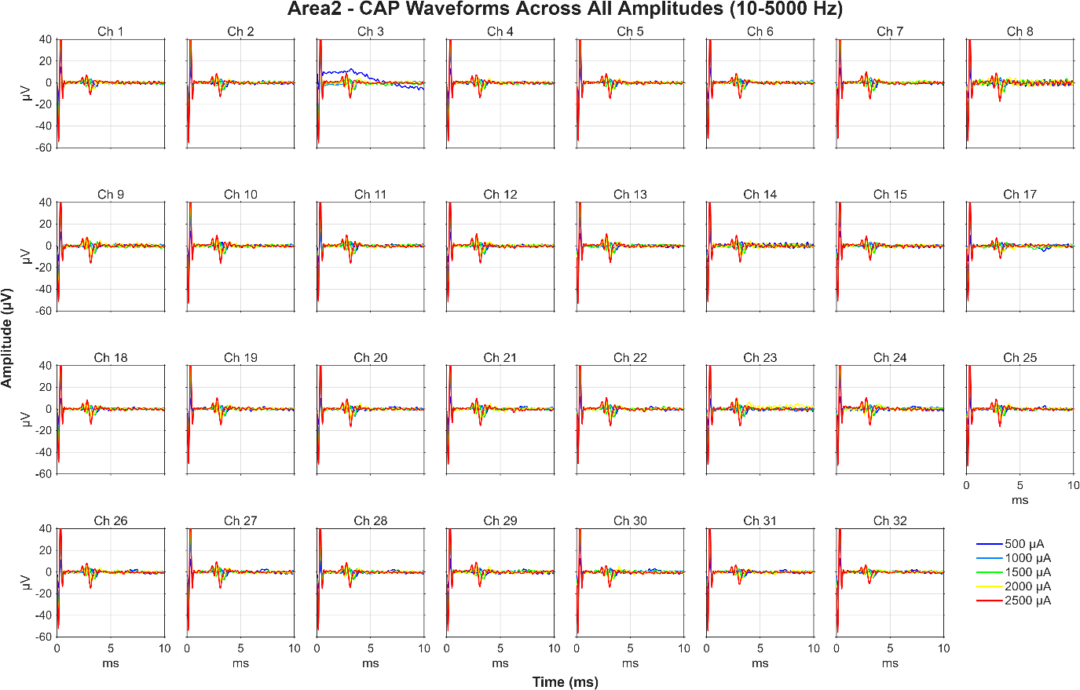
Figure S22. (Area 2). CAP waveforms across all recording channels for Area 2 stimulation, overlaid across amplitudes (500–2500 µA).
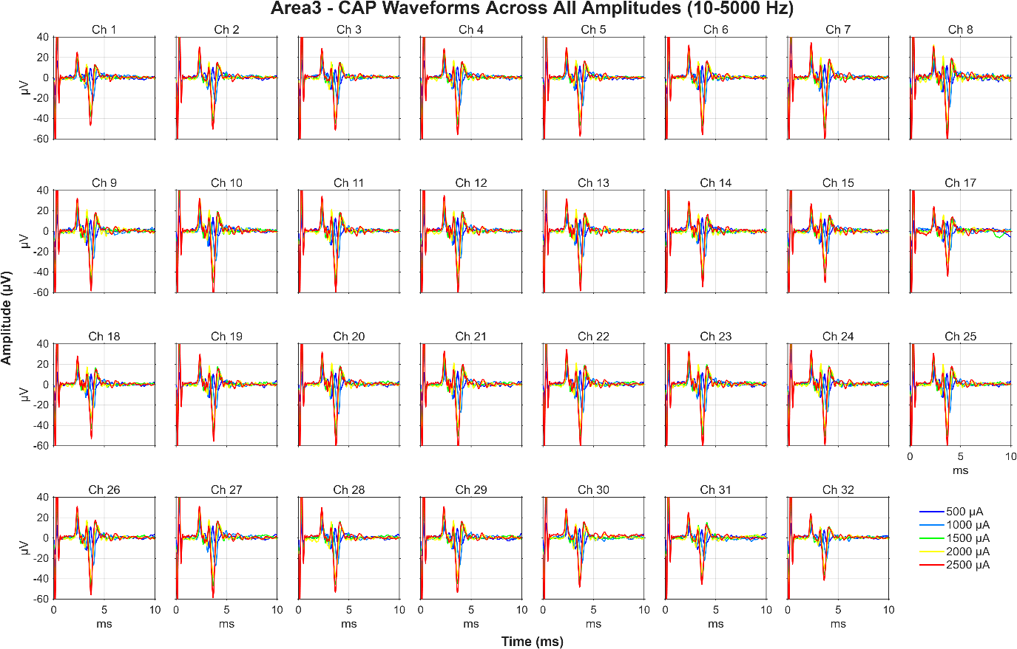
Figure S23. (Area 3). CAP waveforms across all recording channels for Area 3 stimulation, overlaid across amplitudes (500–2500 µA)

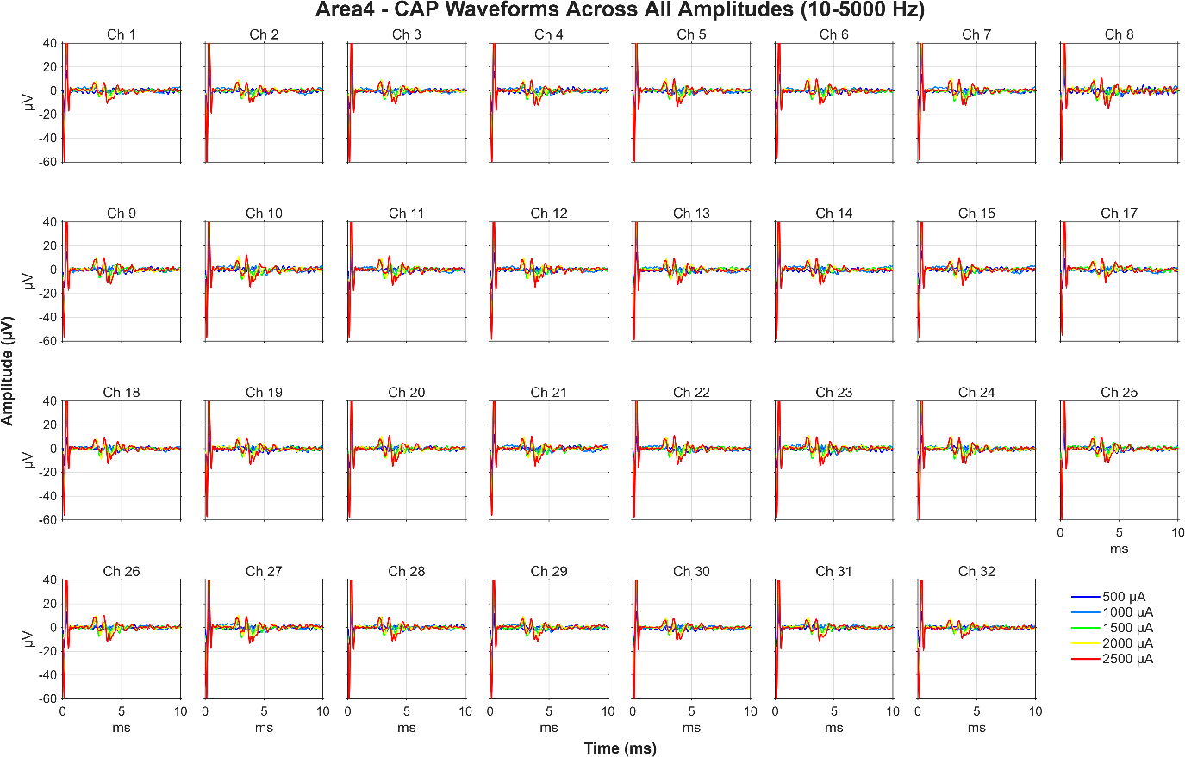
Figure S24. (Area 4). CAP waveforms across all recording channels for Area 4 stimulation, overlaid across amplitudes (500–2500 µA).

Electrode material | Electrode size  (10³ µm²) | Areal impedance at 1 kHz  (Ohm cm²) | Areal capacitance (mF/cm²) | Reference
PEDOT coated AuNWs | 2.5 | 0.16 | 15.4 | This work
Pt plated AuNWs | 120 | 1.2 | 1.4 | ¹
Pt coated Au-TiO₂NW | 2.5 | 0.3 | 2.7 | ⁴
CNTs in PDMS | 160 | 6.2 | 0.7 | ²
Graphene flakes/CNT hydrogel | 385 | 390 | 1.3* | ³
PEDOT:PSS/PEG on microcracked Au | 80 | 0.8 | 0.59 | ¹
PEDOT:PSS/ionic liquid on microcracked Au | 8 | 24 | - | ⁴
PEDOT:PSS/glycerol | 4000 | 10 | 49* | ⁵
PEDOT:PSS/ionic liquid | 60 | 0.2 | 9.8* | ⁶
PPy/PCTC | 800 | 80 | 35* | ⁷
Pt particle/PDMS composite | 71 | 3.7 | 34* | ⁸
Pt on EGaIn/PDMS | 2.8 | 7 | - | ⁹
Microcracked Au | 60 | 3.6 | - | ¹⁰
* Estimated from charge storage capacity.
Table S1. Comparison of stretchable neural electrodes from literature for which areal impedance is provided or can be calculated.

References
1. Decataldo, F. et al. Stretchable Low Impedance Electrodes for Bioelectronic Recording from Small Peripheral Nerves. Scientific reports 9, 10598 (2019).
2. Terkan, K. et al. Soft peripheral nerve interface made from carbon nanotubes embedded in silicone. APL Materials 8, 101111 (2020).
3. Tringides, C. M. et al. Viscoelastic surface electrode arrays to interface with viscoelastic tissues. Nat Nanotechnol 16, 1019–1029 (2021).
4. Liu, J. et al. Intrinsically stretchable electrode array enabled in vivo electrophysiological mapping of atrial fibrillation at cellular resolution. Proc Natl Acad Sci U S A 117, 14769–14778 (2020).
5. Liu, Y. et al. Morphing electronics enable neuromodulation in growing tissue. Nature Biotechnology 38, 1031–1036 (2020).
6. Liu, Y. et al. Soft and elastic hydrogel-based microelectronics for localized low-voltage neuromodulation. Nat Biomed Eng 3, 58–68 (2019).
7. Guo, L., Ma, M., Zhang, N., Langer, R. & Anderson, D. G. Stretchable Polymeric Multielectrode Array for Conformal Neural Interfacing. Advanced Materials 26, 1427–1433 (2014).
8. Minev, I. R. et al. Biomaterials. Electronic dura mater for long-term multimodal neural interfaces. Science 347, 159–163 (2015).
9. Dong, R. et al. Printed Stretchable Liquid Metal Electrode Arrays for In Vivo Neural Recording. Small 17, 2006612 (2021).
10. Hiendlmeier, L. et al. 4D-Printed Soft and Stretchable Self-Folding Cuff Electrodes for Small-Nerve Interfacing. Advanced Materials 35, 2210206 (2023).

