Evaluation of Lens Parameters Using Anterior Segment Optical Coherence Tomography for Zonular Weakness Risk in Cataract Surgery

Tatsuaki Amari, Suguru Nakagawa, and Kiyoshi Ishii

Supplementary Figure S1. Box-and-whisker plots of the CASIA2-derived crystalline lens parameters by zonular status. (A) FrontR, (B) lens decentration, and (C) lens tilt. n = 28 eyes per group. CTR, capsular tension ring; FrontR, anterior curvature radius; IOL, intraocular lens

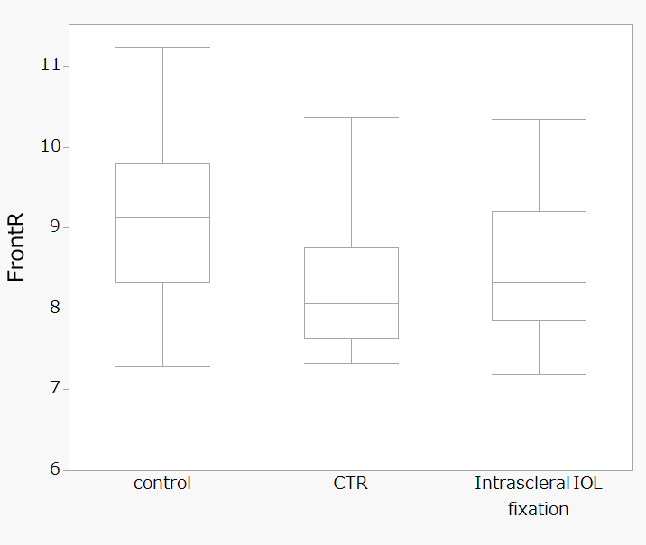
(A) Median FrontR (mm): control, 9.2 mm; CTR, 8.1 mm; intrascleral fixation, 8.3 mm. The CTR group shows significant steepening (p = 0.012 vs. control); a similar trend in the intrascleral fixation group was attenuated by case heterogeneity.

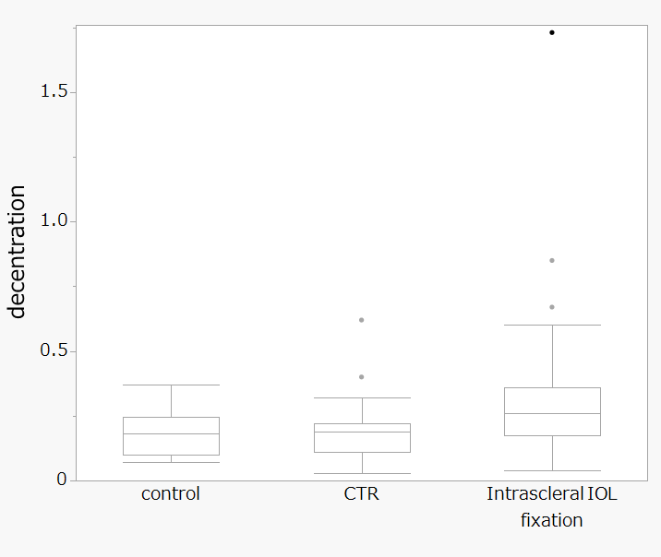
(B) Median decentration (mm): control, 0.18 mm; CTR, 0.19 mm; intrascleral IOL fixation, 0.26 mm. The decentration in the intrascleral IOL fixation group was significantly elevated (p = 0.039 vs. control) with outliers >0.5 mm.
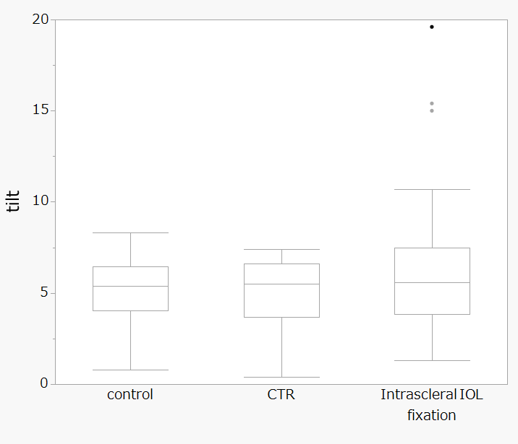
(C) Median lens tilt (°): control 5.4°, CTR 5.5°, intrascleral IOL fixation 5.6°. The intrascleral IOL fixation group demonstrated outliers exceeding 10°.

