Supporting Information
A Highly Potent Nanomedicine for Precision Pancreatic Enzyme Replacement Therapy
Table of Contents

I) Materials 2
II) Manufacturing and Analytics 2
1) Core SNPs production 2
2) Production of PER300N 2
3) Production of PER300F 3
4) PER300N and PER300F radiolabeling 3
5) PER301 drug substance (PER301-DS) synthesis 4
6) PER301 drug product (PER301-DP) production 4
7) PER301 final dosage form (PER301-FDF) production 4
8) Sodium taurocholate quantification 5
9) Chitosan quantification 5
10) Scanning Electron Microscopy (SEM) 6
11) Collapse temperature determination 7
12) Pancreatic lipase activity assay using a fluorescent artificial lipase substrate 7
13) Pancreatic lipase activity assay by pH-stat titration 7
14) Pancreatic protease activity assay 9
15) Pancreatic amylase activity assay 9
16) Volumetric Karl Fischer (KF) titration 10
17) Laser diffraction 10
18) Cell culture 10
19) Development of the in vitro human intestinal barrier model 11
20) Safety of PER301 11
21) CCK-8 assay 12
22) Cell-Titer Glo Luminescent Cell Viability Assay 12
III) In vivo protocols 13
1) Biodistribution study using SPECT/CT in Göttingen Minipig dosed intraduodenal with In-111 labelled nanoparticles 14
2) Proof of concept of PER301 in PDL dogs 20
3) Proof of concept of PER301 in PDL minipigs 23
4) Analyses of biological samples 26

Materials
- Tetraethyl orthosilicate 99% (TEOS), (3-aminopropyl)-triethoxysilane (APTES), ammonium hydroxide (ACS grade, 28–30%), ethanol (ACS grade, anhydrous), glutaraldehyde (grade I, 25% in water), Chelex® 100 sodium form, polysorbate 80, bovine serum albumin (BSA), potassium phosphate monobasic, potassium phosphate dibasic, sodium taurocholate hydrate, acetic acid, histidine, cysteine, trehalose, Bile Acid Assay kit, 1,2-Di-O-lauryl-rac-glycero-3-(glutaric acid 6-methylresorufin ester), olive oil, gum arabic from acacia tree, sodium chloride, sodium hydroxide, Trizma base, bile salts, casein, sodium carbonate, folin reagent, trichloroacetic acid (TCA), starch, Triton X-100 were purchased from Sigma-Aldrich.
- p-SCN-Bn-DOTA was purchased from Macrocyclics.
- Pancreatin was supplied by Nestlé Health Science.
- Benzyltriethoxysilane (96%) was purchased from abcr GmbH.
- Chitosan 95/500 P was purchased from Heppe Medical Chitosan GmbH
- Cell Counting Kit-8 and Chitosan Assay kit were purchased from abcam
- CellTiter-Glo® Luminescent Cell Viability Assay 2.0 was purchased from Promega
- Indium chloride (¹¹¹In) was purchased from Curium
- Animal diet Altromin 1324 and Altromin 9033 were purchased at Altromine international
- The catheters were purchased at Instech Laboratories
- Caco-2 (human colorectal adenocarcinoma cell line) and HT29-MTX-E12 (human colon cancer cell line) was purchased from the European Collection of Authenticated Cell Cultures (ECACC).
- ThinCert™ cell culture insert plates (1.0μm membrane) were purchased from Greiner bio-one.
- Fetal Bovine Serum, Penicillin/Streptomycin (10’000 U/ml Penicillin/10’000 μg/ml Streptomycin), MEM Non-Essential Amino Acids (100x), L-Glutamine 200mM (100x), Dulbecco’s Phosphate Buffered Saline DPBS (1X), DMEM were purchased from Gibco.
- Hydranal – Composite 5, Hydranal – MeOH sec and Water Standards 10.0 (for KF titration) were purchased from Honeywell.
- Eudracap® functional ready-to-fill capsules were purchased from Evonik.

Manufacturing and Analytics

Core SNPs production
In a 1 L bioreactor, EtOH, H₂O and NH₄OH were added. The solution was equilibrated at 20 °C for 1 hour. Then, TEOS was added. The reaction mixture was allowed to react for 21 hours at 290 rpm, 20 °C. The milky solution was concentrated to 250 mL with TFF (proStream membrane 30 kDa) and washed with EtOH and sterile water. The resulting solution was tip sonicated and stored at 4 °C. An aliquot of the suspension of 1 mL was lyophilized to determine nanoparticle concentration.

Production of PER300N
Before production, all solutions were treated with chelex-chelating resin to extract metal ions.
APTES was added to SNPs (10 mg/mL) in H₂O/PS80 (8 mg/L). The reaction mixture was allowed to react for 10 min at 20 °C, 290 rpm to yield amino-modified SNPs. Then, p-SCN-Bn-DOTA was added. The reaction mixture was allowed to react for 1 hour at 50 °C. The particles were washed 3 times by centrifugation (20 min at 20000 rcf) in H₂O/PS80 (8 mg/L) and resuspended in H₂O/PS80 (8 mg/L). The resulting suspension was tip sonicated. To DOTA-modified SNPs (10 mg/mL) in H₂O/PS80 (8 mg/L) was added APTES. The reaction mixture was allowed to react for 10 min at 20 °C, 290 rpm. Then, glutaraldehyde (25% in H₂O) was added. The reaction mixture was allowed to react for 10 min at 20 °C, 400 rpm to yield SNPs-DOTA-GA. A priming step was performed by adding APTES. The reaction mixture was allowed to react for 10 min at 20 °C, 290 rpm to yield SNPs-DOTA-P. Then, a BSA solution was added. The reaction mixture was allowed to react for 10 min at 20 °C, 290 rpm to yield SNPs-DOTA-BSA. An organosilica layer was grown at the surface of SNPs-DOTA-BSA by adding APTES and TEOS. The reaction mixture was allowed to react for 5 hours at 20 °C, 290 rpm.
The particles were centrifuged (5 min at 20000 rcf) and the supernatant was collected. Particles were washed 3 times in H₂O/PS80 (8 mg/L), NaCl (0.9%) and resuspended in H₂O/PS80 (8 mg/L), NaCl (0.9%) to yield PER300N. PER300N were stored in the fridge at ~4 °C. A sample of the resulting suspension was lyophilized to determine PER300N concentration. An aliquot of the suspension of 1 mL was lyophilized to determine nanoparticle concentration. Concentration was adjusted to 33 mg/mL.

Production of PER300F
A chitosan solution (500 µg/mL) in acetic acid (0.1 M) was added to PER300N suspension. The reaction mixture was allowed to react for 30 min at 20 °C, 290 rpm. The particles were centrifuged (5 min at 20000 rcf) and washed 3 times in H₂O/PS80 (8 mg/L), NaCl (0.9%) and resuspended in H₂O/PS80 (8 mg/L), NaCl (0.9%) to yield PER300F. An aliquot of the suspension of 1 mL was lyophilized to determine nanoparticle concentration. Concentration was adjusted to 33 mg/mL.

PER300N and PER300F radiolabeling
The particles were radiolabeled with Indium-111 (¹¹¹In) to achieve a specific activity of 400-500 MBq/g.
The labeling reaction was initiated by combining ¹¹¹In (supplied in 0.02 M HCl) with the particle suspension. A labeling buffer was subsequently added, the volume of which was calculated to be 1/9 of the combined volume of the particle suspension (30 mL) and the ¹¹¹In solution. The initial activity and the reaction pH were measured using an indicator paper. The reaction mixture was then incubated for 20 hours at 45°C under continuous stirring.
After incubation, the reaction mixture was cooled to room temperature. A sample was withdrawn for radio-TLC analysis to determine the initial incorporation yield. The labeled particles were separated by centrifugation at 5000 g. The supernatant was carefully discarded, and its residual activity was measured. The resulting pellet was resuspended in 18 mL of 20 mM sodium acetate containing 8 mg/L PS80. Resuspension was achieved by tip sonication for 5 min. To chelate any remaining free radionuclide, 2 mL of 1 mM DTPA pH 5 (representing 10% of the total volume) was added to the reaction mixture. The quenching process was carried out overnight at room temperature. Following the quenching step, the particles were subjected to a final purification process. The mixture was centrifuged at 5000 g for 5 min. The supernatant was measured and discarded. The pellet was then resuspended in 20 mL of a formulation buffer 0.9% NaCl, 8 mg/L polysorbate 80, pH 5 via tip sonication. This washing cycle was repeated two additional times for thorough purification. A sample of the final product was taken for radio-TLC analysis to confirm the final radiochemical purity. Prior to administration in vivo, the labeled compound was immediately drawn into a syringe to strictly prevent aggregation or sedimentation of the particles.

PER301 drug substance (PER301-DS) synthesis
APTES was added to SNPs (30 mg/mL) in phosphate buffer (20 mM, pH 8), PS80 (8 mg/L). The reaction mixture was allowed to react for 10 min at 20 °C, 290 rpm to yield the amino-modified SNPs. Then, glutaraldehyde (25% in H₂O) was added. The reaction mixture was allowed to react for 10 min at 20 °C, 290 rpm to yield SNPs-GA. A priming step was performed by adding additional APTES. The reaction mixture was allowed to react for 10 min at 20 °C, 290 rpm to yield SNPs-P. Then, sodium taurocholate was added. The suspension was stirred for 2 minutes and pancreatin was added. The reaction mixture was allowed to react for 10 min at 20 °C, 290 rpm to yield SNPs-Pancreatin. The organosilica layer was grown by adding APTES, TEOS and benzyltriethoxysilane. The reaction mixture was allowed to react for 5 hours at 20 °C, 290 rpm. The particles were centrifuged (5 min at 1000 rcf), the supernatant was collected and protein quantification (Lowry assay). Particles were washed 3 times (by centrifugation during 5 min at 1000 rcf) in phosphate buffer (20 mM, pH 8), PS80 (8 mg/L) and resuspended in phosphate buffer (20 mM, pH 8), PS80 (8 mg/L). SNPs-Pancreatin-ATB were cured overnight in a water bath at 20 °C. A chitosan solution (1500 µg/mL) in acetic acid (0.1 M) was added to the particle suspension. The reaction mixture was allowed to react for 30 min at 20 °C, 290 rpm. The particles were centrifuged (5 min at 1000 rcf) and washed 3 times in histidine buffer (125 mM), PS80 (8 mg/L) and resuspended in histidine buffer (125 mM), PS80 (8 mg/L) to yield SNPs-Pancreatin-ATB-Chitosan. An aliquot of the suspension of 1 mL was lyophilized to determine nanoparticle concentration. Nanoparticle concentration was adjusted to 50 g/L with a solution of histidine buffer (125 mM), PS80 (8 mg/L) and trehalose (20 mM) and cysteine (15 mM) were added.

PER301 drug product (PER301-DP) production
PER301-DS was fast frozen using a liquid nitrogen freezer. The collected pellets were transferred into a lyophilizer and lyophilized for 7 days. Powder was blended and transferred into a glove box under inert atmosphere.

PER301 final dosage form (PER301-FDF) production
PER301-DP (150 mg) was loaded into enteric capsules (Eudracap enteric) using an Optima 100 capsule loading kit (Farmalabor). Capsules were loaded into aluminum bags and shipped to the CRO for further testing.

Sodium taurocholate quantification
Sodium taurocholate (NaTc) quantification in PER301 samples was conducted using a fluorometric Bile Acid Assay Kit based on the 3-hydroxysteroid dehydrogenase-mediated reduction of NAD to NADH. Working Reagents (WR) and Blank Reagents (BR) were prepared according to the manufacturer’s specifications, utilizing Assay Buffer, NAD, Probe, and Enzymes A and B, while an 80 µM sodium cholate solution served as the internal standard (IS). Reaction supernatants were pre-diluted 50-fold in ultrapure water prior to analysis. For the assay, 24 µL of sample was mixed with either 6 µL of water (Sample), 6 µL of IS (Internal Standard), or 6 µL of water (Sample Blank) in triplicate. Subsequently, 96 µL of WR was added to the Sample and Internal Standard tubes, while 96 µL of BR was added to the Sample Blank. The mixtures were incubated in the dark at 20°C and 400 rpm for 20 minutes, followed by centrifugation at 20,000 x g for 5 minutes. A 105 µL aliquot of each supernatant was transferred to a dark 96-well half-area microplate, and fluorescence intensity was measured at λ_{ex}/λ_{em} = 530/585 nm.
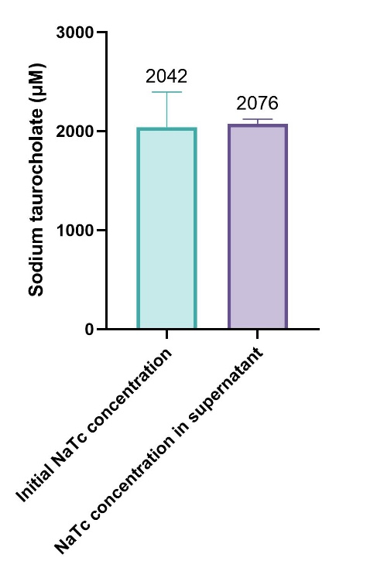
Figure S 1. Quantification of sodium taurocholate in PER301 supernatant, demonstrating that NaTc is not retained in PER301.

Chitosan quantification
Chitosan quantification was performed on reaction supernatants using a colorimetric assay kit. Experimental samples, including reaction supernatants and the initial chitosan concentration sample (diluted in phosphate buffer at pH 8 with PS80), were diluted 5-fold in assay solution to a final volume of 200 μL. A standard curve ranging from 0 to 100 μg/mL was established by adjusting volumes with Chitosan Assay Solution to a final volume of 200 μL per tube. To initiate the reaction, 5 μL of Chitosan Converter Solution was added to all tubes, followed by incubation at 85-90°C for 30 minutes. Subsequently, 200 μL of Developer Mix R Solution was added, and the mixture was heated for an additional 20 minutes at 85-90°C. Following incubation, 250 μL of the resulting colored solution was transferred to a 96-well clear flat-bottom plate, and the absorbance was measured immediately at 532 nm and 25°C.
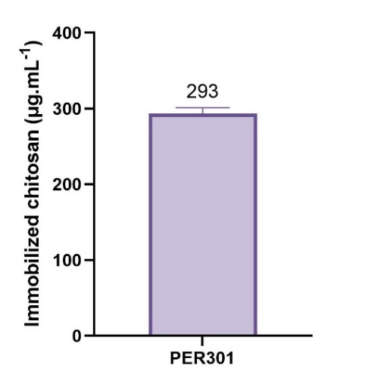
Figure S 2. Immobilized chitosan quantification.

Scanning Electron Microscopy (SEM)
Nanoparticles were imaged using a Zeiss SUPRA® 40VP scanning electron microscope.
A 1 μL drop of the nanoparticle sample was added on a freshly cleaned silicon wafer, dried under ambient conditions, and sputter-coated with a gold-platinum alloy for 15 s at 20 mA. Secondary electron micrographs were acquired using the InLens mode at a magnification of 150 000X with an accelerating voltage of 10 kV.
Particle sizes were measured using ImageJ. At least 100 measurements were performed for each sample.
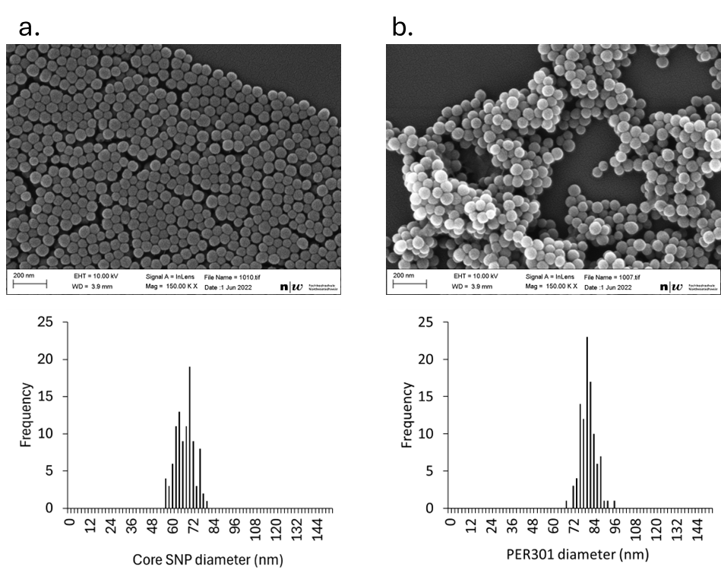
Figure S 3. Organosilica layer thickness. a) Scanning electron microscopy study of core SNP, b) Scanning electron microscopy study of PER301.

Collapse temperature determination
The formulations were analyzed using a Lyostat freeze-drying microscope, equipped with Link image and data capture software. A 2 μL sample of each formulation was pipetted between a quartz slide and glass cover slip to create a 70 μm thick sandwich of sample (this ensures that the sublimation front can be observed so that the critical temperature can be established). The principal information obtained from FDM analysis is the collapse (Tc) or Eutectic (Teu) point of each formulation.
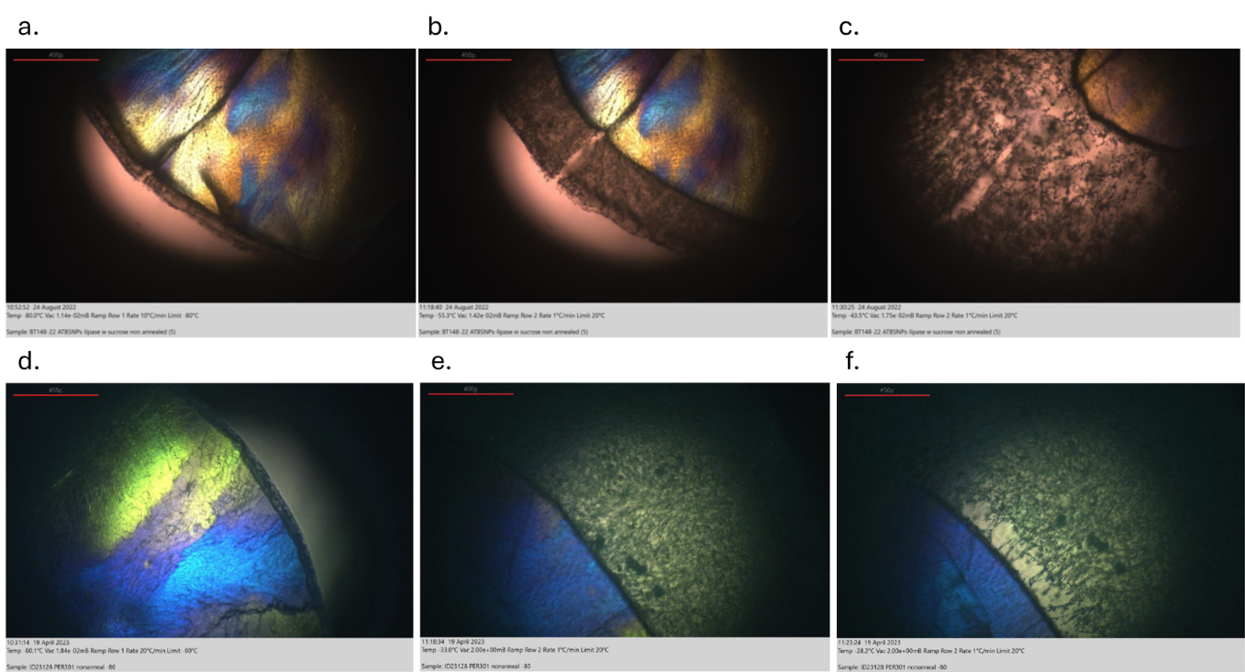
Figure S 4. Microscopic evaluation of PER301 in phosphate buffer (0.120 M, pH 6)/PS80 (8 mg/L) showing a) the good structure of the sample at -80°C, b) the first sign of collapse at -55.3°C, c) the total collapse of the sample at -45.3°C; or microscopic evaluation of PER301 in the identified formulation composition showing d) the good structure of the sample at -80°C, e) the first sign of collapse at -33.0°C, f) the total collapse of the sample at -28.2°C.

Pancreatic lipase activity assay using a fluorescent artificial lipase substrate
To a solution of nanoparticles (15 µg/mL of enzyme) in Tris buffer (0.1 M, pH 8.4) was added 1,2-Di-O-lauryl-rac-glycero-3-(glutaric acid 6-methylresorufin ester) (50 µM). Lipase activity kinetics was monitored by steady-state fluorescence measurement (λ_{ex}/ λ_{em} = 529/600 nm) in a dark 96-well plate for 30 min at 37 °C.

Pancreatic lipase activity assay by pH-stat titration
The olive oil solution was prepared by mixing olive oil / gum arabic / water (1 / 8.25 / 0.75). The buffer solution was prepared by dissolving Trizma base (0.6 g/L) and sodium chloride (2.34 g/L) in nanopure water. The bile salts solution was prepared by dissolving sodium taurocholate (80 g/L) in water.
The activity assay was performed by mixing the olive oil solution (13.8 mL), the buffer solution (11 mL), the bile salts solution (2.8 mL) and water (12.4 mL) in a bioreactor at 37°C. The pH was adjusted to 9.2 by adding a sodium hydroxide solution (0.1 M). Nanomedicines (1.4 mL, 10 mg/mL) were washed twice in water and added to the bioreactor. Lipase kinetics was monitored by measuring the amount of sodium hydroxide added to the reaction mixture to maintain the pH at 9 for 15 minutes.
Figure S 5. Formulation compositions enabling full lipase activity recovery after lyophilization. Summary of the lipase pharmacopeia assays performed (in triplicate) on the best formulation compositions after lyophilization (H25 = Histidine (25 mM), T4 = Trehalose (4 mM), C3 = Cysteine (3 mM), S6 = Sucrose (6 mM), T5 = Tryptophan (5 mM), T6 = Trehalose (6 mM), C5 = Cysteine (5 mM)) compared with the specific activity of unlyophilized PER301.

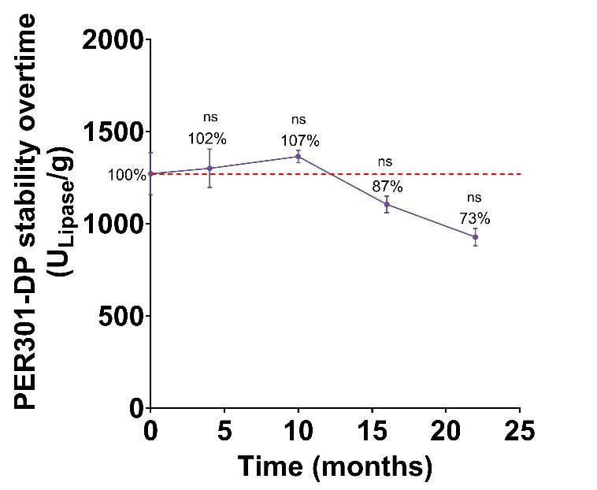
Figure S 6. PER301-DP long-term stability over storage at room temperature without light protection. Statistical analysis was conducted using Student’s t-test. Differences were considered not significant (ns) for P > 0.05, P ≤ 0.05 (*), P ≤ 0.01 (**), and P ≤ 0.001 (***).

Pancreatic protease activity assay
A multi-stage static in vitro digestion model was employed to evaluate the proteolytic efficacy of PER301. Simulated fluids, including artificial saliva buffer (ASB, pH 6.9), gastric priming acid (GPA), gastric acid (GA), hepatic juice (HJ), and pancreatic juice (PJ), were prepared with electrolyte concentrations and enzymatic activity (Pepsin 8.9 kU/mL) standardized to physiological conditions. PER301-DP at a concentration of 1.682 mg/mL was used for experimental evaluation. All reagents were pre-incubated at 37°C prior to use.
The digestion was performed in three sequential phases under constant agitation (750 rpm at 37°C):
- Oral Phase: Casein (30 mg/mL) was mixed with ASB and incubated for 30 seconds.
- Gastric Phase: The mixture was acidified with GPA and GA (containing pepsin) and incubated for 3 hours. For the negative control, an enzyme-free GA was used.
- Intestinal Phase: The chyme was neutralized to pH 6.8 using 10 M NaOH. HJ and PJ (containing PER301) were added, followed by a 3-hour incubation. For the negative control, an enzyme-free PJ was used.
Protein hydrolysis was quantified by measuring the release of TCA-soluble peptides and tyrosine equivalents. Proteolysis was terminated by adding 50 g/L trichloroacetic acid (TCA) in a 1:1 ratio. Samples were incubated (10 min, 37°C), centrifuged (20,000 rcf, 5 min), and the supernatant was collected. Supernatants were treated with 500 mM Na₂CO₃ and 1 M Folin-Ciocalteu reagent. After a 30-minute incubation at 37°C, the absorbance was measured at 660 nm. Results were calibrated against a Tyrosine standard curve (0–1.5 µmol) processed under identical conditions to account for matrix interference.

Pancreatic amylase activity assay
A multi-stage static in vitro digestion model was employed to evaluate the amylolytic efficacy of PER301. A 20 mg/mL starch suspension was prepared in nanopure water, gelatinized by boiling for 5 minutes, and cooled to room temperature before use. Simulated digestive fluids, artificial saliva (AS), gastric priming acid (GPA), gastric acid buffer (GAB), hepatic juice (HJ) and pancreatic juice (PJ), were formulated to mimic physiological electrolyte compositions. Enzymatic activity was standardized to 36 U/mL for salivary α-amylase and 1.675 mg/mL of PER301 for experimental evaluation.
The digestion was conducted in three sequential phases at 37°C under constant agitation (750 rpm).
- Oral Phase: Gelatinized starch was incubated with AS (containing salivary amylase) for 30 seconds to initiate polysaccharide breakdown. For the negative control, an enzyme-free AS was used.
- Gastric Phase: Samples were acidified with GPA and GAB and incubated for 3 hours. This phase serves to simulate gastric transit while allowing for the partial inactivation salivary amylase.
- Intestinal Phase: The mixture was neutralized to pH 6.8 using 10 M NaOH. HJ and PJ (containing PER301) were added, followed by a 3-hour incubation.
The residual starch content was quantified via the iodine-binding assay, which measures the formation of the blue-colored starch-polyiodide complex. Enzymatic activity was halted by adding 50 g/L TCA in a 1:1 ratio. After incubation (10 min, 37°C) and centrifugation (20,000 rcf, 5 min), the supernatant containing residual starch/dextrins was collected. Supernatants were treated with an iodine solution (120 mM KI, 7.9 mM I₂). Samples were incubated in the dark (5 min, 20°C, 400 rpm), and the absorbance was measured at 600 nm. A standard curve was generated using starch concentrations ranging from 0 to 10 mg/mL, processed through the identical digestion and TCA-precipitation matrix to ensure accurate quantification of starch degradation.

Volumetric Karl Fischer (KF) titration
Volumetric KF titration was performed using Karl Fischer kit from Mettler Toledo.
First, water calibration was performed. The instrument automatically adjusted the titration parameters based on the results of the water standard. The residual moisture content of PER301-DP was performed on at least 160 mg of powder.

Laser diffraction
Particle size distribution was assessed using laser diffraction (dry dispersion, n=3). A standard was employed with the following parameters: particle refractive index (RI) 1.500, zero absorption, dispersant RI 1.000, and beads were utilized for dispersion.
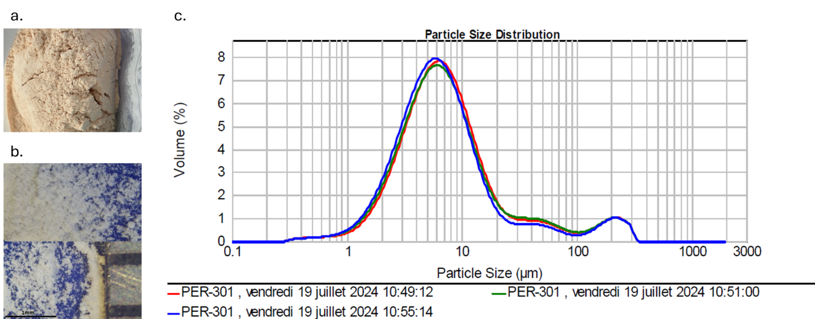
Figure S 7. PER301-DP characterization. a) Macroscopic appearance, b) Appearance by binocular lens, c) Particles size distribution.

Cell culture
For the establishment of an in vitro human intestinal barrier model, Caco-2 and HT29-MTX-E12 cell lines were obtained from the European Collection of Authenticated Cell Cultures (ECACC; catalogue numbers 12040401 and 86010202, respectively). Caco-2 cells were used between passages 21 and 25, while HT29-MTX-E12 cells were used between passages 50 and 55.
Cells were cultured in T75 flasks using complete Dulbecco’s Modified Eagle’s Medium (DMEM; Gibco, Cat. No. 10313-021) supplemented with 10% (v/v) fetal bovine serum (FBS; Gibco, Cat. No. 10270-106), 1% (v/v) penicillin–streptomycin (Gibco, Cat. No. 15140-122), 1% (v/v) L-glutamine (Gibco, Cat. No. 25030-081), and 1% (v/v) non-essential amino acids (MEM-NEAA; Gibco, Cat. No. 11140-035).
The culture medium was replaced three times per week, and cells were maintained at 37 °C in a humidified atmosphere containing 5% CO₂.

Development of the in vitro human intestinal barrier model
The in vitro human intestinal barrier model was established using polyethylene terephthalate (PET) transwell inserts with a pore size of 3 µm, compatible with 24-well plates (Greiner Bio-One, Cat. No. 662630). Cells were seeded at a density of 2.6 × 10⁶ cells/cm², resulting in a total of 8.74 × 10⁵ cells per transwell insert. An optimal co-culture ratio of 75% Caco-2 cells and 25% HT29-MTX-E12 cells was selected. Accordingly, the required number of cells for each cell line was calculated considering 8.74 × 10⁵ cells as 100% of the total seeding density.
A total volume of 250 µL of cell suspension in complete culture medium was added to the apical compartment of each insert, while 800 µL of complete medium was added to the basolateral compartment. The culture medium was replaced three times per week. The in vitro intestinal barrier model was allowed to differentiate for 21 days and was considered ready for treatment thereafter.

Safety of PER301
After 21 days of differentiation, transwell inserts containing the in vitro human intestinal barrier model were used to evaluate the safety of different concentrations of PER301-DP.
The concentrations of PER301-DP were selected based on the planned in vivo dosing regimen for the GLP-tox study, expressed in terms of capsules. To translate the in vivo dose to the in vitro transwell system, a surface area–based scaling approach was applied. Briefly, the amount of PER301 contained in a single capsule (211.2 mg of drug product and 135.17 mg of drug substance) was normalized to the growth area of a transwell insert (0.33 cm²) and expressed as an equivalent concentration in the apical compartment.
Using this approach, one capsule corresponded to an equivalent concentration of 0.89 µg/mL in the apical side of a transwell system. Based on this reference value, a wide range of PER301-DP concentrations was selected to assess dose-dependent effects to cover physiological and extreme supra-physiological exposure levels. The tested concentrations were 0, 0.70, 1.40, 4.18, 6.3, 8.4, 66.5, 700, 4,200, 8,400, 16,800, 35,000 µg.cm⁻², corresponding to 0, 1, 2, 6, 9, 12, 95, 1,000, 6,000, 12,000, 24,000, and 50,000 capsules of PER301, respectively. A total of 50 mg of PER301-DP was weighed and dissolved in complete culture medium to obtain a stock solution with a final concentration of 50 mg/mL. All working concentrations were subsequently prepared by serial dilution of the stock solution in complete culture medium.
Cells were exposed to PER301 for 3 days, after which cell viability was assessed using a CCK-8 and a Cell-Titer Glo Luminescent Cell viability assay.

CCK-8 assay
The Cell Counting Kit-8 (CCK-8) assay was used to assess the safety of a 3-day exposure to different concentrations of PER301-DP on the in vitro human intestinal barrier model.
The assay was performed according to the manufacturer’s instructions (Abcam, Cat. No. ab228554). Briefly, after treatment, cell cultures were washed twice with Dulbecco’s Phosphate-Buffered Saline (DPBS; Gibco, Cat. No. 14190-094). Cells were then incubated in the apical compartment with WST-8 solution diluted 1:10 in complete culture medium. Following a 30-min incubation, conditioned supernatants were collected and transferred to clear, flat-bottom 96-well UV-transparent plates (Greiner Bio-One, Cat. No. 655801).
Absorbance was measured at 460 nm using a BioTek Synergy H1 microplate reader. Cell viability was expressed as a percentage of the untreated control cultures. As a negative control, cultures were treated for 5 min with a solution containing 1% Triton X-100 (Merck, Cat. No. 93443) diluted in complete culture medium.
All calculations were performed using Microsoft Excel, and graphical representations were generated using GraphPad Prism software. Statistical analyses were performed using data obtained from two biological replicates, each including two technical replicates. Comparisons between treated and control groups were carried out using t-test.
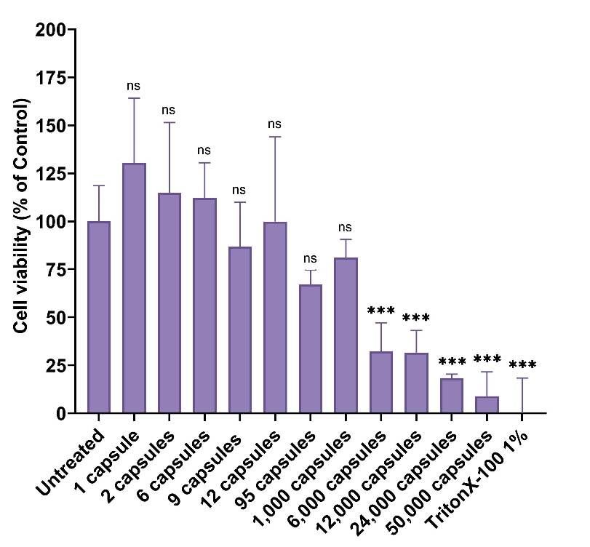
Figure S 8. Safety assessment of PER301 on an in vitro human intestinal barrier model.
Cell viability after a 3-day exposure to increasing concentrations of PER301 through the CCK-8 assay. Data are expressed as a percentage of the untreated control. Experiments were performed using two biological replicates, each with two technical replicates. Statistical analysis was conducted using Student’s t-test. Differences were considered not significant (ns) for P > 0.05, P ≤ 0.05 (*), P ≤ 0.01 (**), and P ≤ 0.001 (***).

Cell-Titer Glo Luminescent Cell Viability Assay
After the CCK-8 assay, cultures were washed twice with DPBS and cell viability was further assessed using the CellTiter-Glo® Luminescent Cell Viability Assay 2.0 (Promega, Cat. No. G9241), according to the manufacturer’s instructions. Briefly, the CellTiter-Glo luminescent reagent solution was diluted 1:1 in distilled water. A volume of 400 µL of the diluted solution was applied to the apical compartment of each insert and incubated for 15 min at room temperature on a thermomixer set at 400 rpm.
Following incubation, 100 µL of the lysed cell–reagent mixture was transferred to a white opaque, flat-bottom 96-well plate (Corning, Cat. No. CLS3922). Luminescence was measured using a BioTek Synergy H1 microplate reader with an integration time of 1000 ms. Untreated cultures were used as the reference control to calculate the percentage of viable cells. As a negative control, cultures were treated for 5 min with a solution containing 1% Triton X-100 diluted in complete culture medium.
Statistical analyses were performed using data obtained from two biological replicates, each including two technical replicates. Comparisons between treated and control groups were carried out using t-test.
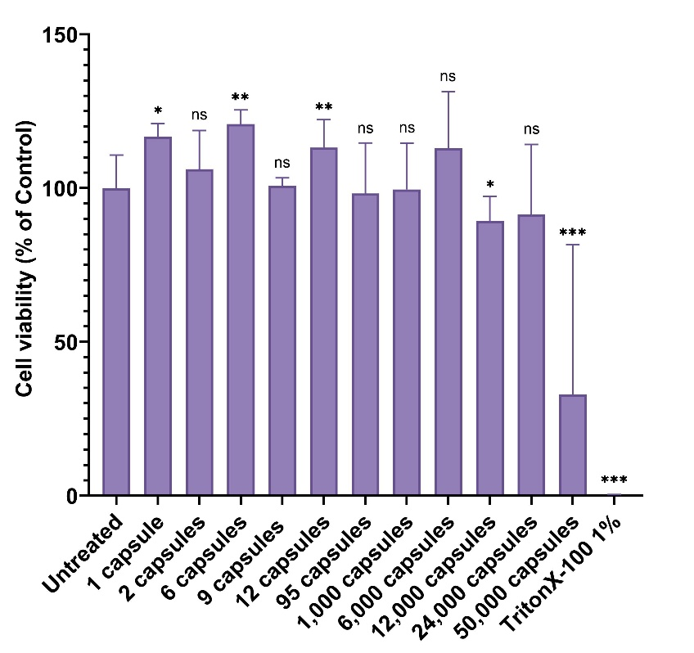
Figure S 9. Safety assessment of PER301 on an in vitro human intestinal barrier model.
Cell viability after a 3-day exposure to increasing concentrations of PER301 through the CellTiter-Glo® Luminescent Cell Viability Assay 2.0. Data are expressed as percentage of untreated control. Minor fluctuations above 100% are attributed to variability in ATP-based readouts rather than biological effects. Experiments were performed using two biological replicates, each with two technical replicates. Statistical analysis was conducted using Student’s t-test. Differences were considered not significant (ns) for P > 0.05, P ≤ 0.05 (*), P ≤ 0.01 (**), and P ≤ 0.001 (***).

In vivo protocols
All animal studies were conducted at Minerva Imaging (Denmark) and were licensed by the Danish Animal Experimentation Inspectorate. All procedures were performed in accordance with the Danish Animal Experimentation Act, which is fully compliant with European Directive 2010/63/EU and international principles for the care and use of laboratory animals.
The studies were subject to welfare evaluations and post-approval monitoring by the Institutional Animal Care and Use Committee (IACUC) at Minerva Imaging. The animal facilities and workflows followed standards set by the Danish Working Environment Authority, the Danish Environmental Protection Agency, and the Danish Health Authority, Radiation Protection. All work adhered to the 3R principles (Replacement, Reduction, and Refinement), with professional care provided by trained technicians and veterinarians to ensure proper housing, nutrition, and health monitoring.

Biodistribution study using SPECT/CT in Göttingen Minipig dosed intraduodenal with In-111 labelled nanoparticles

Animals
The study was performed in 10 female Göttingen SPF minipigs from Ellegaard Göttingen Minipigs A/S, DK-4261 Dalmose, Denmark. The animals were adults (8-9 months) with a body weight of 18.8 kg - 22.4 kg at arrival.

Acclimatization
Animals were clinically examined at arrival. An acclimatization period of minimum 14 days was allowed before insertion of catheters. During the acclimatization period, the pigs were socialized and trained to get used to the personnel and to the procedure (e.g. trained for blood sampling, and touched on the ears).

Housing and environment
Animals were housed in animal rooms 17 (non-radioactive animals) and 18 (radioactive animals).
The holding rooms were illuminated to give a cycle of 12 hours light and 12 hours darkness. Light was on from 06:00 h to 18:00 h.
The temperature and humidity were also controlled. The temperature was set at 20-24 °C and the relative humidity to 30-70%.
During the acclimatization period the animals were group housed. After insertion of ear-vein catheters (to be performed with a staggered start) the animals were housed individually. The pen size was ≥ 3.13 m² (1.59 x 1.97 m).
Before arrival of the animals, the animal room and pens were cleaned and disinfected with a 1% Virkon S solution. During the study, the animal pens were cleaned daily.
Pens contained sawdust and straw as bedding. Approximately 48 hours prior to dosing all bedding material was removed from the pen, and blankets were provided to the animals.

Environmental enrichment
Feed was administered in the straw, or directly on the floor if no straw was provided, and once daily the animals were given sliced apples by hand.

Diet and drinking water
A commercially available pig diet, “Altromin 9033” (Brogaarden ApS, DK-3540 Lynge) were offered to the animals twice daily (200 gram per meal). The animals were fed on the floor in the morning and in the afternoon.
Approximately 24 hours prior to dosing the animals were fasted.
On days with multiple SPECT/CT scanning time points, the animals received a small amount of diet following the 15-minute post dose and 3 hours post dose scan. Approximately ¼ of the daily meal were given.
The animal had ad libitum access to domestic quality drinking water. On the days of dosing water was removed from the pen in the morning and the animals were water fasted until dosing.
Humane endpoints
No premature terminations were performed.

Insertion of ear vein catheter
One ear vein catheter was inserted in each animal. The catheter was inserted with a staggered start no later than 5 days prior to dosing.
The pigs were anesthetized intramuscularly with 1 mL/10 kg of a Zoletil-mixture of 6.25 mL of Rompun Vet® (Xylazine, 20 mg/mL) + 1.25 mL Ketaminol Vet® (Ketamine, 100 mg/mL) + 2.0 mL Torbugesic Vet® (Butorphanol, 10 mg/mL) in one vial of Zoletil Vet 50® (125 mg Tiletamin + 125 mg Zolazepam).
During the anesthesia, Buprenorphine (Vetergesic vet., 0.3 mg/mL) 0.04 mL/kg and Meloxicam (Metacam, 20 mg/mL) 0.02 mL/kg were administered intravenously as analgesics.
Additionally, Meloxicam oral suspension (Metacam susp., 5 mg/mL) was given to all animals once daily for the following three days because of its analgesic and anti-inflammatory activity after per oral administration.
The ears were washed with Mediscrub soap and water (MediScrub surgical scrubs) and disinfected using 70% ethanol solution, which was allowed to evaporate from the skin, before insertion of the catheter.
The central venous catheters, CareflowTM 3Fr, 150 mm REF: 681643, Argon Medical Devices were introduced using aseptic techniques via an ear vein using a cannula and a guidewire. Afterwards, Noromox prolongatum Vet. (Amoxicillin), 1 mL/10 kg was administered intramuscular. The catheters were “locked” with 0.3 ml TauroLock Hep 500 (TauroPharm GmbH) and fixed with a plastic device and screws.

Maintenance of ear vein catheters
The functionality of the catheter was checked at least twice weekly. The content of the catheter was aspirated and discarded. The catheter was flushed with sterile 0.9% NaCl before they were locked with 0.3 mL TauroLock Hep500 (Taurolodin Citrate with 500IU/mL heparin) and closed with a luerlock.
Aseptic technique was used.

Insertion of jugular catheter
The day prior to dosing of animal n° 8, a jugular catheter was inserted using a non-surgical Seldinger technique as it was not possible to implement an ear catheter despite several attempts.
The animal was anaesthetized and medicated.
The throat was washed with Mediscrub soap and water (MediScrub surgical scrubs) and disinfected using 70% ethanol solution, which was allowed to evaporate from the skin, before insertion of the catheter.
A single lumen peripheral venous catheter, Seldipur Smartmidline, 4Fr, 15 cm (REF: 128.14152, Vygon) was introduced using aseptic techniques into the jugular vein. The wings were sutured to the skin.

Dosing
The animals were dosed as described in Table S 1.

Table S 1. Overview of dosing.
Group | Route of administration | Compound |  | In-111 | Dose volume  (mL/animal) | Animal
Group | Route of administration | Name | Dose  (g/animal) | Concentration  (MBq/animal) | Dose volume  (mL/animal) | Animal
1 | Intraduodenal | ¹¹¹In-PER300F | 1 | See Table S 2. Dosing table | 20 | 1-5
2 | Intraduodenal | ¹¹¹In-PER300N | 1 | See Table S 2. Dosing table | 20 | 6-10
Control | Intraduodenal | No compound | - | See Table S 2. Dosing table | 20 | 6

The first day of dosing was Day 0. Dosing was performed as described in the section Endoscopic dosing in duodenum below. Following dosing, the catheter was flushed with 5 mL of 0.9% NaCl. The injected dose was determined by measuring the activity of the syringe and other material which had been in contact with the In-111 labeled compound during dosing before and after (syringe) injection using a dose calibrator (ISOMED 2010). The time of measurement was documented. The formulations were kept at room temperature after labelling and until dosing. The formulation was sonicated shortly prior to dosing.

Table S 2. Dosing table
Group | Animal | BW  (kg) | Compound | Dose  (g/animal) | In-111
 |  |  |  |  | Dose before injection  (MBq) | Dose volume | Residual dose  (MBq)
1 | 1 | 20.4 | ¹¹¹In-PER300F | 1 | 122.64 | 20 | 8.38
1 | 2 | 19.6 | ¹¹¹In-PER300F | 1 | 132.3 | 20 | 2.01
1 | 3 | 19.5 | ¹¹¹In-PER300F | 1 | 106.8 | 20 | 18.8
1 | 4 | 19.3 | ¹¹¹In-PER300F | 1 | 126.9 | 20 | 23.0
1 | 5 | 22.4 | ¹¹¹In-PER300F | 1 | 128.5 | 20 | 1.72
2 | 6 | 21.7 | ¹¹¹In-PER300N | 1 | 90.95 | 20 | 14.05
2 | 7 | 20.7 | ¹¹¹In-PER300N | 1 | 98.0 | 20 | 1.04
2 | 8 | 19.1 | ¹¹¹In-PER300N | 1 | 155.58 | 20 | 1.44
2 | 9 | 19.2 | ¹¹¹In-PER300N | 1 | 111.0 | 20 | 1.3
2 | 10 | 18.8 | ¹¹¹In-PER300N | 1 | 143.7 | 20 | 1.49
3 | 6 | 22.3 | No compound | 0 | 155 | 20 | 0.96

Anesthesia prior to dosing and SPECT/CT imaging
Prior to dosing, the animals were anesthetized and intubated. A mixture (0.2 mL Ketamine to 20 mL Propofol) of Propofol (Propovet multidose, 10 mg/mL) and Ketamine (Ketador Vet., 100 mg/mL) was administered intravenously. The exact amount used during the dosing period is listed in appendix A5.
Following dosing or in relation to dosing the animals were connected to the anesthetic machine and assigned 100% oxygen gas mixed with isoflurane (approx. 2-4%).
During the dosing day the animals received an intramuscular injection of 0.02 mL/kg Metacam (Meloxicam, 20 mg/mL) to avoid swelling and pain related to irritation of the upper airways due to the repeated intubations.

Endoscopic dosing in duodenum
The animals were placed in lateral recumbency on the left side. This facilitated visualization of the pylorus as the stomach content would position in the opposite site of the stomach. A semi-rigid endoscope (Olympus, 160 cm) was introduced via esophagus. Special attention was paid to the amount of water and air used during the procedure. Keeping these at a minimum should avoid artifacts during the study.
Once the pylorus opening was localized the endoscope was advanced through the sphincter and into the duodenum where the compound was administered. Dosing was performed through a needle injector (BodyProducts, Upviser, IN-23-23-5-230). The needle was advanced to a point where the tip was visible on the endoscopic screen before dosing. The needle injector was removed after dosing and was placed in a suitable container for well counting.
Following dosing, the animals were scanned as described in SPECT/CT imaging.

Clinical observation
The animals were observed daily throughout the study. All visible signs of ill health and any behavioral changes during the study period were recorded. Any deviation from normal was recorded with respect to time of onset, duration, and intensity.
No treatment related clinical signs were observed in any of the animals during the study.

Gamma counting – In-111 activity measurement
Blood, urine, and feces for In-111 activity measurement was collected as described below and was measured with an automated gamma counter for 120 s. (Hidex automatic gamma counter, In-111 protocol).

Blood sampling for gamma counting
Blood (15 mL) was collected 15 min, 3, 8, and 24 hours post dose via the ear vein catheter, transferred to 20 mL scintillation vials and weighed.
Blood was collected from control animal n° 6, 15 min, 3, 8, and 24 hours post dose following the dosing with free In-111.

Figure S 10. Pharmacokinetics of blood (%ID/g). Activity measurement in ex vivo blood samples after injection with In-111 labelled PER300N or In-111 labelled PER300F. N=5/group.

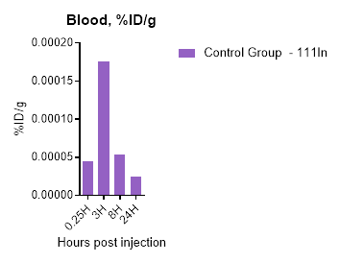
Figure S 11. Pharmacokinetics of blood (%ID/g). Activity measurement in ex vivo blood samples after injection with In-111 labelled PER300N or In-111 labelled PER300F. N=5/group.

Feces collection for gamma counting
Fecal samples were collected 24, 48, and 72 hours post dose from animals dosed with ¹¹¹In-PER300F and ¹¹¹In-PER300N.
All feces available in the morning prior to scanning were collected from the pen floor. Time of collection and weight was noted.
The fecal sample was homogenized by manually kneading. One sample of approximately 1 g was weighed (exact weight was noted) and transferred to 5 mL Scintillation vials for In-111 activity measurements.
Figure S 12. Pharmacokinetics in feces (%ID/g). Activity measurement in ex vivo feces samples after injection with In-111 labelled PER300N or In-111 labelled PER300F. N=5/group.
Urine collection for gamma counting
Following the last scan (72 hours post dose) urine was collected via a urine catheter (Buster Foley catheter, 6 FR (2.0 mm) 55 cm) from animals dosed with ¹¹¹In-PER300F and ¹¹¹In-PER300N. The urine sample (15 mL) was transferred to 20 mL Scintillation vials and weighed.
Figure S 13. Pharmacokinetics in urine (%ID/g). Activity measurement in ex vivo urine samples after injection with In-111 labelled PER300N or In-111 labelled PER300F. N=5/group.

Body weight
The animals were weighed on arrival and weekly thereafter.

SPECT/CT imaging
SPECT/CT scanning (Clinical D670 SPECT/CT, GE) were initiated 15 min, 3, 8, 24, 48 and 72 hours post dosing (+/- ½ h) of the In-111-labeled compound (Table S 3). For the control animal n° 6 the SPECT/CT scanning were initiated 15 min, 3, 8, and 24 hours post dosing of the free In-111. The SPECT acquisition time was decided based on the count rate at the day of scanning. SPECT imaging included two field of views (FOV) to cover the area ranging from the stomach to the rectum. The two FOVs were scanned with the FOV including the stomach and the duodenum as the first acquisition. Prior to the CT scan procedure, an intravenous infusion of an iodine-containing contrast medium (Ultravist®, 370 mg/mL, 1 mL/kg, flow rate 2 ml/s) was performed to improve the visibility of the organs for image analysis. FOV for CT imaging included the entire animal. The animals were imaged on site and were transported from the holding room to the scanner under anesthesia.
Table S 3. Acquisition time for individual SPECT/CT imaging timepoints.
SPECT/CT Imaging | Maximum acquisition time per FOV
15 minutes | 20 min
3 hours | 20 min
8 hours | 20 min
24 hours | 30 min
48 hours | 40 min
72 hours | 40 min

Termination
Following the last scan, the animals were transferred to other study activities.

Analysis of SPECT/CT imaging
For quantification of the uptake of In-111-labeled compounds, region of interest was drawn over relevant parts of the gastrointestinal organs (3 compartments: small intestines, colon, and rectum) identified from the CT image data.
The uptake is expressed as % ID (percentage injected dose) and SUV (standardized uptake value).
Data output obtained by CT guided VOIs (Volume-of-Interest) including either the small intestine, colon, or rectum. Co-registered images of SPECT and CT hereafter determine the %ID in the drawn VOI. All data analysis was performed by single viewer to avoid intra-observed deviations.

Proof of concept of PER301 in PDL dogs

Animals
The study was performed in 4 male beagle dogs from Marshall, France. The animals were 6 months old. Each animal served as its own healthy and untreated controls.

Microchipping
Individual animal identification was ensured by a microchip.

High fat diet administration
High fat diet (HFD) was administered to the animals by offering a food diet with a 30% fat content at the dog’s normal portion size. This was done prior to PDL surgery, to optimize the blood sampling schedule regarding TG measurements in the blood and to retrieve control measurements, after the PDL surgery to confirm the change in uptake of TGs and again after treatment with PER301 post PDL surgery.
The diet was fed within a 15-minute window, whereafter the remaining food (if any) was weighed.

Food intake
Food consumption (% of diet consumed at each meal) was recorded during the recovery phase to monitor the animal health. Furthermore, food consumption was recorded during study days.

Blood sampling
Blood samples were collected via a venflon or cannula and syringe in non-anesthetized animals according to Table S 4 in relation to morning HFD administration, both prior to and after the PDL surgery.
Table S 4. Blood samples
Usage | Time points | Method | Preservation and storage | Specifics
Plasma, triglycerides  (TG) analysis | -1h, 1h, 2h, 3h, 4h, 6h | Venflon/ cannula  + syringe | -20 ⁰C | K3 EDTA  tubes

Anesthesia and antibiotics
For surgical procedures, the animal was initially sedated with methadone 0.3-0.4 mg/kg intramuscularly (IM)/intravenously (IV) in combination with dexmedetomidine 0.005-0.01 mg/kg IM/IV or butorphanol 0.3 mg/kg IM/IV in combination with dexmedetomidine 0.005-0.01 mg/kg IM/IV. Anesthesia was then induced with a propofol 1-4 mg/kg IV bolus followed by maintenance on inhalation anesthesia with isoflurane 2-4% after intubation. During anesthesia, amoxicillin (150 mg/mL) 15 mg/kg was administered subcutaneously (SC) as a prophylactic antibiotic.

Analgesia
In relation to the surgical procedure, meloxicam 0.2 mg/kg IV/SC was given just prior to the procedure. Buprenorphine 0.01-0.02 mg/kg IM/IV was given 4 hours post methadone treatment, and thereafter every 8 hours if assessed necessary. Meloxicam 0.1-0.2 mg/kg PO was administered 3-5 days post surgery.

Placement of venflon
When IV access was needed, a venflon (BD 22G) was inserted in v. cephalica (front leg) or in v. saphena (hind leg).

Pancreatic duct ligation
Pancreatic duct ligation (PDL) was performed by accessing the duodenum from a midline incision. The pancreas was localized in the duodenal mesentery and the pancreatic ducts were double ligated and incised.

Dosing, Peroral (PO)
The animals were dosed according to Table S 5. The test compound was administered by oral capsule administration followed by 5-10 mL tap water. PER301 was administered on up to 8 days (once or twice daily) followed by HFD administration in all animals.
Table S 5. Group overview.
Group | Number of animals | Dose (U/dosing) | Route of administration | Dosing timepoints
Vehicle | 4 | - | - | -
PER301 (3-day assessment) | 4 | 859 | PO | 30 minutes prior to HFD administration
PER301 (7-day study) | 4 | 1144 | PO | 30 minutes prior to HFD administration

Clinical observation
The animals were observed daily throughout the study. All visible signs of ill health and any behavioral changes during the study period were recorded. Any deviation from normal were recorded with respect to time of onset, location and severity.
No treatment related clinical signs were observed in any of the animals during the study.

Animal body weight monitoring
The animals were weighed the day before surgery, every other day in the recovery phase (10-14 days), the day before dosing and otherwise once weekly.

Pancreatic enzyme supplement
Panzym (pancreatic enzyme supplement) was administered to the dogs post study, and in between studies, in order to resume their normal digestion and normal weight.

Termination
The animals were euthanized by an intravenous injection of Pentobarbital 400 mg/mL via a venflon.

TG measurements
Blood samples (1-1.3 mL) were collected in EDTA tubes and centrifuged at 2000G at 4°C for 10 minutes. Plasma was collected, and TG measurements were analyzed.

TLI measurements
TLI was analyzed on blood serum prior to surgery (as control), 10-14 days post PDL surgery in order to confirm EPI.

Fecal sampling
Feces were collected, pooled and kept at -20°C. Fecal fat content was analyzed.

Proof of concept of PER301 in PDL minipigs

Animals
The study was performed in 4 female Göttingen SPF minipigs from Ellegaard Göttingen Minipigs A/S, DK-4261 Dalmose, Denmark. The animals were adults (7-9 months). Each animal served as its own healthy and untreated controls.

Microchipping
Individual animal identification was ensured by a microchip.

Anesthesia
Light sedation
For minor procedures such as bandage change or suture removal the animal could be lightly sedated by xylazine 0.5-1 mg/kg IM/IV or propofol (2-6 mg/kg).

Heavy sedation
For placement of the ear-vein catheter the animal was sedated using Zoletil mixture (25 mg zolazepam + 25 mg tiletamine dissolved in 6.25 ml xylazine (20mg/ml), 1.25 ml ketamine (100 mg/ml) and 2.5 ml butorphanol (10 mg/ml) administered intramuscularly (IM) at a dose of 1 ml mixture/10 kg bodyweight. A supplementation of approximately 1/3 of the original dose could be given based on individual needs.

Inhalation anesthesia
For the surgical procedure, anesthesia was induced by an intramuscular (IM) injection of Zoletil mixture as described above. Anesthesia was maintained by inhalation of isoflurane 2-3%.

Intubation
The animal was intubated under anesthesia, followed by connection to the anesthetic machine.

Analgesia
Analgetic treatment in case of clinical symptoms
In case of inflammation or fever within the animals, NSAIDs could be taken into use, i.e., meloxicam administrated IM/intravenously (IV)/per orally (PO) and/or paracetamol administrated PO/IV. In case of moderate to severe symptoms, i.e. in case of injuries, analgesics such as meloxicam and buprenorphine administered IM/IV or stronger opioids could be taken into use.
Analgetic treatment in connection to ear-vein catheter placement
During the anesthesia, meloxicam (20 mg/mL) 0.4 mg/kg was administered IM or IV as analgesics. Additionally, meloxicam (15 mg/mL) was administered orally once daily for the following three to four days because of its analgesic and anti-inflammatory.

Analgetic treatment in connection to PDL
An injection with local analgesia consisting of lidocaine + noradrenalin (10 mg/ml + 5 μg/ml) and bupivacaine (5 mg/ml) was used as local analgesia where the incision was made.
For treatment of post-surgical pain, fentanyl patches were attached to the animal just after surgery. The animal was treated IM once with buprenorphine (0.3 mg/mL) before awakening, to ensure analgesia until there is full effect of the Fentanyl patch.
As an alternative to the fentanyl patches, buprenorphine patches (5.25 μg/h/animal) could be taken into use. The patches were attached to the skin in an area that can be bandaged easily. The area was clipped prior to attachment.
As an alternative to analgesic patches, the animals could be given an IV/IM injection of 0.012 mg/kg buprenorphine (0.3 mg/ml) in the afternoon and/or the evening after surgery depending on time of surgery, and if needed in the morning the day after.

Insertion of ear vein catheter
One ear-vein catheter was inserted in all pigs.
The animal was anesthetized as described in III. 3. c.
When anesthetized amoxicillin (150 mg/mL), 15 mg/kg was administered intramuscular and analgesia was provided according to III. 3. e.
The venous catheters were inserted in an ear vein using aseptic techniques and fixed to the ear with a plastic device and screws.
At least twice weekly and on days with blood sampling the functionality of the catheter was checked.

Blood sampling
Blood samples were collected via an ear-vein catheter in non-anesthetized animals according to Table S 6. Spill blood was collected and discarded prior to sampling. 5-10 mL of sterile heparinized saline (sterile 0.9% NaCl with 10 IE/mL Heparin) was flushed afterwards, following 0.3 mL TauroLock Hep 500.
Table S 6. Blood samples
Usage | Time points | Method | Preservation and storage | Specifics
SACT* test.  Plasma, triglycerides  (TG) analysis | predose, 0.5h 1h, 2h, 3h, 4h, 6h, 8h, 12h  after HFD administration | Ear vein  catheter | -20 ⁰C | K3 EDTA  tubes
Plasma, triglycerides  (TG) analysis | Morning samples prior to feeding. | Ear vein  catheter | -20 ⁰C | K3 EDTA  tubes
*SACT= substrate absorption challenge test

Pancreatic duct ligation
Pancreatic duct ligation (PDL) was performed by accessing the duodenum from a midline incision. The pancreas was localized in the duodenal mesentery and the pancreatic duct was double ligated and incised. The incision was closed in three layers with absorbable sutures and the animal was bandaged afterwards.

High fat diet administration
High fat diet (HFD) was administered to the animals by offering a commercially available dog food diet with a 30% fat content at the minipigs normal portion size.
This was done prior to PDL surgery, to optimize the blood sampling schedule regarding TG measurements in the blood and to retrieve control measurements, after the PDL surgery to confirm the change in uptake of TGs and again after treatment with PER301 post PDL surgery. The diet was fed within a 15-minute window, whereafter the remaining food (if any) was weighed.

Food intake
Food consumption (% of diet consumed at each meal) was recorded during the recovery phase to participate in monitoring the animal health. Furthermore, food consumption was recorded during study days.

Removal of bedding and straw
Approximately 36h prior to any substrate absorption challenge test (SACT) bedding and straw was removed from the pen and was offered again after end of the SACT.

Dosing, Peroral (PO)
The animals were dosed according to Table S 7 one hour prior to HFD administration both at morning and afternoon feeding. The test compound was administered by capsule administration followed by tap water or juice.

Table S 7. Group overview
Name | Animals | Dose (U/dosing) | Route of administration | Dosing timepoints
Vehicle | 4 | - | - | -
PER301 | 4 | 2002 | PO | One hour prior to HFD administration
Standard of care | 4 | 40000 | PO | Just prior to HFD  administration

Clinical observation
The animals were observed daily throughout the study. All visible signs of ill health and any behavioral changes during the study period were recorded. Any deviation from normal was recorded with respect to time of onset, location and severity.
No treatment related clinical signs were observed in any of the animals during the study.

Animal body weight monitoring
The animals were weighed on arrival, on the day before surgery, every other day in the recovery phase (10-14 days), the day before dosing and otherwise once weekly.

Zenpep dosing test
After first dosing test with PER301, a washout period of 7 days was included, whereafter Zenpep (pancrealipase) was administered twice daily for 7 days to the minipigs. Blood samples for TG and vitamin D analysis, and fecal samples were collected during this study period.

Pancreatic enzyme supplement (Panzym)
Panzym was administered to the minipigs post study in order to resume their normal digestion and normal weight until the minipigs initiated a new dosing study.

Termination
The animals were euthanized by an intravenous injection of Pentobarbital 400 mg/mL via the ear-vein catheter.

TG measurements
Blood samples (1-1.3 mL) were collected in EDTA tubes and centrifuged at 2000G at 4°C for 10 minutes. Plasma was collected, and TG measurements were analyzed.

Fecal sampling
Feces were collected from each pig at different timepoints and fecal fat content was analyzed.

Analyses of biological samples

Trypsin-like Immunoreactivity (TLI) measurements
The analysis was performed using a chemiluminescent immunoassay (CLIA) test method.
Interpretation:
< 5.5 µg/L: This value indicates an exocrine pancreatic insufficiency (EPI)
5.5 - 10.9 µg/L: The result is inconclusive and the test should be repeated in 2 weeks or stool pancreatic elastase should be determined
> 10.9 µg/L: Unlikely to be suffering from an EPI
> 50 µg/L: Can be an indication of an acute or chronic pancreatitis. Renal failure can also lead to increased values due to TLI retention. Pancreas-specific lipase should be determined.
Table S 8. TLI measurements on dog’s blood serum.
 | ID1 | ID2 | ID3 | ID4
TLI (µg/L) measured before pancreatic duct ligation | 32.7 | 26.7 | 39.3 | 28.1
TLI (µg/L) measured after pancreatic duct ligation | 2.1 | 2.8 | 15.5* | 1.4
* ID 3 was the only animal that did not receive a complete confirmation of EPI through TLI measurements. The fecal fat content and the weight loss however indicated that ID 3 had EPI. Other affections of the pancreatic tissue can also lead to an increase in TLI and therefore might not have provided the true result of ID 3 through TLI measurements.

Triglycerides analysis
Triglycerides were hydrolyzed by lipase to glycerol and fatty acids. The glycerol was phosphorylated to glycerol-3- phosphate, which was then oxidized to dihydroxyacetone phosphate and hydrogen peroxide. The hydrogen peroxide reacted with 4-aminoantipyrine and 4-chlorophenol forming a quinonimine dye. The absorbance of the formed color was measured at 510 nm.

Fecal fat content analysis via Near-Infrared Spectroscopy (NIRS)
Homogenized stool samples were loaded into glass Petri dishes to a thickness of at least 5 mm. Care was taken to eliminate air gaps to ensure consistent light pathlength. Samples were analyzed using a Perkin Elmer FT 9700 Impana spectrometer (spectral range: 10,600–4,000 cm⁻¹; resolution: 16 cm⁻¹; 32 scans). The instrument measured the absorption of near-infrared light through the bottom of the dish to quantify target parameters.

