Supplementary data for

Design and Evaluation of EGFR-Targeted Near-Infrared Fluorescent Probes for Selective Tumor Cell Imaging
Content
1 Reagent and Instruments 1
1.1 The drugs and reagents used in the experiment 1
1.2 The instruments used in the experiment and their models 2
2 Experiments 3
2.1 Synthesis of Sulfo-Cyanine7 3
2.2 Synthesis of Control 3
3 Supplementary data 5
3.1 Fluorescence emission spectra 5
3.2 The anti-interference testing of Cy7-Gefitinib2/3 in 5
4 Nuclear magnetic resonance and mass spectrometry spectra 6

- Reagent and Instruments
  - The drugs and reagents used in the experiment
The reagents used in this experiment were all purchased from commercial sources and were not subjected to additional purification prior to use. Only certain solvents were dried before use.
No. | Chemical Name | Purity | Supplier
1 | N-Boc-2-chloroethylamine | 98% | Le Yan
2 | 4-(3-chloro-4-fluorophenylamino) -7-methoxyquinazolin-6-ol | 99% | Le Yan
3 | 1-Ethyl-2,3,3-trimethyl-3H-indole-5-sulfonic acid internal salt | 99% | Bi De
4 | N-[(3-(phenylmethylene)-2-chloro-1-cyclohexene-1-yl)methylen] aniline hydrochloride | 99% | Le Yan
5 | Tertbutyl(2-(2-bromoacetamide) ethyl) carbamate | 99% | Le Yan
6 | [2-(2-aminoethoxy)ethyl]carbamate tertbutyl ester | 99% | Le Yan
7 | bromoacetyl bromide | 99% | Le Yan
8 | Potassium carbonate | 99% | Le Yan
9 | Potassium iodide | 99% | Energy
10 | N,N-dimethylformamide | 99% | Le Yan
11 | n-butanol | 99% | Le Yan
12 | Saturated sodium bicarbonate | 99% | Taitan
13 | Methylamine hydrochloride | 99% | Le Yan
14  15  16 | trifluoroacetic acid  p-hydroxyphenylpropionic acid  4-Dimethylaminopyridine | 99%  99%  99% | Le Yan  Le Yan  Taitan
17 | p-hydroxyphenylpropionic acid | 99% | Taitan
18 | Sodium hydride | 99% | Taitan
19 | Methylamine hydrochloride | 99% | Taitan
20 | EDCI | 99% | Le Yan
21 | acetic acid | 99% | Le Yan
22 | toluene | 99% | Le Yan
23 | acetonitrile | 99% | Le Yan
24 | ether | 99% | Le Yan
25 | acetone | 99% | Le Yan
26 | dichloromethane | 99% | Taitan
27 | triethylamine | 99% | Le Yan
28 | methanol | 99% | Taitan
29 | Column chromatography silica gel | 200~300 Mesh | Taitan

  - The instruments used in the experiment and their models
No. | Instrument | Model | Supplier
1 | Nuclear magnetic resonance instrument | DRX-400 | Bruker
2 | High resolution mass spectrometer | 6410B | Agilent
3 | Fluorescence spectrophotometer | F-7000 | HITACHI
4 | UV-Vis | UV-3900 | HITACHI
5 | Ultraviolet-visible spectrophotometer | FE20 | pH-meter
6 | Laser scanning confocal microscope | TCS SP5 | Leica

- Experiments
  - Synthesis of Sulfo-Cyanine7
Scheme S1. Synthesis routine of Sulfo-Cyanine7
Compound 1 (1.5 g, 5.62 mmol) and 2 (1.01 g, 2.81 mmol) were added to a three necked flask. Under a nitrogen atmosphere, 100 mL of a mixed solvent system (n-butanol: toluene = 7: 3) was introduced. The reaction mixture was refluxed at 160 °C for 6 hours. After cooling, the crude product was precipitated using diethyl ether and collected by centrifugation, followed by rotary evaporation to afford a green solid. The crude solid was purified via silica gel column chromatography using dichloromethane: methanol (80: 1) as the eluent, providing 1.24 g of a green powdery solid with 33% yield. ¹H NMR (400 MHz, DMSO-d₆) δ 8.25 (d, J = 14.1 Hz, 2H), 7.81 (s, 2H), 7.67 (d, J = 9.8 Hz, 2H), 7.39 (d, J = 8.3 Hz, 2H), 6.34 (d, J = 14.2 Hz, 2H), 4.25 (d, J = 7.5 Hz, 4H), 2.76 – 2.67 (m, 4H), 1.89 – 1.80 (m, 2H), 1.67 (s, 12H), 1.29 (t, J = 7.1 Hz, 6H). ¹³C NMR (100 MHz, Chloroform-d) δ 172.54, 148.54, 146.22, 143.50, 142.11, 141.11, 133.46, 126.99, 126.80, 120.45, 110.92, 102.13, 49.50, 27.83, 26.38, 20.86, 12.68.

  - Synthesis of Control
Scheme S2. Synthesis routine of Control
p-Hydroxyphenylpropionic acid (1.00 g, 6.02 mmol), methylamine hydrochloride (813 mg, 12.04 mmol), N,N-dimethylpyridin-4-amine (368 mg, 3.02 mmol), and EDCI (1.74 g, 9.09 mmol) were added to a 50 mL round-bottom flask. Then, 15 mL of N,N-dimethylformamide (DMF) was added, and the reaction mixture was stirred at 25 °C for 8 hours. After completion, the mixture was extracted, washed, and dried to yield 0.90 g of a white granular solid. A portion of this white solid (100 mg) and sodium hydride (37 mg, 1.54 mmol) were added to a 25 mL Schlenk tube. Under a nitrogen atmosphere, 10 mL of DMF was added, and the mixture was stirred at 0 °C for 1 hour. Compound Sulfo-Cyanine7 (286 mg) was then added, and the reaction was continued at 45 °C for 3 hours. Then, the mixture was treated with diethyl ether (3 × 50 mL) and centrifuged. The resulting solid was collected, dried, and purified by silica gel column chromatography using dichloromethane: methanol (5: 1) as the eluent to afford a green solid (46 mg) in 13% yield. ¹H NMR (400 MHz, DMSO-d₆) δ 7.83 (s, 1H), 7.79 (s, 1H), 7.75 (d, J = 4.7 Hz, 1H), 7.65 (d, J = 1.5 Hz, 2H), 7.63 (s, 1H), 7.61 (d, J = 1.6 Hz, 1H), 7.30 (d, J = 8.3 Hz, 2H), 7.22 (d, J = 8.3 Hz, 2H), 7.04 (d, J = 8.3 Hz, 2H), 6.18 (d, J = 14.2 Hz, 2H), 4.16 (q, J = 7.2, 6.7 Hz, 4H), 2.72 (q, J = 7.9 Hz, 6H), 2.48 (d, J = 4.5 Hz, 3H), 2.25 (t, J = 7.8 Hz, 2H), 1.92 (s, 2H), 1.25 (d, J = 12.5 Hz, 18H). ¹³C NMR (100 MHz, DMSO-d₆) δ 171.96, 171.73, 158.44, 145.71, 142.08, 141.33, 140.83, 135.96, 130.59, 126.68, 122.33, 120.21, 114.82, 110.54, 105.05, 100.66, 49.01, 37.71, 30.62, 27.50, 25.87, 24.24, 12.52. LCMS(ESI) calcd. For [M-H]⁺: C₄₄H₅₀N₃O₈S₂⁻ 812.31 Found 812.2.

- Supplementary data
  - Fluorescence emission spectra
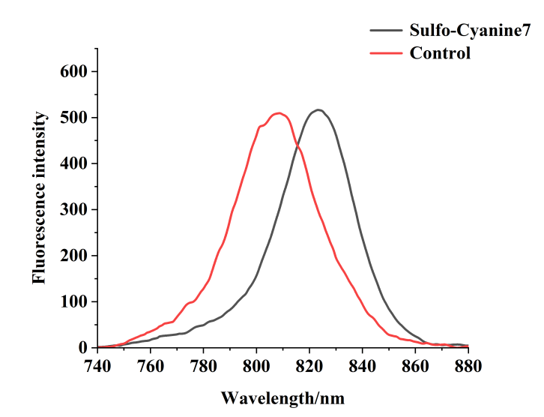
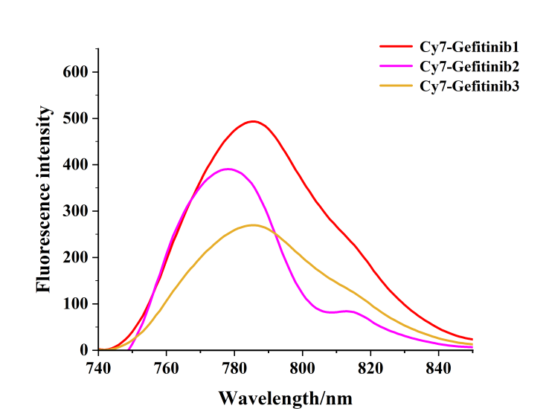
Scheme S3. (A) Fluorescence emission spectra of 10 μM probes (λ_{ex} = 772 nm) in EtOH. (B) Fluorescence emission spectra of 10 μM Sulfo-Cyanine7 and Control (λex = 786 nm) in EtOH.
A
B
  - The anti-interference testing of Cy7-Gefitinib2/3 in
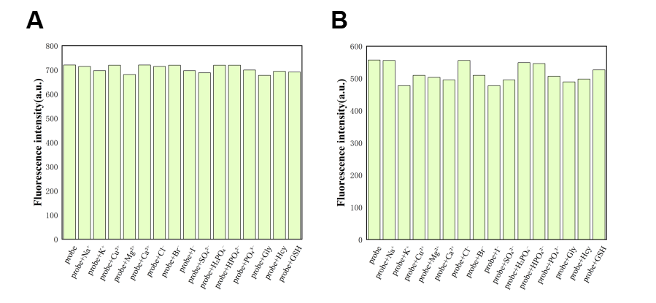
Scheme S4. The fluorescence emission intensity of probes Cy7-Gefitinib2/3 in the presence of interfering substances in PBS (pH = 7.4) solution. (A) Cy7-Gefitinib2 (B) Cy7-Gefitinib3. The concentration of probes is 10 μM, while the concentration of interfering substances is 10 μM.

- Nuclear magnetic resonance and mass spectrometry spectra
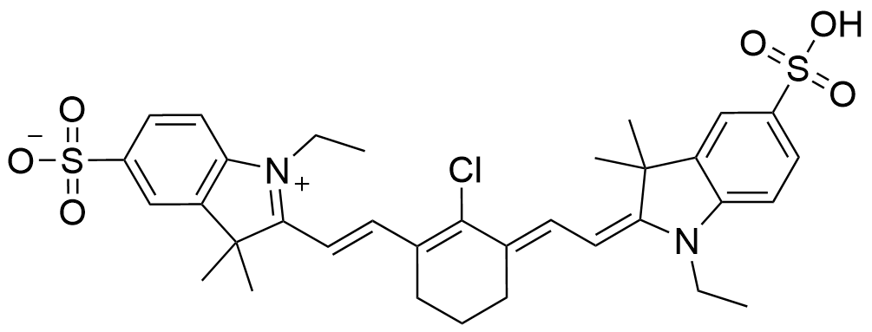
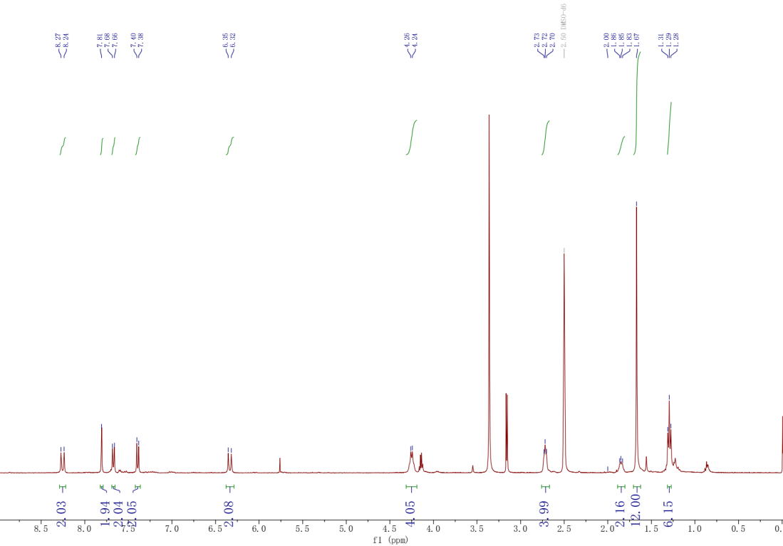
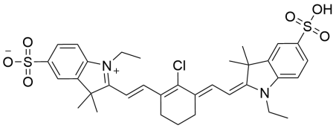
¹H-NMR spectrum of Sulfo-Cyanine7 in DMSO-d₆.
¹³C-NMR spectrum of Sulfo-Cyanine7 in DMSO-d₆.
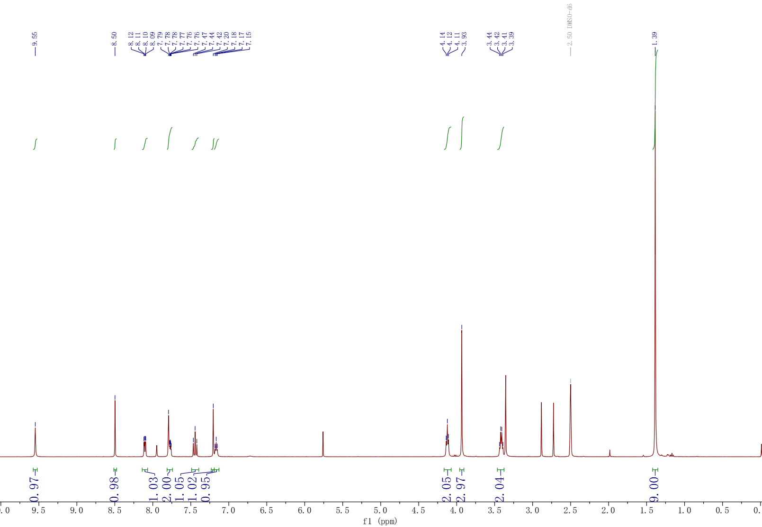
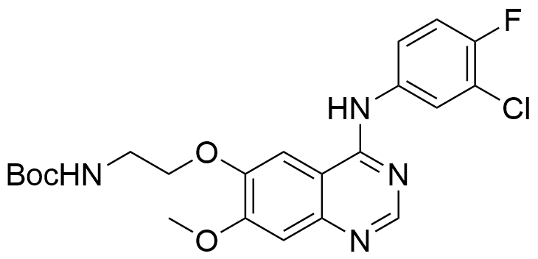
¹H-NMR spectrum of 3a in DMSO-d₆
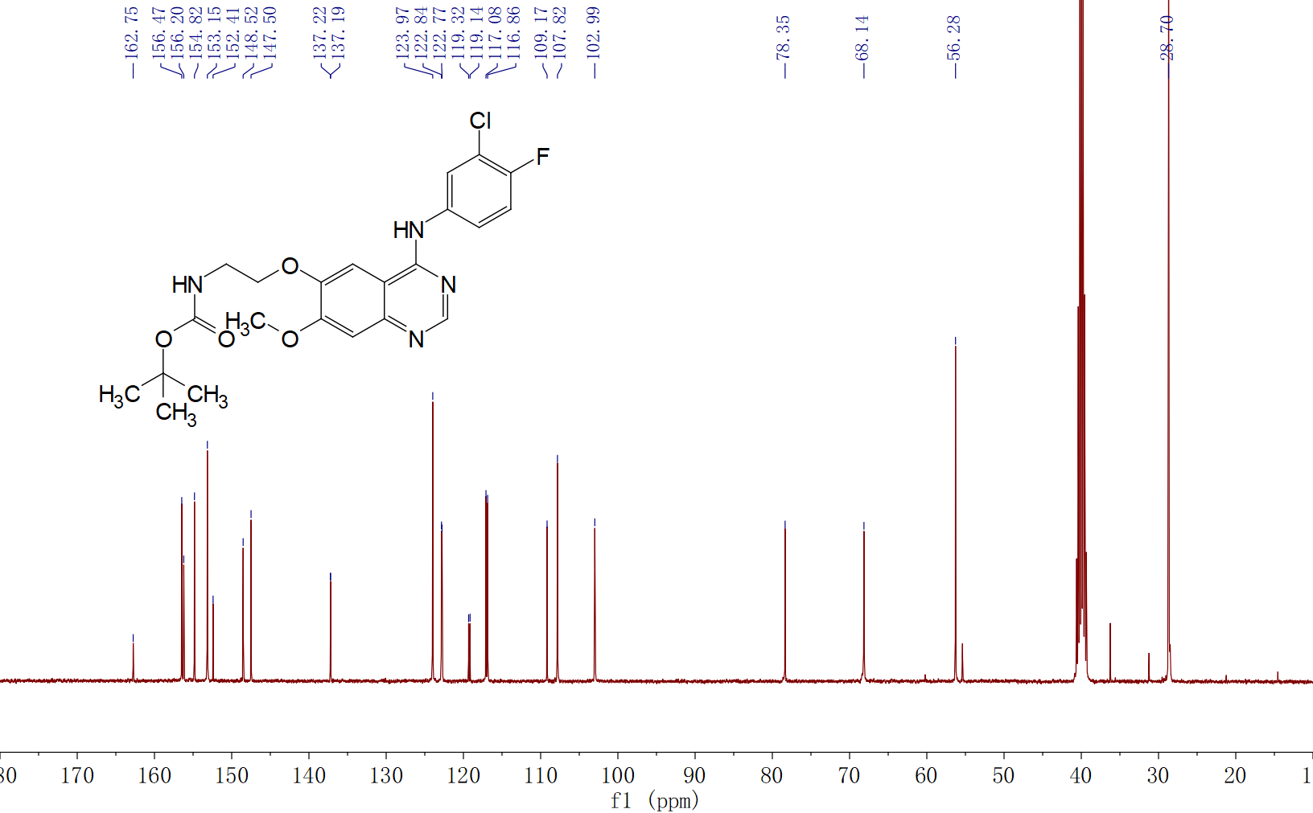
¹³C-NMR spectrum of 3a in DMSO-d₆.

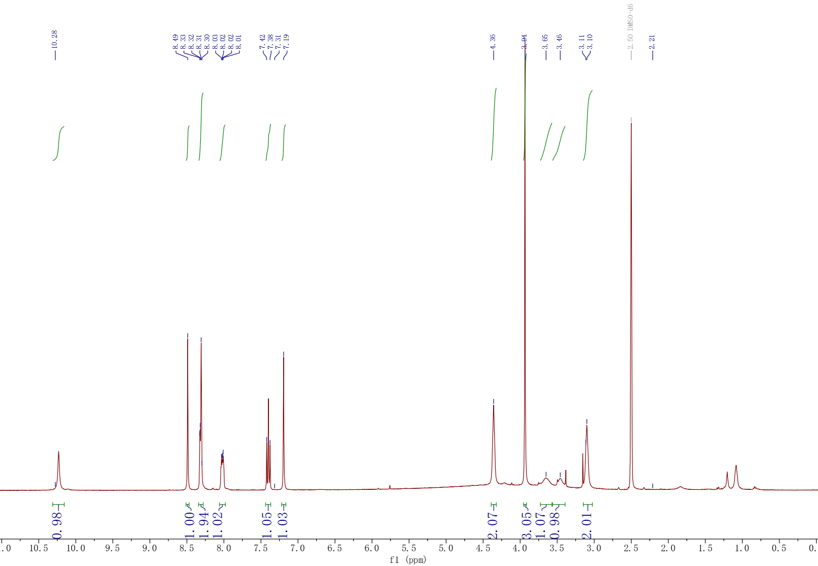
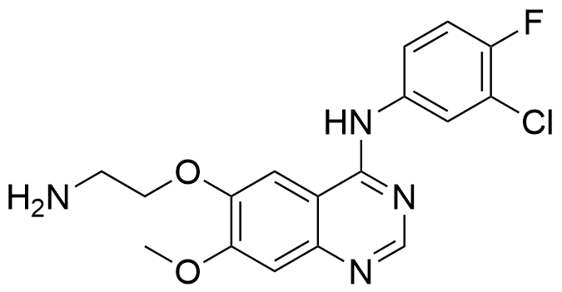
¹H-NMR spectrum of 4a in DMSO-d₆.
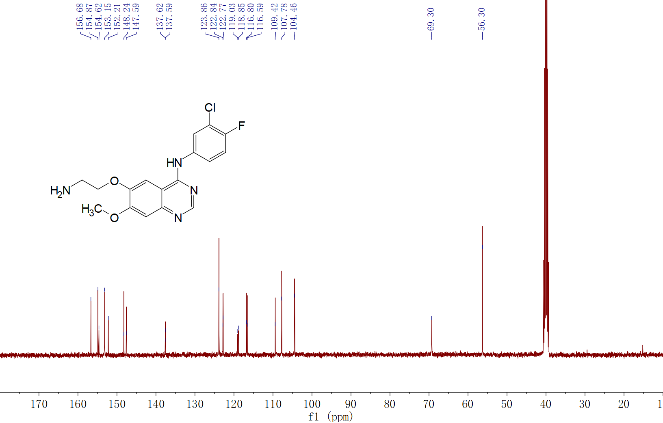
¹³C-NMR spectrum of 4a in DMSO-d₆.

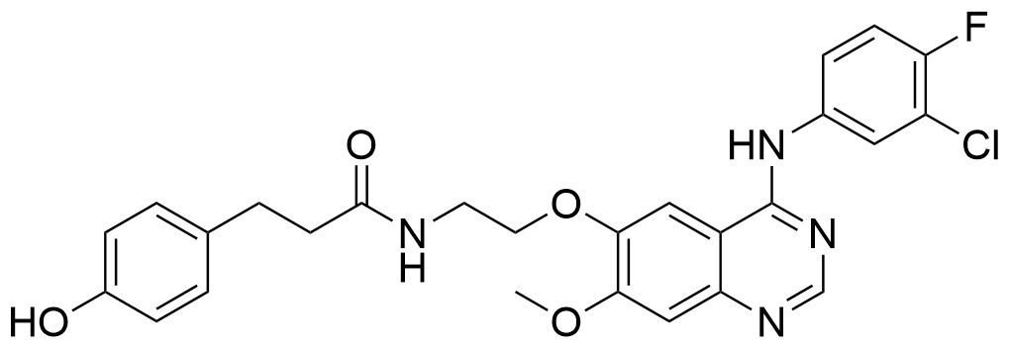

¹H-NMR spectrum of 5a in DMSO-d₆.
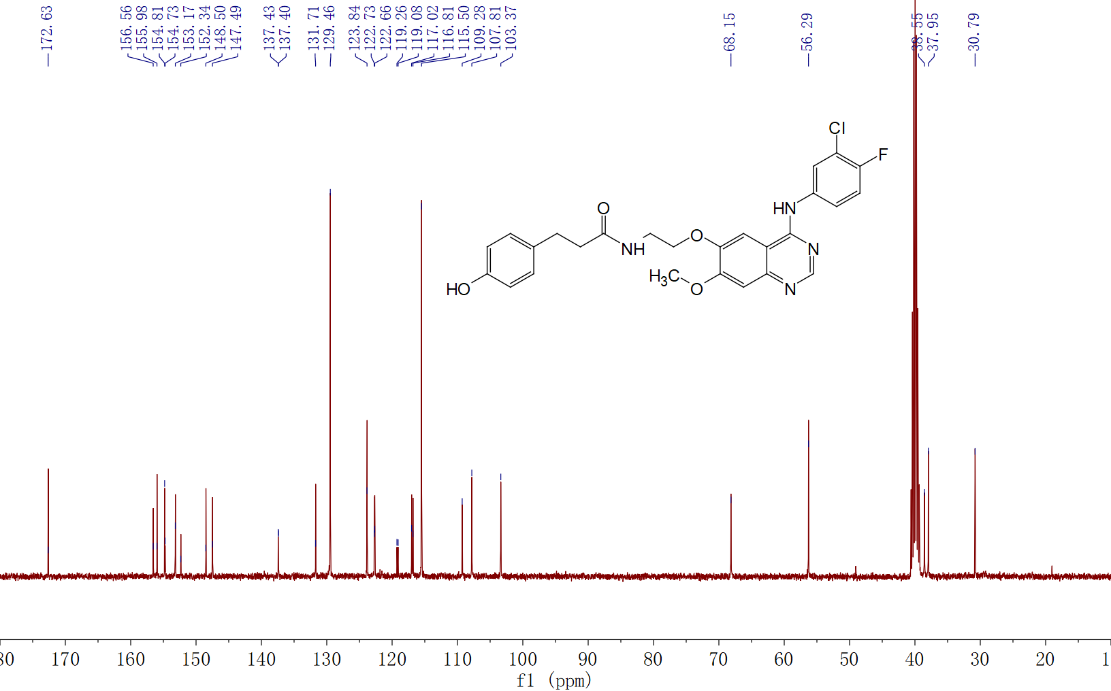
¹³C-NMR spectrum of 5a in DMSO-d₆.

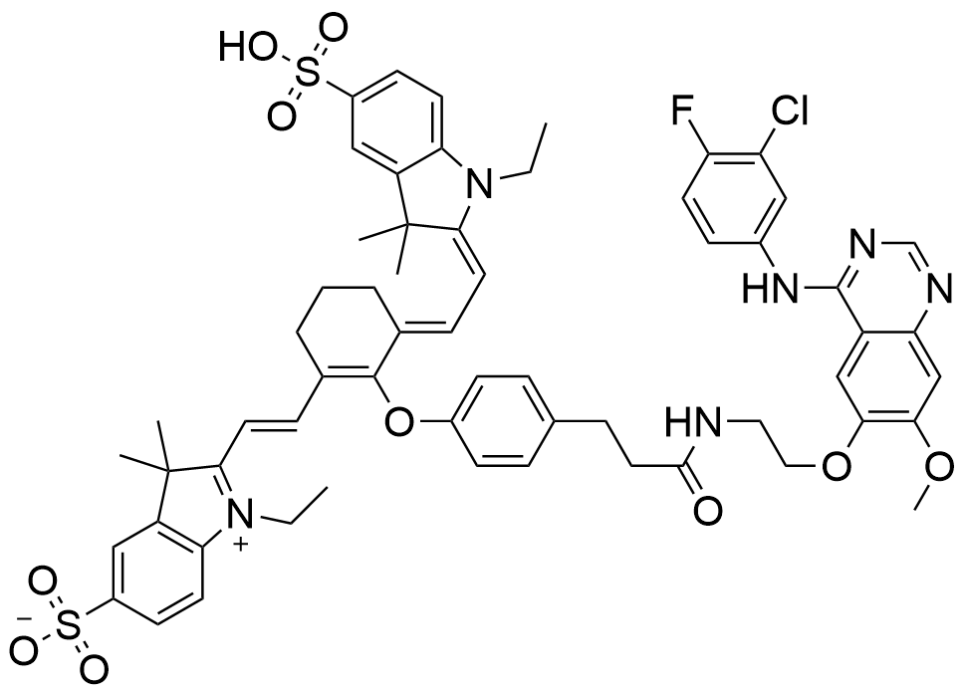
¹H-NMR spectrum of Cy7-Gefitinib1 in DMSO-d₆.

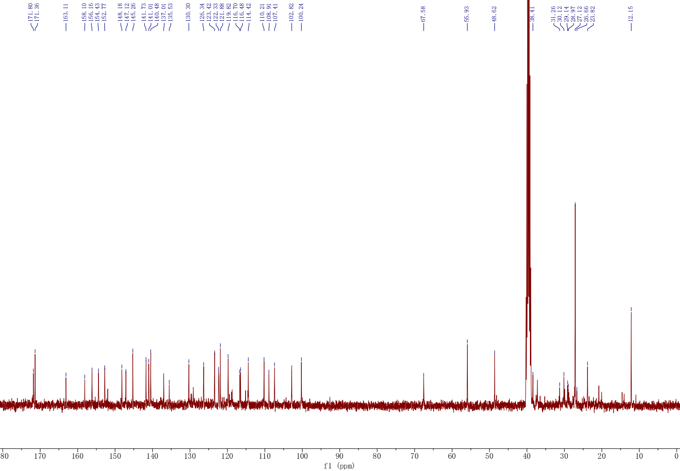
¹³C-NMR spectrum of Cy7-Gefitinib1 in DMSO-d₆.

LCMS(ESI) calcd. For [M+H]⁺: C₆₀H₆₃ClFN₆O₁₀S₂⁺ 1145.37 Found 1145.8.
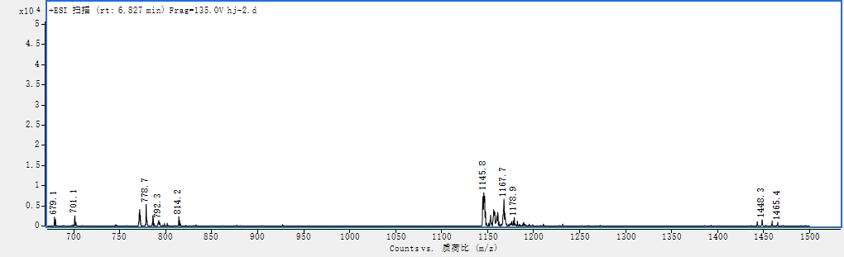
MS spectrum of Cy7-Gefitinib1.

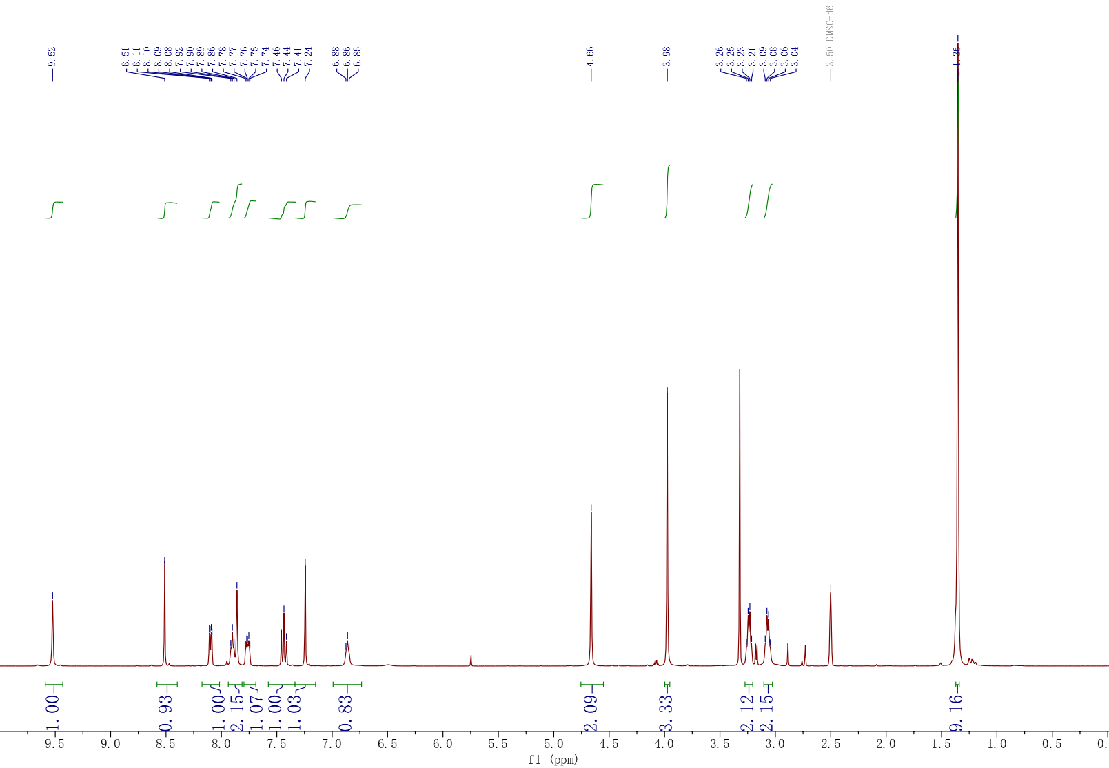
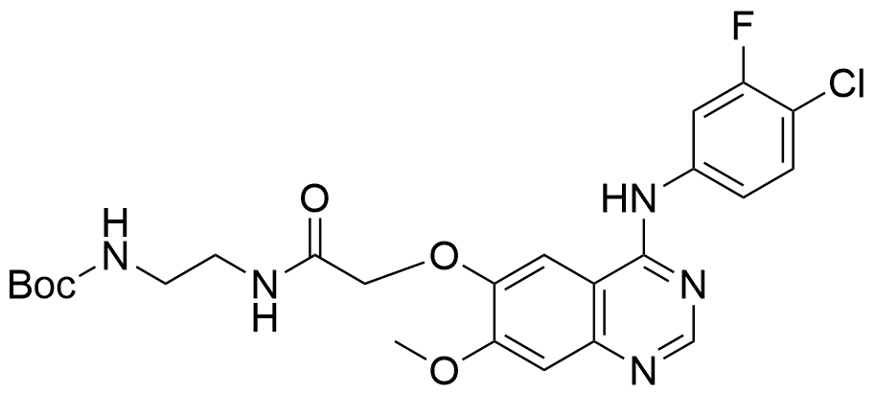
¹H-NMR spectrum of 3b in DMSO-d₆.

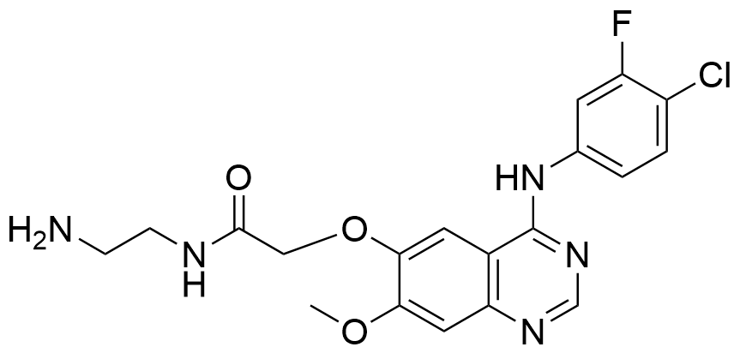
¹H-NMR spectrum of 4b in DMSO-d₆.
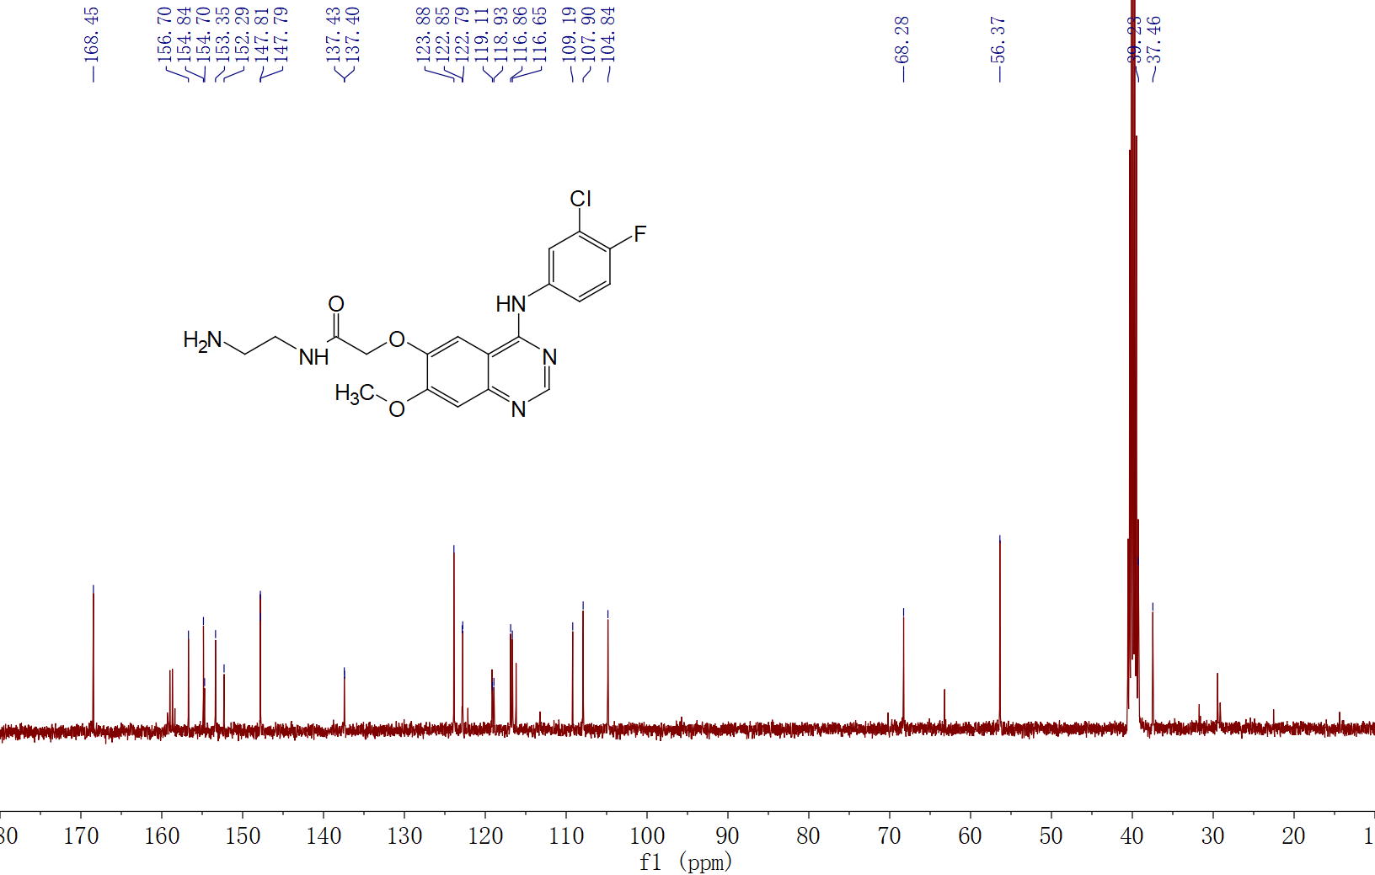
¹³C-NMR spectrum of 4b in DMSO-d₆.

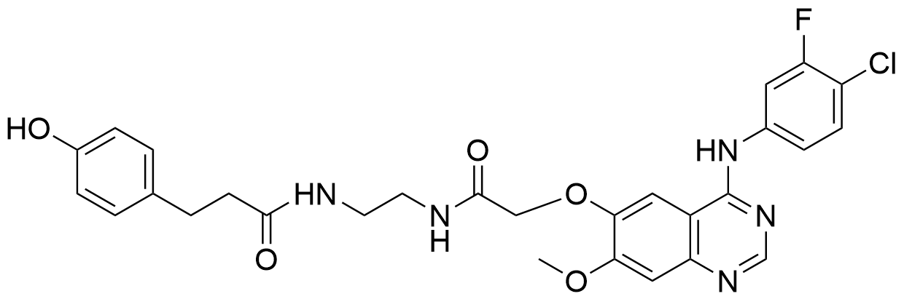
¹H-NMR spectrum of 5b in DMSO-d₆.
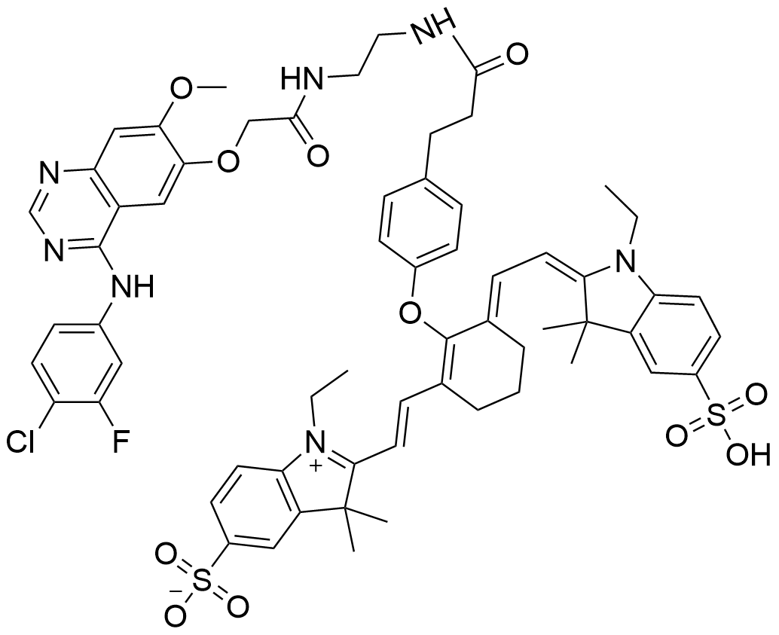
¹H-NMR spectrum of Cy7-Gefitinib2 in DMSO-d₆.

¹³C-NMR spectrum of Cy7-Gefitinib2 in DMSO-d₆.

LCMS(ESI)calcd.For[M-H]⁺:C₆₂H₆₅ClFN₇O₁₁S₂⁻1201.8Found1201.2.
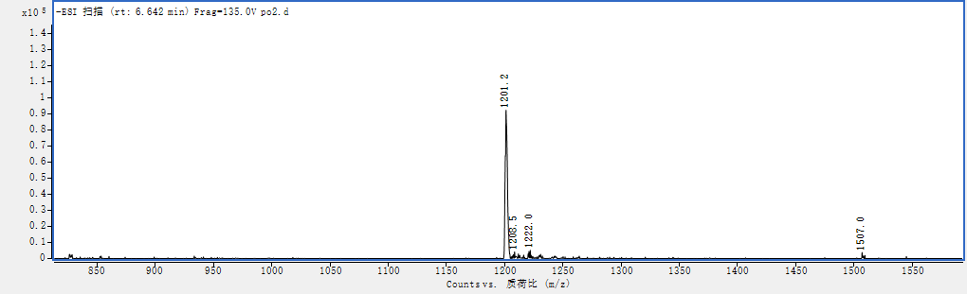
HRMS spectrum of Cy7-Gefitinib2.

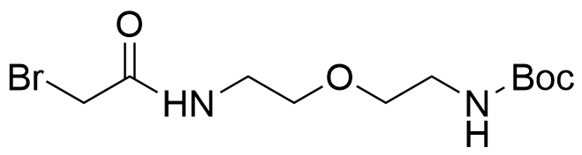
¹H-NMR spectrum of 2c in DMSO-d₆.
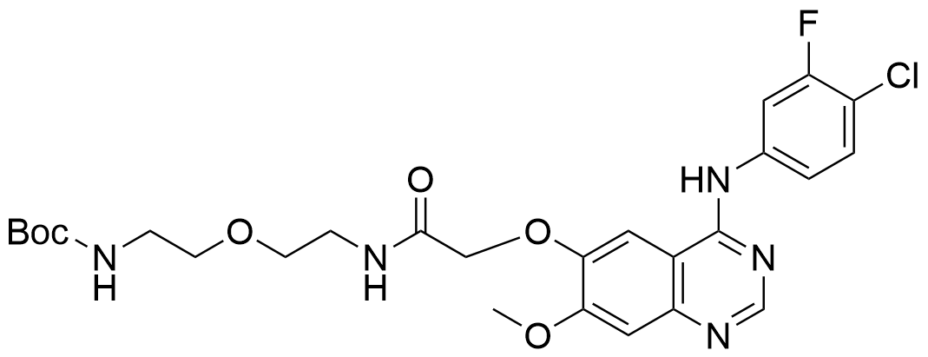
¹H-NMR spectrum of 3c in DMSO-d₆.

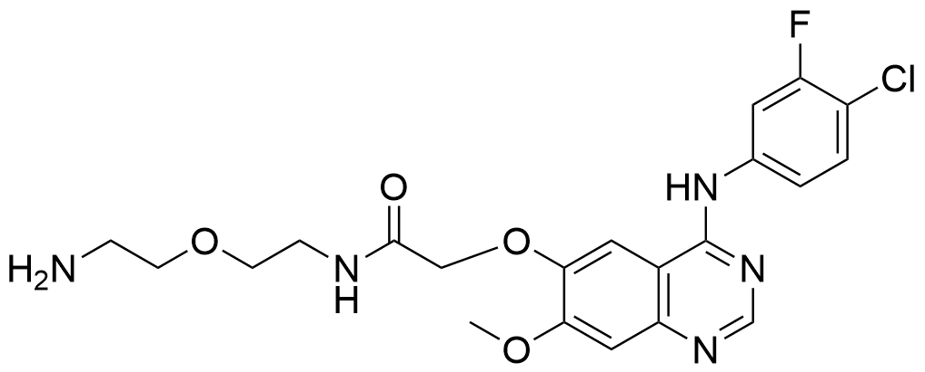
¹H-NMR spectrum of 4c in DMSO-d₆.

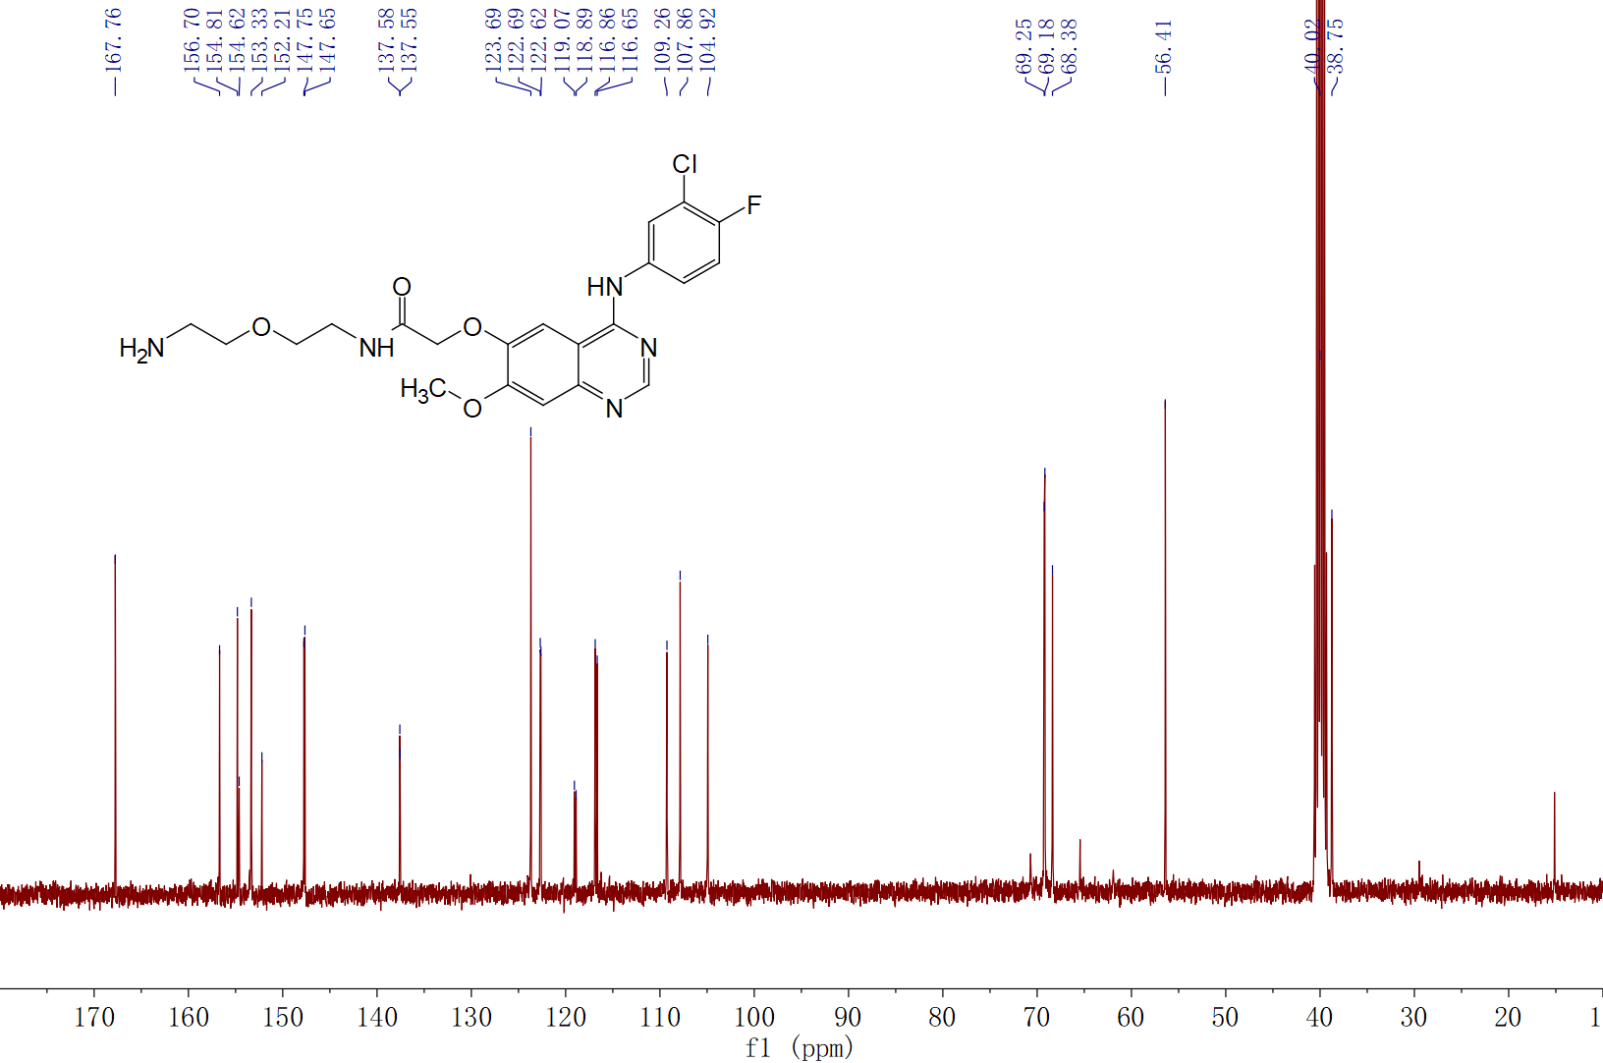
¹³C-NMR spectrum of 4c in DMSO-d₆.
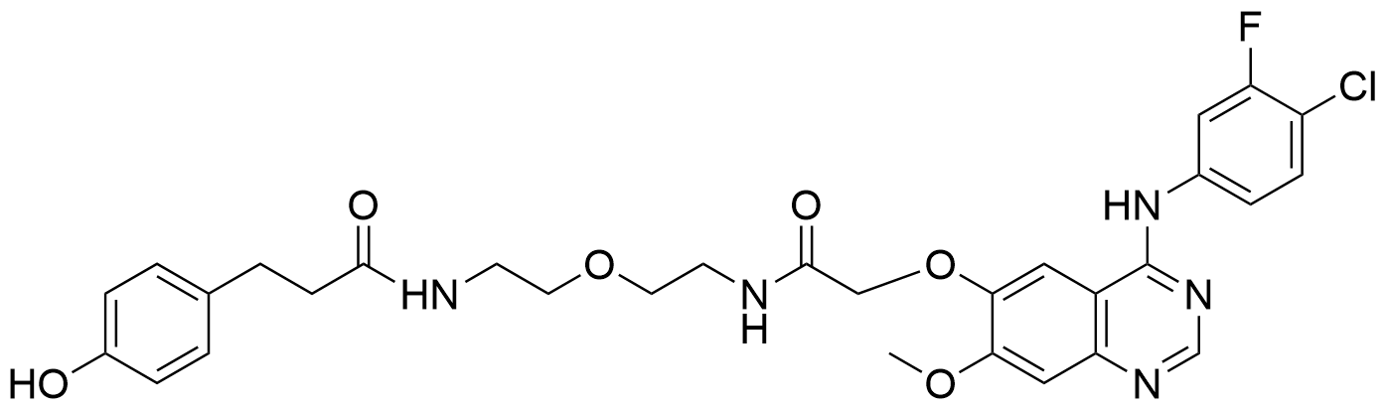
¹H-NMR spectrum of 5c in DMSO-d₆.
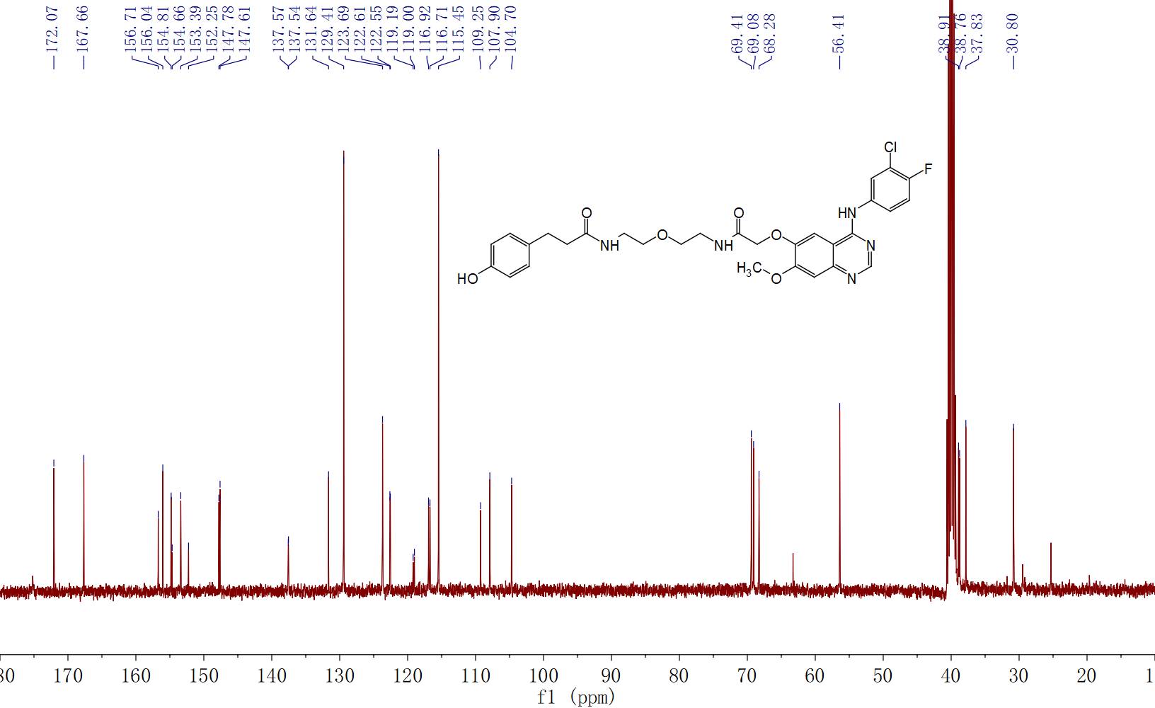¹³C-NMR spectrum of 5c in DMSO-d₆.

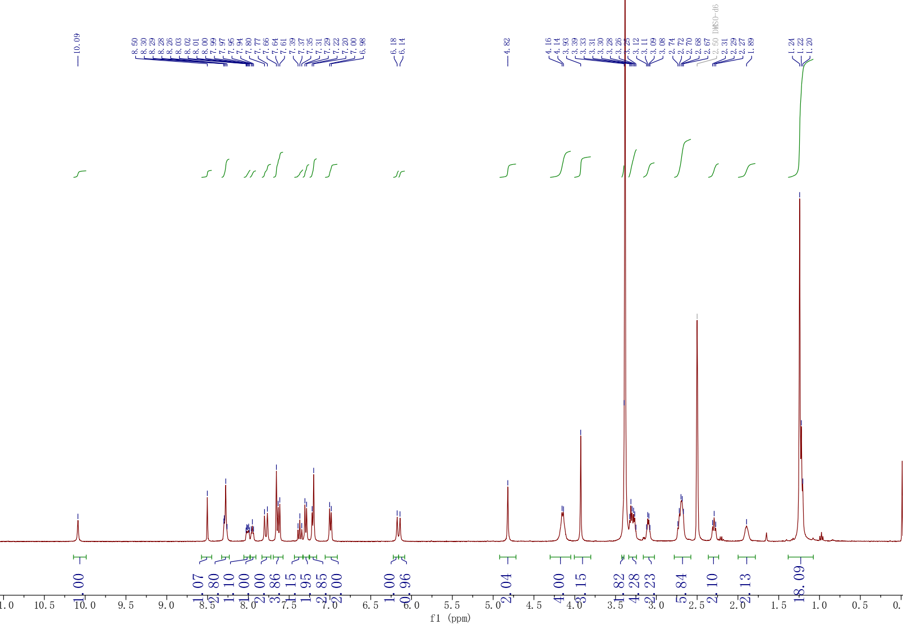
¹H-NMR spectrum of Cy7-Gefitinib3 in DMSO-d₆.
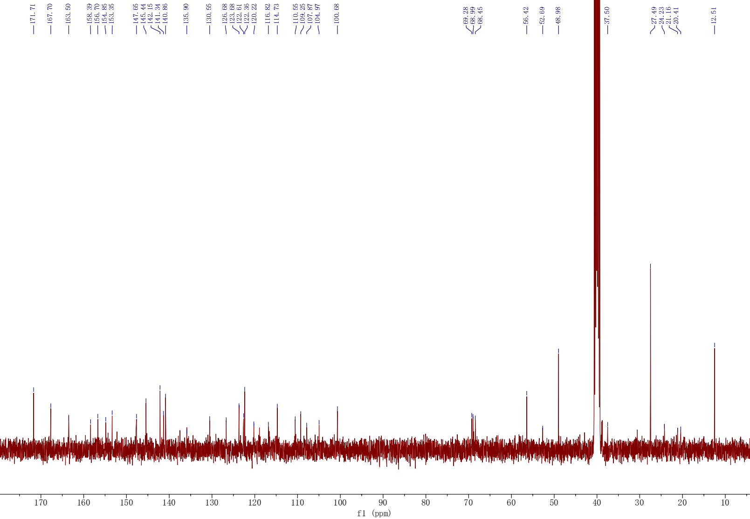
¹³C-NMR spectrum of Cy7-Gefitinib3 in DMSO-d₆.

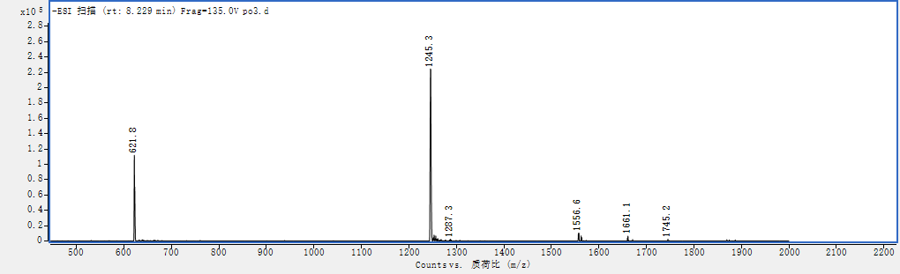
LCMS(ESI) calcd. For [M-H]⁺: C₆₄H₆₈ClFN₇O₁₂S₂⁻ 1245.85 Found 1245.3.
HRMS spectrum of Cy7-Gefitinib3.

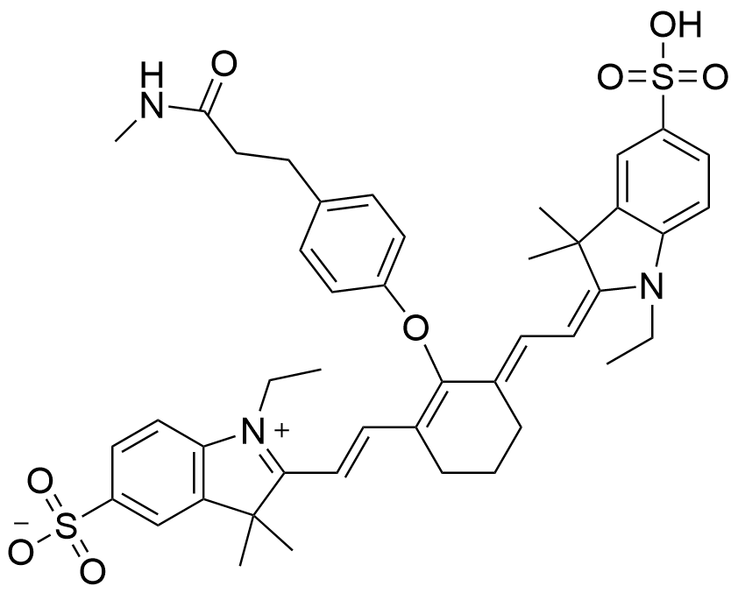
¹H-NMR spectrum of Control in DMSO-d₆.

¹³C-NMR spectrum of Control in DMSO-d₆.
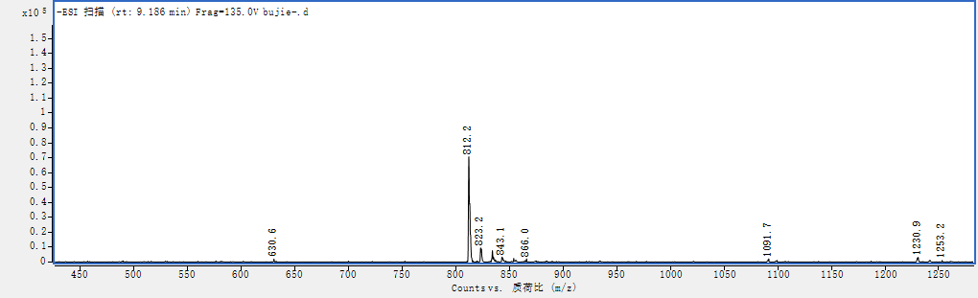
LCMS(ESI) calcd. For [M-H]⁺: C₄₄H₅₀N₃O₈S₂⁻ 812.31 Found 812.2.
HRMS spectrum of Control.

