Additional file 2. Supplementary principal component analysis (PCA) results and related statistical analyses.

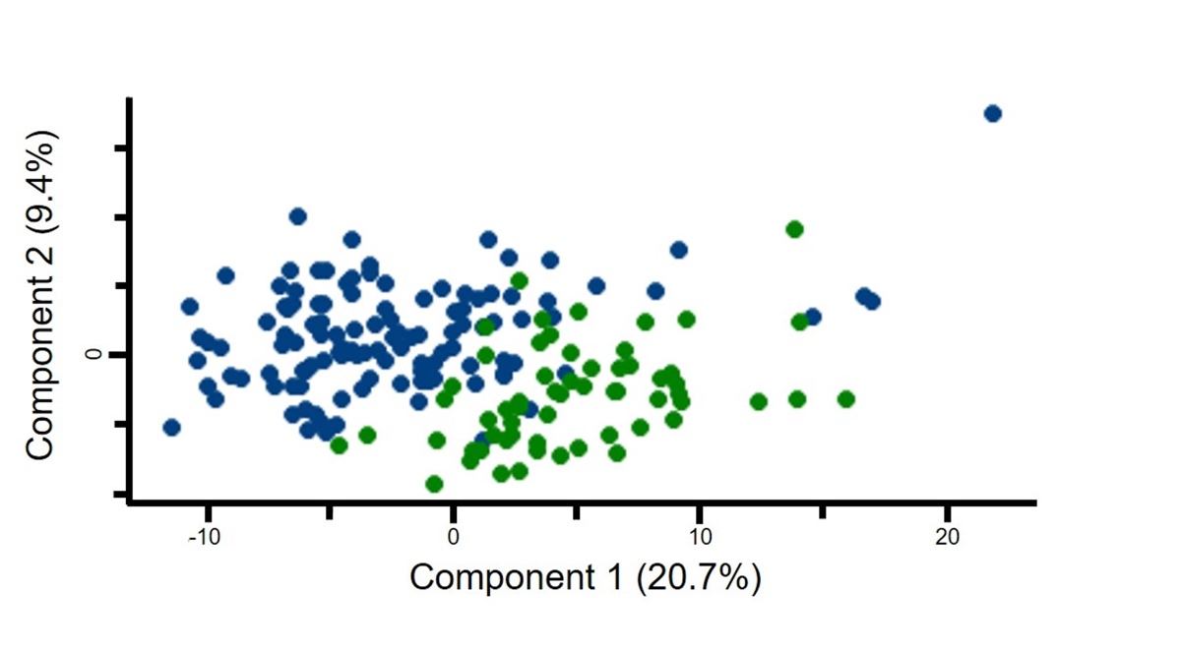
Additional file 2. Principal component analysis (PCA) of plasma proteomic profiles in the healthy aging and cognitive decline cohorts.
Analysis was performed using only proteins commonly included in both cohorts. PCA was performed using proteins quantified in the healthy aging cohort and the cognitive decline cohort. Each dot represents one individual sample. Blue dots indicate samples from the healthy aging cohort, and green dots indicate samples from the cognitive decline cohort, including individuals with mild cognitive impairment (MCI) and Alzheimer’s disease (AD). A partial separation between the two cohorts was observed along principal component 1 (PC1), although substantial overlap remained between groups. Because the two cohorts were processed independently and no explicit batch effect correction was applied, the observed separation may reflect both biological and technical variability. PCA was performed using Perseus software (version 2.1.4.0).

