Supplemental Table 1. Exposure assessment tool embedded within initial ILD clinic note visit.

Environmental Exposure History:
- Water damage or mold/mildew in the home or work place
- House is greater than {insert text} years old
- Hot tub
- Humidifier
- Air Cleaner / air purifier
- Steam sauna / steam shower
- Asbestos
- Birds
- Down pillow or comforters
- Radiation
- Musical wind instruments
- Cement or construction dust
- Coal dust
- Flour dust
- Metal dusts or fumes
- Silica dust
- Wood dust
- Grain dust
- Moldy or damp hay
- Compost or mulch
- Animal husbandry or animal care
- “No exposure”
- Other (free text option)

Occupational Exposure History:
- Pottery worker
- Cotton mill worker
- Pipe worker or plumber
- Insulation worker
- Farmer
- Sandblaster
- Rock miner
- Talc worker
- Beryllium worker
- Aluminum worker
- Carpenter or woodworker
- Plastic worker
- Railroad worker
Supplemental Table 2. ILD diagnosis groups as recorded in the electronic health record
- Idiopathic Interstitial Pneumonias (IIPs)
  - Idiopathic Pulmonary Fibrosis (IPF)
  - Familial Interstitial Fibrosis
  - Non-specific Interstitial Pneumonia
  - Combined Pulmonary Fibrosis and Emphysema
  - Pleuroparenchymal Fibroelastosis
  - Lymphangiomyomatosis
  - Chronic Eosinophilic Pneumonia

- Systemic Autoimmune Rheumatic Disease-Associated ILD (SARD-ILD)
  - Rheumatoid Arthritis
  - Systemic Lupus Erythematosus
  - Systemic sclerosis
  - Sjogren’s syndrome
  - Mixed/Undifferentiated Connective Tissue Disease
  - Vasculitis-associated ILD
  - Idiopathic Inflammatory Myositis
  - Cryptogenic Organizing Pneumonia
  - Interstitial Pneumonia with Autoimmune Features
  - Undifferentiated Autoimmune/Inflammatory ILD

- Hypersensitivity Pneumonitis

- Sarcoidosis

- Other
  - Asbestosis / Other Pneumoconiosis
  - Smoking-related ILD / Respiratory Bronchiolitis-ILD
  - Iatrogenic Causes
    - Drug-related ILD
    - Radiation Fibrosis
  - Granulomatous Lymphocytic ILD
  - Lymphoid Interstitial Pneumonia
  - Unclassifiable

Supplemental Table 3. Exposure groups by specific item in initial clinic visit questionnaire.

(1) Animal/Bird:
  - Birds
  - Down pillow/comforters
  - Animal husbandry or animal care
  - Farmer

(2) Water damage/mold
  - Water damage
  - Mold/mildew in the home or work place
  - Moldy or damp hay
  - Compost or mulch
  - Pipe worker/plumber

(3) Other Organic Particulates
  - Flour dusts
  - Wood dusts
  - Grain dust
  - Cotton mill worker
  - Carpenter

- Vapors/chemical fumes
  - Hot tub
  - Steam sauna/steam shower
  - Plastic Worker

- Metals/inorganic Dusts
  - Asbestos
  - Metal dusts or fumes
  - Silica dust
  - Insulation worker
  - Sandblaster
  - Rock miner
  - Talc worker
  - Beryllium worker
  - Aluminum worker
  - Railroad Worker
Supplemental Table 4. Distribution of exposure types overall and by ILD diagnosis (expanded)
 | IIP |  |  |  |  | Other ILDs
 | IPF  (N= 171) | Non-IPF IIP  (N = 124) | SARD-ILD  (N = 208) | HP  (N= 70) | Sarcoid  (N = 43) | Iatrogenic  (N = 28) | Pneumoconiosis  (N = 9) | Smoking-related  (N = 21) | Other  (N = 91) | Total  (N = 765)
Exposure Type
Animal/Bird | 28 (16.4%) | 19 (15.3%) | 24 (11.5%) | 31 (44.3%) | 4 (9.3%) | 1 (3.6%) | 1 (11.1%) | 3 (14.3%) | 14 (15.4%) | 125 (16.3%)
Water Damage/Mold | 17 (9.9%) | 17 (13.7%) | 26 (12.5%) | 30 (42.9%) | 2 (4.7%) | 6 (21.4%) | 1 (11.1%) | 2 (9.5%) | 8 (8.8%) | 109 (14.2%)
Other Organic Particulates | 43 (25.1%) | 25 (20.2%) | 17 (8.2%) | 16 (22.9%) | 3 (7.0%) | 3 (10.7%) | 1 (11.1%) | 3 (14.3%) | 15 (16.5%) | 126 (16.5%)
Vapors/Chemical Fumes | 21 (12.3%) | 21 (16.9%) | 20 (9.6%) | 12 (17.1%) | 4 (9.3%) | 1 (3.6%) | 0 (0.0%) | 3 (14.3%) | 7 (7.7%) | 89 (11.6%)
Metals/Inorganic Dusts | 42 (24.6%) | 30 (24.2%) | 19 (9.1%) | 12 (17.1%) | 9 (20.9%) | 5 (17.9%) | 7 (77.8%) | 2 (9.5%) | 12 (13.2%) | 138 (18.0%)
Any Exposure | 100 (58.5%) | 73 (58.9%) | 74 (35.6%) | 58 (82.9%) | 16 (37.2%) | 13 (46.4%) | 8 (88.9%) | 8 (38.1%) | 38 (41.8%) | 388 (50.7%)

Supplemental Figure 1. Consort diagram for sample cohort
765 patients
included in analysis
1039 patients
identified within study period
14 patients
without recorded exposure registry excluded
133 patients without consensus diagnosis generated from EMR undergo manual chart review
65 patients with negative ILD evaluation excluded from analysis
68 patients with manually confirmed diagnosis included in analysis
195 patients
without consensus diagnosis excluded

Supplemental Figure 2. Cumulative Incidence of ILD Progression by stratified Exposure Status, among patients with IIP
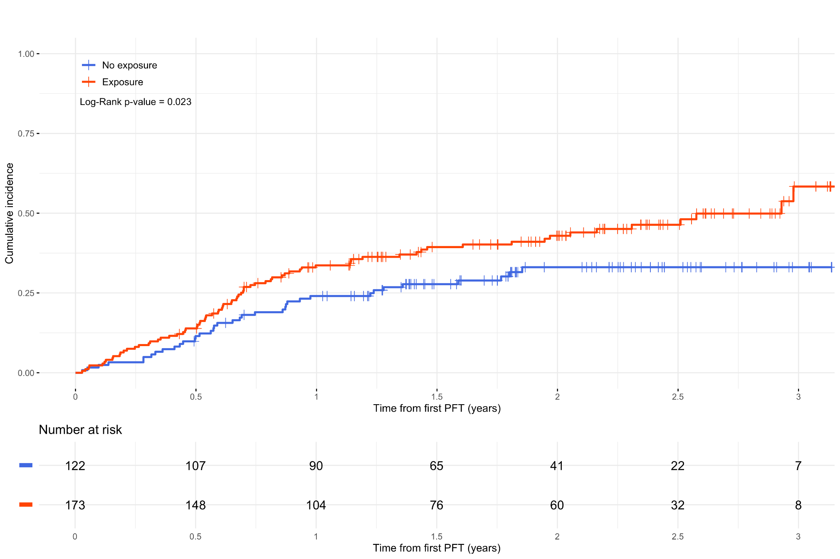
Supplemental Figure 3. Cumulative Incidence of ILD Progression by stratified Exposure Status, among patients with SARD-ILD
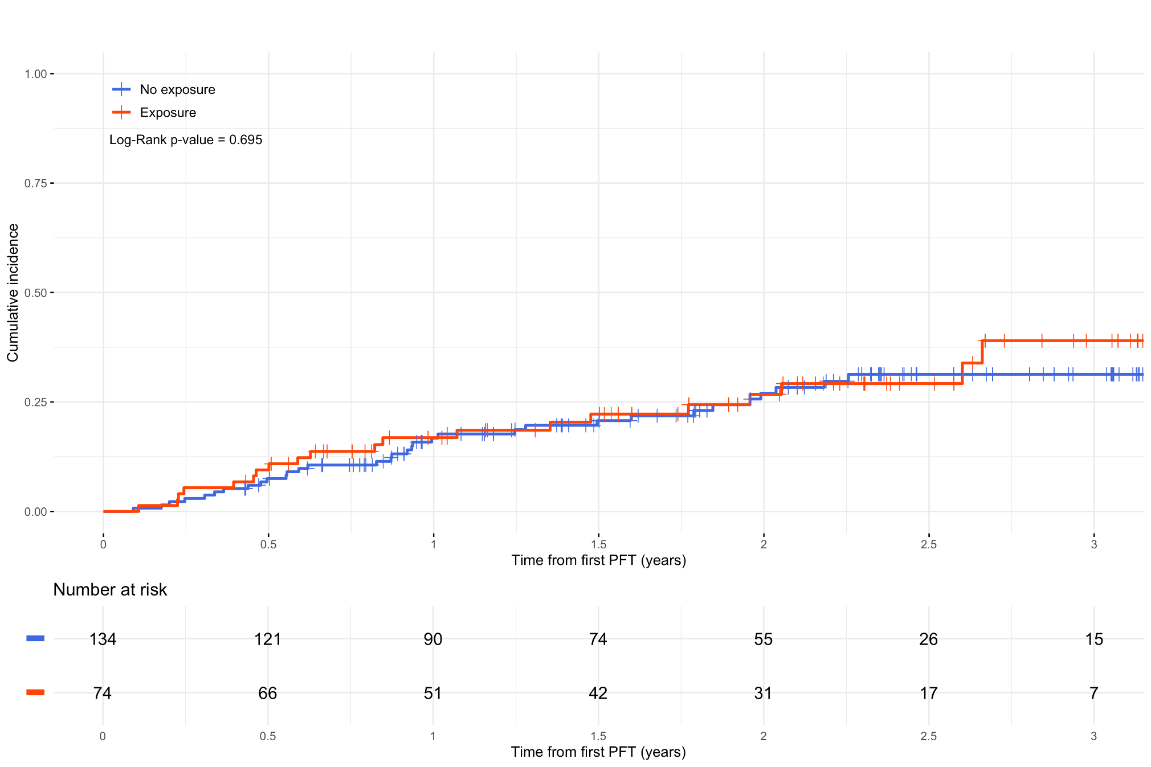

Supplemental Figure 4. Association between the presence of reported exposure and disease progression by clinical and demographic characteristics, excluding individuals with missing FVC values (n=674)

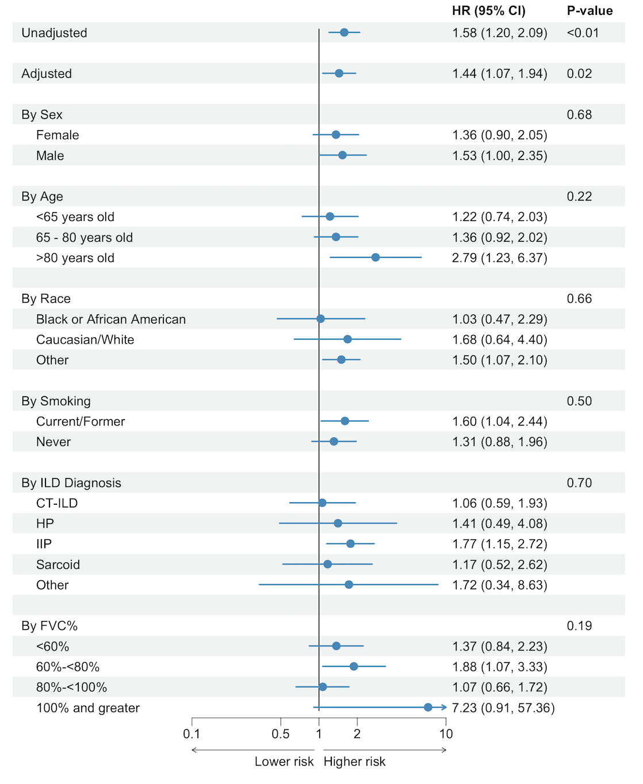

* The first two p-values evaluate the association between exposures and progression in unadjusted or adjusted models, respectively. Subsequent p-values represent the interaction p-values for each patient characteristic variable and exposure status

Supplemental Figure 5. Association between the presence of reported exposure and disease progression, adjusting for IPF and non-IPF as distinct diagnoses. Additional adjustments in each model made for the same covariates in primary analysis including: sex, age, race, and smoking history. 95% confidence intervals shown in parenthesis.

HR for Exposed to Unexposed Group, adjusted for IPF and non-IPF as distinct diagnosis in sensitivity analysis (n=765) | Unadjusted HR for Exposed to Unexposed Group, primary analysis (n=765) | Adjusted HR for Exposed to Unexposed Group, primary analysis (n=765)
1.43 (1.063, 1.937) | 1.60 (1.23, 2.09) | 1.42 (1.07, 1.88)

HR for Exposed to Unexposed Group, adjusting for IPF and non-IPF as distinct diagnosis in sensitivity analysis, excluding individuals with missing FVC values (n=674) | Unadjusted HR for Exposed to Unexposed Group, excluding individuals with missing FVC values (n=674) | Adjusted HR for Exposed to Unexposed Group, excluding individuals with missing FVC values (n=674)
1.41 (1.063, 1.877) | 1.58 (1.20, 2.09) | 1.44 (1.07, 1.94)

