Supporting Materials

A Chromene-Based Fluorescent Probe for Rapid Hypochlorite Detection in Environmental Matrices, Plant Tissues, and a Smartphone Platform

Guangqin Gao¹, Baixue Zhao², Yuli Dang¹, Wenbo Shen¹, Zhanqi Cao¹, Chenyu Li¹, Rubing Feng¹, Puhui Xie^{1*}, Fengqi Guo^{3*}
¹College of Sciences, Henan Agricultural University, Zhengzhou 450002, P. R. China
² College of Forestry, Henan Agricultural University, Zhengzhou 450046, P. R. China
³College of Ecology and Environment, Zhengzhou University, 450001, P. R. China

Fig. S1 Absorption spectra of 1 at pH 4–10.
Fig. S2 Fluorescence spectra of 1 (10 μM) in the presence of ClO⁻ (10 eq) at pH 4–10.

Fig. S3 Time dependence for fluorescence intensity at 530 nm of 1 (10 μM) in the presence of ClO⁻ (10 eq).

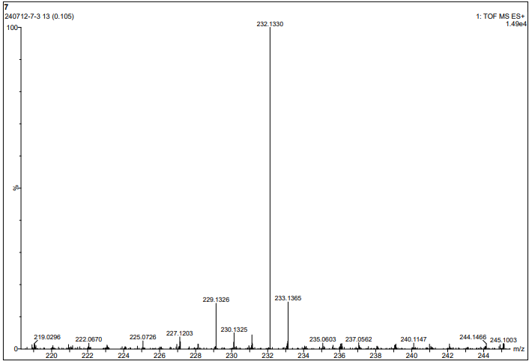
Fig. S4 MS of 1 + ClO⁻.

Fig. S5 Absorption spectra of 1 + ClO⁻ and 1A.

Fig. S6 Lifetime profiles of 1 and 1 + ClO⁻.

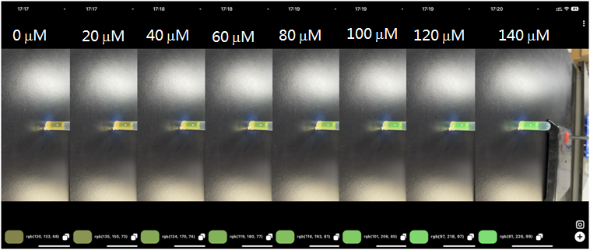
Fig. S7 Digitized RGB information of 1 (10 μM) in presence of ClO⁻ (0–140 μM) based on smartphone platform.

Table S1 The collected RGB values, calculated Euclidean distance and the corresponding ClO⁻ concentration.
C(ClO⁻/μM) | R | G | B | Euclidean distance
0 | 130 | 133 | 68 | 0
20 | 135 | 150 | 73 | 18.4120
40 | 124 | 170 | 74 | 37.9605
60 | 119 | 180 | 77 | 49.1019
80 | 116 | 193 | 81 | 62.9683
100 | 101 | 206 | 85 | 80.3679
120 | 97 | 218 | 97 | 95.6818
140 | 81 | 226 | 99 | 109.5947

