Supplementary Material
Association Between Early Postoperative Fraction of Inspired Oxygen and Pulmonary Complications After Coronary Artery Bypass Grafting: A Retrospective Cohort Study Using Public Databases

Supplementary Methods
Generalized propensity scores were estimated using multinomial logistic regression with baseline covariates only (age, sex, collapsed race, admission type, BMI, COPD, CHF, CKD, diabetes, and hypertension). Missing BMI values were imputed with the median, and categorical covariates were imputed with the mode. For the three-level FiO₂ exposure, generalized overlap weighting was applied. As a sensitivity analysis, the extreme groups (FiO₂ >0.80 vs ≤0.60) were compared using stabilized inverse probability of treatment weighting (IPTW). Covariate balance was assessed using absolute standardized mean differences (SMDs), with SMD <0.10 considered acceptable. Weighted logistic regression was used to estimate odds ratios and 95% confidence intervals.

PPC incidence according to early postoperative FiO₂ group
Supplementary Table S1. PPC incidence according to early postoperative FiO₂ group in the MIMIC-IV and eICU cohorts.
Cohort | FiO₂ group | No. of patients | PPC, n | PPC incidence, % | 95% CI
MIMIC | ≤0.60 | 817 | 45 | 5.51 | 4.14–7.29
MIMIC | 0.61–0.80 | 3223 | 261 | 8.10 | 7.21–9.09
MIMIC | >0.80 | 1417 | 207 | 14.61 | 12.87–16.54
eICU | ≤0.60 | 3400 | 320 | 9.41 | 8.48–10.44
eICU | 0.61–0.80 | 793 | 113 | 14.25 | 11.99–16.86
eICU | >0.80 | 328 | 87 | 26.52 | 22.04–31.55
Supplementary Table S2. Group comparison tests for PPC incidence across FiO₂ groups.
Cohort | Total n | Total PPC | χ² (df) | P (χ²) | Trend Z | P (trend)
MIMIC | 5457 | 513 | 66.08 (2) | <0.001 | 7.77 | <0.001
eICU | 4521 | 520 | 93.19 (2) | <0.001 | 9.31 | <0.001
Note: PPC incidence is presented as n and percentage with Wilson 95% confidence intervals. Between-group comparisons were performed using the chi-square test. Trends across ordered FiO₂ groups were assessed using the Cochran-Armitage trend test.

Propensity score analysis of MIMIC-IV
The MIMIC-IV cohort included 5,457 patients: 817 in the FiO₂ ≤0.60 group, 3,223 in the FiO₂ 0.61–0.80 group, and 1,417 in the FiO₂ >0.80 group. Main multinomial overlap weighting achieved excellent balance, reducing the number of covariates with absolute SMD >0.10 from 7 before weighting to 0 after weighting. The maximum SMD decreased from 0.427 to 0.021. For the binary IPTW sensitivity analysis, the number of imbalanced covariates also decreased from 7 to 0, and the maximum SMD decreased from 0.427 to 0.030.
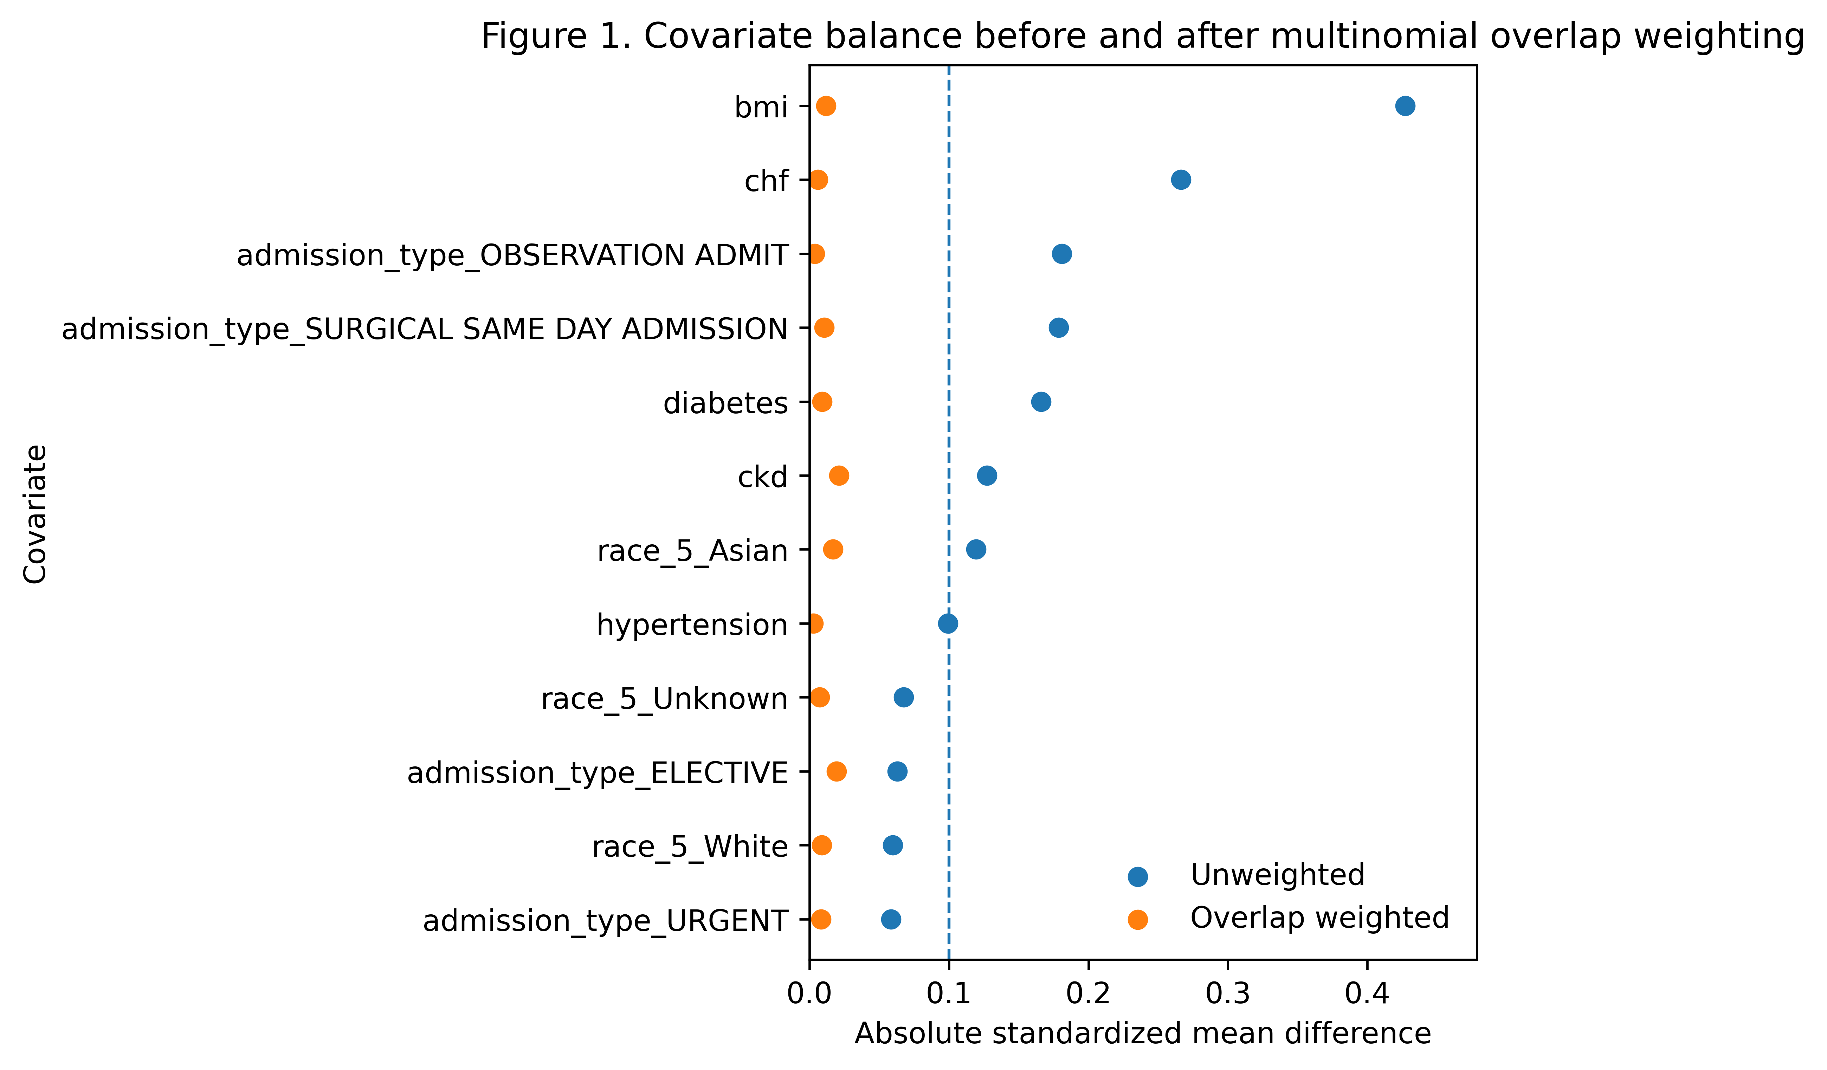
Supplementary Figure S1. Love plot showing covariate balance before and after multinomial overlap weighting.

Supplementary Table S3. Overlap-weighted incidence of PPC composite.
FiO₂ group | Weighted incidence (%) | 95% CI
≤0.60 | 5.52 | 4.47-6.57
0.61-0.80 | 8.27 | 7.00-9.53
>0.80 | 12.66 | 11.13-14.18
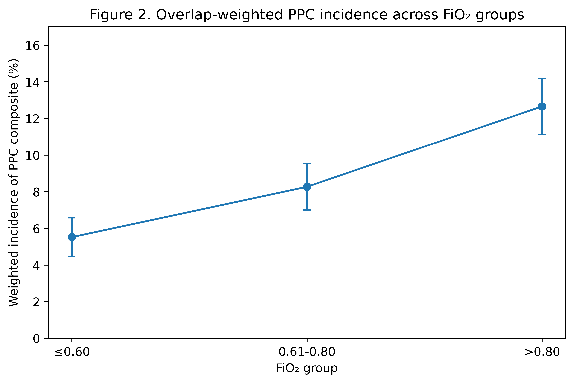
Supplementary Figure S2. Overlap-weighted incidence of PPC composite according to FiO₂ group.

Overlap-weighted outcome analysis
In the multinomial overlap-weighted analysis, compared with FiO₂ ≤0.60, FiO₂ 0.61–0.80 was associated with higher odds of PPC composite and prolonged mechanical ventilation, whereas FiO₂ >0.80 was associated with higher odds of PPC composite, prolonged mechanical ventilation, reintubation, and pneumonia. The association between the highest and middle FiO₂ groups also supported a graded risk pattern.
Supplementary Table S4. Main overlap-weighted logistic regression results.
Outcome | Comparison | OR (95% CI) | P
PPC composite | 0.61-0.80 vs ≤0.60 | 1.54 (1.19-2.00) | 0.001
PPC composite | >0.80 vs ≤0.60 | 2.48 (1.94-3.16) | <0.001
Prolonged mechanical ventilation >48 h | 0.61-0.80 vs ≤0.60 | 1.87 (1.28-2.74) | 0.001
Prolonged mechanical ventilation >48 h | >0.80 vs ≤0.60 | 3.90 (2.76-5.51) | <0.001
Reintubation | 0.61-0.80 vs ≤0.60 | 1.46 (0.95-2.25) | 0.083
Reintubation | >0.80 vs ≤0.60 | 2.43 (1.64-3.61) | <0.001
Pneumonia | 0.61-0.80 vs ≤0.60 | 1.32 (0.94-1.85) | 0.108
Pneumonia | >0.80 vs ≤0.60 | 1.49 (1.07-2.07) | 0.018
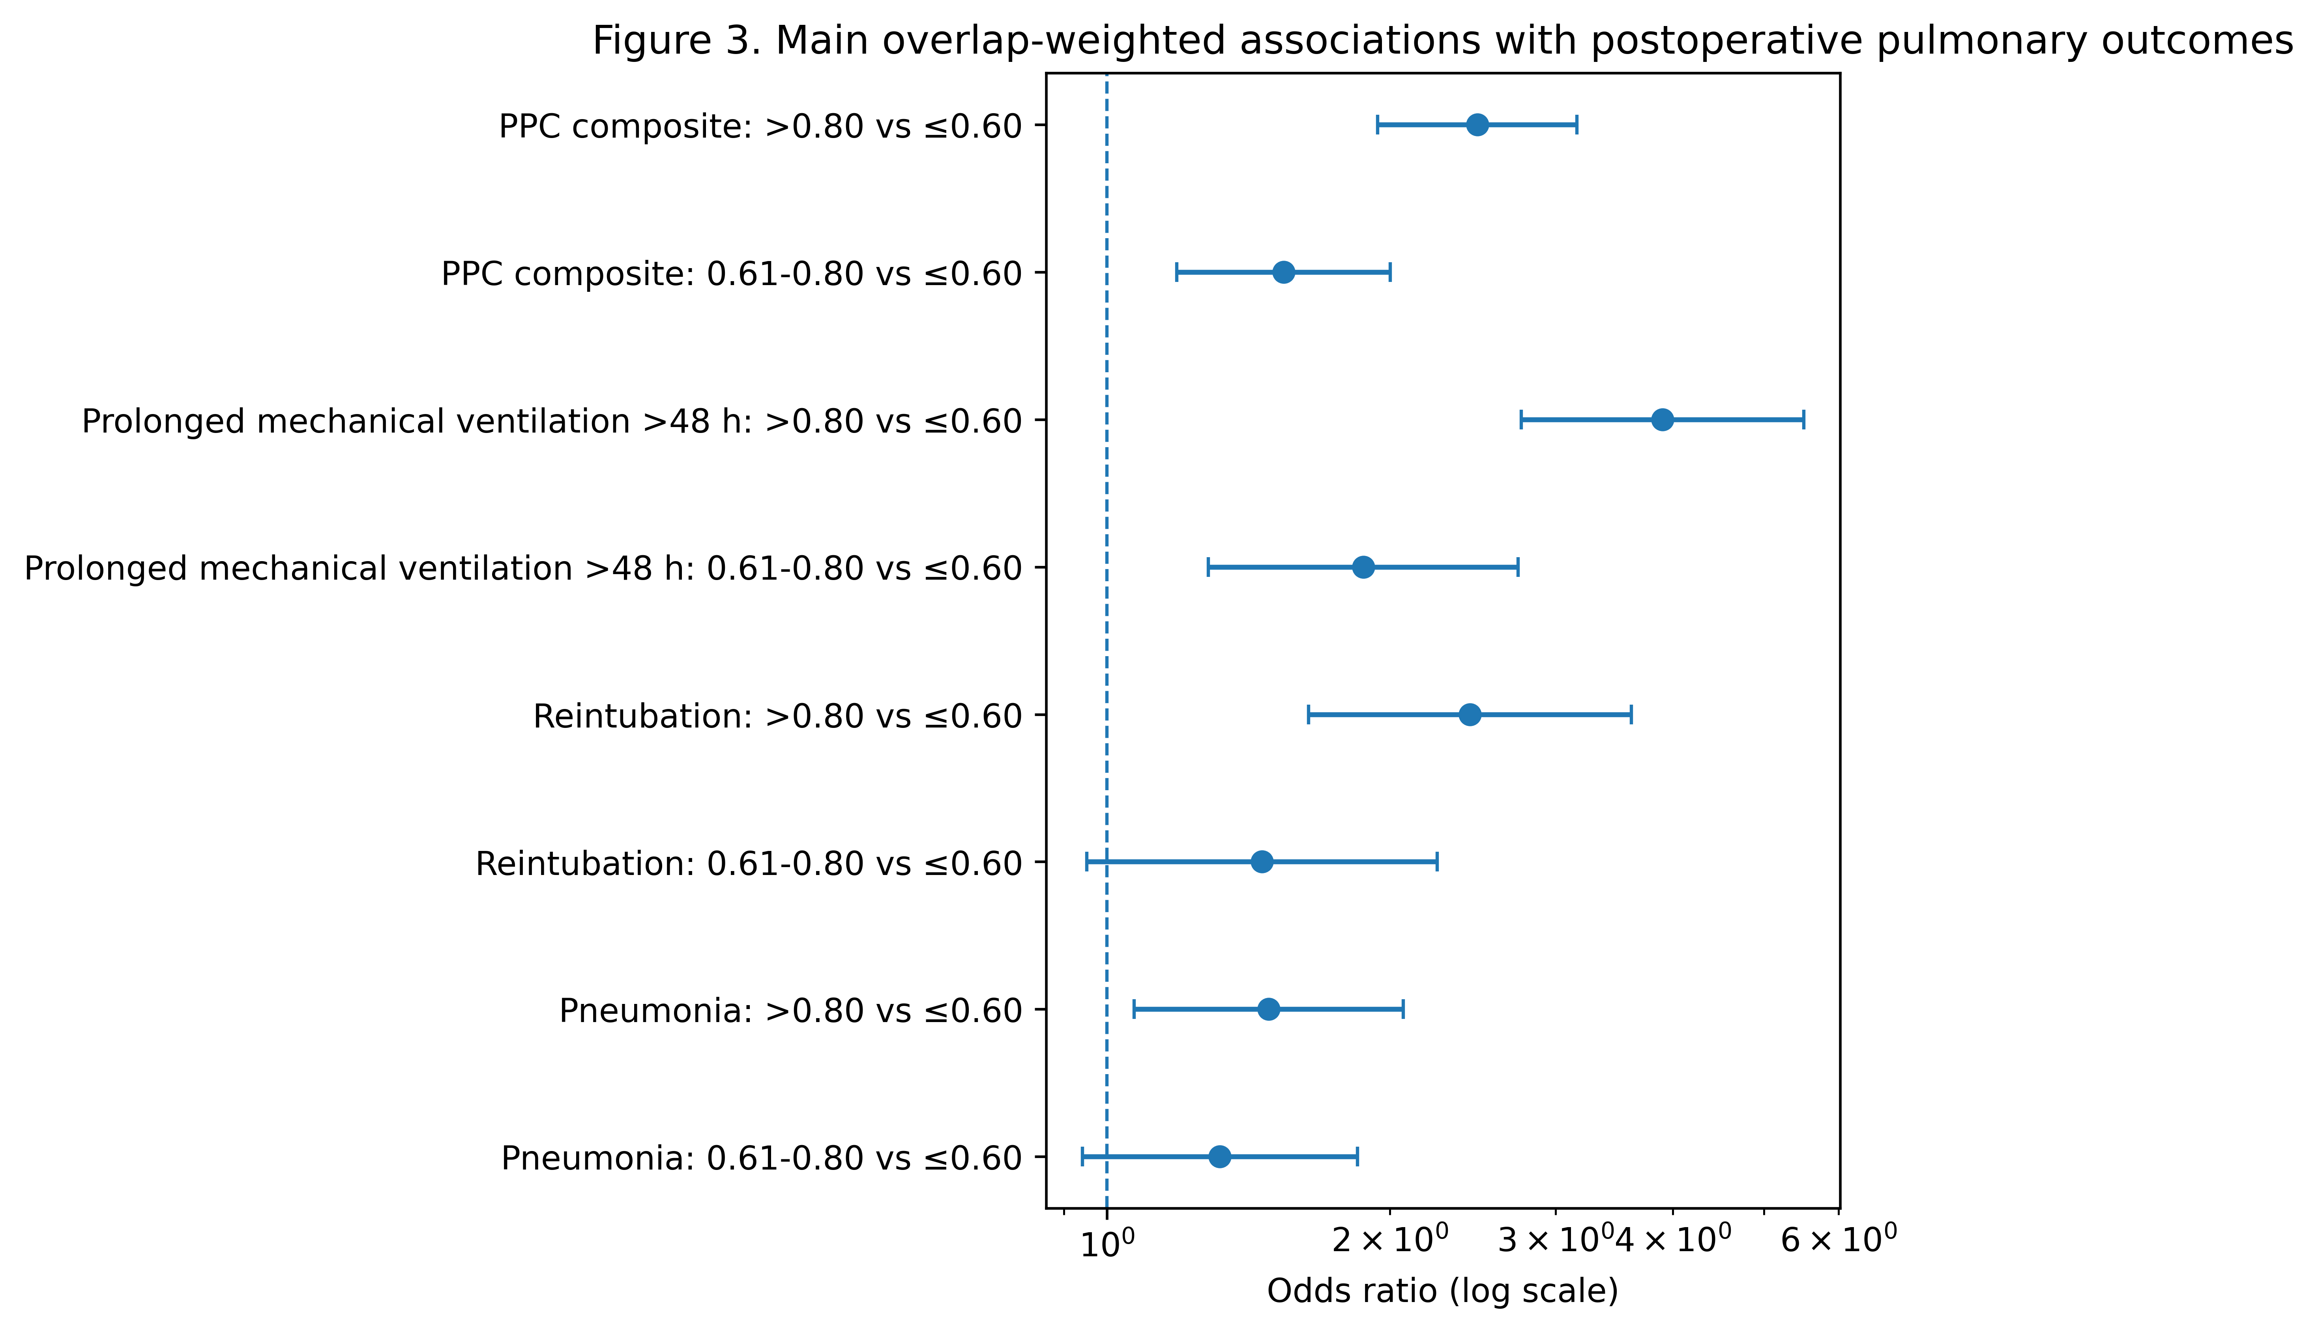
Supplementary Figure S3. Forest plot of overlap-weighted associations in the three-group analysis.

Binary IPTW sensitivity analysis
When the comparison was restricted to the extreme FiO₂ groups (>0.80 vs ≤0.60), the direction of effect was unchanged. Higher FiO₂ exposure remained significantly associated with PPC composite, prolonged mechanical ventilation, reintubation, and pneumonia.
Supplementary Table S5. Binary IPTW sensitivity analysis (>0.80 vs ≤0.60).
Outcome | Comparison | OR (95% CI) | P
PPC composite | >0.80 vs ≤0.60 | 2.69 (1.92-3.76) | <0.001
Prolonged mechanical ventilation >48 h | >0.80 vs ≤0.60 | 3.99 (2.48-6.43) | <0.001
Reintubation | >0.80 vs ≤0.60 | 2.51 (1.46-4.35) | <0.001
Pneumonia | >0.80 vs ≤0.60 | 1.64 (1.06-2.54) | 0.027
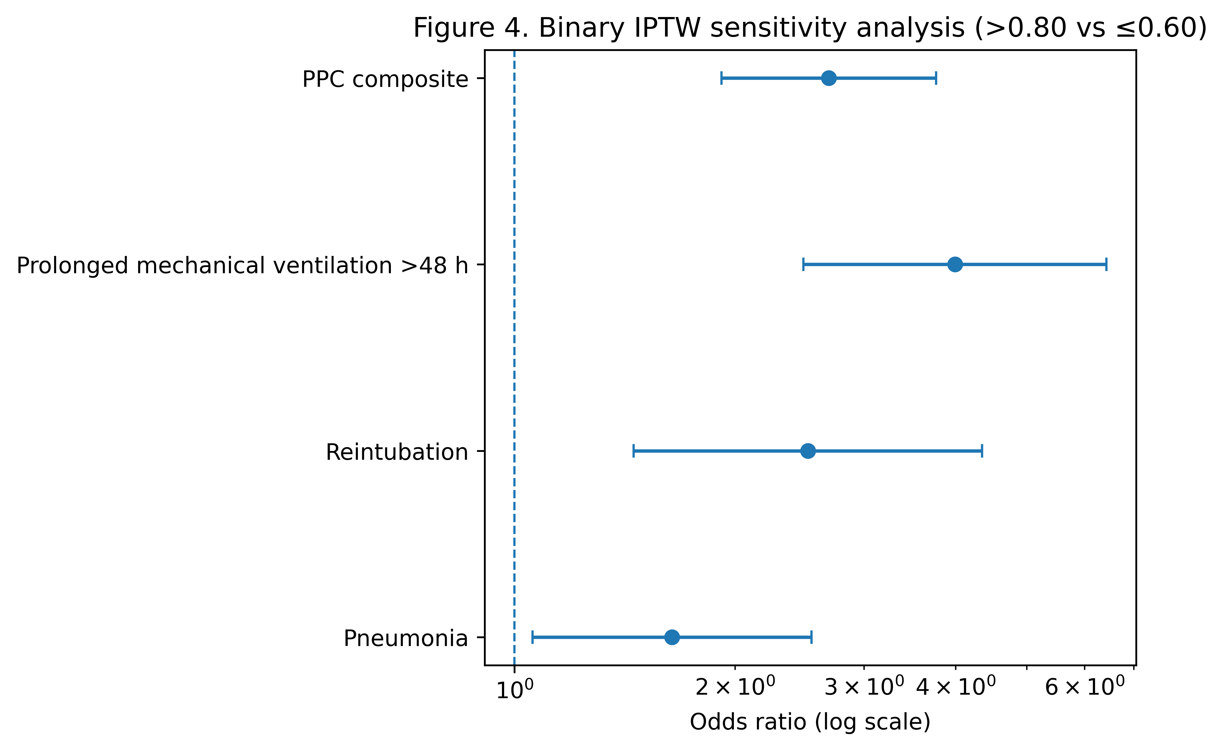
Supplementary Figure S4. Forest plot for the binary IPTW sensitivity analysis.

Subgroup and exploratory feature-importance analyses
Prespecified subgroup analyses were performed in the binary IPTW sensitivity cohort to evaluate whether the association between FiO₂ >0.80 and PPC composite differed by age, COPD status, or obesity status. Boruta feature selection was performed as an exploratory analysis to evaluate the relative importance of candidate variables for PPC prediction.
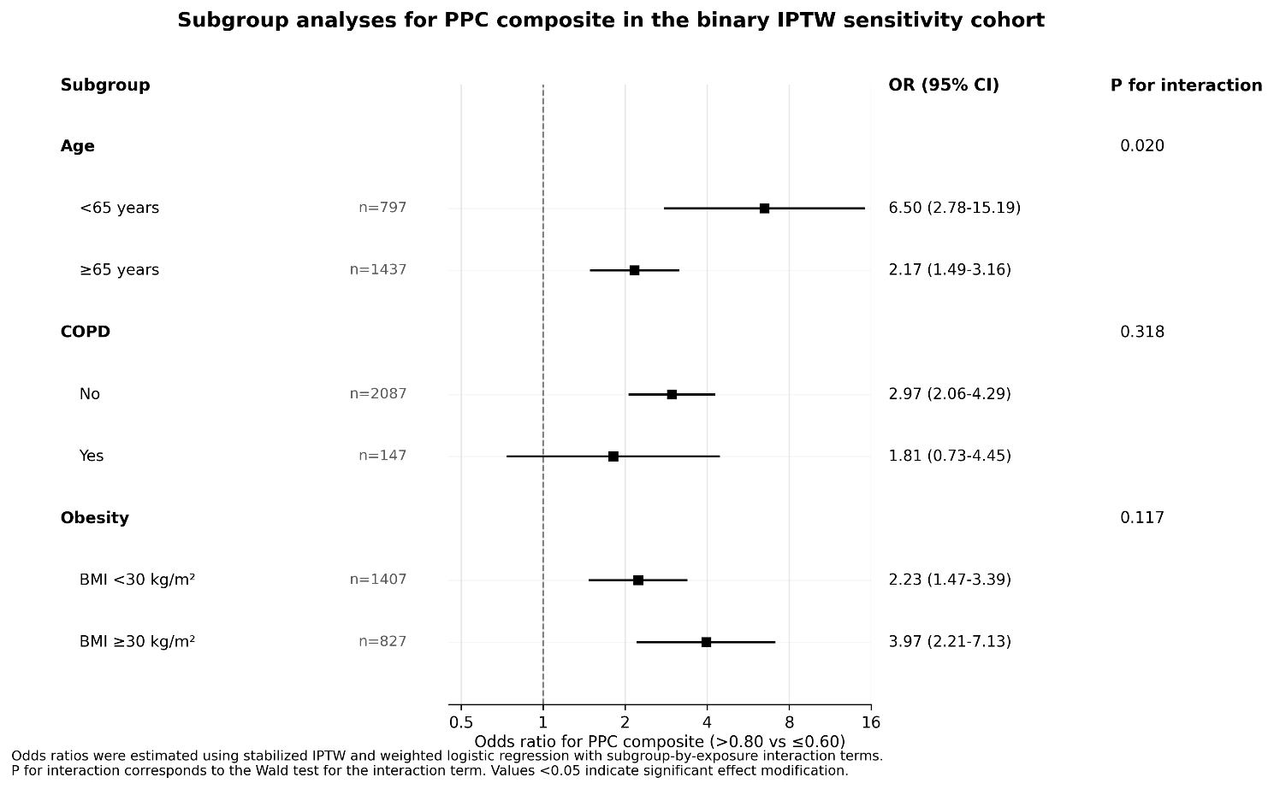
Supplementary Figure S5. Subgroup analyses for PPC composite in the binary IPTW sensitivity cohort. Squares indicate ORs and horizontal lines indicate 95% CIs; the vertical dashed line indicates OR=1.
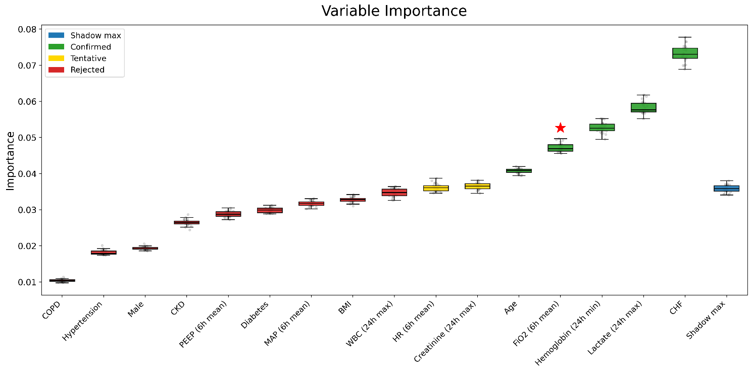
Supplementary Figure S6. Boruta feature importance analysis for PPC-related candidate variables in the MIMIC-IV cohort. The red star marks FiO₂ (6 h mean).

Baseline characteristics of the eICU cohort
Supplementary Table S6. Baseline characteristics according to early postoperative FiO₂ group in the eICU cohort.
Characteristic | Total | FiO₂≤0.60 | FiO₂ 0.61-0.80 | FiO₂ >0.80 | P
No. | 4521 | 3400 | 793 | 328
Age, years | 67.00 (60.00, 74.00) | 67.00 (60.00, 74.00) | 67.00 (60.00, 73.00) | 67.00 (58.00, 73.00) | 0.377
Weight, kg | 88.00 (75.70, 101.20) | 87.10 (74.80, 99.80) | 91.30 (78.10, 103.60) | 92.50 (80.15, 107.00) | <0.001
Height, cm | 172.70 (165.10, 180.00) | 172.70 (165.10, 180.00) | 174.00 (167.00, 180.30) | 175.30 (167.60, 180.30) | 0.011
BMI, kg/m² | 29.31 (25.92, 33.58) | 29.11 (25.72, 33.12) | 29.78 (26.58, 34.16) | 30.72 (26.88, 35.55) | <0.001
PEEP, first 6 h, cmH₂O | 5.00 (5.00, 5.00) | 5.00 (5.00, 5.00) | 5.00 (5.00, 5.55) | 5.00 (5.00, 7.00) | <0.001
Heart rate, first 6 h, bpm | 83.04 (75.88, 91.01) | 82.56 (75.52, 90.12) | 84.41 (76.53, 92.72) | 87.01 (79.21, 95.89) | <0.001
MAP, first 6 h, mmHg | 73.41 (68.55, 78.96) | 73.41 (68.83, 78.84) | 74.11 (68.48, 79.69) | 72.35 (66.24, 79.00) | 0.014
Lactate, first 24 h | 2.40 (1.60, 4.40) | 2.10 (1.48, 3.30) | 2.60 (1.70, 5.10) | 4.00 (1.80, 7.20) | 0.001
Hemoglobin, first 24 h | 9.70 (8.50, 10.90) | 9.70 (8.50, 10.90) | 9.70 (8.60, 10.90) | 9.60 (8.40, 10.78) | 0.491
Creatinine, first 24 h | 1.00 (0.81, 1.26) | 0.98 (0.80, 1.22) | 1.05 (0.85, 1.33) | 1.12 (0.90, 1.47) | <0.001
WBC, first 24 h | 14.20 (11.30, 18.00) | 13.87 (11.00, 17.47) | 15.10 (11.89, 19.32) | 15.20 (12.61, 19.98) | <0.001
P/F ratio, first 24 h | 195.00 (138.00, 260.00) | 210.00 (160.00, 272.40) | 148.54 (103.51, 212.00) | 100.00 (73.00, 171.20) | <0.001
Acute physiology score | 42.00 (32.00, 55.25) | 41.00 (31.00, 54.00) | 44.00 (35.00, 57.00) | 49.50 (37.00, 66.00) | <0.001
APACHE score | 55.00 (44.00, 69.00) | 54.00 (43.00, 67.00) | 57.00 (47.00, 71.50) | 61.00 (48.00, 80.00) | <0.001
Sex, n (%)
Male | 3386 (74.89%) | 2537 (74.62%) | 602 (75.91%) | 247 (75.30%) | 0.738
Female | 1135 (25.11%) | 863 (25.38%) | 191 (24.09%) | 81 (24.70%)
Race, n (%)
White | 3773 (83.45%) | 2842 (83.59%) | 654 (82.47%) | 277 (84.45%) | 0.207
Black | 220 (4.87%) | 173 (5.09%) | 37 (4.67%) | 10 (3.05%)
Asian | 79 (1.75%) | 64 (1.88%) | 11 (1.39%) | 4 (1.22%)
Hispanic | 151 (3.34%) | 114 (3.35%) | 29 (3.66%) | 8 (2.44%)
Other/Unknown | 298 (6.59%) | 207 (6.09%) | 62 (7.82%) | 29 (8.84%)
Comorbidities, n (%)
COPD | 404 (8.94%) | 284 (8.35%) | 81 (10.21%) | 39 (11.89%) | 0.038
CHF | 655 (14.49%) | 460 (13.53%) | 129 (16.27%) | 66 (20.12%) | 0.002
CKD | 538 (11.90%) | 408 (12.00%) | 84 (10.59%) | 46 (14.02%) | 0.254
Diabetes | 1852 (40.96%) | 1389 (40.85%) | 324 (40.86%) | 139 (42.38%) | 0.864
Hypertension | 3108 (68.75%) | 2305 (67.79%) | 558 (70.37%) | 245 (74.70%) | 0.020
Early ICU interventions, n (%)
Vasoactive drugs, first 24 h | 2435 (53.86%) | 1799 (52.91%) | 442 (55.74%) | 194 (59.15%) | 0.049
Transfusion, first 24 h | 1559 (34.48%) | 1165 (34.26%) | 258 (32.53%) | 136 (41.46%) | 0.014
RRT, first 24 h | 50 (1.11%) | 41 (1.21%) | 7 (0.88%) | 2 (0.61%) | 0.494
Note: Continuous variables are presented as median (Q1, Q3) unless otherwise indicated; categorical variables are presented as n (%). Abbreviations: FiO₂, fraction of inspired oxygen; PEEP, positive end-expiratory pressure; MAP, mean arterial pressure; WBC, white blood cell count; P/F ratio, PaO₂/FiO₂ ratio; COPD, chronic obstructive pulmonary disease; CHF, congestive heart failure; CKD, chronic kidney disease; RRT, renal replacement therapy.

Abbreviations
BMI, body mass index; CABG, coronary artery bypass grafting; CHF, congestive heart failure; CI, confidence interval; CKD, chronic kidney disease; COPD, chronic obstructive pulmonary disease; FiO₂, fraction of inspired oxygen; ICU, intensive care unit; IPTW, inverse probability of treatment weighting; OR, odds ratio; PPC, postoperative pulmonary complication; RRT, renal replacement therapy; SMD, standardized mean difference.

