First Author: Jinghong Chen
Title: Estrogen re-enhanced prenatal stress-related visceral sensitization and pain regulation

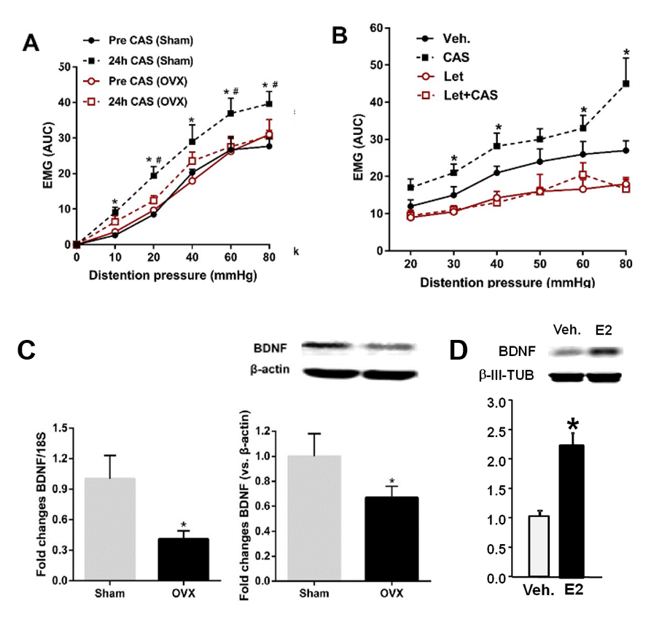
Figure 1. Electromyographic (EMG) activity and BDNF levels. A. EMG activity to graded colorectal distention (CRD) in female chronic prenatal stressed (CPS) Ovariectomy (OVX) or sham recorded before or 24 h after chronic adult stress (CAS) (n=8 rats in each group, two-way ANOVA, *P<0.05 vs. the same pressure pre CAS sham group, #P<0.05 vs. the same pressure CAS OVX group). B. Effect of Letrozole treatment on the visceromotor response to CRD in female CPS rats before and after adult stress (n=4 rats, two-way ANOVA, *P<0.05 vs. the same pressure vehicle group). C. Average BDNF mRNA and protein levels in sham and OVX female rats’ lumbar sacral spinal cord dorsal horn (n=8 rats, two-way ANOVA, *P<0.05 vs. sham group). D. Intrathecal infusion of estrogen into naïve female rats significantly increased BNDF protein levels.

