Supplementary Material

Contents
Figure S1: Spaghetti plot of lactate values at baseline, in the window around 8 hours and 24 hours (restricted to children in primary analysis) 2
Figure S2: Trial schema 3
Table S1: Baseline characteristics of all children enrolled. 4
Table S2: Decisions made by the Data Monitoring Committee 5
Table S3: Outcomes in all children enrolled 6
Table S4: FEAST Paediatric Emergency Triage (PET) score in primary analysis population (n=20) 7
Table S5: Schedule of Assessments 8

Figure S1: Spaghetti plot of lactate values at baseline, in the window around 8 hours and 24 hours (restricted to children in primary analysis)
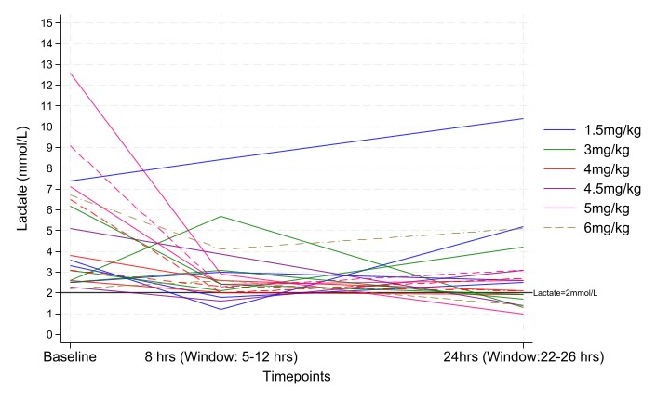

Figure S2: Trial schema
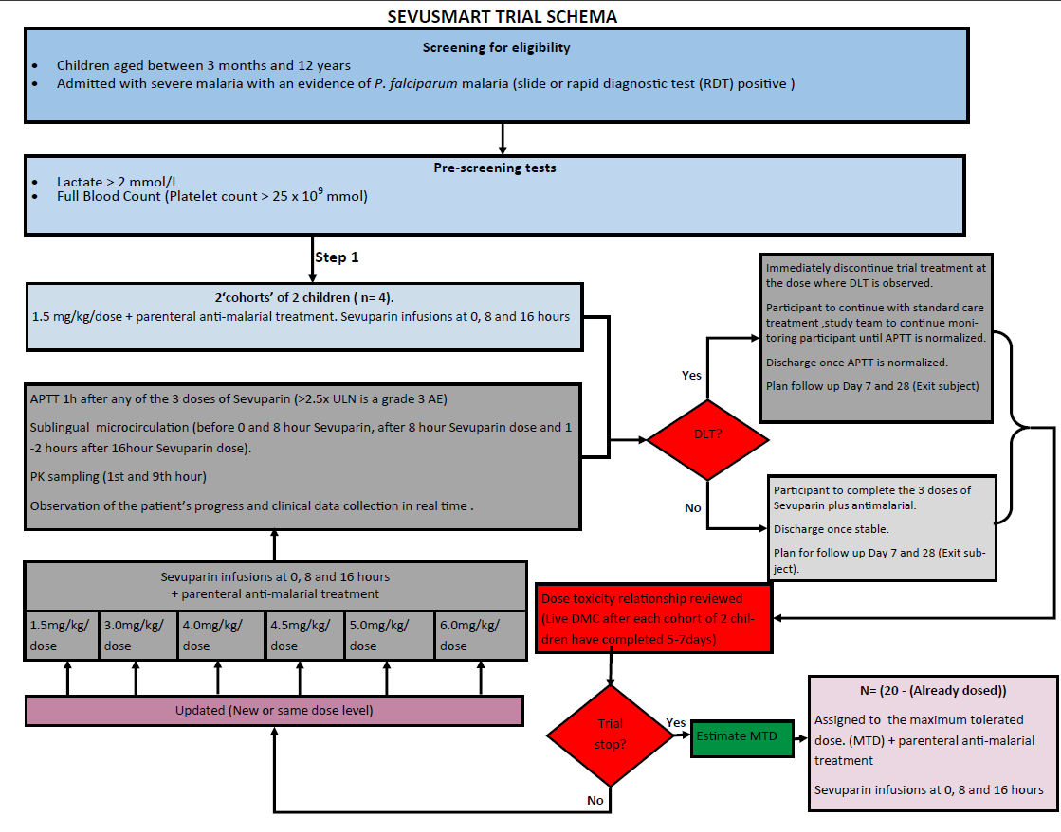

Table S1: Baseline characteristics of all children enrolled.
Characteristic | N=23
Age (months) | 35.0 (21.0, 54.0)
Aged <1 years old | 3 (13.0%)
Gender - Female | 13 (56.5%)
Axillary temperature (°C) | 37.6 (36.9, 38.4)
Blantyre Coma Score
1 | 4 (17.4%)
2 | 8 (34.8%)
3 | 7 (30.4%)
4 | 3 (13.0%)
5 | 1 (4.3%)
Two or more seizures within 24 hours | 10 (43.5%)
Did seizures last >30mins | 4 (40.0%)
Haemoglobinuria | 2 (9.1%)
Neck stiffness | 1 (4.3%)
Deep breathing | 10 (43%)
Haemoglobin (g/dL) | 5.5 (4.6, 6.7)
Haemoglobin <4g/dl | 4 (17.4%)
Lactate (mmols/L) | 3.6 (2.6, 6.5)
Glucose (mmol/L) | 6.4 (4.4, 9.7)
Parasite density (/µL) | 200688 (74062, 356684)
APTT (seconds) (N=20) | 38.5 (36.4, 43.0)
Already received IV antimalarials | 13 (56.5%)
Already received oral antimalarials | 11 (47.8%)

Table S2: Decisions made by the Data Monitoring Committee

Dose (mg/kg) | Number enrolled | Number of dose limiting toxicities* | Decision
1.5 | 4 | 0 | Escalate to 3mg/kg
3 | 2 | 0 | Escalate to 4mg/kg
4 | 2 | 0 | Escalate to 4.5 mg/kg
4.5 | 2 | 0 | Escalate to 5mg/kg
5 | 2 | 0 | Escalate to 6mg/kg
6 | 2 | 2 | De-escalate to 5mg/kg
5 | 2 | 2 | De-escalate to 4mg/kg
4 | 2 | 2 | De-escalate to 3mg/kg
3 | 2 | 0 | Enrolment completed
*Dose limiting toxicity defined by Activated partial thromboplastin time (APTT) >2.5 times the Upper Limit of Normal (ULN)
NB: Each decision was made after considering the Continual Reassessment model’s recommendation.

Table S3: Outcomes in all children enrolled

Outcome | Dose level (mg/kg) |  |  |  |  |  |  | Total
 | 1.5 | 3 | 4 | 4.5 | 5 | 6
 | N=7 | N=4 | N=4 | N=2 | N=4 | N=2 | N=23
Efficacy outcomes
Change in lactate at 8 hrs (mmol/L) ª | -1.6 (1.9) | -0.3 (2.9) | -1.8 (1.8) | -0.7 (-) | -7.1 (2.5) | -1.1 (-) | -2.1 (2.9)
Change in lactate at 24 hrs (mmol/L) ª | -0.4 (2.5) | -1.3 (2.2) | -1.8 (1.4) | -1.5 (-) | -7.4 (3.7) | -1.2 (-) | -1.9 (3.1)
Parasite half-life (hours) (geometric mean) | -^{b} | - ^{b} | 4.2  (N=2) | 11.1  (N=1) | 8.2  (N=1) | 5.0  (N=1) | 6.0 (3.5,10.4) ^{c}
Presence of mature infected erythrocytes at 8 hours | 0 | 0 | 0 | 0 | 0 | 0 | 0
Presence of mature infected erythrocytes at 24 hours | 0 | 0 | 0 | 0 | 0 | 0 | 0
Safety outcomes
Neurological sequalae at day 28 | 0 | 0 | 0 | 0 | 0 | 0 | 0
Adverse events*
Deaths | 0 | 0 | 0 | 0 | 1 | 0 | 1
Non-fatal SAES by day 28 | 1 | 0 | 1 | 0 | 0 | 0 | 2
Adverse events grade 3 or 4 by day 28 | 0 | 0 | 2 | 0 | 3 | 2 | 7
Note: APTT was not measured in the three children included this analysis (compared to the main analysis) and so is not presented here.
Arithmetic mean (sd) or N (%) presented unless specified otherwise. Standard deviation not shown when N<4.
ª One child died prior to the 24 hour measurement of lactate (in the 5mg/kg dose). One child (in the 4.5mg/kg dose) did not have a lactate measured within the window around 8 hours.
^{b}Not estimated as ≤2 measurements in each child
^{c} 95% Confidence interval presented around geometric mean
*A dose limiting toxicity of APTT>2.5xULN was also a grade 3 adverse event and 2/2 events in dose level 4, 2/3 events in dose level 5 and 2/2 events in dose level 6 were dose limiting toxicities. These were deemed possibly or probably related to sevuparin. The other adverse event at the dose of 5mg/kg was a grade 3 clinical event (fever and cough), unlikely related to sevuparin. The non-fatal SAE at the dose of 4 mg/kg was a hospital readmission due to anaemia judged unlikely related to sevuparin; and at a dose of 1.5 mg/kg was a hospital readmission due to convulsions judged unlikely related to sevuparin (occurring in a child without APTT measurements so not included in the primary analysis). The death (due to complicated malaria) was also judged unlikely related to sevuparin.

Table S4: FEAST Paediatric Emergency Triage (PET) score in primary analysis population (n=20)

Component of score | N (%)
Axillary Temp ≤37°C | 15 (75%)
Heart rate - Normal (105-220 beats per minute) | 20 (100%)
Capillary refill>2 seconds | 15 (75%)
Conscious level
Prostration | 9 (47.4%)
Coma | 10 (52.6%)
Difficulty breathing/respiratory distress | 8 (40%)
Bilateral Lung Crepitations | 1 (5%)
Weak pulse | 5 (25%)
FEAST PET score
3 | 1 (5%)
5 | 4 (20%)
6 | 7 (35%)
7 | 8 (40%)

Table S5: Schedule of Assessments

 | Assessment Time
Procedure | Adm | 1h | 2h | 4h | 8h | 9h | 17h | 24h | Bi daily to discharge | Day  7 | Day  28
Clinical assessment | X | X | X | X | X |  |  | X | X | X | X
ECG continuous to 24 hours (Kilifi) | X |  |  |  |  |  |  | X
APTT and coagulation tests (ACT) (1.7ml) | X | X  1 hr post dose |  |  |  | X  1 hr post dose | X  1 hr post dose | X
Lactate (point of care) | X | X |  |  |  | X |  | X
Standard clinical test non-research | X |  |  |  |  |  |  | X |  | X
Malaria slides | X |  |  |  |  | X |  | X | (36,48, 72 hrs) | X | X
Admission plasma ** | X |  |  |  |  | X |  |  |  |  | X
PK sample |  | X |  |  |  | X
Neuro-developmental assessment | X |  |  |  |  |  |  |  |  |  | X
* Standard- non research clinical tests full blood count will be done at admission and at 24 hours and Day 7 (Full blood count only).
Malaria slide and morphology will be done at 0, 9, 17, 24, 36, 48 hours (and 72 hours if in hospital); at follow up (Day 7 and 28)
**For quantitative plasma HRP2 assessment,

