Supplementary material
This supplementary appendix contains supplementary tables and figures for the manuscript.
Supplementary Table S1 Definition of variables
Supplementary Table S2 Descriptive statistics of main variables
Supplementary Table S3 Bacon Goodman test
Supplementary Fig. S1 Results of the parallel trend test
Supplementary Fig. S2 Results of the placebo test
Supplementary Fig. S3 Covariate balance before and after propensity score matching
Supplementary Fig.S4 Kernel density distributions of propensity scores before and after matching
All variables, sample and empirical settings are consistent with those described in the main text.
Supplementary Table S1 Description of variables
Variable name | Symbol of variable | Description of variables
Carbon performance | $$Lncp$$ | ——
New generation artificial intelligence innovation and development pilot zone | DID | ——
Size of enterprise | $$LnSize$$ | Logarithm of the total capital of the firm at the end of the year
Age of enterprise | $$Age$$ | Logarithm of the length of time a firm has been listed
Tobin's Q value | $$TobinQ$$ | The ratio of the market value of the firm to the replacement cost of capital
Tobin's Q value | $$Debts$$ | Logarithm of the ratio of loan amount to total assets in the current year
Return on total assets | $$Roa$$ | Ratio of corporate net profit to total assets
Degree of capital intensity | Ln$Cap_inten$ | The ratio of total assets to operating income
Shareholding ratio of the largest shareholder | $$LnTop1$$ | The proportion of the largest shareholder's shareholding in the total share capital

Supplementary Table S2 Descriptive statistics of main variables
Meaning of variable | Variable | Value of observation | Average value | Standard deviation | Minimum value | Maximum value
Variable explained | Lncp | 28184 | -0.7993 | 0.7770 | -5.3277 | 4.2590
Explanatory variables | DID | 28184 | 0.1750 | 0.3800 | 0 | 1
Variable of control | $$LnSize$$ | 28184 | 3.0904 | 0.0531 | 2.8702 | 3.3192
Variable of control | $$Age$$ | 28184 | 2.8753 | 0.3686 | 0.6931 | 4.1897
Variable of control | $$TobinQ$$ | 28184 | 2.1021 | 1.8384 | 0.6616 | 122.189
Variable of control | $$Debts$$ | 28184 | 0.3914 | 0.1951 | 0.0071 | 1.9391
Variable of control | $$Roa$$ | 28184 | 0.0475 | 0.0729 | -0.7821 | 1.2848
Variable of control | $$lnCap_inten$$ | 28184 | 1.9478 | 1.1712 | 0.4302 | 7.4531
Variable of control | $$LnTop1$$ | 28184 | 0.3376 | 0.1440 | 0.0183 | 0.9000
Variable of control | $$Dependent$$ | 28184 | 37.5334 | 5.5397 | 0 | 80

Supplementary Table S3 Bacon Goodman test
Difference-in-Differences Comparison Type | Weight | Average DD Estimate
Timing groups | 0.041 | 0.062
Within | 0.009 | -0.003
Treated vs. Never-treated | 0.950 | 0.053

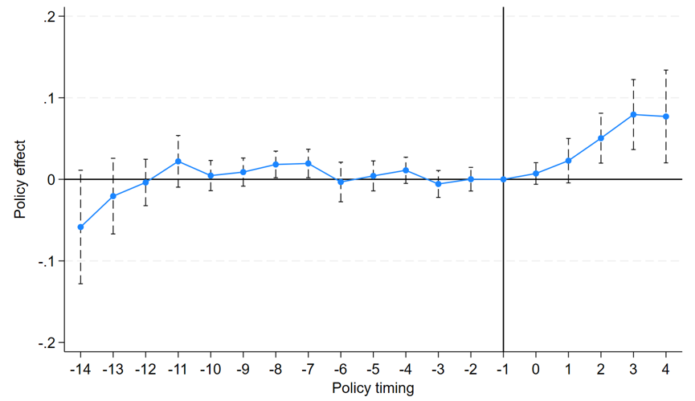
Supplementary Fig. S1 Results of the parallel trend test

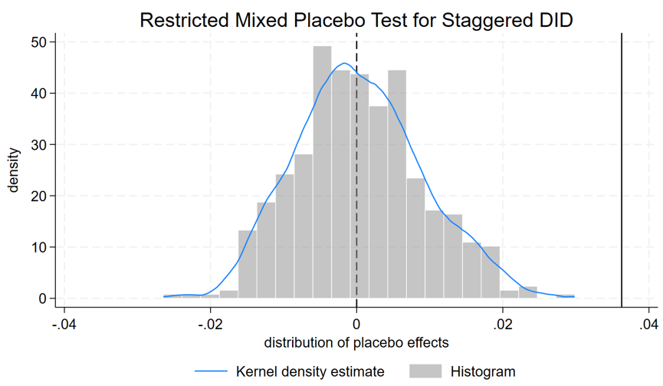
Supplementary Fig. S2 Results of the placebo test
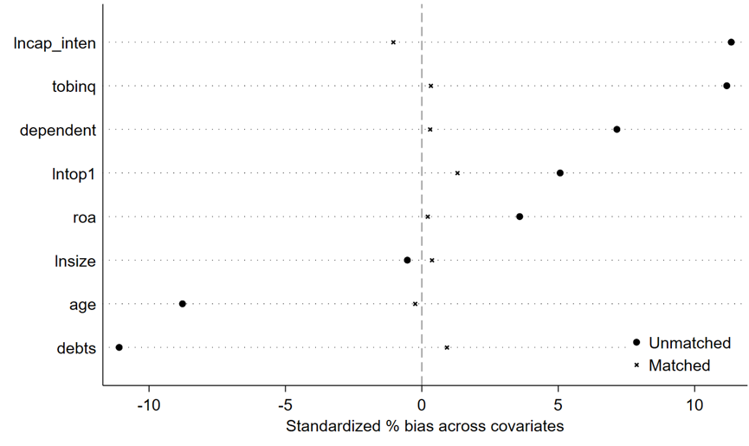
Supplementary Fig. S3 Balance Plot

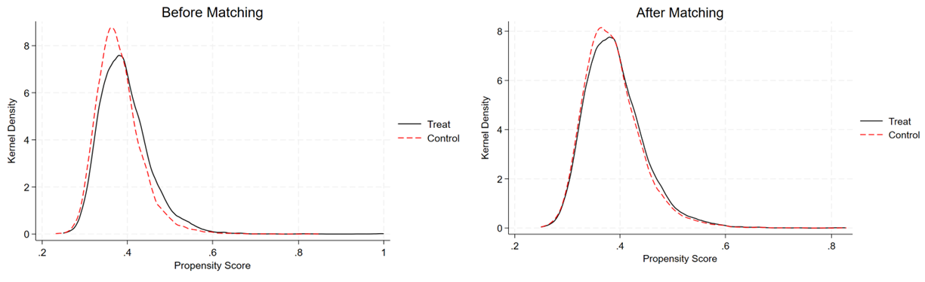
Supplementary Fig. S4 PSM-DID kernel density map

