Supporting information
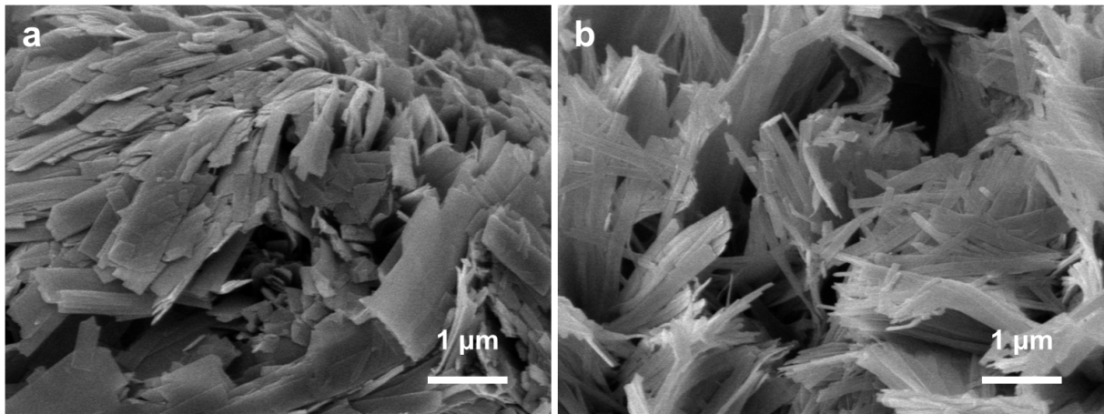
Fig. S1 SEM images of pristine NVO (a) and ANVO (b).
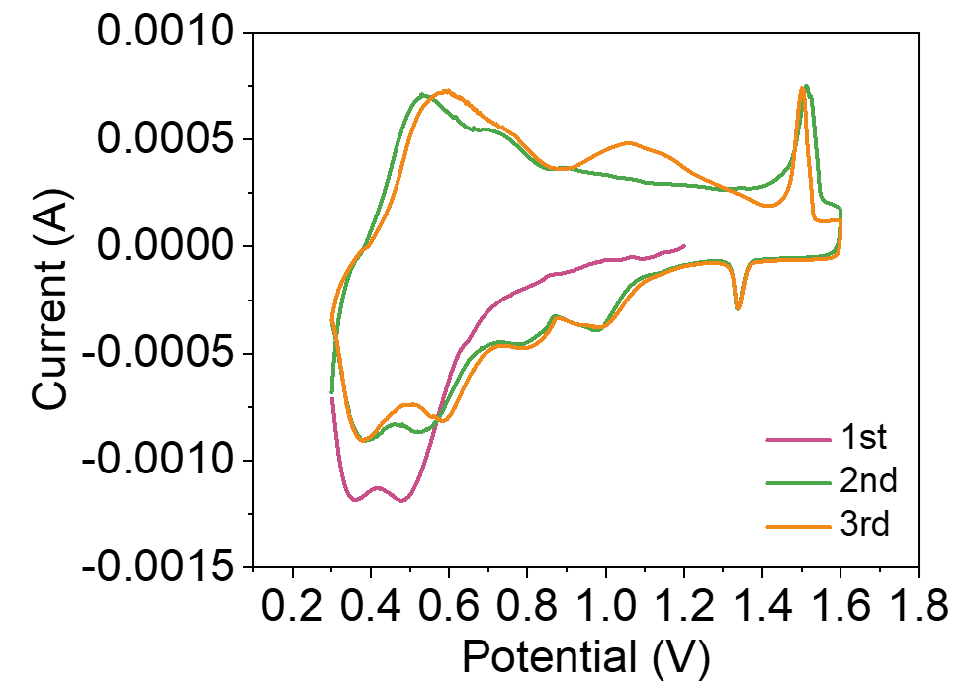
Fig. S2. The first three consecutive CV profiles of ANVO cathode in 0.3-1.6 V potential window.

