SUPPLEMENTARY TABLES

Table 1. PRISMA checklist
Supplementary Methods 1. PRISMA checklist
Section and Topic | Item # | Checklist item | Location
TITLE
Title | 1 | Identify the report as a systematic review. | 1
ABSTRACT
Abstract | 2 | See the PRISMA 2020 for Abstracts checklist. | 1
INTRODUCTION
Rationale | 3 | Describe the rationale for the review in the context of existing knowledge. | 2
Objectives | 4 | Provide an explicit statement of the objective(s) or question(s) the review addresses. | 3
METHODS
Eligibility criteria | 5 | Specify the inclusion and exclusion criteria for the review and how studies were grouped for the syntheses. | 4
Information sources | 6 | Specify all databases, registers, websites, organisations, reference lists and other sources searched or consulted to identify studies. Specify the date when each source was last searched or consulted. | 4
Search strategy | 7 | Present the full search strategies for all databases, registers and websites, including any filters and limits used. | 4
Selection process | 8 | Specify the methods used to decide whether a study met the inclusion criteria of the review, including how many reviewers screened each record and each report retrieved, whether they worked independently, and if applicable, details of automation tools used in the process. | 5
Data collection process | 9 | Specify the methods used to collect data from reports, including how many reviewers collected data from each report, whether they worked independently, any processes for obtaining or confirming data from study investigators, and if applicable, details of automation tools used in the process. | 5
Data items | 10a | List and define all outcomes for which data were sought. Specify whether all results that were compatible with each outcome domain in each study were sought (e.g. for all measures, time points, analyses), and if not, the methods used to decide which results to collect. | 5
Data items | 10b | List and define all other variables for which data were sought (e.g. participant and intervention characteristics, funding sources). Describe any assumptions made about any missing or unclear information. | 5
Study risk of bias assessment | 11 | Specify the methods used to assess risk of bias in the included studies, including details of the tool(s) used, how many reviewers assessed each study and whether they worked independently, and if applicable, details of automation tools used in the process. | 5
Effect measures | 12 | Specify for each outcome the effect measure(s) (e.g. risk ratio, mean difference) used in the synthesis or presentation of results. | 5
Synthesis methods | 13a | Describe the processes used to decide which studies were eligible for each synthesis (e.g. tabulating the study intervention characteristics and comparing against the planned groups for each synthesis (item #5)). | 5
Synthesis methods | 13b | Describe any methods required to prepare the data for presentation or synthesis, such as handling of missing summary statistics, or data conversions. | 10
Synthesis methods | 13c | Describe any methods used to tabulate or visually display results of individual studies and syntheses. | 5
Synthesis methods | 13d | Describe any methods used to synthesize results and provide a rationale for the choice(s). If meta-analysis was performed, describe the model(s), method(s) to identify the presence and extent of statistical heterogeneity, and software package(s) used. | 5
Synthesis methods | 13e | Describe any methods used to explore possible causes of heterogeneity among study results (e.g. subgroup analysis, meta-regression). | 5
Synthesis methods | 13f | Describe any sensitivity analyses conducted to assess robustness of the synthesized results. | 5
Reporting bias assessment | 14 | Describe any methods used to assess risk of bias due to missing results in a synthesis (arising from reporting biases). | 5
Certainty assessment | 15 | Describe any methods used to assess certainty (or confidence) in the body of evidence for an outcome. | 5
RESULTS
Study selection | 16a | Describe the results of the search and selection process, from the number of records identified in the search to the number of studies included in the review, ideally using a flow diagram. | 6
Study selection | 16b | Cite studies that might appear to meet the inclusion criteria, but which were excluded, and explain why they were excluded. | 6
Study characteristics | 17 | Cite each included study and present its characteristics. | 7
Risk of bias in studies | 18 | Present assessments of risk of bias for each included study. | 9
Results of individual studies | 19 | For all outcomes, present, for each study: (a) summary statistics for each group (where appropriate) and (b) an effect estimate and its precision (e.g. confidence/credible interval), ideally using structured tables or plots. | 7
Results of syntheses | 20a | For each synthesis, briefly summarise the characteristics and risk of bias among contributing studies. | 7
Results of syntheses | 20b | Present results of all statistical syntheses conducted. If meta-analysis was done, present for each the summary estimate and its precision (e.g. confidence/credible interval) and measures of statistical heterogeneity. If comparing groups, describe the direction of the effect. | 7
Results of syntheses | 20c | Present results of all investigations of possible causes of heterogeneity among study results. | 7
Results of syntheses | 20d | Present results of all sensitivity analyses conducted to assess the robustness of the synthesized results. | 8
Reporting biases | 21 | Present assessments of risk of bias due to missing results (arising from reporting biases) for each synthesis assessed. | 9
Certainty of evidence | 22 | Present assessments of certainty (or confidence) in the body of evidence for each outcome assessed. | 10
DISCUSSION
Discussion | 23a | Provide a general interpretation of the results in the context of other evidence. | 11
Discussion | 23b | Discuss any limitations of the evidence included in the review. | 13
Discussion | 23c | Discuss any limitations of the review processes used. | 13
Discussion | 23d | Discuss implications of the results for practice, policy, and future research. | 13
OTHER INFORMATION
Registration and protocol | 24a | Provide registration information for the review, including register name and registration number, or state that the review was not registered. | 3
Registration and protocol | 24b | Indicate where the review protocol can be accessed, or state that a protocol was not prepared. | 3
Registration and protocol | 24c | Describe and explain any amendments to information provided at registration or in the protocol. | 14
Support | 25 | Describe sources of financial or non-financial support for the review, and the role of the funders or sponsors in the review. | 14
Competing interests | 26 | Declare any competing interests of review authors. | 14
Availability of data, code and other materials | 27 | Report which of the following are publicly available and where they can be found: template data collection forms; data extracted from included studies; data used for all analyses; analytic code; any other materials used in the review. | 14

Table 2. Quality Assessment (Newcastle-Ottawa Scale)

Author (Year) | Selection (0–4) | Comparability (0–2) | Outcome (0–3) | Total (0–9) | Quality
Abraham (2021) | 3ᵄ | 0ᵇ | 3ᶜ | 6 | Moderate
Ishihara (2024) | 4 | 2 | 3 | 9 | High
Kerr (2019) | 3ᵄ | 0ᵇ | 3 | 6 | Moderate
Kesireddy (2023) | 3ᵄ | 0ᵇ | 3 | 6 | Moderate
Ishihara (2024) | 4 | 2 | 3 | 9 | High
Koks (2021) | 4 | 2 | 3 | 9 | High
Kuo (2020) | 4 | 1ᵈ | 3 | 8 | High
Lumlertgul (2023) | 4 | 2 | 3 | 9 | High
Sengul (2024) | 4 | 1 | 3 | 8 | High
Seydel (2021) | 4 | 1 | 3 | 7 | High
Stein (2021) | 4 | 1 | 3 | 9 | High
Tachibana (2019) | 4 | 0 | 3 | 7 | High
Wang (2022) | 4 | 1 | 3 | 8 | High
Tiu (2023) | 4 | 2 | 3 | 9 | High

Footnotes:
- ᵃ Selection: Single arm study (Abraham et al. had 1 loss at start for absolute analysis).
- ᵇ Comparability: Zero score due to no comparator group.
- ᶜ Outcome: Loss to follow-up < 20% (borderline).
- ᵈ Comparability: ESDR not included in the analysis.

Table 3. GRADE assessment for mains analysis outcomes

Outcome  № of participants  (studies) | Relative effect  (95% CI) | Anticipated absolute effects (95% CI) |  |  | Certainty | What happens
Outcome  № of participants  (studies) | Relative effect  (95% CI) | [comparison] | [intervention] | Difference | Certainty | What happens
Overall survival  assessed with: Overall survival measured as hazard ratio (HR).  № of participants: 7635  (4 non-randomised studies) | HR 0.97  (0.58 to 1.61)  [Overall survival] | High |  |  | ⨁◯◯◯  Very low^{a,b,c} | The effect of CKD on the risk of death in patients receiving immune checkpoint inhibitors is very uncertain.
 | HR 0.97  (0.58 to 1.61)  [Overall survival] | 30.0% | 29.2%  (18.7 to 43.7) | 0.8% fewer  (11.3% fewer to 13.7% more) | ⨁◯◯◯  Very low^{a,b,c}
Progression-free survival (PFS)  assessed with: RECIST v1.1 criteria  № of participants: 443  (3 non-randomised studies) | HR 1.05  (0.76 to 1.44)  [Progression-free survival (PFS)] | High |  |  | ⨁◯◯◯  Very low^{d,e} | The effect of CKD on progression-free survival in patients receiving immune checkpoint inhibitors is very uncertain.
 | HR 1.05  (0.76 to 1.44)  [Progression-free survival (PFS)] | 50.0% | 51.7%  (41 to 63.1) | 1.7% more  (9.0% fewer to 13.1% more) | ⨁◯◯◯  Very low^{d,e}
Incidence of nephritis  assessed with: Clinician-reported immune-related adverse events according to CTCAE criteria  № of participants: 7413  (3 non-randomised studies) | RR 2.43  (1.11 to 5.33) | 2.2% | 5.3% | 3.1% more  (0.2% more to 9.4% more) | ⨁◯◯◯  Very low^{f} | The effect of CKD on the risk of nephritis in patients treated with immune checkpoint inhibitors is very uncertain.
Incidence of acute kidney injury  assessed with: KDIGO criteria  № of participants: 3898  (6 non-randomised studies) | RR 1.39  (0.93 to 2.08) | 9.9% | 13.8% | 3.9% more  (0.7% fewer to 10.7% more) | ⨁◯◯◯  Very low^{g,h} | The effect of CKD on the incidence of acute kidney injury in patients treated with immune checkpoint inhibitors is very uncertain.
Incidence of grade ≥3 irAEs  assessed with: Clinician-reported immune-related adverse events graded according to CTCAE criteria  № of participants: 7485  (3 non-randomised studies) | RR 1.07  (0.92 to 1.25) | 11.5% | 12.3% | 0.8% more  (0.9% fewer to 2.9% more) | ⨁◯◯◯  Very low^{i,j} | The effect of CKD on the incidence of grade 3 or higher immune-related adverse events in patients treated with immune checkpoint inhibitors is very uncertain.
*The risk in the intervention group (and its 95% confidence interval) is based on the assumed risk in the comparison group and the relative effect of the intervention (and its 95% CI).
CI: confidence interval; HR: hazard ratio; RR: risk ratio
GRADE Working Group grades of evidence
High certainty: we are very confident that the true effect lies close to that of the estimate of the effect.
Moderate certainty: we are moderately confident in the effect estimate: the true effect is likely to be close to the estimate of the effect, but there is a possibility that it is substantially different.
Low certainty: our confidence in the effect estimate is limited: the true effect may be substantially different from the estimate of the effect.
Very low certainty: we have very little confidence in the effect estimate: the true effect is likely to be substantially different from the estimate of effect.

Explanations
a. Observational studies with residual confounding and limited comparability between CKD and non-CKD groups.
b. Moderate between-study heterogeneity was present (I² = 56%).
c. The pooled estimate was imprecise because the 95% CI was wide and compatible with both benefit and harm.
d. Observational retrospective studies with potential residual confounding and limited comparability between CKD and non-CKD groups.
e. The confidence interval was wide (HR 0.76 to 1.44) and crossed the line of no effect.
f. Evidence derived from retrospective observational studies with potential residual confounding.
g. Evidence derived from retrospective observational cohort studies with potential residual confounding.
h. Confidence interval crossed the line of no effect and included both potential harm and no effect.
i. Evidence derived from retrospective observational cohort studies with potential residual confounding.
j. The confidence interval crossed the line of no effect and included both possible harm and no effect.

Supplementary Figure 1. Leave-one-out analyses
(A) Overall survival
(B) Progression-free survival
(C) Acute kidney injury incidence
(D) Grade ≥3 immune-related adverse events incidence
(E) Any-grade immune-related adverse events incidence
(A)
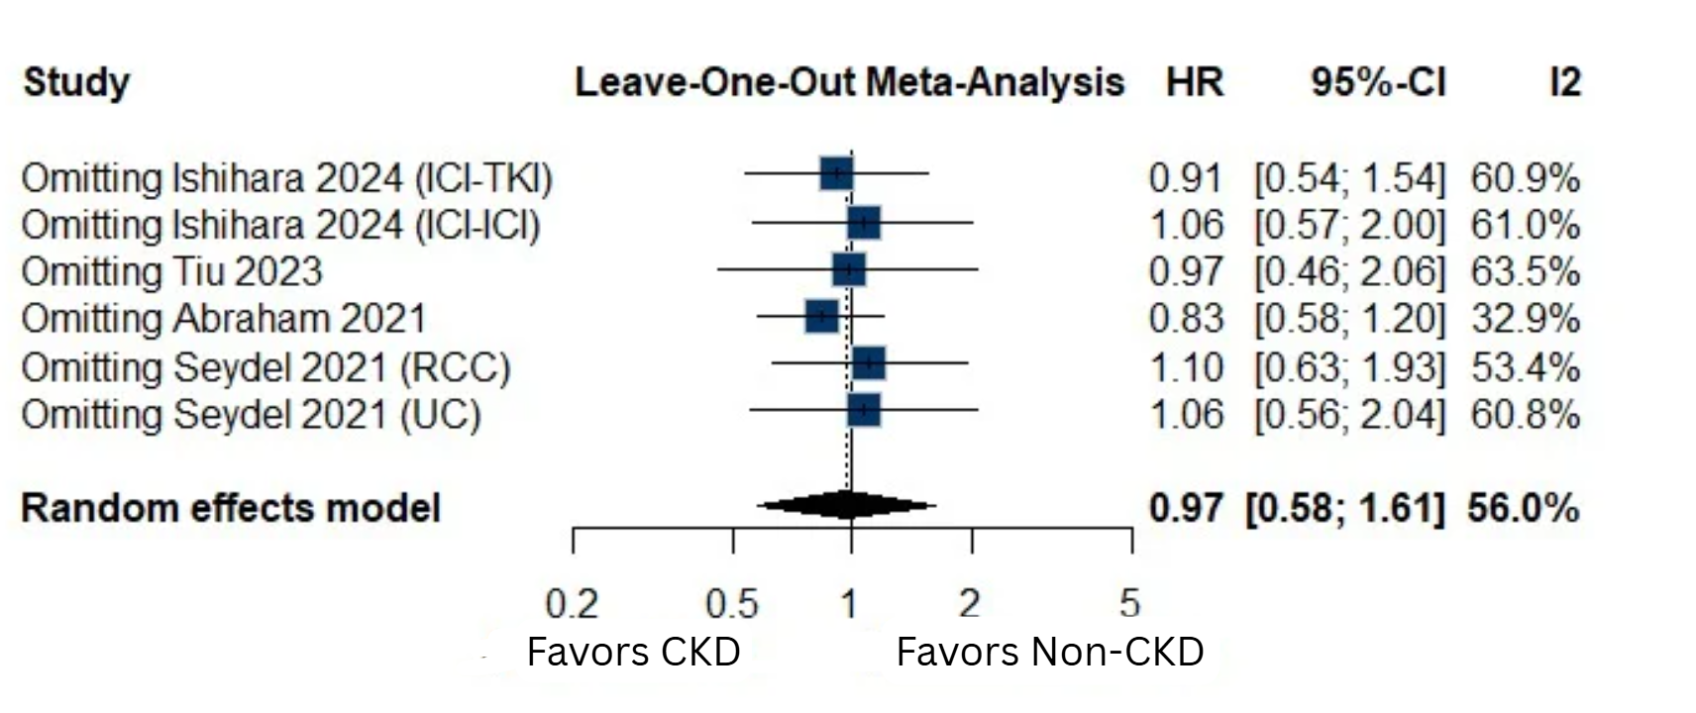
(B)
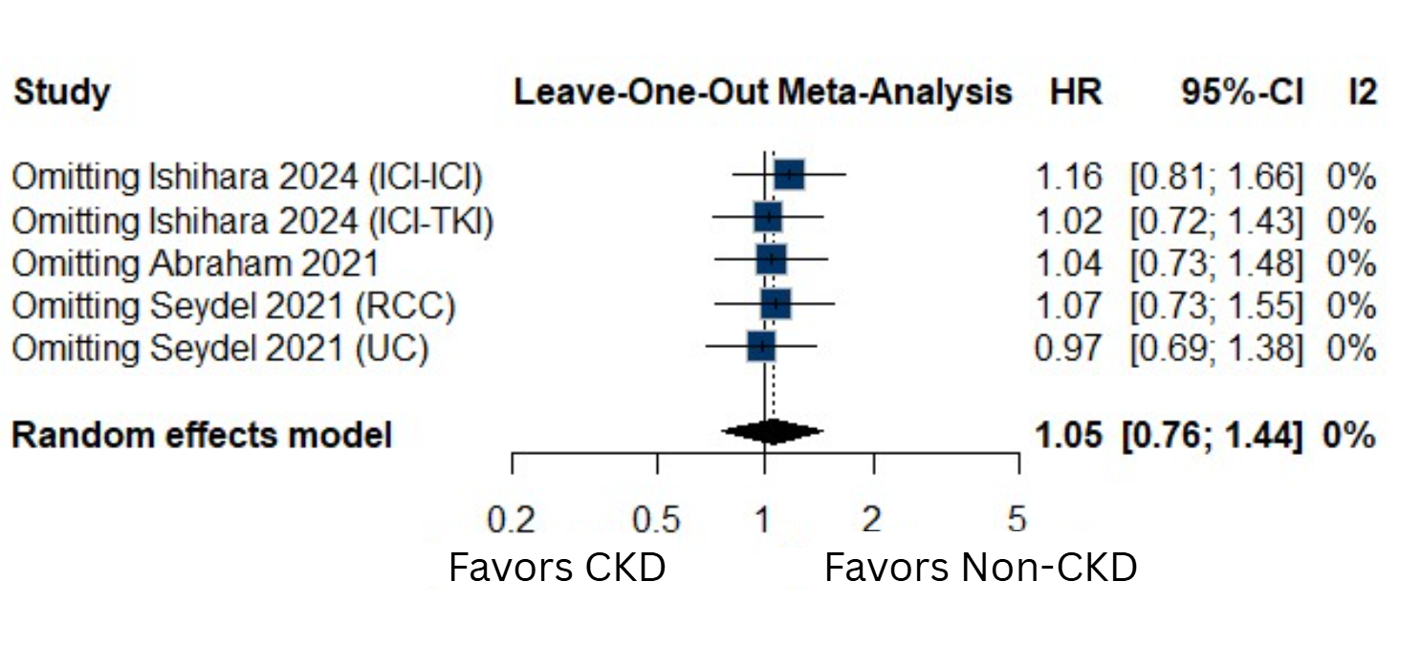
(C)
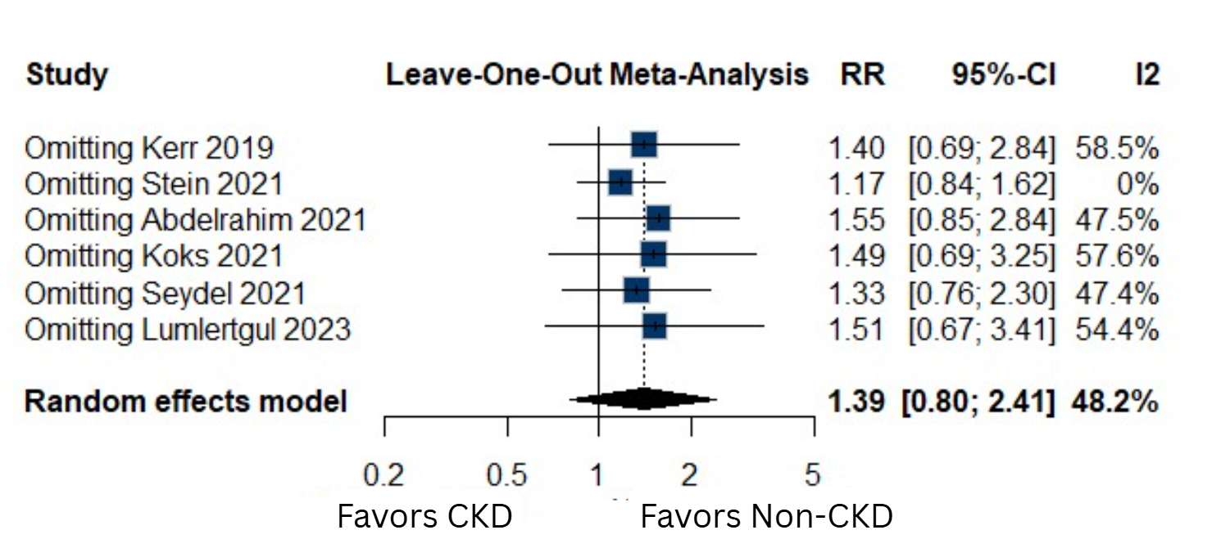

(D)
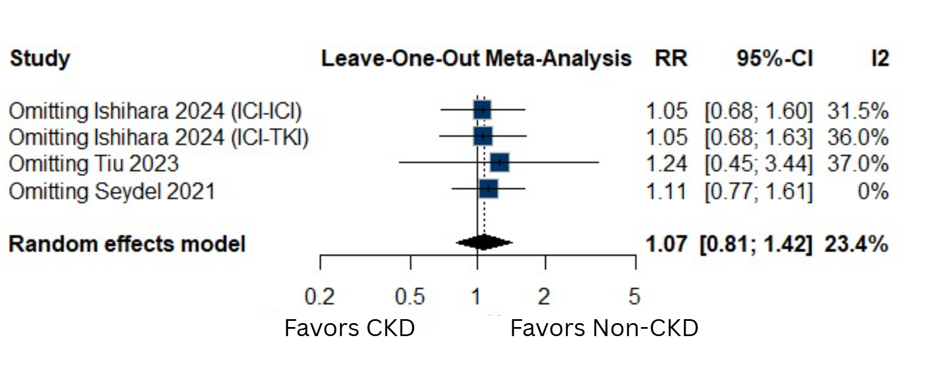
(E)
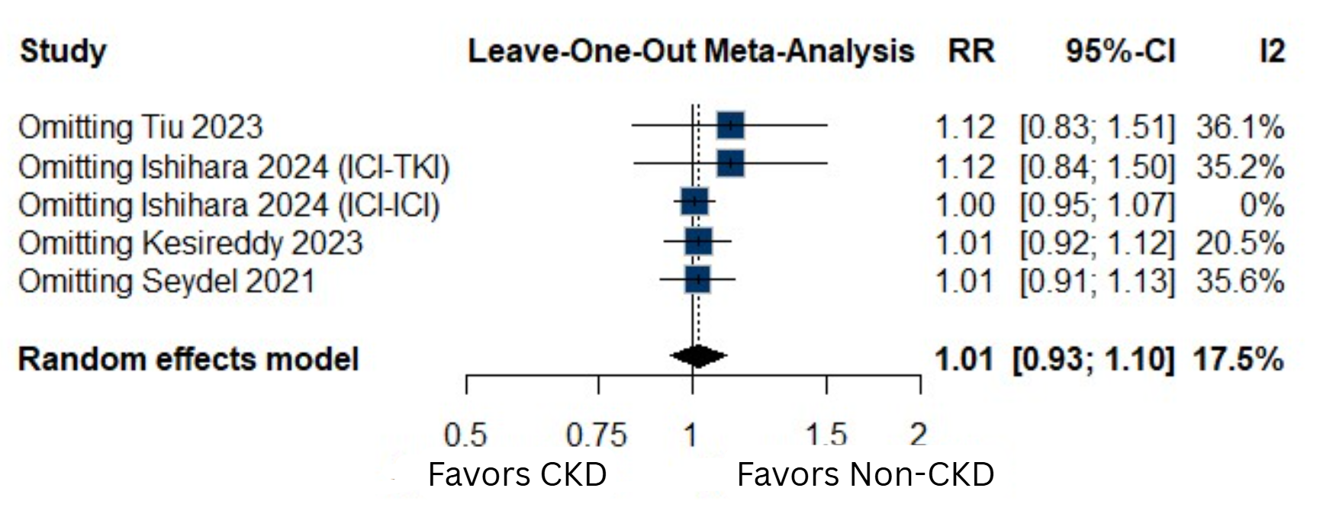
Abbreviations: CI, confidence interval; CKD, chronic kidney disease; HR, hazard ratio; RR, risk ratio; ICI, immune checkpoint inhibitor; IV, inverse variance; RCC, renal cell carcinoma; TKI, tyrosine kinase inhibitor; UC, urothelial carcinoma.

Supplementary Figure 2. Moderate CKD subgroup analyses
(A) Overall survival in patients with moderate CKD vs no CKD
(B) Grade ≥3 immune-related adverse events incidence in patients with moderate CKD vs no CKD
(C) Any-grade immune-related adverse events incidence in patients with moderate CKD vs no CKD

(A)
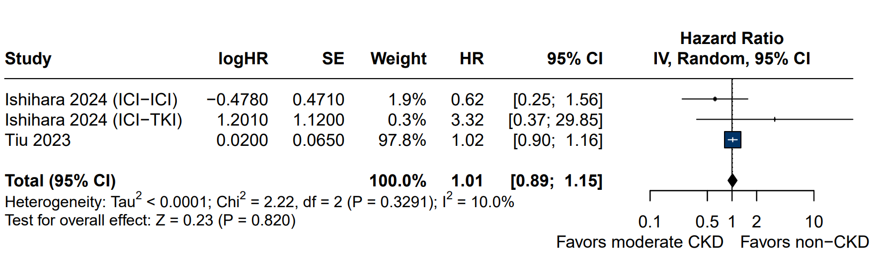

(B)
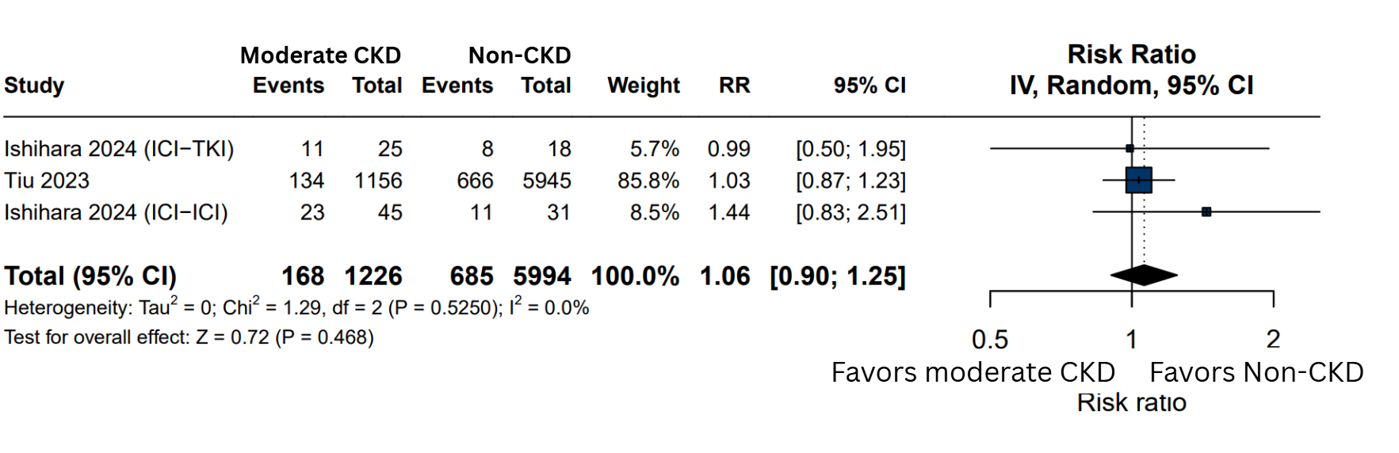
(C)
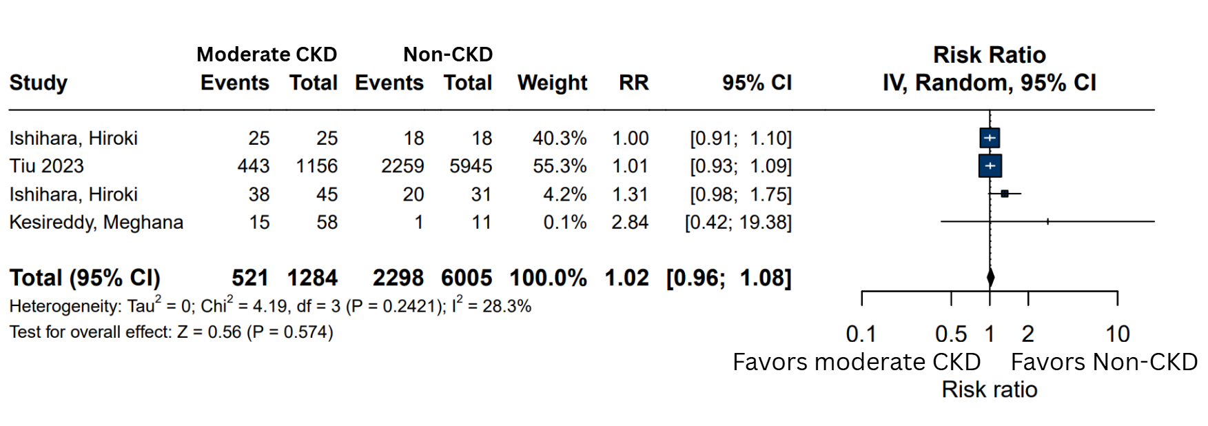

CI: Confidence Interval; CKD: Chronic Kidney Disease; HR: Hazard Ratio; ICI: Immune-Checkpoint Inhibitors; IV: Inverse-Variance; RCC: Renal Cell Carcinoma; TKI: Tyrosine Kinase Inhibitor; UC: Urothelial Carcinoma.

Supplementary Figure 3. Advanced CKD subgroup analyses
(A) Overall survival in patients with advanced CKD vs no CKD
(B) Any-grade immune-related adverse events incidence in patients with advanced CKD vs no CKD
(C) Progression-free survival in patients with advanced CKD vs no CKD
(D) Grade ≥3 immune-related adverse events incidence in patients with advanced CKD vs no CKD
(E) Objective response rate in patients with advanced CKD vs no CKD
(F) Disease control rate in patients with advanced CKD vs no CKD

(A)
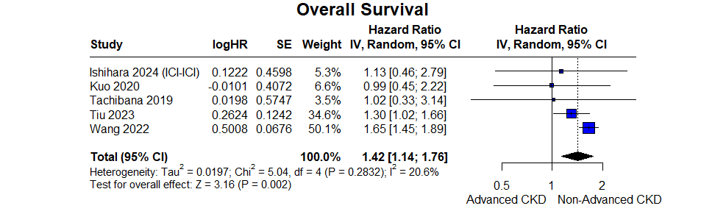
(B)
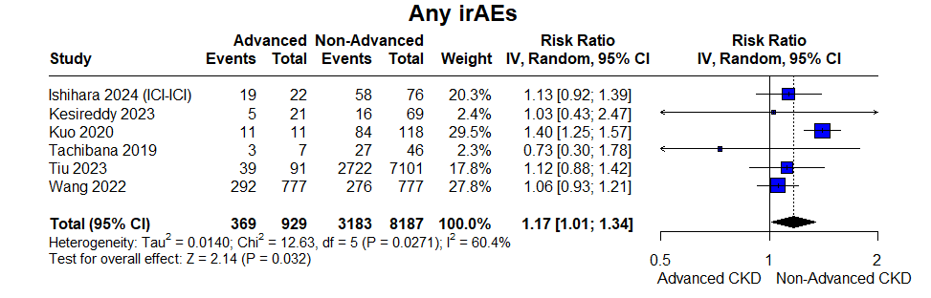
(C)
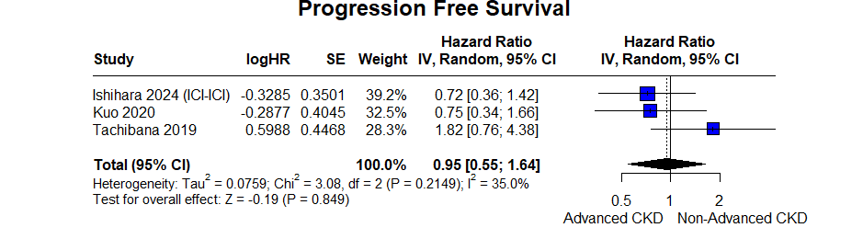
(D) 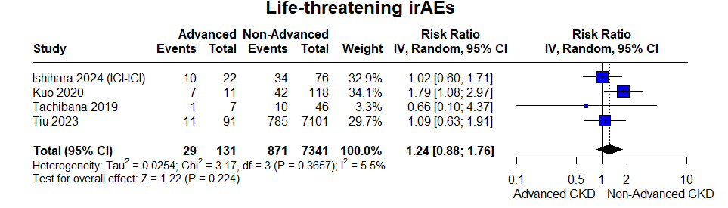
(E)
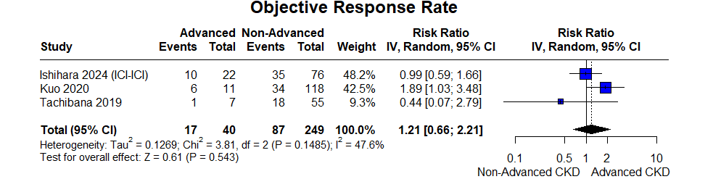
(F)
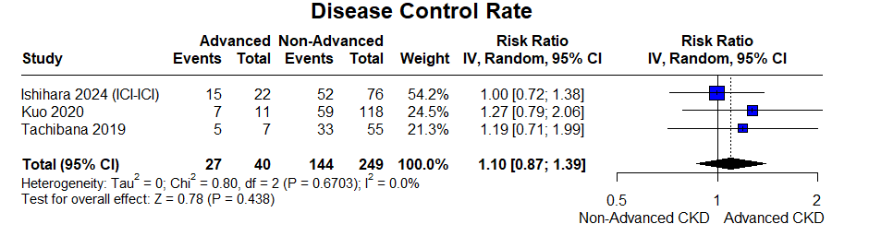
CI: Confidence Interval; CKD: Chronic Kidney Disease; ICI: Immune-Checkpoint Inhibitors; RR: Risk Ratio; TKI: Tyrosine Kinase Inhibitor.

