Here are all the original pictures of our Western blotting experiment for your review and correction.

Figure 1. Expression of LRP16 in tissues and cell lines. (E) The protein expression of LRP16 in five ESCC cell lines was analyzed by western blotting. LRP16, Leukemia-associated protein 16; ESCC, esophageal squamous cell carcinoma.
GAPDH From left to right: EC9706 TE-1 KYSE510 KYSE30 EC109
LRP16 From left to right: EC9706 TE-1 KYSE510 KYSE30 EC109

Figure 2. Cell fluorescence transfection screening and transfection efficiency detection.
(F) Expression of LRP16 in TE-1 cell lines between cells with nothing treatment and cells transfected with sh-LRP16 or sh-LRP16 negative control, as determined via western blotting. Compared with the NC group.
GAPDH From left to right: Control Vector sh-LRP16#1 sh-LRP16#2 sh-LRP16#3
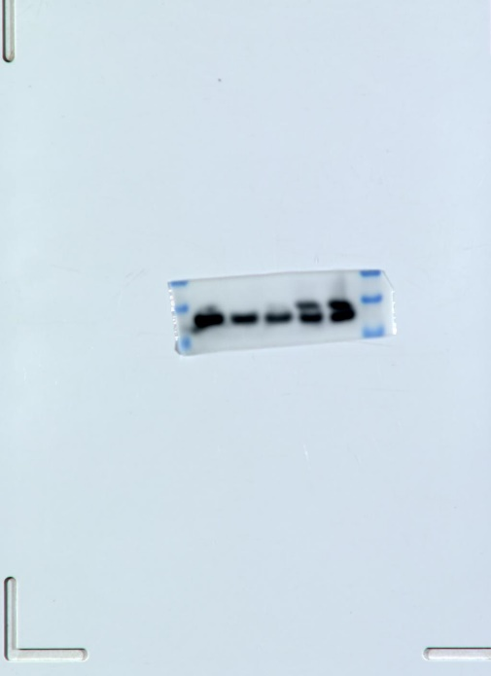

LRP16 From left to right: Control Vector sh-LRP16#1 sh-LRP16#2 sh-LRP16#3
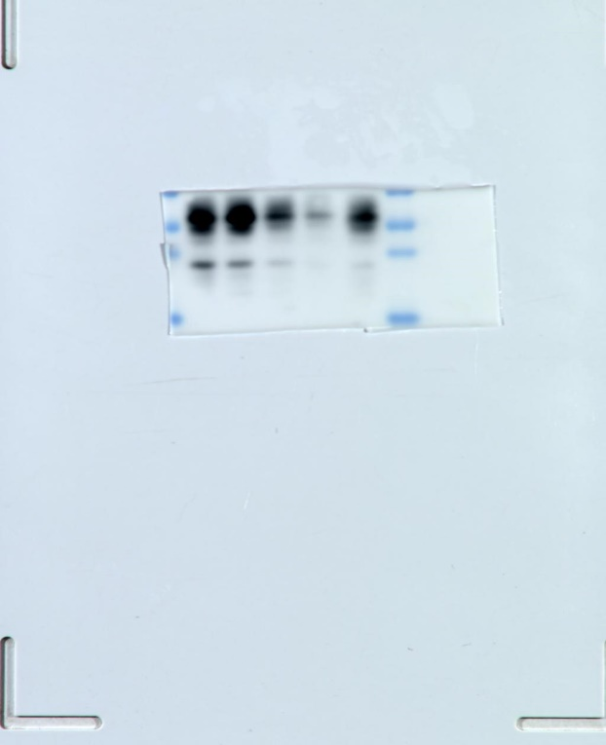

Figure 5. Regulation of Hippo signaling pathway by silencing LRP16. (B) The protein expression of ERα and ERβ in estrogen receptor in LRP16 silenced TE-1 cells was analyzed by western blotting. (D) Western blotting analysis of YAP1 and MST1/2 in Hippo signaling pathway after silencing LRP16 in TE-1 cells.
GAPDH From left to right: Control Vector sh-LRP16#1 sh-LRP16#2 sh-LRP16#3
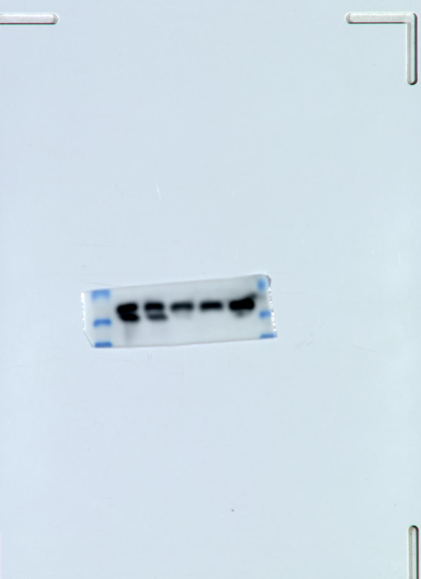
LRP16 From left to right: Control Vector sh-LRP16#1 sh-LRP16#2 sh-LRP16#3
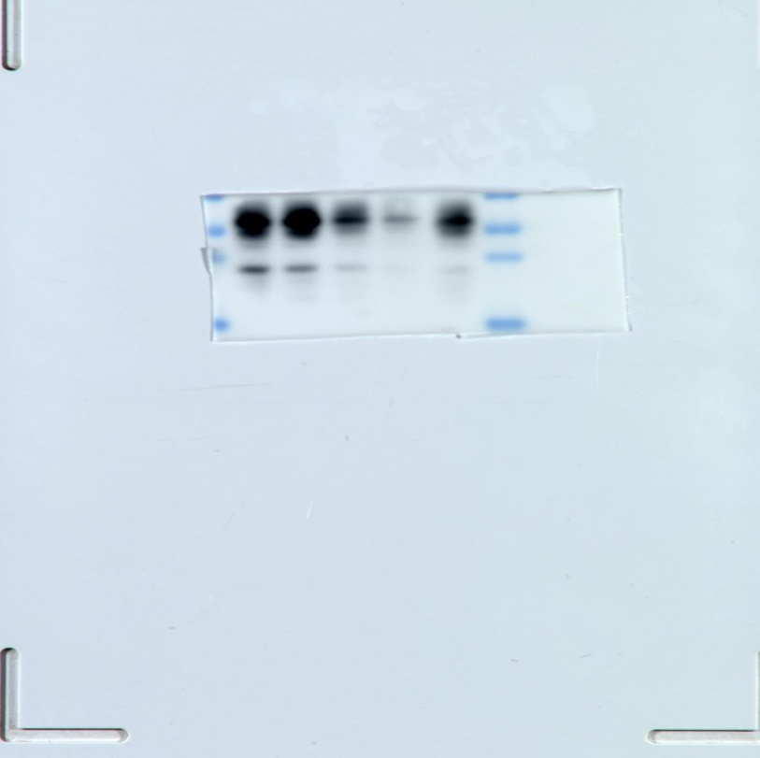
ERα From left to right: Control Vector sh-LRP16#1 sh-LRP16#2 sh-LRP16#3
ERβ From left to right: Control Vector sh-LRP16#1 sh-LRP16#2 sh-LRP16#3
MST1/2 From left to right: Control Vector sh-LRP16#1 sh-LRP16#2 sh-LRP16#3
YAP1 From left to right: Control Vector sh-LRP16#1 sh-LRP16#2 sh-LRP16#3
