Impact of the paper degradation state and constituents on its behavior during and after X-ray exposure
Alice Gimat^{1*}, Sebastian Schöder², Mathieu Thoury³, Anne-Laurence Dupont^{1*}
¹ Centre de Recherche sur la Conservation des Collections (CRC, CNRS USR 3224), Muséum National d'Histoire Naturelle, 36 rue Geoffroy St Hilaire 75005 Paris, France
² Synchrotron SOLEIL, 91192 Gif-sur-Yvette, France;
³ IPANEMA, CNRS, Ministère de la Culture, UVSQ, USR3461, Université Paris Saclay, 91192 Gif-sur-Yvette, France;
*corresponding authors: alice.gimat@mnhn.fr and anne-laurence.dupont@mnhn.fr
W_GI | R_GI | M_I
112 ± 13 µm | 69 ± 9 µm | 30 µm
 | 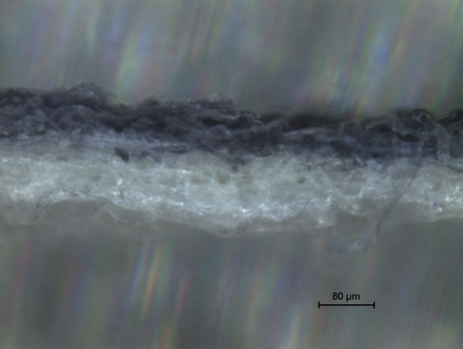 | 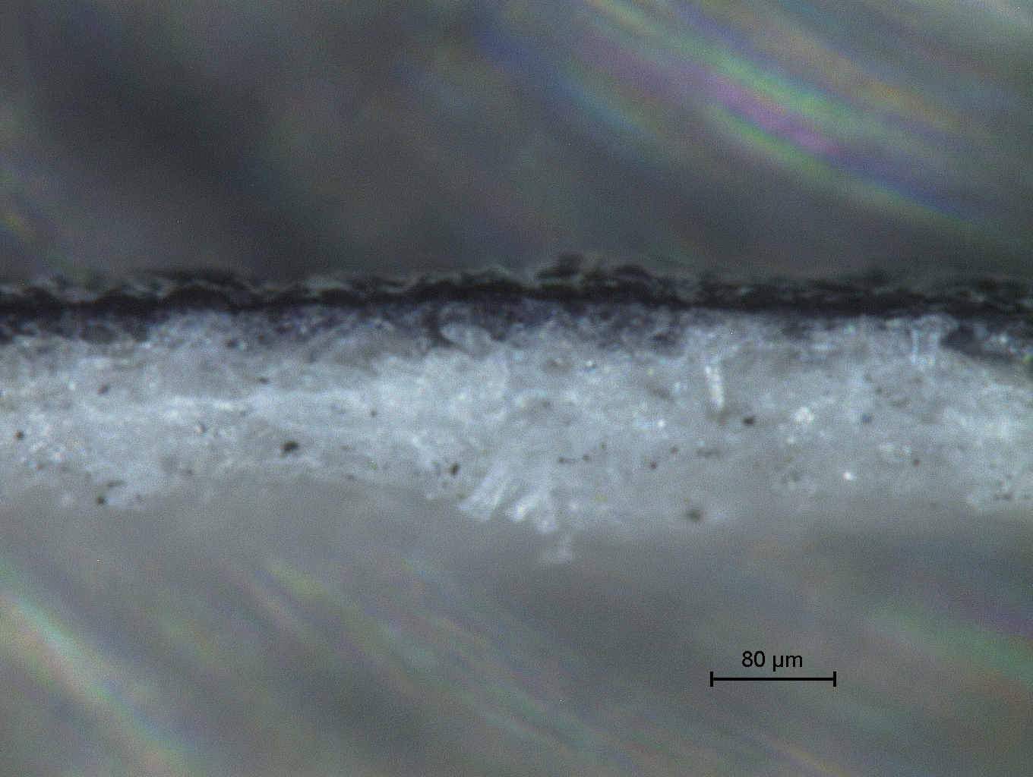
Fig S1 Binocular observations of inked model papers and the average thickness of the ink layer (numbers correspond to the ink penetration depth, the thickness of the paper being 170 µm, 150µm and 125µm respectively for W_GI, R_GI and M_I)

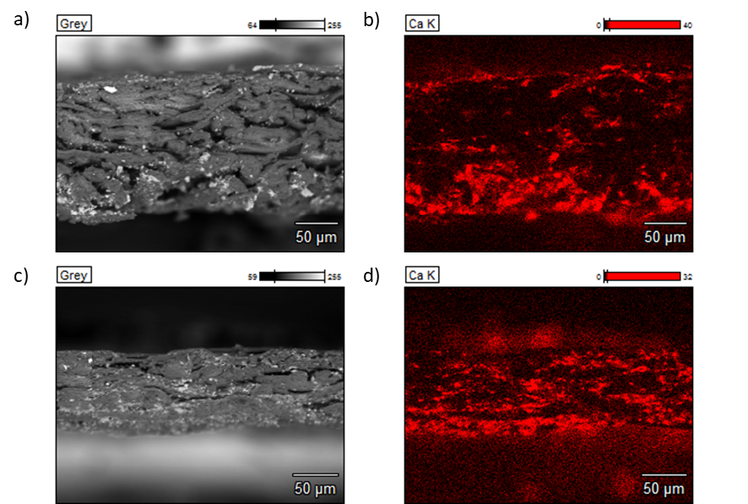
Fig S2 SEM observations (a,c) and EDS mapping of Calcium (b,d) in W_Ca (a,b) and K paper (c,d)
Table S1 Description of original archival papers. Elemental composition was determined by EDS or XRF.
SE  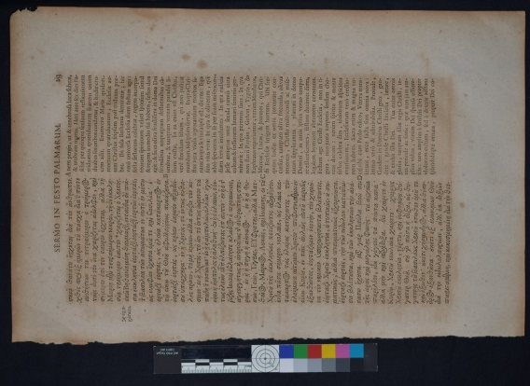 | Description: page from an 18th century printed volume  Composition: Cu, Fe, Mg, Al Si, Ca, S, K
DCN  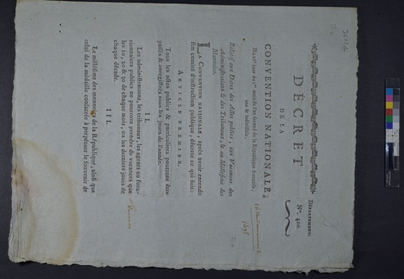 | Description: Printed decree  Composition K, S, Fe, Cu, Ca  IRTF: Calcium carbonate
M  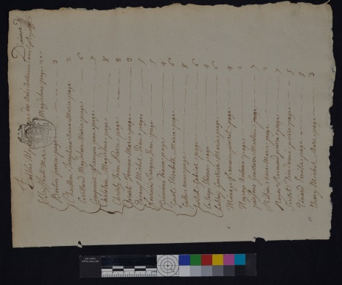 | Description: individual folio of notarial deed letter  Composition Mg, Si, Ca, S Fe, Cu, K, Cl, P
LN1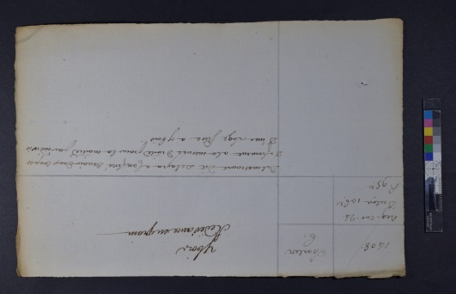 | Description: individual folio of notarial deed letter
LN5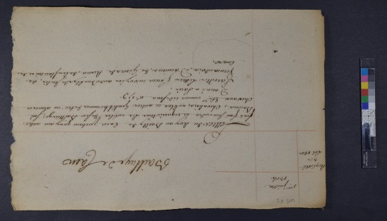 | Description: individual folio of notarial deed letter  Composition S, Ca, Fe

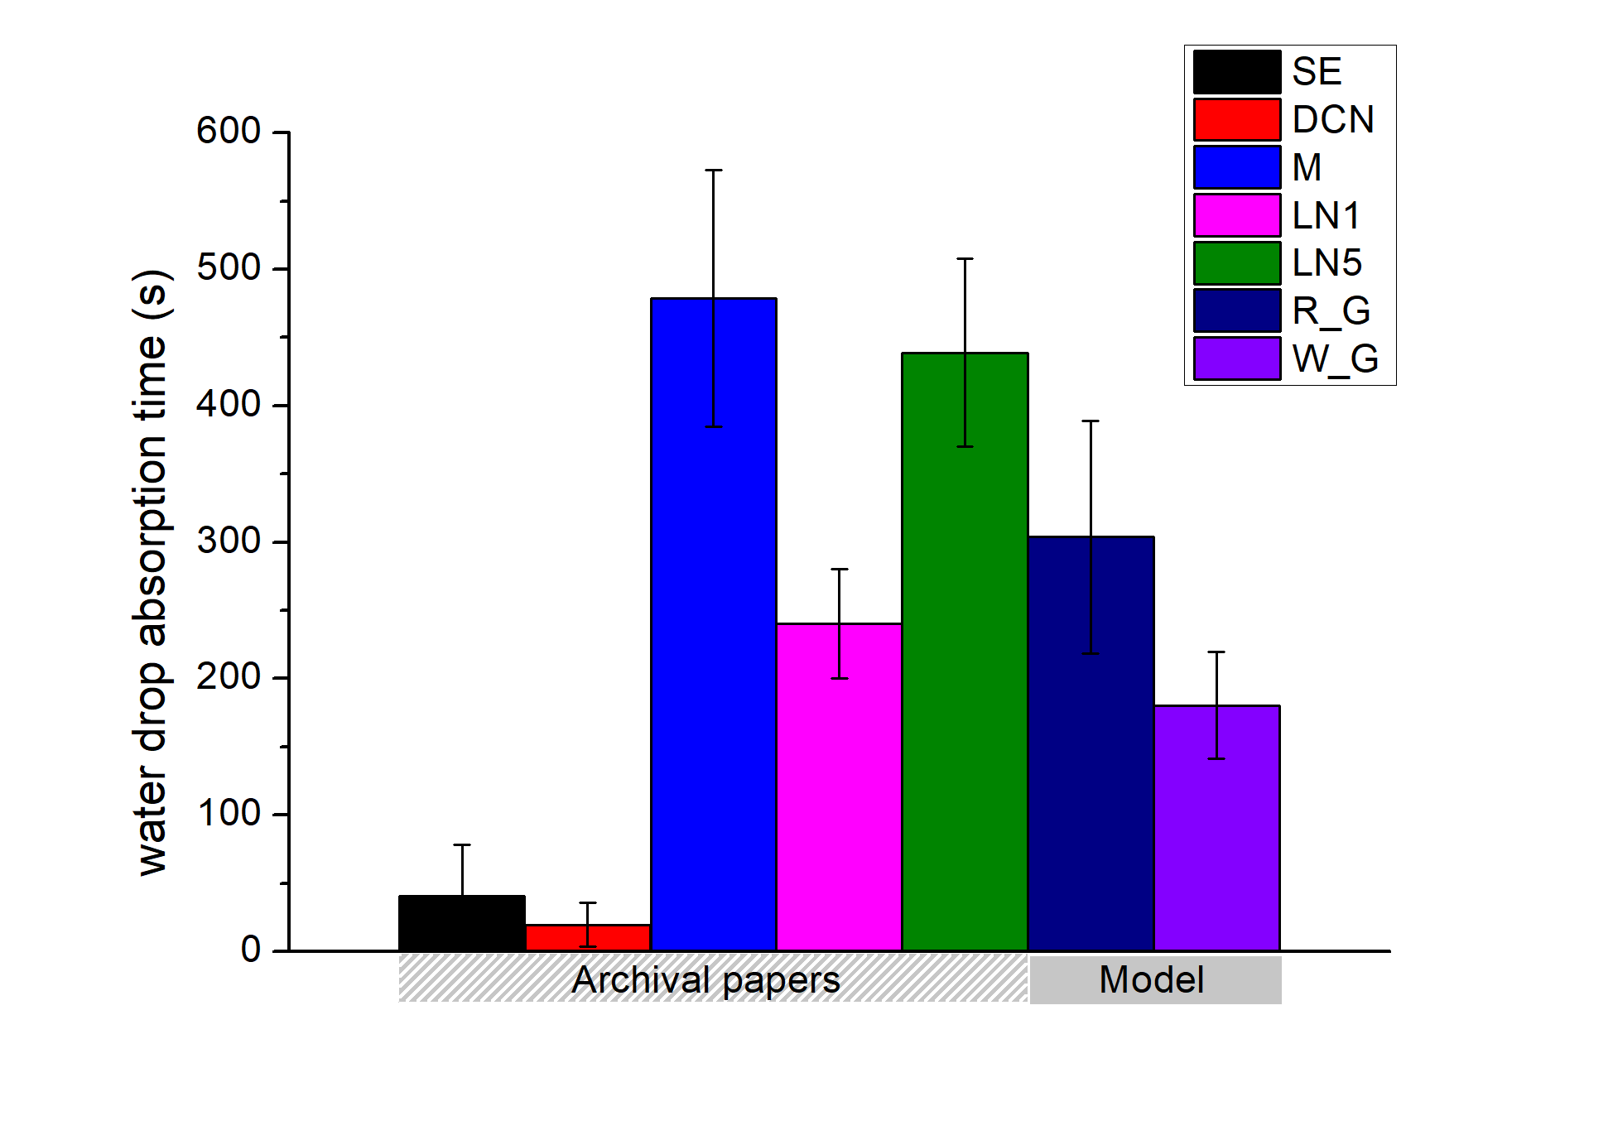

Fig. S3 Comparison of hydrophilic properties of paper using the water drop absorption test. A drop of 1 µl was used. The observation was carried out under binocular loupe and the timing ran until complete disappearance (at least five replicates).

Dose approximation with the XRF scanner M6 Jetstream (Bruker)

The following formula was used to assess the attenuation coefficient of Whatman no. 1 paper at each energy level ($μ_{paper})$:

$$μ_{paper}=ρ_{paper}∙\left(\frac{μ_{cell}}{ρ_{cell}}×a_{cell}+\frac{μ_{water}}{ρ_{water}}×a_{water}+\frac{μ_{air}}{ρ_{air}}×a_{air}\right)$$

With $ρ$, the paper density (g cm⁻³) and a, the mass fraction of the component, estimated at 94,8%, 5% and 0.16% for cellulose, water and air respectively. The linear absorption coefficients (in cm⁻¹) of cellulose, water and air were obtained from the online NIST database (https://physics.nist.gov/PhysRefData/FFast/html/form.html).

The mass fraction of air was estimated as: $a_{air}=\frac{ρ_{air}}{ρ_{paper}}×P$, with P, the paper porosity.
$P=\frac{(ρ_{cell}-ρ_{paper})}{ρ_{cell}}$ (estimated to 68% for Whatman no.1 paper).

The total dose (kGy) was then calculated as the summation of the doses absorbed for each energy $i$ with $D=\sum_{i}{\frac{t×{Pw}_{i}×(1-e^{-μ_{i}∙th})}{ρ∙S∙th}}$,

with t the exposure time in s, Pw the XRF source power (Figure S3a) in W, µ the attenuation coefficient (Figure S3b) in cm⁻¹, x, the paper thickness in cm, and s the beam surface in cm².
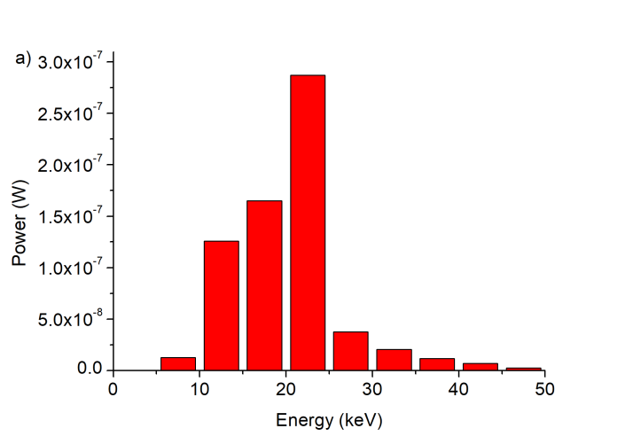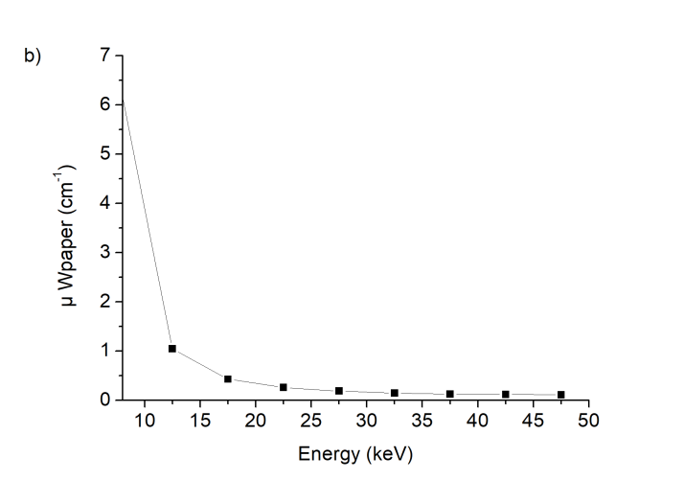
Fig S4 a) XRF source power spectral distribution and b) paper attenuation coefficient estimated by the summation of tabulated absorption coefficients of the individual components.
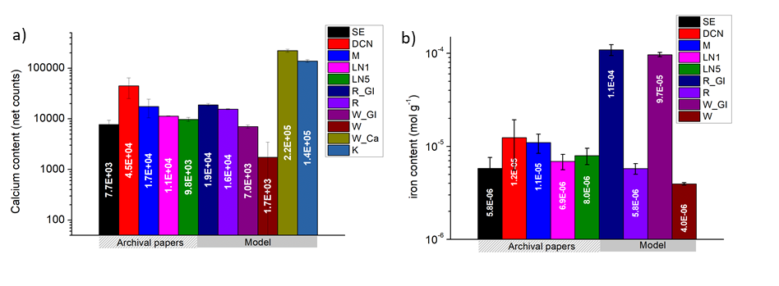
Fig. S5 calcium (a) and iron (b) content in the archival and the model papers as determined using XRF spectroscopy. Iron content was evaluated using a laboratory-made calibration curve with iron impregnated papers (unpublished data).

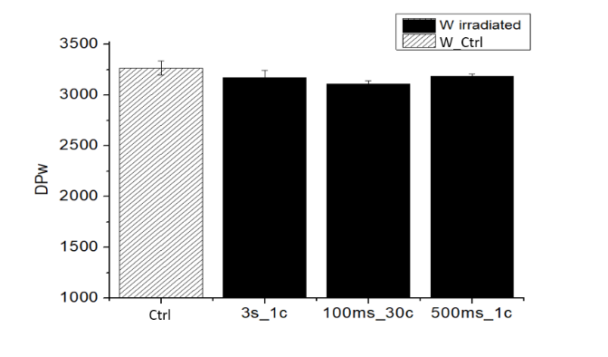
Fig. S6 Weight-average degree of polymerization (DP_{w}) of W irradiated with XRF M6 Jetstream Instrument (Bruker) at several durations (from 500 ms to 3s) and several cycles (from 1 to 30), compared to Control W sample (Ctrl).
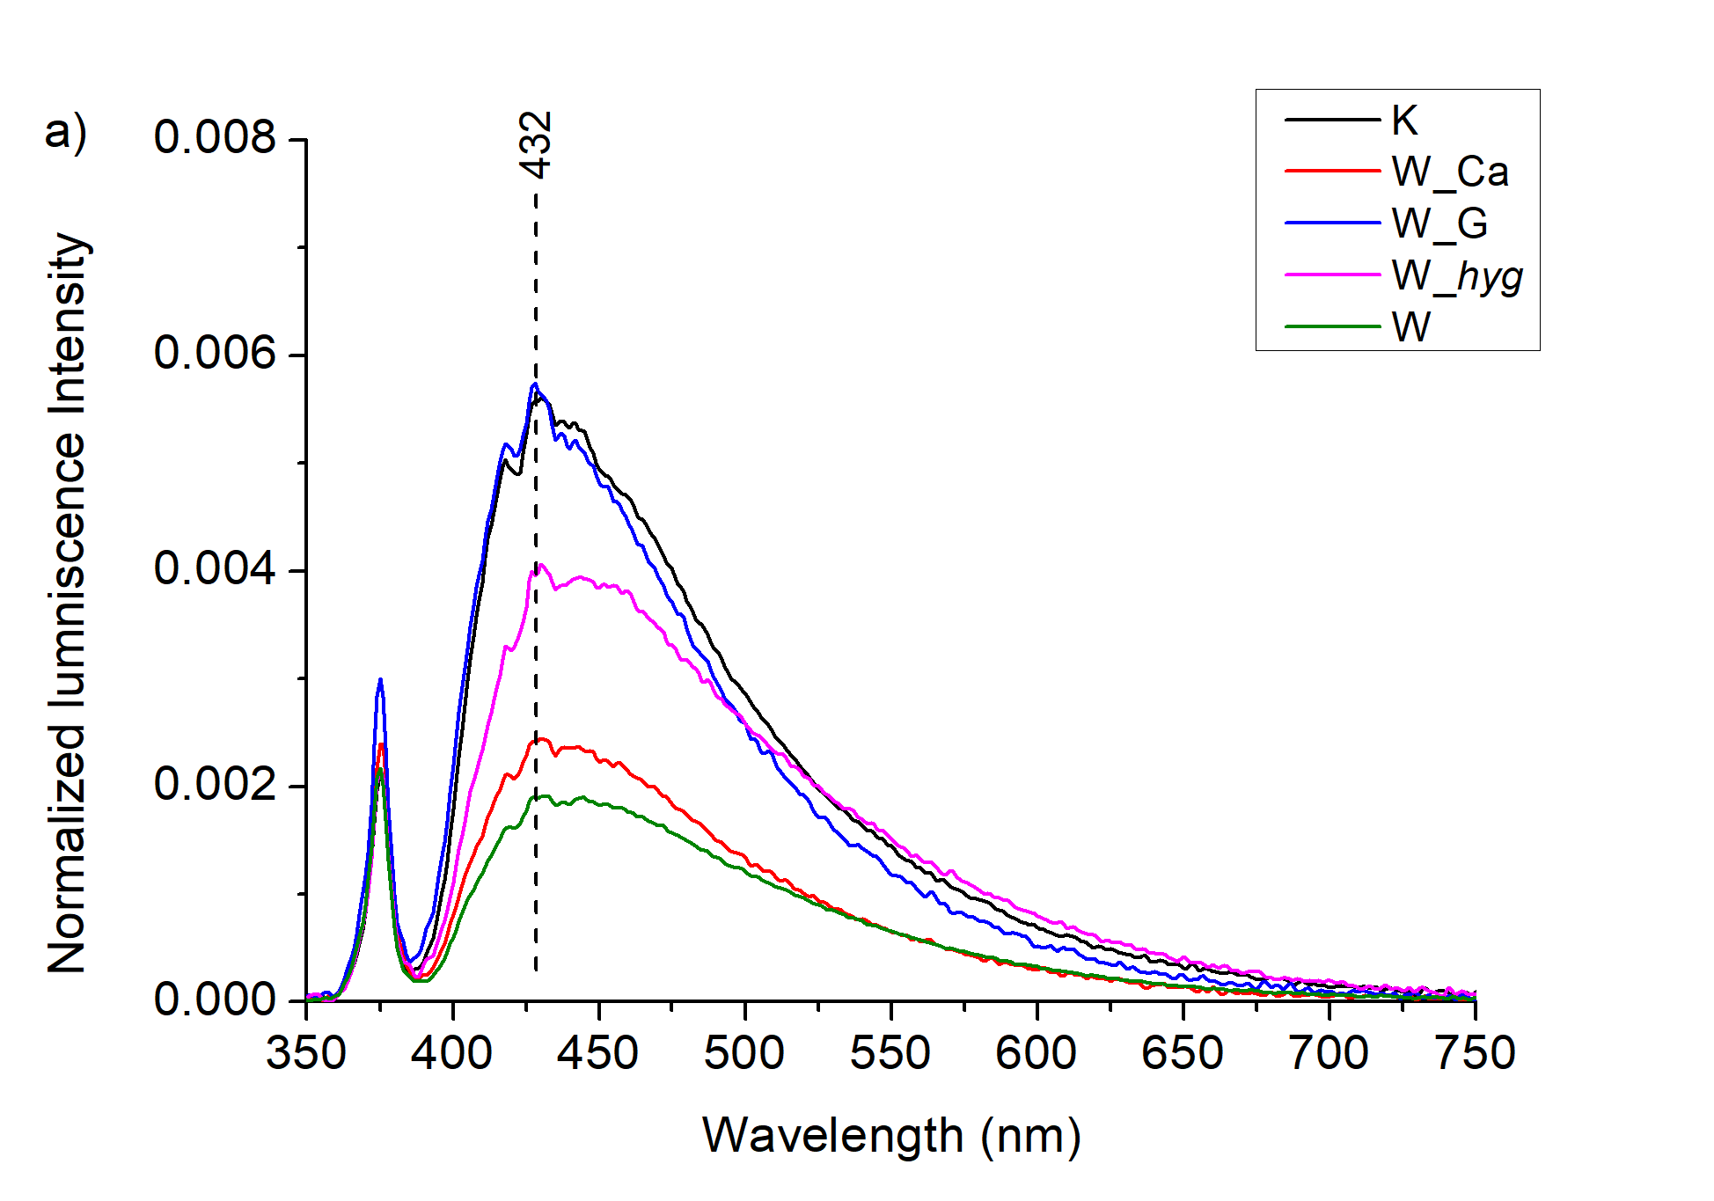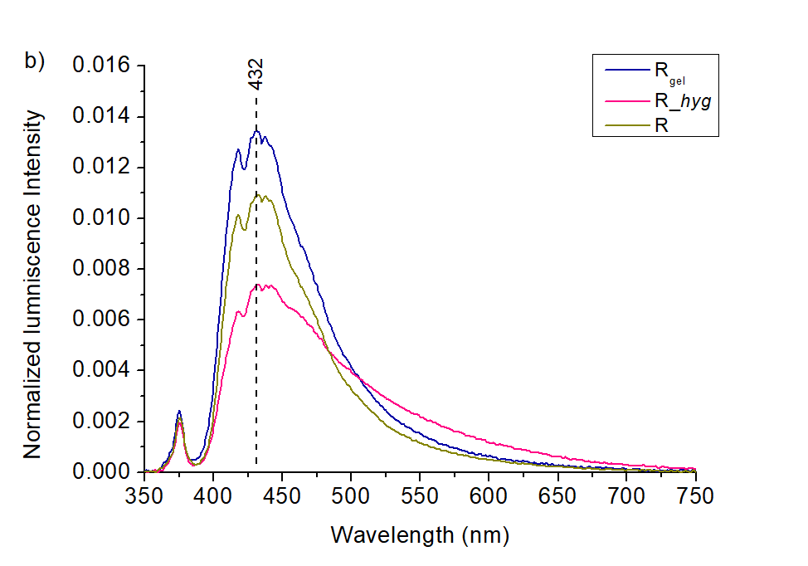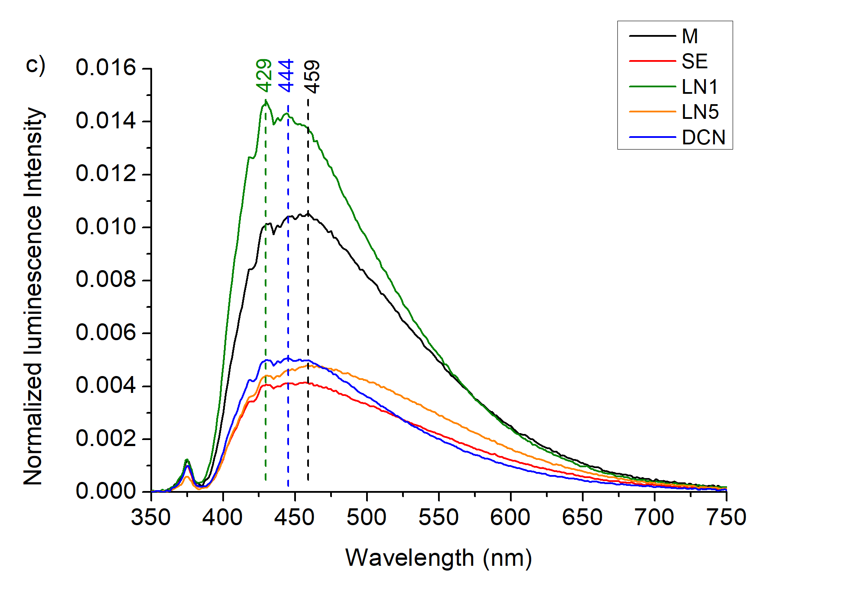
Fig. S7 UV luminescence spectra of samples W (a), R (b) and original archival samples (c) prior to x-ray irradiation. Dotted lines represent the spectrum maxima I(λ_{max}).

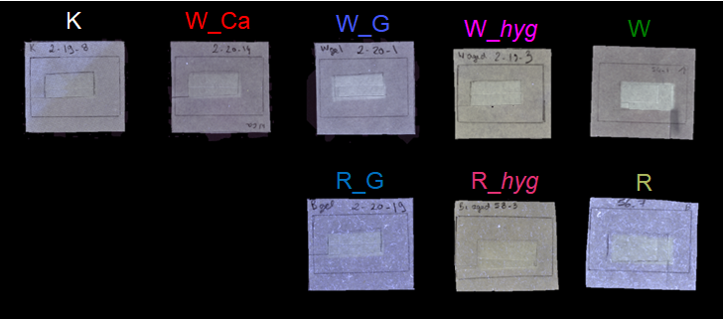
Fig. S8 Photographs of model papers W and R observed under UV light at 365 nm 300 days after the irradiation at 3 kGy. Irradiated area is 2 cm × 1 cm. The spotty aspect of R and R_G is due to a few fibers containing optical brighteners. Measurements were done in locations with no such fibers.

