

BRIDGE GenAI Lab

BIDMC–DFCI Radiology & Imaging Generative AI Hub
Beth Israel Deaconess Medical Center · Harvard Medical School

Supplementary Information
Reporting of fairness and equity in regulator-cleared commercial AI for acute stroke CT: a systematic review.

Contents
Supplementary Information 1
Supplementary Figures 3
Figure S1. Risk-of-bias assessment of the 13 included studies. 3
Supplementary Tables 4
Table S1. Search strategies across databases. 4
Table S2. Risk-of-bias assessment 6
Table S3. Fairness- and equity-related reporting across the 13 included studies (full grid). 7

Supplementary Figures

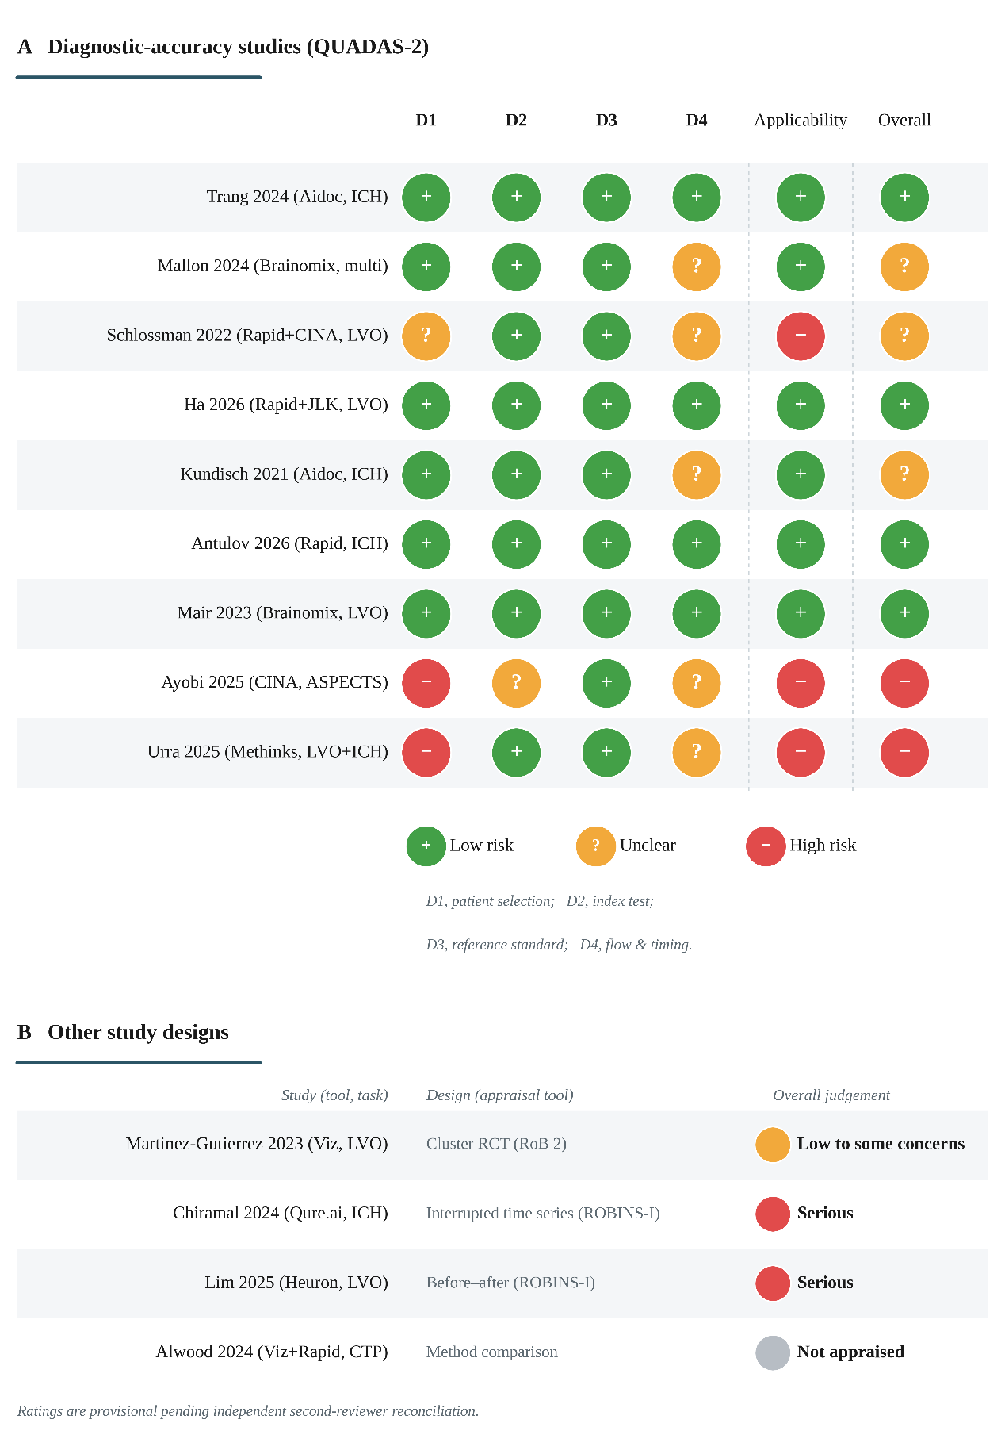
Figure S1. Risk-of-bias assessment of the 13 included studies.

(A) QUADAS-2 risk-of-bias and applicability judgements for the nine studies that reported diagnostic accuracy against a reference standard; each domain is rated low (green, +), unclear (amber, ?), or high (red, −), with applicability shown separately and an overall judgement equal to the least favourable of the four bias domains. (B) The four studies that did not report diagnostic accuracy, appraised with design-appropriate tools (RoB 2 for the cluster randomized trial; ROBINS-I for the interrupted time series and the before-after study) and shown with their overall judgement; the method-comparison study was not eligible for accuracy-based appraisal. Risk of bias was assessed to describe study quality and was not used to weight or exclude studies. Ratings are provisional pending independent second-reviewer reconciliation. QUADAS-2 denotes Quality Assessment of Diagnostic Accuracy Studies 2; RoB 2, Risk of Bias 2; ROBINS-I, Risk Of Bias In Non-randomized Studies of Interventions.

Supplementary Tables

Table S1. Search strategies across databases.

PubMed:
(
"Stroke"[Mesh] OR "Intracranial Hemorrhages"[Mesh] OR ASPECTS[tiab] OR "large vessel occlusion"[tiab]) AND ("Artificial Intelligence"[Mesh] OR "deep learning"[tiab] OR "machine learning"[tiab] OR "convolutional neural"[tiab]
)
AND
(
"Tomography, X-Ray Computed"[Mesh] OR "CT angiography"[tiab] OR "CT perfusion"[tiab] OR NCCT[tiab]
)
AND
(
Humans[Mesh] NOT (Review[Publication Type] OR Editorial[Publication Type] OR Letter[Publication Type] OR Comment[Publication Type] OR "Case Reports"[Publication Type]
)
Filters: Language- English; Date: 2018/01/01 - Present
PubMed Total: 608
Scopus:
TITLE-ABS-KEY
( (
"stroke" OR "ischemic stroke" OR "ischaemic stroke" OR "intracranial hemorrhage" OR "intracranial haemorrhage" OR "intracerebral hemorrhage" OR "intracerebral haemorrhage" OR "large vessel occlusion" OR "LVO" OR "ASPECTS"
)
AND
(
"artificial intelligence" OR "deep learning" OR "machine learning" OR "convolutional neural network" OR "neural network" OR "computer aided detection"
)
AND
(
"computed tomography" OR "CT angiography" OR "CT perfusion" OR NCCT OR "non-contrast CT" OR CTA
) )
AND
PUBYEAR > 2017 AND DOCTYPE ( ar )
Scopus Total: 1650
PubMed Central
(
"Stroke"[Mesh] OR "Intracranial Hemorrhages"[Mesh] OR stroke[tiab] OR "intracranial hemorrhage"[tiab] OR LVO[tiab] OR ASPECTS[tiab] OR "large vessel occlusion"[tiab]
)
AND
(
"Artificial Intelligence"[Mesh] OR "deep learning"[tiab] OR "machine learning"[tiab] OR "convolutional neural"[tiab]
)
AND
(
"Tomography, X-Ray Computed"[Mesh] OR "CT angiography"[tiab] OR "CT perfusion"[tiab] OR NCCT[tiab]
)
Filters: Date: 2018/01/01 - Present
PubMed Central Total: 456

Summary
PubMed: 608 results
Scopus: 1650 results
PubMed Central: 456 results
Total records before duplicate removal: 2714

Table S2. Risk-of-bias assessment
Study (tool, task) | Patient selection | Index test | Reference standard | Flow & timing | Applicability | Appraisal note
Trang 2024 (Aidoc, ICH) | Low | Low | Low | Low | Low | Consecutive cohort; blinded adjudicated reference standard
Mallon 2024 (Brainomix, multi) | Low | Low | Low | Unclear | Low | Prospective, consecutive, unselected
Schlossman 2022 (Rapid+CINA, LVO) | Unclear | Low | Low | Unclear | High | Single-center retrospective; consecutive enrolment
Ha 2026 (Rapid+JLK, LVO) | Low | Low | Low | Low | Low | Consecutive, including non-stroke cases
Kundisch 2021 (Aidoc, ICH) | Low | Low | Low | Unclear | Low | Some scans excluded at the AI-processing step
Antulov 2026 (Rapid, ICH) | Low | Low | Low | Low | Low | Unselected emergency-department cohort
Mair 2023 (Brainomix, LVO) | Low | Low | Low | Low | Low | Independent test set; vendor not involved in analysis
Ayobi 2025 (CINA, ASPECTS) | High | Unclear | Low | Unclear | High | Curated multi-reader study; vendor-conducted
Urra 2025 (Methinks, LVO+ICH) | High | Low | Low | Unclear | High | Sampled by disease status; AI-based case exclusions
Martinez-Gutierrez 2023 (Viz, LVO) | — | — | — | — | — | RoB 2 (cluster RCT): low to some concerns
Chiramal 2024 (Qure.ai, ICH) | — | — | — | — | — | ROBINS-I (interrupted time series): Serious risk of bias (secular trend; vendor-funded)
Lim 2025 (Heuron, LVO) | — | — | — | — | — | ROBINS-I (before-after): serious (uncontrolled temporal confounding)
Alwood 2024 (Viz+Rapid, CTP) | — | — | — | — | — | Method-comparison study; no independent reference standard, not eligible for accuracy-based appraisal
QUADAS-2 domains were rated Low (green), Unclear (amber), or High (red) risk of bias for the nine studies that reported diagnostic accuracy. The four studies that did not report diagnostic accuracy (one cluster randomized trial, one interrupted time series, one before-after study, and one method-comparison study) were appraised with design-appropriate tools and are shown with their overall judgement. The risk of bias was assessed to describe study quality and was not used to weight or exclude studies.

Table S3. Fairness- and equity-related reporting across the 13 included studies (full grid).
Study (tool, task) | Cohort demog. (age/sex) | Sex / gender perf. | Age perf. | Race / ethnicity perf. | SES / insurance perf. | Site / scanner perf. | Training-data demog. | Explicit fairness eval.
Trang 2024 (Aidoc, ICH) | ● | ● | ● | ● | ● |  |  | ●
Martinez-Gutierrez 2023 (Viz, LVO) | ● | ◐ | ◐ | ◐
Alwood 2024 (Viz+Rapid, CTP) | ◐ |  |  |  |  | ● |  | ◐
Urra 2025 (Methinks, LVO+ICH) | ◐ |  |  |  |  |  |  | ◐
Antulov 2026 (Rapid, ICH) | ● |  |  |  |  |  |  | ◐
Lim 2025 (Heuron, LVO) | ● |  |  |  |  |  |  | ◐
Chiramal 2024 (Qure.ai, ICH) | ● | ◐ | ◐
Mair 2023 (Brainomix, LVO) | ●
Ha 2026 (Rapid+JLK, LVO) | ●
Kundisch 2021 (Aidoc, ICH) | ●
Mallon 2024 (Brainomix, multi) | ●
Ayobi 2025 (CINA, ASPECTS) | ●
Schlossman 2022 (Rapid+CINA, LVO) | ●
Studies reporting, n/13 | 11 | 1 | 1 | 1 | 1 | 1 | 0 | 1

A filled circle denotes reported (subgroup performance reported; for cohort and training-data demographics, an explicit description); a half-filled circle denotes partial reporting (baseline demographics only, adjustment for a variable in a model without subgroup performance, or a bias or data gap acknowledged without measurement); a blank cell denotes not reported. The explicit-fairness evaluation column scores measured subgroup performance as reported and acknowledgment of a bias or data gap as partial. Counts are the number of studies with reported status. No study reported training-data demographics (0 of 13). SES denotes socioeconomic status.

