Table S1 Functional assessment of four coating bacterial strains
Strain | Top-hit Taxon | ANI Value with the Closest Reference Strain (%) | Patent Number | Amylase (%) | Protease (%) | Cellulase (%) | Inorganic phosphorus solubilization (μg/g) | Potassium-dissolving
WN088 | Priestia aryabhattai | 99.21 | ZL 202310701097.8 | 3.77±0.49 | 4.36±0.46 | 6.06±0.25 | 0.68±0.20 | -
3-218 | Flavobacterium erigeronis | 100.00 | ZL 202411233751.8 | 1.41±0.17 | 3.05±0.27 | 2.32±0.25 | 0.68±0.12 | √
MS11 | Bradyrhizobium japonicum | 98.65 | - | - | - | 5.19±0.58 | 0.83±0.18 | √
YB35 | Bacillus velezensis | 97.67 | - | - | - | - | 1.37±0.05 | -

Table S2 Analysis of the drivers of bacterial community assembly
Group | Process | Percentage (%)
MSC | variable selection | 35.172
MSC | homogeneous selection | 0
MSC | dispersal limitation | 8.276
MSC | homogeneous dispersal | 0.230
MSC | drift | 56.322
CK | variable selection | 61.839
CK | homogeneous selection | 0
CK | dispersal limitation | 5.747
CK | homogeneous dispersal | 1.149
CK | drift | 31.264

Fig. S1 Phylogenetic tree of the four coating strains and references constructed using the maximum-likelihood method based on orthologous single-copy core genes
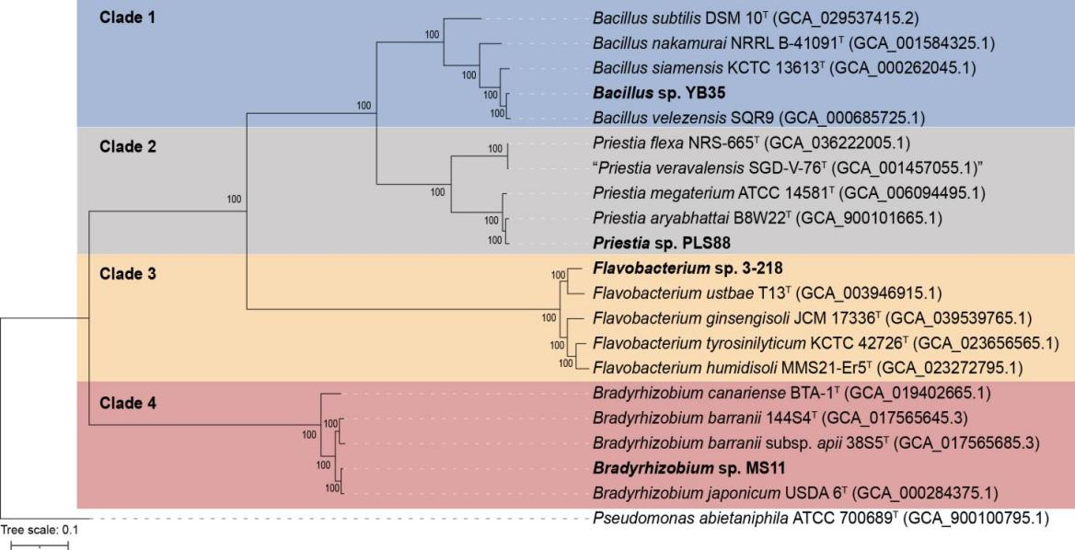

Fig. S2 Rhizosphere microbial community composition and differential taxa analysis under CK (red) vs MSC (blue) treatments
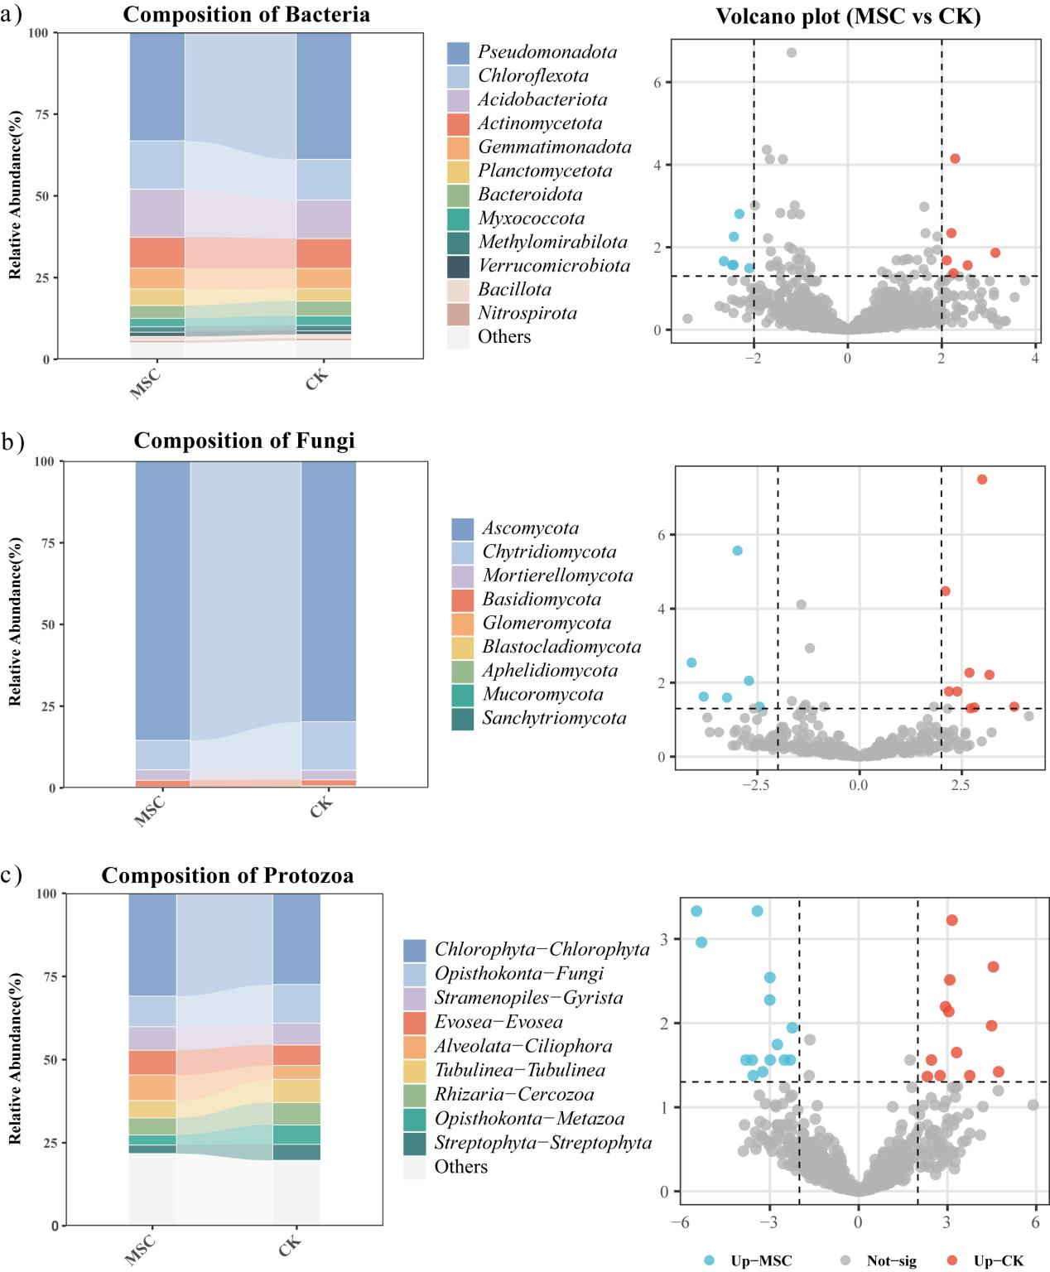
Fig. S3 Associations between rhizosphere bacterial, fungal, and protozoan communities and maize agronomic traits and yield (Mantel test and Spearman correlation analysis)
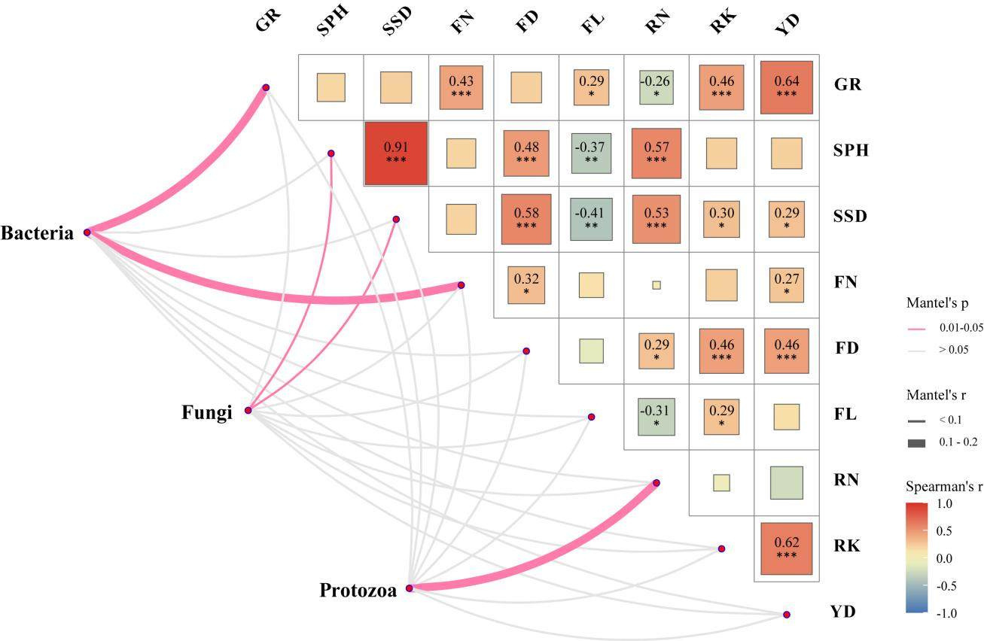

Fig. S4 Bacterial co-occurrence networks and node roles in maize rhizosphere under CK vs MSC treatments
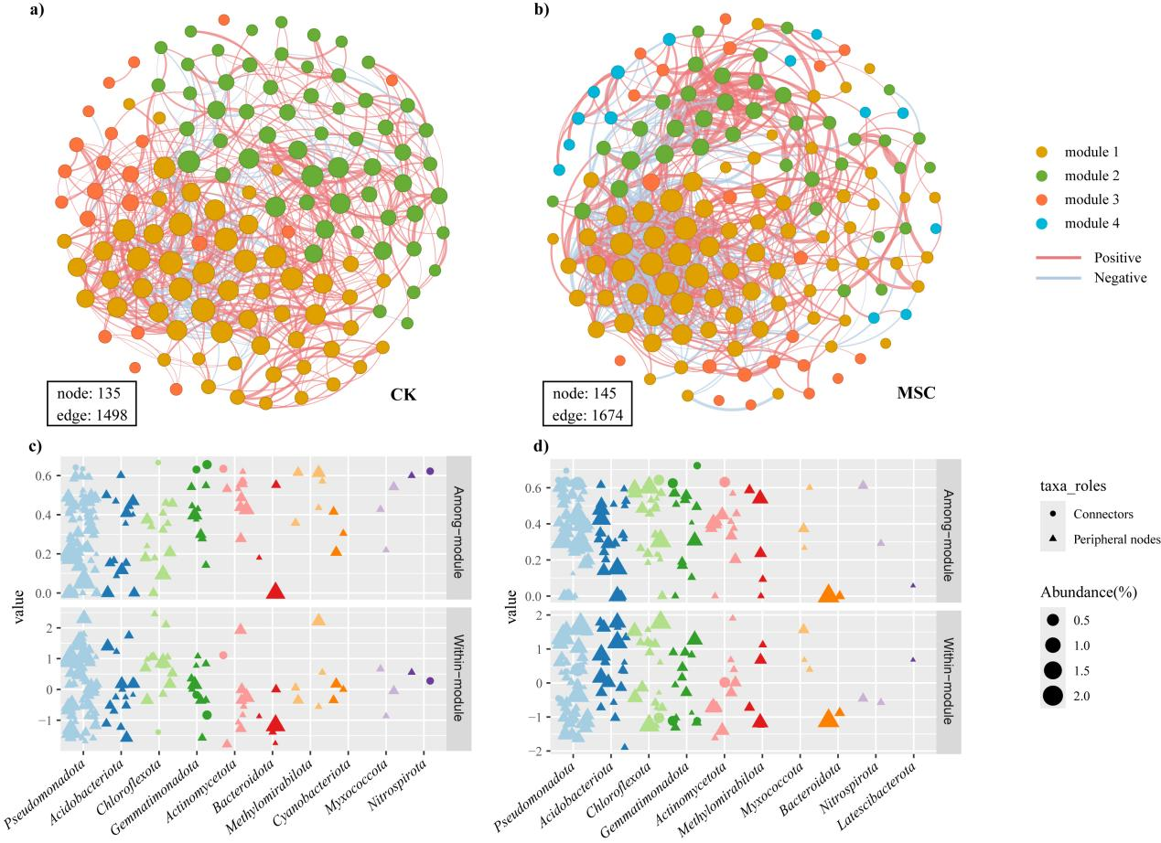
Fig. S5 Fungal co-occurrence networks and node roles in maize rhizosphere under CK vs MSC treatments
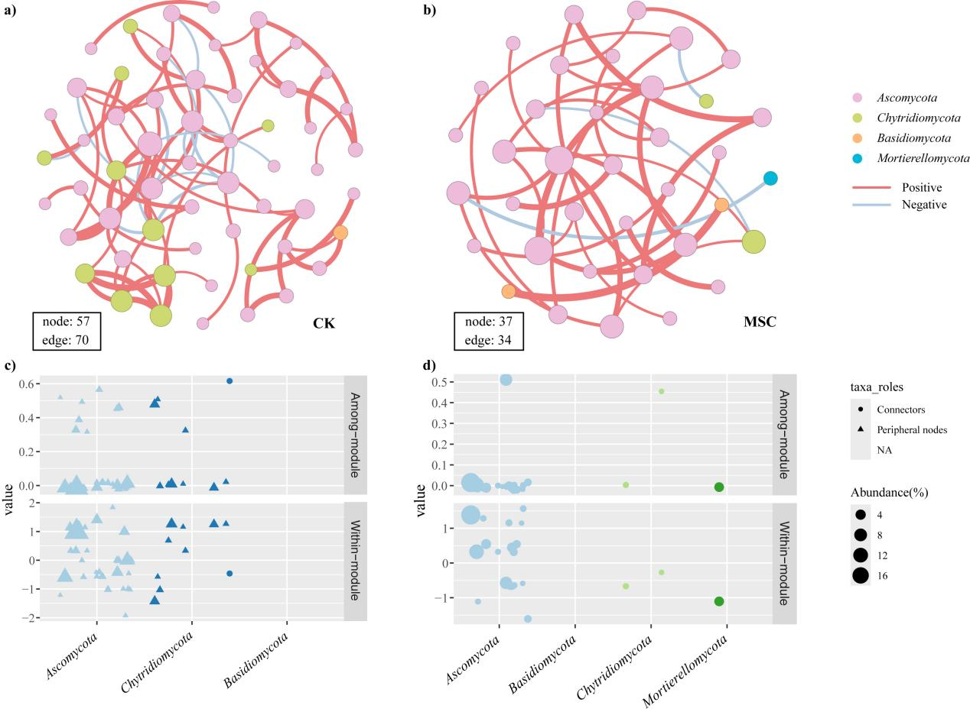
Fig. S6 Protozoan co-occurrence networks and node roles in maize rhizosphere under CK vs MSC treatments
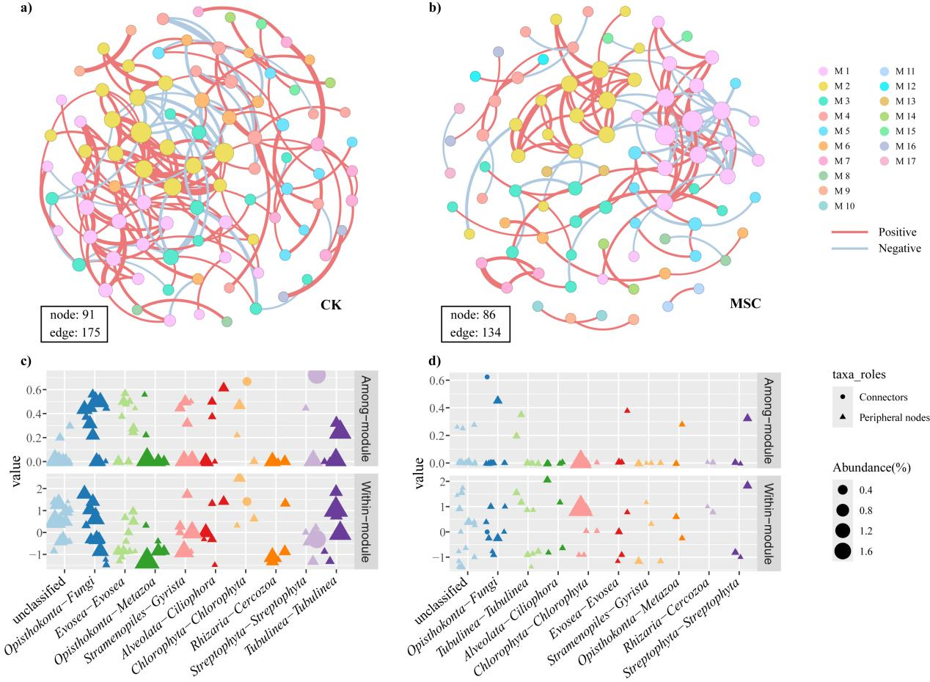
Fig. S7 Protozoan co-occurrence networks and node roles in maize rhizosphere under CK vs MSC treatments
