Topic guide
for
People living with chronic pain

(Informed consent will be taken via a consent form for voluntary participation and audio-recording discussion)
Pre-interview (Before formally starting the interview, use the below script to verbally explain the background of this research)
Thank you (name), for taking the time to join me today. My name is (name), and I am part of this research project where we are exploring the idea of a digital tool to help patients with chronic musculoskeletal pain to better self-manage their conditions. This tool will be incorporated into a digital pain self-reporting tool called Manchester Digital Pain Manikin, which is a smartphone app incorporating human-shaped figure to draw pain directly on it, and capturing pain triggers, relievers, and its impact on daily lives. We think capturing and summarising this information may support self-learning and self-management. This tool is original developed and tested in the United Kingdom, and later developed and tested in Pakistan. Our work in Pakistan generated positive results, which we want to build upon to deliver direct patient benefits.

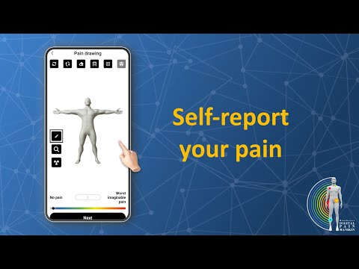
Have a look at this video as an introduction to the Manchester Digital Pain Manikin (https://www.youtube.com/watch?v=iVqz4asf094&t=5s).

However, additional information or resources might be required. We're not testing a specific tool or app, rather gathering your expert insights to shape what this sort of tool should do and how.

We will keep your identity and data confidential. If you have any questions, you can ask me without hesitation. If you want to take a break anytime during the interview you can let me know. If you are ready, we can start.
(recording starts here)

Q. Can you describe your chronic pain and experience of living with it?
- History of symptoms and diagnosis and current treatment
- Explore any beliefs, traditions or cultural explanations that they might believe caused their condition.
- How good and bad days are described
- How it impacts your life, relationships, social life, day-to-day activities (home chores, or professional work) and mental wellbeing
- How others perceive it
- Experience with healthcare professionals and pain management services (explore satisfaction also)
- What kind of support they receive from health care professionals (explore financial, social and cultural limitations)

Q. How have you been managing your chronic pain condition at home?
- Details of current pain management practices (medications, doctor visits, need for physiotherapy, home remedies, dietary modification, calming through prostration or prayer).
- How different choices of management are evaluated and decided? (explore any financial, social or cultural beliefs or practices that influence decision making).
- Explore the role of home remedies “totkaas” and allopathic medications (beliefs and practices).
- Explore the role of family members, friends, and community members in guiding pain management choices and practices
- Any identified triggers and relievers/are there things they have learnt to do differently over time?
- How do they deal with a flare/cope or manage the challenges of their conditions?
- Explore the current role of digital health tools or information shared via social media
Q. If you could choose any type of pain management program regardless of cost and availability, what would you like to choose and what do you hope to achieve from it?
- Explore the need for information, from whom and how to get help
- Being able to manage at home (self-efficacy)/ how confident are they about dealing with their condition at home by themself?
- Explore about improved functionality vs reducing pain intensity/what is more important to them; being able to improve their mobility or pain relief?
- Emotional support and support groups/ How do they feel about talking in a group of people with similar condition? How do they think it can help them?
- Explore the need for behavior modifications, psychotherapy, role of diet, home remedies, medication adherence, persistence

Q. What is your opinion about the use of smartphone-based tools or apps to help with self-management of your pain?
- Skills and information (plus their format) needed to use these devices and tools
- Pain self-reporting regularly to learn about their own chronic pain, rather than from experiences of other people?
- What kind of things in a digital app would keep them motivated to use it regularly to manage their condition.
[Watch video to understand what pain self-reporting means and inset a table to specification exercise here to gather user requirements. Keep referring to pain self-reporting as basis for developing pain self-management tool or intervention]

Q. Is there anything you would like to add to this conversation, which you have not said before?

Thank you for your time. I hope you have a great day!
(End recording here)

