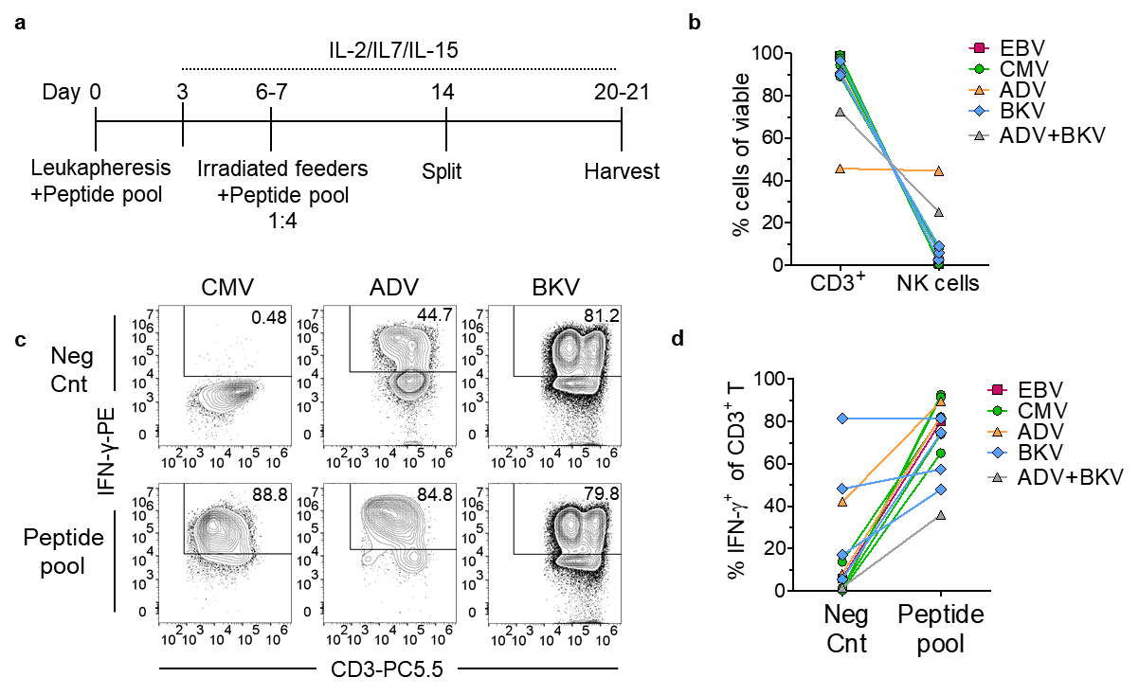
Supplementary Figure 1. Generation and expansion of VSTs from leukapheresis. (a) Schematic timeline of VSTs generation. (b) Percentage of CD3⁺ T cells or NK cells (CD3⁻CD56⁺) among total viable cells at day 21. (c) Representative flow cytometry plots gated on CD3⁺ cells showing IFN-γ expression in unstimulated negative control (Neg Cnt) and peptide pool stimulated samples at day 21. (d) Percentage of IFN-γ⁺ cells among CD3⁺ T cells in unstimulated Neg Cnt and peptide pool stimulated samples at day 21.
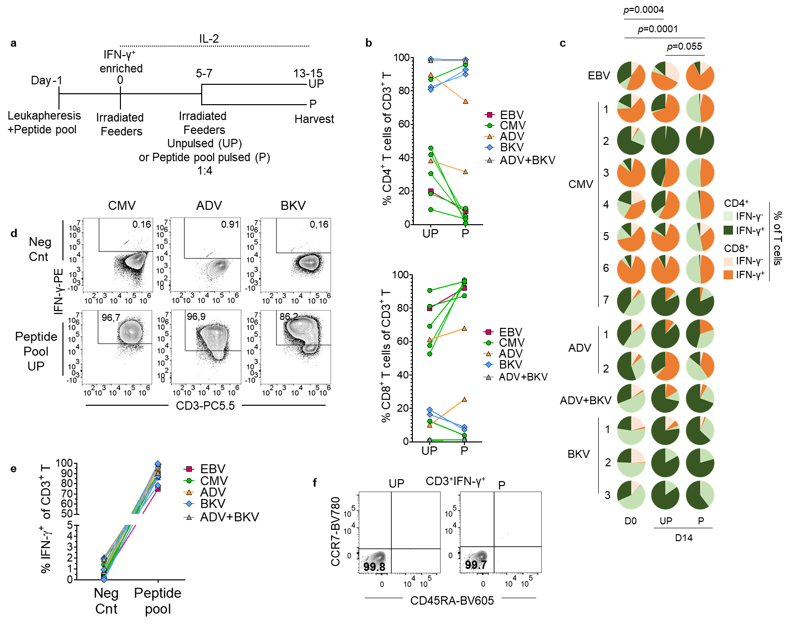
Supplementary Figure 2. VSTs IFN-γ-enriched expanded phenotype. (a) Schematic timeline of VSTs generation. (b) Proportion of CD4⁺ or CD8⁺ T cells among CD3⁺ T cells of UP or P condition. (c) Percentage of CD4⁺IFN-γ⁻, CD4⁺IFN-γ⁺, CD8⁺IFN-γ⁻, or CD8⁺IFN-γ⁺ cells among total T cells, Wilcoxon matched-pairs test. (d) Representative flow cytometry plots gated on CD3⁺ cells showing IFN-γ expression in unstimulated negative control (Neg Cnt) and peptide pool stimulated samples of UP condition. (e) Percentage of IFN-γ⁺ cells among CD3⁺ T cells in unstimulated Neg Cnt and peptide pool stimulated samples of UP condition. (f) Representative flow cytometry plots gated on CD3⁺IFN-γ⁺ cells depicting memory T cell marker expression under UP or P expansion conditions.

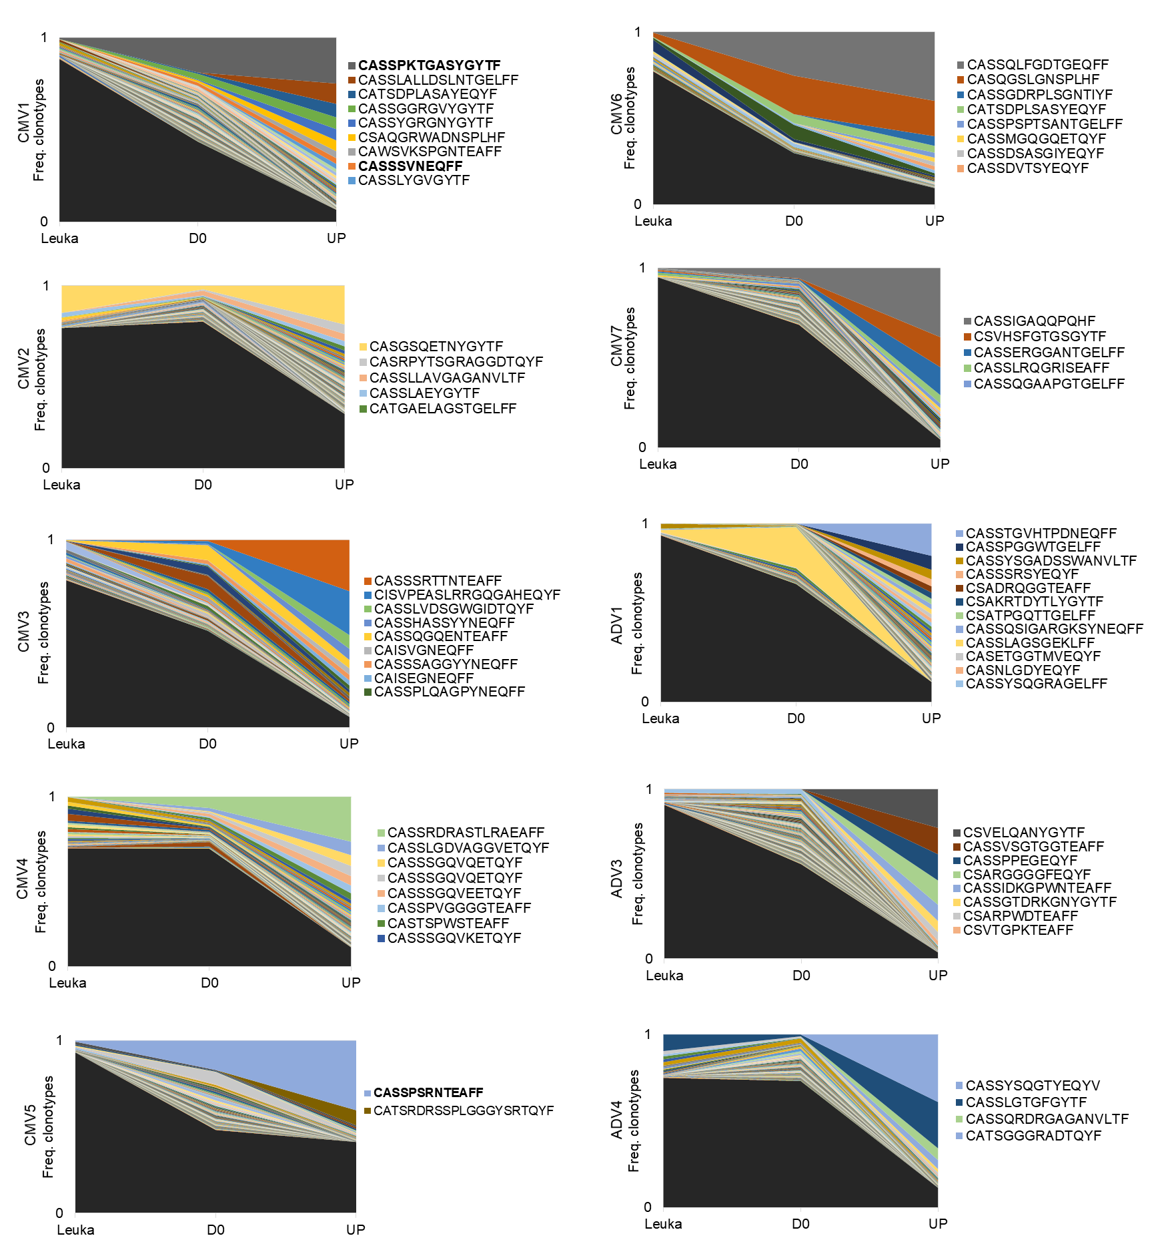
Supplementary Figure 3. TCRβ clonal of VSTs. Clonotype frequencies in IFN-γ-enriched day 0 product, and final UP or P T cell product. Clonotypes with <0.2% frequency are shown in black; CDR3 amino acid sequences are indicated for clonotypes representing ≥2% of the final product.
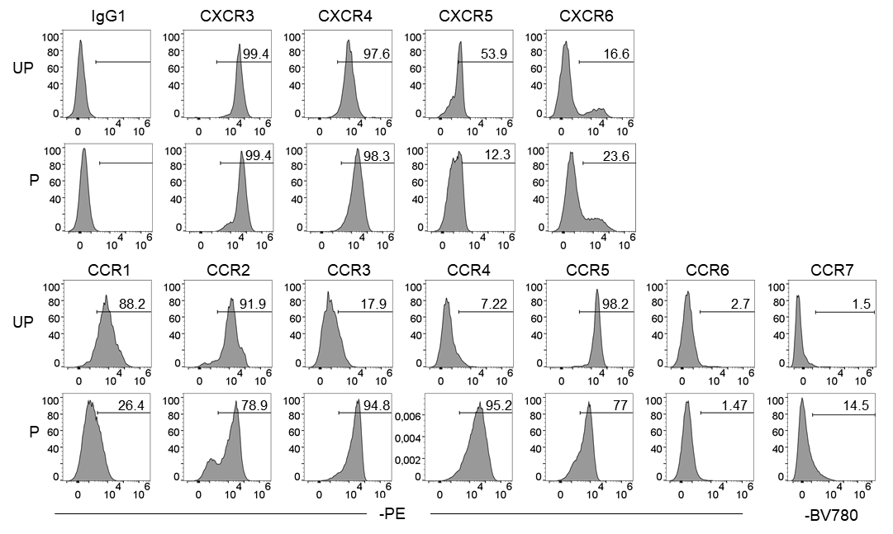
Supplementary Figure 4. Chemokine receptor expression by flow cytometry. Representative flow cytometry histograms of VSTs stained with chemokine receptor antibodies from UP and P conditions.

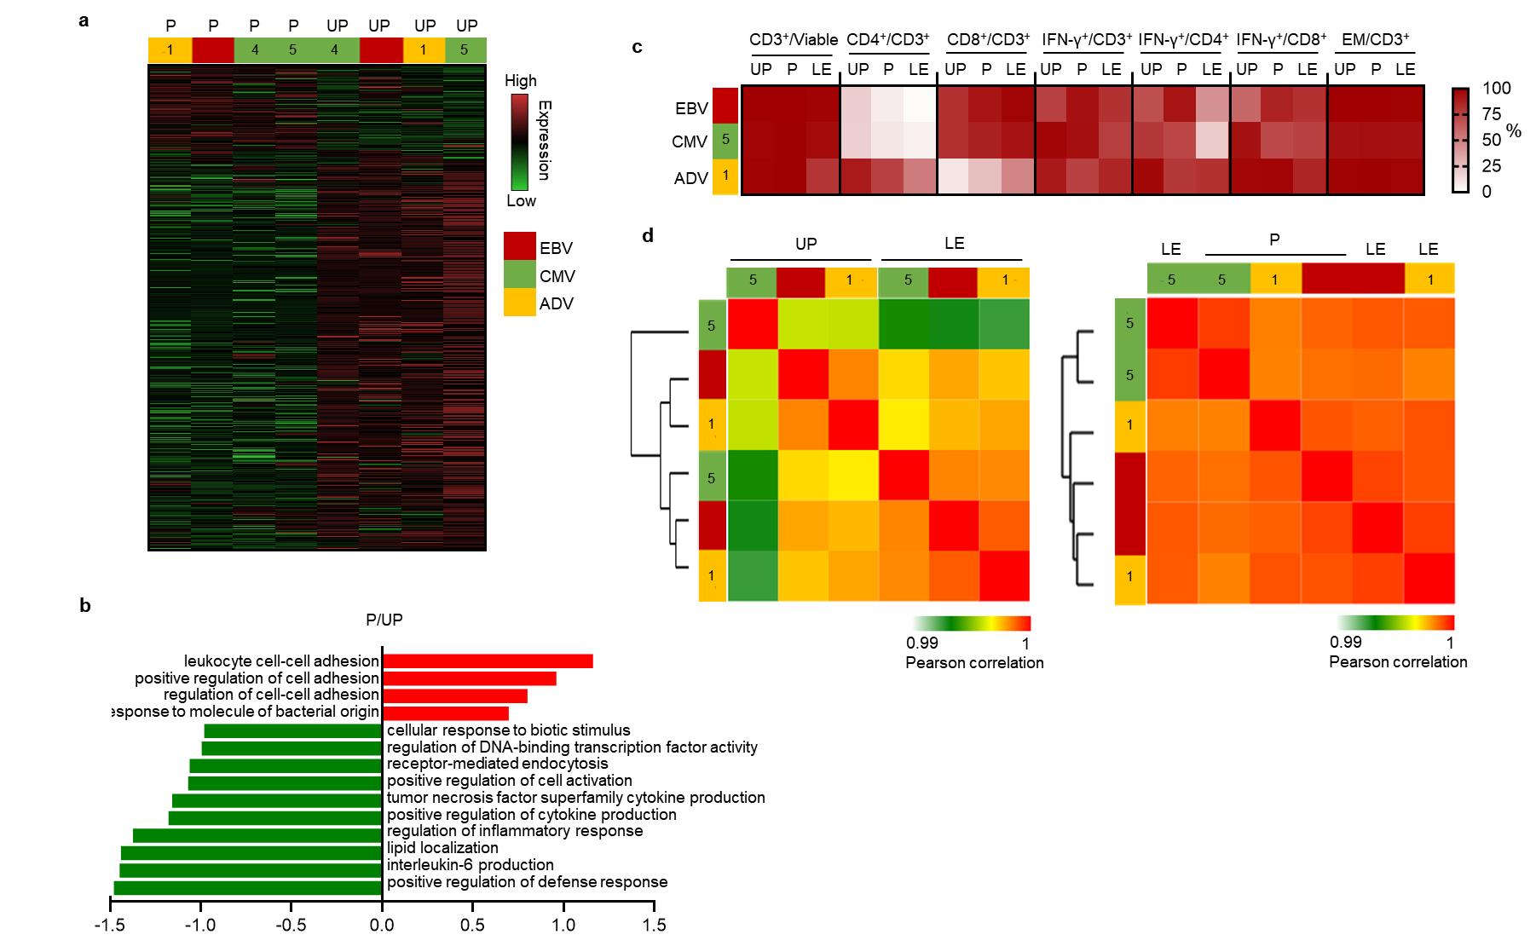
Supplementary Figure 5. Comparative transcriptional profiles across protocol conditions. (a) Heatmap of differential gene expression analysis between UP and P samples using a paired analysis, showing the distribution of significantly up-regulated (red) and down-regulated (green) genes and highlighting transcriptional differences between the two conditions. (b) Phenotypic characteristics and antigen specificity of VSTs generated under different protocols. (c) Gene set enrichment analysis of biological processes, with top ten positively enriched categories in red and negatively enriched categories in green for the P vs NP condition. (d) Hierarchical clustering heatmap based on sample-to-sample Pearson correlations, showing the grouping of LE samples with either UP or P conditions and highlighting global similarity patterns among samples.

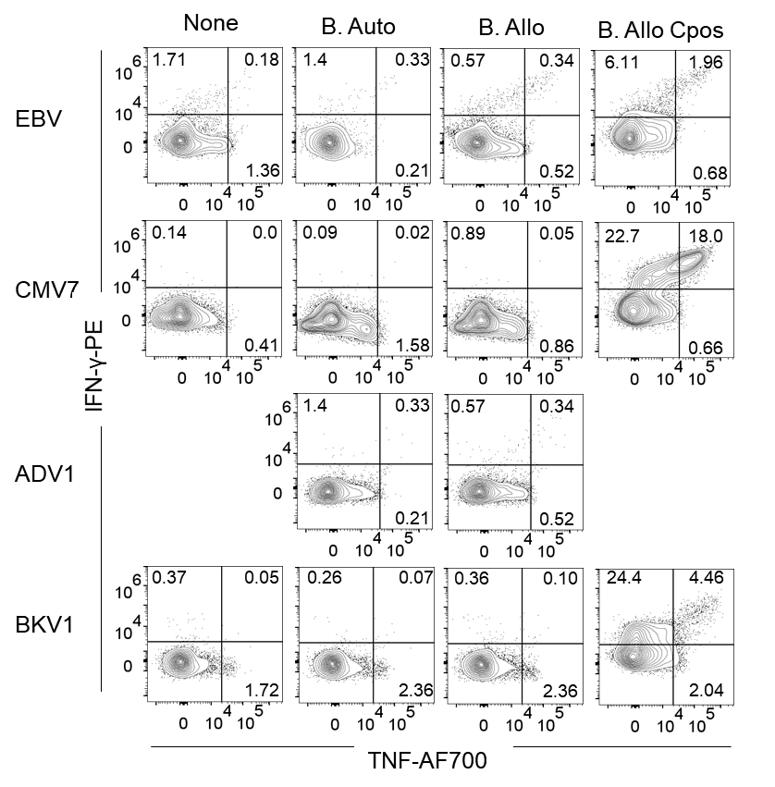
Supplementary Figure 6. Cytokine production of VSTs cocultured with autologous (Auto), or mix of three allogenic (Allo) PHA blasts (B) at effector:target ratio of 1:5.
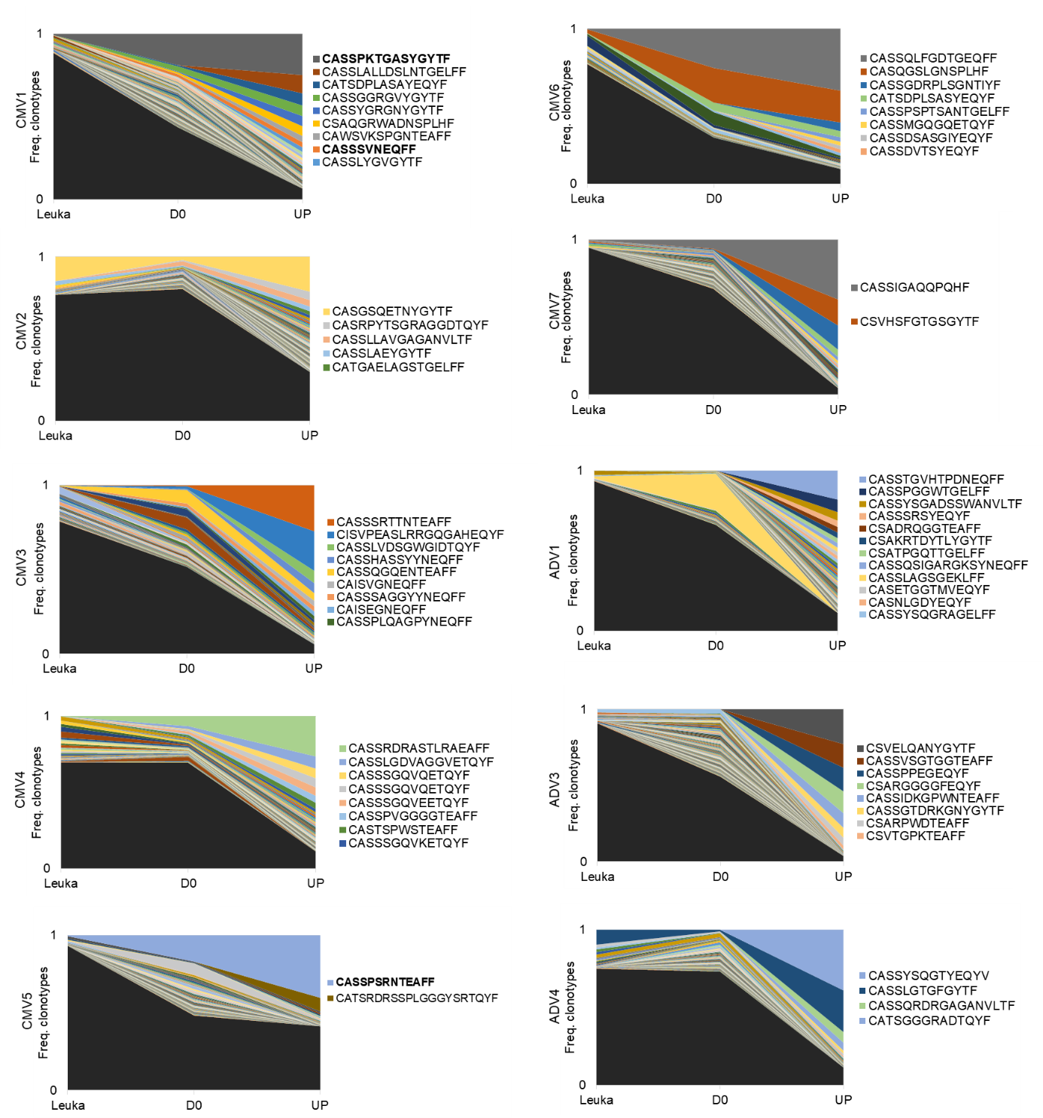
Supplementary Figure 7. TCRβ clonal expansion of VSTs. Clonotype frequencies in the original leukapheresis, IFN-γ-enriched day 0 product, and final T cell product. Clonotypes with <0.2% frequency are shown in black; CDR3 sequences are indicated for clonotypes representing ≥2% of the final product.
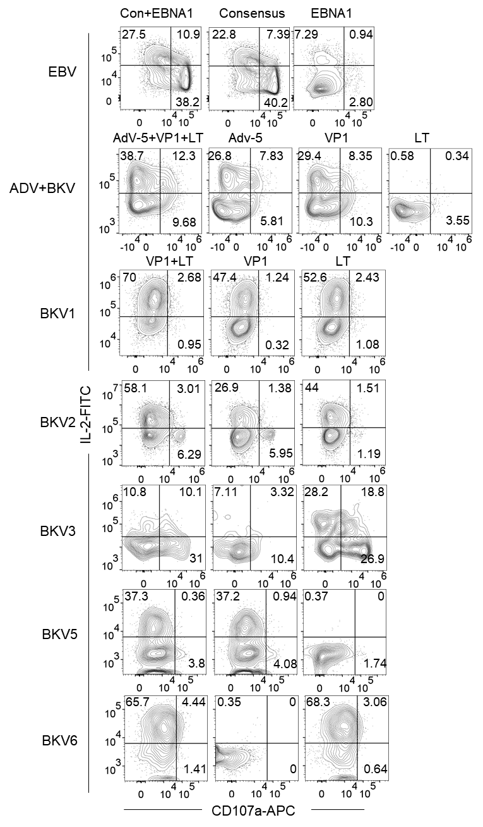
Supplementary Figure 8. IL-2 and CD107a expression among CD3⁺ T cells following stimulation with the indicated peptide pools.

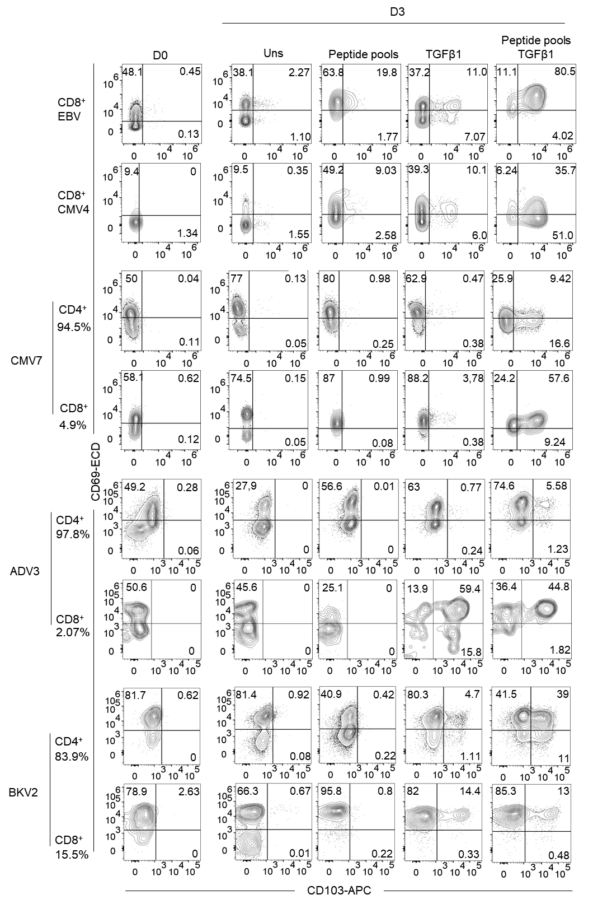
Supplementary Figure 9. Expression of adhesion receptors in VSTs stimulated with antigen and TGF-β1.
Thawed VSTs were stimulated for 3 days in the presence or absence of peptide pools, consensus+EBNA for EBV, pp65 for CMV, AdV5 Hexon for ADV, and VP1+LT for BKV, and/or TGF-β1, and stained for CD69 and CD103 expression.

Supplementary Table 1. T cell differentiated expressed genes in P condition vs UP condition.
Gene | log2FoldChange | Gene | log2FoldChange
SPRED1 | -8.13297125 | DOCK1 | -4.22688567
RAB7B | -7.67371866 | RAB31 | -4.18039562
CCND1 | -6.95089061 | TLR2 | -4.09466511
SIGLEC7 | -6.79307221 | SLC7A8 | -4.07090962
UBE2E2 | -6.76634754 | RAB32 | -4.00942576
TYROBP | -6.52704192 | TNFAIP2 | -3.98183102
PPIC | -6.34412735 | ZNF385A | -3.96523301
SYK | -6.31013854 | RAB20 | -3.96470987
IFNGR2 | -6.2290089 | RNF144B | -3.87790604
SPP1 | -6.16390249 | PLA2G4A | -3.85957836
P2RY6 | -6.15826825 | CSF2RA | -3.83722732
LMO2 | -6.15439485 | CDC42BPB | -3.45416565
IL1R1 | -6.10854676 | CUEDC1 | -3.43807806
LRP1 | -6.01888657 | BATF2 | -3.3818148
BTK | -6.00885812 | CXCL16 | -3.34795114
MMP9 | -6.00441255 | NEK6 | -3.00882366
FFAR4 | -5.98092688 | IL6 | -2.88947901
ARHGAP22 | -5.95714583 | ST6GALNAC2 | -2.81010576
ABCC3 | -5.9259596 | IL17RC | -2.67905188
GPR82 | -5.34966363 | PTGDR | -2.65257991
KCNMA1 | -5.34404476 | TNS1 | -2.55072514
IL13RA1 | -5.31174539 | SH2B2 | -2.5234743
FABP3 | -5.24818313 | IFIT2 | -2.48643113
NFAM1 | -5.24385271 | TNFSF13B | -2.34142446
NOTCH3 | -5.21576388 | RIPK2 | -2.29697848
SLC7A7 | -5.0821511 | CD33 | -2.29327076
LPAR1 | -5.00096655 | GM2A | -2.16890669
FCER1G | -4.92189722 | IFIT3 | -2.16296772
DAPK1 | -4.91229385 | CXCL8 | -2.12122083
RAB39A | -4.91046758 | NPC2 | -2.0033247
NRP2 | -4.82313719 | TSC22D1 | -1.95289101
EPB41L1 | -4.74396116 | ATP1B1 | -1.94806323
CTSL | -4.71208538 | CYP27B1 | -1.84796144
ST3GAL6 | -4.68655431 | EGR2 | -1.77589466
FZD1 | -4.66397357 | TCF7 | -1.69548562
F3 | -4.59951899 | CSF2 | 1.71743478
CDK14 | -4.55671038 | TNFRSF9 | 1.7354969
FMN1 | -4.52385797 | RAB6B | 2.08281946
ALOX5 | -4.45210939 | FOXP3 | 2.22727066
CXCL2 | -4.42009984 | EGR3 | 2.693671
CTBP2 | -4.40748767 | KLRC2 | 2.87052228
JAG1 | -4.36882164 | DGKI | 3.74817801
CAMSAP2 | -4.23337149 | NT5E | 4.72373456

Supplementary Table 2. HLA genotyping of the cell donors.
Sample | HLA-A | HLA-B | HLA-C | HLA-DRB1 | HLA-DQB1 1
EBV | A*02:01, A*24:02 | B*35:02, B*40:02 | C*04:01, C*15:02 | DRB1*04:03, DRB1*11:04 | DQB1*03:01, DQB1*03:02
CMV1 | A*02:01, A*29:02 | B*44:02, B*49:01 | C*05:01, C*07:01 | DRB1*01:01, DRB1*01:01 | DQB1*05:01, DQB1*05:01
CMV2 | A*02:01, A*30:02 | B*08:01, B*18:01 | C*05:01, C*07:01 | DRB1*03:01, DRB1*03:01 | DQB1*02:01, DQB1*02:01
CVM3 | A*24:02, A*29:02 | B*35:03, B*44:03 | C*12:03, C*16:01 | DRB1*13:01, DRB1*15:01 | DQB1*06:02, DQB1*06:03
CMV4 | A*24:02, A*33:01 | B*14:02:, B*51:01 | C*02:02, C*08:02 | DRB1*01:02, DRB1*04:07 | DQB1*03:01, DQB1*05:01
CVM5 | A*01:01, A*03:01 | B*07:02, B*37:01 | C*06:02, C*07:02P | DRB1*10:01, DRB1*11:01 | DQB1*03:01, DQB1*05:01
CMV6 | A*02:01, A*02:01 | B*13:01, B*57:01 | C*06:02, C*04:03 | DRB1*07:01, DRB1*15:01 | DQB1*06:01, DQB1*03:03
CMV7 | A*02:01, A*29:02 | B*18:01, B*44:03 | C*07:01, C*16:01 | DRB1*07:01, DRB1*11:04 | DQB1*02:02, DQB1*03:01
ADV1 | A*01:01, A*23:01 | B*08:01, B*27:05 | C*02:02, C*07:01 | DRB1*03:01, DRB1*03:01 | DQB1*02:01, DQB1*02:01
ADV2 | A*24:02, A*26:01 | B*07:02, B*14:01 | C*07:02, C*08:02 | DRB1*01:03, DRB1*15:01 | DQB1*05:01, DQB1*06:02
BKV1 | A*24:02, A*01:01 | B*18:01, B*52:01 | C*12:02, C*12:03 | DRB1*15:02, DRB1*13:01 | DQB1*06:01, DQB1*06:03
BKV2 | A*02:01, A*24:02 | B*44:03, B*51:01 | C*02:02, C*16:01 | DRB1*07:01, DRB1*07:01 | DQB1*02:02, DQB1*02:02
BKV3 | A*02:01, A*11:01 | B*37:01, B*38:01 | C*06:02, C*12:03 | DRB1*01:01, DRB1*10:01 | DQB1*05:01, DQB1*05:01
ADV+BK | A*02:01, A*24:02 | B*35:01, B*35:02 | C*04:01, C*04:01 | DRB1*11:01, DRB1*11:04 | DQB1*03:01, DQB1*03:01
ADV3 | A*25:01, A*33:01 | B*14:02, B*18:01 | C*08:02, C*12:03 | DRB1*01:02, DRB1*13:01 | DQB1*05:01, DQB1*06:03
ADV4 | A*11:01, A*33:03 | B*51:01, B*58:01 | C*03:02, C*15:02 | DRB1*13:01, DRB1*15:01 | DQB1*06:02, DQB1*06:03
BKV4 | A*01:01, A*02:01 | B*08:01, B*44:02 | C*05:01, C*07:01 | DRB1*03:01, DRB1*08:01 | DQB1*02:01, DQB1*04:02
BKV5 | A*02:01, A*66:01 | B*14:01, B*35:01 | C*04:01, C*08:02 | DRB1*07:01, DRB1*07:01 | DQB1*02:02, DQB1*02:02
BKV6 | A*02:01, A*30:02 | B*18:01, B*49:01 | C*05:01, C*07:01 | DRB1*01:01, DRB1*03:01 | DQB1*02:01, DQB1*05:01
BKV Scale-up | A*30:02, A*31:01 | B*18:01, B*18:01 | C*05:01, C*05:01 | DRB1*03:01, DRB1*03:01 | DQB1*02:01, DQB1*02:01

