Sample preparation
Bile acids (BAs) were extracted using liquid-liquid extraction procedure (1) A 150 µL plasma aliquot was mixed with 5 µL of hydroxytoluene solution (0.4 mg/mL), 10 µL of deuterated internal standards solution, and 150 µL of a buffer solution composed of 0.2 M citric acid and 0.1 M disodium hydrogen phosphate. Then, 1000 µL of extraction solvent (a mixture of methyl tert-butyl ether and butanol 50:50, v/v) was added, followed by mixing for 5 min using a bullet blender (Next Advance, Averill Park, NY) and centrifugation (16,000 x g, 10 min, 4°C). Next, 900 µL of the upper layer was collected and evaporated until dry in a SpeedVac system. The dried residue was reconstituted with 50 µL methanol:acetonitrile (70:30, v/v) and centrifuged (16,000 x g, 10 min, 4°C), after which 40 µL of the supernatant was injected into the LC-MS/MS system.
Liquid chromatography–tandem mass spectrometry
Samples were analyzed using a Shimadzu LC system (Shimadzu Corporation, Kyoto, Japan) coupled to a SCIEX QTRAP 6500+ mass spectrometer (SCIEX, Framingham, MA, USA). Separation was carried out using a BEH C18 column (50 mm × 2.1 mm, 1.7 μm) from Waters Corporation (Milford, MA, USA) kept at 40°C. The mobile phase consisted of 0.1% acetic acid in water, 0.1% acetic acid in acetonitrile/methanol (90:10, v/v), and 0.1% acetic acid in isopropanol. Experiments were carried out using electrospray ionization in negative mode. MS/MS acquisition was performed using Selected Reaction Monitoring (SRM), with transitions individually optimized for each targeted analyte and its corresponding internal standards using standard solutions.
Data pre-processing and quality control
The ratio between the peak area of the target analyte and the peak area of its respective internal standard was calculated and used for downstream analysis with the SCIEX OS-MQ Software. The quality of the data was monitored via regular injection of quality control (QC) samples. QC samples were also used to correct for between-batch variations using the in-house developed mzQuality workflow (2). For each target analyte present in the QC samples, relative standard deviations (RSDs) of the peak area ratios were calculated (Table S1). All analytes except GLCA showed acceptable RSD values in QC samples (<25%), indicating satisfactory analytical performance.

Table S1. List of the targeted bile acids analyzed with LC-MS/MS.
Abbreviation | IUPAC name | ChEBI ID | RSD QCs
CA | 3α,7α,12α-trihydroxy-5β-cholan-24-oic acid | 16359 | 12.5%
GCA | N-(3α,7α,12α-trihydroxy-5β-cholan-24-oyl)-glycine | 17687 | 11.3%
DCA | 3α,12α-dihydroxy-5β-cholan-24-oic acid | 28834 | 12.9%
GDCA | N-(3α,12α-dihydroxy-5β-cholan-24-oyl)-glycine | 27471 | 12.3%
CDCA | 3α,7α-dihydroxy-5β-cholan-24-oic acid | 16755 | 20.1%
GCDCA | N-(3α,7α-dihydroxy-5β-cholan-24-oyl)-glycine | 3593 | 21.5%
GLCA | N-[(3α,5β)-3-hydroxy-24-oxocholan-24-yl]-glycine | 37998 | 25.4%
GUDCA | N-(3α,7β-dihydroxy-5β-cholan-24-oyl)-glycine | 89929 | 10.7%
ChEBI: Chemical Entities of Biological Interest; IUPAC: International Union of Pure and Applied Chemistry; RSD: relative standard deviation; QC: quality control.

Table S2. Association between plasma levels of bile acids and cardiometabolic risk factors, adjusted by visceral adipose tissue and age in middle-aged men (n=33).
 |  | Model 1: adjusted for age and VAT mass
Dependent variable | Predictor | Standardized β | adjusted R² | P value
GPT | Total BA | 0.292 | 0.001 | 0.125
GPT | Secondary BA | 0.298 | 0.005 | 0.110
GPT | DCA | 0.267 | -0.012 | 0.148
GPT | GUDCA | -0.031 | -0.088 | 0.881
Total cholesterol | GUDCA | 0.248 | 0.444 | 0.103
LDL-C | CDCA | 0.070 | 0.488 | 0.609
FLI | Total BA | 0.189 | 0.446 | 0.186
FLI | Secondary BA | 0.197 | 0.452 | 0.159
FLI | DCA | 0.186 | 0.179 | 0.179
Systolic blood pressure | Total BA | 0.360 | 0.120 | 0.064
Systolic blood pressure | Secondary BA | 0.410 | 0.167 | 0.028
Systolic blood pressure | DCA | 0.351 | 0.125 | 0.057
Systolic blood pressure | GLCA | 0.370 | 0.121 | 0.062
Diastolic blood pressure | Total BA | 0.503 | 0.160 | 0.010
Diastolic blood pressure | Secondary BA | 0.564 | 0.236 | 0.002
Diastolic blood pressure | GCDCA | 0.210 | -0.049 | 0.300
Diastolic blood pressure | DCA | 0.476 | 0.150 | 0.011
Diastolic blood pressure | GDCA | 0.534 | 0.182 | 0.006
Diastolic blood pressure | GLCA | 0.500 | 0.141 | 0.013
Data are derived from multiple linear regression analyses performed only in men. Standardized β coefficients, adjusted R², and two-sided P values are reported. BA: bile acid; CA: cholic acid; CDCA: chenodeoxycholic acid; DCA: deoxycholic acid; GCDCA: glycochenodeoxycholic acid; GDCA: glycodeoxycholic acid; GLCA: glycolithocholic acid; GPT: glutamic-pyruvic transaminase; GUDCA: glycoursodeoxycholic acid; LDL-C: low-density lipoprotein cholesterol; FLI: fatty liver index; VAT: visceral adipose tissue.

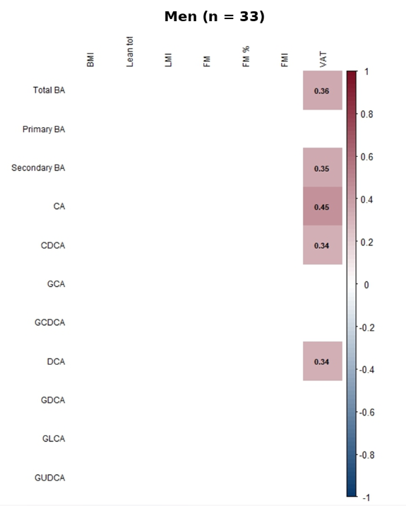
Figure S1. Non-parametric partial correlations between plasma bile acid levels and body composition parameters adjusted by age in middle-aged men (n=33).
Spearman's ρ
Values within the boxes represent significant Spearman's rho coefficients after adjusting for multiple comparisons using the Benjamini-Hochberg False Discovery Rate (FDR < 0.15). BA: bile acid; BMI: body mass index; CA: cholic acid; CDCA: chenodeoxycholic acid; DCA: deoxycholic acid; FM: fat mass; FMI: fat mass index; GCA: glycocholic acid; GCDCA: glycochenodeoxycholic acid; GDCA: glycodeoxycholic acid; GLCA: glycolithocholic acid; GUDCA: glycoursodeoxycholic acid; LMI: lean mass index; VAT: visceral adipose tissue.
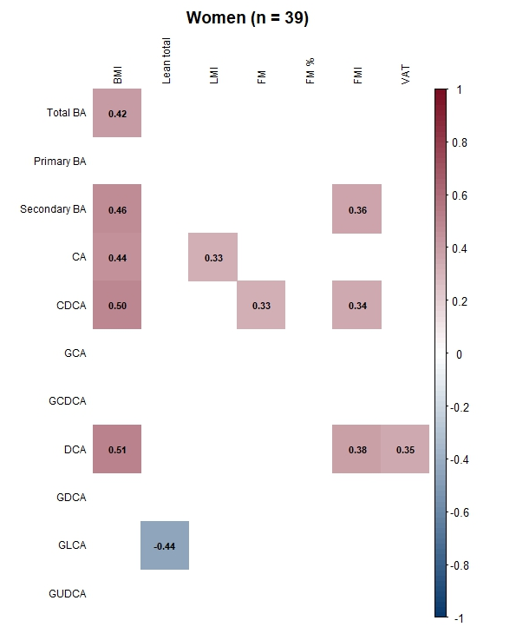
Figure S2. Non-parametric partial correlations between plasma bile acid levels and body composition parameters adjusted by age in middle-aged women (n=39).
Spearman's ρ

Values within the boxes represent significant Spearman's rho coefficients after adjusting for multiple comparisons using the Benjamini-Hochberg False Discovery Rate (FDR < 0.15). BA: bile acid; BMI: body mass index; CA: cholic acid; CDCA: chenodeoxycholic acid; DCA: deoxycholic acid; FM: fat mass; FMI: fat mass index; GCA: glycocholic acid; GCDCA: glycochenodeoxycholic acid; GDCA: glycodeoxycholic acid; GLCA: glycolithocholic acid; GUDCA: glycoursodeoxycholic acid; LMI: lean mass index; VAT: visceral adipose tissue.

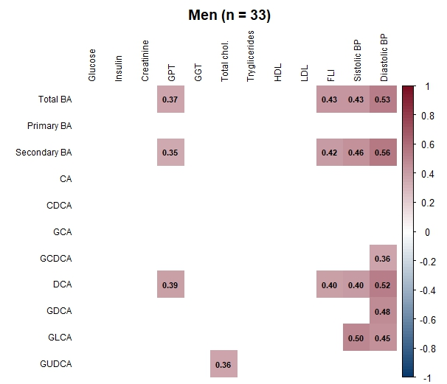
Figure S3. Non-parametric partial correlations between plasma bile acid levels and cardiometabolic risk factors adjusted by age in middle-aged men (n=33).
HDL-C
LDL-C

Values within the boxes represent significant Spearman's rho coefficients after adjusting for multiple comparisons using the Benjamini-Hochberg False Discovery Rate (FDR < 0.15). BA: bile acid; BP: blood pressure; CA: cholic acid; CDCA: chenodeoxycholic acid; DCA: deoxycholic acid; FLI: fatty liver index; GCA: glycocholic acid; GCDCA: glycochenodeoxycholic acid; GDCA: glycodeoxycholic acid; GGT: gamma-glutamyl transferase; GLCA: glycolithocholic acid; GPT: glutamic-pyruvic transaminase; GUDCA: glycoursodeoxycholic acid; HDL: high-density lipoprotein cholesterol; LDL-C: low-density lipoprotein cholesterol.

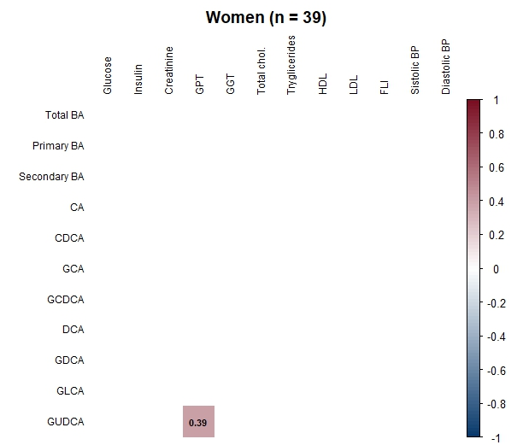
Figure S4. Non-parametric partial correlations between plasma bile acid levels and cardiometabolic risk factors adjusted by age in middle-aged women (n=39).
HDL-C
LDL-C

Values within the boxes represent significant Spearman's rho coefficients after adjusting for multiple comparisons using the Benjamini-Hochberg False Discovery Rate (FDR < 0.15). BA: bile acid; BP: blood pressure; CA: cholic acid; CDCA: chenodeoxycholic acid; DCA: deoxycholic acid; FLI: fatty liver index; GCA: glycocholic acid; GCDCA: glycochenodeoxycholic acid; GDCA: glycodeoxycholic acid; GGT: gamma-glutamyl transferase; GLCA: glycolithocholic acid; GPT: glutamic-pyruvic transaminase; GUDCA: glycoursodeoxycholic acid; HDL: high-density lipoprotein cholesterol; LDL-C: low-density lipoprotein cholesterol.
Figure S5. Multiple linear regression analyses showing the associations between circulating bile acid levels and blood pressure levels in men (n = 33), adjusted for visceral adipose tissue.
Scatter plots showing the associations between circulating bile acid (BA) levels and systolic and diastolic blood pressure in men. Upper panels depict systolic blood pressure in relation to total secondary BAs (A), deoxycholic acid (DCA) (B), glycodeoxycholic acid (GDCA) (C), and glycolithocholic acid (GLCA) (D). Lower panels depict diastolic blood pressure in relation to total secondary BAs (E), DCA (F), GDCA (G), and GLCA (H). Each dot represents an individual participant. Solid lines indicate the line of best fit, and dotted lines represent the 95% confidence intervals. Reported β coefficients, R² values, and p-values correspond to linear regression models adjusted for visceral adipose tissue (VAT) and age. BA concentrations are expressed as peak area ratio and blood pressure in mmHg. BA variables were log₁₀-transformed when model residuals deviated from normality.

REFERENCES
1. Humbert L, Maubert MA, Wolf C, et al. Bile acid profiling in human biological samples: Comparison of extraction procedures and application to normal and cholestatic patients. Journal of Chromatography B. 2012;899:135-145. doi:10.1016/j.jchromb.2012.05.015
2. van der Peet M, Maas P, Wegrzyn A, et al. mzQuality: An Open-Source Software Tool for Quality Monitoring and Reporting of Targeted Mass Spectrometry Measurements. J Am Soc Mass Spectrom. 2025;36(8):1669-1676. doi:10.1021/jasms.5c00073

