Organic loading optimization is the key to unlocking the VFAs potential of poultry manure during alkaline fermentation

Boyang Chen^{1,4}, Samet Azman², Nick Sweygers¹, Sam Crauwels³, Raf Dewil¹, Lise Appels¹
¹KU Leuven, Department of Chemical Engineering, Chemical and Biochemical Reactor Engineering and Safety, Jan Pieter De Nayerlaan 5, B-2860 Sint-Katelijne-Waver, Belgium
²Avans University of Applied Sciences, Academy of Life Sciences and Technology, Lovensdijk 61, 4818 AJ Breda, Netherlands
³ KU Leuven, Department of Microbial and Molecular Systems (M²S), Centre of Microbial and Plant Genetics, Willem de Croylaan 46, 3001 Leuven, Belgium
⁴ Chinese Academy of Sciences, Qingdao Institute of Bioenergy and Bioprocess Technology, Shandong Industrial Engineering Laboratory of Biogas Production & Utilization, Key Laboratory of Biofuels, Shandong Provincial Key Laboratory of Synthetic Biology, Songling Road 189, 266101 Qingdao, China

*Corresponding author: lise.appels@kuleuven.be (LEL)
Journal: Waste and Biomass Valorization

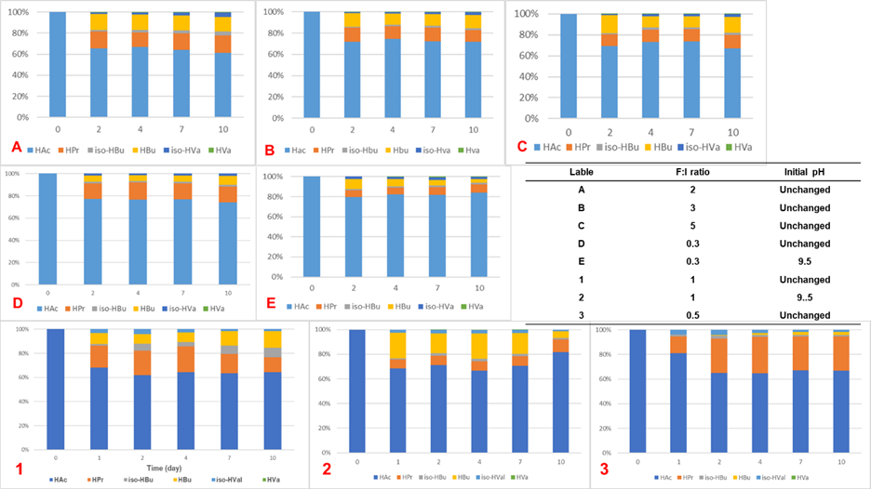
Figure S1. The VFA profiles from different conditions. (Due to the operational feasibility, A-E and 1-3 were operated in two sperate batches by same inoculum).

Table S1. Analysis of the alpha diversity indices of PM continuous reactor.
 | Ace | Shannon | Simpson | Chao
Day 0 | 1766.59 | 5.15 | 0.025 | 1818.28
Stage 7 | 1659.58 | 4.74 | 0.039 | 1693.22
Stage 8 | 1686.86 | 4.97 | 0.023 | 1684.19

Table S2. The relative abundance of two main archaea found in the reactor.
 | Methanosarcina, % | Methanobrevibacter, %
Day 0 | 44.03 | 50.97
Stage 7 | 96.11 | 3.89
Stage 8 | 97.31 | 2.69

