Supplemental Information
The effect of supraphysiological estradiol levels in ovarian stimulation cycles on the birthweight of neonates conceived through subsequent frozen-thawed cycles is modified by endometrial preparation protocols

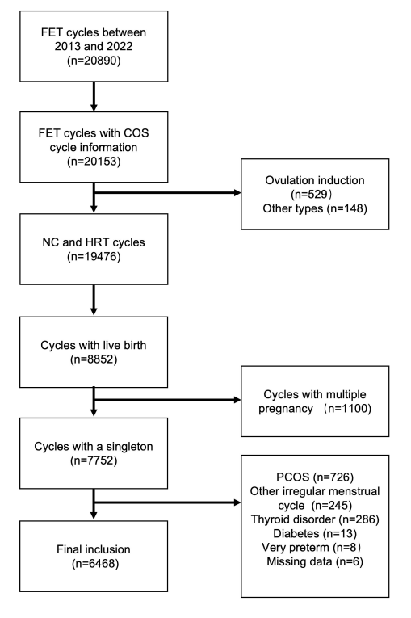
Figure S1. Flow chart of the study design.

Figure S2. Distributional balance for “distance”.

Figure S3. Association between peak estradiol levels during ovarian stimulation and birth weight of singletons following frozen-thawed embryo transfer cycles using different endometrial preparation protocols in the matched cycles. (A) Association between peak estradiol levels during ovarian stimulation and birth weight z-score of singleton following frozen-thawed embryo transfer (FET) cycles using natural (NC) and hormone replacement (HRT) cycles. (B) The difference in the association between peak estradiol levels during ovarian stimulation and birth weight z-score comparing singletons following HRT cycles with those following NC cycles. (C) Association between peak estradiol levels during ovarian stimulation and large-for-gestational-age (LGA) in singleton following FET cycles using NC and HRT cycles. (D) The difference in the association between peak estradiol levels during ovarian stimulation and FET comparing singletons following HRT cycles with those following NC cycles. The pink shaded area indicates a significant difference.

