Appendix A: Supplementary Robustness Checks:

A.1 Double Machine Learning (DML) Robustness Checks
To address potential model misspecification, we re-estimate the baseline model using double machine learning (DML) with random forest and Lasso algorithms. By separating the fitting of high-dimensional control variables from the estimation of the policy effect, DML effectively mitigates biases arising from model misspecification and omitted variables. To probe the algorithmic robustness of our findings, we perform two additional exercises: (i) replacing the prediction learner with alternative machine learning algorithms, and (ii) varying the number of cross-validation folds. All specifications include county and year fixed effects, as well as linear and quadratic terms of the control variables to capture potential nonlinearities.
Alternative Machine Learning Algorithms. The validity of DML estimation hinges on accurate prediction of confounding variables, yet different algorithms rest on distinct assumptions about data structure and functional form. To rule out that our conclusions depend on a single algorithm, we sequentially re-estimate the model using gradient boosting trees (GBT), neural networks (NN), and support vector machines (SVM). As columns (1)–(3) of Table A1 report, regardless of the algorithm employed, the estimated coefficients on RMEPP remain positive and statistically significant at the 1% level. Notably, the neural network estimator yields a considerably larger coefficient (0.971) than the other algorithms. This is likely because neural networks are particularly adept at capturing highly complex nonlinear interactions between controls and the outcome variable, thereby revealing the policy’s treatment effect more fully. Collectively, these results demonstrate that the positive effect of the RMEPP is robust to the choice of prediction algorithm.
Sensitivity to the Number of Cross-Validation Folds. In machine learning, the number of cross-validation folds influences hyperparameter tuning and model complexity, which may indirectly affect the final estimates. To assess the sensitivity of our results to this technical choice, we re-estimate the DML model using the random forest algorithm while changing the number of folds from the baseline 5 to 3 and 8, respectively. Columns (4) and (5) of Table A1 show that under both alternative validation strategies, the policy effect coefficients (0.465 and 0.534, respectively) remain highly statistically significant. This indicates that our estimates are not sensitive to the sample-split ratio used during model training.
Taken together, these tests confirm that the positive and significant impact of the RMEPP on intra-county spatial structure persists across a wide range of machine learning algorithms and key validation parameters.

Table A1. Robustness Checks: Double Machine Learning Specifications
 | (1) | (2) | (3) | (4) | (5)
 | GBT | Neural Network | SVM | 3‑fold CV | 8‑fold CV
RMEPP | 0.5658*** | 0.9712*** | 0.6220*** | 0.4651*** | 0.5338***
 | (0.1384) | (0.3567) | (0.1370) | (0.1396) | (0.1402)
Constant | 0.0026 | -0.0184 | 2.0049*** | -0.2466*** | -0.2241***
 | (0.0380) | (0.0384) | (0.0385) | (0.0362) | (0.0354)
Controls (linear) | Yes | Yes | Yes | Yes | Yes
Controls (quadratic) | Yes | Yes | Yes | Yes | Yes
County fixed effects | Yes | Yes | Yes | Yes | Yes
Year fixed effects | Yes | Yes | Yes | Yes | Yes
Observations | 25960 | 25960 | 25960 | 25960 | 25960
*Notes: Robust standard errors clustered at the county level are reported in parentheses. ***, *, and * indicate statistical significance at the 1%, 5%, and 10% levels, respectively.

A.2 Local Projection DID (LP-DID) Results
To further address potential dynamic biases inherent in conventional DID estimators and to provide more transparent evidence on the dynamic evolution of the policy effect, we reassess our baseline findings using the local projection difference-in-differences (LP-DID) approach, drawing on the frontier methods developed by Rambachan and Roth (2023) and Dube et al. (2025). By directly estimating the dynamic treatment effects in each period following the policy shock, LP-DID relaxes the strong assumptions of “no anticipation” and “effect homogeneity” embedded in traditional event-study designs, thereby offering a more flexible and robust framework for causal inference.
The LP-DID dynamic estimates, presented in Figure A1, clearly trace the trajectory of the policy effect. In the periods preceding the policy rollout, the estimated lead coefficients fluctuate around zero and are statistically insignificant, providing further support for the parallel trends assumption. Following policy implementation, the treatment effects turn positive as early as the first year and exhibit a pronounced increasing trend. Both the magnitude and statistical significance of the effects strengthen progressively over time, indicating that the RMEPP’s spatial equalization effect is not a one-time shock but rather a cumulatively amplifying process.
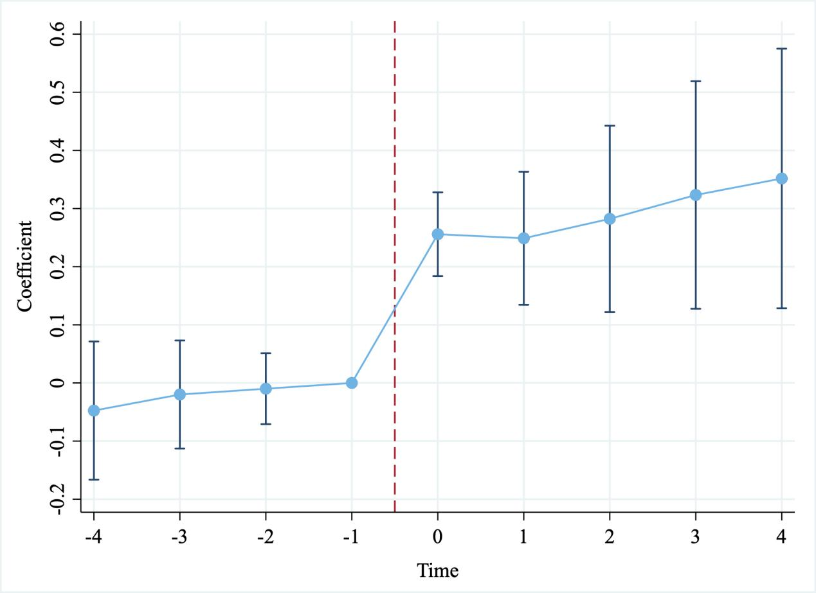
Figure A1. LP-DID Dynamic Treatment Effects

Table A2 reports the pooled estimates of the pre- and post-policy effects. The average pre-treatment effect (–0.0352) is statistically indistinguishable from zero, reaffirming the comparability of treatment and control counties prior to the RMEPP rollout. The average treatment effect (ATE) for the post-policy period is 0.2916, significant at the 1% level. This estimate is directionally consistent with our baseline DID results, yet the monotonically increasing effect path revealed by LP-DID provides crucial incremental information for understanding the policy’s underlying mechanisms. The gradual strengthening of the effect over time likely reflects the growth cycle of entrepreneurial ventures, the progressive formation of local industrial networks, and accelerating knowledge spillovers—a pattern consistent with the cumulative entrepreneurial dynamics emphasized by Ceci et al. (2026).
In summary, the LP-DID analysis not only corroborates the positive causal effect of the RMEPP on intra-county spatial structure from an alternative econometric perspective, but also uncovers the dynamically reinforcing nature of this effect.
Table A2. LP-DID Pooled Estimates
 | Coefficient | Std. Error | t‑statistic | p‑value | Observations
Average pre‑treatment effect (Pre) | -0.0352 | 0.0482 | -0.73 | 0.4649 | 14595
Average treatment effect (ATE) | 0.2916 | .00723 | 4.03 | 0.0001 | 12620
Notes: Robust standard errors clustered at the county level are reported in parentheses. *** indicates statistical significance at the 1% level.

A.3 Propensity Score Matching (PSM-DID) Results
The selection of pilot counties for the RMEPP may not be entirely random. Rather, it is likely influenced by observable factors such as regional economic fundamentals, resource endowments, and policy preferences. This self-selection problem could threaten the causal validity of our baseline estimates. To alleviate potential sample selection bias, we re-estimate the policy effect using a propensity score matching combined with difference-in-differences (PSM-DID) approach.
We first estimate each county’s propensity score—the probability of being designated as a pilot—using a Logit model that incorporates a vector of pre-treatment county characteristics potentially affecting policy assignment, including economic development level, industrial structure, population size, fiscal capacity, and infrastructure conditions. We then employ two matching strategies—nearest-neighbor 1:1 matching without replacement and 1:2 matching—to construct comparable control groups for the treated counties, ensuring covariate balance between treatment and control groups prior to policy implementation. Finally, we apply both the conventional DID estimator and the DML estimator to the matched samples.
The results are reported in Table A3. In the 1:1 matched sample, the conventional DID estimate is 0.340, significant at the 10% level, while the DML estimate—which is better suited to high-dimensional nonlinear relationships—is 0.659, significant at the 1% level. Although the sample size is reduced after matching, the direction and statistical significance of the policy effect remain largely unchanged. In the 1:2 matched sample, the estimates are closer to the baseline results: the conventional DID and DML coefficients are 0.328 and 0.596, respectively, both significant at the 1% level. Taken together, these findings confirm that the positive effect of the RMEPP on intra-county spatial structure remains robust after accounting for sample selection.
Table A3. PSM-DID Estimation Results
 | (1) | (2) | (3) | (4)
 | Nearest Neighbor 1:1 |  | Nearest Neighbor 1:2
 | Conventional DID | DML | Conventional DID | DML
RMEPP | 0.3402* | 0.6585*** | 0.3283*** | 0.5957***
 | (0.1895) | (0.2243) | (0.0935) | (0.1413)
Constant | 3.3074*** | -0.2343** | 3.4875*** | -0.2412***
 | (0.2228) | (0.0922) | (0.0749) | (0.0357)
Controls (linear) | Yes | Yes | Yes | Yes
Controls (quadratic) | No | Yes | No | Yes
County fixed effects | Yes | Yes | Yes | Yes
Year fixed effects | Yes | Yes | Yes | Yes
Observations | 3436 | 3436 | 25716 | 25716
R² | 0.982 |  | 0.972
*Notes: Robust standard errors clustered at the county level are reported in parentheses. ***, *, and * indicate statistical significance at the 1%, 5%, and 10% levels, respectively.

A.4 Instrumental Variable (IV) Estimation
Although our baseline specification incorporates two-way fixed effects and a battery of robustness checks to absorb a wide range of observable confounders, the selection of pilot counties for the RMEPP may still be influenced by unobserved time-varying factors that are simultaneously correlated with intra-county spatial structure. Such unobserved heterogeneity could bias our causal estimates. To discipline this concern, we follow the approach of Deng et al. (2025) and implement an instrumental variable (IV) strategy using two-stage least squares (2SLS).
A valid instrument must satisfy two conditions: relevance (correlation with the endogenous regressor) and exogeneity (affecting the outcome only through the endogenous variable). We propose the Terrain Ruggedness Index as an instrument for the RMEPP dummy (Zhang et al., 2025). The rationale is twofold. First, relevance: terrain ruggedness is a fundamental geographical constraint that shapes regional economic development and entrepreneurial costs. Rugged terrain is typically associated with poor transportation links, sparse population distribution, and underdeveloped infrastructure, all of which substantially increase the fixed costs and operational difficulties of entrepreneurial activities. Consequently, counties with flatter terrain are more likely to be selected as pilot sites. Second, exogeneity: terrain ruggedness is a geologically determined, time-invariant physical feature. It is unlikely to directly affect short-term fluctuations in intra-county spatial structure except through its influence on policy placement and subsequent entrepreneurial dynamics. To construct a time-varying instrument suitable for panel data models, we interact the cross-sectional Terrain Ruggedness Index with a full set of year dummies.
Table A4 reports the 2SLS estimation results. Column (1) presents the first-stage results. The coefficient on the instrument is positive and statistically significant at the 1% level, consistent with our expectation that less rugged (i.e., flatter) counties are more likely to be selected as RMEPP pilots. The Kleibergen-Paap rk LM statistic is 934.65 (p < 0.01), strongly rejecting the null of underidentification. The Kleibergen-Paap rk Wald F statistic is 32.213, well above the Stock-Yogo critical value of 16.38 for 10% maximal IV size, indicating that our instrument is not weak. These diagnostics collectively confirm the relevance and strength of the chosen instrument.
After correcting for potential endogeneity, column (2) reports the second-stage estimate. The coefficient on RMEPP remains positive and statistically significant at the 5% level (0.4295). The magnitude is somewhat larger than the baseline DID estimate, suggesting that OLS may have attenuated the true effect due to measurement error or omitted variable bias. Overall, the IV results reinforce our core finding: the RMEPP exerts a positive and causal impact on intra-county spatial structure.
Table A4. Endogeneity Test: Two‑Stage Least Squares (2SLS) Estimates
 | (1)  First Stage | (2)  Second Stage
IV (Terrain Ruggedness × Year Dummies) | 0.0007***
 | (0.0001)
RMEPP |  | 0.4295**
 |  | (0.1810)
Kleibergen-Paap rk LM statistic | 934.650***
Kleibergen-Paap rk Wald F statistic | 32.213  （16.38）
Controls (linear) | Yes | Yes
County fixed effects | Yes | Yes
Year fixed effects | Yes | Yes
Observations | 25960 | 25960
R² | 0.651 | 0.003
Notes: Robust standard errors clustered at the county level are reported in parentheses. *** and ** indicate statistical significance at the 1% and 5% levels, respectively. The Kleibergen-Paap rk LM statistic tests underidentification; the Kleibergen-Paap rk Wald F statistic tests weak identification, with the Stock-Yogo critical value for 10% maximal IV size reported in curly brackets.

