Supplementary Information
for
Jian Gao, Changgui Gu, Chuansheng Shen & Huijie Yang:
Tree structures are employed by pigeons as leadership structures to flock

1. Supplementary Figures

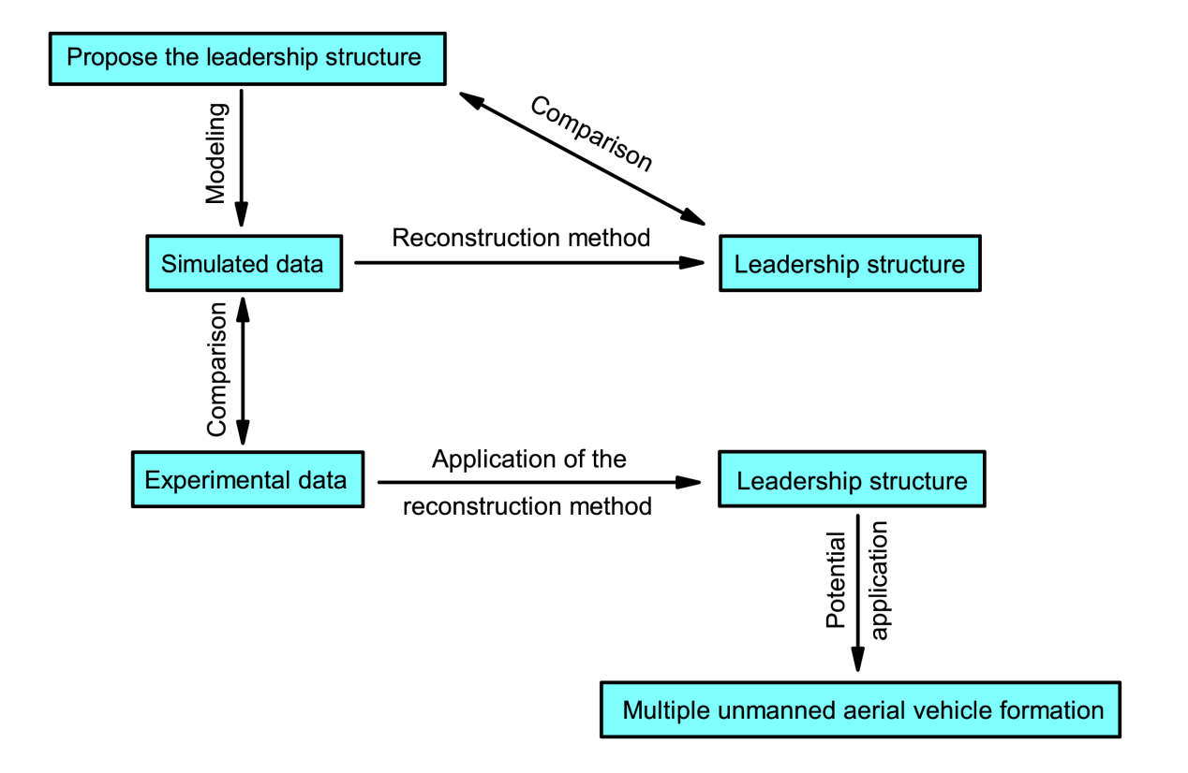
Figure S1: The logical organization of this article.

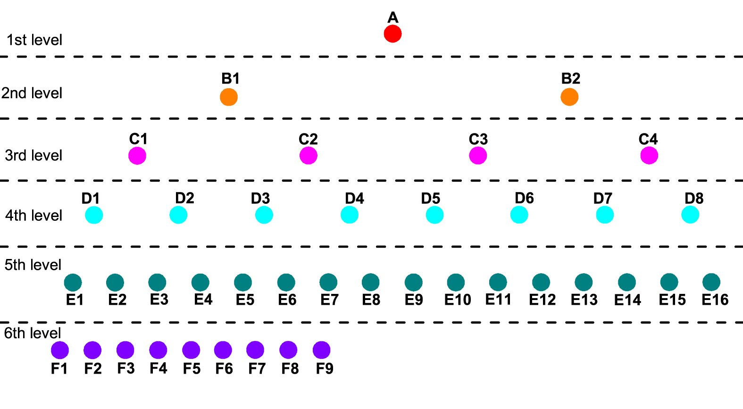
Figure S2: Hierarchical structure in the flock.

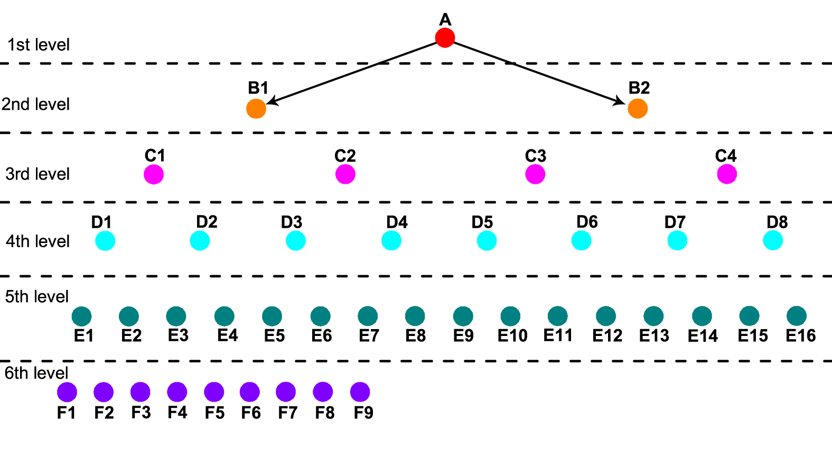
Figure S3: Hierarchical structure and a part of leadership relationships in the flock.

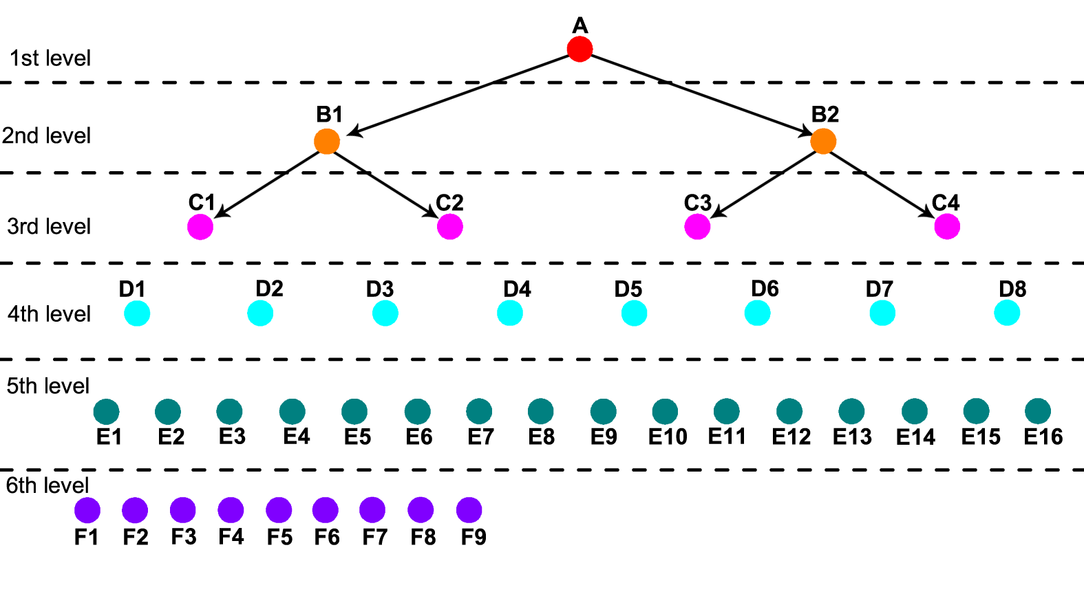
Figure S4: Hierarchical structure and a part of leadership relationships in the flock.

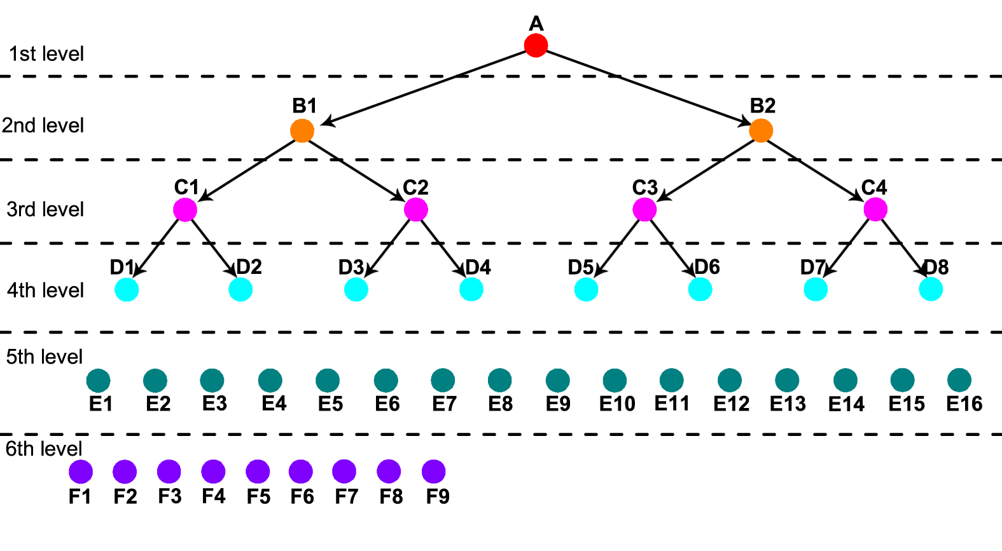
Figure S5: Hierarchical structure and a part of leadership relationships in the flock.

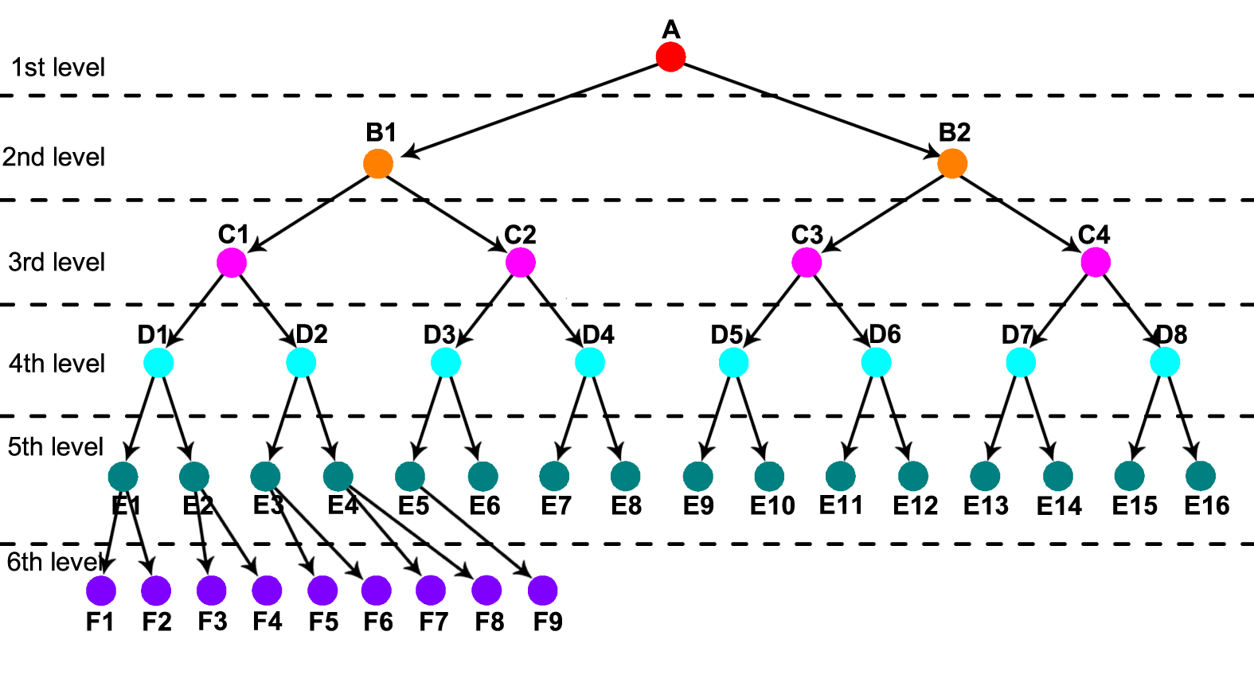
Figure S6: Leadership network in the flock.

2. Supplementary Method

The Lorentz system reads
$\left\{\begin{aligned}\frac{dx}{dt}=σ(y−x), \\ \frac{dy}{dt}=x(ρ−z)−y, \\ \frac{dz}{dt}=xy−βz, \end{aligned}\right.$ (S1)
where, x, y and z represent the variables of the equation. The parameters of the equation are fixed: $σ=10, β=8/3, ρ=25$. This system was carried out by the 4th-order Runge-Kutta method with time steps of $∆t=0.01$. The initial values of the system were x₀=3.4077, y₀=2.5429, z₀=20.7357. Figure S7 shows the trajectory of the state in the phase space x-z.
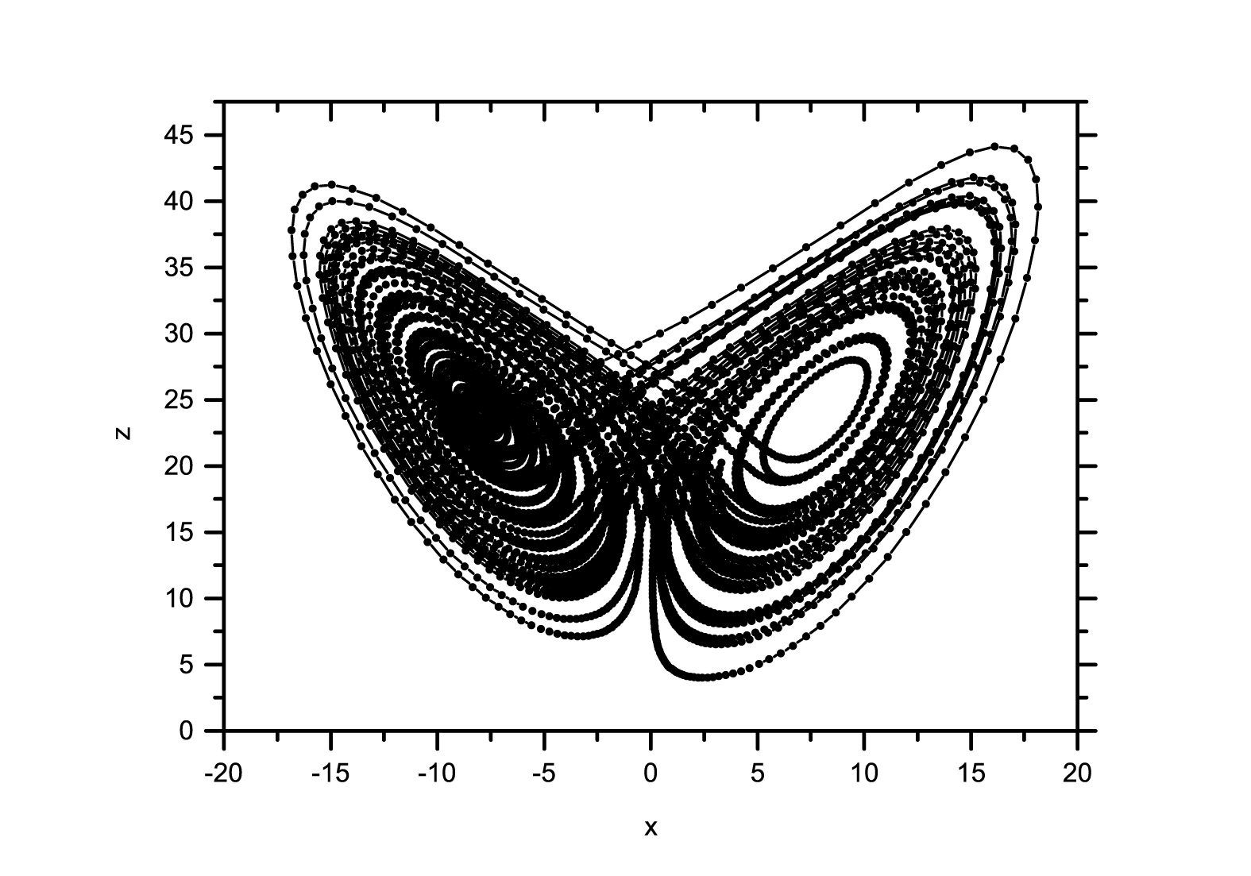
Figure S7: Phase trajectory of the system.

