Applied Biochemistry and Biotechnology

Title: In vitro and in silico analysis of recombinant arginine deiminase from Pseudomonas furukawaii as a potential anticancer enzyme

Authors: Rakhi Dhankhar¹, Vatika Gupta^{1,2}, Aparajita Mohanty³ and Pooja Gulati¹*

Affiliations:
¹ Medical Microbiology and Bioprocess Technology Laboratory, Department of Microbiology, Maharshi Dayanand University, Rohtak, Haryana, India
²Molecular Biology and Genetic Engineering Laboratory, School of Biotechnology, Jawaharlal Nehru University, New Delhi, India.
³Department of Botany, Gargi College, University of Delhi, India.

*Corresponding author:
Dr. Pooja Gulati
Medical Microbiology and Bioprocess Technology Laboratory, Department of Microbiology, Maharshi Dayanand University, Rohtak, Haryana, India
Tel: +91-9818222243
Email: gulatipooja1@gmail.com, pooja.micro@mdurohtak.ac.in
ORCID ID: 0000-0002-3442-5125

Supplementary data
Table S1: ADI sequences for the phylogenetic analysis

Entry | Organism | Length
A0A5E6ZNT7 | Pseudomonas fluorescens | 418
V9UWQ6 | Pseudomonas monteilii SB3101 | 417
Q4ZSZ9 | Pseudomonas syringae pv. syringae (strain B728a) | 418
Q88P52 | Pseudomonas putida (strain ATCC 47054 / DSM 6125 / NCIMB 11950 / KT2440) | 417
P13981 | Pseudomonas aeruginosa (strain ATCC 15692 / DSM 22644 / CIP 104116 / JCM 14847 / LMG 12228 / 1C / PRS 101 / PAO1) | 418
A4XRA9 | Pseudomonas mendocina (strain ymp) | 416
A4VRK0 | Pseudomonas stutzeri (strain A1501) | 418
A0A127N1E6 | Pseudomonas citronellolis | 418
A0A2X2CYV7 | Pseudomonas luteola | 418
S6AJZ3 | Pseudomonas resinovorans NBRC 106553 | 416
Q1I5H4 | Pseudomonas entomophila (strain L48) | 418
F2KCT7 | Pseudomonas brassicacearum (strain NFM421) | 418
W6R686 | Pseudomonas pseudoalcaligenes (strain CECT 5344) | 416
A0A1N7U0V3 | Pseudomonas simiae | 418
A0A127I6Q5 | Pseudomonas azotoformans | 418
A0A0H5ABP1 | Pseudomonas trivialis | 418
A0A0E3GYB5 | Pseudomonas synxantha | 418
S2K3H8 | Pseudomonas plecoglossicida NB2011 | 417
QCH03923.1 | Pseudomonas furukawaii | 416
P41141 | Mycoplasma hominis | 409
1LXY | Mycoplasma arginini | 409

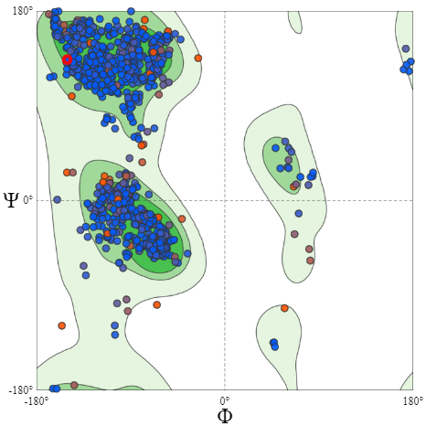
Fig. S1: Ramachandran plot for the 3D structure of ADI obtained via homology modelling

