Agulhas oceanic plateau formed from a branch of hydrous Indo-Africa mantle plume tree

Jia Liu^{1*}, Jörg Geldmacher², Yuji Ichiyama³, Peter Davidson^{2,4}, Qunke Xia¹, Jingjun Zhou¹, Yifan Chen¹
¹ School of Earth Sciences, Zhejiang University, Hangzhou, China
² GEOMAR Helmholtz Centre for Ocean Research Kiel, Germany
3 Chiba University, Japan
4. College of Earth Ocean and Atmospheric Science, Oregon State University, Corvallis, OR USA
Correspondence: liujia85@zju.edu.cn

The Supplementary file contains:
Supplementary Figures
Supplementary Figure S1-S4
Supplementary Table
Supplementary Table S1. The recovered water contents of the parental magma and primitive magma.
Supplementary Table S2. The compositions of the primary magma used as the input for the fractionation modeling.

Supplementary Datasets
Supplementary Dataset S1. The major-, trace-elemental concentrations and isotopic compositions of the glasses from U1582.
Supplementary Dataset S2. The geochemical composition of the basaltic samples from U1579 and U1580 site.
Supplementary Dataset S3. The water contents and major elemental composition of the cpx, and the water contents of the parental magma for the cpx from the samples from U1579 and U1580.

Supplementary Figures
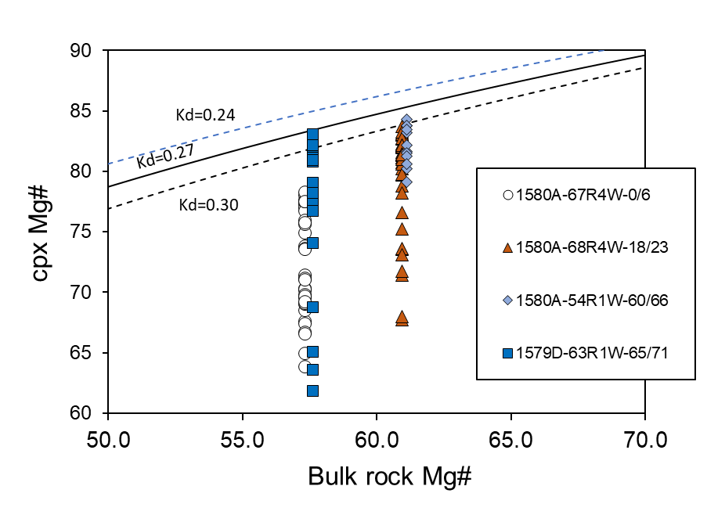
Figure S1. Rhodes diagrams for cpx from Agulhas Plateau samples. The bulk rock and cpx compositional data are in Supplementary Dataset S2 and S3, respectively.

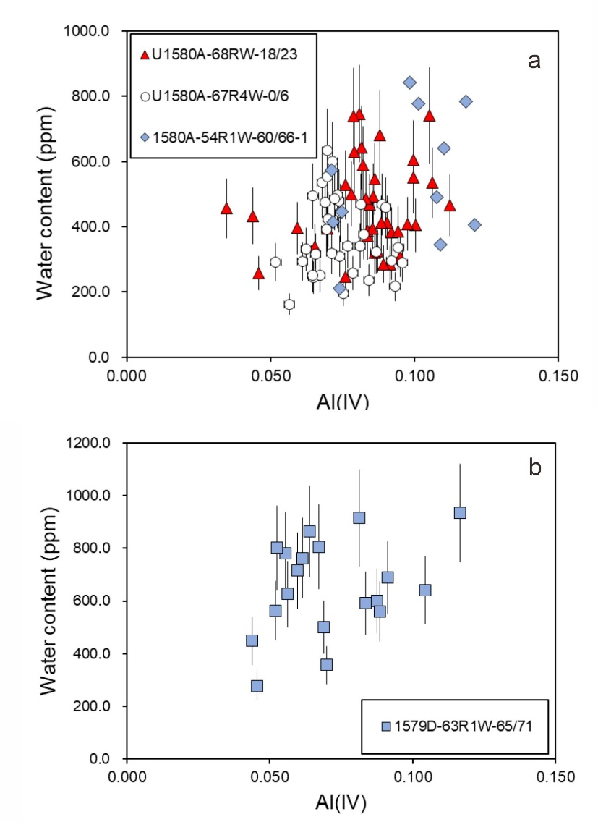
Figure S2. Correlation between water content and the tetrahedra Al³⁺ for the cpx. Data are in Supplementary Datasets S3.

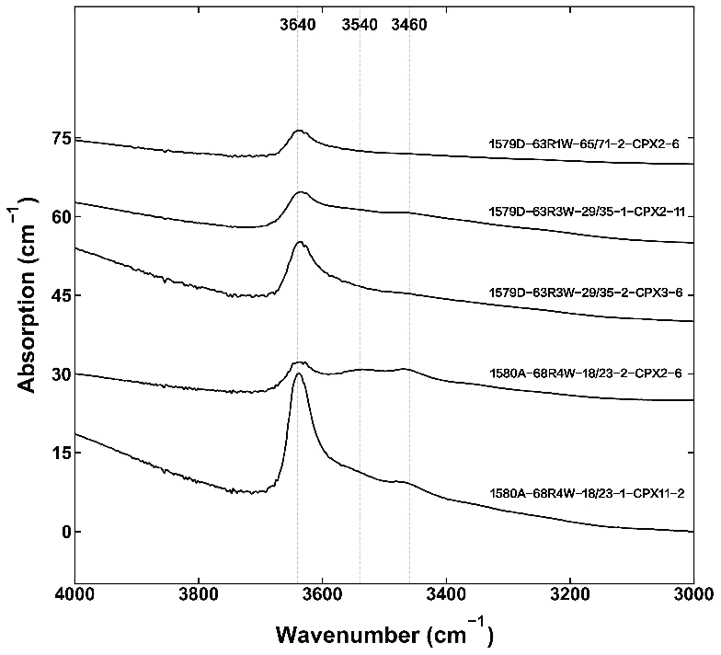
Figure S3. OH bands of cpx phenocrysts from U1579 and U1580 samples. The vertical dashed lines mark the typical groups of OH absorption bands^{1,2}. The spectra have been normalized to the thickness of 1 cm.

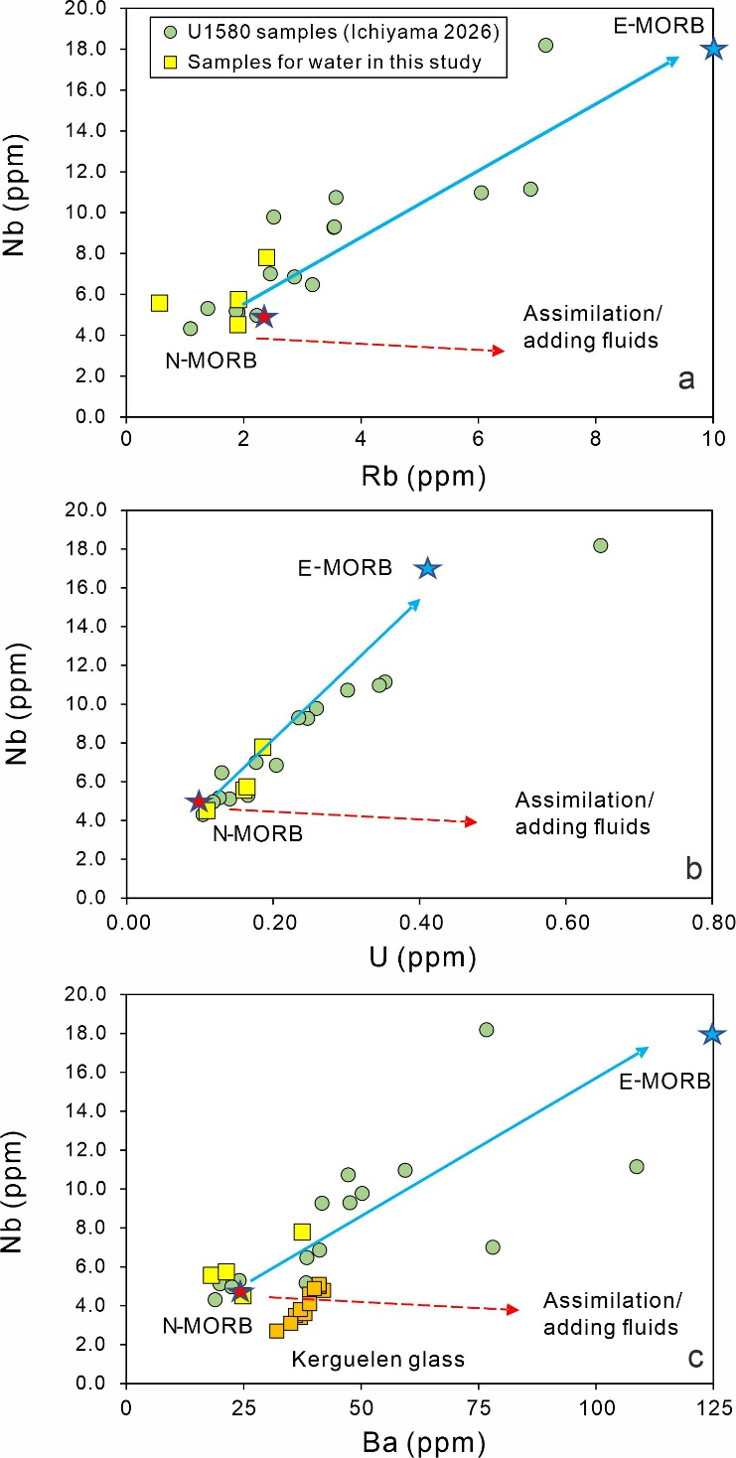
Figure S4. The correlations among Rb, Ba, U and Nb for U1579 samples. The composition of N-MORB (red star) and E-MORB (blue star), and Kerguelen plateau glasses (orange squares) are also shown for comparison. The data for U1580 samples is from Ichiyama et al. (2026)³, and others are from Gale et al., (2013)⁴ and Wallace (2002)⁵. The red dashed points to the trend caused by the assimilation of alteration or fluids.

Supplementary Tables

Table S1. The recovered water contents of the primitive magma and the mantle sources for Agulhas Plateau at sites U1580 and U1579.

Sample | 1580A 54R1W 60/66 |  | 1580A 67R4W 0/6 | 1580A 68R4W 18/23 | 1579D 63R1W 65/71 | Average | SD
Highest Mg# of cpx |  | 84.3 | 78.3 | 83.7 | 83.0
Melt Fraction (M_{f})¹ |  | 59.0 | 44 | 57 | 55
$C_{melt}^{maxMg\#} (wt.\%)$² |  | 4.11 | 4.50 | 4.85 | 6.40
$C_{melt}^{0} (wt.\%)$³ |  | 2.42 | 1.98 | 2.76 | 3.52
Partial melting degree (F) |  | 0.1 | 0.1 | 0.1 | 0.1
Water partition coefficient (D) |  | 0.012 | 0.012 | 0.012 | 0.012
Water in source (wt.%)(C₀)⁴ |  | 0.269 | 0.219 | 0.306 | 0.390 | 0.30 | 0.062
Ce |  | 19.4 | 15.0 | 9.58 | 9.93
H₂O/Ce |  | 1250 | 1320 | 2886 | 3545 | 2250 | 993
Notes: 1. The melt fraction was the mass proportion of the melt when the cpx with highest Mg# was crystallized, calculated by the Petrolog3⁶. 2. The water content of the parental magma for the cpx with highest Mg#. 3. The water content of the primitive magma in equilibrium with the mantle, $C_{melt}^{0}=C_{melt}^{maxMg\#}$×M_{f}. 4. The water content of the mantle source, C₀=$C_{melt}^{0}$×F+$C_{melt}^{0}$×D×(1-F). Water partition coefficient was from Hirschmann (2006)⁷. Ce content are from this study (Supplementary Datasets S2).

Table S2. The compositions of the primary magma used as the input for the fractionation modeling.
SiO₂ | TiO₂ | Al₂O₃ | Cr₂O₃ | Fe₂O₃ | FeO | MnO | MgO | CaO | Na₂O | K₂O | Mg#
46.99 | 0.91 | 12.06 | 0.00 | 0.81 | 9.31 | 0.16 | 17.80 | 9.93 | 1.90 | 0.06 | 77

Note: the data are the recovered composition for the Ontong Java plateau by Herzberg and Asimow (2015) (ref. ⁸), listed in their supplementary PRIMELT3 MEGA.xlsm.

References
1. Skogby, H. & Rossman, G. R. OH- in pyroxene; an experimental study of incorporation mechanisms and stability. American Mineralogist 74, 1059-1069 (1989).
2. Bell, D. R., Ihinger, P. D. & Rossman, G. R. Quantitative analysis of trace OH in garnet and pyroxenes. American Mineralogist 80, 465-474 (1995).
3. Ichiyama, Y. et al. Petrogenesis of the mafic rocks from the Agulhas Plateau, Southwest Indian Ocean: Insights from core samples recovered during IODP Expedition 392. Lithos 538–539, 108592 (2026).
4. Gale, A., Dalton, C. A., Langmuir, C. H., Su, Y. & Schilling, J. The mean composition of ocean ridge basalts. Geochem Geophys Geosyst 14, 489-518 (2013).
5. Wallace, P. J. Volatiles in Submarine Basaltic Glasses from the Northern Kerguelen Plateau (ODP Site 1140): Implications for Source Region Compositions, Magmatic Processes, and Plateau Subsidence. Journal of Petrology 43, 1311-1326 (2002).
6. Danyushevsky, L. V. & Plechov, P. Petrolog3: Integrated software for modeling crystallization processes: PETROLOG3. Geochem. Geophys. Geosyst. 12, Q07021 (2011).
7. Hirschmann, M. M. Water, melting, and the deep Earth H₂O cycle. Annu. Rev. Earth Planet. Sci. 34, 629-653 (2006).
8. Herzberg C, Asimow PD. PRIMELT 3 MEGA. XLSM software for primary magma calculation: peridotite primary magma MgO contents from the liquidus to the solidus. Geochem. Geophys. Geosyst. 16(2):563-78 (2015).

