Supplementary Table 1. Fully Adjusted Multivariable Cox Proportional Hazards Analysis of Overall Survival in Patients with Locally Advanced Esophageal Squamous Cell Carcinoma
Variable | HR (95%CI) | P value | HRs (95%CIs) | P value
Age(＞＝65 vs ＜65) | 0.97 (0.66~1.43) | .896 | 0.81 (0.52~1.26) | .357
Gender(Male vs Female) | 1.93 (1.06~3.52) | .031 | 1.8 (0.86~3.8) | .120
∆WL%(time0-1)(Yes vs NO) | 0.95 (0.6~1.51) | .837 | 1 (0.59~1.69) | .989
∆WL%(time1-2)(Yes vs NO) | 2.19 (1.43~3.36) | <.001 | 2.21 (1.39~3.51) | .001
∆WL%(time2-3)(Yes vs NO) | 1.71 (1.05~2.77) | .03 | 2 (1.18~3.4) | .010
∆WL%(time3-4)(Yes vs NO) | 1.1 (0.64~1.9) | .725 | 0.94 (0.53~1.67) | .833
Malnutrition (Mild vs NO) | 0.69 (0.35~1.38) | .296 | 0.7 (0.34~1.42) | .319
Malnutrition (Moderate vs NO) | 1.36 (0.78~2.36) | .28 | 1.5 (0.82~2.73) | .184
Malnutrition (Severe vs NO) | 1.19 (0.63~2.27) | .595 | 1.19 (0.57~2.49) | .650
BMI(Normal weight vs Low weight) | 0.68 (0.35~1.33) | .259 | 0.56 (0.28~1.15) | .116
BMI(Overweightvs Low weight) | 0.72 (0.35~1.47) | .365 | 0.7 (0.32~1.53) | .376
BMI(Obesity vs Low weight) | 0.92 (0.33~2.53) | .869 | 0.63 (0.2~2) | .431
Therapeutic regimen(TC vs TP) | 0.94 (0.62~1.42) | .769 | 1.03 (0.66~1.59) | .904
Therapeutic regimen  (Tax+NDP vs TP) | 2.04 (1.15~3.63) | .015 | 2.16 (1.17~3.99) | .014
Nutritional.support(Yes vs NO) | 1.29 (0.89~1.89) | .181 | 1.01 (0.65~1.57) | .970
NIS(1 vs 0) | 1.7 (0.87~3.34) | .121 | 1.96 (0.97~3.94) | .060
NIS(＞＝ vs 0) | 1.97 (1.07~3.63) | .03 | 2.23 (1.15~4.33) | .018
KPS(70-80 VS 90-100) | 0.97 (0.56~1.67) | .917 | 0.8 (0.44~1.44) | .449
Smoking(Yes vs NO) | 1.35 (0.9~2.01) | .148 | 1.01 (0.53~1.94) | .966
Drinking(Yes vs NO) | 1.37 (0.92~2.03) | .126 | 1.01 (0.55~1.83) | .985
Tumor location (Middle 1/3 vs Upper 1/3) | 1.09 (0.6~1.98) | .772 | 1.12 (0.6~2.08) | .721
Tumor location (Lower 1/3 vs Upper 1/3) | 0.97 (0.53~1.75) | .908 | 0.85 (0.46~1.6) | .621
Clinical stage (III vs II) | 1.49 (0.54~4.08) | .437 | 1.27 (0.45~3.61) | .648
Clinical stage (IV vs II) | 2.45 (0.87~6.89) | .09 | 2.07 (0.7~6.08) | .187
TTS (≥42 vs < 42) | 0.86 (0.44~1.7) | .668 | 0.79 (0.39~1.63) | .530

Abbreviations: BMI, body mass index; KPS, Karnofsky performance status; NCRT, neoadjuvant chemoradiotherapy; Time0-1, Within one month before the initiation of NCRT; Time1-2, the entire course of NCRT; Time2-3, from the end of NCRT to before surgery ;Time3-4, from before surgery to after surgery; TC, taxane combined with carboplatin; TP, taxane combined with cisplatin; Tax, paclitaxel; DNP, nedaplatin；TTS, the time to surgery interval.

Supplemental Table 2: Supplementary Table 2. Fully Adjusted Multivariable Cox Proportional Hazards Analysis of Progression-Free Survival in Patients with Locally Advanced Esophageal Squamous Cell Carcinoma
Variable | HR (95%CI) | P value | HRs (95%CIs) | P value
Age(＞＝65 vs ＜65) | 0.81 (0.58~1.14) | .227 | 0.72 (0.49~1.06) | .093
Gender(Male vs Female) | 1.67 (1.02~2.73) | .042 | 1.34 (0.71~2.49) | .364
∆WL%(time0-1)(Yes vs NO) | 0.77 (0.5~1.16) | .208 | 0.74 (0.46~1.19) | .217
∆WL%(time1-2)(Yes vs NO) | 1.94 (1.32~2.86) | .001 | 1.87 (1.23~2.84) | .003
∆WL%(time2-3)(Yes vs NO) | 1.31 (0.83~2.07) | .238 | 1.33 (0.82~2.14) | .249
∆WL%(time3-4)(Yes vs NO) | 0.96 (0.59~1.58) | .886 | 0.92 (0.55~1.54) | .762
Malnutrition (Mild vs NO) | 0.58 (0.34~1) | .049 | 0.58 (0.33~1.02) | .06
Malnutrition (Moderate vs NO) | 0.86 (0.56~1.33) | .502 | 0.98 (0.61~1.58) | .93
Malnutrition (Severe vs NO) | 0.74 (0.43~1.26) | .27 | 0.84 (0.45~1.57) | .591
BMI(Normal weight vs Low weight) | 0.78 (0.43~1.42) | .42 | 0.69 (0.36~1.3) | .245
BMI(Overweightvs Low weight) | 0.88 (0.46~1.66) | .68 | 0.87 (0.43~1.74) | .689
BMI(Obesity vs Low weight) | 0.95 (0.37~2.42) | .917 | 0.99 (0.36~2.76) | .986
Therapeutic regimen(TC vs TP) | 1.24 (0.87~1.78) | .23 | 1.38 (0.95~2) | .09
Therapeutic regimen(Tax+NDP vs TP) | 1.81 (1.04~3.17) | .037 | 1.98 (1.1~3.55) | .023
Nutritional.support(Yes vs NO) | 1.16 (0.84~1.61) | .362 | 1.01 (0.7~1.46) | .962
NIS(1 vs 0) | 1.82 (1.03~3.21) | .039 | 2.16 (1.2~3.88) | .01
NIS(＞＝ vs 0) | 1.91 (1.14~3.2) | .015 | 2.24 (1.29~3.88) | .004
KPS(70-80 VS 90-100) | 0.82 (0.5~1.34) | .428 | 0.8 (0.47~1.35) | .405
Smoking(Yes vs NO) | 1.46 (1.03~2.07) | .035 | 1.15 (0.65~2.04) | .638
Drinking(Yes vs NO) | 1.36 (0.96~1.91) | .082 | 1.01 (0.6~1.69) | .97
Tumor location (Middle 1/3 vs Upper 1/3) | 1.09 (0.64~1.85) | .74 | 1.13 (0.65~1.94) | .669
Tumor location (Lower 1/3 vs Upper 1/3) | 1.13 (0.67~1.89) | .641 | 1.07 (0.62~1.84) | .813
Clinical stage (III vs II) | 2.21 (0.82~6) | .119 | 1.85 (0.67~5.12) | .237
Clinical stage (IV vs II) | 2.66 (0.95~7.45) | .062 | 2.36 (0.82~6.78) | .111
TTS (≥42 vs < 42) | 0.82 (0.45~1.48) | .506 | 0.84 (0.45~1.56) | .581

Abbreviations: BMI, body mass index; KPS, Karnofsky performance status; NCRT, neoadjuvant chemoradiotherapy; Time0-1, Within one month before the initiation of NCRT; Time1-2, the entire course of NCRT; Time2-3, from the end of NCRT to before surgery ;Time3-4, from before surgery to after surgery; TC, taxane combined with carboplatin; TP, taxane combined with cisplatin; Tax, paclitaxel; DNP, nedaplatin；TTS, the time to surgery interval.

Supplementary Table 3. Model Fit Statistics and Mean Posterior Probabilities for Latent Class Models with Different Numbers of Classes

Group | AIC | BIC | SABIC | entropy | Posterior probability  1 | Posterior probability  2 | Posterior probability  3 | Posterior probability  4 | Posterior probability  5
2 | 10270.69 | 10329.67 | 10282.08 | 0.997 | 0.98 | 0.99 | NA | NA | NA
3 | 10266.89 | 10345.54 | 10282.08 | 0.945 | 1 | 0.99 | 0.81 | NA | NA
4 | 10242.90 | 10341.21 | 10261.89 | 0.702 | 0.99 | 0.82 | 0.83 | 0.81 | NA
5 | 10240.11 | 10358.07 | 10262.89 | 0.778 | 0.99 | 0.88 | 0.74 | 0.82 | 0.84

Abbreviations: AIC, Akaike Information Criterion; BIC, Bayesian Information Criterion; SABIC, Sample-Size Adjusted Bayesian Information Criterion. Posterior probabilities represent the mean posterior probability of assignment for each latent class.

Supplementary Table 4. Baseline Characteristics of Study Participants According to Weight Index Trajectory Groups

Variables | low gradual increase trajectory  (n = 204) | increase followed by decrease trajectory  (n = 5) | decrease followed by increase trajectory  (n = 16) | low gradual decrease trajectory  (n = 152) | P
Age |  |  |  |  | .076
＜65 | 138 (67.6) | 3 (60) | 12 (75) | 84 (55.3)
≥65 | 66 (32.4) | 2 (40) | 4 (25) | 68 (44.7)
Gender |  |  |  |  | .003
Female | 49 (24) | 1 (20) | 1 (6.2) | 15 (9.9)
Male | 155 (76) | 4 (80) | 15 (93.8) | 137 (90.1)
Malnutrition |  |  |  |  | .048
No | 28 (13.7) | 2 (40) | 2 (12.5) | 27 (17.8)
Mild | 44 (21.6) | 2 (40) | 1 (6.2) | 37 (24.3)
Moderate | 98 (48) | 1 (20) | 5 (31.2) | 60 (39.5)
Severe | 34 (16.7) | 0 (0) | 8 (50) | 28 (18.4)
BMI |  |  |  |  | < .001
Low weight | 23 (11.3) | 0 (0) | 0 (0) | 1 (0.7)
Normal weight | 158 (77.5) | 4 (80) | 12 (75) | 53 (34.9)
Overweight | 22 (10.8) | 1 (20) | 4 (25) | 84 (55.3)
Obesity | 1 (0.5) | 0 (0) | 0 (0) | 14 (9.2)
Therapeutic regimen |  |  |  |  | .225
TP | 77 (37.7) | 1 (20) | 8 (50) | 48 (31.6)
TC | 107 (52.5) | 3 (60) | 8 (50) | 95 (62.5)
Tax+NDP | 20 (9.8) | 1 (20) | 0 (0) | 9 (5.9)
Nutritional.support |  |  |  |  | .12
No | 94 (46.1) | 1 (20) | 3 (18.8) | 70 (46.1)
Yes | 110 (53.9) | 4 (80) | 13 (81.2) | 82 (53.9)
NIS |  |  |  |  | .517
0 | 38 (18.6) | 1 (20) | 3 (18.8) | 25 (16.4)
1 | 53 (26) | 3 (60) | 3 (18.8) | 35 (23)
≥2 | 113 (55.4) | 1 (20) | 10 (62.5) | 92 (60.5)
KPS |  |  |  |  | .179
90-100 | 170 (83.3) | 5 (100) | 16 (100) | 135 (88.8)
70-80 | 34 (16.7) | 0 (0) | 0 (0) | 17 (11.2)
Smoking |  |  |  |  | .775
No | 71 (34.8) | 1 (20) | 5 (31.2) | 59 (38.8)
Yes | 133 (65.2) | 4 (80) | 11 (68.8) | 93 (61.2)
Drinking |  |  |  |  | .919
No | 78 (38.2) | 1 (20) | 6 (37.5) | 56 (36.8)
Yes | 126 (61.8) | 4 (80) | 10 (62.5) | 96 (63.2)
Tumor location |  |  |  |  | .087
Upper 1/3 | 32 (15.7) | 1 (20) | 2 (12.5) | 13 (8.6)
Middle 1/3 | 90 (44.1) | 1 (20) | 6 (37.5) | 55 (36.2)
Lower 1/3 | 82 (40.2) | 3 (60) | 8 (50) | 84 (55.3)
Clinical stage |  |  |  |  | .707
Ⅱ | 10 (4.9) | 1 (20) | 0 (0) | 9 (5.9)
Ⅲ | 150 (73.5) | 3 (60) | 13 (81.2) | 107 (70.4)
Ⅳ | 44 (21.6) | 1 (20) | 3 (18.8) | 36 (23.7)
TTS |  |  |  |  | .161
≤42 | 184 (90.2) | 4 (80) | 13 (81.2) | 142 (93.4)
＞42 | 20 (9.8) | 1 (20) | 3 (18.8) | 10 (6.6)

Abbreviations: BMI, body mass index; KPS, Karnofsky performance status; NCRT, neoadjuvant chemoradiotherapy; Time0-1, Within one month before the initiation of NCRT; Time1-2, during the NCRT phase ; Time2-3, in the interval between completion of NCRT and surgery ; Time3-4, from before surgery to after surgery; TC, taxane combined with carboplatin; TP, taxane combined with cisplatin; Tax, paclitaxel; DNP, nedaplatin；TTS, the time to surgery interval.

Supplementary Figure 1. Flow Diagram of Participant Selection

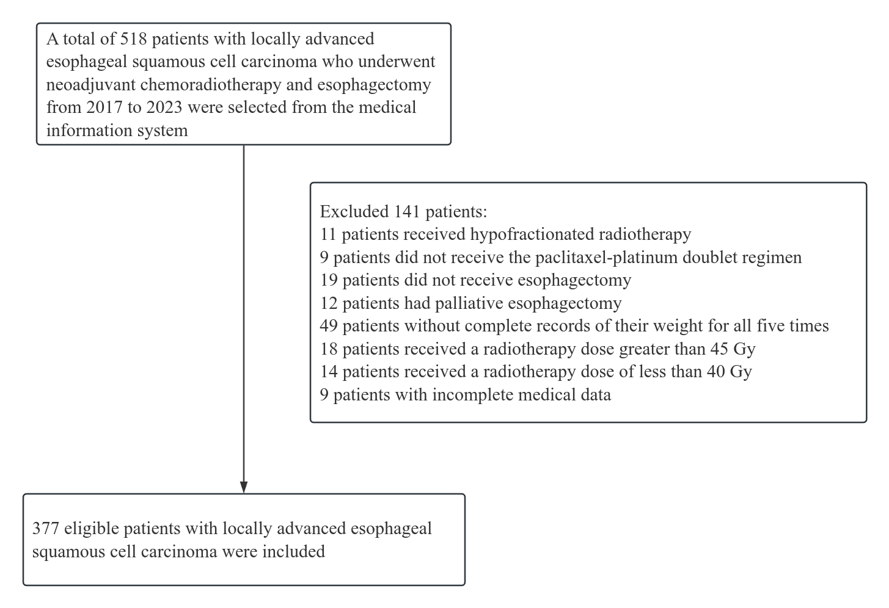

Supplementary Figure 2. Temporal Patterns of Body Weight among Patients with Locally Advanced Esophageal Squamous Cell Carcinoma Receiving Neoadjuvant Chemoradiotherapy and Esophagectomy.

Abbreviations: Time 0 (baseline): within 1 month before treatment initiation; Time 1: initiation of neoadjuvant chemoradiotherapy (NCRT); Time 2: completion of NCRT; Time 3: within 1 week before surgery; Time 4: early postoperative period. LA-ESCC = locally advanced esophageal squamous cell carcinoma; NCRT = neoadjuvant chemoradiotherapy.

Supplementary Figure 3. Kaplan–Meier Curves for Overall Survival (A) and Progression-Free Survival (B) in Patients with Locally Advanced Esophageal Cancer Receiving Neoadjuvant Chemoradiotherapy.

Supplementary Figure 4. Kaplan–Meier Curves for Overall Survival and Progression-Free Survival According to Weight-Loss Status during Different Treatment Periods in Patients with Locally Advanced Esophageal Squamous Cell Carcinoma.
(A) Overall survival (OS) according to weight-loss status during Time 0–1; (B) progression-free survival (PFS) according to weight-loss status during Time 0–1; (C) OS according to weight-loss status during Time 3–4; and (D) PFS according to weight-loss status during Time 3–4.
Ti0Abbreviations: Time0–1 denotes the period from within 1 month before initiation of neoadjuvant chemoradiotherapy (NCRT) to the start of NCRT. Time 3–4 denotes the period from the preoperative assessment (within 1 week before surgery) to the early postoperative period. LA-ESCC, locally advanced esophageal squamous cell carcinoma; OS, overall survival; PFS, progression-free survival; WL, weight loss; no-WL, no weight loss.

Supplemental Figure 5. Supplementary Figure 5. Kaplan–Meier Curves for Overall Survival (A) and Progression-Free Survival (B) According to Body Weight Trajectory Groups in Patients with Locally Advanced Esophageal Squamous Cell Carcinoma. Trajectory 1, Low Gradual Increase; Trajectory 2, Increase Followed by Decrease; Trajectory 3, Decrease Followed by Increase; and Trajectory 4, Low Gradual Decrease. Abbreviations: OS, overall survival; PFS, progression-free survival.

Supplemental Figure 6. Restricted Cubic Spline Analyses of the Associations Between Body Weight Percentage Change and Survival Outcomes.
(A) Unadjusted association between body weight percentage change and OS; (B) unadjusted association between body weight percentage change and PFS; (C) adjusted association between body weight percentage change and OS; and (D) adjusted association between body weight percentage change and PFS.

Abbreviations: OS, overall survival; PFS, progression-free survival; RCS, restricted cubic spline.

