Supplementary Table S1. Oligonucleotide primers and their sequences used in this study
Primers |  | Sequence (5’-3’)
GrxD | Forward 1 | acaGGATCCCAGAAAGTGATGGATCGAG
GrxD | Reverse 1 | acaTCTAGACTAACCTTTTTGGGCGTCT
GrxD | Forward 2 | ACGATGGAAAAAGAGTGTTG
GrxD | Reverse 2 | TTCCTCGCTTAAGACCCTT
GrxD | Forward | TCGCCTTCTTGACGAGTTCTTCTGATGAGGTGGATGTGGATGTG
GrxD | Reverse | TTCCTCGCTTAAGACCCTT
Neomycin | Neo3 | TGAATGAACTGCAAGACGAGGCAGC
Neomycin | Neo4 | CGGCCATTTTCCACCATGATATTCG

Supplementary Table S2. Peak areas of HPLC shown in Fig. 6 (siderophore contents) in the main text
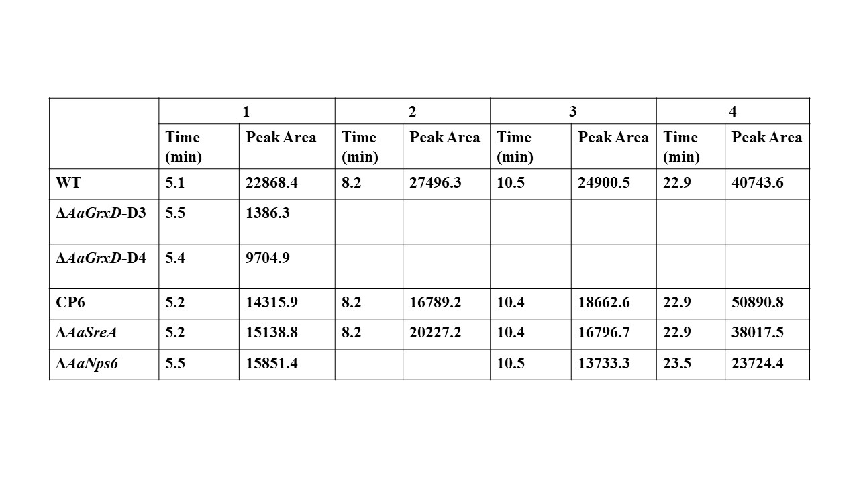

Supplementary Table S3. Peak areas of HPLC shown in Fig. 8 (toxin metabolites) in the main text
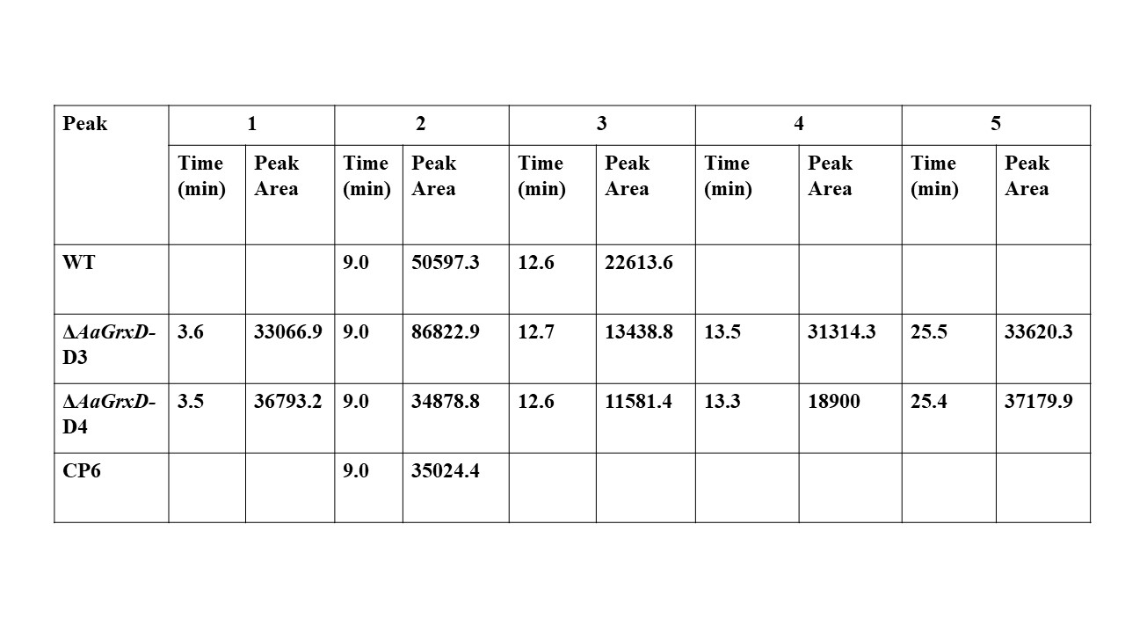

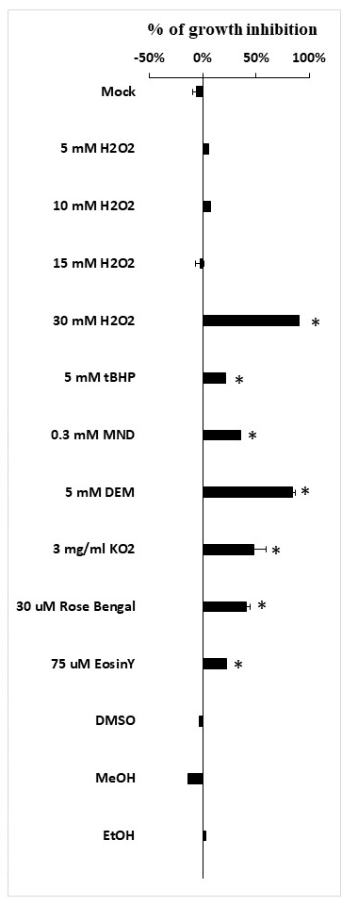

Supplementary Fig. S1. AaGrxD is essential for resistance to oxidative stress in Alternaria alternata. Quantitative analysis of growth inhibition in two AaGrxD mutants (D3 and D4) and the wild type grown on PDA or PDA amended with the indicated chemical. Each treatment included two replicates, and all experiments were repeated three times. Data were analyzed in SPSS 20. Group differences were tested with one-way ANOVA, followed by Tukey’s HSD (p < 0.05). Means with different letters denote significant differences.

