Supplementary Information for
Chlorothalonil induces metabolic syndrome in mice by regulating host gut microbiota and bile acids metabolism via FXR pathways

Zhiyuan Meng ^{1, 2}, Sen Yan ¹, Wei Sun ¹, Jin Yan ¹, Miaomiao Teng ^{1,3}, Ming Jia ¹, Sinuo Tian ¹, Ruisheng Li ¹, Shiran Huang ¹, Yu Wang ¹, Xiaojun Chen ², Zhiqiang Zhou ¹, Wentao Zhu ^{1,} *

¹ Innovation Center of Pesticide Research, Department of Applied Chemistry, College of Science, China Agricultural University, Beijing 100193, China.
² School of Horticulture and Plant Protection, Yangzhou University/Joint International Research Laboratory of Agriculture & Agri-Product Safety (Yangzhou University), Jiangsu Yangzhou, 225009, China
³ State Key Laboratory of Environmental Criteria and Risk Assessment, Chinese Research Academy of Environmental Sciences, Beijing 100012, China

*Corresponding author:
Wentao Zhu, Innovation Center of Pesticide Research, Department of Applied Chemistry, College of Science, China Agricultural University, Beijing 100193, China E-mail: wentaozhu@cau.edu.cn

Figure captions
Fig. S1. Low-dose CHI induced MetS in C57BL/6 mice. (A) Design of low-dose CHI exposure experiment; (B) Body weight and body weight gain; (C) Liver weight and %Liver weight/Body weight; (D) epiWAT weight and %epiWAT weight/Body weight; (E) Serum LDL-C and HDL-C contents; (F) Serum TG and TC contents; (G) Serum glucose and insulin levels and insulin resistance index (HOMA-IR); (H) Representative images of H&E staining of liver tissues and epiWAT tissues at 100 × and 400 ×from different groups; (I) Serum liver ALT and AST activities; (J) Liver TC and TG contents; (K) Average areas and sizes of epiWAT cells. *P <0.05, **P <0.01 as compared to Ctrl group, n = 6.
Fig. S2. Effects of low-dose CHI on average daily water and food intake of ICR and C57BL/6 mice. (A) Average daily food intake/Body weight; (B) Average daily water intake/Body weight. *P <0.05, **P <0.01 as compared to Ctrl group, n = 6.
Fig. S3. Low-dose CHI induced inflammatory response in liver tissue and epiWAT of mice. (A and B) Relative mRNA expressions of inflammation-related genes in liver tissue of ICR and C57BL/6 mice; (C and D) Relative mRNA expressions of inflammation-related genes in epiWAT of ICR and C57BL/6 mice. *P <0.05, **P <0.01 as compared to Ctrl group, n = 6.
Fig.S4. Low-dose CHI disrupted gut microbiota of C57BL/6 mice. (A) Principal component analysis (PCA) based on OTUs; (B) Alpha-diversity indices; (C) Average relative abundances of gut microbiota at phylum level; (D) Changes in the relative abundances of the main gut microbiota at phylum level; (E) Ratio of the relative abundances of Firmicutes and Bacteroidetes; (F) Average relative abundance of the gut microbiota at genus level; (G) Changes in the main gut microbiota at genus level. *P <0.05, **P <0.01 as compared to Ctrl group, n = 5.
Fig. S5. Extraction ion chromatograms (EICs) of 41 bile acids under the optimal conditions. (A) Standard solution; (B) Serum sample.
Fig. S6. Low-dose CHI altered BAs metabolic profile of C57BL/6 mice. (A) PCA analysis based on serum bile acids contents; (B) Serum total BAs contents; (C) Serum primary BAs contents; (D) Serum secondary BAs contents; (E) Serum unconjugated BAs contents; (F) Serum conjugated BAs contents; (G) Average contents of serum BAs; (H) Heat map of the relative contents of serum BAs; (I) Significant changes in serum BAs. *P <0.05, **P <0.01 as compared to Ctrl group, n = 6.
Fig. S7. Antibiotic treatment improved MetS induced by low-dose CHI in mice. (A) Liver TC and TG contents; (B) Serum liver ALT and AST activities; (C) Average areas and sizes of epiWAT cells. (D) Representative images of H&E staining of liver tissues and epiWAT tissues at 200 × and 400 ×from different groups; *P <0.05, **P <0.01 as compared to Ctrl group, n = 6.
Fig.S8. Low-dose CHI induced MetS of mice could be transferred through gut microbiota transplantation. (A) PCA analysis based on OTUs from donor and recipient mice; (B) Average relative abundances of gut microbiota from donor and recipient mice at phylum level; (C) Ratio of the relative abundances of Firmicutes and Bacteroidetes in donor and recipient mice; (D) Body weight gain; (E) %Liver weight/Body weight; (F) %epiWAT weight/Body weight; (G) Average daily food intake/Body weight; (H) Average daily water intake/Body weight (H) Serum TC contents; (I) Liver TC contents; (J) Average areas of epiWAT cells. *P <0.05, **P <0.01 as compared to T-Ctrl group, n = 6.
Fig.S9. Low-dose CHI -induced serum bile acids metabolism profiles disorder in mice could be transferred by gut microbiota transplantation. (A): Principal component analysis based on serum bile acids contents; (B): Serum total bile acids contents; (C): Serum primary bile acids contents in serum; (D): Serum secondary bile acids contents in serum; (E): Serum unconjugated bile acids contents; (F): Serum conjugated bile acids contents; (G): The average contents of serum bile acids; (H): Heat map of the relative contents of the serum bile acids; (I): Significant changes in serum bile acids. *P <0.05, **P <0.01 as compared to T-Ctrl group, n = 6.
Fig. S10. The relative expression of Fxr and its downstream related genes in liver tissue and epiWAT in T-Ctrl and T-CHI treatment groups. *P <0.05, **P <0.01 as compared to T-Ctrl group, n = 6.
Fig. S11. Low-dose CHI induced glycolipid metabolism disorders in C57BL/6 mice. Relative mRNA expressions of (A) fatty acid synthesis-related genes; (B) fatty acid uptake-related genes; (C) fatty acid oxidation-related genes; (D) lipoprotein secretion-related genes; and (E) glucose metabolism-related genes in the liver tissue and epiWAT of ICR mice. *P <0.05, **P <0.01 as compared to Ctrl group, n = 6.
Fig. S12. FXR activators ameliorated low-dose CHI-induced MetS in mice. (A) Body weight gain, %Liver weight/Body weight, and %epiWAT weight/Body weight; (B) Average daily food intake/Body weight and average daily water intake/Body weight; (C) Serum TC and HDL-C contents; (D) Serum AST activities; (E) Liver TC and TG contents; (F) Average areas of epiWAT cells. *P <0.05, **P <0.01 as compared to T-Ctrl group, n = 6.
Fig. S13. Underlying mechanism of exposure to low-dose CHI induce metabolic syndrome in mice. Low-dose CHI exposure could change the composition of the gut microbiota, leading to disorders of serum bile acid metabolism. Furthermore, the signal response of bile acid receptor FXR was inhibited, causing disorders of glucose and lipid metabolism, and finally induced metabolic syndrome in mice.
Table S1. Sequences of primers of related genus in qPCR.
Table S2. UHPLC-MS/MS qualitative and quantitative ions of 41 bile acids in serum.
Table S3. The contents of bile acids in serum samples of ICR mice.
Table S4. The contents of bile acids in serum samples of C57BL/6 mice.
Table S5. The contents of bile acids in serum of T-Ctrl and T-CHI treatment groups.

Supporting Information
BAs targeted metabolomics analysis
Metabolites Extraction: 100 μL of serum sample was transferred to an EP tube. After the addition of 400 μL of extract solvent (acetonitrile-methanol, 1:1, containing 0.1% formic acid and isotopically-labelled internal standard mixture), the samples were vortexed for 30 s, sonicated for 10 min in ice-water bath followed by incubation at -40 ºC for 1 h and centrifugation at 12000 rpm and 4 ºC for 15 min. The clear supernatants were transferred to an auto-sampler vial for UHPLC-MS/MS analysis.

Standard Solution Preparation: Stock solutions were individually prepared by dissolving or diluting each standard substance to give a final concentration of 10 mmol/L. An aliquot of each of the stock solutions was transferred to a 10 mL flask to form a mixed working standard solution. A series of calibration standard solutions were then prepared by stepwise dilution of this mixed standard solution (containing isotopically-labelled internal standard mixture in identical concentrations with the samples).

UHPLC-PRM-MS Analysis: The UHPLC separation was carried out using an UHPLC System (Vanquish, Thermo Fisher Scientific), equipped with a Waters ACQUITY UPLC BEH C18 column (150 * 2.1 mm, 1.7 μm, Waters). The mobile phase A was 1 mmol/L ammonium acetate and 0.1% acetic acid in water, and the mobile phase B was acetonitrile. The column temperature was set at 50 ℃. The auto-sampler temperature was set at 4 ℃ and the injection volume was 1 μL. A Q Exactive HFX mass spectrometer (Thermo Fisher Scientific) was applied for assay development. Typical ion source parameters were: spray voltage = +3500/-3100 V, sheath gas (N₂) flow rate = 40, aux gas (N₂) flow rate = 15, sweep gas (N₂) flow rate = 0, aux gas (N₂) temperature = 350 ℃, capillary temperature = 320 ℃. The parallel reaction monitoring (PRM) parameters for each of the targeted analyses were optimized, by injecting the standard solutions of the individual analyses, into the API source of the mass spectrometer. Since most of the analyses did not show product ion acceptable for quantification, the precursor ion in high resolution was selected for quantification.

Fig. S1
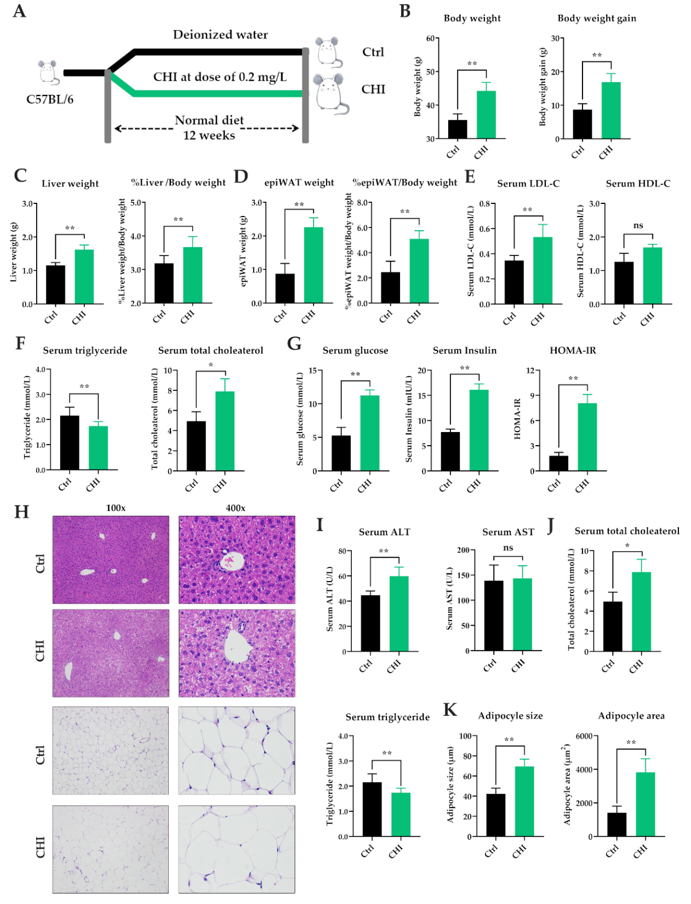
Fig. S1. Low-dose CHI induced MetS in C57BL/6 mice. (A) Design of low-dose CHI exposure experiment; (B) Body weight and body weight gain; (C) Liver weight and %Liver weight/Body weight; (D) epiWAT weight and %epiWAT weight/Body weight; (E) Serum LDL-C and HDL-C contents; (F) Serum TG and TC contents; (G) Serum glucose and insulin levels and insulin resistance index (HOMA-IR); (H) Representative images of H&E staining of liver tissues and epiWAT tissues at 100 × and 400 ×from different groups; (I) Serum liver ALT and AST activities; (J) Liver TC and TG contents; (K) Average areas and sizes of epiWAT cells. *P <0.05, **P <0.01 as compared to Ctrl group, n = 6.

Fig. S2
Fig. S2. Effects of low-dose CHI on average daily water and food intake of ICR and C57BL/6 mice. (A) Average daily food intake/Body weight; (B) Average daily water intake/Body weight. *P <0.05, **P <0.01 as compared to Ctrl group, n = 6.

Fig. S3
Fig. S3. Low-dose CHI induced inflammatory response in liver tissue and epiWAT of mice. (A and B) Relative mRNA expressions of inflammation-related genes in liver tissue of ICR and C57BL/6 mice; (C and D) Relative mRNA expressions of inflammation-related genes in epiWAT of ICR and C57BL/6 mice. *P <0.05, **P <0.01 as compared to Ctrl group, n = 6.

Fig. S4
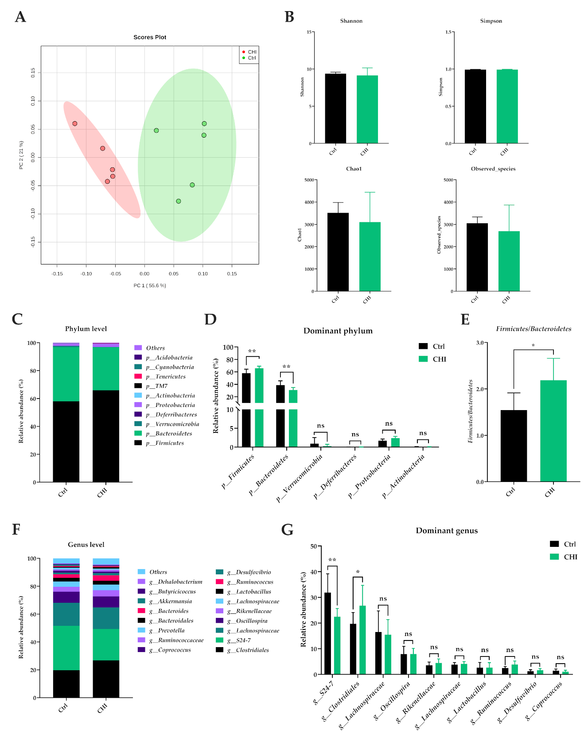
Fig.S4. Low-dose CHI disrupted gut microbiota of C57BL/6 mice. (A) Principal component analysis (PCA) based on OTUs; (B) Alpha-diversity indices; (C) Average relative abundances of gut microbiota at phylum level; (D) Changes in the relative abundances of the main gut microbiota at phylum level; (E) Ratio of the relative abundances of Firmicutes and Bacteroidetes; (F) Average relative abundance of the gut microbiota at genus level; (G) Changes in the main gut microbiota at genus level. *P <0.05, **P <0.01 as compared to Ctrl group, n = 5.

Fig. S5
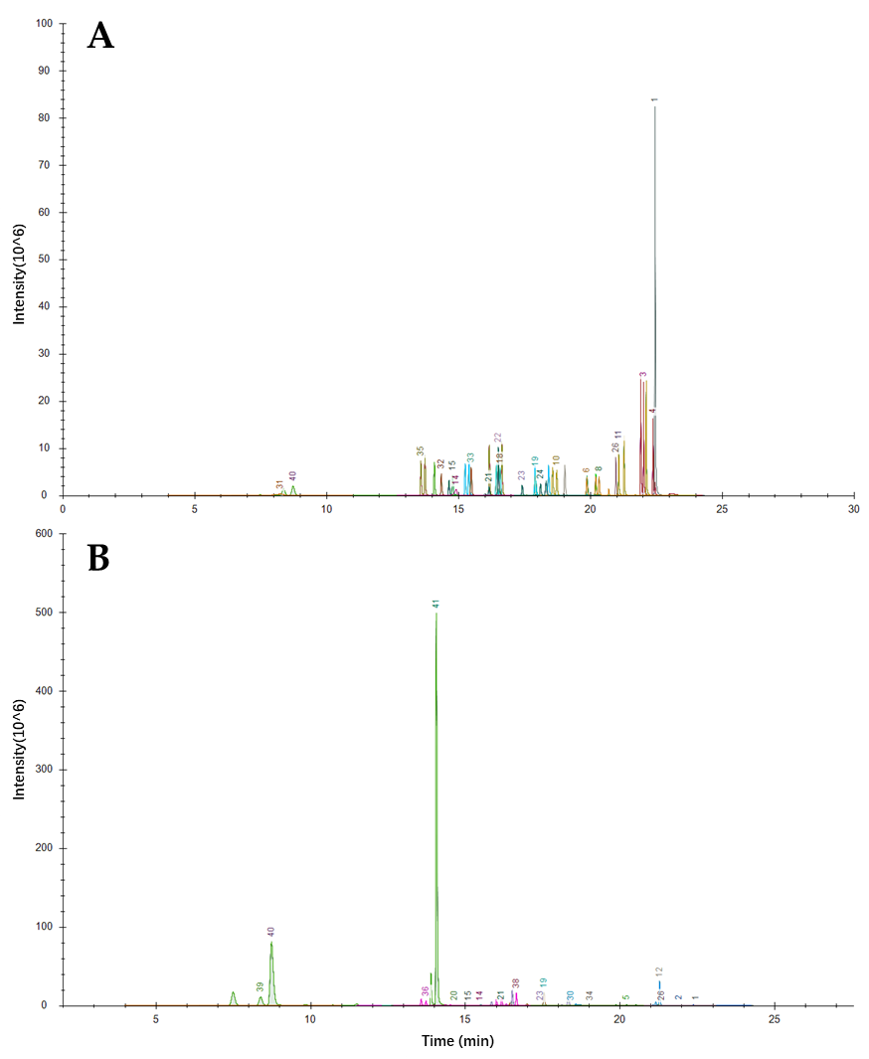
Fig. S5. Extraction ion chromatograms (EICs) of 41 bile acids under the optimal conditions. (A) Standard solution; (B) Serum sample.
Note: 1.DHLCA; 2. Isoallolithocholic acid; 3. IsoLCA; 4. LCA; 5. 23norDCA; 6. 7-ketoLCA; 7. 12-ketoLCA; 8. ApoCA; 9. UDCA; 10. HDCA; 11. CDCA; 12. DCA; 13. IsoDCA; 14. DHCA; 15. 7,12-diketoLCA; 16. 6,7-diketoLCA; 17. 7-KHCA; 18. 12-DHCA; 19. 3-DHCA; 20. UCA; 21. α-MCA; 22.β-MCA; 23. HCA; 24. ACA; 25. CA; 26. GLCA; 27. GUDCA; 28. GHDCA; 29. GCDCA; 30. GDCA; 31. GDHCA; 32. GHCA; 33. GCA; 34. TLCA; 35. TUDCA; 36. THDCA; 37. TCDCA; 38. TDCA; 39. T-α-MCA; 40. T-β-MCA; 41 TCA.

Fig. S6
Fig. S6. Low-dose CHI altered BAs metabolic profile of C57BL/6 mice. (A) PCA analysis based on serum bile acids contents; (B) Serum total BAs contents; (C) Serum primary BAs contents; (D) Serum secondary BAs contents; (E) Serum unconjugated BAs contents; (F) Serum conjugated BAs contents; (G) Average contents of serum BAs; (H) Heat map of the relative contents of serum BAs; (I) Significant changes in serum BAs. *P <0.05, **P <0.01 as compared to Ctrl group, n = 6.

Fig. S7
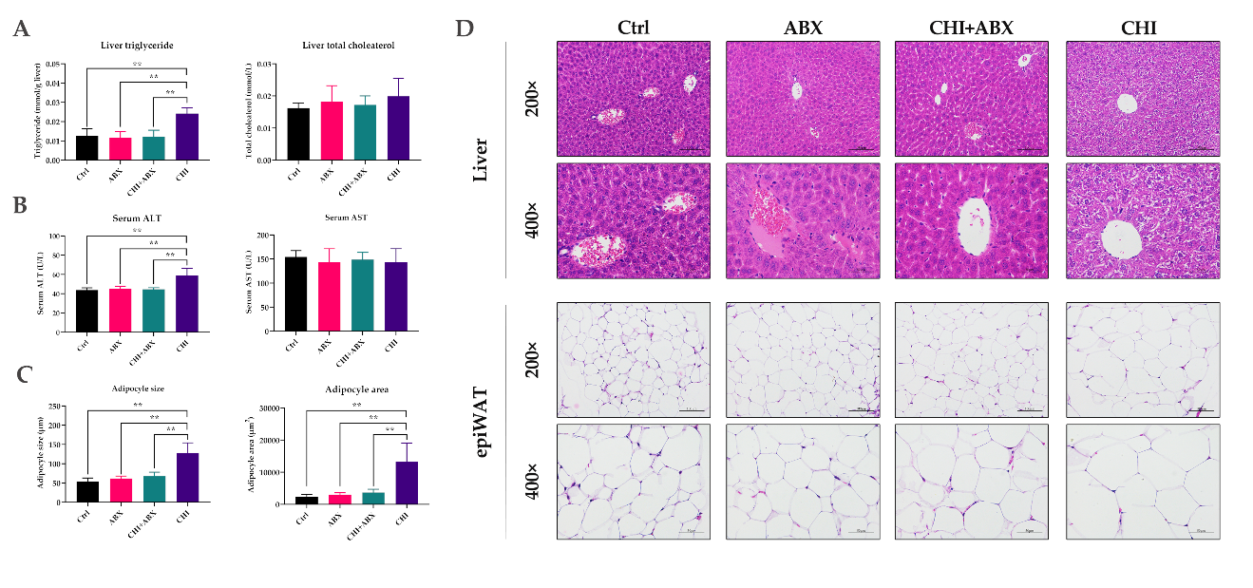
Fig. S7. Antibiotic treatment improved MetS induced by low-dose CHI in mice. (A) Liver TC and TG contents; (B) Serum liver ALT and AST activities; (C) Average areas and sizes of epiWAT cells. (D) Representative images of H&E staining of liver tissues and epiWAT tissues at 200 × and 400 ×from different groups; *P <0.05, **P <0.01 as compared to Ctrl group, n = 6.

Fig. S8
Fig.S8. Low-dose CHI induced MetS of mice could be transferred through gut microbiota transplantation. (A) PCA analysis based on OTUs from donor and recipient mice; (B) Average relative abundances of gut microbiota from donor and recipient mice at phylum level; (C) Ratio of the relative abundances of Firmicutes and Bacteroidetes in donor and recipient mice; (D) Body weight gain; (E) %Liver weight/Body weight; (F) %epiWAT weight/Body weight; (G) Average daily food intake/Body weight; (H) Average daily water intake/Body weight (H) Serum TC contents; (I) Liver TC contents; (J) Average areas of epiWAT cells. *P <0.05, **P <0.01 as compared to T-Ctrl group, n = 6.

Fig. S9
Fig.S9. Low-dose CHI -induced serum bile acids metabolism profiles disorder in mice could be transferred by gut microbiota transplantation. (A): Principal component analysis based on serum bile acids contents; (B): Serum total bile acids contents; (C): Serum primary bile acids contents in serum; (D): Serum secondary bile acids contents in serum; (E): Serum unconjugated bile acids contents; (F): Serum conjugated bile acids contents; (G): The average contents of serum bile acids; (H): Heat map of the relative contents of the serum bile acids; (I): Significant changes in serum bile acids. *P <0.05, **P <0.01 as compared to T-Ctrl group, n = 6.

Fig. S10
Fig. S10. The relative expression of Fxr and its downstream related genes in liver tissue and epiWAT in T-Ctrl and T-CHI treatment groups. *P <0.05, **P <0.01 as compared to T-Ctrl group, n = 6.

Fig. S11
Fig. S11. Low-dose CHI induced glycolipid metabolism disorders in C57BL/6 mice. Relative mRNA expressions of (A) fatty acid synthesis-related genes; (B) fatty acid uptake-related genes; (C) fatty acid oxidation-related genes; (D) lipoprotein secretion-related genes; and (E) glucose metabolism-related genes in the liver tissue and epiWAT of ICR mice. *P <0.05, **P <0.01 as compared to Ctrl group, n = 6.

Fig. S12
Fig. S12. FXR activators ameliorated low-dose CHI-induced MetS in mice. (A) Body weight gain, %Liver weight/Body weight, and %epiWAT weight/Body weight; (B) Average daily food intake/Body weight and average daily water intake/Body weight; (C) Serum TC and HDL-C contents; (D) Serum AST activities; (E) Liver TC and TG contents; (F) Average areas of epiWAT cells. *P <0.05, **P <0.01 as compared to T-Ctrl group, n = 6.

Fig. S13
Fig. S13. Underlying mechanism of exposure to low-dose CHI induce metabolic syndrome in mice. Low-dose CHI exposure could change the composition of the gut microbiota, leading to disorders of serum bile acid metabolism. Furthermore, the signal response of bile acid receptor FXR was inhibited, causing disorders of glucose and lipid metabolism, and finally induced metabolic syndrome in mice.

Table S1. Sequences of primers of related genus in qPCR.
Genues | Sequences of forward primers | Sequences of reverse primers
Fxr | TGGGCTCCGAATCCTCTTAGA | TGGTCCTCAAATAAGATCCTTGG
Shp | TCTGCAGGTCGTCCGACTATTC | AGGCAGTGGCTGTGAGATGC
Srebp-1c | CAGACACTGGCCGAGATGTG | CTTGGTTGTTGATGAGCTGGAG
Chrebp | CGGGACATGTTTGATGACTATGTC | CATCCCATTGAAGGATTCAAATAAA
Acaca | CCAACATGAGGACTATAACTTCCT | TACATACGTGCCGTCAGGCTTCAC
Fasn | AGTCAGCTATGAAGCAATTGTGGA | CACCCAGACGCCAGTGTTC
Pparγ | CACAATGCCATCAGGTTTGG | GCTGGTCGATATCACTGGAGATC
Mogat1 | TCCCGTTGTTCCGAGAATATCT | TGCTCAGCACATGAGACAAAC
Cd36 | TCCAGCCAATGCCTTTGC | TGGAGATTACTTTTCAGTGCAGAA
Dgat1 | GACGGCTACTGGGATCTGA | TCACCACACACCAATTCAGG
Dgat2 | CGCAGCGAAAACAAGAATAA | GAAGATGTCTTGGAGGGCTG
Gpat1 | CCACAGAGCTGGGAAAGGTT | GTGCCTTGTGTGCGTTTCAT
Agpat1 | GCGCAATGTCGAGAACATGA | TCATTCCAAGCAGGTCGAGG
Fabp1 | TGAAGGCAATAGGTCTGCCC | GTCATGGTCTCCAGTTCGCA
Fabp2 | CTTCGGGAACCACAGGTCTTC | CATAGCAAGGCCTGTCCCATAC
Fatp5 | TTCGAAAGAACCAACCCTTCCT | GCGTCGTACATTCGCAACAA
Cpt1α | AAAGATCAATCGGACCCTAGACA | CAGCGAGTAGCGCATAGTCA
Acat1 | CCCCATTGATTTTCCACTTG | AGCACAACCACACTGAATGC
Acox1 | CACGGCTATTCTCACAGCAG | CAGGCTGTTAATGTCCACCA
Mttp | AGCCAGTGGGCATAGAAAATC | GGTCACTTTACAATCCCCAGAG
Pparα | TATTCGGCTGAAGCTGGTGTAC | CTGGCATTTGTTCCGGTTCT
Apob | TACTTCCACCCACAGTCCCCT | CCTTAGAAGCCTTGGGCACAT
G6pase | CTCACTTTCCCCACCAGGTC | GCTGAAAGTTTCAGCCACAGC
Gck | TCGCAGGTGGAGAGCGA | TCGCAGTCGGCGACAGA
Glut2 | GTCCAGAAAGCCCCAGATACC | GTGACATCCTCAGTTCCTCTTAG
Pepck | CAGGATCGAAAGCAAGACAGT | AAGTCCTCTTCCGACATCCAG
Pklr | CCGCATCTACATTGACGACG | CCGTGTTCCACTTCGGTCAC
Gys2 | CCAGCTTGACAAGTTCGACA | ATCAGGCTTCCTCTTCAGCA
Gapdh | GTGGACCTCATGGCCTACAT | TGTGAGGGAGATGCTCAGTG

Table S2. UHPLC-MS/MS qualitative and quantitative ions of 41 bile acids in serum.
No | Bile acids | Abbreviation | CAS | Qualitative ion | Quantitative ion | Category 1 | Category2
1 | Dehydrolithocholic acid | DHLCA | 1553-56-6 | 373.2741 | 373.2741 | — | Unconjugated
2 | Isoallolithocholic acid | — | 2276-93-9 | 375.2903 | 375.2903 | Secondary | Unconjugated
3 | Isolithocholic acid | isoLCA | 1534-35-6 | 375.2902 | 375.2902 | Secondary | Unconjugated
4 | Lithocholic acid | LCA | 434-13-9 | 375.2902 | 375.2902 | Secondary | Unconjugated
5 | 23-Nordeoxycholic acid | 23norDCA | 53608-86-9 | 377.2699 | 377.2699 | — | Unconjugated
6 | 7-Ketolithocholic acid | 7-ketoLCA | 4651-67-6 | 389.2696 | 389.2696 | Secondary | Unconjugated
7 | 12-Ketolithocholic acid | 12-ketoLCA | 5130-29-0 | 389.2696 | 389.2696 | Secondary | Unconjugated
8 | Apocholic acid | apoCA | 641-81-6 | 389.2700 | 389.2700 | — | Unconjugated
9 | Ursodeoxycholic acid | UDCA | 128-13-2 | 391.2854 | 391.2854 | Primary (mice) | Unconjugated
10 | Hyodeoxycholic acid | HDCA | 83-49-8 | 391.2852 | 391.2852 | Secondary | Unconjugated
11 | Chenodeoxycholic acid | CDCA | 474-25-9 | 391.2848 | 391.2848 | Primary | Unconjugated
12 | Deoxycholic acid | DCA | 83-44-3 | 391.2864 | 391.2864 | Secondary | Unconjugated
13 | Isodeoxycholic acid | isoDCA | 566-17-6 | 391.2855 | 391.2855 | — | Unconjugated
14 | Dehydrocholic acid | DHCA | 81-23-2 | 401.2333 | 401.2333 | — | Unconjugated
15 | 7,12-Diketolithocholic acid | 7,12-diketoLCA | 517-33-9 | 403.2483 | 403.2483 | Secondary | Unconjugated
16 | 6,7-Diketolithocholic acid | 6,7-diketoLCA | — | 403.2493 | 403.2493 | Secondary | Unconjugated
17 | 7-Ketodeoxycholic acid | 7-KHCA | 911-40-0 | 405.2648 | 405.2648 | Secondary | Unconjugated
18 | 12-Dehydrocholic acid | 12-DHCA | 2458-08-4 | 405.2655 | 405.2655 | — | Unconjugated
19 | 3-Dehydrocholic acid | 3-DHCA | 2304-89-4 | 405.2648 | 405.2648 | — | Unconjugated
20 | Ursocholic acid | UCA | 2955-27-3 | 407.2802 | 407.2802 | — | Unconjugated
21 | α-Muricholic acid | α-MCA | 2393-58-0 | 407.2804 | 407.2804 | Primary | Unconjugated
22 | β-Muricholic acid | β-MCA | 2393-59-1 | 407.2801 | 407.2801 | Primary | Unconjugated
23 | Hyocholic acid | HCA | 547-75-1 | 407.2801 | 407.2801 | Primary | Unconjugated
24 | Allocholic acid | ACA | 2464-18-8 | 407.2804 | 407.2804 | Secondary | Unconjugated
25 | Cholic acid | CA | 81-25-4 | 407.2804 | 407.2804 | Primary | Unconjugated
26 | Glycolithocholic acid | GLCA | 474-74-8 | 432.3119 | 432.3119 | Secondary | Conjugated
27 | Glycoursodeoxycholic acid | GUDCA | 64480-66-6 | 448.3069 | 448.3069 | Secondary | Conjugated
28 | Glycohyodeoxycholic acid | GHDCA | 13042-33-6 | 448.3072 | 448.3072 | Secondary | Conjugated
29 | Glycochenodeoxycholic acid | GCDCA | 640-79-9 | 448.3071 | 448.3071 | Primary | Conjugated
30 | Glycodeoxycholic acid | GDCA | 360-65-6 | 448.3069 | 448.3069 | Secondary | Conjugated
31 | Glycodehydrocholic acid | GDHCA | 3415-45-0 | 458.2551 | 458.2551 | — | Conjugated
32 | Glycohyocholic acid | GHCA | 32747-08-3 | 464.3019 | 464.3019 | Primary | Conjugated
33 | Glycocholic acid | GCA | 475-31-0 | 464.3013 | 464.3013 | Primary | Conjugated
34 | Taurolithocholic acid | TLCA | 6042-32-6 | 482.2947 | 482.2947 | Secondary | Conjugated
35 | Tauroursodeoxycholic acid | TUDCA | 14605-22-2 | 498.2897 | 498.2897 | Secondary | Conjugated
36 | Taurohyodeoxycholic acid | THDCA | 2958-04-5 | 498.2894 | 498.2894 | Secondary | Conjugated
37 | Taurochenodeoxycholic acid | TCDCA | 516-35-8 | 498.2889 | 498.2889 | Primary | Conjugated
38 | Taurodeoxycholic acid | TDCA | 516-50-7 | 498.2889 | 498.2889 | Secondary | Conjugated
39 | Tauro α-Muricholic acid | T-α-MCA | 25613-05-2 | 514.2843 | 514.2843 | Primary | Conjugated
40 | Tauro β-Muricholic acid | T-β-MCA | 25696-60-0 | 514.2839 | 514.2839 | Primary | Conjugated
41 | Taurocholic acid | TCA | 81-24-3 | 514.2839 | 514.2839 | Primary | Conjugated

Table S3. The contents of bile acids in serum samples of ICR mice.
Samples | Ctrl-1 | Ctrl-2 | Ctrl-3 | Ctrl-4 | Ctrl-5 | Ctrl-6 | CHI-1 | CHI-2 | CHI-3 | CHI-4 | CHI-5 | CHI-6
LCA | NA | 1.28 | 1.35 | 2.2 | 2.08 | 1.82 | NA | NA | NA | NA | NA | NA
UDCA | NA | NA | 2.49 | 2.47 | 2.08 | 4.61 | 5.38 | 3.32 | 4.97 | 4.99 | 4.92 | 5.56
CDCA | 25.37 | 31.33 | 35.41 | 26.75 | 28.58 | 24.69 | 6.64 | 6.68 | 8.33 | 8.25 | 11.93 | 4.1
DCA | 14.87 | 18.9 | 22.33 | 30.29 | 25.38 | 19.67 | 4.35 | 4.33 | 5.48 | 9.49 | 7.76 | 7.53
isoDCA | 5.03 | 4.22 | 5.48 | 5.73 | 5.32 | 7.47 | 7.42 | 3.27 | 6.99 | 4.9 | 7.13 | 4.49
7-KHCA | NA | NA | NA | NA | NA | NA | 2.33 | NA | NA | NA | 2.86 | 2.01
3-DHCA | NA | NA | NA | 2.9 | NA | NA | 5.45 | 4.78 | NA | NA | 1.68 | 2.39
α-MCA | NA | NA | NA | NA | NA | 2.68 | 2.48 | NA | NA | 3.22 | 3.02 | 5.05
β-MCA | 2.36 | 3.72 | 2.87 | 25.25 | 28.18 | 16.55 | 46.09 | 11.00 | 6.14 | 8.18 | 56.27 | 58.88
ACA | NA | NA | NA | NA | NA | NA | 2.08 | NA | NA | NA | 3.24 | 3.01
CA | 40.63 | 51.1 | 54.1 | 76.26 | 53.03 | 55 | 24.45 | 24.19 | 22.68 | 20.27 | 21.73 | 47.09
TUDCA | 2.39 | 4.38 | 3.58 | 10.64 | 10.68 | 6.52 | 16.18 | 10.82 | 13.47 | 14.62 | 25.28 | 19.16
THDCA | 1.94 | 2.99 | 1.99 | 4.26 | 2.12 | 1.47 | NA | 1.68 | 1.82 | 3.39 | 2.61 | 1.8
TCDCA | NA | NA | NA | 5.06 | 5.38 | 3.32 | 5.53 | 4.9 | 5.87 | 6.04 | 9.85 | 7.17
TDCA | 13.64 | 14.89 | 10.61 | 12.35 | 10.62 | 7.46 | 1.66 | 2.66 | 4.36 | 6.44 | 4.81 | 3.06
T-α-MCA | NA | 11.44 | 5.53 | 18.64 | 17.68 | 10.56 | 35.46 | 14.99 | 16.16 | 17.62 | 55.96 | 44.95
T-β-MCA | 73.66 | 119.51 | 99.63 | 315.9 | 325.76 | 214.94 | 575.41 | 314.26 | 349.99 | 371.38 | 897.5 | 727.53
TCA | 49.29 | 70.01 | 85.53 | 258.61 | 260.27 | 181.42 | 291.43 | 275.27 | 287.66 | 319.89 | 498.6 | 371.31
Note: The data in the table are the concentrations of bile acids in the samples, and the unit is nmol/kg. NA means that no target metabolites were detected in the sample.

Table S4. The contents of bile acids in serum samples of C57BL/6 mice.
Samples | Ctrl-1 | Ctrl-2 | Ctrl-3 | Ctrl-4 | Ctrl-5 | Ctrl-6 | CHI-1 | CHI-2 | CHI-3 | CHI-4
LCA | 17.2 | 21.9 | 19.19 | 15.93 | 32.01 | 1.53 | 2.48 | 8.75 | 8.24 | 6.01
23norDCA | 3.59 | 3.01 | 4.38 | 3.63 | 5.91 | 1.34 | 2.46 | 1.77 | 3.47 | 3.27
7-ketoLCA | 53.32 | 51.07 | NA | NA | 109.38 | NA | NA | NA | NA | NA
12-ketoLCA | 52.35 | 52.67 | 59.48 | 53.07 | 146.94 | NA | NA | NA | NA | NA
apoCA | 7.84 | 8.2 | 6.85 | NA | 17.19 | NA | NA | NA | NA | NA
UDCA | 16.55 | 21.79 | 8.94 | 14.85 | 15.74 | 129.28 | 113.22 | 76.99 | 72.55 | 173.91
HDCA | 61.01 | 63.78 | 77.48 | 63.47 | 161.16 | 5.01 | 6.64 | 16.4 | 25.33 | 20.26
CDCA | 298.52 | 270.75 | 213.91 | 228.16 | 146.9 | 62.24 | 68.21 | 63.31 | 36.97 | 99.95
DCA | 1017.58 | 1084.32 | 1237.87 | 1103.69 | 2645.54 | 64.65 | 99.87 | 163.48 | 203.12 | 181.15
isoDCA | 6.3 | 8.01 | 5.15 | 4.15 | 4.61 | 5.13 | 6.47 | 8.18 | 6.76 | 5.33
6,7-diketoLCA | 9.56 | 8.29 | 4.45 | 4.24 | 21.5 | NA | NA | NA | NA | NA
7-KHCA | 244.83 | 234.54 | 59.17 | 48.68 | 503.42 | NA | 3.06 | 7.23 | 11.55 | 11.7
12-DHCA | NA | NA | NA | NA | NA | NA | NA | NA | NA | NA
3-DHCA | 27.1 | 24.84 | 11.18 | 7.97 | 56.78 | NA | 3.71 | NA | 3.27 | 4.73
UCA | 8.96 | 9.84 | 3.88 | 3.46 | 23.48 | NA | NA | NA | NA | NA
α-MCA | 168.64 | 174.3 | 382.45 | 346.72 | 654.17 | 4.07 | 8.8 | 19.66 | 22.62 | 22.57
β-MCA | 867.05 | 900.22 | 647.76 | 563.88 | 2265.58 | 18.24 | 26.11 | 54.71 | 82.14 | 80.61
HCA | 10.57 | 9.66 | 10.7 | 10.3 | 27.58 | 6.68 | 2.11 | 9.63 | 3.68 | 3.52
ACA | 149.16 | 152.11 | 147.86 | 123.99 | 410.76 | 2.08 | 4.72 | 10.08 | 13.81 | 13.11
CA | 2338.1 | 2272.48 | 800.65 | 675.58 | 4932.17 | 28.41 | 47.24 | 147.96 | 206.93 | 201.09
GLCA | 2.09 | NA | 2.37 | NA | 1.8 | NA | NA | NA | NA | NA
GCA | 77.46 | 76.02 | 53.85 | 48.56 | 185.92 | NA | NA | NA | 2.12 | NA
TLCA | 427.1 | 407.68 | 680.96 | 547.61 | 1213.11 | 12.16 | 15.57 | 24.4 | 27.04 | 18.1
THDCA | 193.35 | 187.09 | 526.07 | 416.75 | 673.52 | 3.45 | 3.88 | 33.09 | 37.13 | 20
TCDCA | 423 | 373.89 | 360.87 | 297.28 | 977.26 | 2.92 | 4.02 | 12.61 | 12.54 | 6.35
TDCA | 686.63 | 650.72 | 484.42 | 405.79 | 1445.92 | 11.36 | 13.19 | 54.44 | 59.85 | 29.51
T-α-MCA | 5.01 | 7.53 | 52.84 | 45.28 | 25.72 | 1636.02 | 1560.45 | 6528.71 | 5534.54 | 7345.46
T-β-MCA | 26.77 | 36.75 | 83.65 | 87.95 | 67.17 | 10027.06 | 9452.29 | 33477.25 | 28951.06 | 39083.08
TCA | 29255.84 | 28087.21 | 28581.52 | 24991.21 | 73699.1 | 42.47 | 56.89 | 204.11 | 208.53 | 125.34
Note: The data in the table are the concentrations of bile acids in the samples, and the unit is nmol/kg. NA means that no target metabolites were detected in the sample.

Table S5. The contents of bile acids in serum of T-Ctrl and T-CHI treatment groups.
Samples | T-Ctrl-1 | T-Ctrl-2 | T-Ctrl-3 | T-Ctrl-4 | T-Ctrl-5 | T-Ctrl-6 | T-CHI-1 | T-CHI-2 | T-CHI-3 | T-CHI-4 | T-CHI-5 | T-CHI-6
LCA | 3.39 | 3.25 | 1.73 | 2.1 | 1.82 | 2.52 | NA | NA | 1.6 | NA | 1.3 | NA
23norDCA | 1.64 | 2.88 | 1.38 | 2.69 | NA | 1.26 | NA | NA | NA | NA | NA | NA
7-ketoLCA | NA | NA | NA | NA | NA | NA | NA | NA | NA | NA | NA | NA
12-ketoLCA | NA | 4.12 | NA | 3.33 | 1.81 | 3.69 | 2.92 | 2.3 | NA | NA | NA | NA
apoCA | NA | 1.7 | NA | 1.47 | NA | NA | NA | NA | NA | NA | NA | NA
UDCA | 25.98 | 46.8 | 30.83 | 33.37 | 11.48 | 22.88 | 51.93 | 58.73 | 82.17 | 49.09 | 57.2 | 40.4
HDCA | 14.25 | 22.17 | 12.36 | 16.94 | 7.69 | 15.84 | 6.09 | 5.25 | 6.22 | 4.15 | 5.94 | 5.25
CDCA | 17.93 | 43.46 | 47.44 | 41.58 | 63.13 | 47.1 | 11.59 | 14.65 | 12.73 | 10.62 | 18.03 | 8.42
DCA | 146.56 | 197.13 | 88.55 | 101.41 | 35.62 | 113.54 | 42.33 | 36.76 | 56.65 | 30.78 | 47.61 | 30.4
isoDCA | 4.93 | 4.97 | 4.22 | 5.88 | 7.33 | 4.29 | 3.87 | 4.77 | 7.02 | 7.05 | 5 | 5.72
6,7-diketoLCA | NA | NA | NA | NA | NA | NA | NA | NA | NA | NA | NA | NA
7-KHCA | 10.95 | 10.62 | 5.17 | 58.56 | 43.89 | 61.24 | 3.14 | 8.47 | 9.89 | 7.98 | 3.49 | 2.78
12-DHCA | 2.71 | 2.22 | NA | NA | NA | 5.89 | NA | NA | NA | NA | NA | NA
3-DHCA | 5.55 | 4.66 | 6.96 | 10.81 | 8.52 | 10.9 | NA | 3.24 | 2.96 | 2.49 | 1.98 | 3.05
UCA | NA | NA | NA | 2.9 | 1.88 | 2.44 | NA | NA | NA | NA | NA | NA
α-MCA | 33.34 | 28.95 | 10.96 | 41.55 | 36.97 | 53.3 | 7.39 | 16.15 | 16.95 | 14.65 | 7.67 | 5.46
β-MCA | 170.42 | 202.82 | 117.5 | 287.39 | 195.24 | 272.1 | 142.64 | 291 | 317.49 | 247.17 | 157.36 | 114.2
HCA | 4.14 | 5.6 | 3.15 | 3.74 | NA | 2.77 | 5.89 | 1.64 | 6.19 | 3.82 | 1.25 | 3.88
ACA | 55.39 | 51.5 | 15.75 | 77.06 | 63.99 | 102.09 | 6.78 | 11.13 | 13.96 | 9.63 | 6.48 | 5.98
CA | 505.73 | 455.89 | 128.84 | 625.16 | 479.02 | 805.08 | 42.25 | 148.72 | 154.12 | 128.11 | 73.36 | 63.45
GLCA | NA | NA | NA | NA | NA | NA | NA | NA | NA | NA | NA | NA
GCA | 4.52 | 4.49 | 1.31 | NA | NA | 3.97 | NA | 1.46 | NA | NA | NA | NA
TLCA | 28.65 | 19.65 | 14.85 | 20.29 | 22.86 | 26.99 | 58.33 | 40 | 47.2 | 38.5 | 53.89 | 54.72
THDCA | 39.12 | 30.72 | 12.05 | 22.57 | 23.6 | 39.02 | 13.12 | 5.73 | 6.00 | 5.61 | 12.3 | 11.66
TCDCA | 19.89 | 9.52 | 8.18 | 7.57 | 13.35 | 15.32 | 23.54 | 26.39 | 29.54 | 24.17 | 23.09 | 23.77
TDCA | 87.98 | 90.24 | 42.65 | 49.17 | 34.1 | 73.96 | 23.16 | 16.77 | 22.97 | 13.93 | 24.24 | 21.69
Note: The data in the table are the concentrations of bile acids in the samples, and the unit is nmol/kg. NA means that no target metabolites were detected in the sample.

