Supplementary Information

Single-atom orbital engineering of plasmonic hot-electron dynamics for ultrafast non-thermal water dissociation
Wenjuan Cheng¹, Zhihua Zheng¹, Zhenjiang Zhao¹, Xing Ran¹, Xiaolong Yao^{1, 2, *}, Fangping Ouyang^{1, 3}
¹School of Physical Science and Technology, Xinjiang Key Laboratory of Solid-State Physics and Devices, Xinjiang University, Urumqi 830017, China
²Beijing Computational Science Research Center, 100193 Beijing, China
³School of Physics, Institute of Quantum Physics, Hunan Key Laboratory for Super-Microstructure and Ultrafast Process, and Hunan Key Laboratory of Nanophotonics and Devices, Central South University, Changsha, 410083, China
*Email: xlyao@xju.edu.cn

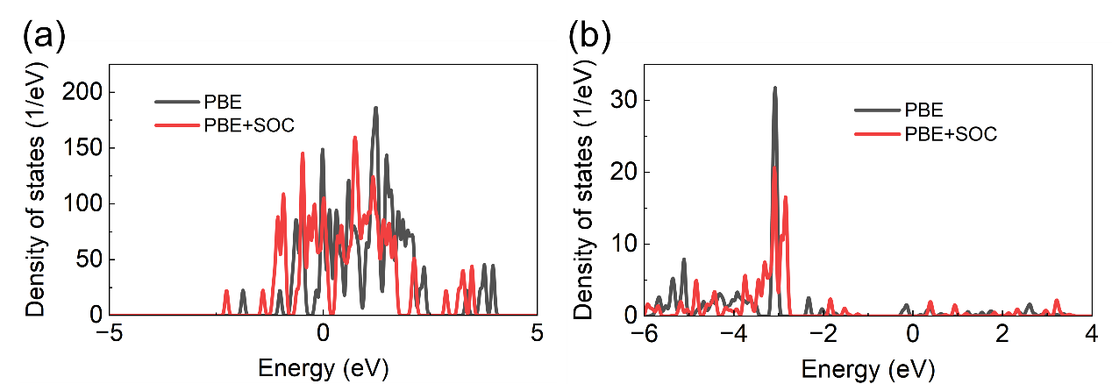
Fig. S1 Effect of spin-orbit coupling (SOC) on the electronic structure of the Ag₁₉Au-H₂O cluster. (a) Total density of states (TDOS) for the complete Ag₁₉Au-H₂O system. (b) Projected density of states (PDOS) specifically isolating the contribution of the Au dopant atom. In both panels, the black and red curves represent calculations performed using the standard PBE functional and the PBE functional with SOC included (PBE+SOC), respectively.

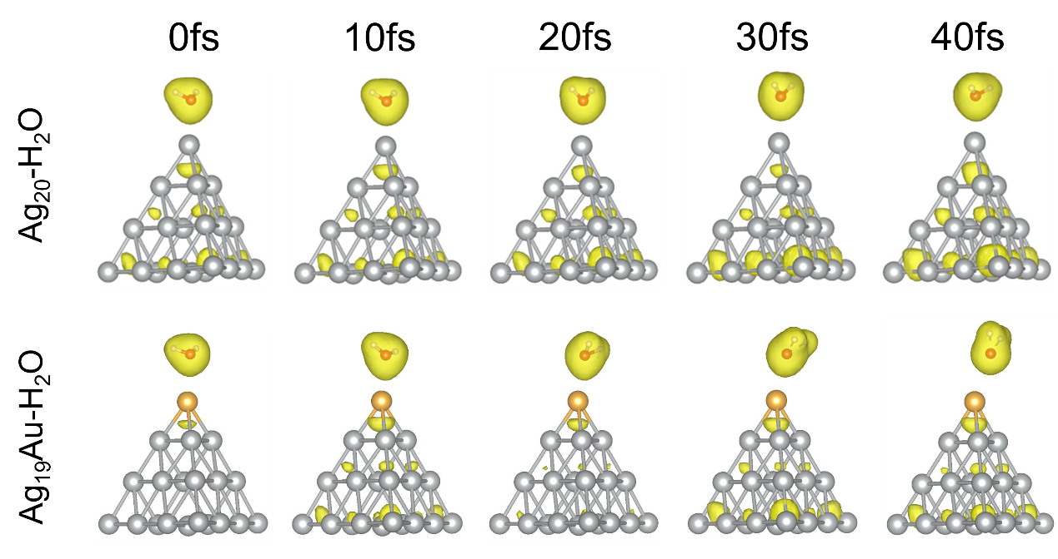
Fig. S2 Dynamic evolution of the charge density in Ag₂₀-H₂O and Ag₁₉Au-H₂O under a lower external field strength of E_{max}=0.1 V/Å. The yellow isosurfaces visualize the instantaneous charge distribution at selected time snapshots (t=0, 10, 20, 30, and 40 fs).

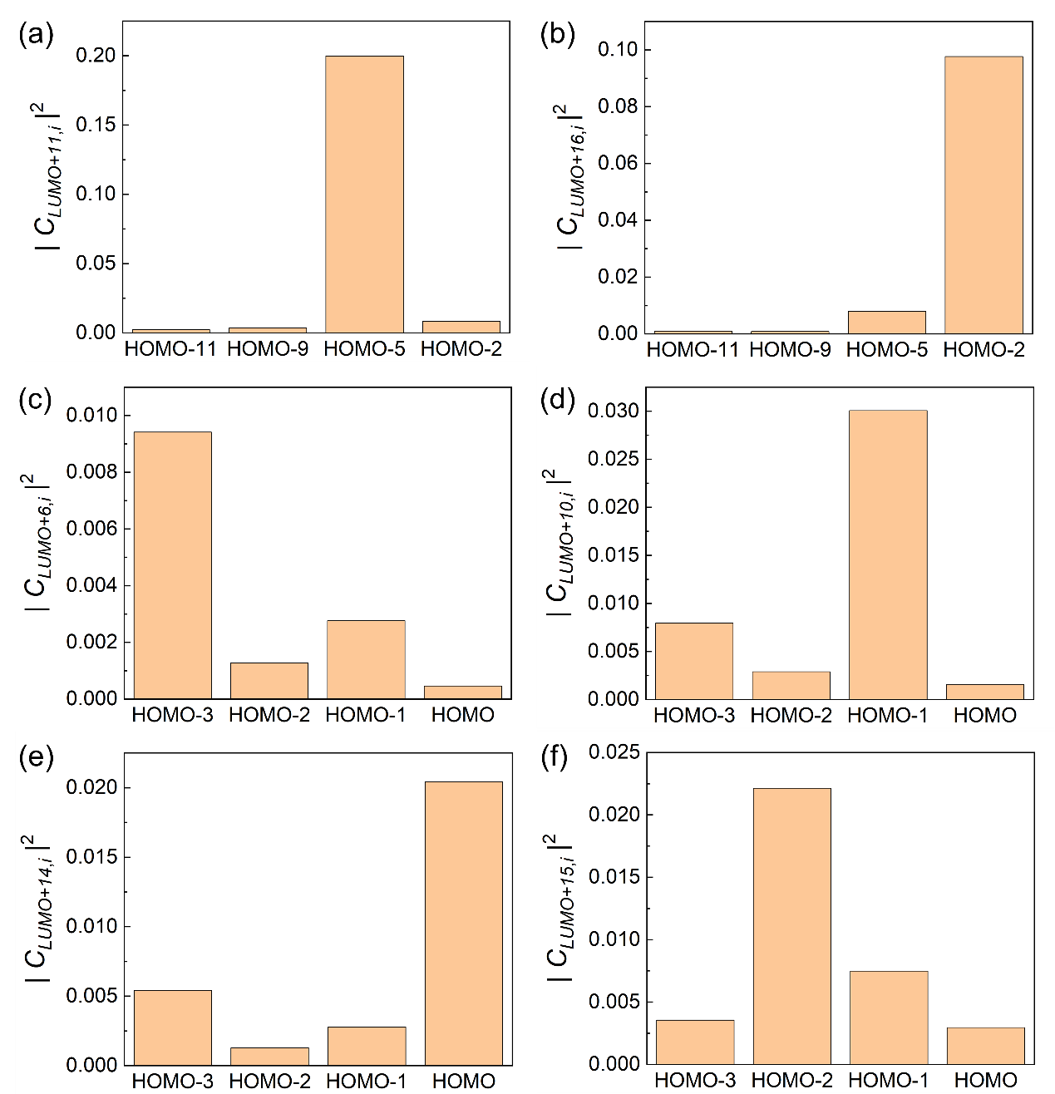
Fig. S3 Snapshot of electron transition probabilities at t=20 fs. (a, b) Transition probabilities for the pure Ag20-H2O system into the (a) LUMO+11 and (b) LUMO+16 target states. (c–f) Corresponding transition probabilities for the doped Ag19Au-H2O system into the (c) LUMO+6, (d) LUMO+10, (e) LUMO+14, and (f) LUMO+15 target states. The bar charts quantify the transition coefficients squared (|C_{LUMO+X,i}|²), representing the likelihood of electron transfer from specific occupied metal states (i) to the designated unoccupied metal-water hybrid states at the moment of peak electronic excitation.

