Groundnut genotypes studied
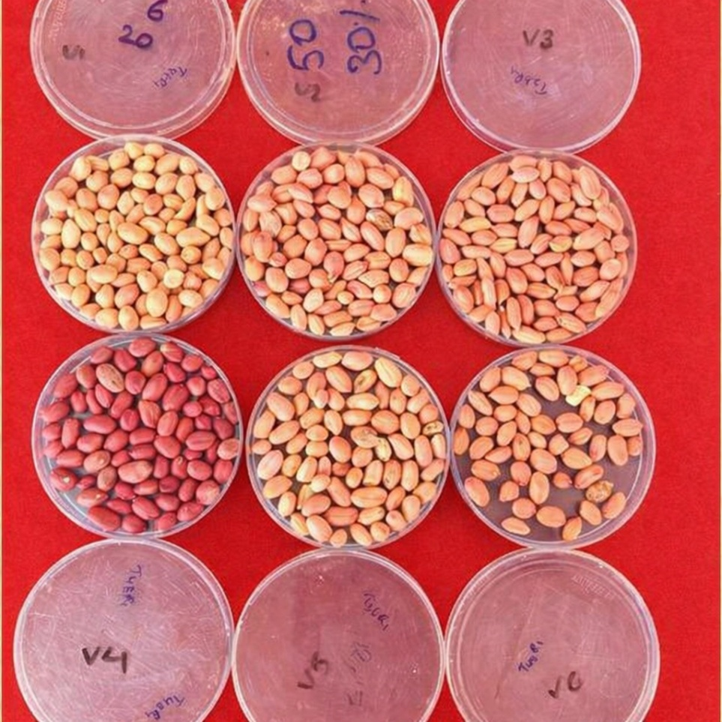
Trend of Phenols content (mg GAE/g FW) of Groundnut Genotypes during pre & post harvest conditions

Photographs displaying performing analysis under laboratory conditions
