Supplementary Figure and figure legends

Supplementary Figure 1.
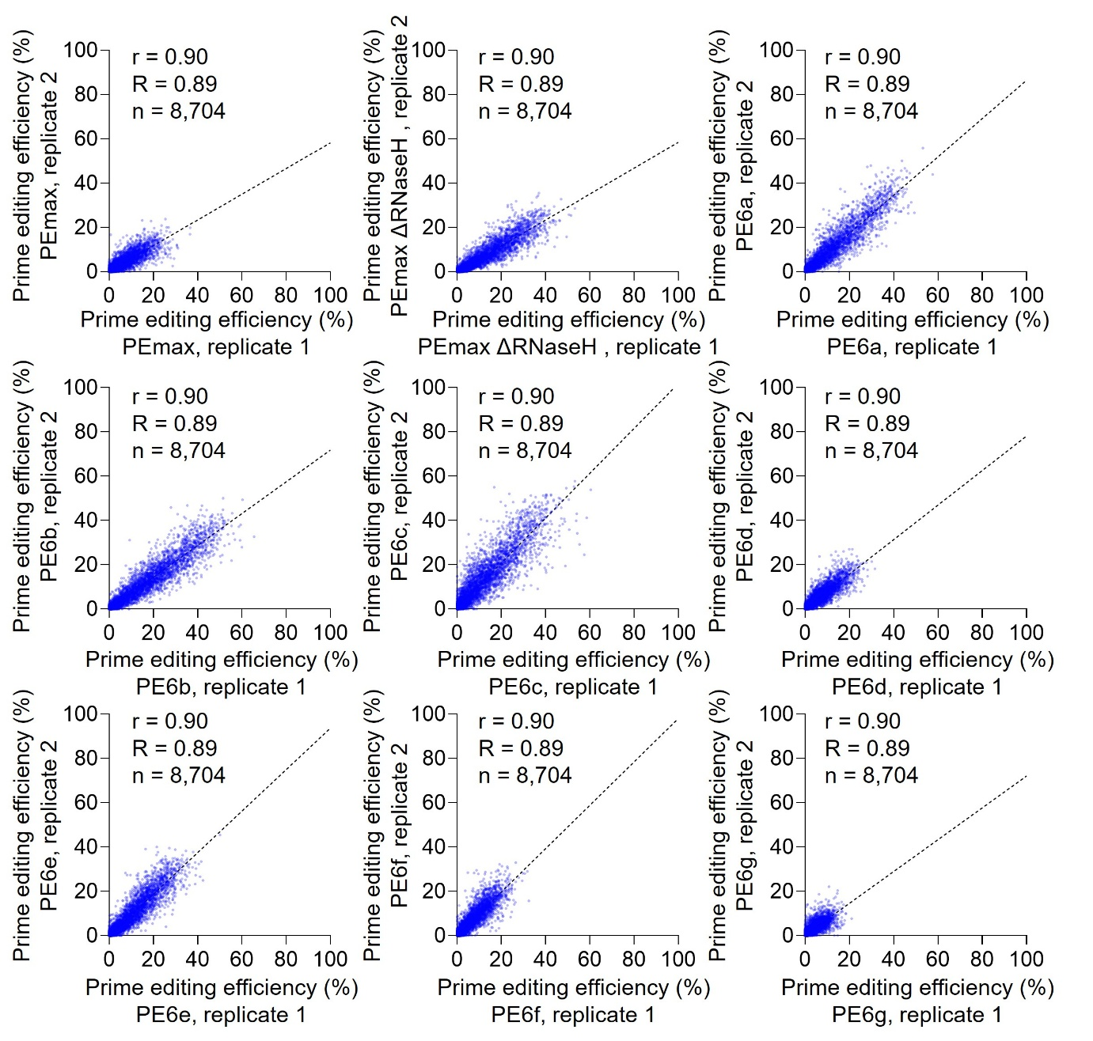
Supplementary Figure 1. Replicate concordance of prime editing efficiencies across prime editor variants. Editing efficiencies measured in two independent replicate experiments were compared for each prime editor variant. For each panel, prime editing efficiency (%) measured in replicate 1 (x-axis) is plotted against that measured in replicate 2 (y-axis) for all epegRNA–target sequence pairs evaluated under the indicated condition. Pearson’s correlation coefficient (r), the coefficient of determination (R²), and the number of data points (n) are reported in each panel. The dashed line represents the linear regression (trend) line fitted to the data.

Supplementary Figure 2.
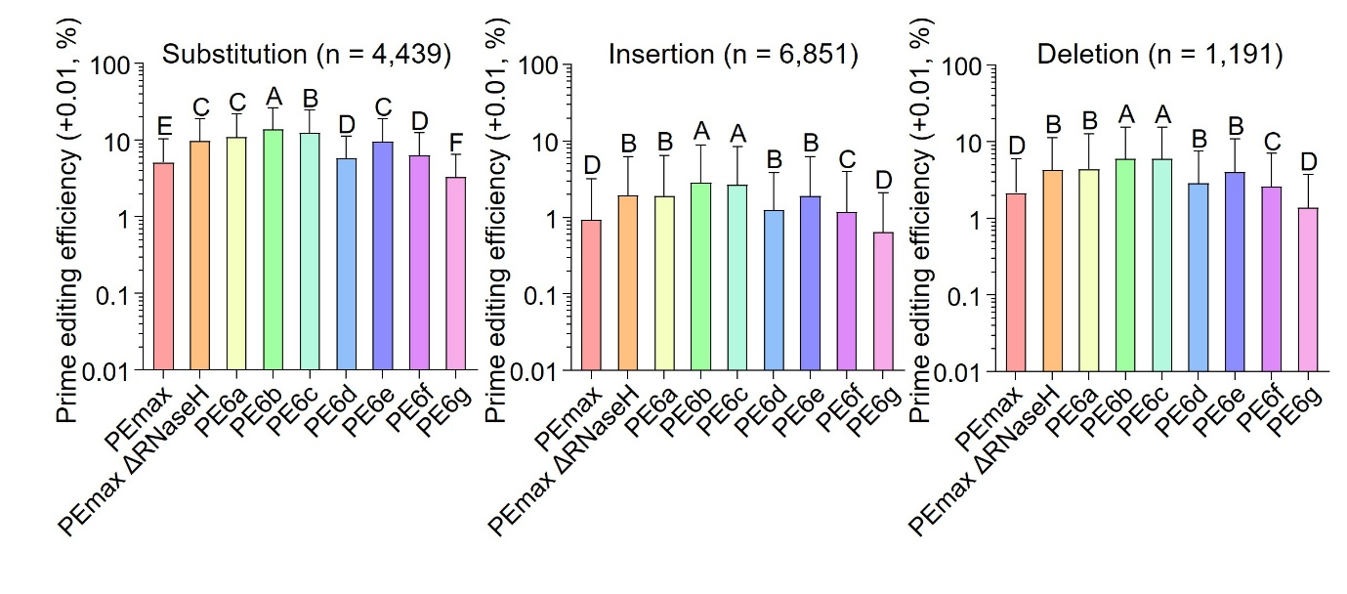
Supplementary Figure 2. Editing efficiencies stratified by intended edit type. Editing efficiencies of nine prime editor variants (PE2max, PE2max-ΔRNaseH, and PE6a–g) were analyzed after grouping pegRNAs by intended edit type: substitution (n = 4,439), insertion (n = 6,851), and deletion (n = 1,191). Editing efficiencies are shown as prime editing efficiency (+0.01, %) on a log scale. Bars represent the mean editing efficiency across pegRNAs within each edit category, and error bars indicate the standard deviation (mean ± SD). Each data point represents the mean of two technical replicates; negative values were set to zero and values were shifted by +0.01 as indicated. Statistical analyses were performed as described in Fig. 1B.
Supplementary Figure 3.
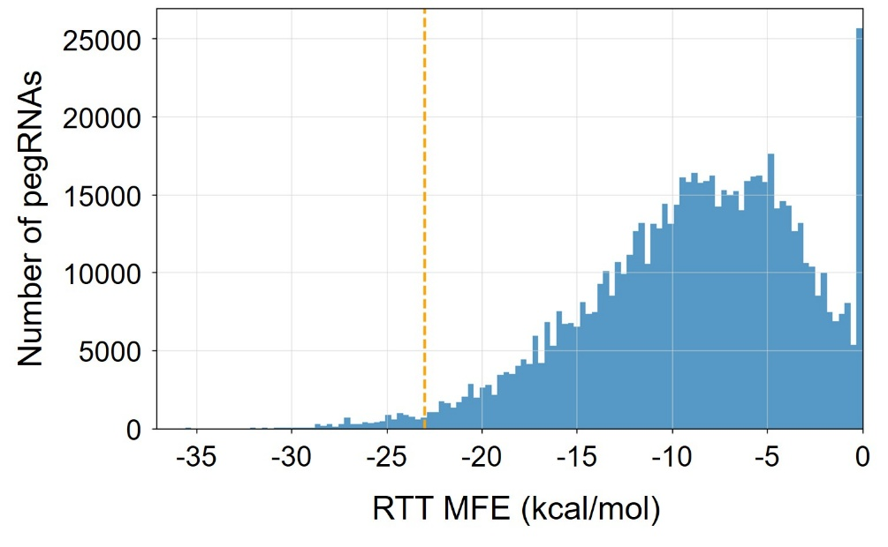
Supplementary Figure 3. Distribution of predicted RTT secondary-structure stability for designed pegRNAs. All possible pegRNAs were designed for 670 randomly selected pathogenic or likely pathogenic ClinVar variants using PBS lengths of 7–17 nt and RTTs encoding a 5–30 nt right homology arm. Predicted minimum free energy (MFE) values of RTT sequences were calculated using RNA secondary-structure prediction, and the distribution of RTT MFE values is shown. The threshold used to define highly stable RTT structures (MFE < −23 kcal/mol) is indicated by the dashed line.

Supplementary Figure 4.
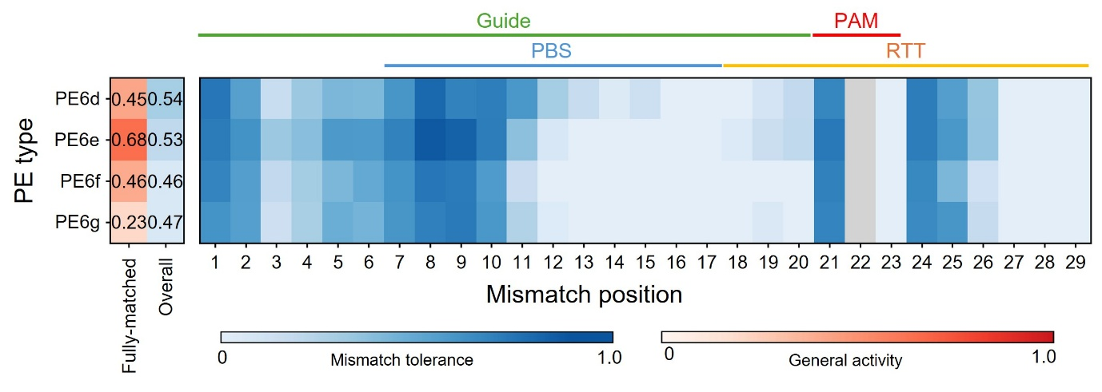
Supplementary Figure 4. Position-dependent mismatch tolerance for PE6d–g. Position-dependent mismatch tolerance was profiled for PE6d–g as described in Figure 2a. Relative editing efficiencies are shown across the guide, PBS, PAM, and RTT regions; position 22 was excluded.

Supplementary Figure 5.
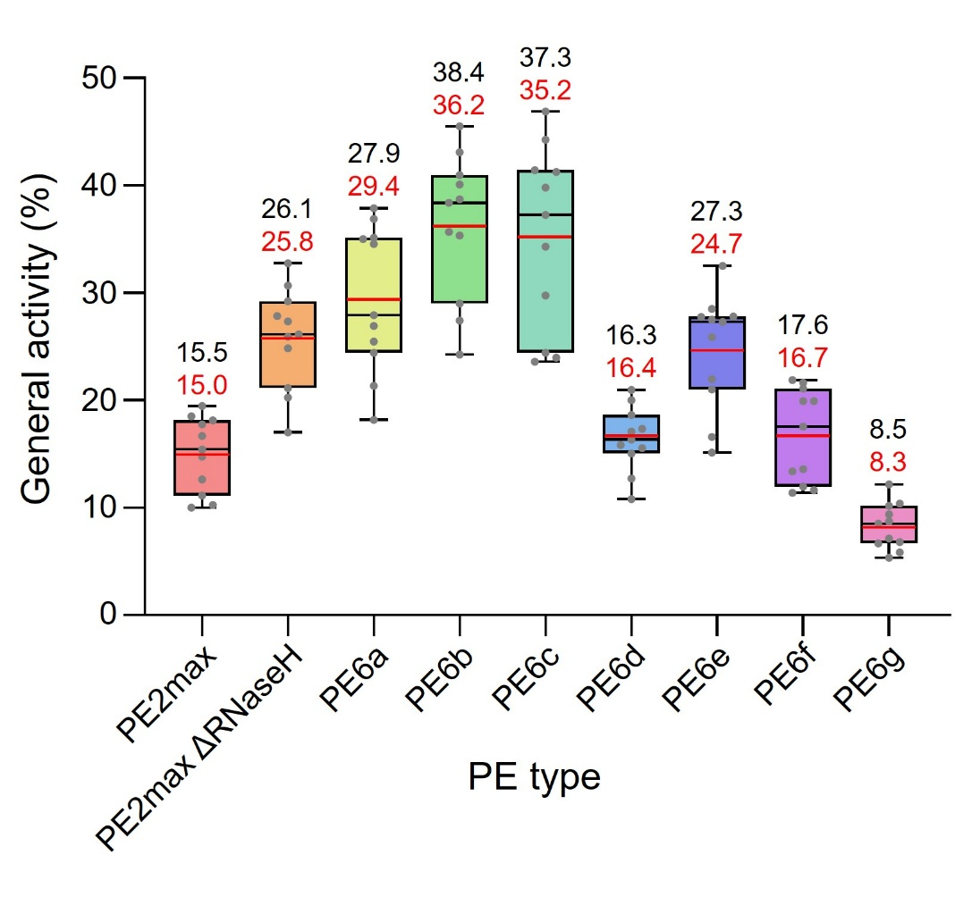
Supplementary Figure 5. Distribution of on-target editing efficiencies used for mismatch tolerance analysis. Editing efficiencies of pegRNAs retained for mismatch tolerance profiling are shown for each prime editor variant. Only pegRNAs with on-target editing efficiencies ≥5% were included in downstream analyses. The retained pegRNAs exhibited comparable on-target editing efficiencies across prime editor variants, ranging from 8% to 36%. In each boxplot, the black horizontal line and black value denote the median, whereas the red horizontal line and red value denote the mean. Each data point represents the mean of two biological replicates.

Supplementary Figure 6.
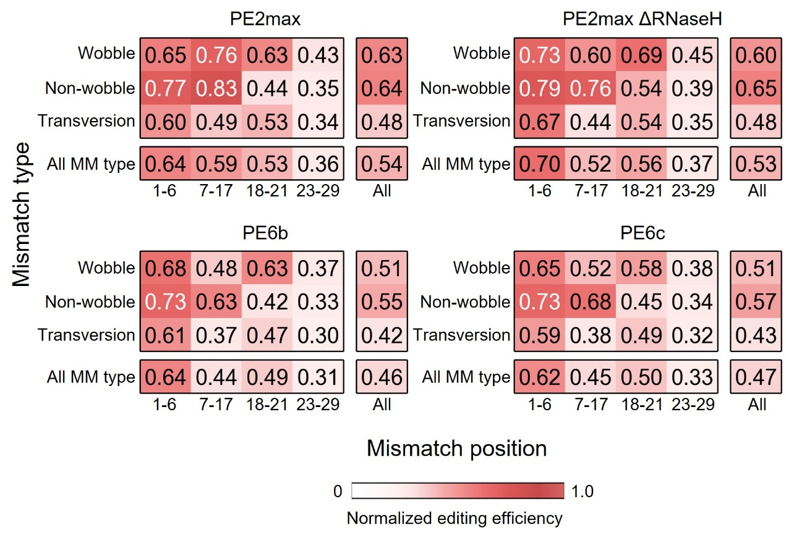
Supplementary Figure 6. Effect of mismatch type and position on prime editing efficiency for PE6d–g. Mismatch type- and position-dependent effects on prime editing efficiency were analyzed for PE6d–g as described in Figure 2d. Values represent mean relative editing efficiencies normalized to perfectly matched targets.

Supplementary Figure 7.
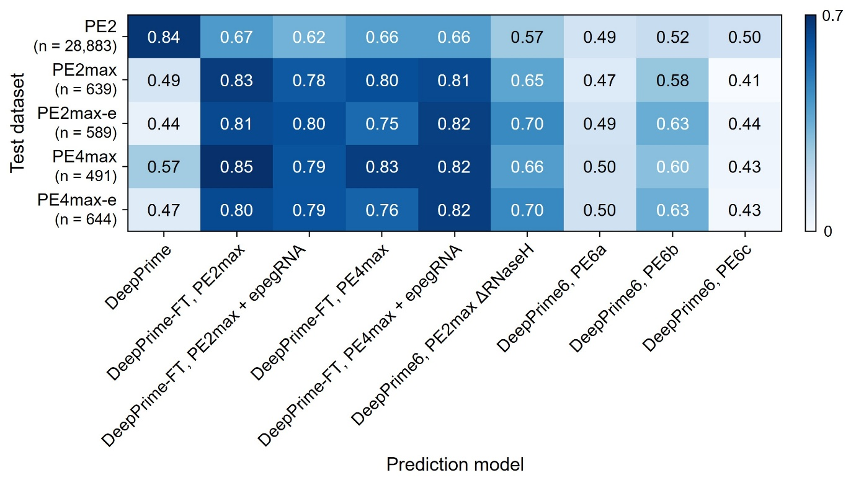
Supplementary Figure 7. Generalizability of fine-tuned DeepPrime models on the original DeepPrime test dataset. Pearson's correlation coefficients between predicted and observed prime editing efficiencies are shown for each fine-tuned model (PE2max-ΔRNaseH, PE6a–c) across five DeepPrime base models pre-trained on PE2, PE2max, PE2max-e, PE4max, and PE4max-e data, respectively.

Supplementary Figure 8.
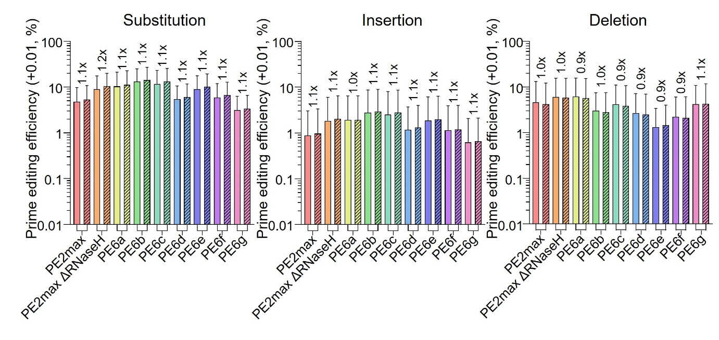
Supplementary Figure 8. Editing efficiencies of epegRNAs stratified by intended edit type. Prime editing efficiencies obtained using engineered pegRNAs (epegRNAs) containing either the tevopreQ1 or tmpknot RNA motif were compared across nine prime editor variants (PE2max, PE2max-ΔRNaseH, and PE6a–g) after grouping pegRNAs by intended edit type: substitution (n = 4,439), insertion (n = 6,851), and deletion (n = 1,191). Bars represent the mean and error bars indicate the standard deviation. Mean values are indicated above each bar. Each data point represents the mean of two biological replicates. Editing efficiencies were normalized to untreated controls and shifted by +0.01 prior to log transformation.

