Supporting Information for
Dimethyl itaconate inhibits TNF-α induced NF-κB signaling pathway in human epithelial cells

Yalei Zhang¹, Xiaobing Deng², Hao Liang², Annan Guo¹, Kenan Li¹, Hongbo Liu², Qi Zhang⁴, Luhua Lai^{1,2,3*}

¹Peking-Tsinghua Center for Life Sciences, Peking University, Beijing, China.
²BNLMS, College of Chemistry and Molecular Engineering, Peking University, Beijing, China.
³Center for Quantitative Biology, Academy for Advanced Interdisciplinary Studies, Peking University, Beijing, China.
⁴The PTN Graduate Program, College of Life Sciences, Peking University, Beijing, China.

*To whom correspondence should be addressed:
Professor Luhua Lai,
College of Chemistry and Molecular Engineering, Peking University, Beijing, China.
Tel: 861062757486
Email: lhlai@pku.edu.cn

Supplementary Methods
Chemicals and Reagents
Acetonitrile (ABSOLV grade) was supplied by Tedia company (Fairfield, OH, USA). Ammonium acetate and ammonium hydroxide were obtained from Sigma-Aldrich (St. Louis, MO, USA). The NH₂ column (150 mm ×4.6 mm, 5 μm) was purchased from Phenomenex company (Torrance, CA, USA)
Mutagenesis Experiments
The pCMV3-N-His-IKKβ plasmid was used as a template to introduce the point mutation of cysteine (C) by alanine (A). All mutagenesis experiments were performed using the QuickChange site-directed mutagenesis kit (SBS Genetech Co., Ltd., Beijing, China). The DNA sequences of the mutants were verified by DNA sequencing.
LC-MS/MS method
LC separation was performed with a Shimadzu Prominence UFLC XR (Shimadzu Corp). Mutiple-reaciton monitoring (MRM) spectra were recorded with a QTRAP 5500 mass spectrometer (AB SCIEX) equipped with an ESI source. A Phenomenex Luna 5μm NH₂ 100A column (150 mm ×4.6 mm, 5 μm) was used for the LC separation. The mobile phase consisted of (A)95% 100 mM ammonium acetate (pH5.8) and 5% acetonitrile and (B) acetonitrile. The flow rate of was 0.3 mL min⁻¹. 20 μL portions of each sample were injected into the HPLC system. All data were acquired in negative-ion mode.

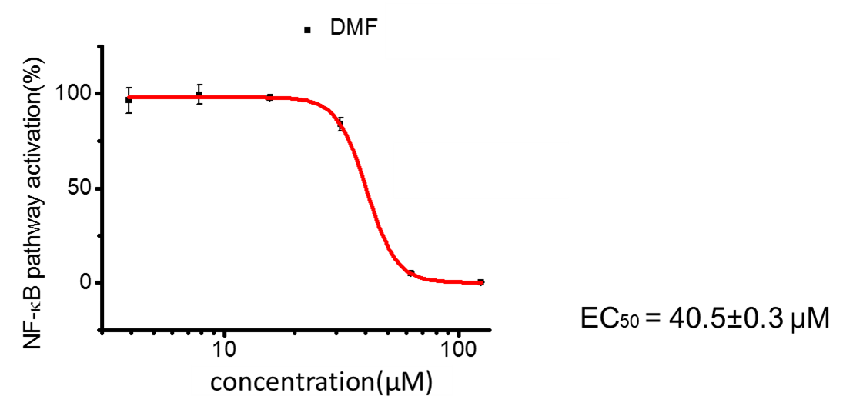
Supplementary Figure 1. The effect of DMF on TNFα-induced NF-κB signaling pathway using luciferase assay.
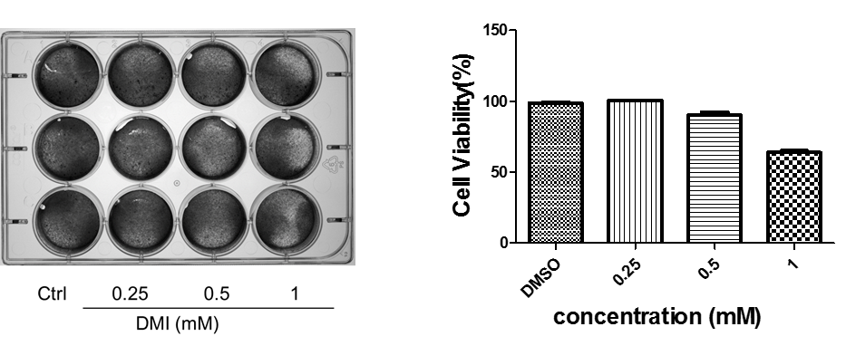
Supplementary Figure 2. The effects of different concentrations DMI on cell viability.

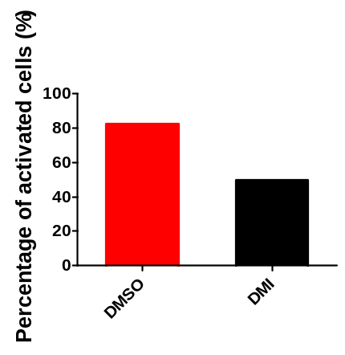
Supplementary Figure 3. Percentage of activated cells pretreated wth DMSO or 0.25 mM DMI and then stimulated with TNFα (10 ng ml⁻¹).

Supplementary Table 1. Modification of IKKβ cysteines by DMI in vitro.
1mM DMI + IKKβ 4℃ 12h
Modification sites | Modification form
C412 | C6H9O4 (C)
C412 | C7H11O4 (C)
C370 | C7H11O4 (C)
C716 | C7H11O4 (C)

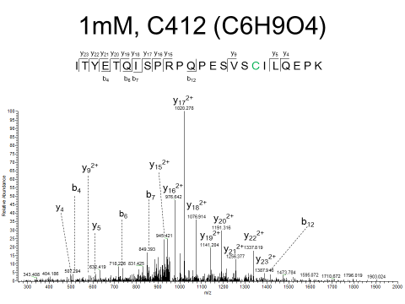
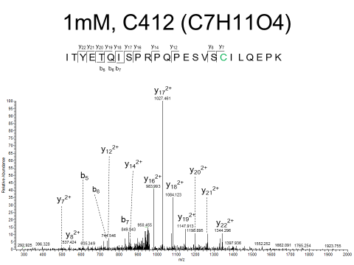
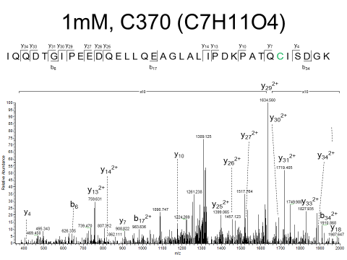
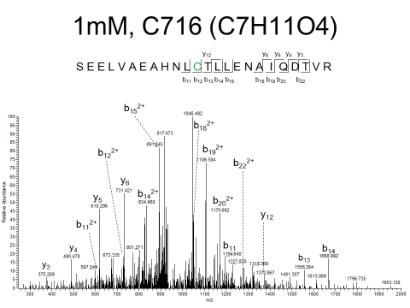
Supplementary Figure 4. LC-MS/MS analysis of DMI-mediated modification of recombinant IKKβ in vitro.

Supplementary Table 2. Modification of IKKβ cysteines by itaconate in vitro.
5 mM Itaconate + IKKβ 4℃ 12h
Modification sites | Modification form
C99 | C5H7O4 (C); 2 Oxidation (M)
C299 | C5H7O4 (C)
C412 | C5H7O4 (C)
C444 | C5H7O4 (C)

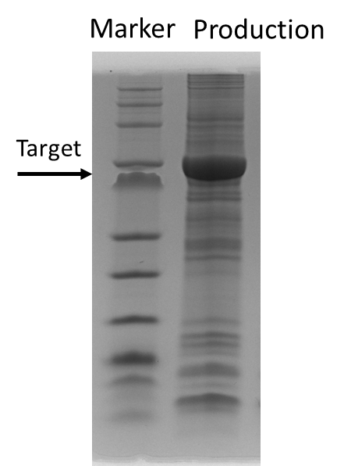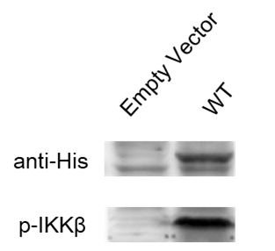
prot_acc | prot_desc | prot_score | prot_mass | prot_cover
IKKB_HUMAN | IKKB OS=Homo sapiens GN=IKKB PE=1 SV=2 | 50744 | 88195 | 84.8

Supplementary Figure 5. Purification of IKKβ from HEK293T cells transfected with the pCMV-N-His-IKKβ expression plasmid. A total of 20 μL of production was loaded onto an SDS/PAGE gel that was stained with Coomassie Blue. The validation of IKKβ by immunoblotting was shown on the right. The LC-MS/MS identification results was shown in the table above.

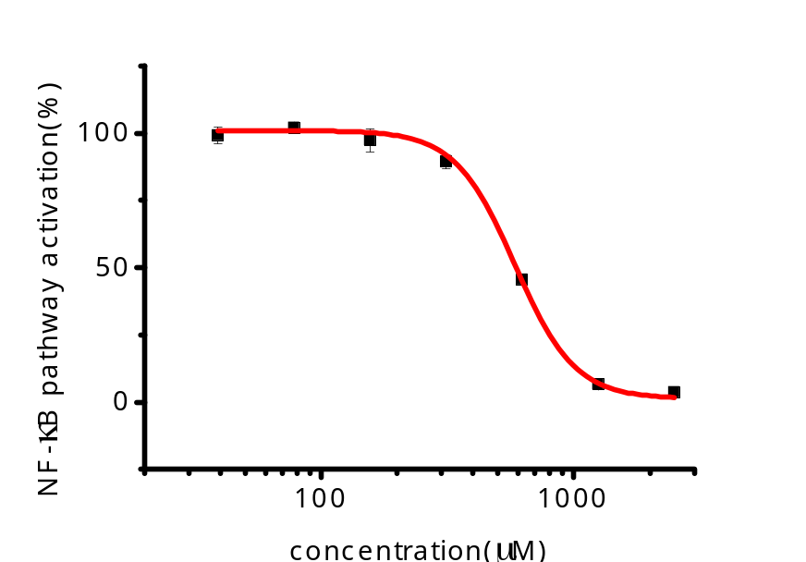

Supplementary Figure 6. Dose-response curve of OI in NF-κB luciferase reporter assay. HEK293T cells transfected with pGL4.32 and pGL4.74 plasmids were pretreated with OI for 12 h before treatment with TNFα (10 ng mL⁻¹) for 6 h.

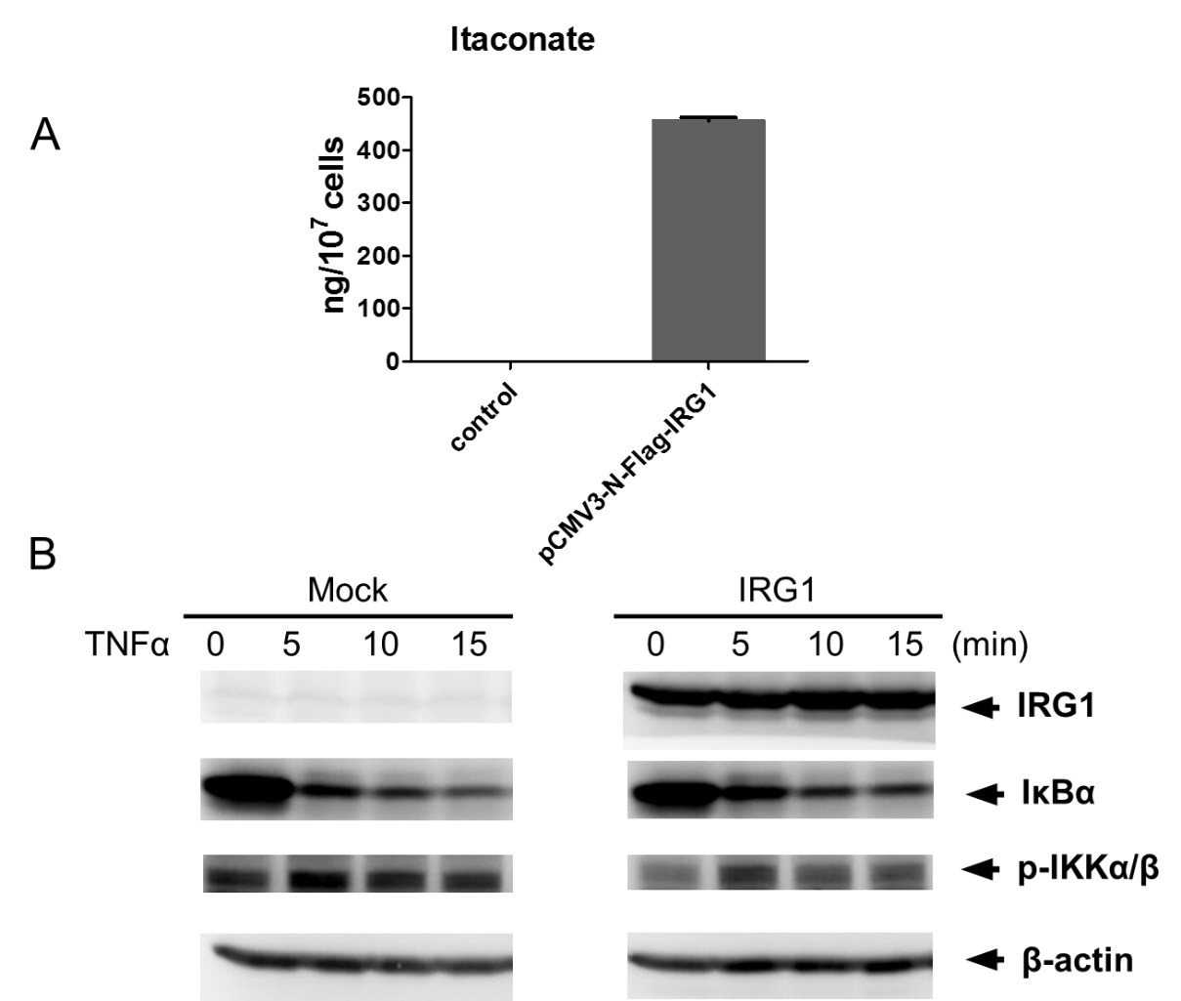
Supplementary Figure 7. Overexpression of IRG1 suppressed IκBα degradation and IKKα/β activation. (A) Intracellular levels of itaconate increased in IRG1 overexpression HEK293T cells after transient transfection with pCMV3-N-Flag-IRG1 compared with control plasmid. Error bars represent the intracellular metabolite levels 24 h transfection of three biological replicates. (B) Immunoblot analysis with the indicated antibodies of cell lysis from HEK293T cells transiently transfected with Flag-tagged IRG1. Data are representative of three independent experiments with similar results.
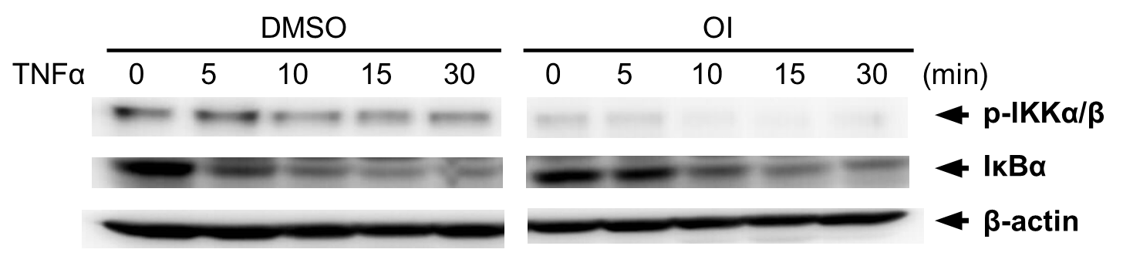
Supplementary Figure 8. OI inhibited NF-κB pathway. Western blot analysis of IκBα and p-IKKα/β in lysate of Hela cells DMSO –pretreated or 1 mM OI pretreated (12h) and stimulated with 10 ng mL⁻¹TNFα for indicated time. β-actin was used as loading control. Blot shown is representative of three independent experiments.

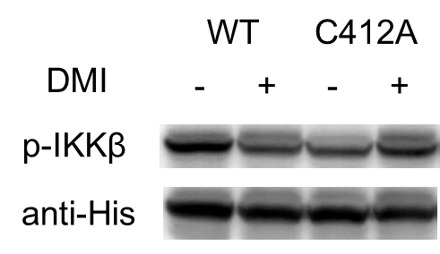
Supplementary Figure 9. Validation of Cys412 as DMI binding site on IKKβ. HEK293T cells were grown to 70% confluence, transfected with pCMV3-N-HisWT-IKKβ and pCMV3-N-His-C412A-IKKβ, and then treated with or without 0.25 mM DMI for 12 h. DMI inhibited activation of wild type IKKβ. Mutation of Cys412 (C412A) reduced the phosphorylation level of IKKβ and dimished the effect of DMI.

